**Project Report**

**BOGGLE**

by

**Group No: 4**

Tran, Duy H.

Hosmath, Akshata Virupakshayya

Narkhede, Mohini B.

Thakkalapelli, Thanaji Rao

**Management Process Review**

* Software used to develop and to test:

Eclipse IDE with Android ADT plugin

BlueStacks emulator

Android phone

* Platform for project management

Redmine

**Version Control**: We used Redmine repository for version control where each member could check the code and incorporate it its own code. Each member could look through the given tasks, bugs. It was very easy to keep updated the team members about progress of project. Apart from Redmine we extensively used Emails, text to communicate and Microsoft office tools to create presentation slides and reports.

**Tracking Issues**: As all team members were well known about status of the project and were active on REDMINE we could easily notify the issues we faced and solved them in a meeting before class or after class or in class.

**Documentation:** We as a team were pretty much be accurate about deadlines and tasks. Apart from this each member did the documentation for each Sprint demo.

**Files:** We used REDMINE extensively to share each small file including slides, some small files, .apk files etc. So it was very easy for us to update the files.

**Required features**

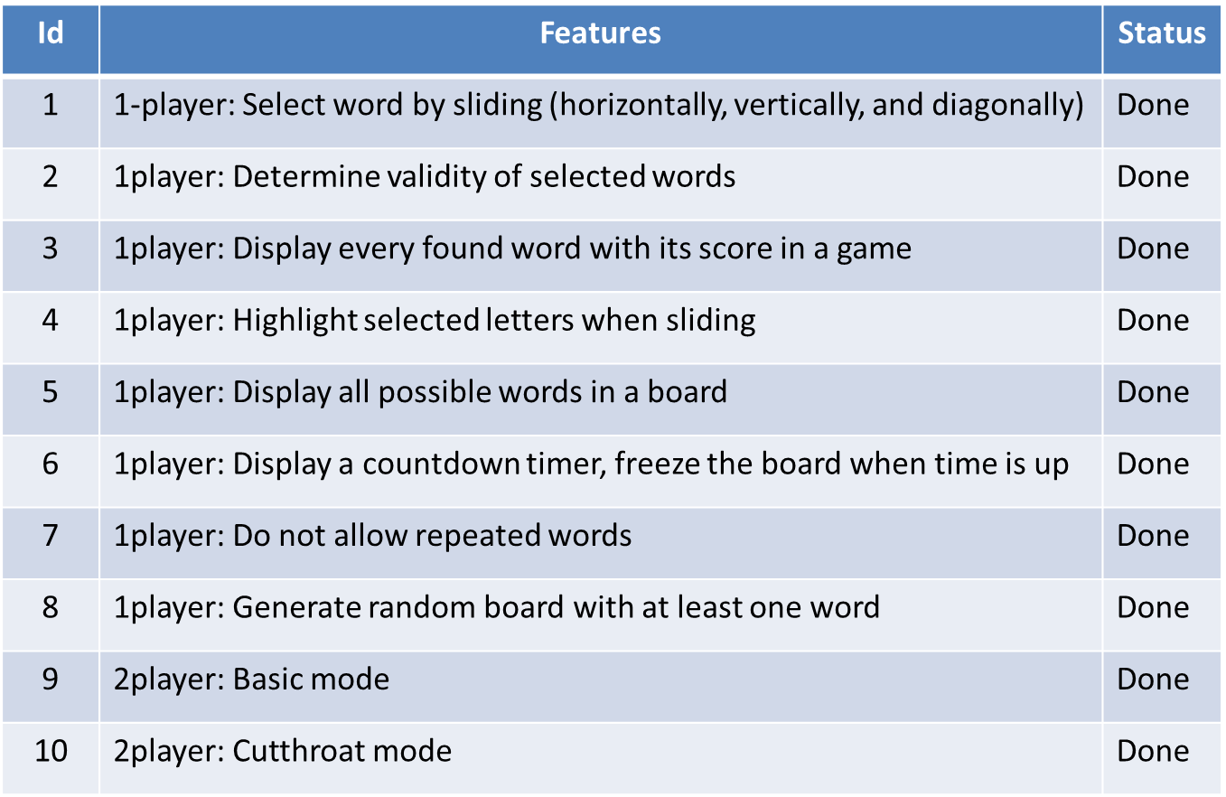

**Extra features**

* It’s a “Multi Player game” where not only two players can play but multiple players can join into the room and play the Basic and cutthroat modes. However, with a drawback of only two list of words display and two scores display.
* The help to know the rules of the game is provided with a help button at the beginning main menu page of the App.
* The game over message with the result of won/lost/tie in the game between the players in both the two player modes.
* Continuous display of the Opponent’s word selected and scores in both the two player modes.
* Play a sound when selecting a letter

**Lists of group member contributions**

**Tran, Duy H.**

* Worked on AppWrap.
* Performance Testing
* Requirement Testing
* Generating random board with at least one valid word.
* 2 player: Cutthroat mode
* Select word by sliding(horizontally, vertically, diagonally)

**Hosmath, Akshata Virupakshayya**

* UI for Application.
* Display of countdown timer, freezing of board when time is up
* Display every word found with its score.
* Worked on AppWrap
* Performance Testing
* Requirement Testing
* 2 player: Basic mode

**Narkhede, Mohini B.**

* Worked on AppWrap
* UI for Application
* Determine validity of each selected word.
* Designing Main page, flash screen, help page.
* Highlight selected letters while selecting
* Performance Testing
* 2 player: Basic mode
* Requirement Testing

**Thakkalapelli, Thanaji Rao**

* Worked on AppWrap
* Performance Testing
* Requirement Testing
* Do not allow repeated words
* Display all possible words in the game
* 2 player: Cutthroat mode

**Instructions for downloading, compiling and Running the Application**

**Downloading**: You can find the correct and final version of Boggle game in **Boggle_Final** folder. And export that project to the ADT and run it.

**Compiling:** You can compile the java code and will get the .apk file for that particular project or you can use the bin

**Running Application**: We were able to run this application on emulator provided by ADT, BlueStacks and android mobile. Whenever you start the application, you will see the flash screen for may be 3-4 seconds and then menu page will appear showing the single player or multi player game. If you choose single player mode the next page you will see will be game page running. You can select words and score for 3 minutes. At the end of the game you will be shown with the score and possible word list.

For two players we have 2 options, 2-Players-Basic mode and 2-Players-Cutthroat.

On clicking basic mode you will be directed to the page to enter the player name. On entering player name you will be asked either to join room (if one existed) or create room. After doing one of that player will wait for other player to join room. The second player should wait for the first one creates a room, and then join his room. When both players are ready to start the game they can hit start button and same board can be seen on both players screen (depends on your device speed, the game may set up earlier and the timer may start sooner. They can select any valid word within 3 minutes and lastly when timer will end, the pop up message will be there resulting the winner. The second player’s score will be updated whenever he found a valid word. Therefore we always know who are winning or losing at that time.

For 2-Players-Cutthroat mode, the functionality is same as basic mode except that if one word is selected by one player then that word will be blocked for other player to select. Not only score but the found words from second player will be updated also.