VBA Homework - The VBA of Wall Street

Github: <https://github.com/speedracer05/VBA-challenge>

# Summary

This is an Excel VBA script for the VBA challenge assignment that analyzes the provided historical stock market data, summarizing yearly change between the opening and close price for a given year, percent change and total volume for each unique stock. Formatting is also applied; conditional format to the yearly change, highlighting a cell green for positive, and red for negative changes; numerical formatting for percent change, and thousands formatting for the total stock volume.

2016

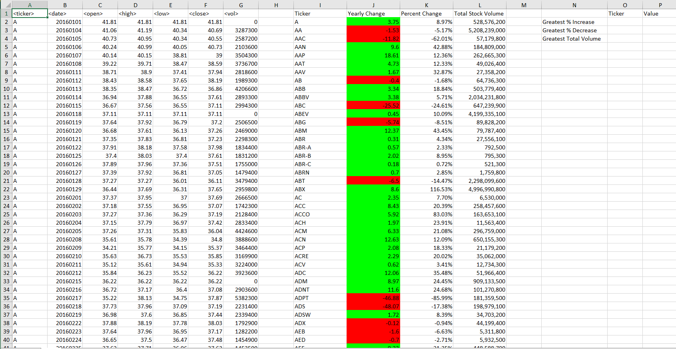

2015

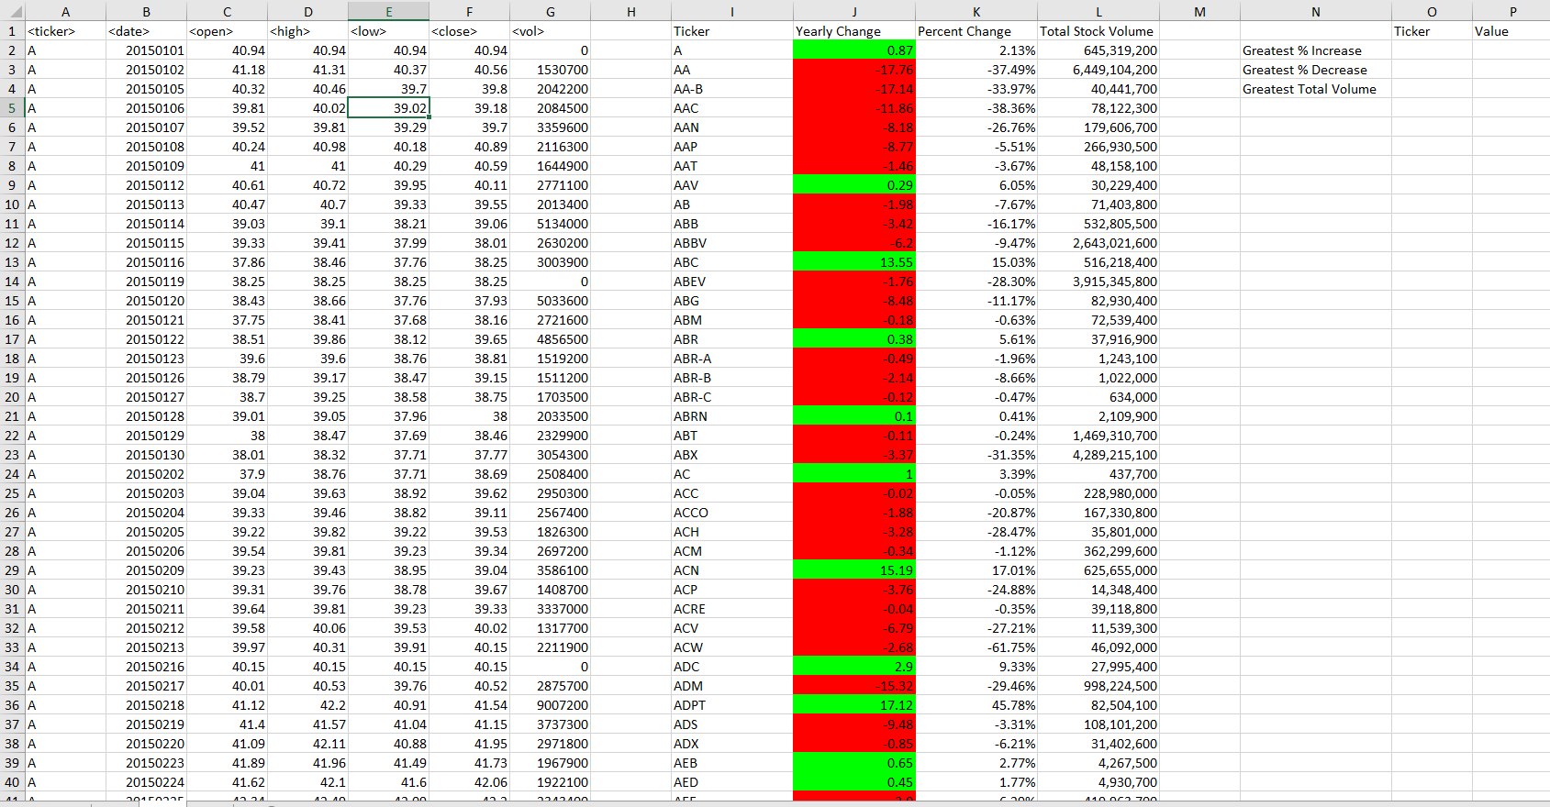

2014

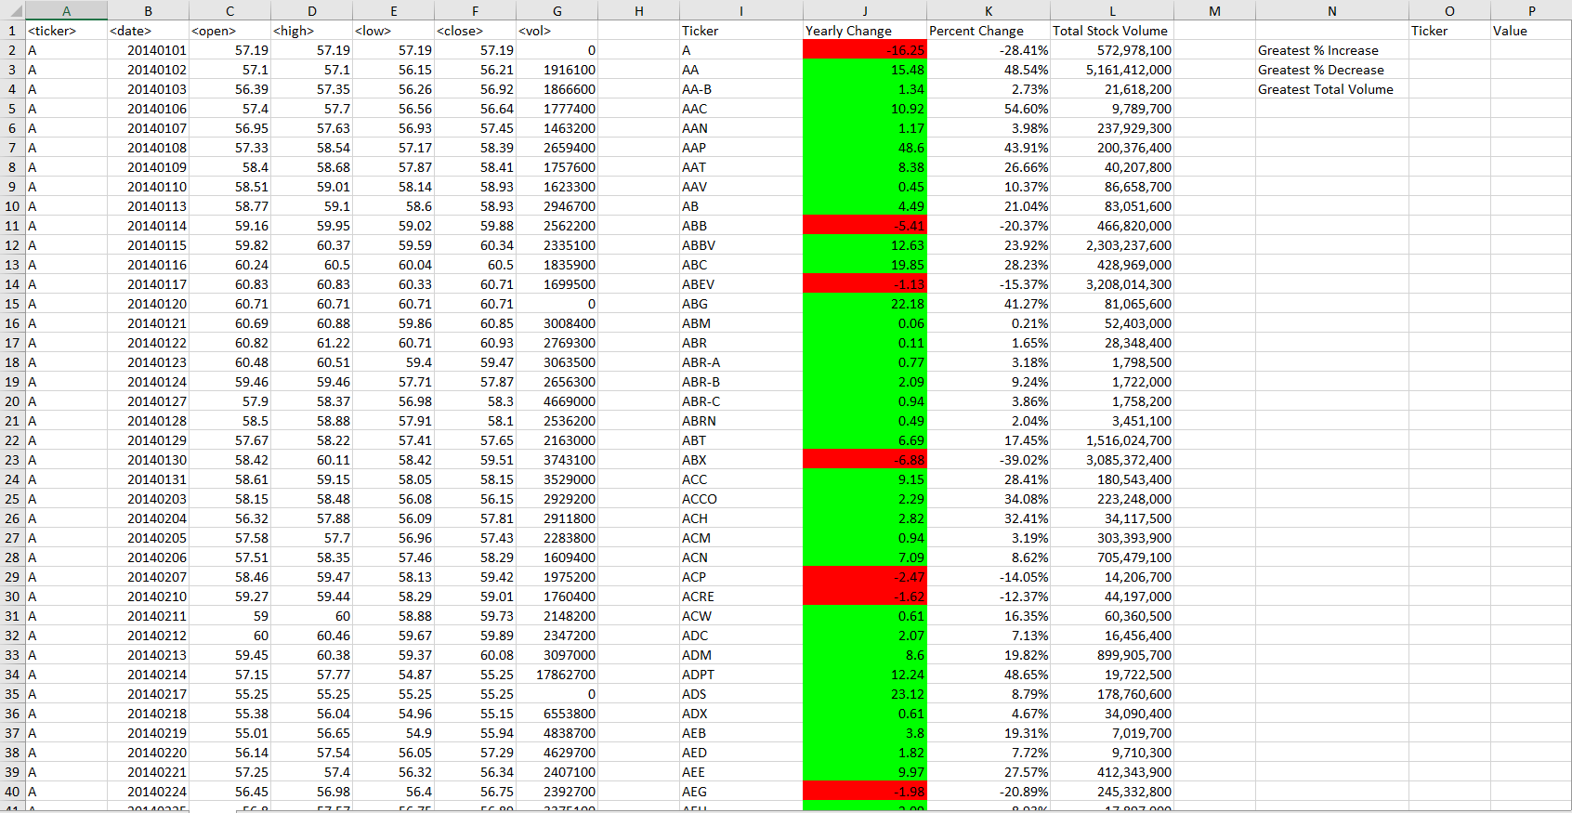

# Error Message for Divide by Zero Error

Spreadsheet 2014 has a stock PLNT that has zeros in the data fields, which cause the program to run into a ”run-time error 6” overflow condition. I put up a script to check for the zero data field and present a message to correct the error.

