利用Verilog开发MIPS流水线处理器

一．整体结构：

流水线处理器包括流水寄存器、各级组合逻辑以及各级控制器三大部分

它们均放在mips.v层次下，其中code.txt中存储相应指令码

处理器为32位处理器，支持的指令集为：**addu,subu, ori, lw, sw, beq, lui, j,jal, jr,nop**

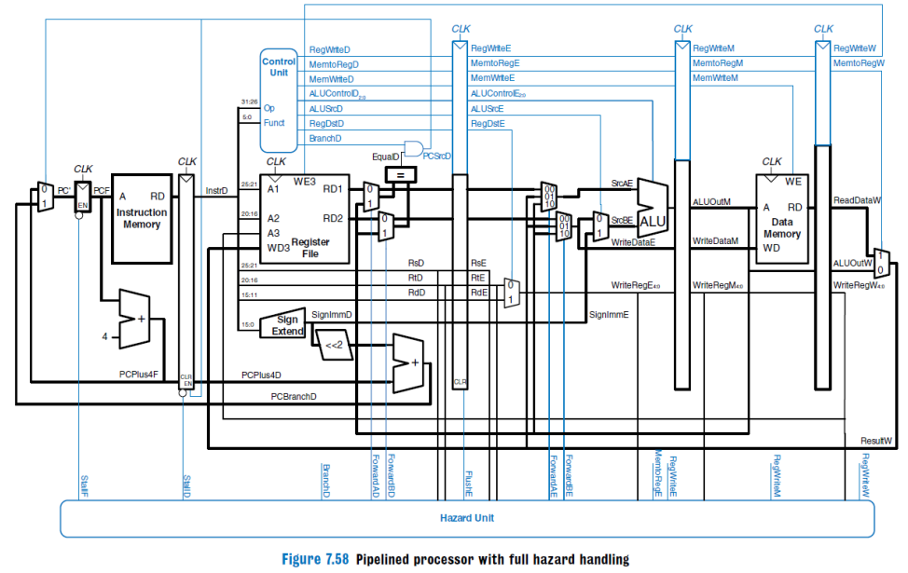

1. **数据通路部分**

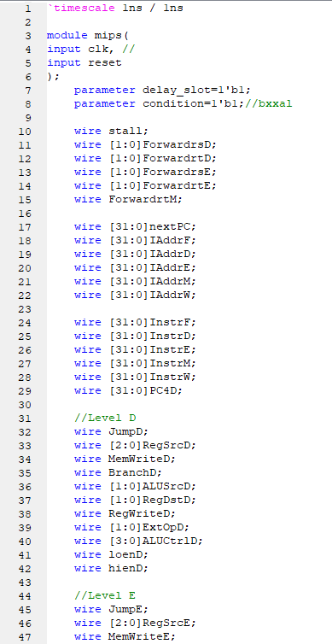

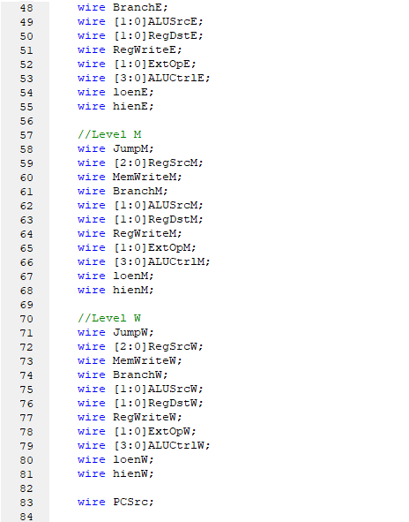

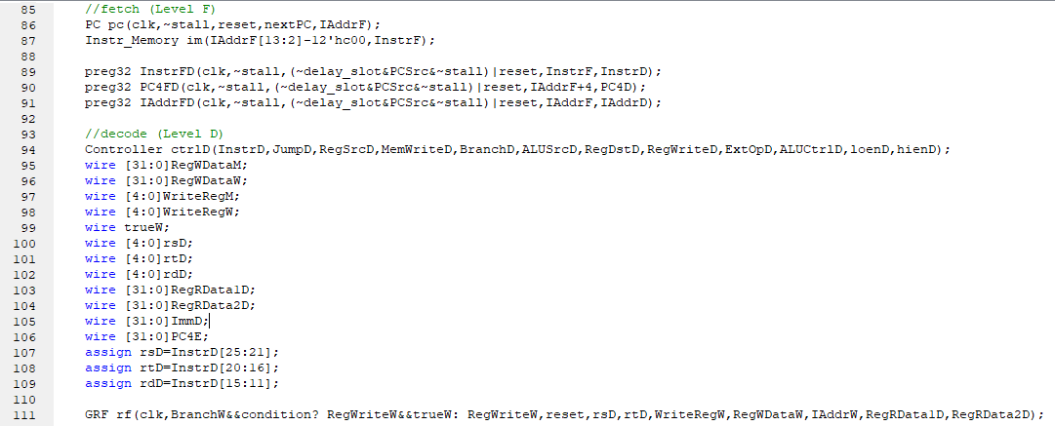

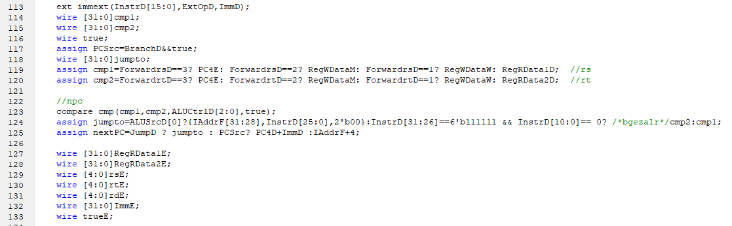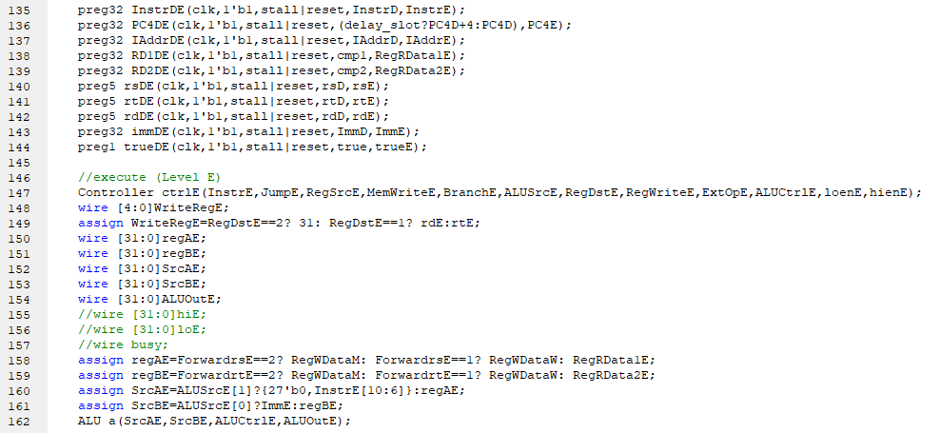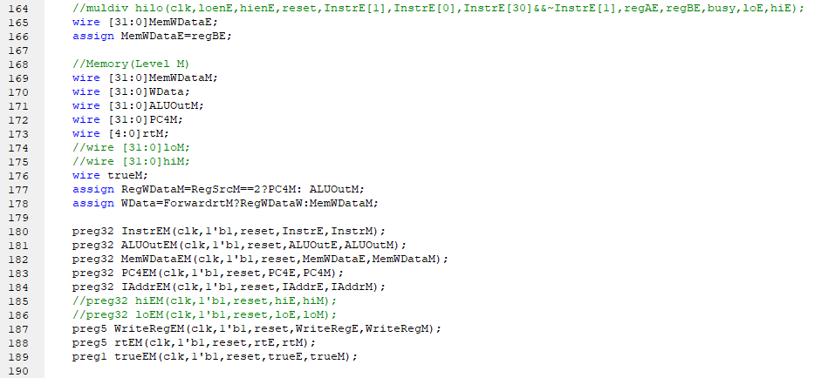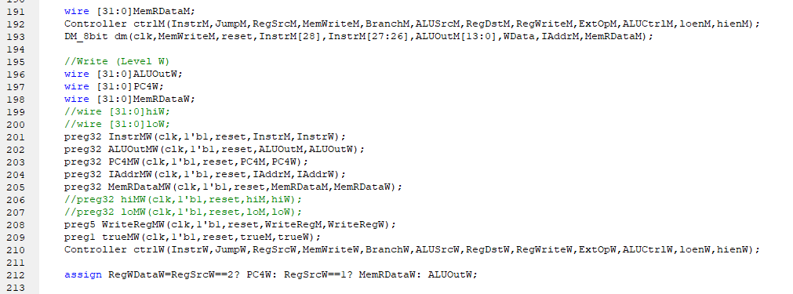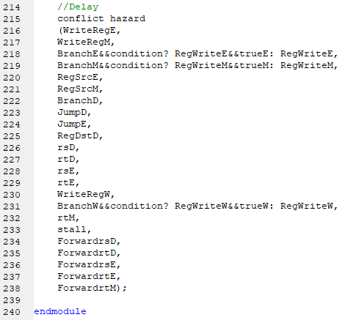

1. PC （PC.V）

初始值：0x30000000

module PC(

input clk, //时钟

input en,

input reset,

input [31:0]next,

output reg [31:0]IAddr=32'h00003000

);

端口定义：

|  |  |  |
| --- | --- | --- |
| 信号名 | 方向 | 描述 |
| next[31:0] | I | 下一条指令地址 |
| clk | I | 时钟信号 |
| reset | **I** | 复位信号  1：有效  0：无效 |
| reg[31:0] | O | 当前指令地址 (IAddr=32'h00003000) |

2．IM（im.v）

容量：32bit*1024 字，地址10 位。只读，不可写。

端口定义：

|  |  |  |
| --- | --- | --- |
| 信号名 | 方向 | 描述 |
| RAddr[9:0] | I | 指令地址后10 位 |
| RData[31:0] | O | 指令机器码 |

module Instr_Memory(

input [9:0]RAddr,//指令地址后10 位

output [31:0]RData//指令机器码

);

存储部件：reg [31:0] rom[0:1023];

初始化：$readmemh("code.txt",rom);

3．GRF（GRF.v）

具有写使能的寄存器实现，寄存器总数为 32 个0 号寄存器的值始终保持为

0。其他寄存器初始值均为 0。

端口定义：

|  |  |  |
| --- | --- | --- |
| 信号名 | 方向 | 描述 |
| IAddr[31:0] | I | 相应指令存储地址 |
| clk | I | 时钟信号 |
| reset | I | 复位信号  1：有效  0：无效 |
| WEnable | I | 读写控制信号  1：写操作  0：读操作 |
| RAddr1[4:0] | I | 读寄存器1 的地址 |
| RAddr2[4:0] | I | 读寄存器2 的地址 |
| WAddr[4:0] | I | 5 为地址输入信号，指定32 个寄存器  中的一个作为写入目标寄存器地址  （写地址） |
| WData[31:0] | I | 向写寄存器中写入的值（写数据） |
| RData1[31:0] | O | 32 位输出1（读数据1） |
| RData2[31:0] | O | 32 位输出2（读数据2） |

module GRF(

input clk,//时钟信号

input WEnable,//写使能

input reset,//同步复位

input [4:0]RAddr1,//读地址1

input [4:0]RAddr2,//读地址2

input [4:0]WAddr,//写地址

input [31:0]WData,//写数据

input [31:0]IAddr,//当前指令地址，仅用于控制台输出

output [31:0]RData1,//读数据1

output [31:0]RData2//读数据2

);

4．ALU（ALU.v）

端口定义：

|  |  |  |
| --- | --- | --- |
| 信号名 | 方向 | 描述 |
| op1[31:0] | I | ALU32 位输入数据A（操作数1） |
| op2[31:0] | I | ALU32 位输入数据B（操作数2） |
| sel[3:0] | I | ALU 功能选择信号 |
| Result[31:0] | O | 32 位数据输出（计算结果） |
| Zero | O | 输出为0 |

module ALU(

input [31:0]op1,//操作数1

input [31:0]op2,//操作数2

input [3:0]sel,//功能选择

output [31:0]result,//计算结果

output zero//计算结果为0 标志位

);

选择信号：

0000---非负 0001---负数 0010---加法 0011---减法

0100---按位与 0101---按位或 0110---按位异或 0111---按位或非

1000---逻辑右移 1001---算术右移 1010---左移 1011---相等

1100---有符号小于 1101---无符号小于 1110---正数 1111---≤0

5．ext（ext.v）

容量：32bit*1024 字，地址10 位

端口定义：

|  |  |  |
| --- | --- | --- |
| 信号名 | 方向 | 描述 |
| imm[15:0] | I | 16 位imm 数据输入 |
| EOp[1:0] | I | 位扩展选择信号  00: 符号扩展  01：无符号扩展  10：加载至高16 位(lui)  11：符号扩展之后，左移两位 |
| ext[31:0] | I | 位扩展后的32 位输出 |

module ext(

input [15:0]imm,//待扩展16 位数

input [1:0]EOp,//扩展方式

output [31:0]ext//扩展后的32 位数

);

扩展方式：

00：符号扩展

01：无符号扩展

10：加载至高16 位(lui)

11：符号扩展之后，左移两位

6．DM（DM_8bit.v）

容量：32bit*1024 字。地址10 位，可读可写可复位（同步复位）。

端口定义：

|  |  |  |
| --- | --- | --- |
| 信号名 | 方向 | 描述 |
| clk | I | 时钟信号 |
| WE | I | 读写控制信号  1：写操作  0：读操作00：无符号扩展  01：有符号扩展  10：加载至高位，低位补零 |
| reset | I | 复位信号  1：有效  0：无效 |
| isu | I | 判断是否无符号或有符号数 |
| MemDst[1:0] | I | 写入数据的输入 |
| Addr[11:0] | I | 数据地址 |
| WData[31:0] | I | 写数据 |
| IAddr[31:0] | I | 指令地址，仅用于控制台输出 |
| RData[31:0] | O | 读数据 |

module Data_Memory(

input clk,//时钟信号

input WE,

input reset,//同步复位

input [9:0]Addr,//数据地址

input [31:0]WData,//写数据、

input [31:0]IAddr,//指令地址，仅用于控制台输出

output [31:0]RData//读数据

);

存储部件：reg [31:0] ram[0:1023];

7．Controller(Controller.v)

端口定义：

|  |  |  |
| --- | --- | --- |
| 信号名 | 方向 | 描述 |
| cmd[31:0] | I | 32 位指令码 |
| Jump | O | 跳转信号  0 为不是跳转指令  1 为是跳转指令 |
| RegSrc[1:0] | O | 寄存器数据来源 |
| MemWrite | O | DM 写控制信号，写入GRF 的数据选择(内  存写使能信号) |
| Branch | O | 分支信号  输出0 为不是Branch  输出为1 是Branch |
| ALUSrc[1:0] | O | ALU 操作数2 的来源 |
| RegDst[1:0] | O | 寄存器地址选择  0:[20:16]  1:[15:11] |
| RegWrite | O | 寄存器写使能信号 |
| ExtOp[1:0] | O | 控制位扩展方式 |
| ALUCtrl[3:0] | O | ALU 功能选择信号 |

module Controller(

input [31:0]cmd, //指令码

output Jump, //跳转信号

output [1:0]RegSrc, //寄存器数据来源

output MemWrite, //写内存信号

output Branch, //分支信号

output ALUSrc, //ALU 操作数2 来源

output [1:0]RegDst, //寄存器写地址选择

output RegWrite, //写寄存器信号

output [1:0]ExtOp, //位扩展方式

output [3:0]ALUCtrl //ALU 运算选择

);

详细解释：

RegSrc：00：ALU 01：DM 10：PC+4

RegDst：00：Instr[20:16] 01：Instr[15:11] 10：31（$ra）

8．Pipeline (pipelineregs.v)

module preg1(

input clk,

input en,

input reset,

input in,

output reg out=0

);

module preg5(

input clk,

input en,

input reset,

input [4:0]in,

output reg [4:0]out=0

);

module preg32(

input clk,

input en,

input reset,

input [31:0]in,

output reg [31:0]out=0

);

9．Compare (compare.v)

module compare(

input [31:0]c1,

input [31:0]c2,

input [2:0]sel,

output reg true

);

10．Conflict (conflict.v)

module conflict(

//stall

input [4:0]WriteRegE,

input [4:0]WriteRegM,

input RegWriteE,

input RegWriteM,

input [2:0]RegSrcE,

input [2:0]RegSrcM,

input BranchD,

input JumpD,

input JumpE,

input [1:0]RegDstD,

input [4:0]rsD,

input [4:0]rtD,

//forward

input [4:0]rsE,

input [4:0]rtE,

input [4:0]WriteRegW,

input RegWriteW,

input [4:0]rtM,

//input mdbusy,

//input usehilo,

//stall out

output stall,

//forward out

output [1:0]ForwardrsD,

output [1:0]ForwardrtD,

output [1:0]ForwardrsE,

output [1:0]ForwardrtE,

output ForwardrtM

);

1. 转发和暂停

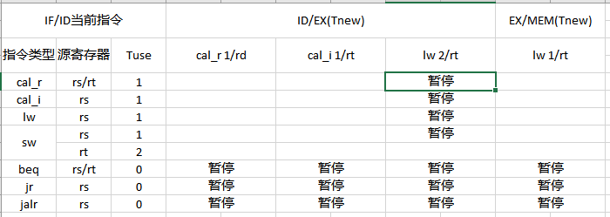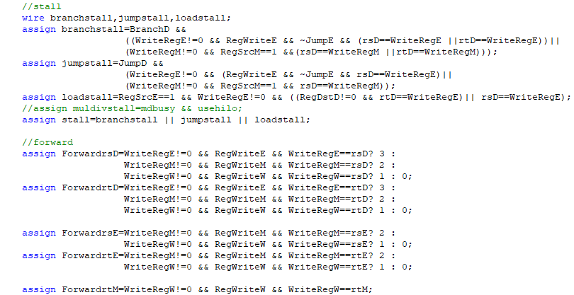

1. 思考题
2. 在本实验中你遇到了哪些不同指令组合产生的冲突？你又是如何解决的？相应的测试样例是什么样的？请有条理的罗列出来。(非常重要)
3. lw后加beq指令出现异常，lw后加beq应该暂停两次。

测试程序：

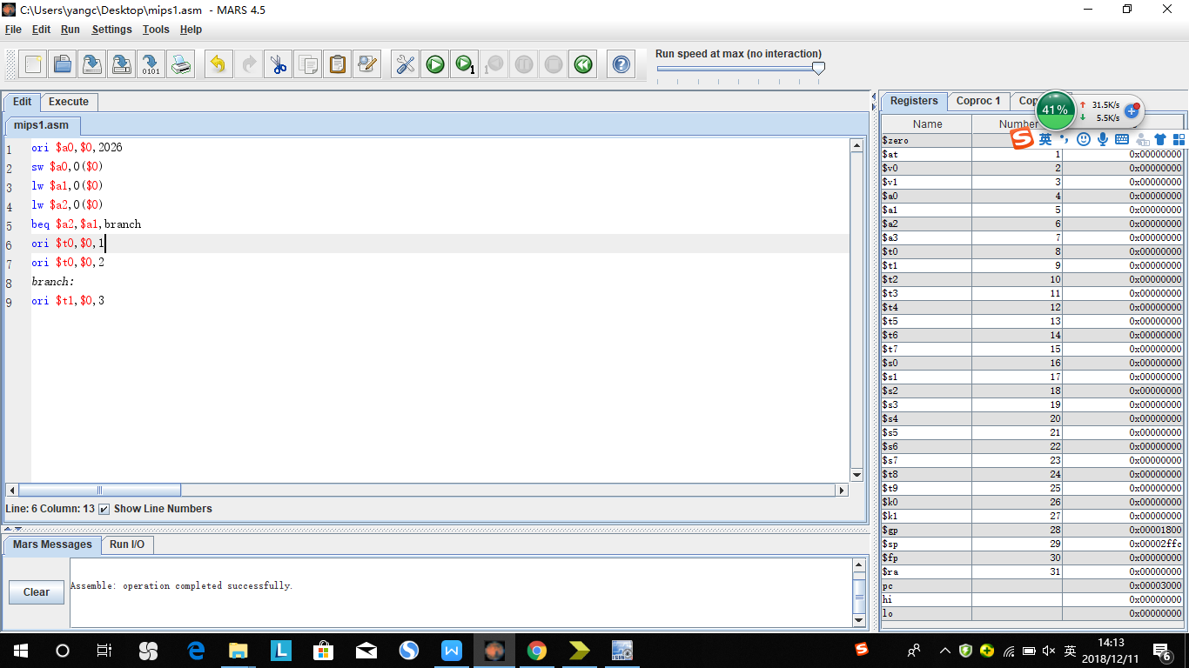

预期结果：

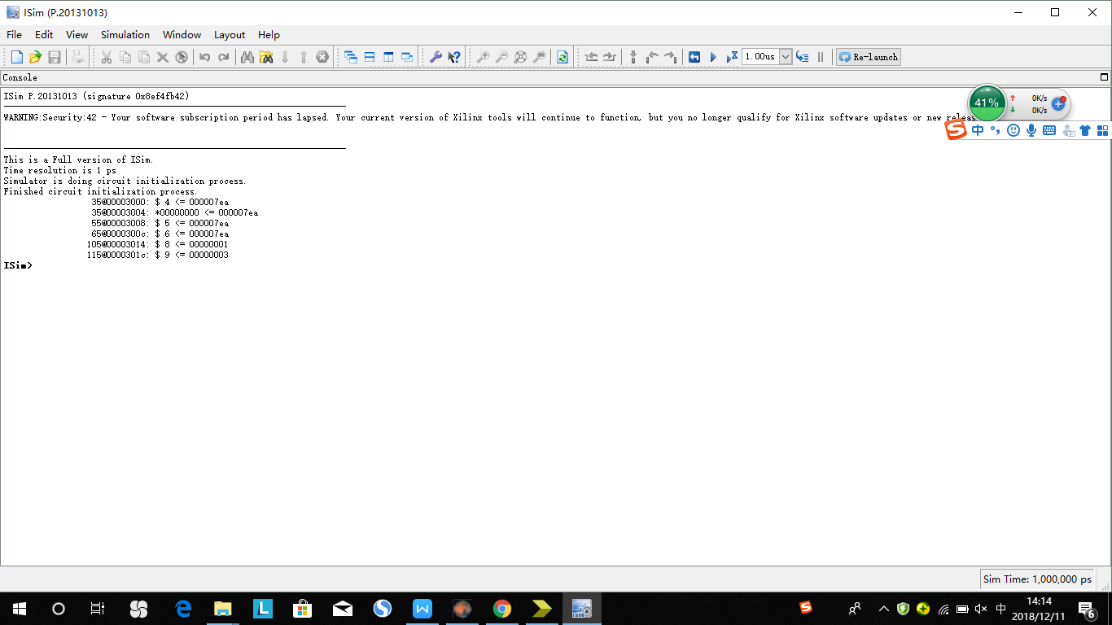

1. jr在D级需要用到rs寄存器的值，需要通过转发来解决，不然中强测前两个点过不去。

测试程序：

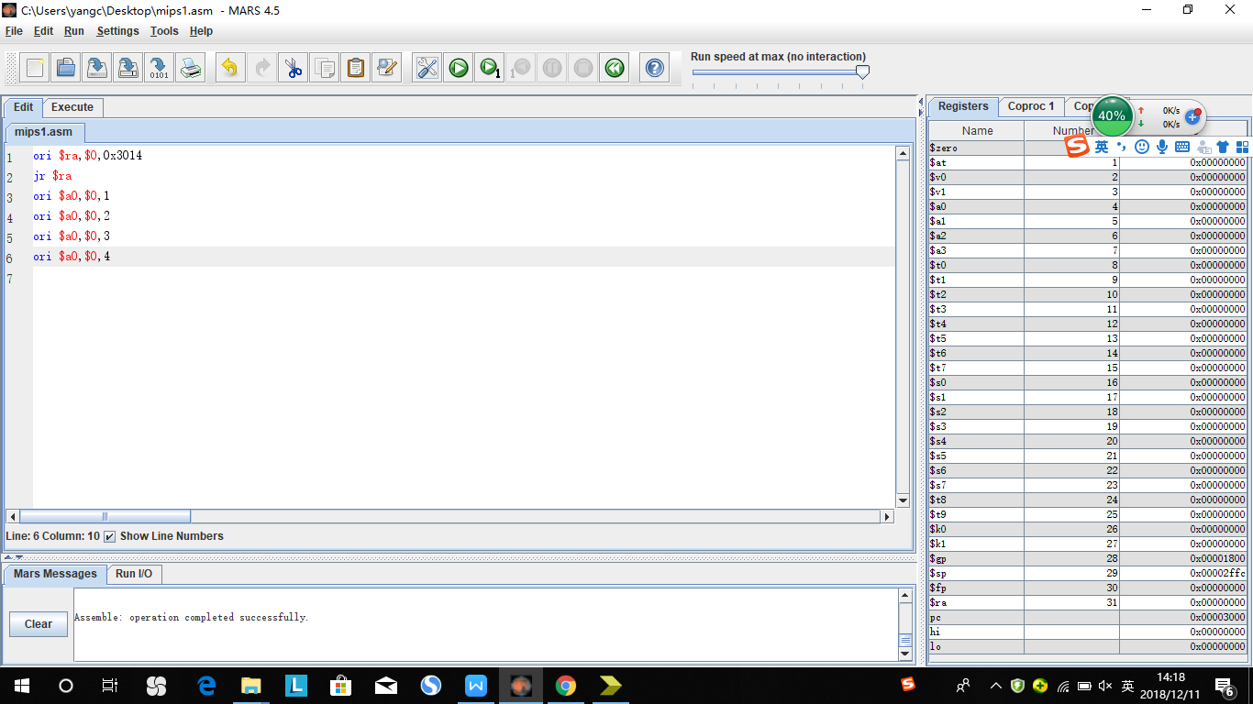

预期结果：

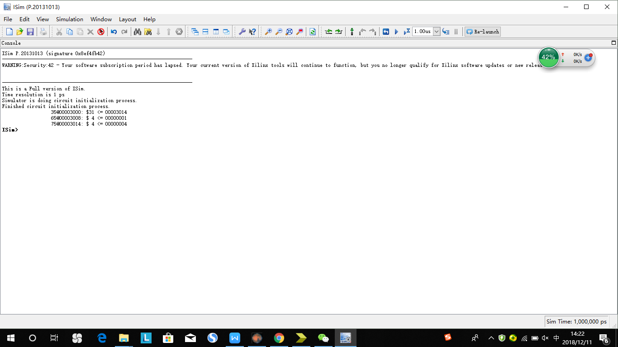

1. 在D级部件将通过转发后的RF_RD1_trans和RF_RD2_trans转发到了下一级寄存器中，实际上应该将转发前的RF_RD1和RF_RD2传到下一级。
2. jal延迟槽后跟jr发生冲突，在E级增加多路选择器，，选择传出的地址是ALU计算出来的值还是PC+8

测试程序：

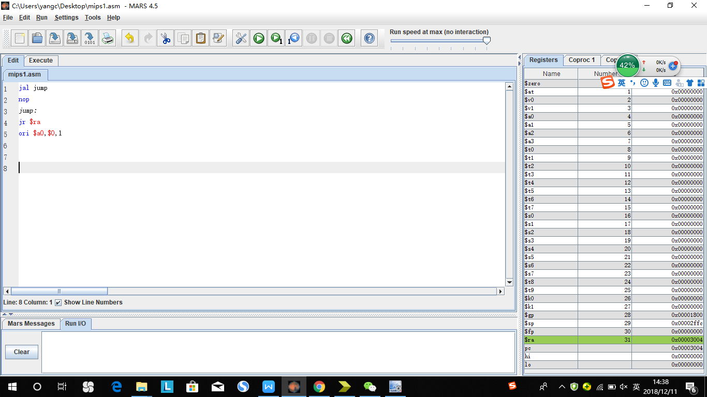

预期结果：

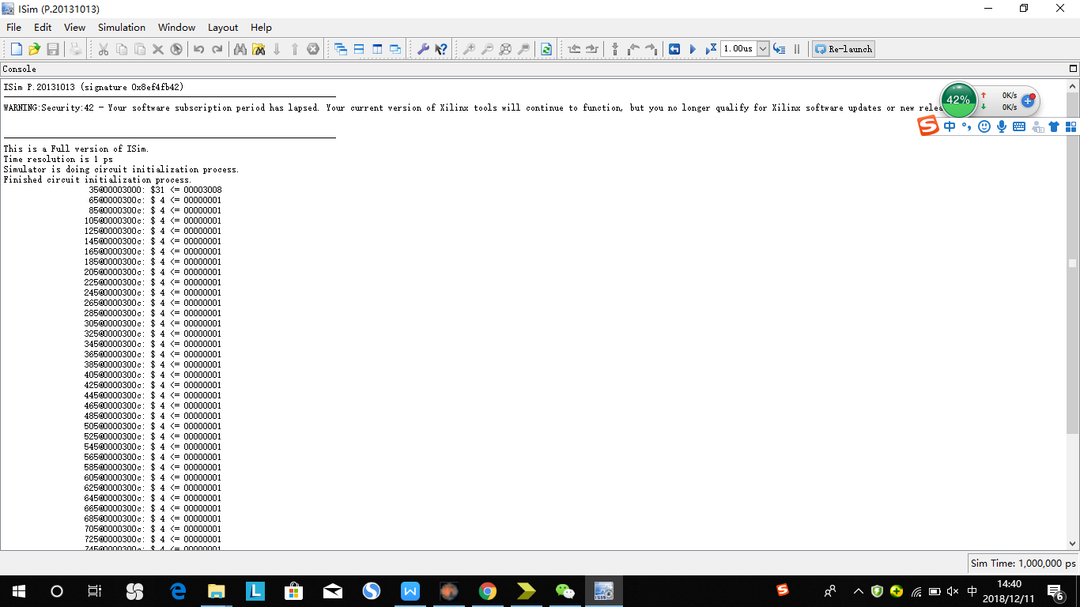

1. beq指令当跳转条件不满足时，应传回PC+8的值，而不是PC+4，不然中强测第二个点过不去。

测试程序：

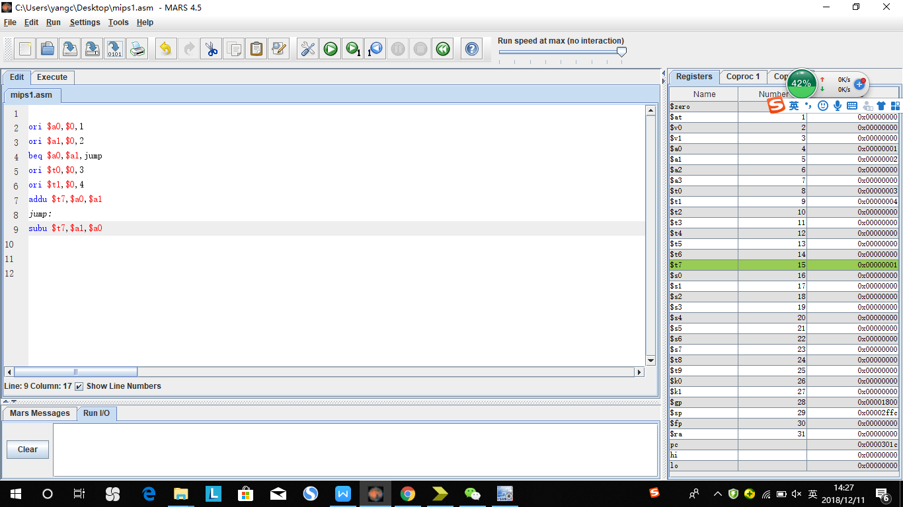

预期结果：

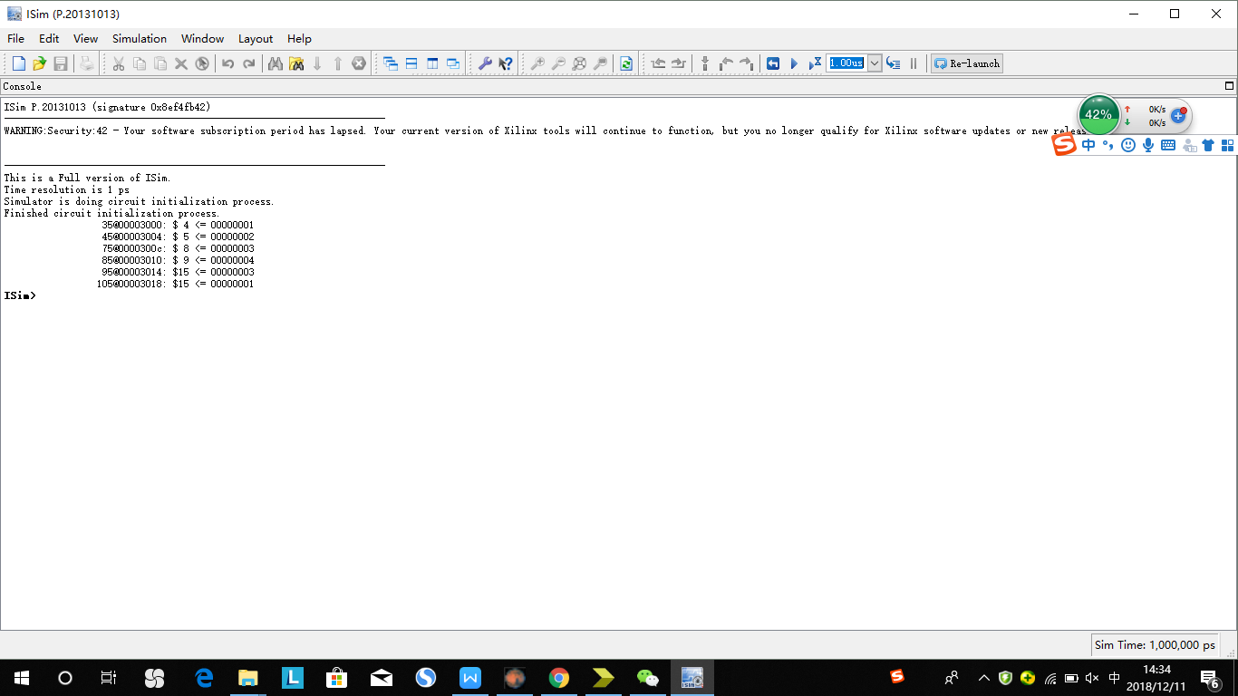

1. 测试程序

（一）整体测试

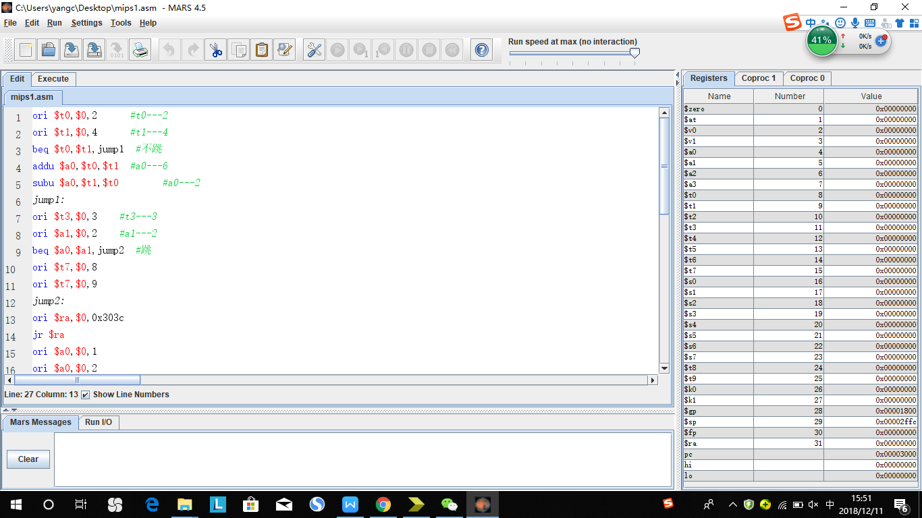

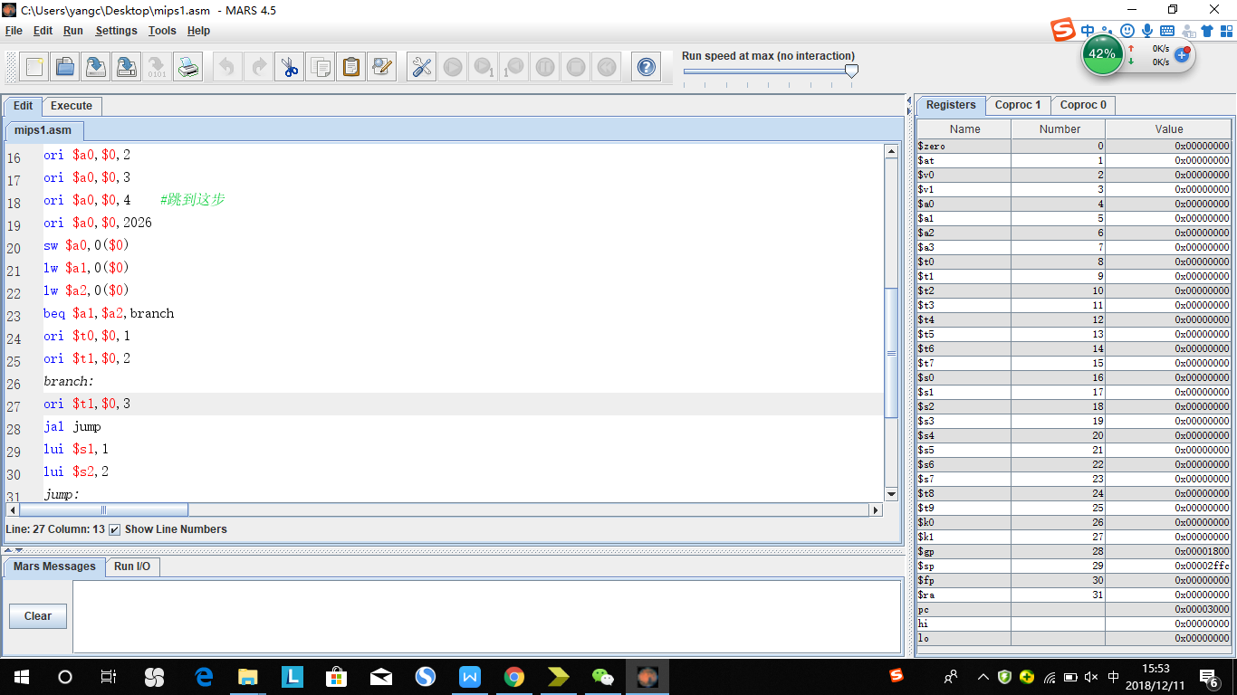

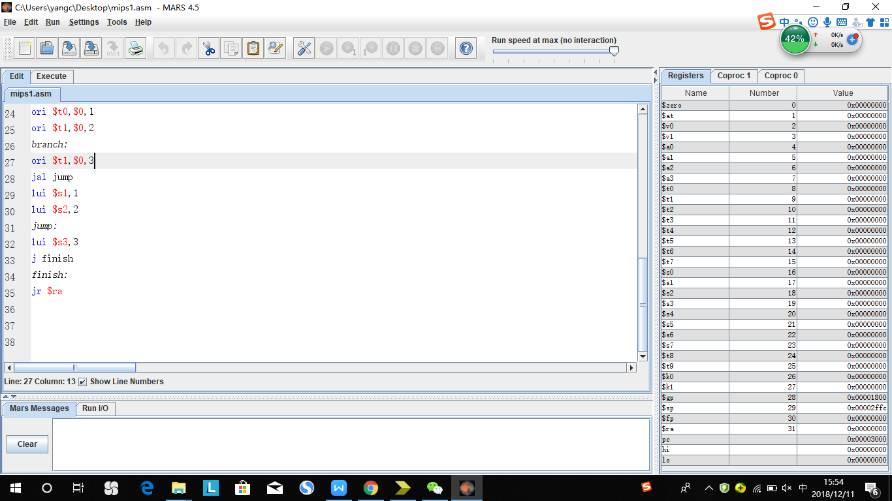

预期结果：

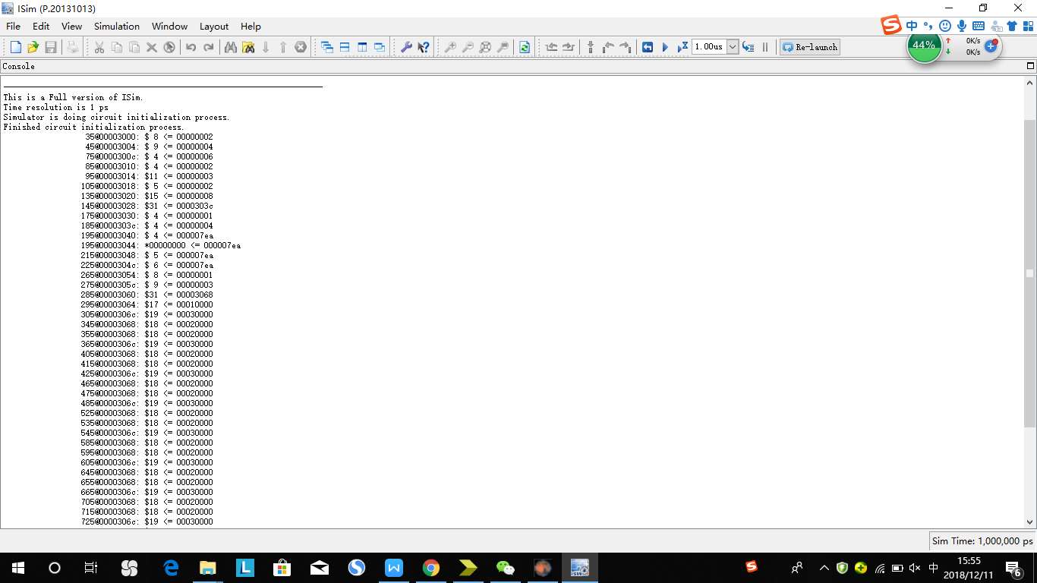

（二）冲突测试

对于冲突的测试类型可以用：X - Y - Z 来表示，它们的含义如下。

* X：产生冲突的前序指令的类型。
* Y：前序指令在哪个阶段与当前指令产生冲突。
* Z：产生冲突的寄存器。

如：

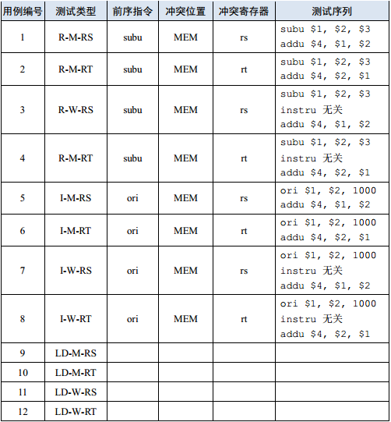

1. Cal_r类型指令

1) R—M—RS

测试序列： 预期结果：

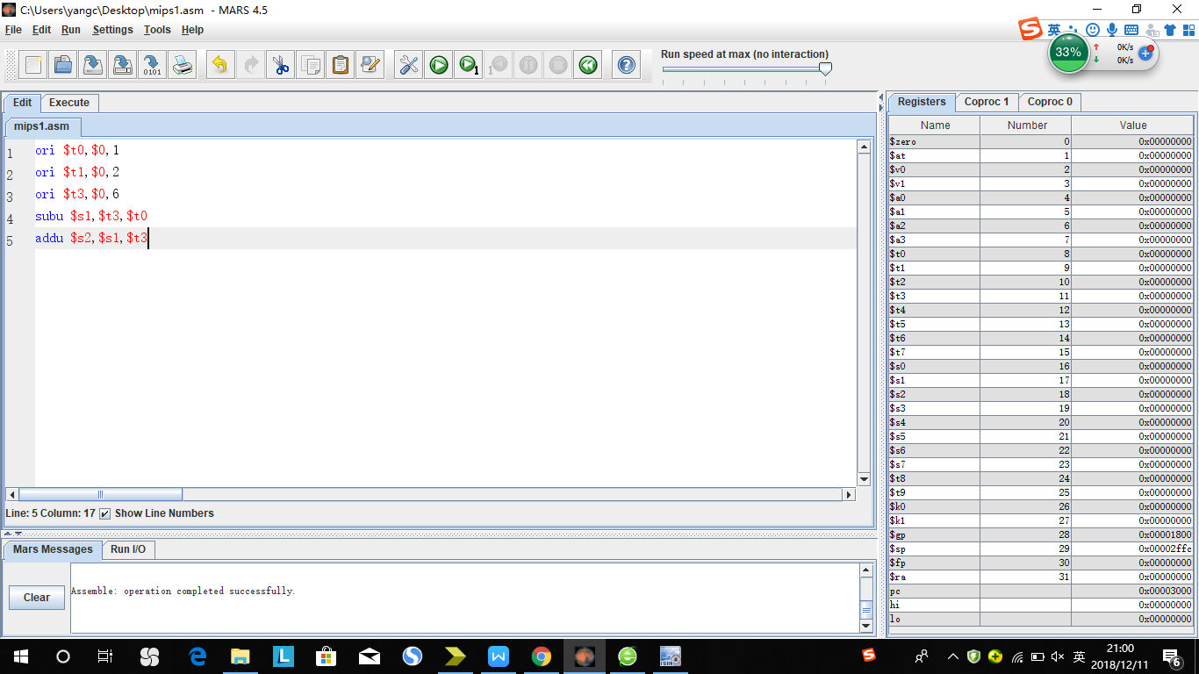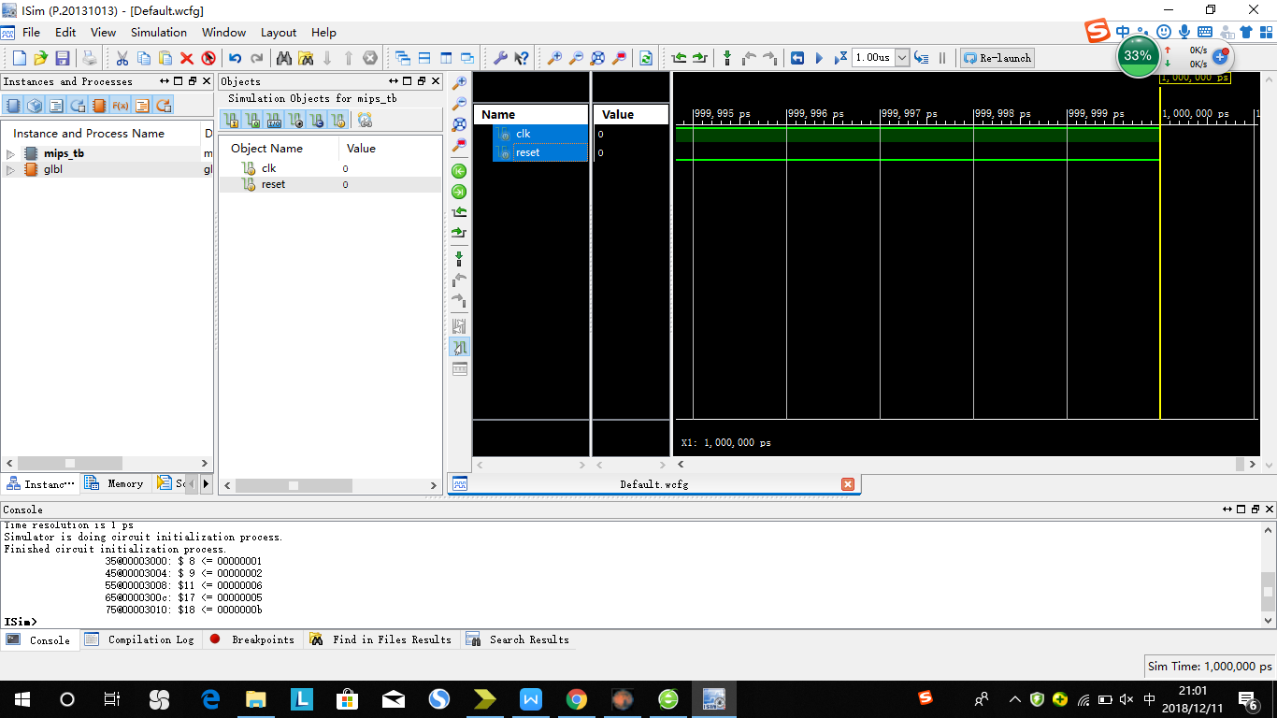

2）R—M—RT

测试序列： 预期结果：

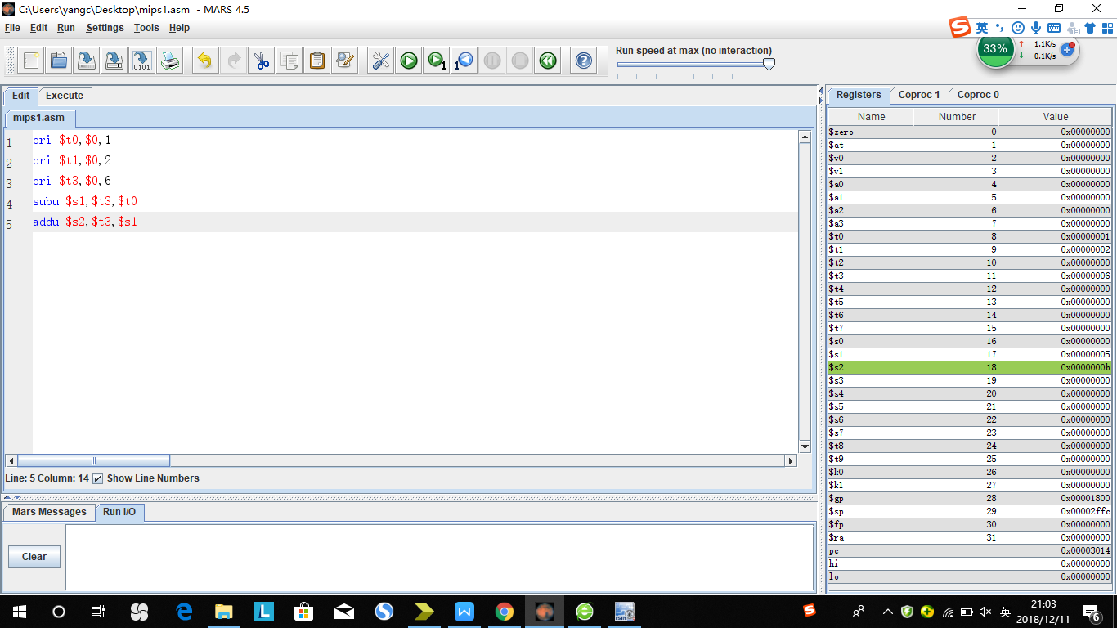

1. R—W—RS 预期结果：

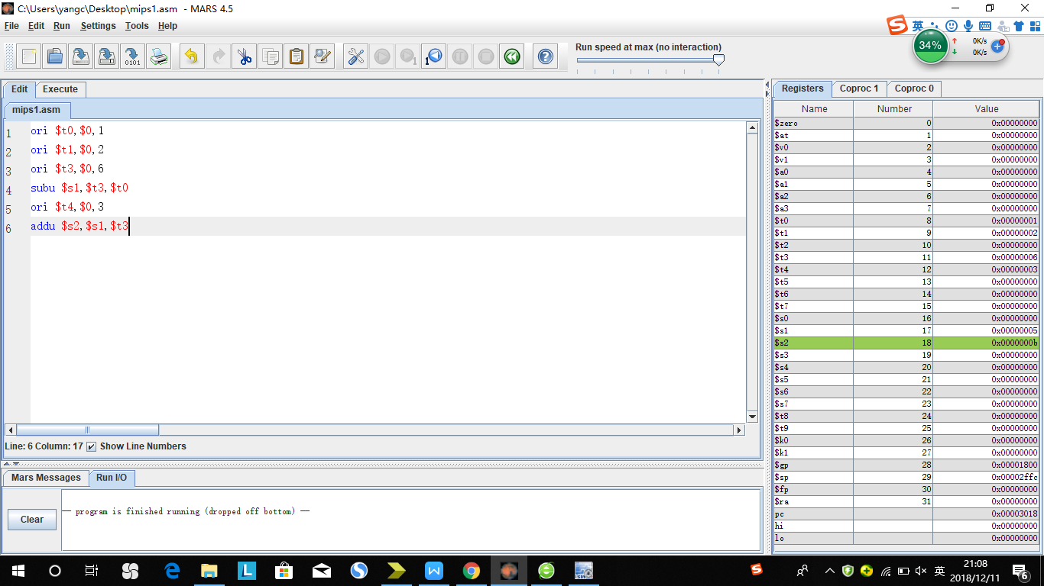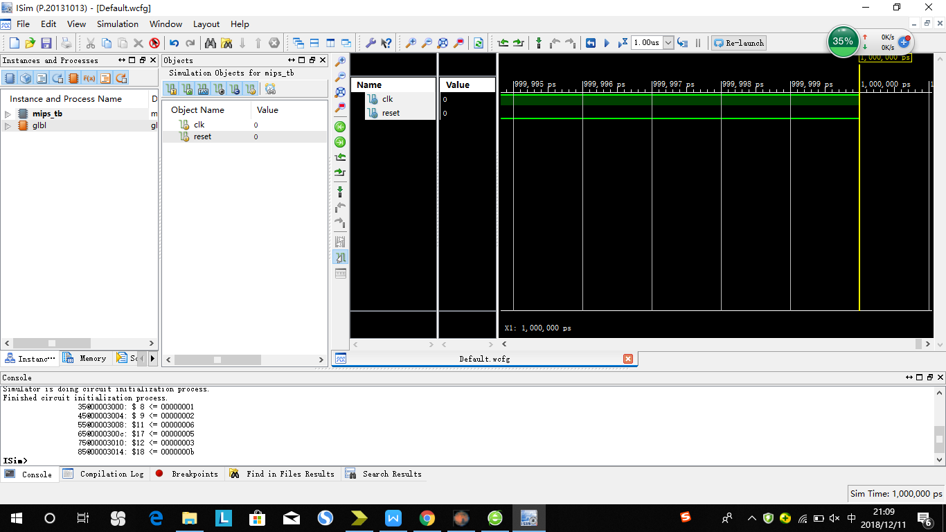

1. R—W—RT 预期结果：

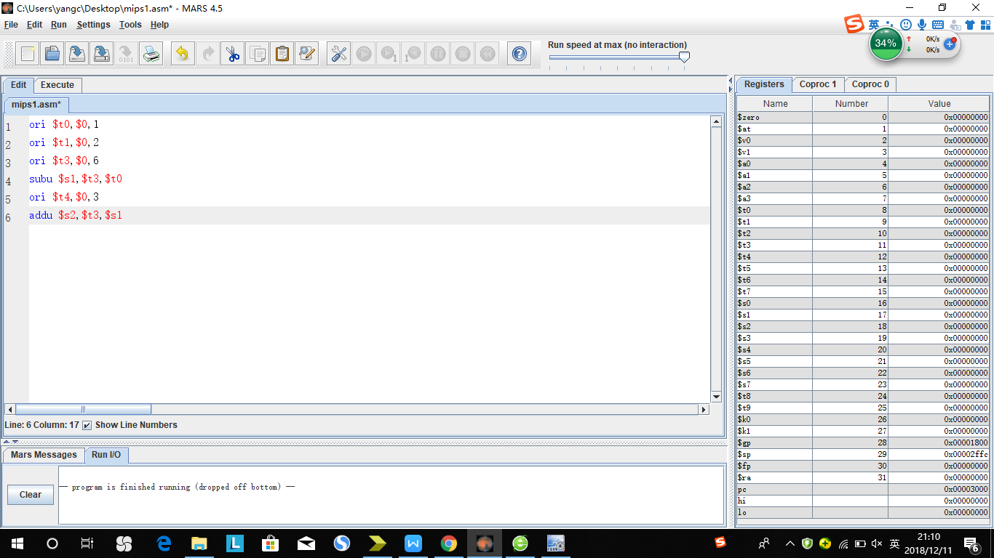

1. I—M—RS 预期结果：

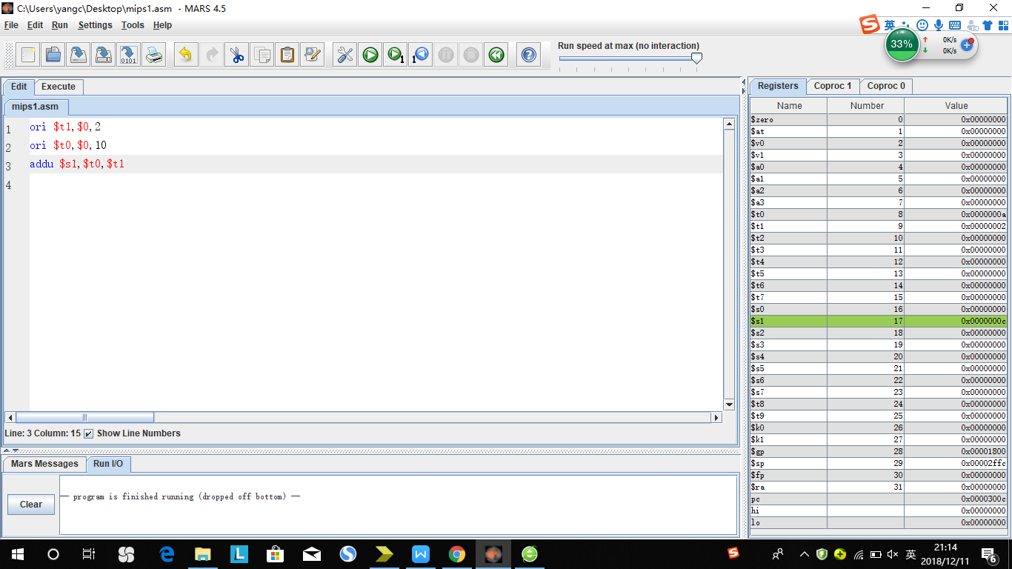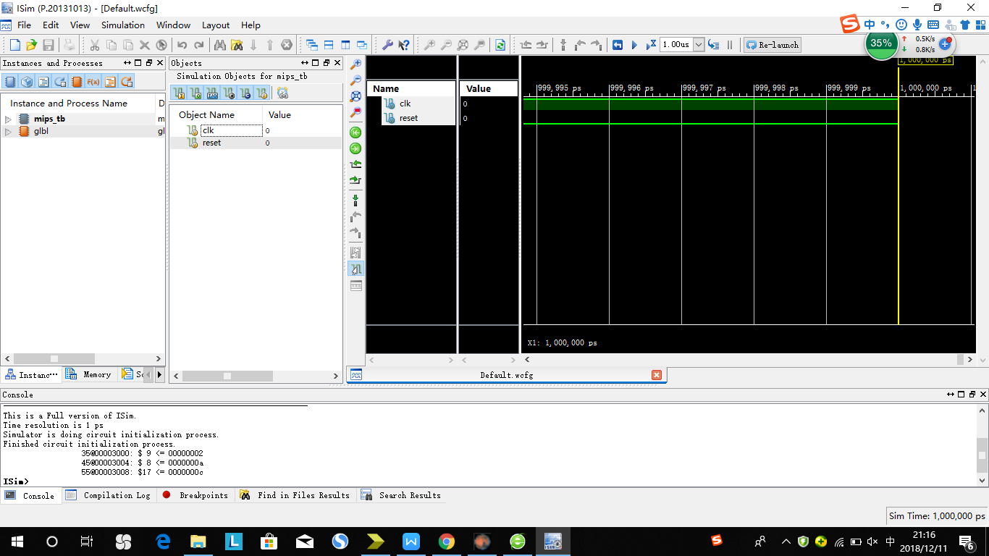

1. I—M—RT 预期结果：

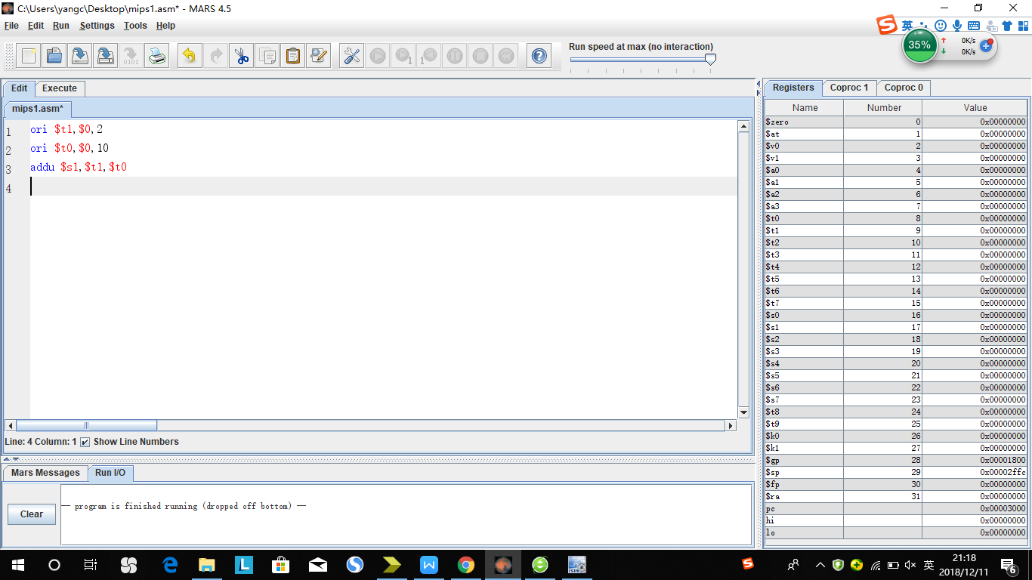

1. I—W—RS

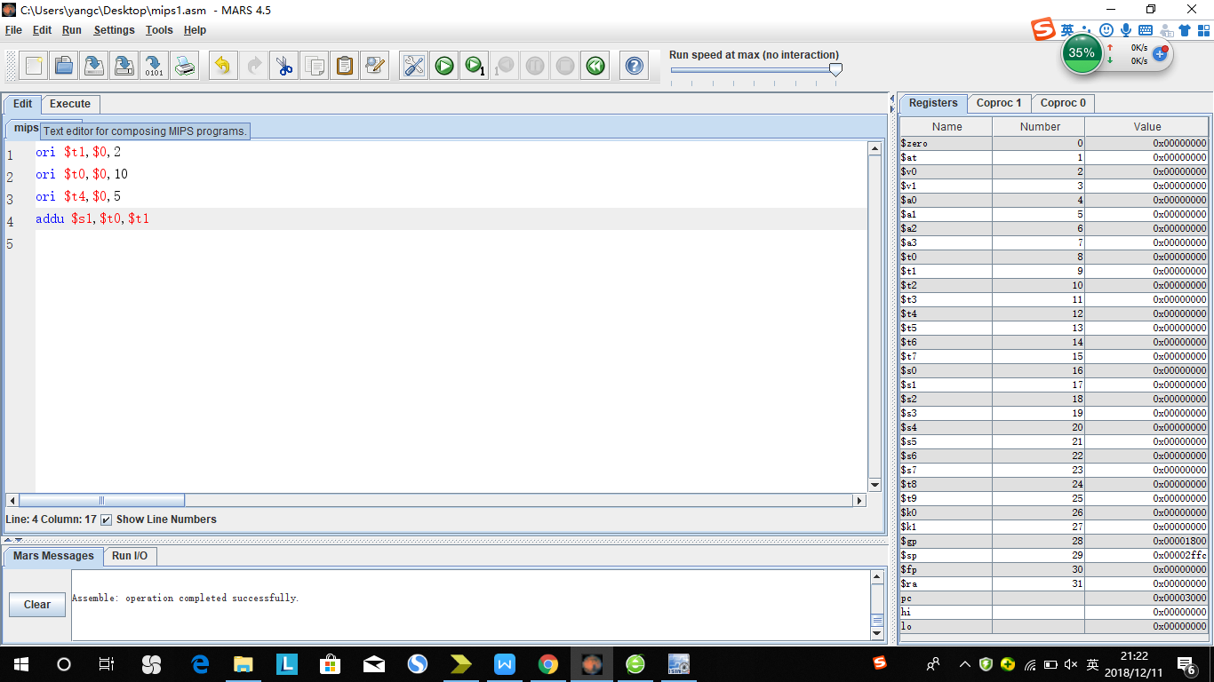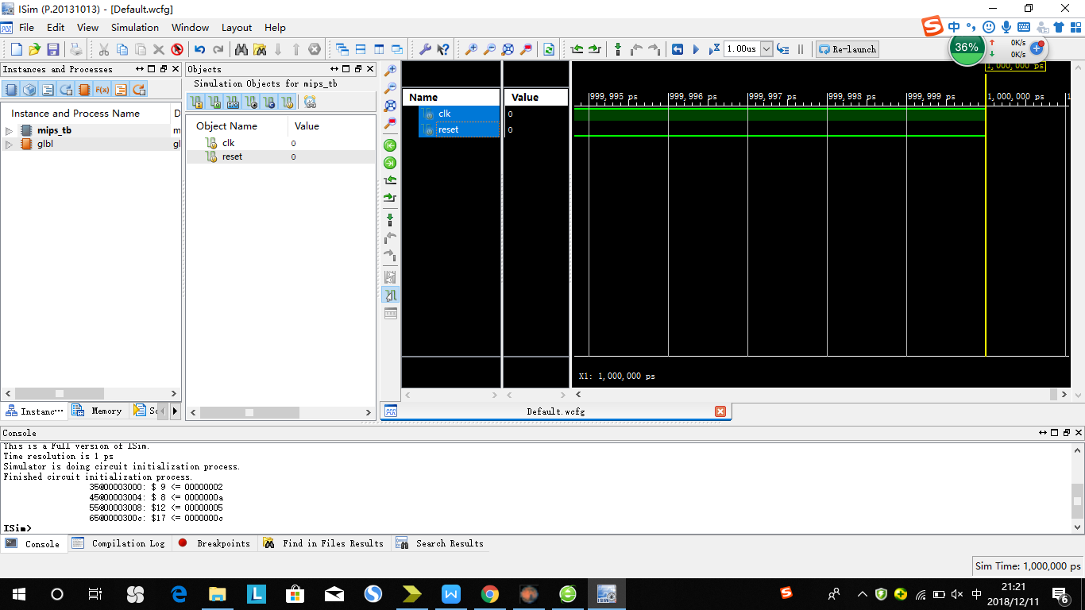

1. I—W—RT 预期结果：

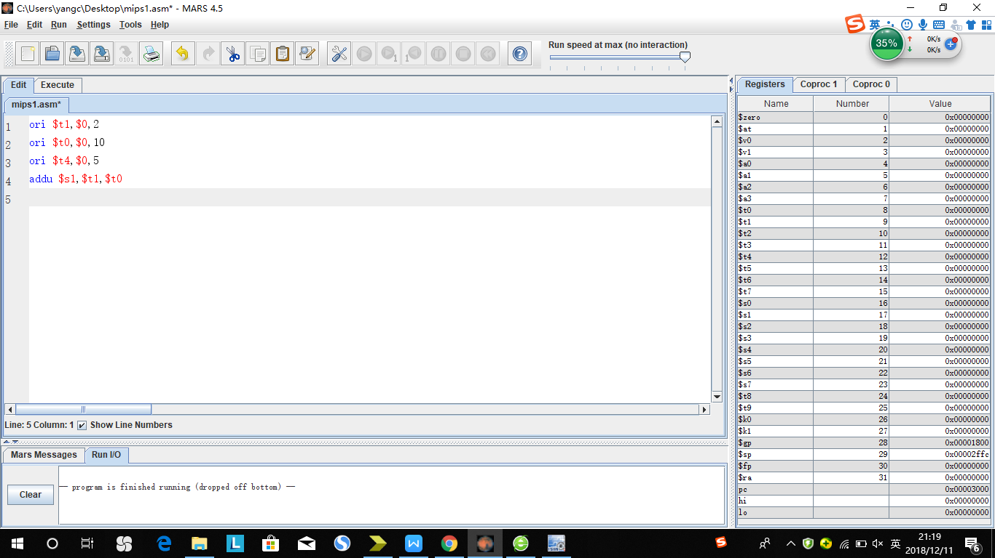

1. LD—M—RS 预期结果：

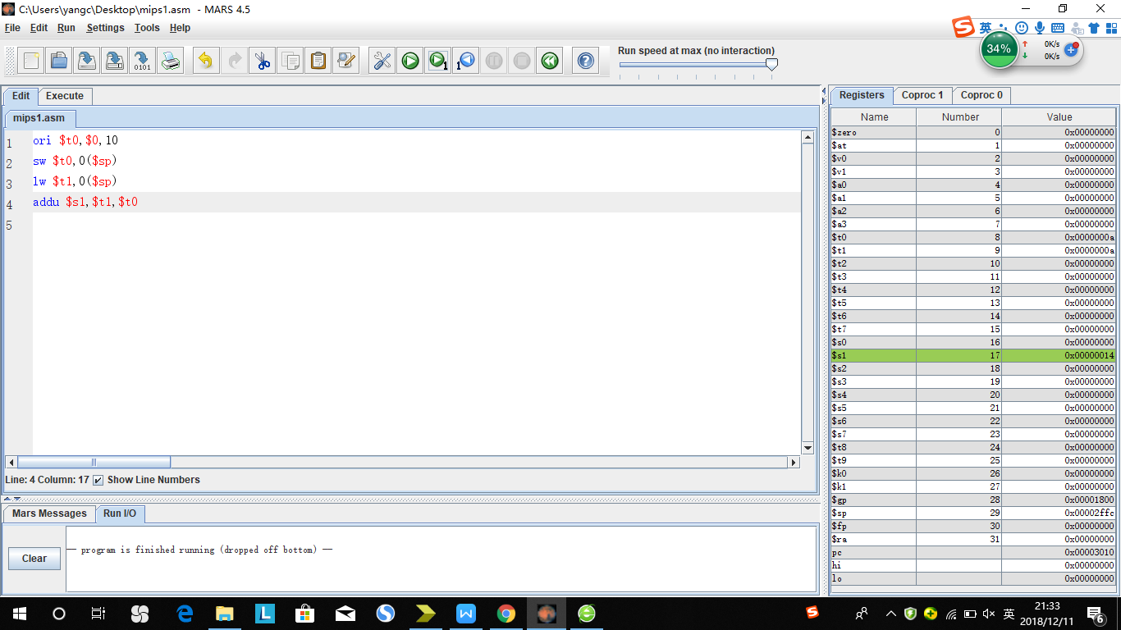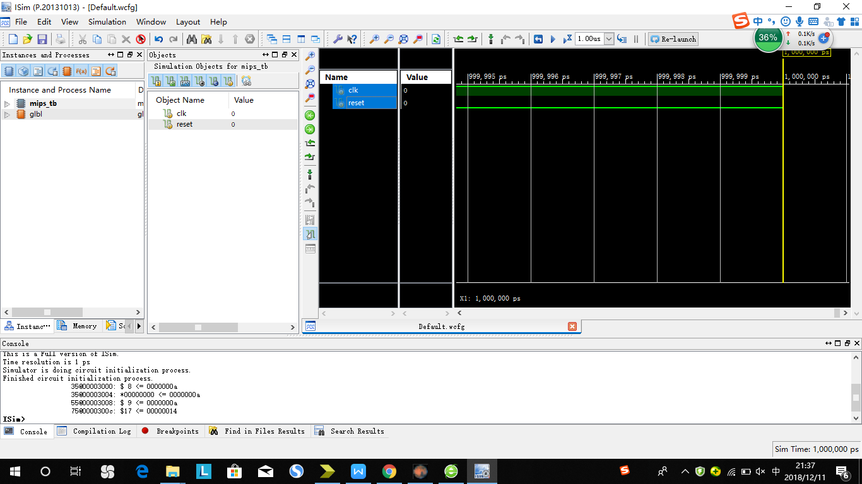

1. LD—M—RT 预期结果：

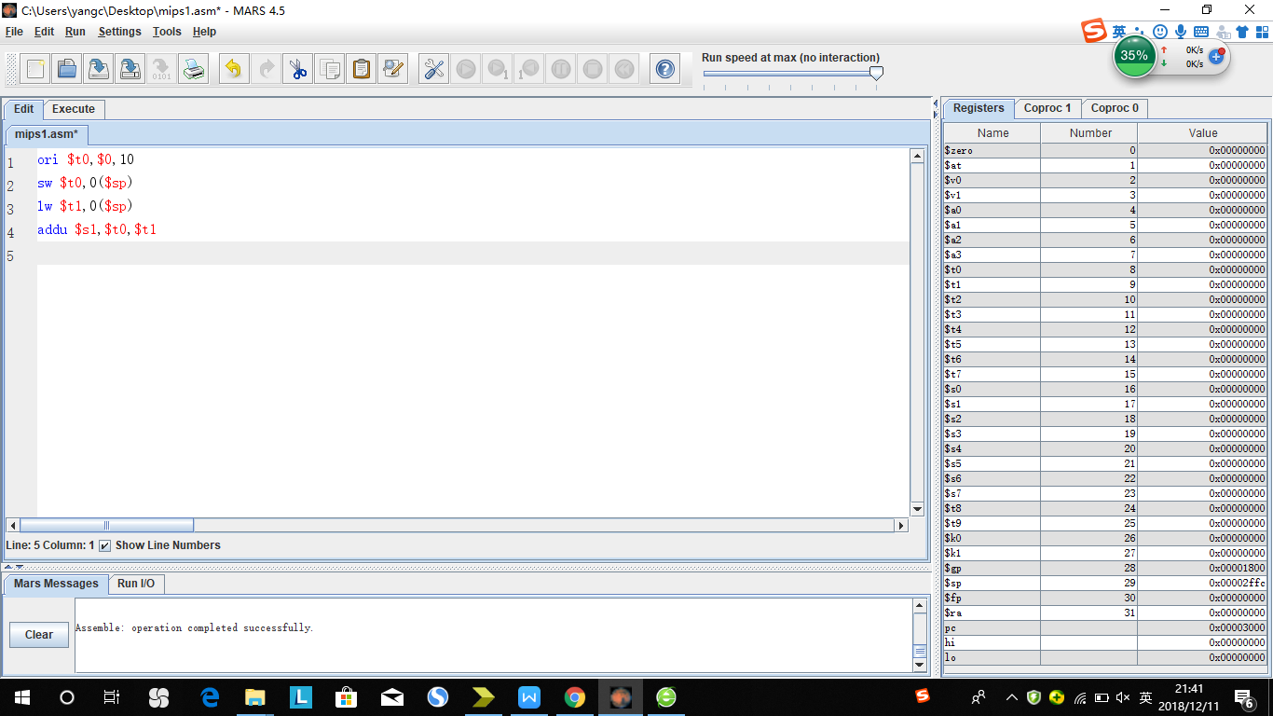

1. LD—W—RS 预期结果：

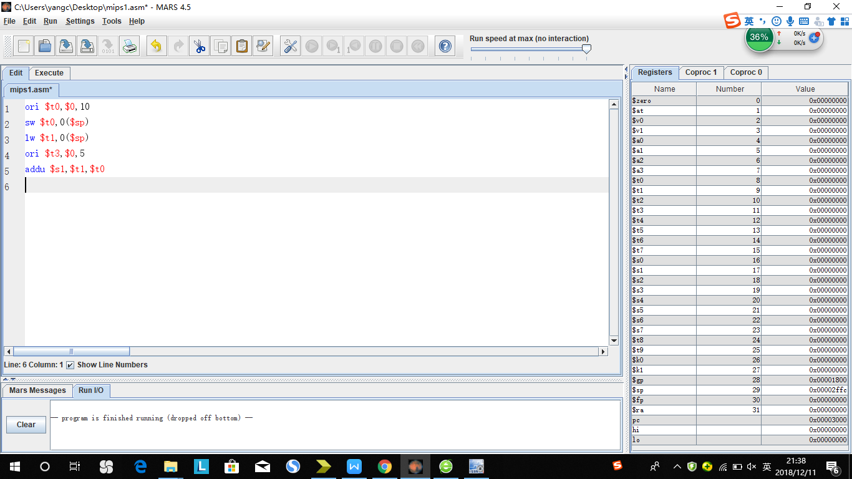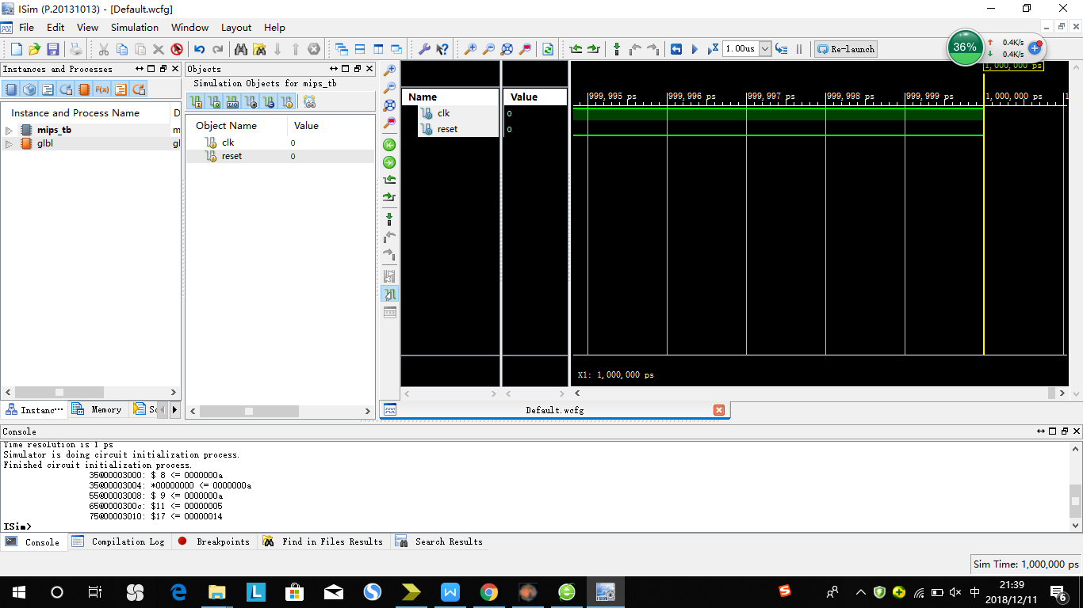

1. LD—W—RT 预期结果：

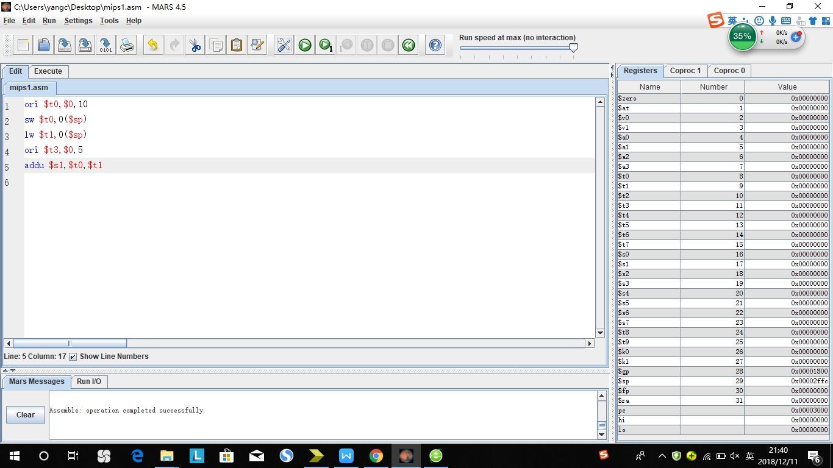

Cal_r整体测试：

ori $0, 50

ori $1, 100

ori $2, 200

ori $3, 300

ori $4, 400

ori $5, 500

top:

beq $1, $4, top

nop

ori $6, 600

ori $7, 700

ori $8, 800

ori $9, 900

ori $10, 1000

ori $11, 100

ori $12, 200

ori $13, 300

ori $14, 100

ori $15, 200

ori $16, 300

ori $17, 50

ori $18, 100

ori $19, 200

ori $20, 300

ori $21, 0x0008

ori $22, 0x0048

ori $23, 0x2ffc

ori $24, 0x120

ori $25, 0x0004

#1

subu $1, $2, $3 # $1=-100

addu $4, $1, $2 # $4=100

#2

subu $1, $2, $3 # $1=-100

addu $4, $3, $1 # $4=200

#3

subu $11, $12, $13 # $11=-100

sw $4, -4($23) # *00002ffc=200

addu $14, $11, $12 # $14=100

#4

subu $11, $12, $13 # $11=-100

subu $23, $23, $25 # $23=0x2ff8

addu $14, $12, $11 # $14=100

#8

ori $1, $0, 128 # $1=128

lui $16 1234

addu $4, $2, $1 # $4=228

#9

lw $1,0($23)

addu $4, $1, $2 # $4=400

#10

lw $1,0($23)

addu $4, $2, $1 # $4=400

#11

lw $1,0($23)

ori $27, 0x2ff4

addu $4, $1, $2 # $4=400

#12

lw $1,4($27)

subu $23, $23, $25

addu $4, $3, $1 # $4=600

#13

jal loop1

addu $4, $31, $1

ori $1, $4, 0

beq $1, $4, loop2

loop1:

#5

ori $1, $0, 128 # $1=128

addu $4, $1, $2 # $4=228

#6

ori $1, $0, 128 # $1=128

addu $4, $2, $1 # $4=228

#7

ori $2, $0, 128 # $1=128

lui $26, 8

addu $4, $2, $1 # $4=228

jr $31

loop2:

nop

jal loop3

addu $4, $1, $31

ori $1, $4, 0

beq $1, $4, loop4

loop3:

#5

ori $1, $0, 128 # $1=128

addu $4, $1, $2 # $4=228

#6

ori $1, $0, 128 # $1=128

addu $4, $2, $1 # $4=228

#7

ori $2, $0, 128 # $1=128

lui $26, 8

addu $4, $2, $1 # $4=228

jr $31

loop4:

sw $4, 0($23)

jal loop5

sw $4, 0($0)

ori $1, $4, 0

beq $1, $4, loop6

loop5:

addu $4, $31, $1

jr $31

loop6:

lw $5, 0($23)

jal loop8

ori $1, $4, 0

beq $1, $4, loop7

loop8:

addu $4, $1, $31

jr $31

loop7:

ori $1, $4, 0

beq $0, $0, top

lui $0, 100

预期输出：

45@00003004: $ 1 <= 00000064

55@00003008: $ 2 <= 000000c8

65@0000300c: $ 3 <= 0000012c

75@00003010: $ 4 <= 00000190

85@00003014: $ 5 <= 000001f4

115@00003020: $ 6 <= 00000258

125@00003024: $ 7 <= 000002bc

135@00003028: $ 8 <= 00000320

145@0000302c: $ 9 <= 00000384

155@00003030: $10 <= 000003e8

165@00003034: $11 <= 00000064

175@00003038: $12 <= 000000c8

185@0000303c: $13 <= 0000012c

195@00003040: $14 <= 00000064

205@00003044: $15 <= 000000c8

215@00003048: $16 <= 0000012c

225@0000304c: $17 <= 00000032

235@00003050: $18 <= 00000064

245@00003054: $19 <= 000000c8

255@00003058: $20 <= 0000012c

265@0000305c: $21 <= 00000008

275@00003060: $22 <= 00000048

285@00003064: $23 <= 00002ffc

295@00003068: $24 <= 00000120

305@0000306c: $25 <= 00000004

315@00003070: $ 1 <= ffffff9c

325@00003074: $ 4 <= 00000064

335@00003078: $ 1 <= ffffff9c

345@0000307c: $ 4 <= 000000c8

355@00003080: $11 <= ffffff9c

355@00003084: *00002ff8 <= 000000c8

375@00003088: $14 <= 00000064

385@0000308c: $11 <= ffffff9c

395@00003090: $23 <= 00002ff8

405@00003094: $14 <= 00000064

415@00003098: $ 1 <= 00000080

425@0000309c: $16 <= 04d20000

435@000030a0: $ 4 <= 00000148

445@000030a4: $ 1 <= 000000c8

465@000030a8: $ 4 <= 00000190

475@000030ac: $ 1 <= 000000c8

495@000030b0: $ 4 <= 00000190

505@000030b4: $ 1 <= 000000c8

515@000030b8: $27 <= 00002ff4

525@000030bc: $ 4 <= 00000190

535@000030c0: $ 1 <= 000000c8

545@000030c4: $23 <= 00002ff4

555@000030c8: $ 4 <= 000001f4

565@000030cc: $31 <= 000030d4

575@000030d0: $ 4 <= 0000319c

585@000030dc: $ 1 <= 00000080

595@000030e0: $ 4 <= 00000148

605@000030e4: $ 1 <= 00000080

615@000030e8: $ 4 <= 00000148

625@000030ec: $ 2 <= 00000080

635@000030f0: $26 <= 00080000

645@000030f4: $ 4 <= 00000100

675@000030d4: $ 1 <= 00000100

705@000030dc: $ 1 <= 00000080

725@00003100: $31 <= 00003108

735@00003104: $ 4 <= 00003188

745@00003110: $ 1 <= 00000080

755@00003114: $ 4 <= 00000100

765@00003118: $ 1 <= 00000080

775@0000311c: $ 4 <= 00000100

785@00003120: $ 2 <= 00000080

795@00003124: $26 <= 00080000

805@00003128: $ 4 <= 00000100

815@00003130: *00002ff4 <= 00000100

835@00003108: $ 1 <= 00000100

865@00003110: $ 1 <= 00000080

865@00003130: *00002ff4 <= 00000100

885@00003134: $31 <= 0000313c

885@00003138: *00000000 <= 00000100

905@00003144: $ 4 <= 000031bc

925@0000314c: $ 5 <= 00000100

935@0000313c: $ 1 <= 000031bc

965@00003144: $ 4 <= 000062f8

975@0000314c: $ 5 <= 00000100

985@00003150: $31 <= 00003158

995@00003154: $ 1 <= 000062f8

**ISim>**

# run 1.00us

1005@0000315c: $ 4 <= 00009450

1025@00003164: $ 1 <= 00009450

1055@0000315c: $ 4 <= 0000c5a8

1065@00003164: $ 1 <= 0000c5a8

1. Cal_i整体测试

ori $t1,$0,7

ori $t2,$t1,8

ori $t1,$0,7

addu $s1,$0,$0

ori $t2,$t1,8

ori $t0,$0,3

ori $t1,$0,4

addu $t2,$t0,$t1

ori $t3,$t2,8

ori $t0,$0,7

sw $t0,0($sp)

lw $t1,0($sp)

ori $t2,$t1,8

jal jump

ori $t0,$0,1

jump:

ori $t1,$0,2

预期输出：

35@00003000: $ 9 <= 00000007

45@00003004: $10 <= 0000000f

55@00003008: $ 9 <= 00000007

65@0000300c: $17 <= 00000000

75@00003010: $10 <= 0000000f

85@00003014: $ 8 <= 00000003

95@00003018: $ 9 <= 00000004

105@0000301c: $10 <= 00000007

115@00003020: $11 <= 0000000f

125@00003024: $ 8 <= 00000007

125@00003028: *00000000 <= 00000007

145@0000302c: $ 9 <= 00000007

165@00003030: $10 <= 0000000f

175@00003034: $31 <= 0000303c

185@00003038: $ 8 <= 00000001

195@0000303c: $ 9 <= 00000002

P5测试指令：

Addu:

Ori_E_RS(addu):

ori $t0, $zero, 8

addu $t1, $t0, $zero

180@00003000: $ 8 <= 00000008

220@00003004: $ 9 <= 00000008

Ori_M_RS(addu)

ori $t0, $zero, 8

ori $t2, $zero, 12

addu $t1, $t0, $zero

180@00003000: $ 8 <= 00000008

220@00003004: $10 <= 0000000c

260@00003008: $ 9 <= 00000008

Ori_W_RS(addu)

ori $t0, $zero, 8

ori $t2, $zero, 12

ori $t3, $zero, 13

addu $t1, $t0, $zero

180@00003000: $ 8 <= 00000008

220@00003004: $10 <= 0000000c

260@00003008: $11 <= 0000000d

300@0000300c: $ 9 <= 00000008

Ori_E_RT(addu)

ori $t0, $zero, 8

addu $t1, $zero, $t0

180@00003000: $ 8 <= 00000008

220@00003004: $ 9 <= 00000008

Ori_M_RT(addu)

ori $t0, $zero, 8

ori $t2, $zero, 12

addu $t1, $zero, $t0

180@00003000: $ 8 <= 00000008

220@00003004: $10 <= 0000000c

260@00003008: $ 9 <= 00000008

Ori_W_RT(addu)

ori $t0, $zero, 8

ori $t2, $zero, 12

ori $t3, $zero, 13

addu $t1, $zero, $t0

180@00003000: $ 8 <= 00000008

220@00003004: $10 <= 0000000c

260@00003008: $11 <= 0000000d

300@0000300c: $ 9 <= 00000008

Lui_E_RS(addu)

lui $t0, 8

addu $t1, $t0, $zero

180@00003000: $ 8 <= 00080000

220@00003004: $ 9 <= 00080000

Lui_M_RS(addu)

lui $t0, 8

lui $t2, 12

addu $t1, $t0, $zero

180@00003000: $ 8 <= 00080000

220@00003004: $10 <= 000c0000

260@00003008: $ 9 <= 00080000

Lui_W_RS(addu)

lui $t0, 8

lui $t2, 12

lui $t3, 14

addu $t1, $t0, $zero

180@00003000: $ 8 <= 00080000

220@00003004: $10 <= 000c0000

260@00003008: $11 <= 000e0000

300@0000300c: $ 9 <= 00080000

Lui_W_RT(addu)

lui $t0, 8

addu $t1, $zero, $t0

180@00003000: $ 8 <= 00080000

220@00003004: $ 9 <= 00080000

Lui_w_RT(addu)

lui $t0, 8

lui $t2, 12

addu $t1, $zero, $t0

180@00003000: $ 8 <= 00080000

220@00003004: $10 <= 000c0000

260@00003008: $ 9 <= 00080000

Lui_W_RT(addu)

lui $t0, 8

lui $t2, 12

lui $t3, 14

addu $t1, $zero, $t0

180@00003000: $ 8 <= 00080000

220@00003004: $10 <= 000c0000

260@00003008: $11 <= 000e0000

300@0000300c: $ 9 <= 00080000

R_E_RS(addu)

lui $t0, 8

addu $t1, $zero, $t0

addu $t2, $t1, $zero

180@00003000: $ 8 <= 00080000

220@00003004: $ 9 <= 00080000

260@00003008: $10 <= 00080000

R_M_RS(addu)

lui $t0, 8

addu $t1, $zero, $t0

addu $t3, $t0, $t0

addu $t2, $t1, $zero

180@00003000: $ 8 <= 00080000

220@00003004: $ 9 <= 00080000

260@00003008: $11 <= 00100000

300@0000300c: $10 <= 00080000

R_W_RS(RT)(addu)

lui $t0, 8

addu $t1, $zero, $t0

addu $t3, $t0, $t0

addu $t4, $t0, $t0

addu $t2, $t1, $t1

180@00003000: $ 8 <= 00080000

220@00003004: $ 9 <= 00080000

260@00003008: $11 <= 00100000

300@0000300c: $12 <= 00100000

340@00003010: $10 <= 00100000

Ld_E_RS(RT)(addu)

ori $t0, $zero, 8

ori $t1, $zero, 12

ori $t2, $zero, 16

ori $t3, $zero, 20

ori $t4, $zero, 24

ori $t5, $zero, 28

sw $t1, 0($t0)

ori $s0, $zero, 4

ori $s1, $zero, 8

ori $s2, $zero, 12

lw $t6, 0($t0)

addu $t7, $t6, $t6

180@00003000: $ 8 <= 00000008

220@00003004: $ 9 <= 0000000c

260@00003008: $10 <= 00000010

300@0000300c: $11 <= 00000014

340@00003010: $12 <= 00000018

380@00003014: $13 <= 0000001c

380@00003018: *00000008 <= 0000000c

460@0000301c: $16 <= 00000004

500@00003020: $17 <= 00000008

540@00003024: $18 <= 0000000c

580@00003028: $14 <= 0000000c

660@0000302c: $15 <= 00000018

Ld_M_RS(RT)(addu)

ori $t0, $zero, 8

ori $t1, $zero, 12

ori $t2, $zero, 16

ori $t3, $zero, 20

ori $t4, $zero, 24

sw $t1, 0($t0)

ori $s0, $zero, 4

ori $s1, $zero, 8

ori $s2, $zero, 12

lw $t6, 0($t0)

ori $t5, $zero, 28

addu $t7, $t6, $t6

180@00003000: $ 8 <= 00000008

220@00003004: $ 9 <= 0000000c

260@00003008: $10 <= 00000010

300@0000300c: $11 <= 00000014

340@00003010: $12 <= 00000018

340@00003014: *00000008 <= 0000000c

420@00003018: $16 <= 00000004

460@0000301c: $17 <= 00000008

500@00003020: $18 <= 0000000c

540@00003024: $14 <= 0000000c

580@00003028: $13 <= 0000001c

620@0000302c: $15 <= 00000018

Ld_W_RS(RT)(addu)

ori $t0, $zero, 8

ori $t1, $zero, 12

ori $t2, $zero, 16

ori $t3, $zero, 20

ori $t4, $zero, 24

sw $t1, 0($t0)

ori $s0, $zero, 4

ori $s1, $zero, 8

ori $s2, $zero, 12

lw $t6, 0($t0)

ori $t5, $zero, 28

ori $t8, $zero, 32

addu $t7, $t6, $t6

180@00003000: $ 8 <= 00000008

220@00003004: $ 9 <= 0000000c

260@00003008: $10 <= 00000010

300@0000300c: $11 <= 00000014

340@00003010: $12 <= 00000018

340@00003014: *00000008 <= 0000000c

420@00003018: $16 <= 00000004

460@0000301c: $17 <= 00000008

500@00003020: $18 <= 0000000c

540@00003024: $14 <= 0000000c

580@00003028: $13 <= 0000001c

620@0000302c: $24 <= 00000020

660@00003030: $15 <= 00000018

Jal_E_RS(RT)(addu)

ori $t0, $zero, 8

ori $t1, $zero, 12

ori $t2, $zero, 16

jal change1

addu $t3, $ra, $ra

ori $t4, $zero, 20

ori $t5, $zero, 24

change1:

ori $t6, $zero, 20

180@00003000: $ 8 <= 00000008

220@00003004: $ 9 <= 0000000c

260@00003008: $10 <= 00000010

300@0000300c: $31 <= 00003014

340@00003010: $11 <= 00006028

380@0000301c: $14 <= 00000014

Jal_M_RS(RT)(addu)

ori $t0, $zero, 8

ori $t1, $zero, 12

ori $t2, $zero, 16

jal change1

ori $t4, $zero, 20

ori $t5, $zero, 24

change1:

addu $t3, $ra, $ra

ori $t6, $zero, 20

ori $t7, $zero, 24

$ 8 <= 00000008

$ 9 <= 0000000c

$10 <= 00000010

$31 <= 00003014

$12 <= 00000014

$11 <= 00006028

$14 <= 00000014

$15 <= 00000018

Jal_W_RS(RT)(addu)

ori $t0, $zero, 8

ori $t1, $zero, 12

ori $t2, $zero, 16

jal change1

ori $t4, $zero, 20

ori $t5, $zero, 24

change1:

ori $t6, $zero, 20

addu $t3, $ra, $ra

ori $t6, $zero, 20

ori $t7, $zero, 24

$ 8 <= 00000008

$ 9 <= 0000000c

$10 <= 00000010

$31 <= 00003014

$12 <= 00000014

$14 <= 00000014

$11 <= 00006028

$14 <= 00000014

$15 <= 00000018

Ori_E_RS(ori)

ori $t0, $zero, 8

ori $t1, $t0, 12

180@00003000: $ 8 <= 00000008

220@00003004: $ 9 <= 0000000c

Ori_M_RS(ori)

ori $t0, $zero, 8

ori $t2, $zero, 20

ori $t1, $t0, 12

180@00003000: $ 8 <= 00000008

220@00003004: $10 <= 00000014

260@00003008: $ 9 <= 0000000c

Ori_W_RS(ori)

ori $t0, $zero, 8

ori $t2, $zero, 20

ori $t3, $zero, 24

ori $t1, $t0, 12

180@00003000: $ 8 <= 00000008

220@00003004: $10 <= 00000014

260@00003008: $11 <= 00000018

300@0000300c: $ 9 <= 0000000c

Subu_E_RS(ori)

ori $t0, $zero, 8

ori $t1, $zero, 20

ori $t2, $zero, 24

ori $t3, $zero, 12

ori $t4, $zero, 16

subu $t5, $t0, $t1

ori $t6, $t5, 13

180@00003000: $ 8 <= 00000008

220@00003004: $ 9 <= 00000014

260@00003008: $10 <= 00000018

300@0000300c: $11 <= 0000000c

340@00003010: $12 <= 00000010

380@00003014: $13 <= fffffff4

420@00003018: $14 <= fffffffd

Subu_M_RS(ori)

ori $t0, $zero, 8

ori $t1, $zero, 20

ori $t2, $zero, 24

ori $t3, $zero, 12

ori $t4, $zero, 16

subu $t5, $t0, $t1

ori $t7, $zero, 20

ori $t6, $t5, 13

180@00003000: $ 8 <= 00000008

220@00003004: $ 9 <= 00000014

260@00003008: $10 <= 00000018

300@0000300c: $11 <= 0000000c

340@00003010: $12 <= 00000010

380@00003014: $13 <= fffffff4

420@00003018: $15 <= 00000014

460@0000301c: $14 <= fffffffd

Subu_W_RS(ori)

ori $t0, $zero, 8

ori $t1, $zero, 20

ori $t2, $zero, 24

ori $t3, $zero, 12

ori $t4, $zero, 16

subu $t5, $t0, $t1

ori $t7, $zero, 20

ori $t8, $zero, 24

ori $t6, $t5, 13

180@00003000: $ 8 <= 00000008

220@00003004: $ 9 <= 00000014

260@00003008: $10 <= 00000018

300@0000300c: $11 <= 0000000c

340@00003010: $12 <= 00000010

380@00003014: $13 <= fffffff4

420@00003018: $15 <= 00000014

460@0000301c: $24 <= 00000018

500@00003020: $14 <= fffffffd

Ld_E_RS(ori)

ori $t0, $zero, 8

ori $t1, $zero, 20

ori $t2, $zero, 4

ori $t3, $zero, 12

ori $t4, $zero, 16

sw $t0, 0($t1)

lw $t5, 0($t1)

ori $t6, $t5, 13

180@00003000: $ 8 <= 00000008

220@00003004: $ 9 <= 00000014

260@00003008: $10 <= 00000004

300@0000300c: $11 <= 0000000c

340@00003010: $12 <= 00000010

340@00003014: *00000014 <= 00000008

420@00003018: $13 <= 00000008

500@0000301c: $14 <= 0000000d

Ld_M_RS(ori)

ori $t0, $zero, 8

ori $t1, $zero, 20

ori $t2, $zero, 4

ori $t3, $zero, 12

ori $t4, $zero, 16

sw $t0, 0($t1)

lw $t5, 0($t1)

ori $t7, $zero, 20

ori $t6, $t5, 13

180@00003000: $ 8 <= 00000008

220@00003004: $ 9 <= 00000014

260@00003008: $10 <= 00000004

300@0000300c: $11 <= 0000000c

340@00003010: $12 <= 00000010

340@00003014: *00000014 <= 00000008

420@00003018: $13 <= 00000008

460@0000301c: $15 <= 00000014

500@00003020: $14 <= 0000000d

Ld_W_RS(ori)

ori $t0, $zero, 8

ori $t1, $zero, 20

ori $t2, $zero, 4

ori $t3, $zero, 12

ori $t4, $zero, 16

sw $t0, 0($t1)

lw $t5, 0($t1)

ori $t7, $zero, 20

ori $t8, $zero, 24

ori $t6, $t5, 13

180@00003000: $ 8 <= 00000008

220@00003004: $ 9 <= 00000014

260@00003008: $10 <= 00000004

300@0000300c: $11 <= 0000000c

340@00003010: $12 <= 00000010

340@00003014: *00000014 <= 00000008

420@00003018: $13 <= 00000008

460@0000301c: $15 <= 00000014

500@00003020: $24 <= 00000018

540@00003024: $14 <= 0000000d

Jal_E_RS(ori)

ori $t0, $zero, 8

ori $t1, $zero, 20

jal change1

ori $t2, $ra, 8

ori $t3, $zero, 14

change1:

ori $t4, $zero, 18

ori $t5, $zero, 22

ori $t6, $zero, 26

180@00003000: $ 8 <= 00000008

220@00003004: $ 9 <= 00000014

260@00003008: $31 <= 00003010

300@0000300c: $10 <= 00003018

340@00003014: $12 <= 00000012

380@00003018: $13 <= 00000016

420@0000301c: $14 <= 0000001a

Jal_M_RS(ori)

ori $t0, $zero, 8

ori $t1, $zero, 20

jal change1

ori $t2, $zero, 4

ori $t3, $zero, 14

change1:

ori $t4, $ra, 18

ori $t5, $zero, 22

ori $t6, $zero, 26

180@00003000: $ 8 <= 00000008

220@00003004: $ 9 <= 00000014

260@00003008: $31 <= 00003010

300@0000300c: $10 <= 00000004

340@00003014: $12 <= 00003012

380@00003018: $13 <= 00000016

420@0000301c: $14 <= 0000001a

Jal_W_RS(ori)

ori $t0, $zero, 8

ori $t1, $zero, 20

jal change1

ori $t2, $zero, 4

ori $t3, $zero, 14

change1:

ori $t7, $zero, 6

ori $t4, $ra, 18

ori $t5, $zero, 22

ori $t6, $zero, 26

180@00003000: $ 8 <= 00000008

220@00003004: $ 9 <= 00000014

260@00003008: $31 <= 00003010

300@0000300c: $10 <= 00000004

340@00003014: $15 <= 00000006

380@00003018: $12 <= 00003012

420@0000301c: $13 <= 00000016

460@00003020: $14 <= 0000001a

Lw:

R_E/M/W_RS(lw)

ori $t0, $zero, 4

ori $t1, $zero, 8

ori $t2, $zero, 9

ori $t3, $zero, 12

sw $t1, 0($t0)

sw $t2, 4($t0)

sw $t3, 8($t0)

occasion1: #R_E_RS

subu $t4, $t1, $t0

lw $t5, 0($t4)

occasion2: #R_M_RS

subu $t5, $t3, $t0

ori $zero, $zero, 5

lw $t6, 0($t5)

occasion3: #R_W_RS

addu $t6, $t0, $t1

ori $s0, $zero, 12

ori $s1, $zero, 16

lw $t7, 0($t6)

$ 8 <= 00000004

$ 9 <= 00000008

$10 <= 00000009

$11 <= 0000000c

*00000004 <= 00000008

*00000008 <= 00000009

*0000000c <= 0000000c

$12 <= 00000004

$13 <= 00000008

$13 <= 00000008

$14 <= 00000009

$14 <= 0000000c

$16 <= 0000000c

$17 <= 00000010

$15 <= 0000000c

I_E/M/W_RS(lw)

ori $t0, $zero, 4

ori $t1, $zero, 8

ori $t2, $zero, 9

ori $t3, $zero, 12

sw $t1, 0($t0)

sw $t2, 4($t0)

sw $t3, 8($t0)

occasion1: #R_E_RS

ori $t4, $zero, 4

lw $t5, 0($t4)

occasion2: #R_M_RS

ori $t5, $zero, 8

ori $zero, $zero, 5

lw $t6, 0($t5)

occasion3: #R_W_RS

ori $t6, $zero, 12

ori $s0, $zero, 12

ori $s1, $zero, 16

lw $t7, 0($t6)

$ 8 <= 00000004

$ 9 <= 00000008

$10 <= 00000009

$11 <= 0000000c

*00000004 <= 00000008

*00000008 <= 00000009

*0000000c <= 0000000c

$12 <= 00000004

$13 <= 00000008

$13 <= 00000008

$14 <= 00000009

$14 <= 0000000c

$16 <= 0000000c

$17 <= 00000010

$15 <= 0000000c

Ld_E/M/W_RS(lw)

ori $t0, $zero, 4

ori $t1, $zero, 8

ori $t2, $zero, 12

ori $t3, $zero, 16

sw $t0, 0($zero)

sw $t1, 0($t0)

sw $t2, 0($t1)

sw $t3, 4($t1)

occasion1: #ld_E_RS

lw $t4, 0($t0)

lw $t5, 0($t4)

occasion2: #ld_M_RS

lw $t5, -4($t0)

addu $zero, $zero, $t1

lw $t6, 0($t5)

occasion: #ld_W_RS

lw $t6, 4($t0)

ori $s0, $zero, 1

ori $s1, $zero, 2

lw $t7, 0($t6)

$ 8 <= 00000004

$ 9 <= 00000008

$10 <= 0000000c

$11 <= 00000010

*00000000 <= 00000004

*00000004 <= 00000008

*00000008 <= 0000000c

*0000000c <= 00000010

$12 <= 00000008

$13 <= 0000000c

$13 <= 00000004

$14 <= 00000008

$14 <= 0000000c

$16 <= 00000001

$17 <= 00000002

$15 <= 00000010

由于DM的容量只有4KB，因此31号寄存器中的值不可能作为lw指令中的寻址

Sw:

R_E/M/W_RS/RT(sw)

ori $t0, $zero, 4

ori $t1, $zero, 8

ori $t2, $zero, 12

ori $t3, $zero, 16

ori $t4, $zero, 20

occasion1: #R_E_RS

addu $t5, $t0, $t1

sw $t2, 0($t5)

occasion2: #R_M_RS

subu $t6, $t2, $t1

ori $s0, $zero, 12

sw $t3, 4($t6)

occasion3: #R_W_RS

subu $t7, $t4, $t0

ori $s1, $zero, 4

ori $s2, $zero, 8

sw $t4, 0($t7)

occasion4: #R_E_RT

subu $t5, $t1, $t0

sw $t5, 0($t0)

occasion5: #R_M_RT

subu $t5, $t2, $t0

ori $s0, $zero, 2

sw $t5, 4($t2)

occasion6: #R_W_RT

addu $t6, $t3, $t4

ori $s0, $zero, 1

ori $s1, $zero, 2

sw $t6, 0($t1)

$ 8 <= 00000004

$ 9 <= 00000008

$10 <= 0000000c

$11 <= 00000010

$12 <= 00000014

$13 <= 0000000c

*0000000c <= 0000000c

$14 <= 00000004

$16 <= 0000000c

*00000008 <= 00000010

$15 <= 00000010

$17 <= 00000004

$18 <= 00000008

*00000010 <= 00000014

$13 <= 00000004

*00000004 <= 00000004

$13 <= 00000008

$16 <= 00000002

*00000010 <= 00000008

$14 <= 00000024

$16 <= 00000001

$17 <= 00000002

*00000008 <= 00000024

I_E/M/W_RS/RT(sw)

ori $t0, $zero, 4

ori $t1, $zero, 8

ori $t2, $zero, 12

ori $t3, $zero, 16

ori $t4, $zero, 20

occasion1: #I_E_RS

ori $t5, $zero, 12

sw $t2, 0($t5)

occasion2: #I_M_RS

ori $t6, $zero, 4

ori $s0, $zero, 12

sw $t3, 4($t6)

occasion3: #I_W_RS

ori $t7, $zero, 16

ori $s1, $zero, 4

ori $s2, $zero, 8

sw $t4, 0($t7)

occasion4: #I_E_RT

lui $t5, 3

sw $t5, 0($t0)

occasion5: #I_M_RT

lui $t5, 1

ori $s0, $zero, 2

sw $t5, 4($t2)

occasion6: #I_W_RT

ori $zero, $zero, 9

ori $s0, $zero, 1

ori $s1, $zero, 2

sw $zero, 0($t1)

$ 8 <= 00000004

$ 9 <= 00000008

$10 <= 0000000c

$11 <= 00000010

$12 <= 00000014

$13 <= 0000000c

*0000000c <= 0000000c

$14 <= 00000004

$16 <= 0000000c

*00000008 <= 00000010

$15 <= 00000010

$17 <= 00000004

$18 <= 00000008

*00000010 <= 00000014

$13 <= 00030000

*00000004 <= 00030000

$13 <= 00010000

$16 <= 00000002

*00000010 <= 00010000

$16 <= 00000001

$17 <= 00000002

*00000008 <= 00000000

Ld_E/M/W_RS_RT(sw)

ori $t0, $zero, 4

ori $t1, $zero, 8

ori $t2, $zero, 12

ori $t3, $zero, 16

ori $t4, $zero, 20

sw $t0, 0($zero)

sw $t1, 0($t0)

sw $t2, 4($t0)

sw $t3, 8($t0)

occasion1: #ld_E_RS

lw $t5, 0($t0)

sw $t2, 0($t5)

occasion2: #ld_M_RS

lw $t6, 0($t0)

ori $s0, $zero, 12

sw $t3, 4($t6)

occasion3: #ld_W_RS

lw $t7, 4($t0)

ori $s1, $zero, 4

ori $s2, $zero, 8

sw $t4, 0($t7)

occasion4: #ld_E_RT

lw $t5, 0($t2)

sw $t5, 0($t0)

occasion5: #ld_M_RT

lw $t5, 4($t2)

ori $s0, $zero, 2

sw $t5, 4($t2)

occasion6: #ld_W_RT

lw $t6, 4($t0)

ori $s0, $zero, 1

ori $s1, $zero, 2

sw $t6, 0($t1)

$ 8 <= 00000004

$ 9 <= 00000008

$10 <= 0000000c

$11 <= 00000010

$12 <= 00000014

*00000000 <= 00000004

*00000004 <= 00000008

*00000008 <= 0000000c

*0000000c <= 00000010

$13 <= 00000008

*00000008 <= 0000000c

$14 <= 00000008

$16 <= 0000000c

*0000000c <= 00000010

$15 <= 0000000c

$17 <= 00000004

$18 <= 00000008

*0000000c <= 00000014

$13 <= 00000014

*00000004 <= 00000014

$13 <= 00000000

$16 <= 00000002

*00000010 <= 00000000

$14 <= 0000000c

$16 <= 00000001

$17 <= 00000002

*00000008 <= 0000000c

(jal_sw的情况)

Beq:

R_E/M/W_RS/RT(beq)(equal)

ori $t0, $zero, 4

ori $t1, $zero, 8

ori $t2, $zero, 12

ori $t3, $zero, 16

subu $t4, $t0, $t1

occasion1: #R_E_RS

addu $t5, $t0, $t1

beq $t5, $t2, change1

ori $s0, $zero, 1

ori $s1, $zero, 2

change1:

ori $s2, $zero, 3

ori $s3, $zero, 4

occasion2: #R_M_RS

addu $t6, $t0, $t1

ori $s0, $zero, 1

beq $t6, $t2, change2

ori $s0, $zero, 1

ori $s1, $zero, 2

change2:

ori $s2, $zero, 3

ori $s3, $zero, 4

occasion3: #R_W_RS

addu $t7, $t0, $t1

ori $s0, $zero, 1

ori $s1, $zero, 2

beq $t7, $t2, change3

ori $s0, $zero, 1

ori $s1, $zero, 2

change3:

ori $s2, $zero, 3

ori $s3, $zero, 4

occasion4: #R_E_RT

subu $t5, $t1, $t2

beq $t4, $t5, change4

ori $s0, $zero, 1

ori $s1, $zero, 2

change4:

ori $s2, $zero, 3

ori $s3, $zero, 4

occasion5: #R_M_RT

subu $t6, $t1, $t2

ori $s0, $zero, 1

beq $t4, $t6, change5

ori $s0, $zero, 1

ori $s1, $zero, 2

change5:

ori $s2, $zero, 3

ori $s3, $zero, 4

occasion6: #R_W_RT

subu $t7, $t1, $t2

ori $s0, $zero, 1

ori $s1, $zero, 2

beq $t4, $t7, change6

ori $s0, $zero, 1

ori $s1, $zero, 2

change6:

ori $s2, $zero, 3

ori $s3, $zero, 4

$ 8 <= 00000004

$ 9 <= 00000008

$10 <= 0000000c

$11 <= 00000010

$12 <= fffffffc

$13 <= 0000000c

$16 <= 00000001

$18 <= 00000003

$19 <= 00000004

$14 <= 0000000c

$16 <= 00000001

$16 <= 00000001

$18 <= 00000003

$19 <= 00000004

$15 <= 0000000c

$16 <= 00000001

$17 <= 00000002

$16 <= 00000001

$18 <= 00000003

$19 <= 00000004

$13 <= fffffffc

$16 <= 00000001

$18 <= 00000003

$19 <= 00000004

$14 <= fffffffc

$16 <= 00000001

$16 <= 00000001

$18 <= 00000003

$19 <= 00000004

$15 <= fffffffc

$16 <= 00000001

$17 <= 00000002

$16 <= 00000001

$18 <= 00000003

$19 <= 00000004

R_E/M/W_RS/RT(beq)(unequal)

ori $t0, $zero, 4

ori $t1, $zero, 8

ori $t2, $zero, 12

ori $t3, $zero, 16

subu $t4, $t0, $t1

occasion1: #R_E_RS

addu $t5, $t0, $t1

beq $t5, $t3, change1

ori $s0, $zero, 1

ori $s1, $zero, 2

change1:

ori $s2, $zero, 3

ori $s3, $zero, 4

occasion2: #R_M_RS

addu $t6, $t0, $t1

ori $s0, $zero, 1

beq $t6, $t3, change2

ori $s0, $zero, 1

ori $s1, $zero, 2

change2:

ori $s2, $zero, 3

ori $s3, $zero, 4

occasion3: #R_W_RS

addu $t7, $t0, $t1

ori $s0, $zero, 1

ori $s1, $zero, 2

beq $t7, $t3, change3

ori $s0, $zero, 1

ori $s1, $zero, 2

change3:

ori $s2, $zero, 3

ori $s3, $zero, 4

occasion4: #R_E_RT

subu $t5, $t1, $t2

beq $t3, $t5, change4

ori $s0, $zero, 1

ori $s1, $zero, 2

change4:

ori $s2, $zero, 3

ori $s3, $zero, 4

occasion5: #R_M_RT

subu $t6, $t1, $t2

ori $s0, $zero, 1

beq $t3, $t6, change5

ori $s0, $zero, 1

ori $s1, $zero, 2

change5:

ori $s2, $zero, 3

ori $s3, $zero, 4

occasion6: #R_W_RT

subu $t7, $t1, $t2

ori $s0, $zero, 1

ori $s1, $zero, 2

beq $t3, $t7, change6

ori $s0, $zero, 1

ori $s1, $zero, 2

change6:

ori $s2, $zero, 3

ori $s3, $zero, 4

$ 8 <= 00000004

$ 9 <= 00000008

$10 <= 0000000c

$11 <= 00000010

$12 <= fffffffc

$13 <= 0000000c

$16 <= 00000001

$17 <= 00000002

$18 <= 00000003

$19 <= 00000004

$14 <= 0000000c

$16 <= 00000001

$16 <= 00000001

$17 <= 00000002

$18 <= 00000003

$19 <= 00000004

$15 <= 0000000c

$16 <= 00000001

$17 <= 00000002

$16 <= 00000001

$17 <= 00000002

$18 <= 00000003

$19 <= 00000004

$13 <= fffffffc

$16 <= 00000001

$17 <= 00000002

$18 <= 00000003

$19 <= 00000004

$14 <= fffffffc

$16 <= 00000001

$16 <= 00000001

$17 <= 00000002

$18 <= 00000003

$19 <= 00000004

$15 <= fffffffc

$16 <= 00000001

$17 <= 00000002

$16 <= 00000001

$17 <= 00000002

$18 <= 00000003

$19 <= 00000004

I_E/M/W_RS/RT(beq)(equal)

ori $t0, $zero, 4

ori $t1, $zero, 8

ori $t2, $zero, 12

ori $t3, $zero, 16

subu $t4, $t0, $t1

occasion1: #I_E_RS

ori $t5, $zero, 16

beq $t5, $t3, change1

ori $s0, $zero, 1

ori $s1, $zero, 2

change1:

ori $s2, $zero, 3

ori $s3, $zero, 4

occasion2: #I_M_RS

ori $t6, $zero, 16

ori $s0, $zero, 1

beq $t6, $t3, change2

ori $s0, $zero, 1

ori $s1, $zero, 2

change2:

ori $s2, $zero, 3

ori $s3, $zero, 4

occasion3: #I_W_RS

ori $t7, $zero, 16

ori $s0, $zero, 1

ori $s1, $zero, 2

beq $t7, $t3, change3

ori $s0, $zero, 1

ori $s1, $zero, 2

change3:

ori $s2, $zero, 3

ori $s3, $zero, 4

occasion4: #I_E_RT

ori $t5, $zero, 8

beq $t1, $t5, change4

ori $s0, $zero, 1

ori $s1, $zero, 2

change4:

ori $s2, $zero, 3

ori $s3, $zero, 4

occasion5: #I_M_RT

ori $t6, $zero, 8

ori $s0, $zero, 1

beq $t1, $t6, change5

ori $s0, $zero, 1

ori $s1, $zero, 2

change5:

ori $s2, $zero, 3

ori $s3, $zero, 4

occasion6: #I_W_RT

ori $t7, $zero, 8

ori $s0, $zero, 1

ori $s1, $zero, 2

beq $t1, $t7, change6

ori $s0, $zero, 1

ori $s1, $zero, 2

change6:

ori $s2, $zero, 3

ori $s3, $zero, 4

$ 8 <= 00000004

$ 9 <= 00000008

$10 <= 0000000c

$11 <= 00000010

$12 <= fffffffc

$13 <= 00000010

$16 <= 00000001

$18 <= 00000003

$19 <= 00000004

$14 <= 00000010

$16 <= 00000001

$16 <= 00000001

$18 <= 00000003

$19 <= 00000004

$15 <= 00000010

$16 <= 00000001

$17 <= 00000002

$16 <= 00000001

$18 <= 00000003

$19 <= 00000004

$13 <= 00000008

$16 <= 00000001

$18 <= 00000003

$19 <= 00000004

$14 <= 00000008

$16 <= 00000001

$16 <= 00000001

$18 <= 00000003

$19 <= 00000004

$15 <= 00000008

$16 <= 00000001

$17 <= 00000002

$16 <= 00000001

$18 <= 00000003

$19 <= 00000004

I_E/M/W_RS/RT(beq)(unequal)

ori $t0, $zero, 4

ori $t1, $zero, 8

ori $t2, $zero, 12

ori $t3, $zero, 16

subu $t4, $t0, $t1

occasion1: #I_E_RS

ori $t5, $zero, 16

beq $t5, $t2, change1

ori $s0, $zero, 1

ori $s1, $zero, 2

change1:

ori $s2, $zero, 3

ori $s3, $zero, 4

occasion2: #I_M_RS

ori $t6, $zero, 16

ori $s0, $zero, 1

beq $t6, $t2, change2

ori $s0, $zero, 1

ori $s1, $zero, 2

change2:

ori $s2, $zero, 3

ori $s3, $zero, 4

occasion3: #I_W_RS

ori $t7, $zero, 16

ori $s0, $zero, 1

ori $s1, $zero, 2

beq $t7, $t2, change3

ori $s0, $zero, 1

ori $s1, $zero, 2

change3:

ori $s2, $zero, 3

ori $s3, $zero, 4

occasion4: #I_E_RT

ori $t5, $zero, 8

beq $t2, $t5, change4

ori $s0, $zero, 1

ori $s1, $zero, 2

change4:

ori $s2, $zero, 3

ori $s3, $zero, 4

occasion5: #I_M_RT

ori $t6, $zero, 8

ori $s0, $zero, 1

beq $t2, $t6, change5

ori $s0, $zero, 1

ori $s1, $zero, 2

change5:

ori $s2, $zero, 3

ori $s3, $zero, 4

occasion6: #I_W_RT

ori $t7, $zero, 8

ori $s0, $zero, 1

ori $s1, $zero, 2

beq $t2, $t7, change6

ori $s0, $zero, 1

ori $s1, $zero, 2

change6:

ori $s2, $zero, 3

ori $s3, $zero, 4

$ 8 <= 00000004

$ 9 <= 00000008

$10 <= 0000000c

$11 <= 00000010

$12 <= fffffffc

$13 <= 00000010

$16 <= 00000001

$17 <= 00000002

$18 <= 00000003

$19 <= 00000004

$14 <= 00000010

$16 <= 00000001

$16 <= 00000001

$17 <= 00000002

$18 <= 00000003

$19 <= 00000004

$15 <= 00000010

$16 <= 00000001

$17 <= 00000002

$16 <= 00000001

$17 <= 00000002

$18 <= 00000003

$19 <= 00000004

$13 <= 00000008

$16 <= 00000001

$17 <= 00000002

$18 <= 00000003

$19 <= 00000004

$14 <= 00000008

$16 <= 00000001

$16 <= 00000001

$17 <= 00000002

$18 <= 00000003

$19 <= 00000004

$15 <= 00000008

$16 <= 00000001

$17 <= 00000002

$16 <= 00000001

$17 <= 00000002

$18 <= 00000003

$19 <= 00000004

Ld_E/M/W_RS/RT(beq)(equal)

ori $t0, $zero, 4

ori $t1, $zero, 8

ori $t2, $zero, 12

ori $s0, $zero, 1

sw $t0, 0($zero)

sw $t1, 4($zero)

sw $t2, 8($zero)

ori $s0, $zero, 1

ori $s1, $zero, 2

occasion1: #ld_E_RS

lw $t3, 0($t0)

beq $t3, $t1, change1

ori $s0, $zero, 1

ori $s1, $zero, 2

change1:

ori $s2, $zero, 2

ori $s3, $zero, 3

occasion2: #ld_M_RS

lw $t4, 0($t0)

ori $s2, $zero, 2

beq $t4, $t1, change2

ori $s0, $zero, 1

ori $s1, $zero, 2

change2:

ori $s2, $zero, 2

ori $s3, $zero, 3

occasion3: #ld_W_RS

lw $t5, 0($t0)

ori $s2, $zero, 2

ori $s3, $zero, 3

beq $t5, $t1, change3

ori $s0, $zero, 1

ori $s1, $zero, 2

change3:

ori $s2, $zero, 2

ori $s3, $zero, 3

occasion4: #ld_E_RT

lw $t6, 0($t0)

beq $t6, $t1, change4

ori $s0, $zero, 1

ori $s1, $zero, 2

change4:

ori $s2, $zero, 2

ori $s3, $zero, 3

occasion5: #ld_M_RT

lw $t7, 0($t0)

ori $s2, $zero, 2

beq $t7, $t1, change5

ori $s0, $zero, 1

ori $s1, $zero, 2

change5:

ori $s2, $zero, 2

ori $s3, $zero, 3

occasion6: #ld_W_RT

lw $t8, 0($t0)

ori $s2, $zero, 2

ori $s3, $zero, 3

beq $t8, $t1, change6

ori $s0, $zero, 1

ori $s1, $zero, 2

change6:

ori $s2, $zero, 2

ori $s3, $zero, 3

$ 8 <= 00000004

$ 9 <= 00000008

$10 <= 0000000c

$16 <= 00000001

*00000000 <= 00000004

*00000004 <= 00000008

*00000008 <= 0000000c

$16 <= 00000001

$17 <= 00000002

$11 <= 00000008

$16 <= 00000001

$18 <= 00000002

$19 <= 00000003

$12 <= 00000008

$18 <= 00000002

$16 <= 00000001

$18 <= 00000002

$19 <= 00000003

$13 <= 00000008

$18 <= 00000002

$19 <= 00000003

$16 <= 00000001

$18 <= 00000002

$19 <= 00000003

$14 <= 00000008

$16 <= 00000001

$18 <= 00000002

$19 <= 00000003

$15 <= 00000008

$18 <= 00000002

$16 <= 00000001

$18 <= 00000002

$19 <= 00000003

$24 <= 00000008

$18 <= 00000002

$19 <= 00000003

$16 <= 00000001

$18 <= 00000002

$19 <= 00000003

Ld_E/M/W_RS/RT(beq)(unequal)

ori $t0, $zero, 4

ori $t1, $zero, 8

ori $t2, $zero, 12

ori $s0, $zero, 1

sw $t0, 0($zero)

sw $t1, 4($zero)

sw $t2, 8($zero)

ori $s0, $zero, 1

ori $s1, $zero, 2

occasion1: #ld_E_RS

lw $t3, 0($t0)

beq $t3, $t0, change1

ori $s0, $zero, 1

ori $s1, $zero, 2

change1:

ori $s2, $zero, 2

ori $s3, $zero, 3

occasion2: #ld_M_RS

lw $t4, 0($t0)

ori $s2, $zero, 2

beq $t4, $t0, change2

ori $s0, $zero, 1

ori $s1, $zero, 2

change2:

ori $s2, $zero, 2

ori $s3, $zero, 3

occasion3: #ld_W_RS

lw $t5, 0($t0)

ori $s2, $zero, 2

ori $s3, $zero, 3

beq $t5, $t0, change3

ori $s0, $zero, 1

ori $s1, $zero, 2

change3:

ori $s2, $zero, 2

ori $s3, $zero, 3

occasion4: #ld_E_RT

lw $t6, 0($t0)

beq $t0, $t6, change4

ori $s0, $zero, 1

ori $s1, $zero, 2

change4:

ori $s2, $zero, 2

ori $s3, $zero, 3

occasion5: #ld_M_RT

lw $t7, 0($t0)

ori $s2, $zero, 2

beq $t0, $t7, change5

ori $s0, $zero, 1

ori $s1, $zero, 2

change5:

ori $s2, $zero, 2

ori $s3, $zero, 3

occasion6: #ld_W_RT

lw $t8, 0($t0)

ori $s2, $zero, 2

ori $s3, $zero, 3

beq $t0, $t8, change6

ori $s0, $zero, 1

ori $s1, $zero, 2

change6:

ori $s2, $zero, 2

ori $s3, $zero, 3

$ 8 <= 00000004

$ 9 <= 00000008

$10 <= 0000000c

$16 <= 00000001

*00000000 <= 00000004

*00000004 <= 00000008

*00000008 <= 0000000c

$16 <= 00000001

$17 <= 00000002

$11 <= 00000008

$16 <= 00000001

$17 <= 00000002

$18 <= 00000002

$19 <= 00000003

$12 <= 00000008

$18 <= 00000002

$16 <= 00000001

$17 <= 00000002

$18 <= 00000002

$19 <= 00000003

$13 <= 00000008

$18 <= 00000002

$19 <= 00000003

$16 <= 00000001

$17 <= 00000002

$18 <= 00000002

$19 <= 00000003

$14 <= 00000008

$16 <= 00000001

$17 <= 00000002

$18 <= 00000002

$19 <= 00000003

$15 <= 00000008

$18 <= 00000002

$16 <= 00000001

$17 <= 00000002

$18 <= 00000002

$19 <= 00000003

$24 <= 00000008

$18 <= 00000002

$19 <= 00000003

$16 <= 00000001

$17 <= 00000002

$18 <= 00000002

$19 <= 00000003

Jal_M/W_RS/RT(beq)(equal)

ori $t0, $zero, 4

ori $t1, $zero, 0x00003014

ori $t2, $zero, 0x00003034

ori $t3, $zero, 0x00003058

ori $t4, $zero, 0x00003078

occasion1: #jal_M_RS

jal change1

ori $s0, $zero, 1

ori $s1, $zero, 2

change1:

beq $ra, $t1, change11

ori $s0, $zero, 1

ori $s1, $zero, 2

change11:

ori $s2, $zero, 2

ori $s3, $zero, 3

occasion2: #jal_W_RS

jal change2

ori $s0, $zero, 1

ori $s1, $zero, 2

change2:

ori $s2, $zero, 2

beq $ra, $t2, change21

ori $s0, $zero, 1

ori $s1, $zero, 2

change21:

ori $s2, $zero, 2

ori $s3, $zero, 3

occasion3: #jal_M_RT

jal change3

ori $s0, $zero, 1

ori $s1, $zero, 2

change3:

beq $t3, $ra, change31

ori $s0, $zero, 1

ori $s1, $zero, 2

change31:

ori $s2, $zero, 2

ori $s3, $zero, 3

occasion4: #jal_W_RT

jal change4

ori $s0, $zero, 1

ori $s1, $zero, 2

change4:

ori $s2, $zero, 2

beq $t4, $ra, change41

ori $s0, $zero, 1

ori $s1, $zero, 2

change41:

ori $s2, $zero, 2

ori $s3, $zero, 3

$ 8 <= 00000004

$ 9 <= 00003014

$10 <= 00003034

$11 <= 00003058

$12 <= 00003078

$31 <= 0000301c

$16 <= 00000001

$16 <= 00000001

$17 <= 00000002

$18 <= 00000002

$19 <= 00000003

$31 <= 0000303c

$16 <= 00000001

$18 <= 00000002

$16 <= 00000001

$17 <= 00000002

$18 <= 00000002

$19 <= 00000003

$31 <= 00003060

$16 <= 00000001

$16 <= 00000001

$17 <= 00000002

$18 <= 00000002

$19 <= 00000003

$31 <= 00003080

$16 <= 00000001

$18 <= 00000002

$16 <= 00000001

$17 <= 00000002

$18 <= 00000002

$19 <= 00000003

Jal_M/W_RS/RT(beq)(unequal)

ori $t0, $zero, 4

ori $t1, $zero, 0x00003010

ori $t2, $zero, 0x00003030

ori $t3, $zero, 0x00003050

ori $t4, $zero, 0x00003070

occasion1: #jal_M_RS

jal change1

ori $s0, $zero, 1

ori $s1, $zero, 2

change1:

beq $ra, $t1, change11

ori $s0, $zero, 1

ori $s1, $zero, 2

change11:

ori $s2, $zero, 2

ori $s3, $zero, 3

occasion2: #jal_W_RS

jal change2

ori $s0, $zero, 1

ori $s1, $zero, 2

change2:

ori $s2, $zero, 2

beq $ra, $t2, change21

ori $s0, $zero, 1

ori $s1, $zero, 2

change21:

ori $s2, $zero, 2

ori $s3, $zero, 3

occasion3: #jal_M_RT

jal change3

ori $s0, $zero, 1

ori $s1, $zero, 2

change3:

beq $t3, $ra, change31

ori $s0, $zero, 1

ori $s1, $zero, 2

change31:

ori $s2, $zero, 2

ori $s3, $zero, 3

occasion4: #jal_W_RT

jal change4

ori $s0, $zero, 1

ori $s1, $zero, 2

change4:

ori $s2, $zero, 2

beq $t4, $ra, change41

ori $s0, $zero, 1

ori $s1, $zero, 2

change41:

ori $s2, $zero, 2

ori $s3, $zero, 3

$ 8 <= 00000004

$ 9 <= 00003010

$10 <= 00003030

$11 <= 00003050

$12 <= 00003070

$31 <= 0000301c

$16 <= 00000001

$16 <= 00000001

$17 <= 00000002

$18 <= 00000002

$19 <= 00000003

$31 <= 0000303c

$16 <= 00000001

$18 <= 00000002

$16 <= 00000001

$17 <= 00000002

$18 <= 00000002

$19 <= 00000003

$31 <= 00003060

$16 <= 00000001

$16 <= 00000001

$17 <= 00000002

$18 <= 00000002

$19 <= 00000003

$31 <= 00003080

$16 <= 00000001

$18 <= 00000002

$16 <= 00000001

$17 <= 00000002

$18 <= 00000002

$19 <= 00000003

Jal_M_RS(jr)

ori $t0, $zero, 4

ori $t1, $zero, 0x00003010

ori $t2, $zero, 0x00003030

ori $t3, $zero, 0x00003050

ori $t4, $zero, 0x00003070

occasion1: #jal_M_RS

jal change1

ori $s0, $zero, 1

ori $s1, $zero, 2

ori $s2, $zero, 2

ori $s3, $zero, 3

change1:

jr $ra

ori $s0, $zero, 1

ori $s1, $zero, 2

$ 8 <= 00000004

$ 9 <= 00003010

$10 <= 00003030

$11 <= 00003050

$12 <= 00003070

$31 <= 0000301c

$16 <= 00000001

$16 <= 00000001

$17 <= 00000002

$18 <= 00000002

$19 <= 00000003

$16 <= 00000001

$17 <= 00000002

$18 <= 00000002

$19 <= 00000003

$16 <= 00000001

$17 <= 00000002

$18 <= 00000002

$19 <= 00000003

$16 <= 00000001

Jal_W_RS(jr)

ori $t0, $zero, 4

ori $t1, $zero, 0x00003010

ori $t2, $zero, 0x00003030

ori $t3, $zero, 0x00003050

ori $t4, $zero, 0x00003070

occasion1: #jal_W_RS

jal change1

ori $s0, $zero, 1

ori $s1, $zero, 2

ori $s2, $zero, 2

ori $s3, $zero, 3

change1:

ori $s3, $zero, 3

jr $ra

ori $s0, $zero, 1

ori $s1, $zero, 2

$ 8 <= 00000004

$ 9 <= 00003010

$10 <= 00003030

$11 <= 00003050

$12 <= 00003070

$31 <= 0000301c

$16 <= 00000001

$19 <= 00000003

$16 <= 00000001

$17 <= 00000002

$18 <= 00000002

$19 <= 00000003

$19 <= 00000003

$16 <= 00000001

$17 <= 00000002

$18 <= 00000002

$19 <= 00000003

$19 <= 00000003

ori $t0, $zero, 4

ori $t1, $zero, 8

ori $t2, $zero, 0x00003000

ori $s0, $zero, 1

ori $s1, $zero, 2

ori $s2, $zero, 3

occasion1: #R_E_RS

addu $t3, $t0, $t2

jr $t3

ori $s0, $zero, 1

ori $s1, $zero, 2

ori $s2, $zero, 3

$ 8 <= 00000004

$ 9 <= 00000008

$10 <= 00003000

$16 <= 00000001

$17 <= 00000002

$18 <= 00000003

$11 <= 00003004

$16 <= 00000001

$ 9 <= 00000008

$10 <= 00003000

$16 <= 00000001

$17 <= 00000002

$18 <= 00000003

$11 <= 00003004

$16 <= 00000001

$ 9 <= 00000008

$10 <= 00003000

R_M_RS(jr)

ori $t0, $zero, 4

ori $t1, $zero, 8

ori $t2, $zero, 0x00003000

ori $s0, $zero, 1

ori $s1, $zero, 2

ori $s2, $zero, 3

occasion1: #R_M_RS

addu $t3, $t0, $t2

ori $s0, $zero, 1

jr $t3

ori $s0, $zero, 1

ori $s1, $zero, 2

ori $s2, $zero, 3

$ 8 <= 00000004

$ 9 <= 00000008

$10 <= 00003000

$16 <= 00000001

$17 <= 00000002

$18 <= 00000003

$11 <= 00003004

$16 <= 00000001

$16 <= 00000001

$ 9 <= 00000008

$10 <= 00003000

$16 <= 00000001

$17 <= 00000002

$18 <= 00000003

$11 <= 00003004

$16 <= 00000001

$16 <= 00000001

$ 9 <= 00000008

$10 <= 00003000

R_W_RS(jr)

ori $t0, $zero, 4

ori $t1, $zero, 8

ori $t2, $zero, 0x00003000

ori $s0, $zero, 1

ori $s1, $zero, 2

ori $s2, $zero, 3

occasion1: #R_W_RS

addu $t3, $t0, $t2

ori $s0, $zero, 1

ori $s1, $zero, 2

jr $t3

ori $s0, $zero, 1

ori $s1, $zero, 2

ori $s2, $zero, 3

$ 8 <= 00000004

$ 9 <= 00000008

$10 <= 00003000

$16 <= 00000001

$17 <= 00000002

$18 <= 00000003

$11 <= 00003004

$16 <= 00000001

$17 <= 00000002

$16 <= 00000001

$ 9 <= 00000008

$10 <= 00003000

$16 <= 00000001

$17 <= 00000002

$18 <= 00000003

$11 <= 00003004

$16 <= 00000001

$17 <= 00000002

$16 <= 00000001

I_E_RS(jr)

ori $t0, $zero, 4

ori $t1, $zero, 8

ori $t2, $zero, 0x00003000

ori $s0, $zero, 1

ori $s1, $zero, 2

ori $s2, $zero, 3

occasion1: #R_E_RS

ori $t3, $t2, 0

jr $t3

ori $s0, $zero, 1

ori $s1, $zero, 2

ori $s2, $zero, 3

$ 8 <= 00000004

$ 9 <= 00000008

$10 <= 00003000

$16 <= 00000001

$17 <= 00000002

$18 <= 00000003

$11 <= 00003000

$16 <= 00000001

$ 8 <= 00000004

$ 9 <= 00000008

$10 <= 00003000

$16 <= 00000001

$17 <= 00000002

$18 <= 00000003

$11 <= 00003000

$16 <= 00000001

$ 8 <= 00000004

I_M_RS(jr)

ori $t0, $zero, 4

ori $t1, $zero, 8

ori $t2, $zero, 0x00003000

ori $s0, $zero, 1

ori $s1, $zero, 2

ori $s2, $zero, 3

occasion1: #R_M_RS

ori $t3, $t2, 0

ori $s0, $zero, 1

jr $t3

ori $s0, $zero, 1

ori $s1, $zero, 2

ori $s2, $zero, 3

$ 8 <= 00000004

$ 9 <= 00000008

$10 <= 00003000

$16 <= 00000001

$17 <= 00000002

$18 <= 00000003

$11 <= 00003000

$16 <= 00000001

$16 <= 00000001

$ 8 <= 00000004

$ 9 <= 00000008

$10 <= 00003000

$16 <= 00000001

$17 <= 00000002

$18 <= 00000003

$11 <= 00003000

$16 <= 00000001

$16 <= 00000001

$ 8 <= 00000004

I_W_RS(jr)

ori $t0, $zero, 4

ori $t1, $zero, 8

ori $t2, $zero, 0x00003000

ori $s0, $zero, 1

ori $s1, $zero, 2

ori $s2, $zero, 3

occasion1: #R_W_RS

ori $t3, $t2, 0

ori $s0, $zero, 1

ori $s1, $zero, 2

jr $t3

ori $s0, $zero, 1

ori $s1, $zero, 2

ori $s2, $zero, 3

$ 8 <= 00000004

$ 9 <= 00000008

$10 <= 00003000

$16 <= 00000001

$17 <= 00000002

$18 <= 00000003

$11 <= 00003000

$16 <= 00000001

$17 <= 00000002

$16 <= 00000001

$ 8 <= 00000004

$ 9 <= 00000008

$10 <= 00003000

$16 <= 00000001

$17 <= 00000002

$18 <= 00000003

$11 <= 00003000

$16 <= 00000001

$17 <= 00000002

Ld_E_RS(jr)

ori $t0, $zero, 0X00003004

ori $t1, $zero, 0X00003008

ori $s0, $zero, 0

ori $s0, $zero, 0

sw $t0, 0($zero)

sw $t1, 4($zero)

ori $s0, $zero, 0

ori $s0, $zero, 0

occasion1: #ld_E_RS

lw $t2, 0($zero)

jr $t2

ori $s0, $zero, 0

ori $s0, $zero, 0

ori $s0, $zero, 0

$ 8 <= 00003004

$ 9 <= 00003008

$16 <= 00000000

$16 <= 00000000

*00000000 <= 00003004

*00000004 <= 00003008

$16 <= 00000000

$16 <= 00000000

$10 <= 00003004

$16 <= 00000000

$ 9 <= 00003008

$16 <= 00000000

$16 <= 00000000

*00000000 <= 00003004

*00000004 <= 00003008

$16 <= 00000000

$16 <= 00000000

$10 <= 00003004

ld_M_RS(jr)

ori $t0, $zero, 0X00003004

ori $t1, $zero, 0X00003008

ori $s0, $zero, 0

ori $s0, $zero, 0

sw $t0, 0($zero)

sw $t1, 4($zero)

ori $s0, $zero, 0

ori $s0, $zero, 0

occasion1: #ld_M_RS

lw $t2, 0($zero)

ori $s0, $zero, 0

jr $t2

ori $s0, $zero, 0

ori $s0, $zero, 0

ori $s0, $zero, 0

$ 8 <= 00003004

$ 9 <= 00003008

$16 <= 00000000

$16 <= 00000000

*00000000 <= 00003004

*00000004 <= 00003008

$16 <= 00000000

$16 <= 00000000

$10 <= 00003004

$16 <= 00000000

$16 <= 00000000

$ 9 <= 00003008

$16 <= 00000000

$16 <= 00000000

*00000000 <= 00003004

*00000004 <= 00003008

$16 <= 00000000

$16 <= 00000000

$10 <= 00003004

ld_W_RS(jr)

ori $t0, $zero, 0X00003004

ori $t1, $zero, 0X00003008

ori $s0, $zero, 0

ori $s0, $zero, 0

sw $t0, 0($zero)

sw $t1, 4($zero)

ori $s0, $zero, 0

ori $s0, $zero, 0

occasion1: #ld_W_RS

lw $t2, 0($zero)

ori $s0, $zero, 0

ori $s0, $zero, 0

jr $t2

ori $s0, $zero, 0

ori $s0, $zero, 0

ori $s0, $zero, 0

$ 8 <= 00003004

$ 9 <= 00003008

$16 <= 00000000

$16 <= 00000000

*00000000 <= 00003004

*00000004 <= 00003008

$16 <= 00000000

$16 <= 00000000

$10 <= 00003004

$16 <= 00000000

$16 <= 00000000

$16 <= 00000000

$ 9 <= 00003008

$16 <= 00000000

$16 <= 00000000

*00000000 <= 00003004

*00000004 <= 00003008

$16 <= 00000000

$16 <= 00000000

$10 <= 00003004