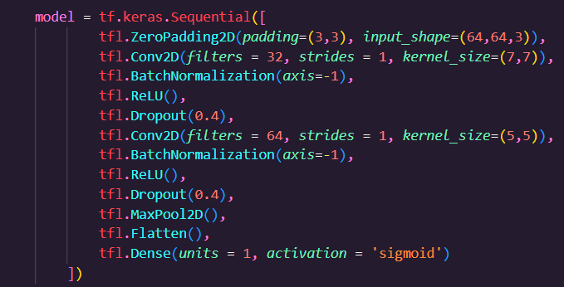

 | Optimizers | Training Accuracy(%) | Validation Accuracy(%) | Test Accuracy(%) | F1-Score  (Validation) | ROC AUC  (Validation) | F1-Score  (Test) | ROC AUC  (Test)
1. | AdaDelta | 87.30 | 94.29 | 92.31 | 0.9565 | 0.9365 | 0.9450 | 0.8864
2. | Adam | 100 | 96.88 | 96.92 | 0.9762 | 0.9767 | 0.9772 | 0.9545
3. | Nadam | 100 | 97.14 | 100 | 0.9778 | 0.9782 | 1 | 1
4. | RMSProp | 100 | 97.14 | 98.46 | 0.9778 | 0.9782 | 0.9882 | 0.9883
5. | Stochastic Gradient Descent | 97.50 | 100 | 93.85 | 1 | 1 | 0.9555 | 0.9091

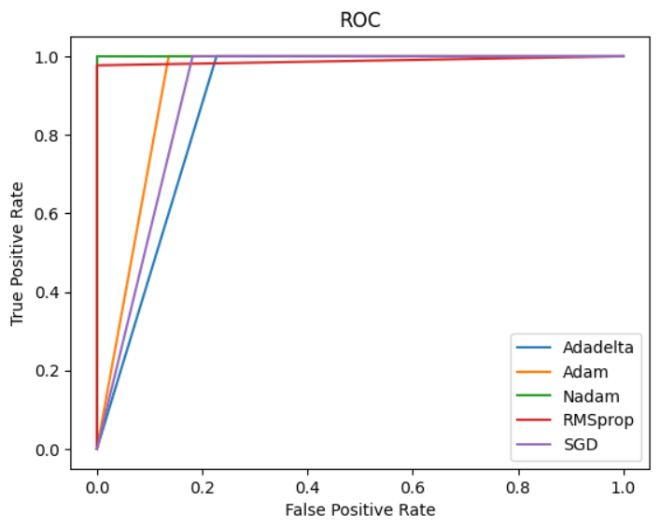

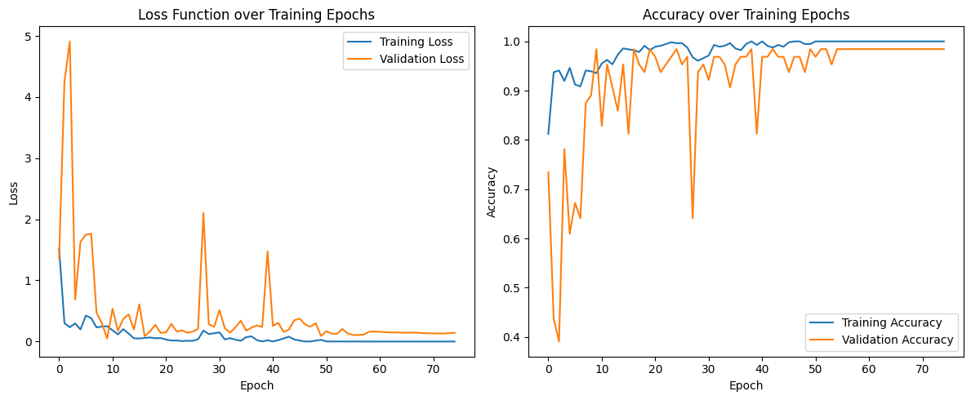

NADAM
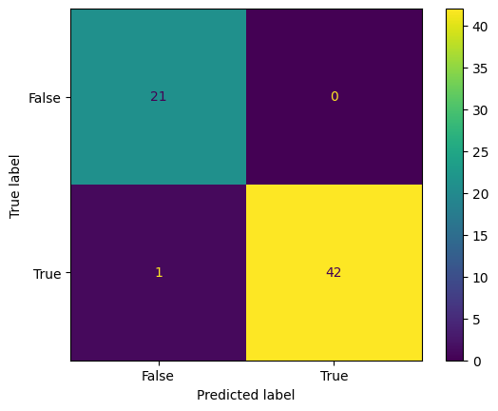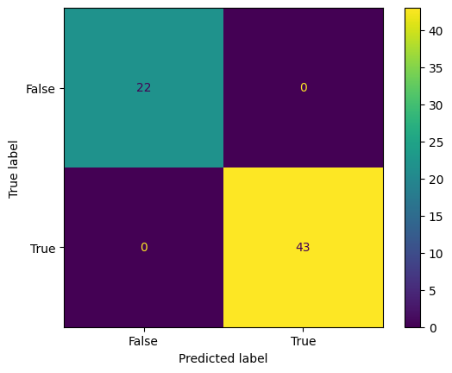
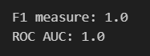
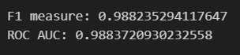

Validation Test

NADAM

