Semi-Supervised Learning Generative Adversarial Networks

Train a generative model G and a discriminator D on a dataset with inputs belonging to one of N classes. At training time, D is made to predict which of N+1 classes the input belongs to, where an extra class is added to correspond to the outputs of G.
In regular GAN, the discriminator is trained in an unsupervised manner to classify an image as real or fake (binary classification)
In SGAN, in addition to the unsupervised section, the discriminator gets trained in a supervised manner on class labels for the real images (in this case, binary classification)
Unsupervised mode learns the features
In SGAN, we discard the generator and keep the supervised classifier (discriminator) as our goal to train a classifier with limited labelled data
(SGAN approach achieves better accuracy for limited labelled data compared to CNNs)

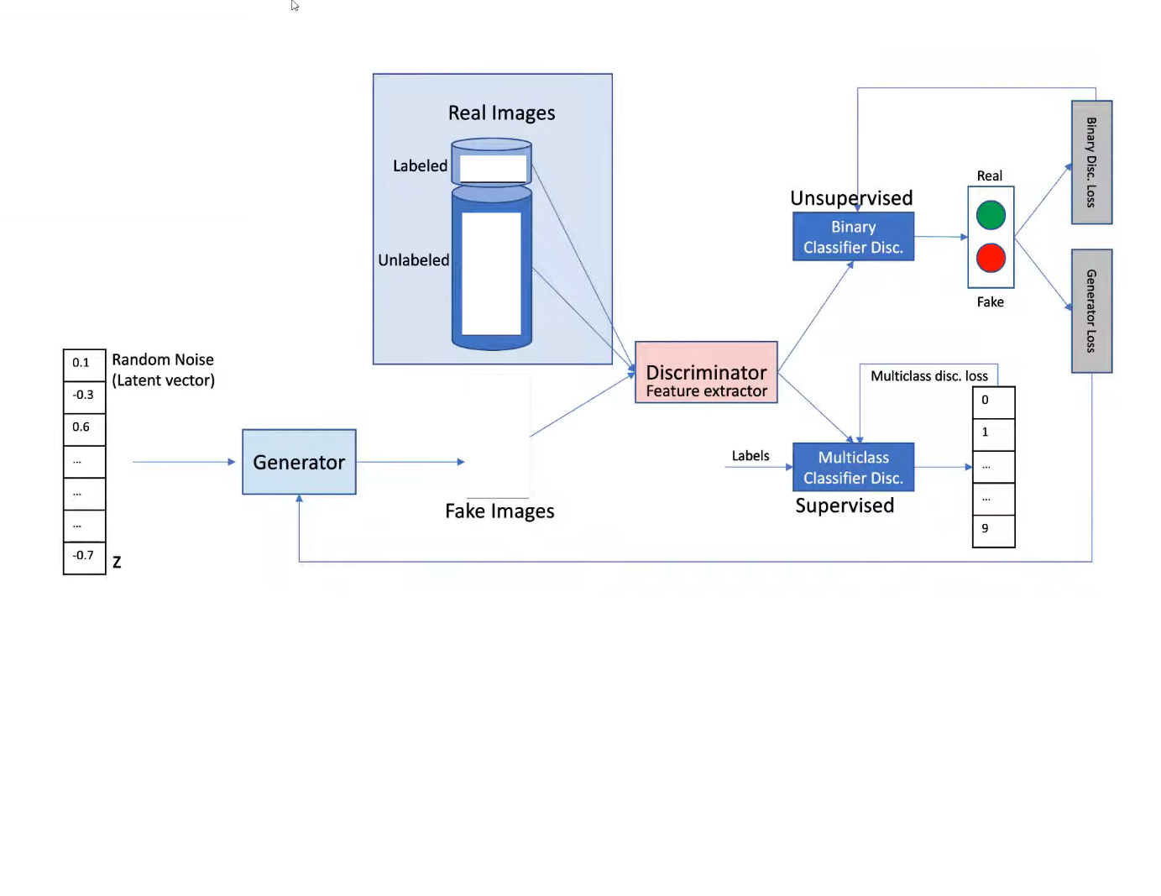

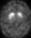
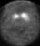
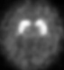
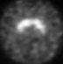

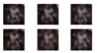

This model can be used as a multiclass classifier but in this case, we are only predicting presence (1) or absence (0) of Parkingson’s Disease

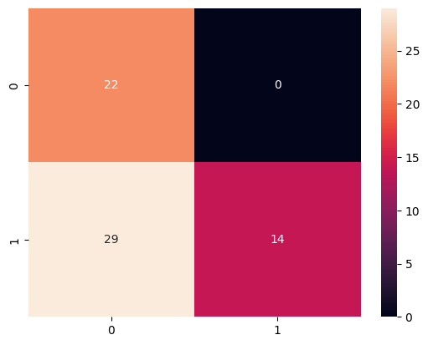
Samples = 10

Best Discriminator Accuracy = 50.722%
Best Test Accuracy = 55.385%

Saved => SSL_Graphs_10/disc_sup_0120

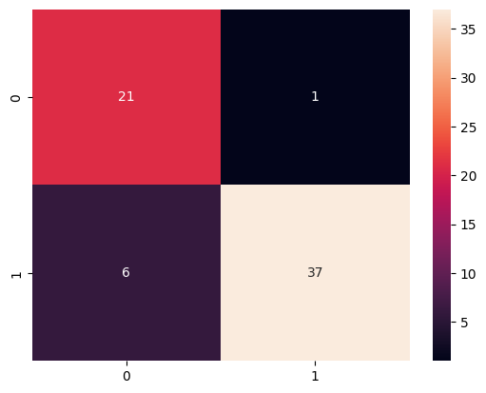
Samples = 20

Best Discriminator Accuracy = 87.134%
Best Test Accuracy = 89.231%

Saved => SSL_Graphs_20/disc_sup_0138

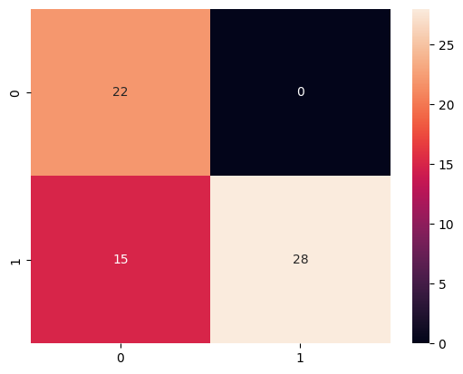
Samples = 30

Best Discriminator Accuracy = 72.552%
Best Test Accuracy = 76.923%

Saved => SSL_Graphs_30/disc_sup_0072

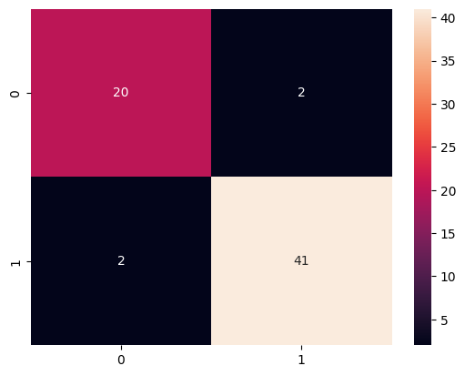
Samples = 40

Best Discriminator Accuracy = 90.851%
Best Test Accuracy = 93.846%

Saved => SSL_Graphs_40/disc_sup_0114

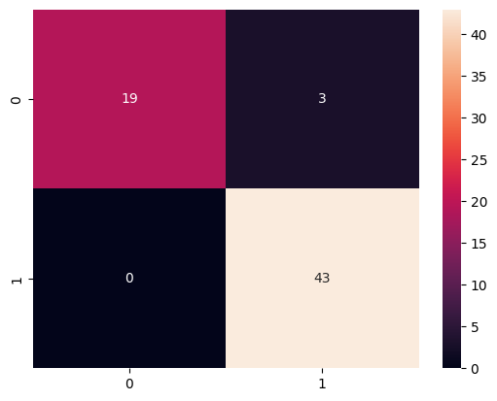

Samples = 50

Best Discriminator Accuracy = 93.098%
Best Test Accuracy = 95.385%

Saved => SSL_Graphs_50_New/disc_sup_0180

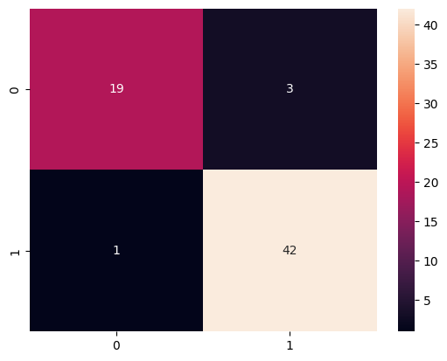
Samples = 60

Best Discriminator Accuracy = 93.579%
Best Test Accuracy = 93.846%

Saved => SSL_Graphs_20/disc_sup_0108

