Statistical Inference Project Part 1

Ryan Wissman

Saturday, January 24, 2015

# Coursera Statistical Inference Course Project

This project consists of two parts:

1. Data simulations
2. Data Analysis

More information regarding this project:

In this project you will investigate the exponential distribution in R and compare it with the Central Limit Theorem. The exponential distribution can be simulated in R with rexp(n, lambda) where lambda is the rate parameter. The mean of exponential distribution is 1/lambda and the standard deviation is also 1/lambda. Set lambda = 0.2 for all of the simulations. You will investigate the distribution of averages of 40 exponentials. Note that you will need to do a thousand simulations.

This project will cover 3 areas:

Illustrate via simulation and associated explanatory text the properties of the distribution of the mean of 40 exponentials. You should 1. Show the sample mean and compare it to the theoretical mean of the distribution. 2. Show how variable the sample is (via variance) and compare it to the theoretical variance of the distribution. 3. Show that the distribution is approximately normal.

# Setup and Simulation

First we will need set the parameters and run a simlulation of 1000 means for 40 samples.

#set the number of simulations  
n_sim <- 1000  
  
#set the sample size  
n_samples <- 40  
  
#set the random seed  
set.seed(1313)  
  
#set the value of lambda  
lambda <- 0.2  
  
#create dataframe containing simulated means  
mean_data <- data.frame(mean = apply(matrix(rexp(n_samples*n_sim, lambda), n_sim), 1, mean))  
head(mean_data)

## mean  
## 1 7.028397  
## 2 5.321861  
## 3 6.276993  
## 4 4.088829  
## 5 5.591798  
## 6 5.513257

## Question 1

Show the sample mean and compare it to the theoretical mean of the distribution. We see that sample mean (5.003448) is extremely close to the theoretical mean (1/0.2=5).

#Theoretical mean  
1/lambda

## [1] 5

#Sample mean  
mean(mean_data$mean)

## [1] 5.003448

## Question 2

Show how variable the sample is (via variance) and compare it to the theoretical variance of the distribution. The sample standard deviation (.7628219) is also very clost to the theoretical standard deviation (.7905694)

#Theoretical standard deviation - CLT  
(1/lambda)/sqrt(n_samples)

## [1] 0.7905694

#Sample standard deviation  
sd(mean_data$mean)

## [1] 0.7628219

We also notice that sample variance (.5818972) and theoretical variance (.625) are also very close.

#Theoretical variance  
((1/lambda)/sqrt(n_samples))^2

## [1] 0.625

#Sample variance  
var(mean_data$mean)

## [1] 0.5818972

## Question 3

Show that the distribution is approximately normal. We will plot a histogram of the sample population and a overlay the simulated normal distribution to visualize how close they appear.

#plot the sample distribution  
hist(mean_data$mean, breaks=16, freq=FALSE, col="gray", main="Sample Dist w/Theoretical Normal Dist Overlay", xlab="Mean")  
  
#add the theoretical normal distribution curve on top in red  
curve(dnorm(x, 1/lambda, (1/lambda/sqrt(n_samples))), col="red", lty=1, lwd=5, add=TRUE)

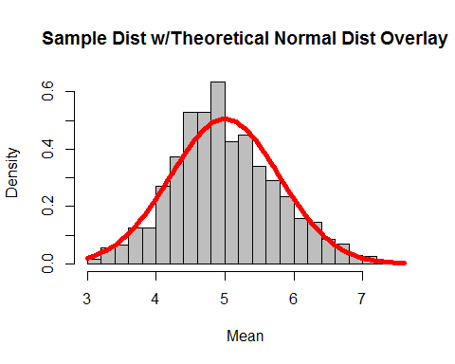

As we can see, the sample distribution follows the normal distribution quite nicely.