Mitchell Wolfe

ATLS 4010: Capstone

3/13/15

Thesis Paper: Imagery, Mood, and Narrative

The forms of storytelling generally are pigeonholed to a specific art form. Watership Down is a novel and Blade Runner is a movie, and while these examples seem obvious there can be a distinct overlap between different areas that can define something new. This overlap has become increasingly more common and can produce incredible pieces of art and media. There are many different types of storytelling conduits that utilize the combination of different elements; the focus here will be the mixture of written word and image. Fleckenstein creates a word for the combination of image and text, which is “necessary for our meanings…a double dialect, a double vision of literacy as image and word, as imageword.” (Fleckenstein) The terminology imageword will continue to be used here because the meaning is the same.

When putting these two elements together balance becomes a main concern. Considering how the two will compliment and enhance each other is of paramount importance and is contemplated differently for different art forms that merge the two elements. For forms such as infographics and data visualization the visuals, rather than text, tend to shoulder most of the purpose of conveying the ideas. This contrasts with figures in a technical report where the text holds the most importance while the image is complimentary. Another contrast is a comic book or manga where the text and image are on equal footing when telling the story. Since comics are the most similar to this project in terms of purpose a more deliberate definition is needed. Kukkonen says, “words and images combined into a sequence for a particular purpose, namely, to tell a narrative.” (Kukkonen) The sequence aspect should be remembered. For comics the combination together as sequence is important however this if the images and text are separated the sequence could change. With all of the different ways that imagetext can appear the main objective of combining text and image is the same, simply to enhance the meaning of the message being presented. Each of the different forms uses the components differently through means of differences in size on the page, relation to each other, coloring, contrast, and many more different methods. In this way imagetext is much more physical than that of only the text. A description of comics in this way “We tend to forget that we read – or rather use – comics in a very physical way.” (Hague) The addition of image is more than just that it is there, for example you can’t listen to a comic. Through this thesis project how text and image relate and combine to enhance meaning shall be explored and then expressed. The final deliverable shall be a book that is interspersed with images that focus on creating a mood in combination with the text.

When looking at how these elements interact a consideration of their past use is helpful. Imagery has been used as a way to communicate ideas for centuries. Cave drawings and hieroglyphics provide image based writing those these are different from images that are used in conjunction with text to create a narrative. In a more modern sense William Hogarth created the first combination of text and image. A narrative series of six engravings was the first look at creating a “novel” by using prints. (Smoldren) Low literacy rates at the time pushed image as a medium 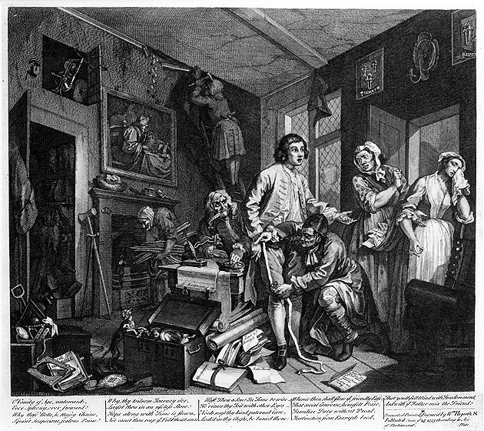for transferring messages because the only way to pass ideas among the entire populace was to give out information through pictures. Later once the working class began to have time for other actives besides labor cartoons provided entertainment. Political cartoons took advantage as when they were “Read” by the population political ideas could be spread. These lines of communication were completely unavailable through text. Despite the face that literacy rates are much higher the use of graphics has not declined. The use of the image then is greater than creating a means of communication, the use is that the communication provided is better in many cases than text could ever be. Political cartoons work because the effect created through the imagery is more memorable and potent than a description of political affairs could ever be.

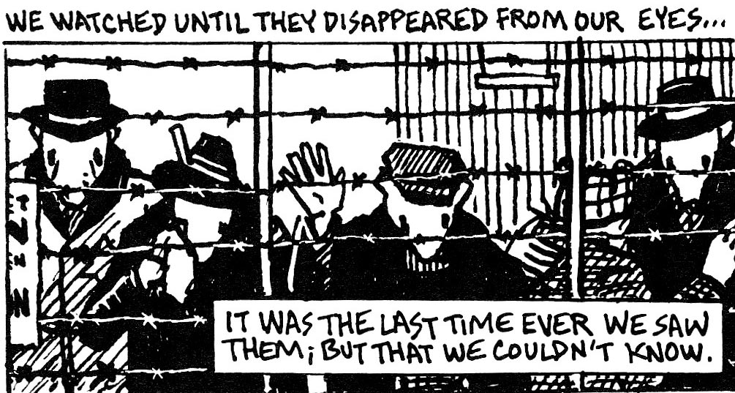 The comics that started to appear grew with weekly iterations bringing new adventures. Interest was garnered by anticipation for the next part of the story. These continuations were put together for the first time into novel length form in 1842 by Radolphe Toffler as “The Adventures of Obadiah Oldbuck” This was the start of a new age where comic grew from being simply a few panels into full stories and books of panels that told novel length and scale stories. The graphic novel proved that the novel length form was not only possible, but also an effect way for conducting narrative. The use of the term graphic novel though has some criticism. The term is generally seen by those who right this content as “a marketing tool for conveying respectability that leads to books that are made to be studied in academia and that’s no less of a marketplace than making comics to appeal to 12-year-old-boys.” (Humphrey) There industry has had to fight, particularly in American to establish the medium as being on the same level as written literature. A worldwide look through means such as manga show that this acceptance is starting to take further grasp established the combination of text and image as an artistic story form on the same level as straight written word. This formation has been more possible because the use of images is more accepted in the present day. “It’s the visual crisis of our culture…Our students, our children, and we ourselves are immersed in a culture that live its life on-screen and in front of a screen” (Fleckenstein) Comics have even started to be used more with teaching as the merits of the medium start to rival usual literature with the realization that people are visual in nature. “Children weave details and thoughts from one medium into another to create a whole text.” (Nixon) This shift has been widespread through more than just comics with data visualization and other computer generated art. With the ability to be more visual possibilities have opened up many more possibilities. With these new options the expansion of image and text as a form of narrative to more than just comics or graphic novels.

With comics and graphic novels the words and image have become “mutually constitutive, mutually infused” (Fleckenstein) in a way that they build off each other 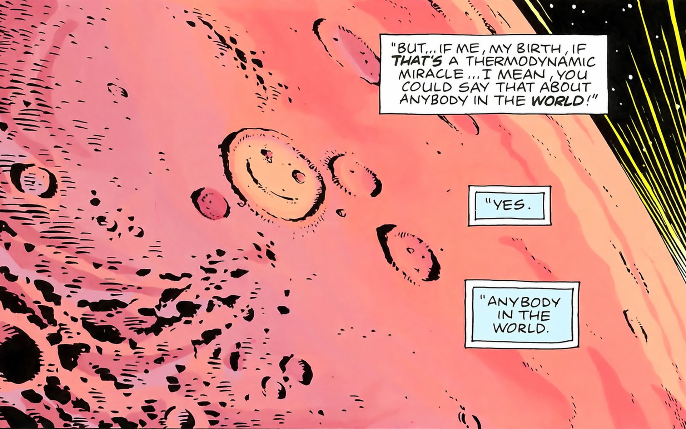by way of character and scenes. This seems obvious since the images are showing the characters and their actions. The balance is equal and without one of either the text of image the effect of the narrative is not nearly as strong. What would happen then if this balance changed? By separating the two so that they are no longer dependent on each other is what this thesis project will address. Having a story that could work by itself and then exploring how images can possibly expand and improve the story. With comics, the image and text directly work together which generally is positive, but can take away some of the imagination that is inherent in the text. Yet, “language does not have exclusive properties for enabling people to construct and represent meaning,” which is why images are so powerful. How much the images affect the reading though has yet to be experimented with though it has been thought of. “It is not hard to imagein a non-pictorial comic, perhaps composed of a sequence of non-depictive images along with text in some format.” (Cook) The use of images will be to enhance the mood of the story instead of taking over the imagery.

By stimulating the reader into a certain mood through images that are situated along the edges of the page the reader should experience the story differently from that if they had read the text only. The purpose will be to then guide the experience subconsciously with color and scenery. The type of imagery that is to accompany the text is important because not only does the mood have to be set, but also there cannot be a level of distraction that interferes with the text. For these purposes the use of several different types of photography will be put throughout the book. The first type of photography will be lomography. This type of photography originated with Lomo LC-A camera which was produced in Russia during the 1980’s The images produced by the camera were slightly blurry with an emphasis on oversaturated colors. This effect is incredibly conducive to providing 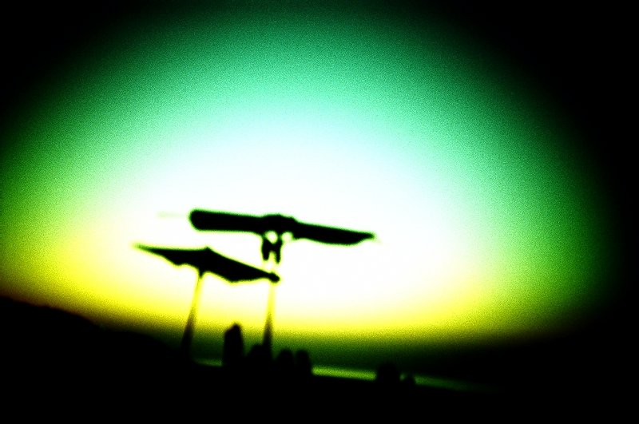eerie images that functional better singular rather than in a series. The blurriness helps draw focus away from the content in the frame. For these reasons lomography is an excellent choice for creating mood and not distracting from the text. Another type of photography that will be used is low light and light painting. By focusing on shapes created by light and by the generally 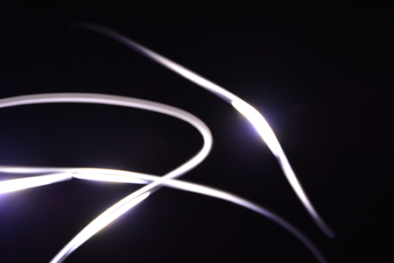darkness of the images there is no focus on content in the frame. Parts of these can also be used as decorators on the sides of the pages. This also leads into the last type of photography, which will focus on textures. Dirt, pipes, garage walls and the like will help to create a seriousness for the plot (which I discuss below) and are almost completely distinct while still providing a certain feeling when observing them.

In terms of story the plot really shouldn’t be affected by the medium. In comics and graphic novels the stories can be anything just as they are for normal novels. With the chosen types of photography a more somber story fits with the darkness and blurriness of the image and the two should play of off each other nicely. The types of images also tend to have a sort of fantasy and mythical feel to them, or at least my own photography down when I take these images. As this thesis is a work done by a single person it is important to take into consideration the personal flavor the persons existing artwork as new forms are explored. This entire project is trying to explore into a form that while new in certain ways is an extension of the world of imagetext and should provide many similarities to the previous works.

# Works Cited

Cook, Roy. "Do Comics Require Pictures." The Journal of Aestetics and Art Criticism (2011).

Fleckenstein, Kristie. Embodied Literacies. Carbondale: Southern Illinois University PRess, 2013.

Hague, Ian. Comics and the Sense. New York: Routledge, 2014.

Humphrey, Aaron. "Beyond Graphic Novels." 151 (2014): 73-80.

Kukkonen, Karin. Contemporary Comics Storytelling. Lincoln: University of Nebraska, 2013.

Miodrag, Hannah. Comics and Language. Jackson: University Press of Mississippi, 2013.

Nixon, Rhonda. "Teaching Narrative Writing using Comics." (2012).

Rida Afrilyasanti, Yazid Basthomi. "Adapting Comcis and Cartoons to Develop 21st Century Learners." Language in India 11.11 (2011): 552-568.

Smoldren, Thierry. The Origins of Comics. Jackson: Les Impressions Nouvelles, 2000.