Student ID: 10135033

Module: 5000CEM Introduction to Artificial Intelligence

Course: Computer Science BSc

**Table of Contents**

**Lab 1 – Introduction to AI** 4

**Basic Task** 4

**a)** **An Artificial Intelligent Application and its Impact** 4

**Advanced Tasks** 4

**a)** **United National Sustainable Development Goals** 4

**b)** **V-Rep Robot** 4

**c)** **Gender and/or Racial Bias in Artificial Intelligence** 4

**Lab 3 – Machine Learning Techniques** 5

**Basic Tasks** 5

**a)** **Outputs from Perceptron** 5

**b)** **Outputs from the Multilayer Perception Neural Network** 5

**c)** **Root Decision Tree** 5

**Advanced Tasks** 5

**a)** **Machine Learning Model** 5

**b)** **Multilayer perceptron or Self-Organising Map** 5

**Lab 5 – Knowledge Representation** 6

**Basic Tasks** 6

**a)** **Strengths and Limitations of two Representation Approaches** 6

**b)** **Robotics Engineers Semantic Network** 6

**Advanced Tasks** 6

**a)** **Outcomes from Prolog for Olympics Semantic Network** 6

**b)** **Prolog Knowledge Base for Robotics Engineers Semantic Network** 6

**Lab 6 – Turing Test** 7

**Basic Tasks** 7

**a)** **Limitation of Turing Test** 7

**b)** **Turing Test Questions** 7

**Advanced Tasks** 7

**a)** **Satisfactory Answers of Entities** 7

**b)** **Types of Entities** 7

**Lab 7 – Fuzzy Logic** 8

**Basic Tasks** 8

**a)** **Fuzzy Membership Functions Titles** 8

**b)** **Fuzzy Cleanliness Levels for the Hotel Rooms** 8

**c)** **Manual Fuzzy Inferencer to Predict the Rating for Hotels** 8

**Advanced Tasks** 8

**a)** **Fuzzy Logic inferencer to determine the levels of risk faced by a research group** 8

**b)** **Own Fuzzy Logic Inferencer** 8

**Lab 8 – Intelligent Agents and Robotics** 9

**Basic Tasks** 9

**a)** **Two Advantages and One Disadvantage of using Social Robots** 9

**Advanced Task** 9

**a)** **Intelligent Agent System** 9

**References** 10

# **Lab 1 – Introduction to AI**

## **Basic Task**

### **a) An Artificial Intelligent Application and its Impact**

1. As for the military, the AI can be used for predictions, such as next enemy moves, according to (Leprince-Ringuet, 2021) Also I think that the AI could be used with quantum computers, assuming quantum computers can make fast and multiple calculations and AI can make decisions. For instance, if there is an AI and quantum computer operated rocket launcher for border defence, the AI could locate the target and measure the distance and the quantum computer could calculate the angle at which to shoot the enemy, if that would work and the AI would be trained well enough, the hit rate would be almost 100% in any weather conditions. Or the robots that use AI, they could be used between the soldiers, or just an army of AI robot soldiers itself, but that implication could be very dangerous due to unpredictability of the system itself, the AI could train itself to destroy allies, livelihoods, all ongoing vehicles, there must be spent many years in developing such kind of things, there was also mentioned on the internet that if the AI would suddenly be connected to the internet, it could become dangerous, so to for AI replace a human a really precise training should be provided.

Leprince-Ringuet, D. (2021, August 3). *The Pentagon says its new AI can see events ‘days in advance’*. ZDNet. Retrieved 1 December 2021, from https://www.zdnet.com/article/the-pentagon-says-its-new-ai-can-see-events-days-in-advance/

## **Advanced Tasks**

### **a) United National Sustainable Development Goals**

**import** random

a **=** input**(**'Enter your student id: '**)**

b**=** **0**

c**=** **0**

goals**=[**'No Poverty'**,**

'Zero Hunger'**,**

'Good Health and Well-being'**,**

'Quality Education'**,**

'Gender Equality'**,**

'Clean Water and Sanitation'**,**

'Affordable and Clean Energy'**,**

'Decent Work and Economic Growth'**,**

'Industry, Innovation and Infrastructure'**,**

'Reduced Inequality'**,**

'Sustainable Cities and Communities'**,**

'Responsible Consumption and Production'**,**

'Climate Action'**,**

'Life Below Water'**,**

'Life on Land'**,**

'Peace and Justice Strong Institutions'**,**

'Partnerships to achieve the Goal'**]**

**def** UNGoals**(**a**,** goals**):**

**print(**'Your student ID is '**+**a**)**

b**=(**random**.**randint**(1,17))**

c**=(**random**.**randint**(1,17))**

**if(**b**!=**c**):**

**print(**'The goals you have to learn are: '**+**str**(**b**)+**'.'**+**goals**[**b**-1]+**' and also '**+**str**(**c**)+**'.'**+**goals**[**c**-1])**

UNGoals**(**a**,** goals**)**

The AI can contribute to health and well being by implanting special chip inside humans body, the chip could analyze overall health status, but for that we would need some sort of UI for that, so there could be a phone app or a special machine ouside that would use NFT technology just to connect to the chip, the AI would analyze information and give end user suggestions or even build a special diet plan to improve health, also industry innovation and infostructure, this could be improved by making AI operated trains, AI operated taxi’s, AI operated busses, a huge pro of that any kind of public transport would never be late in the future, the public transport would be available 24/7 which goes on any stop every 5 or 10 minutes, there is a possibility of people giving up on their cars in the future what would make traffic jams disappear, because of that if AI’s would operate any kind of transport, the speed limit in cities could be removed, for safety purposes pedestrian crossings would all be traffic light operated and very strict with face recognition cameras.

### **b) V-Rep Robot**

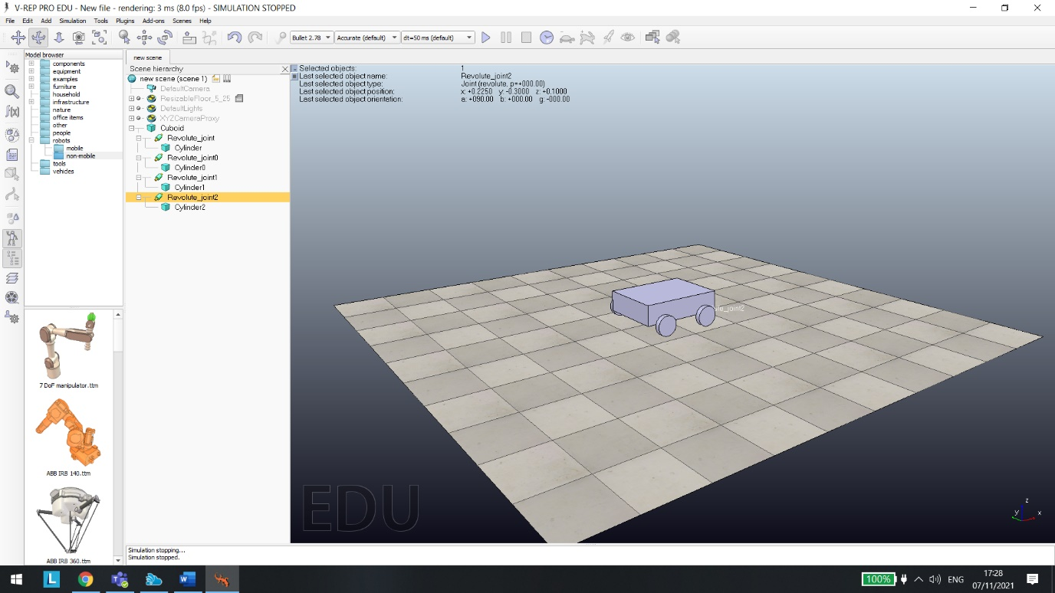

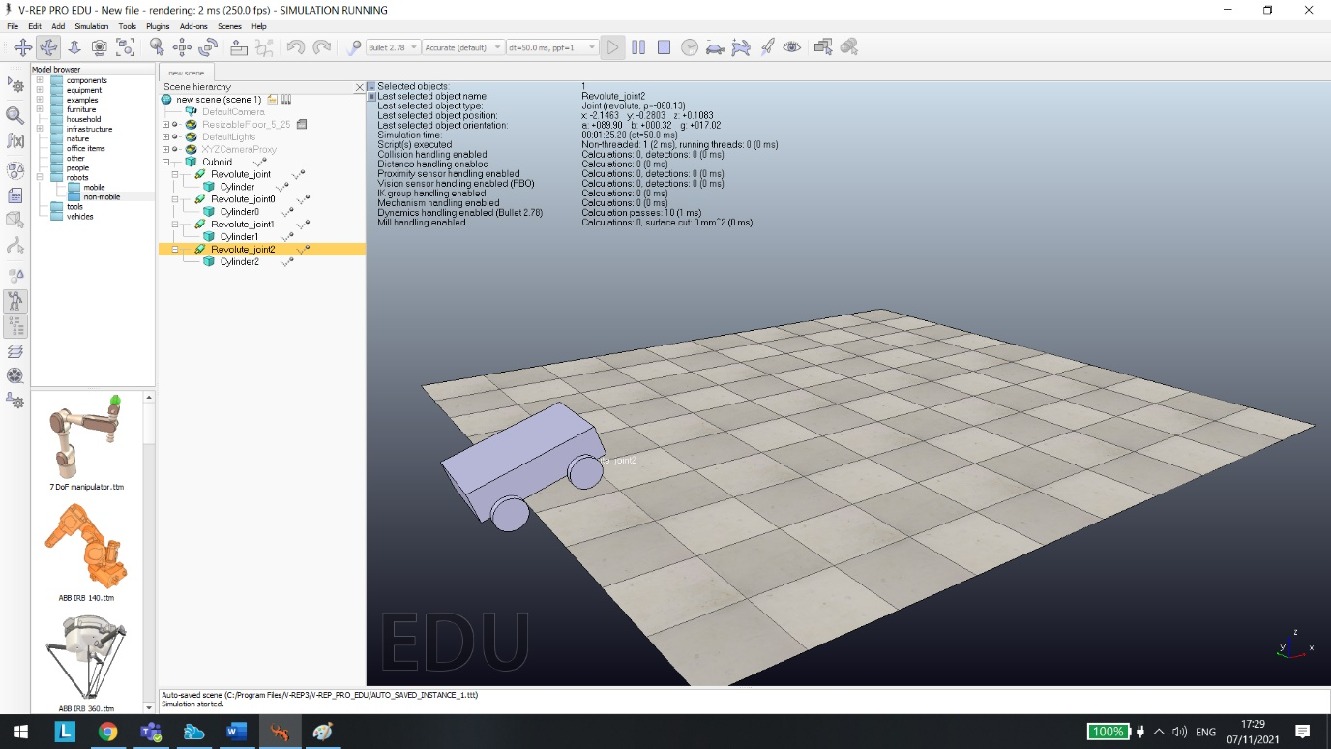

### **c) Gender and/or Racial Bias in Artificial Intelligence**

The issue can be solved easily. Every citizen has a passport. A citizen signs in into government-provided service and uploads a 3d model of their face into the government website. Now the AI will recognize not even their gender but their name, surname, DOB, etc. Otherwise, AI could be fooled as a man could put on makeup on themselves and the AI may say that they are a woman.

# **Lab 3 – Machine Learning Techniques**

## **Basic Tasks**

### **a) Outputs from Perceptron**

3*0.3=1

4*0.2=0.8

2*(-0.5)=-1

Sum>=threshold output and sum<0

1+0.8+(-1)=0.8

0.8>=1 and 0.8<1.6

Output : 0

### **b) Outputs from the Multilayer Perception Neural Network**

Set 1

A (5*0.2)+(20*0.4)=9

B (20*(-0.3))+(5*0.5)=-3.5

$$A=\frac{1}{1+e^{-9}}=0.999…$$

$$B=\frac{1}{1+e^{3.5}}=0.029$$

(0.999*0.2)+(0.029*0.9)=0.2259

$$\frac{1}{1+e^{-0.2259}}=0.566$$

Output : 0.566

Set 2:

(1*0.2)+(60*0.4)=24.2

(60*(-0.3)+(1*0.5)=-17.5

$$A=\frac{1}{1+e^{-24.2}}=1$$

$$B=\frac{1}{1+e^{17.5}}=2.511*{2.511}^{-8}$$

(1*0.2)+(2.511 ${10}^{-8}*0.9)$*=0.2

Output : 0.2

### **c) Root Decision Tree**

<Calculations to determine the root node for the decision node>

## **Advanced Tasks**

### **a) Machine Learning Model**

<Evaluation of the relevant outputs from your machine learning model>

### **b) Multilayer perceptron or Self-Organising Map**

<Code and weight representation for either the MLP or SOM>

# **Lab 5 – Knowledge Representation**

## **Basic Tasks**

### **a) Strengths and Limitations of two Representation Approaches**

Semantic networks – advantages:

Easy to visualise.

There is an identified representation approach.

Related knowledge can be linked together.

Semantic networks – disadvantages:

Inheritance can cause problems.

Facts positioning can cause problems.

No standards about node and arc values.

Frames – advantages:

Allow exceptions in particular instances.

Frames can be queried using spreading activation.

Simplified structures of frames allow for easy reasoning.

Frames – disadvantages:

Inference mechanism lacks a clear standard.

Inference mechanism cannot be smoothly proceeded by frames.

Frame representation is more of general approach rather than a representation.

### **b) Robotics Engineers Semantic Network**

<Semantic network for the Robotics Engineers scenario>

## **Advanced Tasks**

### **a) Outcomes from Prolog for Olympics Semantic Network**

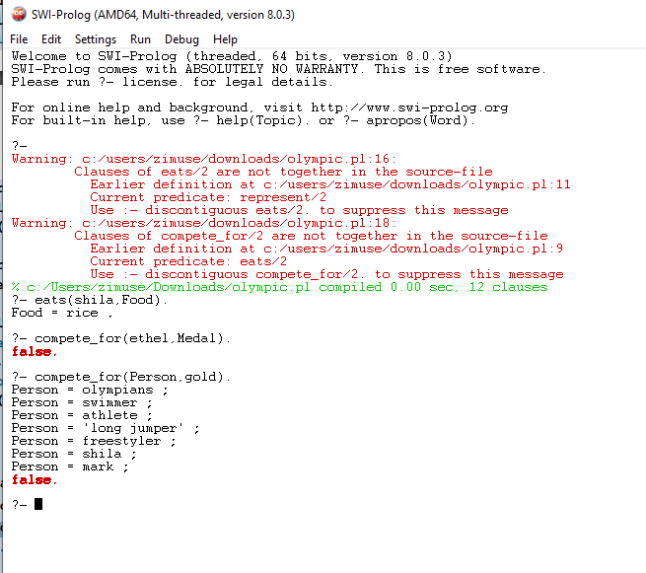

### **b) Prolog Knowledge Base for Robotics Engineers Semantic Network**

<Your Prolog facts, rules and queries shown working for the Robotics Engineers scenario>

# **Lab 6 – Turing Test**

## **Basic Tasks**

### **a) Limitation of Turing Test**

A limitation of turing test is basically trying to fool the judge rather than demonstrating true computing power. The test also could be considered weak and mainly it is for chat bots, as a computer would not solve any logical or so called mathematical questions for you, the only things that computer would do is respond to questions, but as mentioned with Turing test, if the computer is not thinking by itself, but has a pool of 5000-10000 questions and answers, and only uses an if statements to generate an answer, the machine might pass turing test in that way as it might be able to fool the judge during Turing test. As an alternative computer could be asked logical but not mathematical questions in my opinion. Example: Build me a sentence from these words: like, birds, fly, to; expected answer has to be: birds like to fly.

### **b) Turing Test Questions**

Which butter can be used for frying eggs: peanut butter, olive oil? This question may sound very wrong but an intelligent machine would probably answer peanut butter as there is butter keyword in the question itself. A human would say olive oil and would correct the question that it is wrongly formulated.

## What size does the boiling pot have to be to make spaghetti with tomato pasta and cheese?

Apparently AI does not know how to cook. Humans do.

Both questions were tested on cleverbot.com and it was not able to answer them.

## **Advanced Tasks**

### **a) Satisfactory Answers of Entities**

In my opinion the entities are answering in the statisfactory manner as they are able to understand questions, but it can be seen that the hidden entities sometimes are able to understand grammar errors, sometimes not and then they get confused. Or they get consfused by the questions. For the first transcript left hidden entity makes it obvious that it is a bot as it does not answer questions clearly. The right hidden entity is more like of human response. For the second transcript, the left hidden entity has not the best responses and the right hidden entity makes a feeling that it is a person having bad English skills.

### **b) Types of Entities**

For the first transcript one human one machine, as interrogator is asking questions and the left hidden entity is still having similar tendency of the behaviour in the conversation, answering with words or phrases such as : don’t know, sorry, wrong, bot is very doubtful about everything.

For the second transcript my opinion it is two machines as there are weird instant topic changes, or text that does not suit the context at all, off-topic additions to sentences just to continue the conversation.

# **Lab 7 – Fuzzy Logic**

## **Basic Tasks**

### **a) Fuzzy Membership Functions Titles**

NHS Spending in the UK – low, high, mid.

The traste of a pasta dish you created – tasteless, bad, cold, fair, warm, well done.

### **b) Fuzzy Cleanliness Levels for the Hotel Rooms**

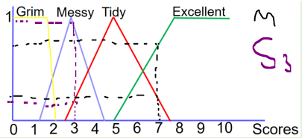

Mark with 7 points is black color, Sheila is purple with 3 points. So for Mark it is around 0.2 Tidy and 0.7 excellent. Sheila around 0.18 Tidy, 0.95 Messy.

### **c) Manual Fuzzy Inferencer to Predict the Rating for Hotels**

<The process to create the Fuzzy inferencer that can predict the rating for hotels>

## **Advanced Tasks**

### **a) Fuzzy Logic inferencer to determine the levels of risk faced by a research group**

<Screenshots of the interferencer to determine the levels of risk faced by a research group>

### **b) Own Fuzzy Logic Inferencer**

<Screenshots of your influencer>

# **Lab 8 – Intelligent Agents and Robotics**

## **Basic Tasks**

### **a) Two Advantages and One Disadvantage of using Caregiver Robots**

Using social robots to care for older people has an advantages such as it could carry certain

things to them, like pen, paper, a mobile phone maybe a tv remote, it can socialise with

them so they would not be bored, the robot itself could built in operating system which

could let the human use e-mail, web browser, video player through built in screen. For the

cons, supposedly it disconnects from internet, half of its features would not be working

unless the robot is offline based and it could still socialise with the human.

## **Advanced Task**

### **a) Intelligent Agent System**

**import** math

**import** time

age**=**float**(**input**(**"What is your age? "**))**

weight**=**float**(**input**(**"What is your weight? "**))**

height**=**float**(**input**(**"What is your height in cm? "**))**

time**.**sleep**(1)**

bmi**=(**weight**/((**height**/100)**2))**

**print(**"Hey I am a health bot! Ask me questions about water or food or activities!"**)**

*#question1=input("Do you know how much water should you drink today? enter just the number in litres, i.e. 4 ")*

*#comp1=question1.split()*

*#for(int i=1, i<len(comp1), i++):*

ans1**=**int**(**input**(**"Do you know how much water should you drink today? enter just the number in litres, i.e. 4 "**))**

aans**=**int**(**weight**)*0.033**

**if(**math**.**trunc**(**ans1**)==**math**.**trunc**(**aans**)):**

**print(**"Yes! that is correct, but don't forget that you must drink exactly "**+**str**(**aans**)+**" litres of water a day"**)**

**else:**

**print(**"You are wrong! You must drink "**+**str**(**aans**)+**" litres water a day"**)**

**print(**"Now ask me questions"**)**

aans2**=**input**(**""**)**

**if(**aans2**==**"How much water should I drink today?"**):**

**print(**"You have to drink "**+**str**(**aans**)+**" litres of water today"**)**

aans3**=**input**(**""**)**

**if(**aans3**==**"I just sat on my sofa watching tv all day."**):**

**print(**"Bad. Go outside for a walk, if it is raining take your umbrella with you."**)**

aans4**=**input**(**""**)**

**if(**aans4**==**"Is food that is high in salt good for me?"**):**

**print(**"No. Rather eat something plain today."**)**

aans5**=**input**(**""**)**

**if(**aans5**==**"I do not really like fruit, how much should I eat"**):**

**print(**"Your normal daily intake please refer to your BMI, it is: "**+**str**(**bmi**)+**" , as you now know find a nutrition table online"**)**

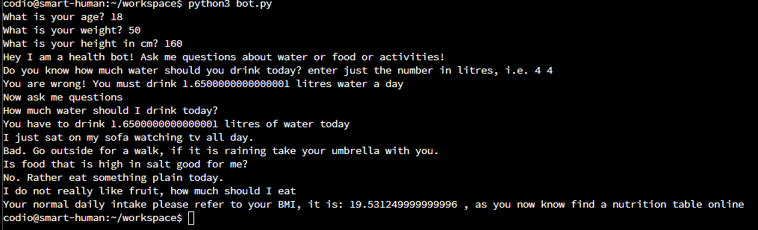

This bot honestly has limited functionality and can only respond to direct questions, needs improvement in the future.

# **References**

Leprince-Ringuet, D. (2021, August 3). *The Pentagon says its new AI can see events ‘days in advance’*. ZDNet. Retrieved 1 December 2021, from <https://www.zdnet.com/article/the-pentagon-says-its-new-ai-can-see-events-days-in-advance/>

5001CEM module lab tasks ranging from week 1 – week 8, as well as lecture slides which can be found there https://coventry.aula.education/?#/dashboard/09b4b176-a3aa-45aa-98e9-66597dbddf2e/journey/materials/611281d9-40cc-460c-a9c5-57144d586c05