MetaQuerier User Documentation

# Author:: Sergio Espeja
# License:: GPL License
# More Information:: http://meta-rails.rubyforge.org

Contents
0.Introduction 3
1.Profiles 4
2.Build a query 6
1.Select first model 7
2.Join models 7
3.Select attributes 9
4.Add conditions 11
3.Run a query 14
4.New query 16
5.Edit query 16
6.Save query 17
7.List and History queries 19

Introduction

MetaQuerier is a RubyOnRails plugin that is a part of MetaRails. Its aim is to make any kind of query to a database in a RubyOnRails application with zero configuration.
MetaQuerier detects the structure of the application models. Shows a diagram of the application and offers a custom form for building queries and browsing its data.
It also permits save and load queries, and parametrice them allowing made conditions fixed or variables. If you save a query with variable conditions then when you run this query MetaQuerier ask you for the condition value to assign.
Shows the result in HTML and permits export it to CSV, text separated by tabs, XML or Excel.
Integrates itself with ActAsAuthenticated plugin.
Manages different profiles that can be used to define different zones of the application database. This functionality helps the user defining queries.

This document will show you how to use MetaQuerier once it is installed and running.

Profiles

The concept of profiles in MetaQuerier is common to all MetaRails components. Profiles are the way how MetaRails manages to divide the database into smaller and more easy to use zones of the database.

Currently profiles are defined using metarails YAML formated files at “db/metarails” directory of our rails application. For each metarails YAML file into the directory we have got a profile. In each file we can codify the desired models (with its attributes and relations) that we want for the profile.

A metarails YAML file example (music_catalog.yml):

artists:
class_attr:
name: string
created_on: date
class_ass:
- has_many: albums

albums:
class_attr:
title: string
year: string
created_on: date
class_ass:
- belongs_to: artist
- has_many: songs

songs:
class_attr:
name: string
created_on: date
class_ass:
- belongs_to: album

If there are not metarails profile files at “db/metarails” then the only profile avaliable will be the “ALL” profile that contains all the application models (and its associations and attributes).

The MetaQuerier upper menu contains a select field from which we can change the current profile:

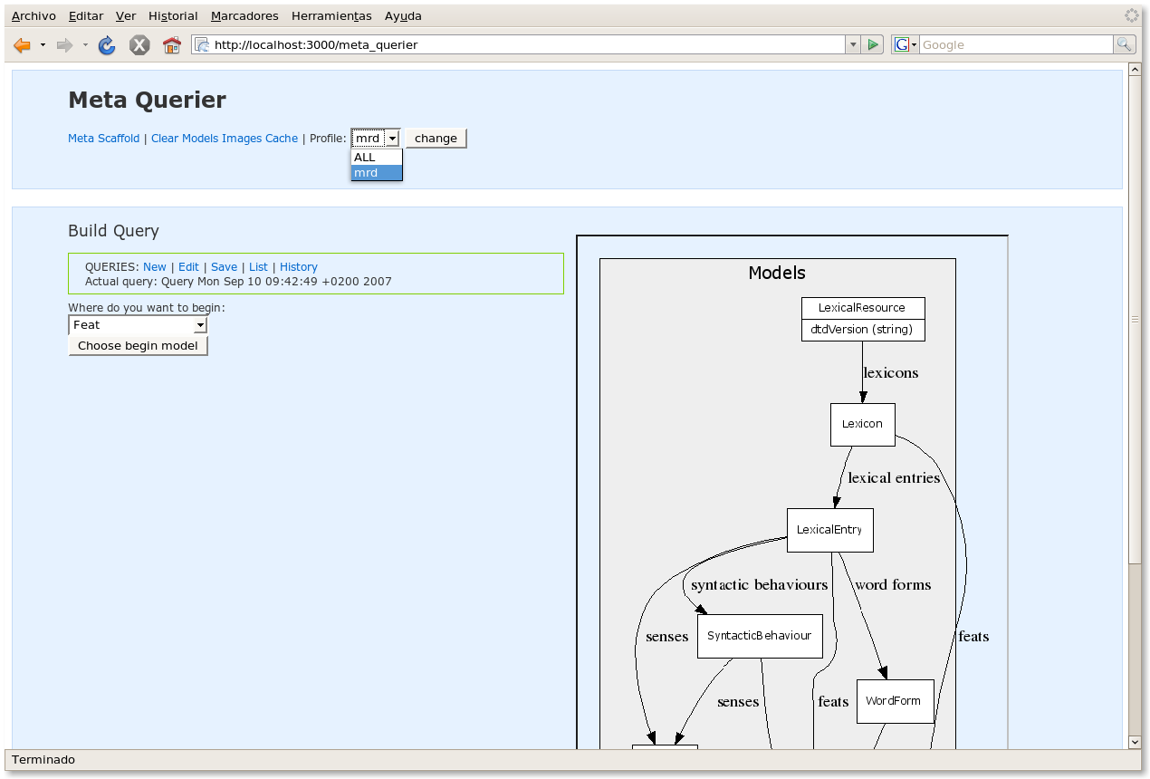
By default the choosed profile is “ALL”.

Build a query

The main objective of MetaQuerier is to query the application database, to do it first we need to build a query. In this section we will learn how to build a query and the posibilities that MetaQuerier gives us to do it.

The first time we go into MetaQuerier we can see the query builder form with a empty query. Later we can clear the actual query and create a new empty one using the “New” option at the queries menu:

As you can see we have an aide for building the queries at the right side of the screen. This graph is a picture that shows the avaliable models (with its attributes and relations). We can use it to plan how we will query the appliaction database.

To build the query we must select a first model and join desired additional models. If the model has attributes we will be able to select/unselect them and add conditions to this attributes.

Select first model

This is the first step to take in order to make a query, select the model from which we will begin to build the query.

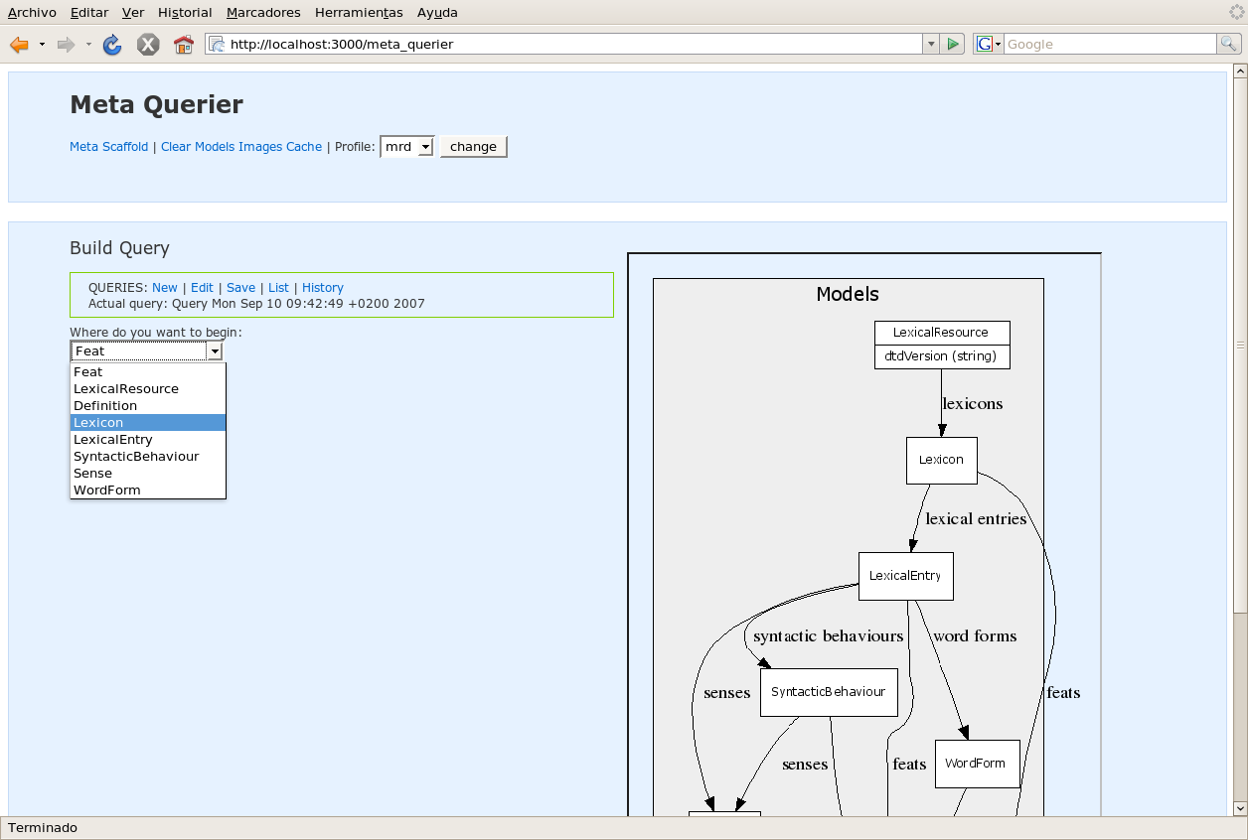

Join models

Once we have choose the initial model we can add joins to it :

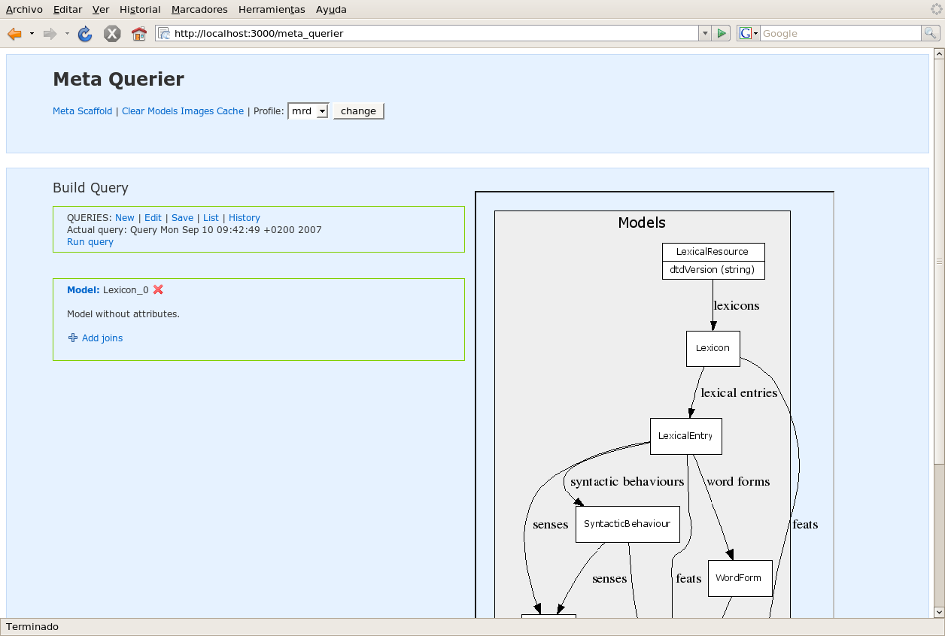
As you can see, the join form shows the current model related models and gives the possibility of join them using inner, left or right join (in case of doubt choose inner).

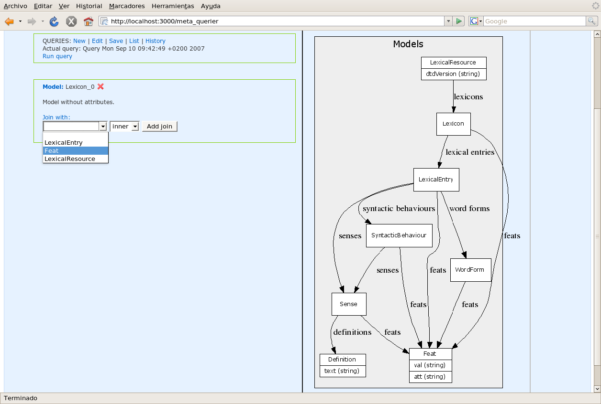

Once we have made the join MetaQuerier shows the new added model, and we can join more models to both models. This let us to build avanced queries.

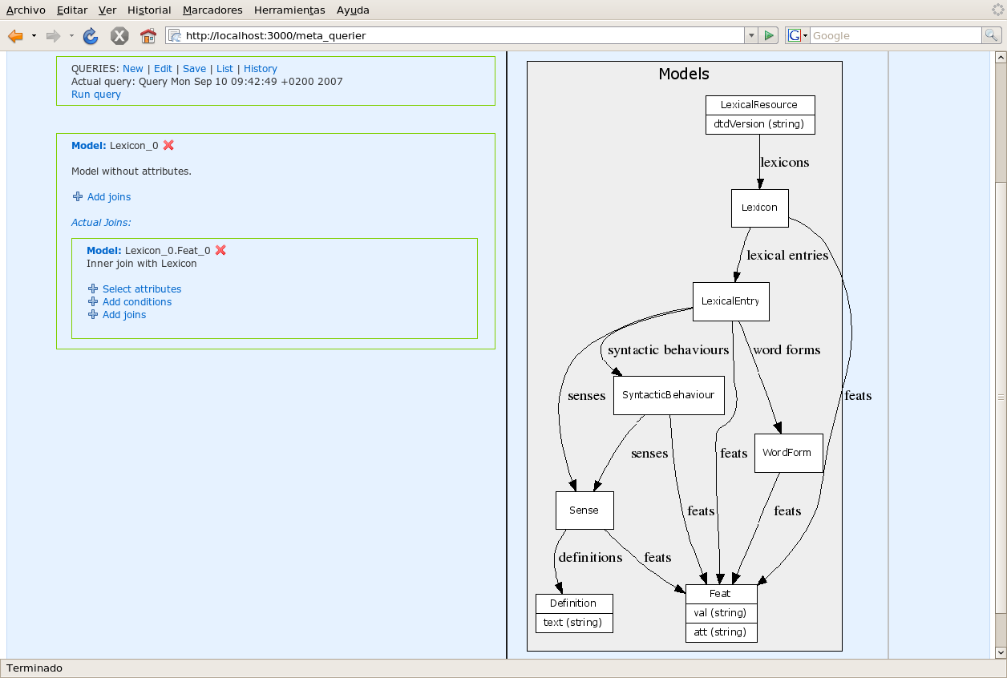

Select attributes

We can select which attributes will be shown or not when running the query with “select attributes” option.

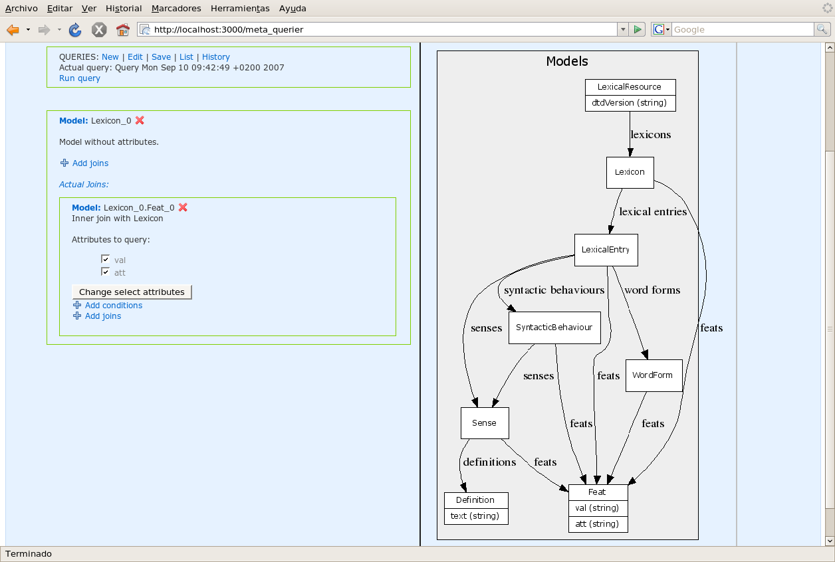
Check or uncheck desired attributes and click “change select attributes”. By default all model attributes will be shown.

Add conditions
Normally when you query a database you only want to show the values that fullfil some conditions. To do this, MetaQuerier permits to add as many conditions as you want to the attributes of a model.

Once you choose to add a condition, a select box shows you the avaliable model attributes. Depending of the type (string, number or date) of the attribute you choose MetaQuerier allows you to choose condition operations.

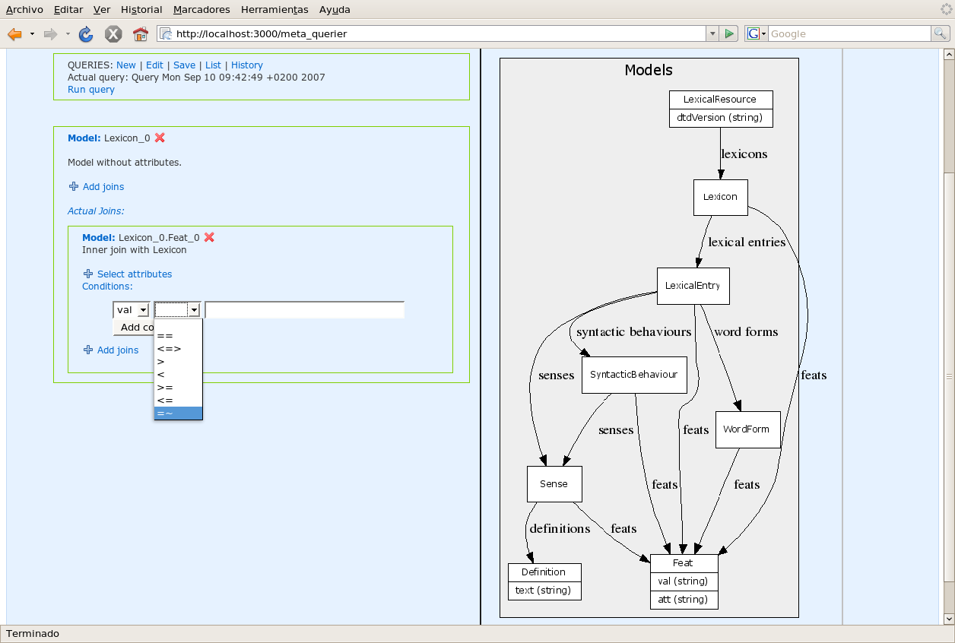
Avaliable condition operations for strings are == (equal), <=> (not equal), > (bigger than), < (smaller than), >= (bigger or equal than), <= (smaller or equal than), =~ (like). Most common operator used with strings is like (=~) that lets you restrinct the query to the rows that accomplish given pattern.

Example: Ask for the lexical entries with feats have in its attribute val the string “alar”:
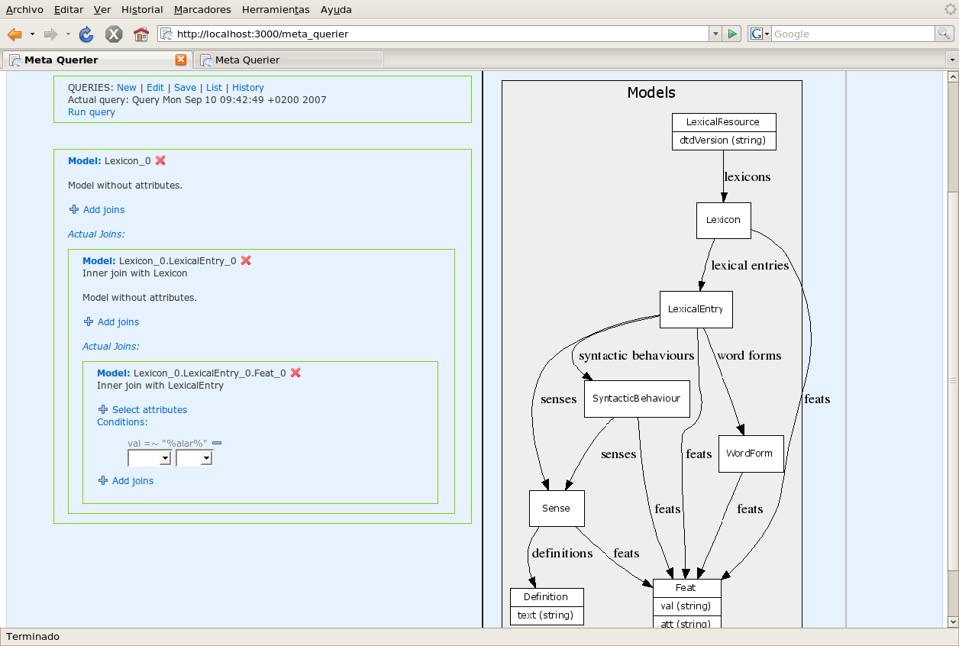
To add this condition we have chick in “Add condition” inside Feat box, we choose “val” attribute, later we coose “=~” operation and finally put “alar” at the input text box at the right side of the operation select box.

The result will be:

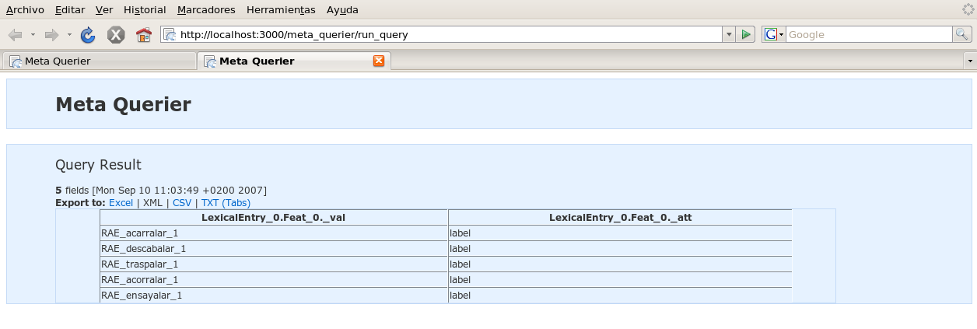

Run a query

There are two ways of running a query, run the actual query or run a saved query.

To run the actual query we must click at the “Run query” link at the query menu:

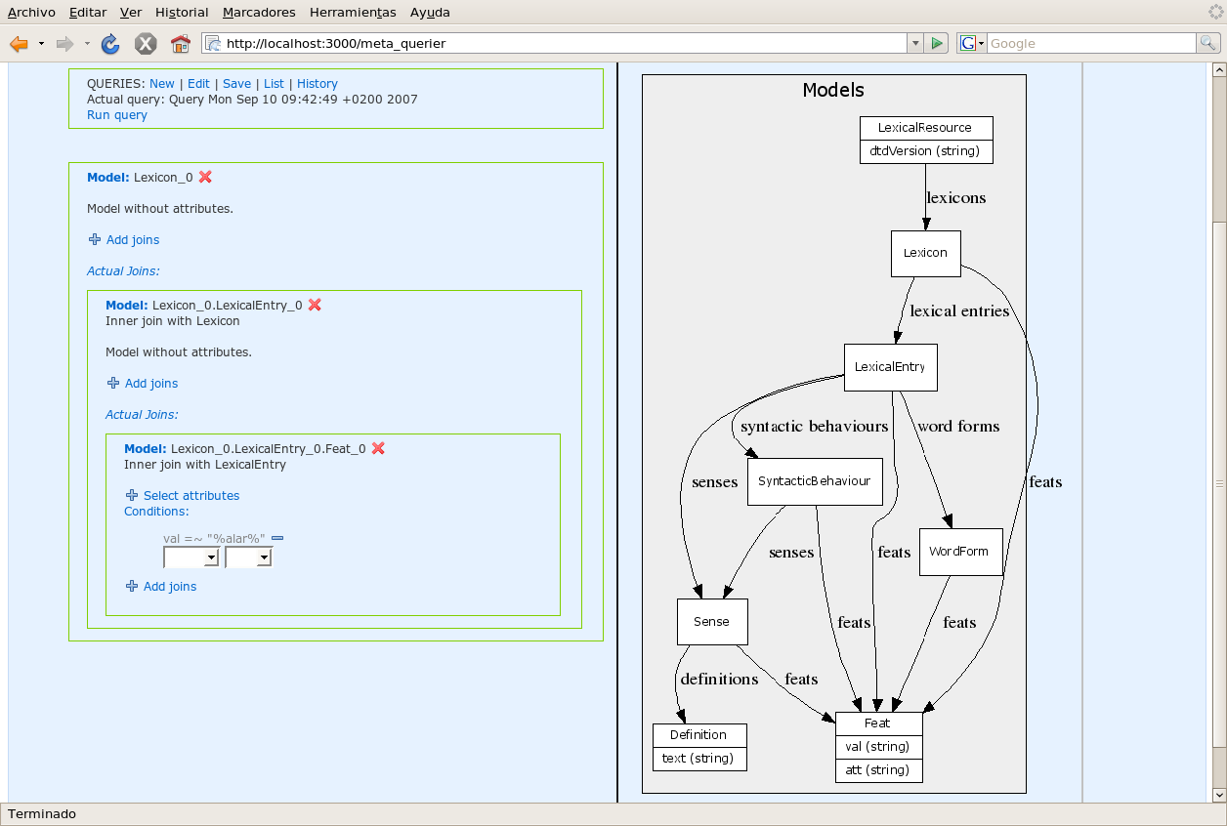
To run a saved query go to the queries list or history, clicking at “List” or “History” at the query menu, and click at “Run” link into the desired query.

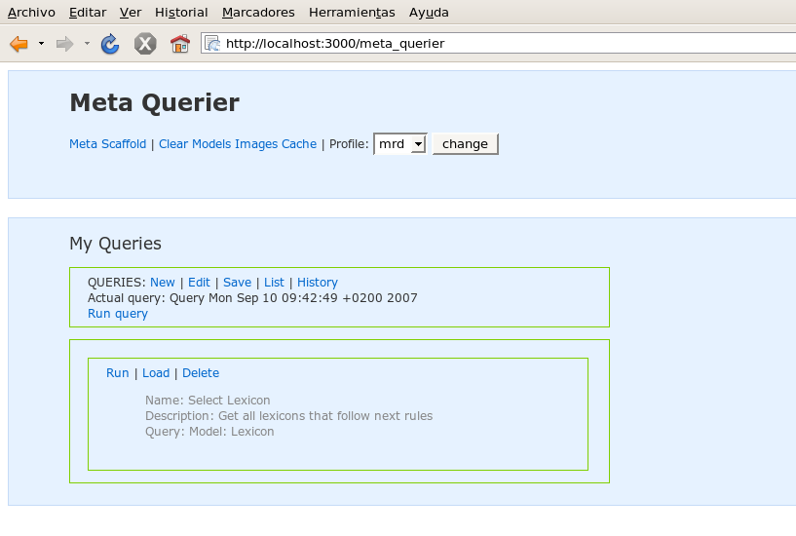

When the query es executed it pops up a new window with the result, from this new window you can export the data to Excel, XML, CSV (coma separated values) or text separated by tabs.

Saved queries can have variable parameters, if so MetaQuerier ask the user to fill this conditions before running the query.

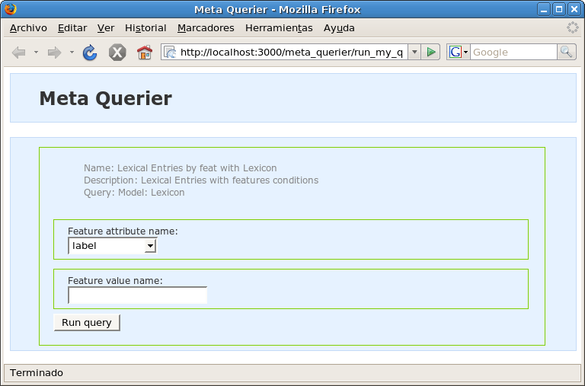

New query

This option allows to create a new empty query.

Edit query

This link goes to the query builder form for editing the actual query.

Save query

MetaQuerier allows the user to save his queries and also to parametrize them.

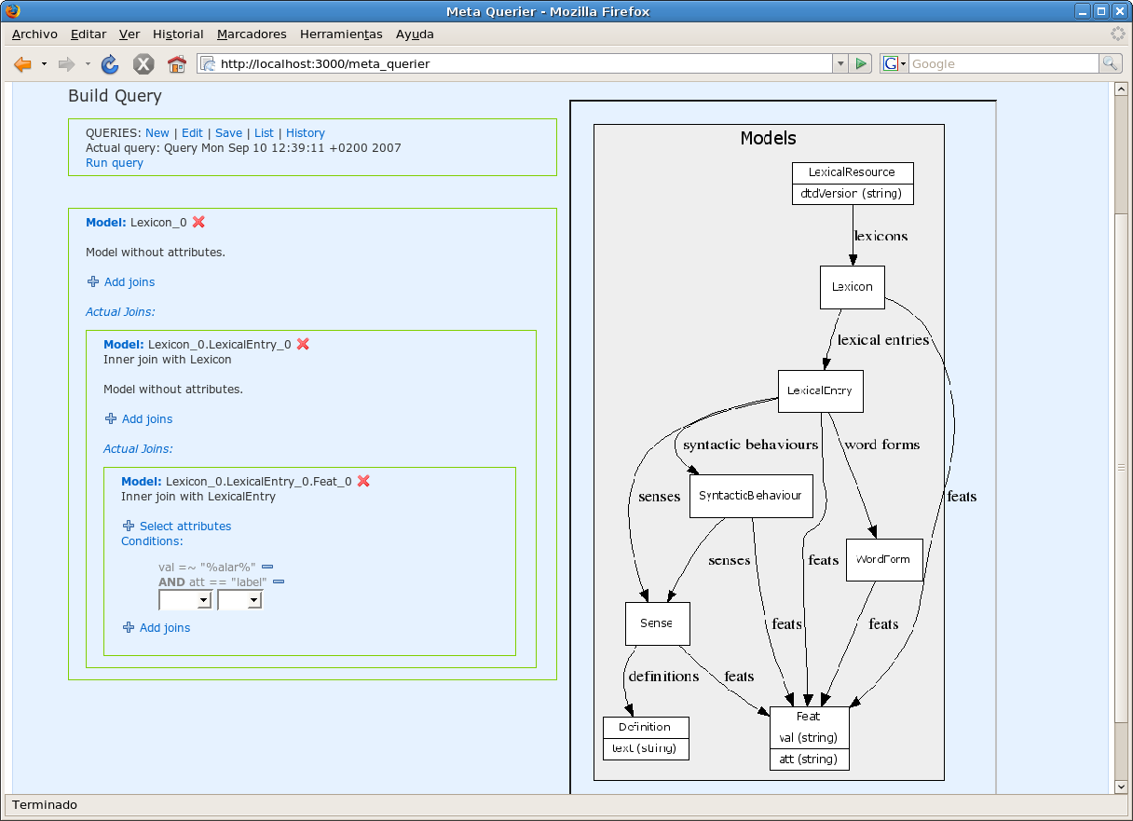
When you click at the “Save” link at the queries menu, MetaQuerier shows you a save query form. In this form you can set a name and a description for the query that will be seen at the query list.
If the query has conditions you can made them variable by clicking at “Make variable” links.

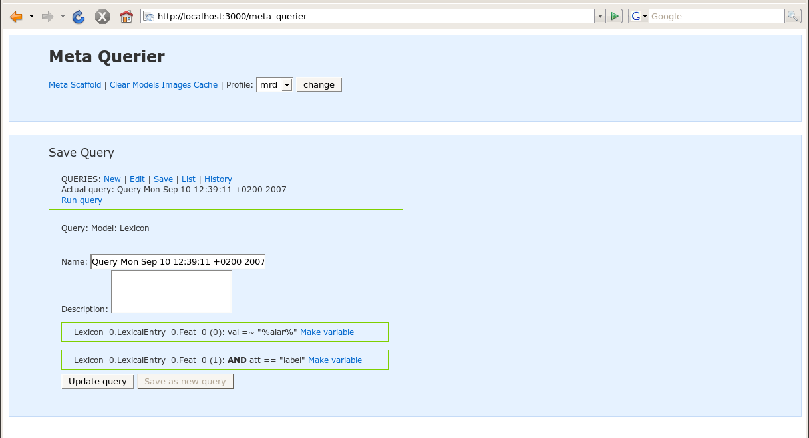
If you make variable some parameter, MetaQuerier will ask for the desired values of this variable coditions before running the query.
If the condition is == (equal) MetaQuerier allows you to check the option “Select from db values”, this option ask for the condition value using a select box with all the existing values in the database for the attribute, instead of showing a blank text box.

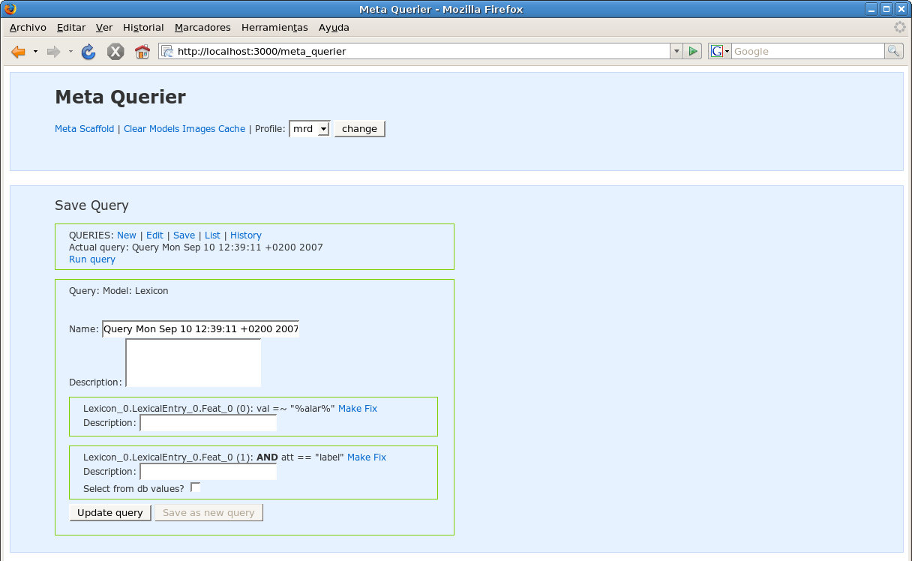
MetaQuerier also allows to put a little description of the variable condition that will be shown when filling this variable conditions before running the query.

List and History queries

Allows to browse all user saved queries (List) or queries saved automatically (History).

