|  |
| --- |
| Author: Scott Pelger  Sycle |
|  |

Contents

1 Introduction 5

1.1 Purpose 5

1.2 Capabilities 5

1.3 Requirements 5

1.4 Supported 5

1.5 Development Environment 5

1.6 Special Note 5

2 Main App 6

2.1 Configuration 6

2.1.1 User Configuration 6

2.1.2 Power Zone Configuration 7

2.1.3 Power Zone Configuration 8

2.1.4 Strava Configuration 9

2.1.5 Workouts 10

2.2 Pairing 11

3 Main Functions 12

3.1 Re-Ride 12

3.2 Workout 12

3.2.1 Power Based Interval Workout 12

3.2.2 Heart Rate Based Interval Workout 13

4 Re-Ride Grade 14

5 Getting Fit Files 18

Revision History

|  |  |  |  |
| --- | --- | --- | --- |
| Version | Author | Date | Description |
| 1.0.0.0 | Scott Pelger | 22OCT20 | Document creation. |
| 1.1.0.0 | Scott Pelger | 07NOV20 | 1. Corrected conversion of gpx files that do not contain cadence, heart rate, or power data. 2. Was not saving elevation data during re-rides. Corrected. 3. Added ability to convert between KML and FIT files. 4. Corrected display of speed in pairing dialog. 5. Allowing more time to send trainer user configuration data. for months this had been working as is. Now some failures are coming back from trainer and more time/attempts are needed. The failures could be a result of the recent physical bike/dongle/laptop position changes made. 6. Reduced gradient resolution from 100m to 50m. |
| 1.1.1.0 | Scott Pelger | 23MAR21 | 1. Changed interval workouts to rides so when uploaded to Strava their distances will be uploaded and counted. 2. Allowing workouts to be biased with respect to speed/distance. 3. Prevent Sycle from closing when a ride is in progress. 4. More work on gradient. Reduced from 50m to 20m and far more improved smoothing. 5. Added interesting grades to the grade graph. |

# Introduction

## Purpose

I wrote this because I wanted something to use during the off Zwift months and because I like to do some things myself. I am a firmware engineer, not a software engineer so it looks admittedly utilitarian but the application does what I intended for it to do: let me ride past rides, rides in places I’ve never been to, and training sessions. While riding I can watch TV, read, or even pay attention to the really quite boring ride.

## Capabilities

The main capabilities:

1. Re-ride a previously ridden ride
2. Define and ride an elevation profile
3. Define and ride a power based interval training session
4. Define and ride a heart rate based interval training session
5. Some FIT file utilities such as combining, reversing, and converting

## Requirements

1. Windows PC with at least Windows 7 installed. The app was developed on a Windows 7 machine and used with a Windows 10 machine. These are the only two operating systems tested so far.
2. An ANT+ dongle will be needed. There are various sources available on amazon.com. I paid $20ish for this: <https://www.amazon.com/Garmin-010-R1058-00-Stick-Fitness-Devices/dp/B0769KTMGP/ref=pd_ybh_a_23?_encoding=UTF8&psc=1&refRID=NPC7M8ZA0SA2TQMMRYVY>
3. An ANT compliant fitness equipment trainer. This is a typical smart trainer that can be controlled using the ANT+ wireless protocol. The application strictly adheres to the specifications found in the ANT+ fitness equipment document number D000001231 revision 5. Typical smart trainers provide power, speed, and distance as feedback. My smart trainer is a 2018 model Wahoo Kicker Core I picked up new mid 2019, it was a good deal, new, low demand during the summer, previous year model.

## Supported

1. An ANT compliant cadence sensor.
2. An ANT compliant heart rate monitor.

## Development Environment

Sycle was developed using a Windows 7 based laptop. Smart trainer used was a Wahoo Kicker Core that comes with a cadence sensor. A Wahoo Ticker heart rate monitor was also used.

## Special Note

Yes, I know, when riding on a trainer my absolute speed is zero. I also know that the number of meters I have climbed is zero. Power is power whether on the trainer or out on the road and that is hard to counter. When I mention distance or feet climbed I understand that it is all fictional so let’s just get past that. Besides, I sweat my butt off and breath just as heavily on the trainer as I do out on the road.

# Main App

The application looks like the following when first started with no ANT+ dongle installed. The message will go away once the dongle is installed and the disabled buttons will become available.

For first time execution the configuration dialog will appear to collect some necessary information.

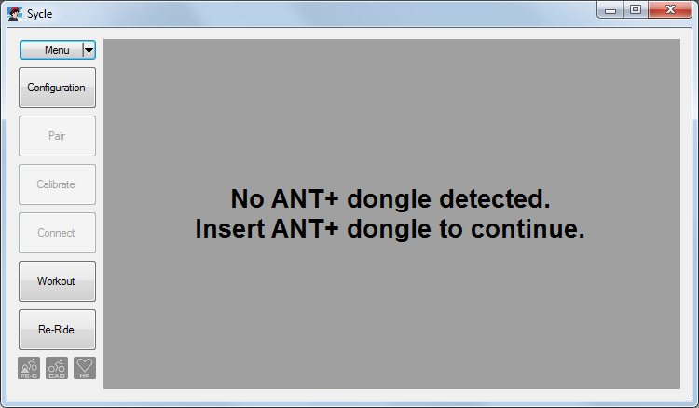

## Configuration

### User Configuration

User configuration is entered on the Configuration tab. The user’s and bike’s weight are sent to the trainer each time a connection with the trainer is established. The user’s height is not used in this version but it is anticipated in a future release that it will be sent when simulated wind conditions are added to add to the simulated re-ride functionality. Wheel circumference is not used as of yet. FTP and Max Heart Rate are used for interval training.

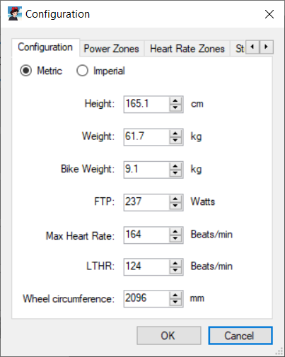

### Power Zone Configuration

This tab provides typical power zone divisions and assigns colors. The default maximum percent values come from <https://www.trainingpeaks.com/blog/power-training-levels>. Power levels are based on the FTP setting from the User Configuration tab. These colors are used during display of a power based interval training session.

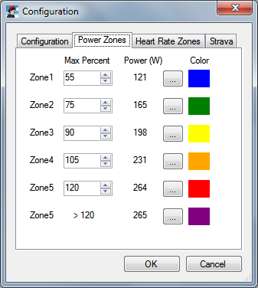

### Power Zone Configuration

This tab provides typical heart rate zone divisions and assigns colors. The default maximum percent values come from [https://blog.wahoofitness.com/the-ultimate-guide-for-tracking-your-cycling-heart-ratehttps://www.trainingpeaks.com/blog/power-training-levels](https://blog.wahoofitness.com/the-ultimate-guide-for-tracking-your-cycling-heart-ratehttps:/www.trainingpeaks.com/blog/power-training-levels). Heart rate levels are based on the Maximum Heart Rate setting from the User Configuration tab. These colors are used during display of a heart rate based interval training session.

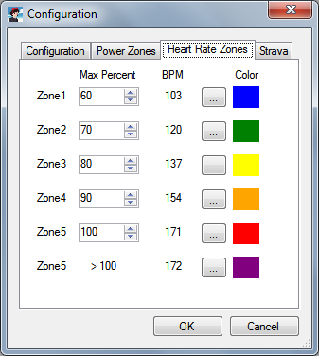

### Strava Configuration

This tab enables Sycle to upload completed rides to your Strava account. When saving a ride/training Sycle will automatically upload the results to an authenticated Strava account. Enable this feature at your own risk. To use the feature you will be required to give Sycle authorization to read and write. You have the option to authorize each time a ride is uploaded or once. Authorizing once is convenient but results in a token being written to a configuration file as plain text. The token in and of itself *should* be useless except for Sycle. If Sycle will only be used by one person in a controlled environment such as a private premises then this feature should be safe to use. If Sycle will be shared (and there is no provision for that in this version) then authentication each time might be a better option.

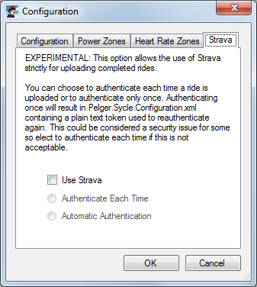

### Workouts

This tab allows you to decide how much distance is applied to a given workout.

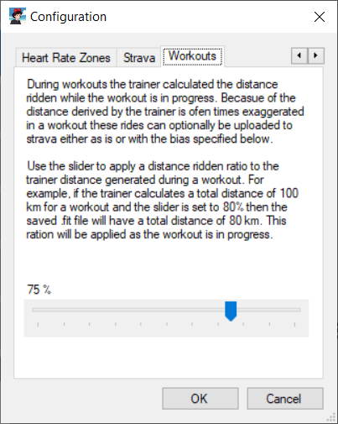

## Pairing

Press the Pairing button to pair, no connection is necessary. If pairing has never been performed then the following dialog will automatically come up when an ANT+ dongle is present. It looks something like this:

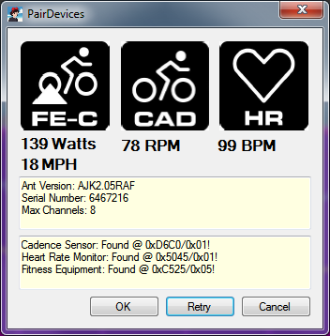

Any fitness equipment, cadence sensor, or heart rate monitoring ANT+ devices should appear. A grey icon means no connection has been established. If what you are looking for is not present then press the **Retry** button. Press **OK** when all are paired.

When retrying the connection to any connected devices will be closed then reopened.

Pairing information is stored in the configuration file and no further pairing is required unless sensors are changed.

# Main Functions

This section defines common terms used throughout the document.

## Re-Ride

This is the main reason why the application was written, so rides can be redone during the summer when not subscribed to Zwift *and* the weather is not cooperative. This year in particular it came in handy. The summer of 2020 was very bad with respect to the air quality in the western US and still is as of early October.

Press the **Re-Ride** button and you will be greeted with a google map and a few buttons below the ANT+ sensor icons. Press the **Open** button and load a .FIT file. The route will appear on the map along with an elevation profile in blue and a grade profile in yellow. Notice that the grade is not smooth. Refer to § 4 for details.

With a ride loaded and the app connected you can just press the **Start** button and away you go. Stats on the right depict speed, cadence, heart rate, power, grade and next grade, elevation climbed, and time elapsed.

The map has a context menu so you can start a ride from a different position if needed.

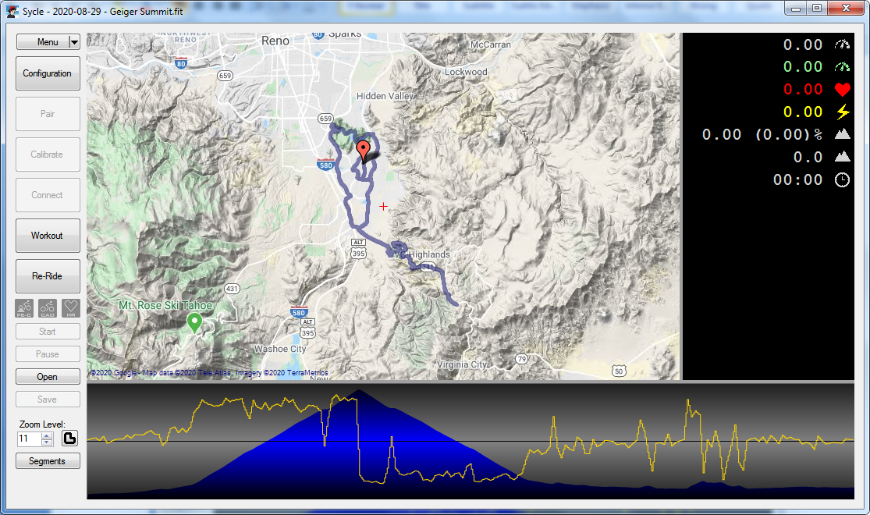

## Workout

There are two types of workouts, one that is power level based and another that is heart rate based.

### Power Based Interval Workout

Begin a power based interval workout session by pressing the **Workout** button. Either create a new workout or load a previously created workout. Press **Start** and off you go. When saving a new workout Sycle will mark the content as power based but the file extension will be the same as heart rate based workouts so use helpful file names.

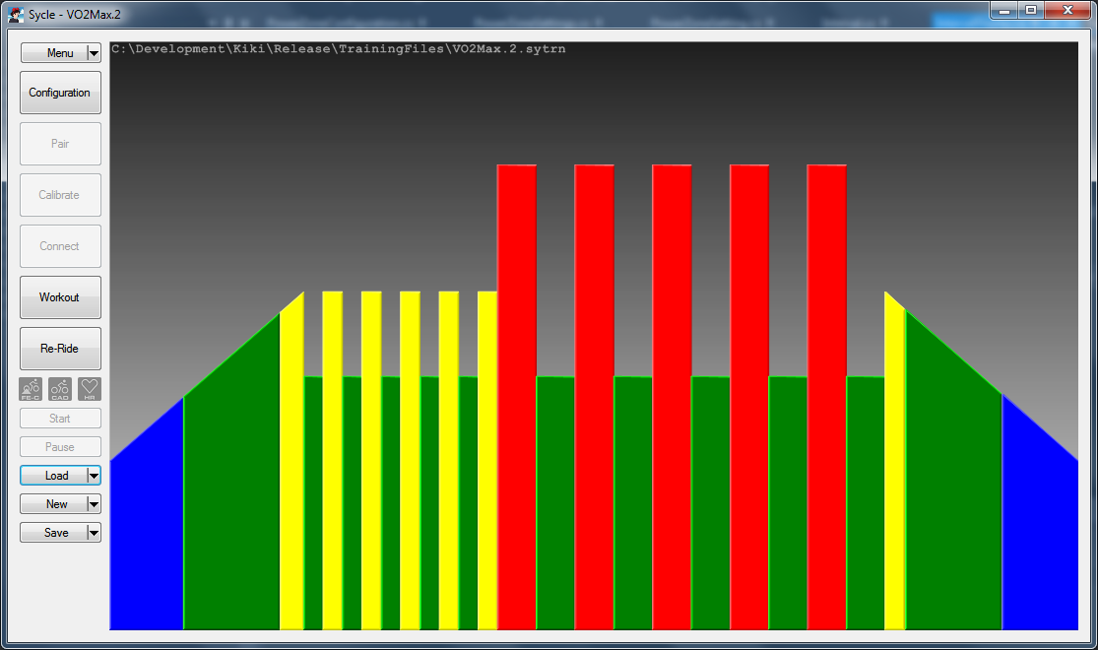

### Heart Rate Based Interval Workout

I had not even considered adding this until a BikeForums.net member asked about it. Start the same way as a power based workout.

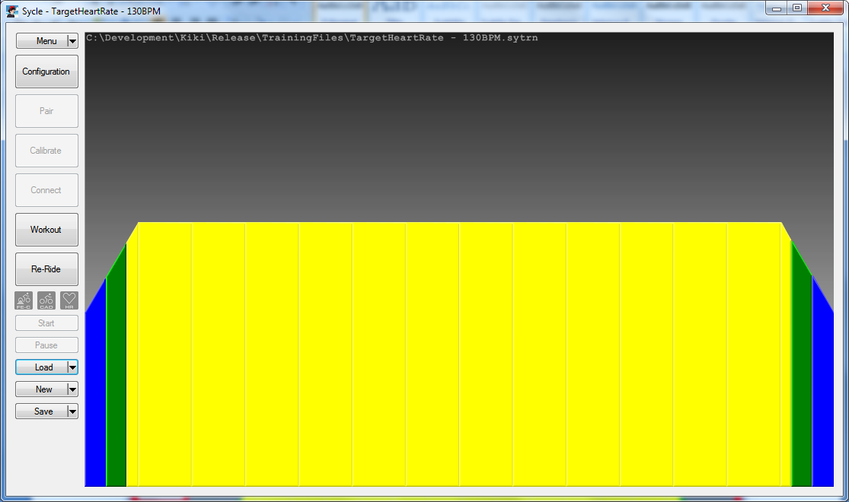

# Re-Ride Grade

Among other things FIT files contain position, distance, and altitude information. Currently I have two sources: rides recorded using CycleMeter on a Samsung phone and rides extracted from Strava and RideWithGPS (§5).

So far these sources contain very poor elevation data. This is the part that gave the most trouble while developing Sycle. As an example, a number of rides I had performed up Geiger Grade (a local ride near me) were downloaded from Strava and compared. For the most part the elevation is similar but there are random spikes of grades exceeding 100%. I’ve ridden this route so many times and I know it really well, I just don’t recall any monster grades like that. I learned quite a bit about what Strava does with data that is uploaded during this head scratching endeavor. I have even opened up rides that had a grade of over 3000%. Try riding up that!

Strava post processes the data that it receives. This should come as no surprise, after all, how are segments to be found if Strava did not sift through the data. What I was not aware of is that Strava may change coordinates and elevations. Strava inspects positional data from a given ride and compares that with data from other similar rides as well as a digital elevation map (DEM). If the file being uploaded was created by a device with a built in barometric altimeter then the elevation is taken as is, not sure about the position data, probably could be modified as well. For most other devices GPS is relied upon strictly for position *and* elevation. Positions may be moved if Strava can clearly tell if positions do not make sense. Regardless, based on these positions and the DEM the elevation reported by the GPS is replaced with the DEM elevation.

There is surely something going on in there that is not working quite right because some grades that I find are a bit steeper that anyone is likely to encounter. Also, I find some rides with positive going grades immediately followed by negative going grades and the cycle repeats for a while. Since I know and love the Geiger Grade hill very well I used these rides as a basis for my data manipulation since I know these crazy grades and patterns are garbage data. Overall the data can be sifted through to produce a decent representation of reality but it is certainly not perfect and likely never will be, at least for those sources that do not originate from a barometric pressure equipped device. Until I see a .FIT file from one of those devices this is the best I will be doing. Right now, Sycle does not inspect the source of elevation data, it assumes the worst.

To give an example of how bad the raw data is here is a screen shot from a tool I wrote to help sort out this mess showing the Geiger Grade route (incidentally, I learned that Greg Lemond used this ride for training way back when). The blue line is the elevation profile, pink the raw grade data, and green is the resulting filtered grade data. This particular ride has a maximum grade of 125.03% and a minimum of -63.47%.

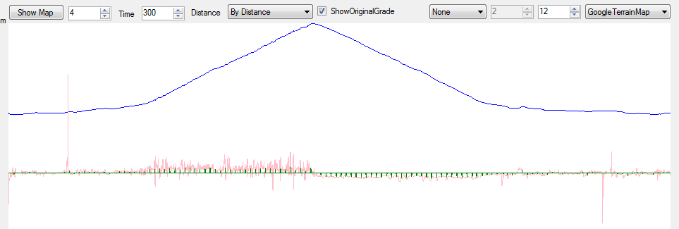

In reality the worst is about 7% up and down. Filtering the data results in a maximum grade of 7.21% and a minimum grade of -7.68%. I tried a few different ways to get here. Below is a zoomed in portion about midway up the hill. The data points are taken every second but the X axis is distance. There are no negative going grades when heading up to what I call the false summit (my typical turn around point on weekdays). Also, there is no herky-jerky grade differences. In reality the ride in this area is a smooth ~5ish % grade. Unfiltered:

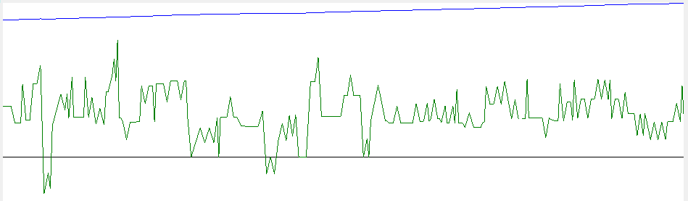

My first attempt was to use a simple moving average against the data resulting in this mess: Better but not much really.

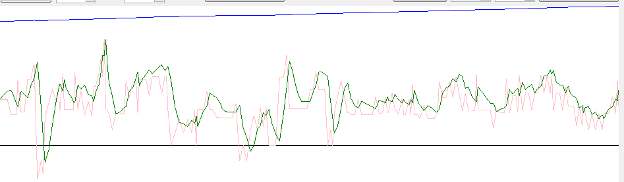

Also I tried to average the grade between fixed time spans. Below is one such example where the time span is 15 seconds: Does not look too bad but not shown here is the maximum grade is 11.47%.

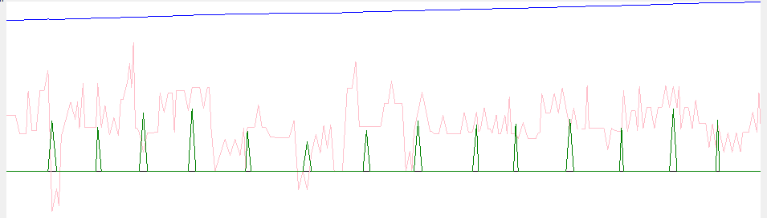

I had noticed some nice patterns and attempted to apply something like a rectification filter (I made this up) only to find out that something similar already existed; a Savitzky-Golay filter. Result below: I liked this because it was really quite smooth in places where I needed it to be. unfortunately it sill resulted in crazy grades: [-18.47%, 29.06]%.

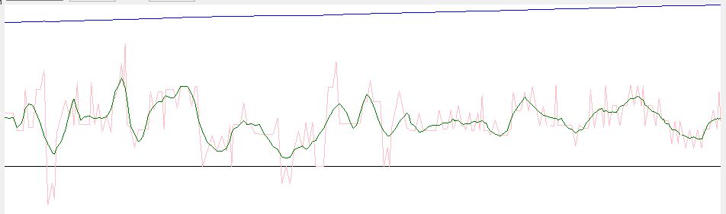

I finally settled on averaging across a fixed distance resulting in the following image. Although it looks similar to the averaging over a fixed time distance it results in a grade span of [-7.68, 7.21] % which is pretty darn close to reality.

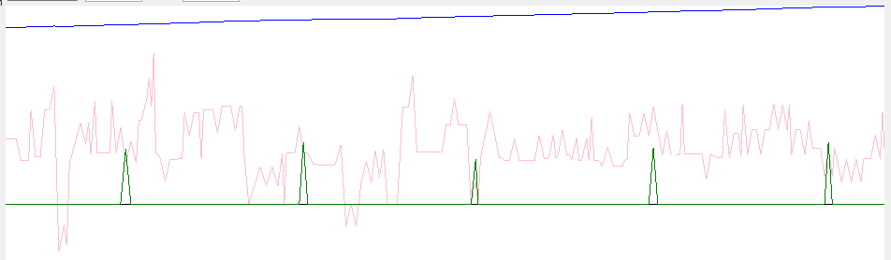

The distance span is 300 meters. Sycle takes this data and divides up each into 3 evenly spaced 100 meter spans and interpolates what the grade between should be. Why? Running the filter again at 100 meters instead of 300 meters results in a grade span of [-9.80, 12.33] % which is just not right. This should explain to those with a keen eye why the gradient in the Korea images (below) is very step-ish and that the height (difference in grade) of each step is the same in groups of three. Anyway, the grade is held throughout each 100 meter span.

I settled on 100 meters partly because when I first rode this at 300 it just felt wrong. Also, my trainer has a noticeable 3 second delay when sending it a new grade or target power level. I had to make sure that the trainer had a chance to put the command into effect before issuing another.

Still, at 100 meters the ride still feels artificial and I am considering reducing the 100 to something that makes better sense depending on the grade and a reasonable amount of time/distance that can be covered in the 3 seconds plus some additional time. As of V1.1.1.0 grades will potentially change every 20 meters. This feels much more natural.

The result of this improved resolution in addition to applying a spline for grade interpolation is a very smooth feel. It is not perfect, but this is much better. The image below shows the new improved grade which is the same ride as the image up above. Note also, the interesting grade peaks.

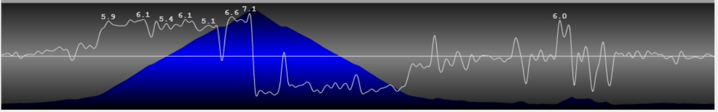

One other thing that is done is that a grade limit of [-20, 20]% is imposed because the trainer I have has that as its limits.

# Getting Fit Files

My source of .FIT files has been to simply down load past rides from my Strava account. You can export the original or a GPX version. The original will be just that, what was uploaded from whatever the source may be. Use the conversion tools to convert from .GPX to .FIT. Some older rides I found have turned out to be .JSON files. I have not bothered with a converter for these but it would be trivial to do.

1. I use RideWithGPS to generate rides in places I have never been to. These .FIT files are probably the worst in terms of elevation and positions possibly be due to the locations chosen but so far I’ve only generated rides in Japan, Korea, and Hawaii and I would have expected these generated routes to have accurate data.
2. Since uploading Sycle for the first time RideWithGPS now wants me to be a paying member to create routes. I know these companies need paying customers to stay in business and I don't have a problem with that but since all I want is to generate routes I won't be using them anymore. I have now found another site that is useful: BikeMap.net. Here I have been able to create a new route and download others that were uploaded by other users. I've pulled and ridden one from just north of Beijing, China. A bit of a tough route because the steepest part was near the end when I was a bit tired. The coordinates from this ride were really off when overlaid on the map.
3. Google maps has the ability to create routes and download as a KML file but there is no elevation data.

Files pulled from Strava have positional data about every one second. This is likely related to the rate at which a given capture data device is configured for. Having a one second interval between data points is really nice because it provides a lot of elevation and positional data to play with, curves are more curvier, elevation data is plentiful.

A one second interval is not the case with files pulled from RideWithGPS, at least not the ones I have generated using their routing facility, and they can't be because the route has not been ridden yet, at least not by me. There can be large positional gaps between data points. From a file size standpoint this makes sense but for the purpose of generating an elevation profile the task at hand is impossible. For example, a path that is a straight line for a hundred meters or more may have only two data points: one at each extreme. Moving at a reasonable speed would result in many data points spaced one second apart and Sycle does this easily using positional interpolation. Unfortunately, what is missing with these interpolated positions is elevation data. Between these two extremes there could be hills and valleys all of which will be missed. It isn’t until the ride is done, uploaded, and then pulled back down that I have been able to look at the corrected elevation data from Strava and compare. An example of a ride that was done in Korea: the top image is the elevation profile directly from the RideWithGPS file. The next image shows a corrected profile from Strava after having been corrected against the DEM. The summit of the highest peak is ~50 meters less in the corrected data set than with the raw data set. The greatest grade with the raw data set is about 9.41% whereas with the corrected data set it is ~8.08%. Not too great a difference but it adds up.

