Assigned: 2013-08-29
Due: 2013-09-05

Turn-In: Store your .html pages, any images or other assets in a sub-folder (“./content/”), zip everything and submit it via Blackboard.

Work on this by yourself. To complete this assignment, you will need to use the HTML tags we've talked about during class, which may include:
- required tags (doctype, <html>, <head>, <title>, <body>)
- headers (<h1>, <h2>, etc.)
- images (<img src=”...” />)
- links (<a href=”...” title=”...” />)
- paragraphs and line-breaks (<p>, <br/>)
- emphasis tags (<em>, <strong>)
- list tags (<ul>, <ol>, <li>)
- tables (<table>, <thead>, <tbody>, <tr>, <th>, <td>)
- form elements (<form>, <input>, <label>, <textarea>, <select>, <option>)
- page sectioning (<div>, <span>)
- html5 tags (<audio>, <video>)
And you need to understand the concept of tag attributes.

Note: While you should only use assets that you own IP to or are public domain/creative-commons licensed and what you have explicit permission to use, feel free to use random images from around the internet. This is a private assignment, I'm not submitting it online, so you don't need to own the rights to any content you use.

Specification
You will be creating several pages that link together with the anchor tags. Don't worry about styling since we are not yet using CSS.
You will be making a 1990s-styled band webpage. This will include the homepage, albums page, photo gallery, concert info, and a buying page.
Use a real band or make one up, feel free to take images. If you want to use some audio clips, you can get some free music here: http://incompetech.com/music/royalty-free/collections.php

For all pages:
- Include a <h1> tag with the page's name. This should be unique to this page.
- Remember to add a title attribute for your images and links
- Indent properly! Make sure your markup is easy to read!
- Split up sections of the page within divs and wrap special text within span.

index.html
This is the landing page when you first get to the band's site. Include a picture of the band, and include an unordered list that contains links to the other pages
Also include a brief description of the band within paragraph tags.

Sample:
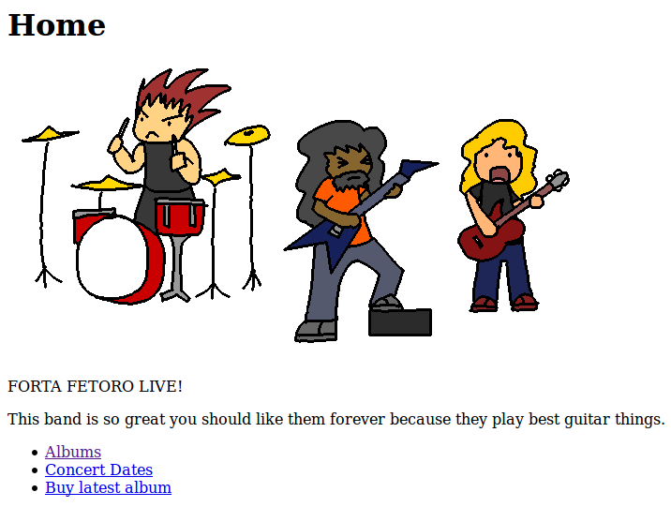

albums.html
The albums page will contain information on several albums. Include some images to be album covers (resize in a photo editor since we're not using CSS – make these images around 200x200 pixels).
Create a div with the class “album-container”, and for each album create another div with the class “album”.
Include information about the album: Album title, year, cover image. You can use an audio tag to embed an audio player on the page if you would like.

Sample:
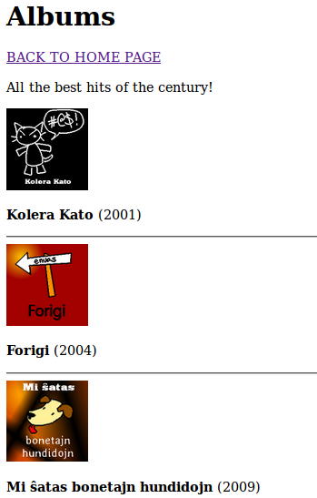

concerts.html
Here you will display concert dates within a table. Make sure to use thead and tbody where appropriate.
If you want to add borders to the table, put this CSS in the header (this is optional):
<style type="text/css">
table tr td { border: solid 1px #aaaaaa; padding: 5px; }
</style>

Sample:
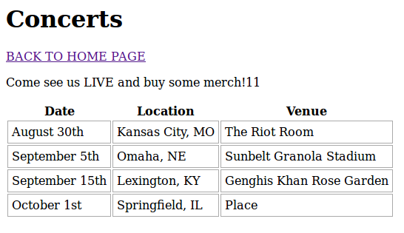

buy.html
This page will have a form for the user to buy the latest band album. Nothing will actually happen when the submit button is clicked, just build the form.
Remember to enclose all the form elements within the <form> tag. Set the form's method attribute to get.

The form should contain:
Element | Element type | Element attributes
Paypal username | Input type text | id="paypal-name"  name="paypal-name"
Paypal password | Input type password | id="paypal-pass"  name="paypal-pass"
State select | select with options | Select  name="state"  id="state"  Option 1  value="kansas"  Option 2  value="missouri"
Album radio buttons | Input type radio | name="album"  id="album-one"  value="one"  Change “one” to album name for each item.  Notice that the name attribute stays the same.
T-Shirt Checkbox | Input type checkbox | type="checkbox"  name="include-tshirt"  id="include-tshirt"  value="true"
Submit button | Input type submit | value="Submit"  name="submit-buy"  id="submit-buy"
Special order instructions | Textarea | name="special"  id="special"

Remember to add label elements and link them to input/button elements. The label's for attribute must match the input item's id attribute.
Hint: since we're using the get method in the form, if you click submit you should see the URL change to include the key-value pairs!

Sample:
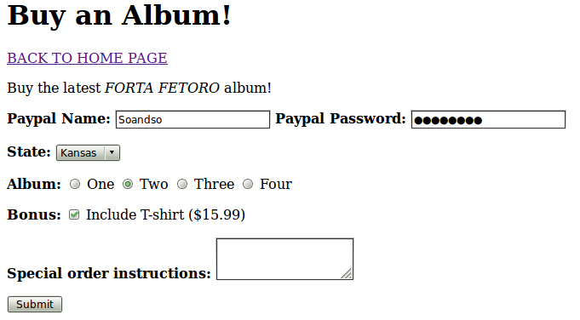

Grading rubric (10 points total)
Pages
0 | 1 | 2
No pages turned in | Some pages missing | All pages submitted

Markup quality
1 | 2 | 3
Base elements available, maybe incorrectly.  Required tags may be missing. | Base elements available, few or no divs/spans utilized.  Required tags present. | Proper use of divs and spans, labels, form elements, nesting tags.  Required tags present.

Tag types
1 | 2 | 3
Pages mostly do not follow directions of the specification. | Not all tag types specified were used. | All tag types requested were used.

Attributes
0 | 1 | 2
No attributes used, or attributes mostly used incorrectly. | Some attributes not utilized properly, or some are missing. | Attributes utilized properly.

