Assigned: 2013-09-05
Due: 2013-09-12

Turn-In: Store your .html pages, any images, css files, etc. in a directory (you can have sub-directories within that directory if you'd like). Zip the entire directory and turn-in via Blackboard.

If anything is unclear, please email me as soon as possible!

CSS Concepts:
- floats, clearfix
- positions and dimensions
- display
- margins and padding
- pseudoclasses
- overriding styles
- colors, backgrounds
- font families
- italics, bold, and underline for text
- list style

Tips
Remember, to add CSS within the <head>...</head> tags in a single page, use:
<link rel="stylesheet" type="text/css" href="path/file.css">

And to link to an external CSS file from within <head>...</head>, use:
<style type="text/css">
</style>

Make sure your document is XHTML-Compliant! This means required tags and formatting:
http://www.w3schools.com/html/html_xhtml.asp

Store each exercise in a separate document. If you use one .css file for all of them, make sure to leave comments on which set of styles goes with which exercise. Remember that comments use /* … */

Work Incrementally! Don't try to implement everything all at once, this makes debugging harder. Get small chunks done before moving on!

Exercise 1: Backgrounds, Fonts, and Colors
Note: It would be useful to look up a website with a list of hex values for colors, open Photoshop/GIMP, etc.

In a paint program, create a logo around 200x200 px in dimension. Save it in the assignment folder.
Your page will end up looking something like this:
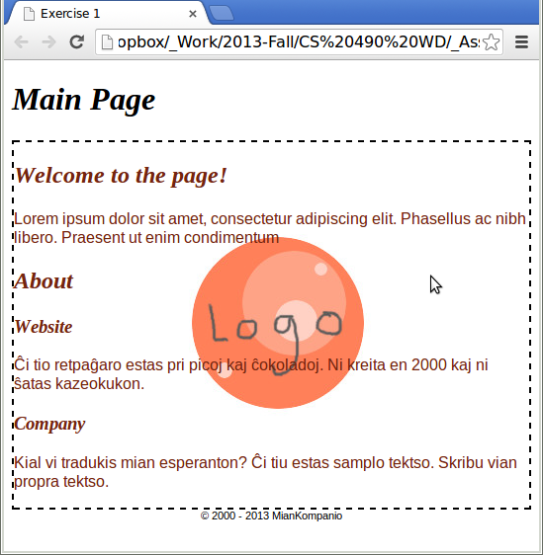
Except you'll create your own logo and fill out your own text. Use an online Lorem Ipsum program if you would like.

Markup
For your HTML Markup, you should have:
- A <header> section.
  - This contains an <h1> tag, which I have specified as “Main Page” in the example.
- A <div> with the class “main-content”. Within main-content you should have:
  - <h2> section called “Welcome”:
    - A paragraph with the Welcome message (can be lorem ipsum)
  - <h2> section called “About”:
    - An <h3> section called “Website”:
      - A paragraph about the website (can be lorem ipsum)
    - An <h3> section called “Company”:
      - A paragraph about the company (can be lorem ipsum)
- A <footer> section.
  - This contains the copyright symbol, year, and company name. To create the copyright symbol, use &copy; in your markup.

Styling:
You should apply the following rules in CSS:
- body element
  - Set the font family to “arial”
- h1, h2, h3 elements
  - Set the font family to serif
  - Set the font style to italic
- main-content class
  - Set the background to your logo. Make sure it's positioned in the center, both horizontally and vertically, and does not repeat.
  - Set the font color to #75250d;
  - Set the border to be dashed, 2 pixels thick, and the color black (#000000).
- footer element
  - Set the font size to 11 px.
  - Set the text alignment to center.

Exercise 2: Horizontal Navbar with a List
For this exercise, we will use floats to turn the contents of a list into a navigation bar.
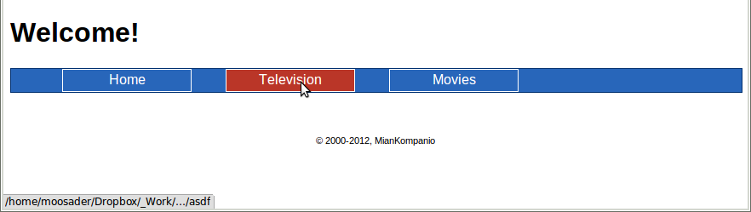

Markup:
- Create a <header> tag:
  - It should contain an <h1> with “Welcome!”
- Create a <nav> tag:
  - It should contain an unordered list <ul>. This ul should contain the class “cf”
    - List item 1 contains a link to “Home”
    - List item 2 contains a link to “Television”
    - List item 3 contains a link to “Movies”
    - Your links don't need to point anywhere
- Create a <footer> tag:
  - &copy; 2000-2012, CompanyName

Styling:
Implement these rules:
- For the body, set the font family to “arial”.
- For the nav:
  - Set the border to solid, 1 px thick, and the color #002f6f.
  - Set the background to #2866ba
  - Set the width to 100%
- For the anchor tag within nav, AND for the anchor tag with the pseudoclass active within nav
(i.e., nav a, nav a:active):
  - Set the color to #ffffff
  - Set text decoration to none
- For the unordered list within nav:
  - Set the margin to 0
- For the list item within nav:
  - Set the list style type to none
  - Set float to left
  - Set the margin to 0 20px (0 vertical, 20px horizontal)
  - Set the display to block
  - Set the border to solid, 1px thick, #ffffff
  - Set the height to 25 px
  - Set the width to 150 px
  - Set the text alignment to center
  - Set the line height to 25 px
- For the list item with the pseudoclass hover within nav:
  - Set the background to #ba3628
- For the footer:
  - Set the font size to 11px
  - Set the text alignment to center
  - Set the margin-top to 50px
- Look up “clearfix” in google and copy over the cf class code. (or copy it here):
Clearfix CSS:
.cf:before,
.cf:after {
content: " ";
display: table;
}

.cf:after {
clear: both;
}

Exercise 3: Layout
Layouts can be tricky in CSS, so it's important to practice.
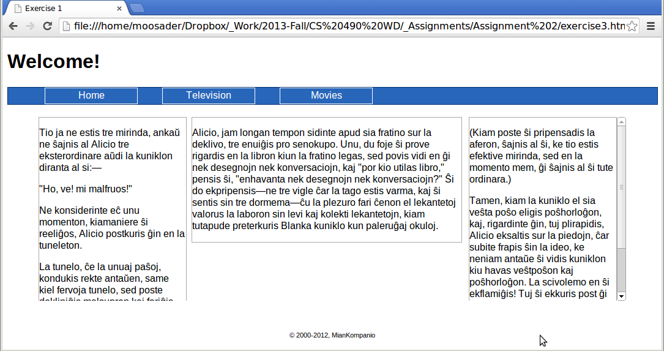
Make a copy of your Exercise2 file and name it Exercise3.html. We want to re-use the navbar.

Note that, even though we're using position here, implementing a multi-column layout would be better with floats. With the absolute positioning, things may get wonky upon resizing.

Markup:
Underneath the closing </nav> tag and above the <footer> tag, add:
- A <div> with the class “main-content-wrapper”. Within this div, create:
  - A <div> with the class “column-1”. Within this div add lorem ipsum text in a paragraph.
  - A <div> with the class “column-2”. Within this div add lorem ipsum text in a paragraph.
  - A <div> with the class “column-3”. Within this div add lorem ipsum text in a paragraph.

Styling:
Keep the old styling from the last exercise. Add on:
- The main-content-wrapper class:
  - Width is 960 px
  - Margin is 20px auto (20 px vertically, automatic margins horizontally)
  - Height is 300 px
  - Overflow-y is auto
  - Position is Relative
- A common style between classes column-1, column-2, and column-3 (list them out and separate by commands to give one common style)
  - Border is solid, 1 px thick, and the color #aaaaaa.
  - Position is absolute
- Style for only class named column-1:
  - Left is 0px
  - Top is 0px
  - Width is 240px
- Style for only class named column-2:
  - Left is 250px
  - Top is 0px
  - Width is 440px
- Style for only class named column-3:
  - Right is 0px
  - top is 0px
  - Width is 240px

Hint: There will be styles for the columns specified both as shared rules and individual rules. For example, for the shared rules you will write:
.main-content-wrapper .column-1,
.main-content-wrapper .column-2,
.main-content-wrapper .column-3
{
/* Styles go here */
}

But for the individual styles, you will write them normally.

