Instructions
To get credit for this extra credit assignment, you must work with one other person doing pair programming. The person you pair up with does not need to be in your semester project group.
- Group size of exactly 2

This set of extra credit assignments will be over topics covered on the midterm, such as XHTML, CSS, and PHP.
- HTML, CSS, and PHP

Zip any and all files for this project and submit it via Blackboard before the due date. Make sure to include both peoples' names.

Description
Create a webpage that lists out book information. You will hard-code book information in an array in PHP, and then display them on the webpage. The page will also require proper XHTML and some CSS styling, as listed in the requirements.

Requirements

XHTML
- Use proper XHTML
- Have appropriate divs and sections to enable styling of certain elements
- There should be an h1 tag with the page's title (“Library Listing”).
- There should be a table with the appropriate inner tags for the header and main body. Columns are:
  - ISBN
  - Title
  - Author
  - Publish Year

CSS
- The body element's background must have a background image. It can repeat or not repeat as you desire.
- There should be a section or div that holds all of the page's content (h1 tag, information about books, etc.). This section should have:
  - A border around every side
  - A solid background color
  - It should be 960 pixels wide.
  - It should be positioned in the center of the webpage.
- For the table:
  - All of the row headers should have centered text.
  - The publisher year column should have centered text.

PHP
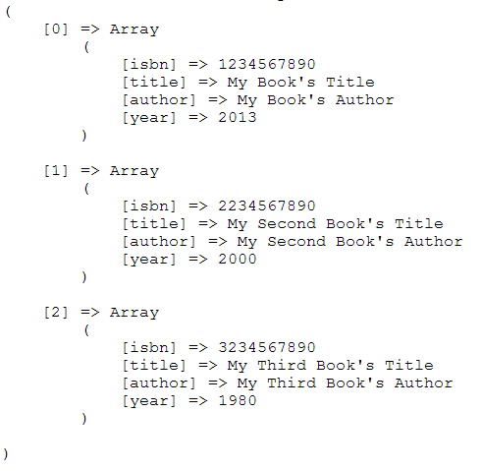
- In the PHP code, create an array variable. This array contains four more arrays, in the following layout:
- You should use a for-each loop to display all of this data in a table.

Screenshot Sample
