Assigned: 2013-09-20
Due: 2013-10-01 (Tuesday)

Turn In
You can test your PHP files on the inclass server space, but to turn in your work you just need to zip up all project files (.php5, .css, etc.) and submit them via Blackboard.

Tip: If FileZilla asks whether to reopen or discard a file...

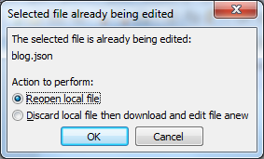 | Click on Discard local file then download and edit file anew. If you try to Reopen, you might not see your changes appear!

Tip: Check the sample code from the class webpage if you get stuck on loading/saving files.

PHP Concepts
- Including other PHP files
- JSON File reading/writing
- Pulling data out of a form

Description
For this assignment we are going to write a simple blog, with a control panel and a main view. From the control panel, the author can enter a title, date, and the blog post. Blog posts are stored in a .json file which will be read in each time.

Files
For this assignment, we are going to have three main php files. You can add a CSS file if you would like, I have no requirements for styling.
Make sure your XHTML is valid.

File | Description
Control-panel.php5 | Webpage, contains new blog post form
Blog.php5 | Webpage, contains read-only view of all blog posts
Model.php5 | Not a webpage: Just a script file. Contains functionality for reading and writing the .json blog post.

Building the Blog

The Control Panel
Start by building the XHTML for the control panel. Minimum required XHTML is as follows:

<!DOCTYPE html>
<html>
<head>
<title>Blog Control Panel</title>
</head>

<body>
</body>
</html>

Within the blog, we are going to have two main sections: A list of posts that have already been posted, and a form where the user will enter the new post information.

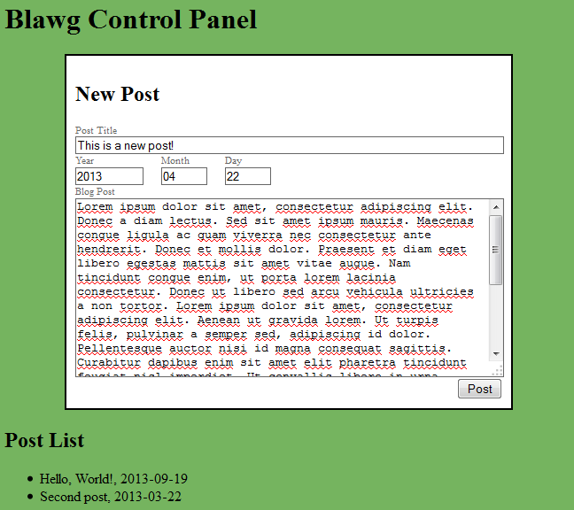

You can style each page however you would like.

Create only one form element, and make sure to set its method attribute to post.

Then, create the following form elements:
Element Type | Element Name | Element ID | Description
Input type text | post[title] | post-title | Will store the title of the post
Label for post-title
Input type number | post[date] | post-year | Stores the year for the post's timestamp
Label for post-year
Input type number | post[date] | post-month | Stores the month for the post's timestamp
Label for post-month
Input type number | post[date] | post-day | Stores the day for the post's timestamp
Label for post-day
Text area | post[content] | post-content | The actual blog post text
Label for post-content
Input type submit | new-post |  | The submit button

For the Post List section of the page, create an unordered list, but don't add any list elements yet. We will come back to this later.

Once the form and post list are set up, make sure to add

<? include_once( "model.php5" ); ?>

to the top of your file (after the DOCTYPE tag)

Make sure to upload your file to the server!

The Model
The model.php5 file is a script file, containing back-end functionality for handling blog posts. It will be shared by both the control-panel and the blog pages. Keeping functionality separate from the markup is usually a good idea, just like keeping your .css styles and .js scripts outside of the XHTML markup.

Within the Model, first create two variables: A variable named blogPath which is set to “blog.json”, and a variable named blogPosts, which is a new array.

Then, create two comments in your page so we can keep things sectioned off:

<?
$blogPath = "blog.json";
$blogPosts = array();

/* Load Posts */

/* Save Posts */
?>

On both pages, we will always load the existing posts, if there are any. On the control panel, it will just display a simple list of previous posts (we are not adding edit functionality). On the blog page, it will display all blog posts on one page. The blog posts will be loaded out of blog.json and the json_decode function will be used to turn it from a JSON string to a PHP array.

For the save functionality, first it will check to see if the new-post submit button has been hit. From there, it will push the new blog post on to the array of blog posts, and then encode the array to json and save to the blog.json file.

Since there are no posts to load in right now, let's start with saving the post. Note that our form element on the control panel is set to method=”post”. In PHP, we will use the $_POST array to look at the values entered into the form.

Let's start by looking at how this array is build. Add this code after our Save Posts comment:

/* Save post on form submit */
?>
<pre>
<? print_r( $_POST ); ?>
</pre>
<?

Notice that we can end a PHP script at any time (with the closing ?>), add in XHTML, and then re-open the PHP script to call a function.

Now, upload the model.php5 to the server. Refresh the control-panel.php5 page, enter information into the various input fields, and then click Submit. You should see an array pop up after the refresh, which looks somewhat like this:

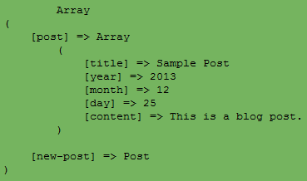

Our $_POST array contains an element named “post”. Post itself is also an array, which contains “title”, “year”, “month”, “day”, and “content”.

There is also a second element within $_POST named “new-post”. This is the submit button we clicked.

Now, remember that our input boxes had names like this:
post[day], post[title], post[content]

By adding the square brackets and text inside, we're telling PHP that all these fields belong to the post array, and the value within the square brackets are the specific element within post that we're storing.

Now we know what is being posted to the server, but we need to actually do something with this information...

First, we need to check for the new-post flag. We can use PHP's isset function to do so. The isset function returns true or false, based on whether the variable passed in exists or not.
We can check
if ( isset( $_POST["new-post"] ) )
{
}

And, if the new-post button hadn't been pressed, this would return false. Otherwise, we know the new-post submit button was clicked and we should then save our blog post.

Saving our Blog Posts
The first time around, we won't have any blog.json file and no blog posts to pre-load; it's a blank slate. We can use the array in $_POST and encode it to JSON to store it in the file. However, we will have to come back to this later in order to account for pre-existing posts that we don't want to remove each time.

Within the if ( isset( $_POST["new-post"] ) ) if block, we will do the following:
- Convert the array to json and store it in a variable. (json_encode function)
- Open a file to write to (fopen function).
Store this as $fileWrite. This is the same sort of thing as $fileHandler in the sample code.
We're using “fileWrite” here because we will also have a “fileRead”.
- Write the json variable to the file (fwrite function)
- Close the file (fclose function)
* Remember that we created $blogPath and $blogPosts variables at the top of this file! We're not using $blogPosts yet, but you will store the current post at the $blogPath.

Upload all of the changed files to the server via your FTP client. Then, go back to control-panel.php5 in your web browser, fill out the post information, and click Submit.
If you don't get any error messages, go back to the FTP client and refresh (F5). See if blog.json was created.
[{"title":"Hello, World!","year":"2013","month":"12","day":"25","content":"This is a sample blog post."}]
Sample blog.json file

Loading existing blog posts
Now that we have one post saved, let's write the logic to load existing posts. Once this is written, it will work whether there is 1 post or 100, since it will store them in an array.

Back in model.php5, under the Load Posts comment, we will first need to check to see if blog.json exists. If it does not, we will get errors when trying to load it for a read. (If the file doesn't exist, we don't need to load existing blog posts, anyway!)

You can check to see if a file at some path exists with the file_exists function. This will return true or false.
if ( file_exists( $blogPath ) )
{
}

Now do the following:
- Load the file into a $fileRead variable using fopen.
- Remember that we already declared a $blogPosts array at the top of the file. Use json_decode to store the contents of the $fileRead to this array.
Make sure to convert the JSON to an associative array by setting the second argument in the json_decode function to true.
- Close the $fileRead file

Now, any existing blog posts should be stored in $blogPosts.
Add this to your model.php5 file after the if block:
?>
<pre>
<? print_r( $blogPosts ); ?>
</pre>
<?

Upload all changes to the server, then open the control-panel.php5. You should see an array similar to last time, except this array was loaded from a file, not posted from the form.

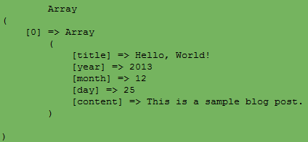

Notice how the first element is [0]. Any additional blog posts will be [1], [2], etc. We can use a for-each loop to iterate through all posts on the blog page now!

The Blog Page
Before we continue adding functionality to the control panel, let's go ahead and load our blog post into the blog page.
Remember to start of with the XHTML base, plus the include_once for our model:
<!DOCTYPE html>
<? include_once( "model.php5" ); ?>
<html>
<head>
<title>Blog</title>
</head>

<body>
</body>
</html>

By including model.php5, the blog post loaded above (shown in the control panel) will automatically also be loaded on this blog page.
You can style this how you would like later, but for now, create a foreach loop within the <body> tags:

<body>

<h1>My Blog</h1>

<?
foreach( $blogPosts as $post )
{
}
?>

</body>

Remember that PHP's foreach loop is in the opposite order from Python's. Python has
for single-item in array
and PHP has
foreach array as single-item

Output each element of the $post element: title, content, year, month, and day.
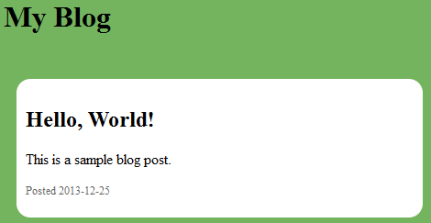

Now, let's finish up by making sure we append new blog posts to the blog.json file, rather than overwriting it every time.

Saving, revisited.
Back in model.php5, we are going to modify the save section.
Now that we have the file loading working, all existing blog posts will already be loaded in every time a web page is loaded. We're half way there.
Now, we just need to make sure that we append any new blog posts to the end before saving the file.

Add this step to the beginning:
- Remember that we have existing posts in the $blogPosts variable. We want to store the $_POST[“post”] data at the end of this array. Use the array_push function to push the new post onto the array of existing posts.

Our posts are in the form of an array. Now we can continue as before by converting the array to json (json_encode), opening a file to write to, and overwriting the existing blog.json.
Note that by overwriting blog.json, we're still maintaining the old posts because the old posts were part of the $blogPosts array that was loaded earlier in the model file.

Screenshots

Control Panel with two existing posts:
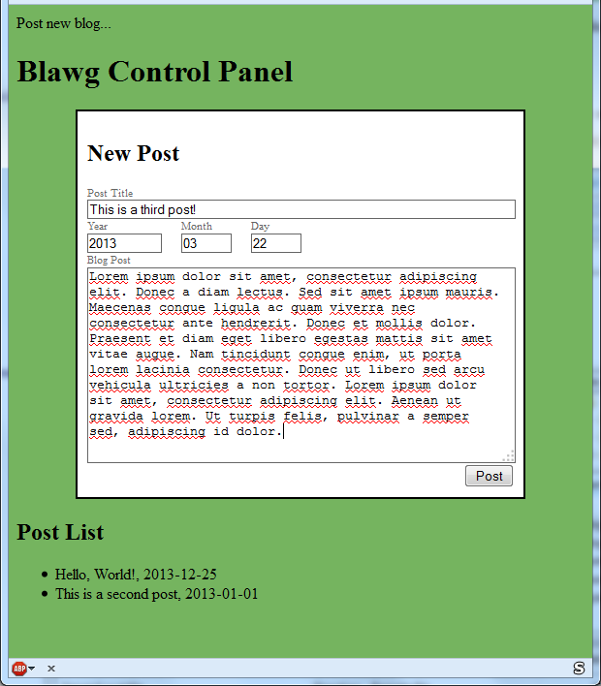

Blog page with multiple posts:
