**SE 251 – JavaScript**

Assignment week 3

Due: Monday, August 7 before class

Create a web page that displays the result of some random gameReviews. Upon clicking any of the links, the image for the game is displayed to the right of the table.

See the below for an example.

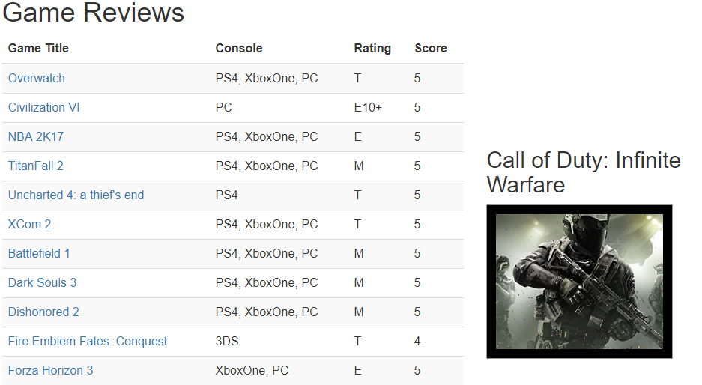

Download gameReview.zip from Canvas. This zip file contains all of the images along with the document gameReview.html. Note that gameReview.html contains some JSON that is parsed into an array of objects called reviews.

After the document is loaded, you do the following:

* Loop through the reviews array, and create a string that contains the tr and td tags for all of the games in the reviews array. Create each of the links with a class review and a property data-img and set this property to the correct image.
* Set the innerHTML property of the reviewsBody to this string that you generated.
* Use document.getElementsByClassName to get a reference to an array of all of the links
* Loop through this links array and add an event listener called selectReview for each of the links using addEventListener.
* Within the function selectReview do the following:
  + Set the src property of the image gameImage to "images/" + this.dataset.img;
  + Set the innerText property of the gameTitle to this.text