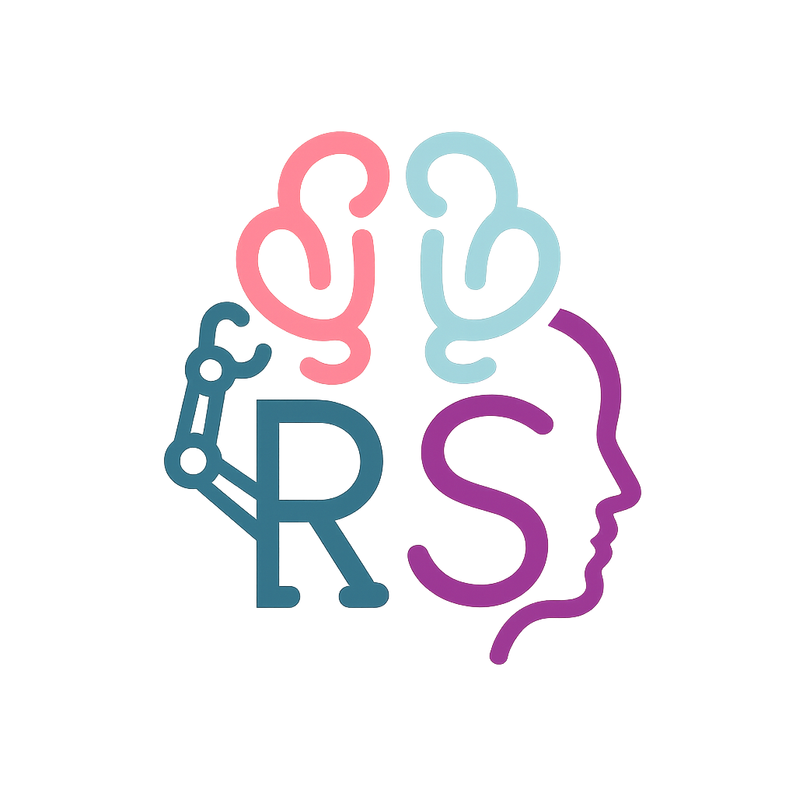
Robert (Rob) J. Spenceley

Spenceley@wisc.edu | (720) 388-0242 | My Website | Google Scholar

RESEARCH INTERESTS

My research interests revolve around how humans interact with robots and other forms of embodied automation. As robots and automation become more sophisticated, the next step towards implementation is understanding operator states (cognitive and physical) and how to adapt agent behavior appropriately using physiological data.

Keywords: Human-Robot Interactions, Human-Automation Teaming, Neuroergonomics¹, Embodied Automation.

EDUCATION
University of Wisconsin – Madison (UW-Madison) Jan. 2025 – Present
Doctor of Philosophy – Industrial and Systems Engineering
Advisor: Dr. Ranjana K. Mehta
Expected Graduation Date – Fall 2029

Colorado State University – Fort Collins (CSU) Aug. 2021 – Dec. 2024
Bachelor of Science in Psychology
Major: Psychology (Concentration: Mind, Brain, & Behavior²)
Minor: Business Administration

RESEARCH EXPERIENCE

Graduate Research Assistant – Neuroergonomics Lab Jan. 2025 – Present
Department of Engineering – Industrial and Systems Engineering
University of Wisconsin-Madison
Principal Investigator: Dr. Ranjana Mehta

Project: Physical Human-Robot Interaction
- Conducted experiments using a breadth of bioinstrumentation (EEG, fNIRS, eye-tracking, AMTI Force Plate EMG, & ECG) and a UR10e robotic arm.
- Using methods such as Lab Streaming Layer, Python, & MATLAB to streamline data collection.
- Data analysis on the previously listed methodologies.

Project: Trust in Multi-Human Robot Teams
- Analysis of EEG data using power spectrum density and hyperscanning analyses, collected from a virtual reality disaster robotics experiment.
- MATLAB, EEGLAB, & ERPLAB

National Science Foundation (NSF) Research Traineeship (NRT) Trainee Jan. 2025 – Present
Department of Computer Science - Integrating Robotics into the Future of Work (INTEGRATE)
University of Wisconsin-Madison
Principal Investigator: Dr. Bilge Mutlu

Project: Comfort Survey
- Development of a survey to quantify human comfort when working with robots in occupational settings.
- Leading a team of RAs to develop virtual reality experiments.
- Data collection & analysis of survey data using methods like exploratory factor analysis, confirmatory factor analysis, and the Delphi Method.

Lab Manager – Davalos Lab Jul. 2023 – Dec. 2024
Department of Psychology – Cognitive Neuroscience
Colorado State University

Project: Neural Correlates of Prospective Memory
- Training new undergraduate research assistants/graduate students in EEG, overseeing the creation of data collection schedules, ensuring the proper maintenance of lab equipment, & assisting with other undergraduate projects using the lab’s data.
- I have conducted over 300 hours of EEG data collection, building on my prior experience as a research assistant.

Lab Manager – Wickens Lab Aug. 2024 – Dec. 2024
Department of Psychology – Cognitive Psychology
Colorado State University

Projects: FIPRED, Augmented reality cueing in visual search, germane load.
- Overseeing data collection schedules and maintaining clear communication with participants throughout the study process.
- Data collection with graduate students’ (Dr. Amelia Warden) studies and a project I developed, FIPRED.
- I have collected over 150 hours of data using the HoloLens 2, Meta Quest 3, and wide-angle displays.

PUBLICATIONS
Spenceley, R. J., & Mehta, R. K. (2026). When robots reshape teams: Neurodynamic insights into taskwork and teamwork in search and rescue. Frontiers in Neuroergonomics, 7. https://doi.org/10.3389/fnrgo.2026.1771753
Spenceley, R., Wickens, C., & De Toledo Piza., B. (2025) FIPRED: A study of predictive automated displays for wildfire fighting management. Sage Journals In Proceedings of the Human Factors and Ergonomics Society Annual Meeting (p.1-7 ). Sage CA: Los Angeles, CA: SAGE Publications.
Wickens, C., & Spenceley R. (In Press). The trajectory prediction challenge (TPC): An application of cognitive engineering. In Khalid, H. M. (Eds.), Helander’s compendium of human factors and ergonomics.

PRESENTATIONS

Spenceley, R., Rice, M., & Davalos, D. (2024). Components of executive functioning involved in prospective memory. Rocky Mountain Psychology Association Conference, Denver, Colorado. - Poster
Spenceley, R., Wickens, C., & De Toledo Piza, B. (2025). FIPRED: A study of predictive automated displays for wildfire fighting management. Human Factors and Ergonomics Society – ASPIRE, Chicago, Illinois. - Poster
Spenceley, R., Yadav, A., & Mehta, R. (2025). EEG theta power varies across roles in mixed human-robot teams. Human Factors and Ergonomics Society – ASPIRE, Chicago, Illinois. - Poster

EXTRA CIRICULARS

Human Factors & Ergonomics Society – UW-Madison Chapter Fall 2025 – Fall 2026
Vice President of Events

TEACHING EXPERIENCE

Instructor
PSY 292C – Controversial Issues in Psychology Fall 2024

Responsibilities: In my role as an instructor, I created a welcoming environment where students felt comfortable sharing their opinions on challenging topics. My focus during this course was for students to develop a framework that would allow them to dissect difficult psychological topics, debunk common myths, and become masters of APA format. I was also responsible for facilitating class discussions, creating and grading assignments, and adjusting course materials the interests of my 10 students.

Teaching Assistant
PSY 252 – Mind, Brain, & Behavior Spring & Summer 2022, Summer 2024

Responsibilities: In my role as a teaching assistant, I conducted comprehensive exam reviews to clarify concepts important to the course, and that would be important for later psychology courses, integrating knowledge from upper-division psychology courses and lab experience. Additionally, I was tasked with efficiently grading assignments and tests while providing constructive feedback to support student growth and regularly attending class to build strong relationships with courses of roughly 100 students.

Teaching Assistant
PSY 250 – Research Design & Analysis I Fall 2022

Responsibilities: In my role as a teaching assistant, I reviewed and graded approximately 100 student papers with a specific focus on APA formatting, evaluated extra-credit assignments to determine where additional instruction was needed, demonstrated to students how to locate high-quality academic sources, and collaborated with graduate teaching assistants to coordinate teaching strategies.

HONORS & AWARDS
College of Natural Science Dean’s List - CSU 2022, 2023, & 2024
Chancellor’s Opportunity Award - UW-Madison 2024

RELEVANT SKILLS
Research Techniques: EEG/fNIRS cap placement/fitting (10-20), EMG, ECG, human motion tracking (XSENSE), eye-tracking (Tobii), HoloLens 2, & Meta Quest 3.
Software: R, MATLAB (EEGLAB/ERPLAB), BrainVision, Homer3, Aurora, Noraxon, Tobii, Lab Streaming Layer (LSL), Curry7, PsychoPy, Python, Qualtrics, Claude, ChatGPT, & Gemini.
Certifications: Behavioral/social CITI Training, & Delta Program Mentorship Certificate.

MEMBERSHIPS
Human Factors and Ergonomics Society (HFES) – Student Affiliate 2025 – Present
Human AI Teaming (HART) Technical Group (HFES) 2026 – Present

APPENDIX
- Neuroergonomics, as defined by Parasuraman (2003), is the study of the human brain in relation to performance at work and everyday settings.
- The Mind, Brain, and Behavior concentration at CSU is a research-oriented program, focused on preparing students to enter cognitive/behavioral neuroscience, cognitive psychology, and sensation & perception focused fields.

