Reader Study Instructions

1. Unlock the Lab 1

Hudson Annex, RM 256 1

Code: 3152 + Enter 1

2. Power on the Computer 2

3. Unlock the Computer 2

Username: KRNLAB 2

Code: ThisIs4TheProstateStudy 2

4. Double Click the Reader Study Application 2

5. Click on Your Name or Add Yourself as a New Reader 3

6. Reader Training 3

I. Open the Slicer Scene for the Training Case 3

II. Open the Training File 3

7. Review the Slicer Scene 4

8. Identify all Lesions of Suspicion 4

9. Select up to the 4 Most Suspicious Lesions 5

10. Indicate on the Case Interface How Many Targets You Would Biopsy 5

11. Complete the ARFI Core Information for Your Most Suspicious Lesions 6

12. Submit the Case 7

13. Review Segmentations in Case 7

14. Close and Save Slicer Scene to Your Directory 8

15. Close the Slicer Scene and Progress to Next Case 9

## Unlock the Lab

### Hudson Annex, RM 256

### Code: 3152 + Enter

You may access the lab at any time. The lab door may be closed early in the morning or off work hours. In order to unlock the door, press **3152 + Enter** to access the lab.

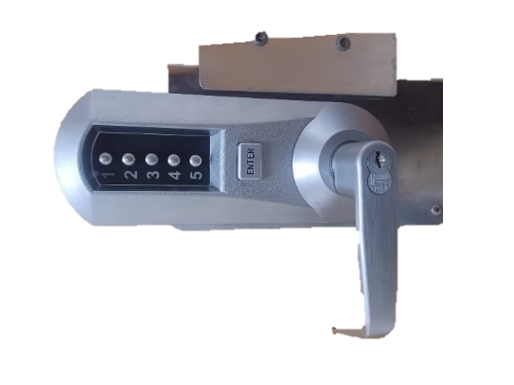

**1. 3152 + Enter**

## Power on the Computer

The computer may be off. There is a power button on the lower right side of the screen.

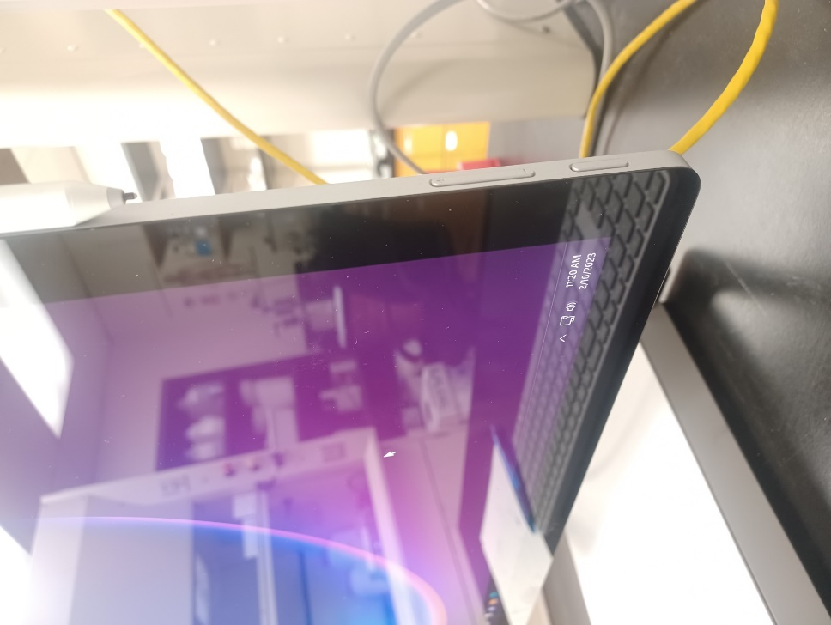

**2. Power Button**

## Unlock the Computer

### Username: KRNLAB

### Code: ThisIs4TheProstateStudy

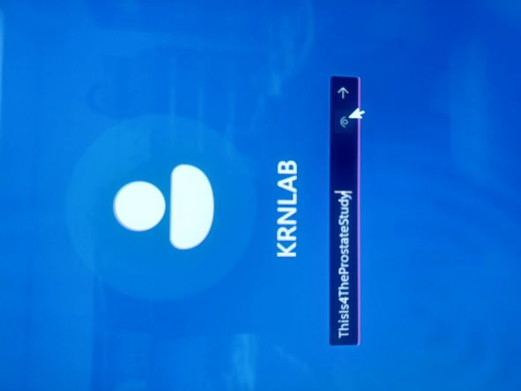

## Double Click the Reader Study Application

In the center of the desktop is the ARFI Reader Study application. Double click the icon to open the reader study. **DO THIS ONCE** and wait. A command window will open that will automatically update the application. This may take some time depending on what updates we apply to the study. I will email you regarding any important updates for you to be aware of.

*If 2+ command windows open, close both and restart the application.*

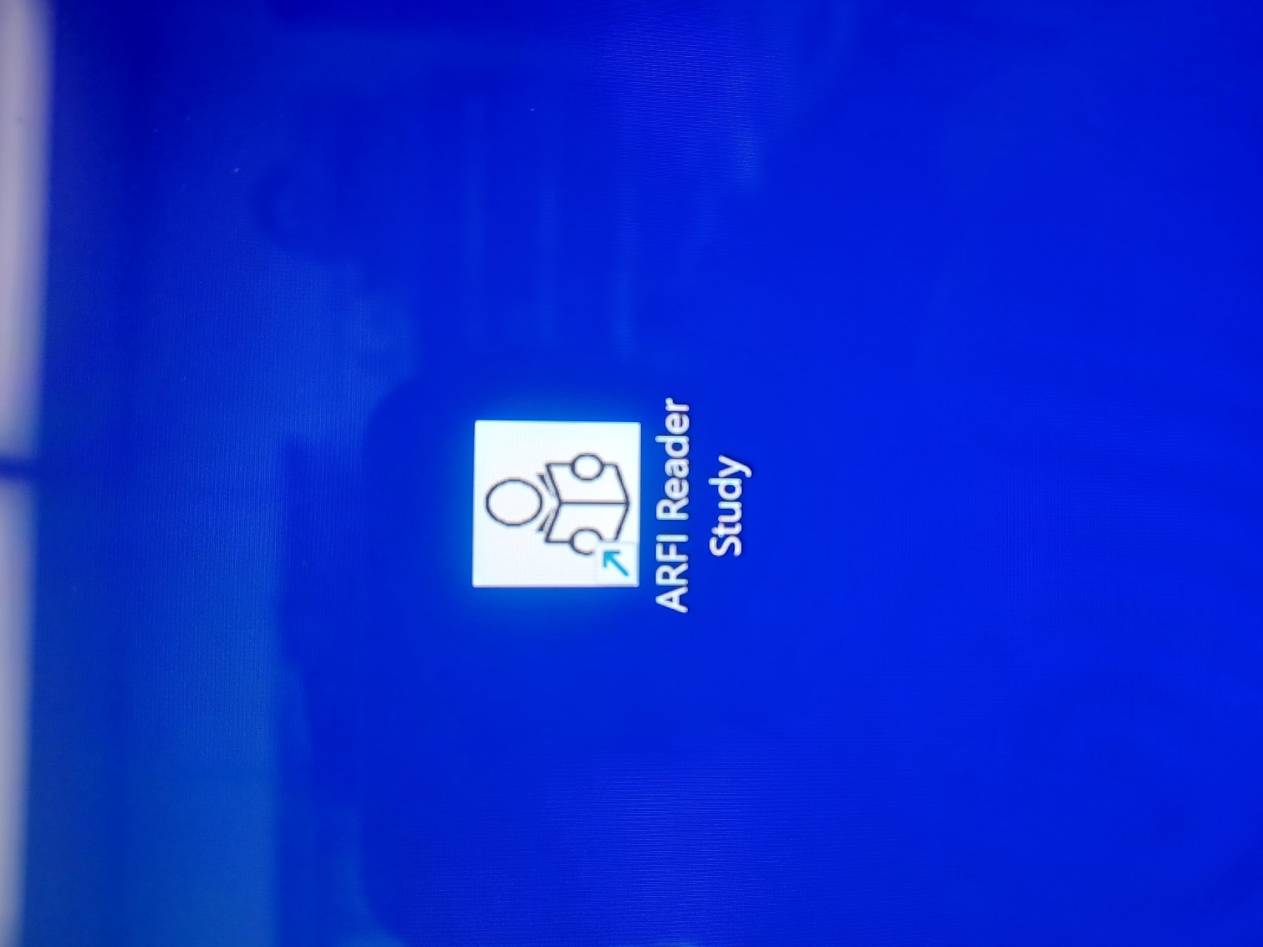

## Click on Your Name or Add Yourself as a New Reader

This is the first interface that opens. Click on your name to open your current progress and resume your study sessions. The Slicer scene will automatically open along with the case interface

If you are a new reader, click on **Add Reader**, type in your name, and then click on your new name button to begin your study sessions.

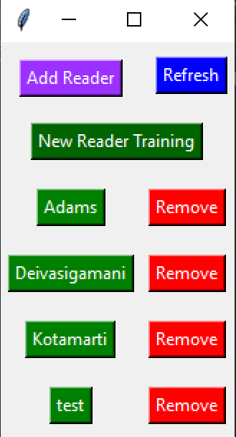

Restart the application

Add a new reader to the study

**5. Begin training or click on your name to resume your reader study progress**

Remove your name from the reader study. (This removes you from the current instance of the application. It does not delete your progress.)

## Reader Training

### Open the Slicer Scene for the Training Case

Either open the first training case or resume at the training case you previously left off on. Complete Steps 7-12 below for each training case.

### Open the Training File

Only after opening the training case will the “Training File” button allow opening the document explaining all lesions identified in the training case. Review this information along with the lesions marked in Slicer.

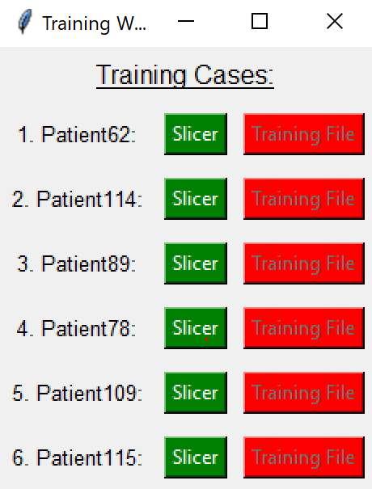

**6. II. Open the training document to review the case**

**6. I. Open the Slicer scene corresponding to the training case**

## Review the Slicer Scene

Scan through the scene coronally or axially using the **Windows Dial** or the **Mouse**. Swap between B-mode and mpUS images by clicking the **Windows Dial**. Adjust the contrast as necessary, especially as you move from posterior to anterior.

*(Instructions for navigating Slicer are below)*

## Identify all Lesions of Suspicion

Mark each location that is suspicious for cancer (IOS 3, 4, 5). Line all 3 views with the lesion and place a fiducial in the center of the lesion *or* on the most suspicious part of the lesion. Ensure your fiducial is with the **F** node, meaning your markers are labeled as **F-#**. **DO NOT** delete a control point or fiducial marker – place another marker instead or move an existing one.

Close Slicer Scene

Create a Fiducial

Adjust Contrast

Mouse Pointer

Signifies F-node

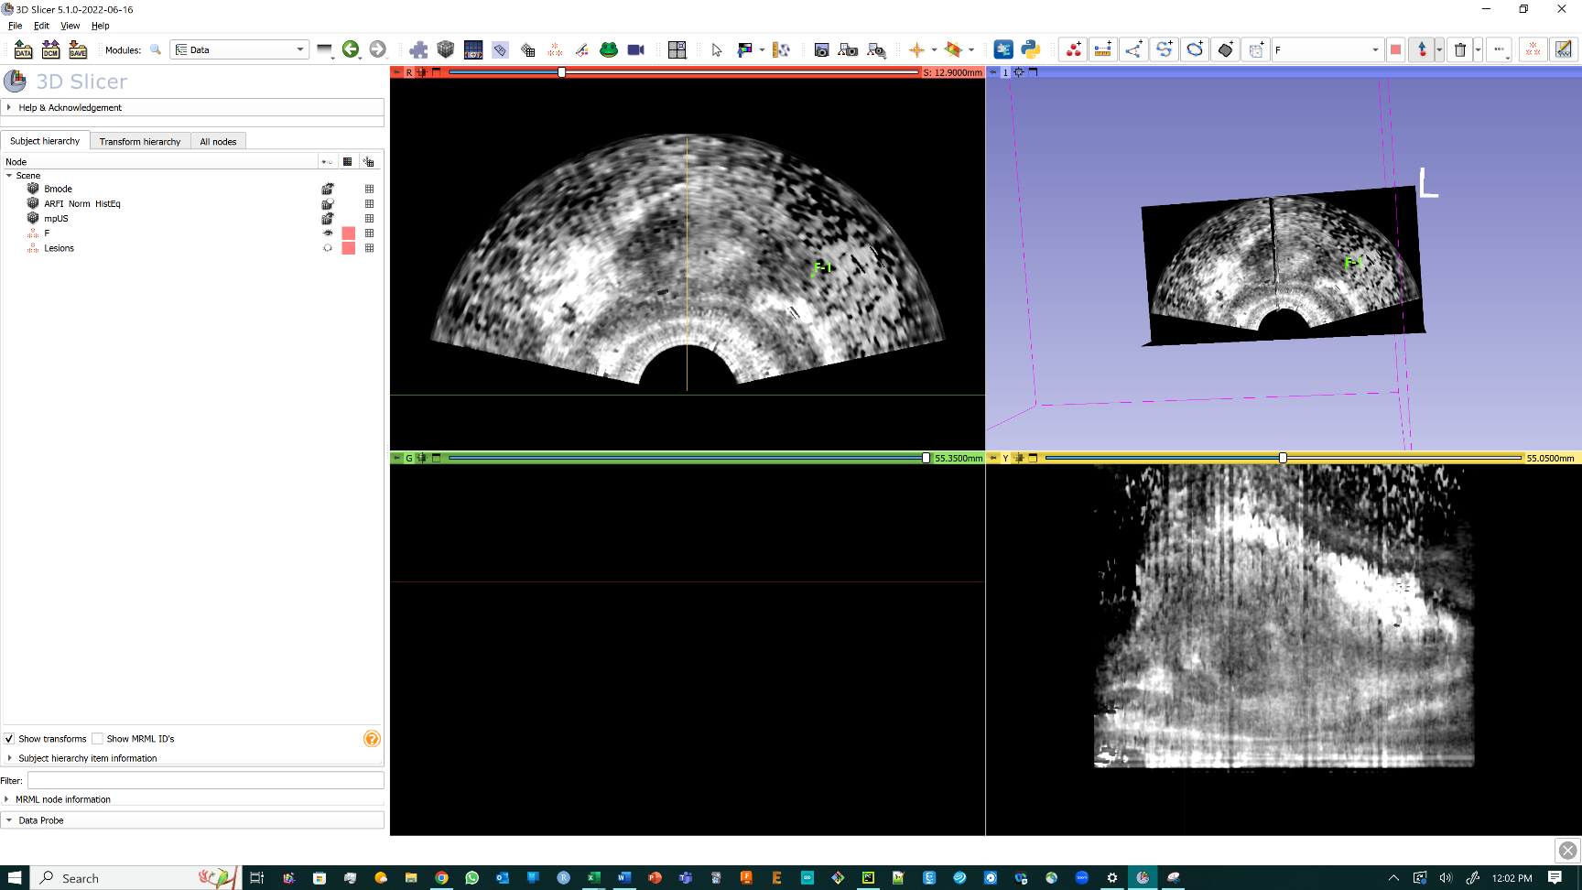

Axial View

Data Module shows the F-node as visible for you marking fiducials. It also contains hidden segmentations for review following case submission

Sagittal View

Coronal View

## Select up to the 4 Most Suspicious Lesions

Identify all the lesions you find suspicious in the Slicer Scene. Pick up to the **TOP 4** targets that you would like to biopsy for each case and order these by **Most to Least** suspicious. *The Fiducial numbers* ***DO NOT*** *have to match your order of suspicion.* Note these as your ARFI Cores.

## Indicate on the Case Interface How Many Targets You Would Biopsy

You can add an ARFI Core with the **Add ARFI Core** button. You can remove the latest ARFI core with the **Remove ARFI Core** button. Confirm the **Case Number** field and **Reader Name** field.

**9. Confirm the case number and your name**

If there is a bug or glitch in the interface, Refresh and Validate information to allow submission

Load caseinformation of a prior case you have completed

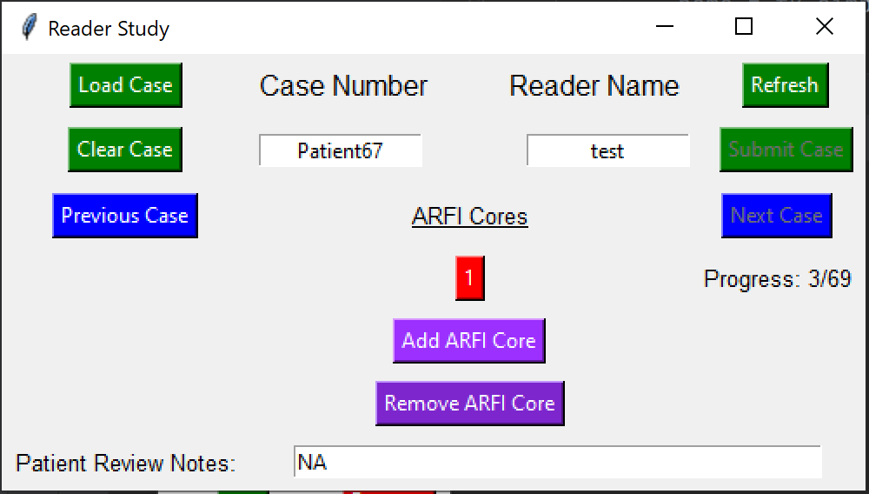

Restart case which deletes all current information and opens a new Slicer scene

Progress in reader study

c

**9. Fill out your most suspicious to least suspicious cores for biopsy**

Load Previous Case. This deletes progress on the current case

**9. Remove the most recent core information**

**9. Add up to 4 cores you would target in a biopsy**

Input any notes specific to the case or your decision making in targeting

## Complete the ARFI Core Information for Your Most Suspicious Lesions

For each ARFI core, the Target Interface will open. With each target you would biopsy, fill out the target information included in the Target Interface. Select the location descriptors that best match the location of the target. **Populate** the location notes – this will populate what would be the core description in clinic. Select you index of suspicion. Enter the fiducial number on the slicer scene corresponding to the core. Submit the core. Once you properly fill out the Target Interface and submit the core, the ARFI core will turn green.

Enter the location of each fiducial

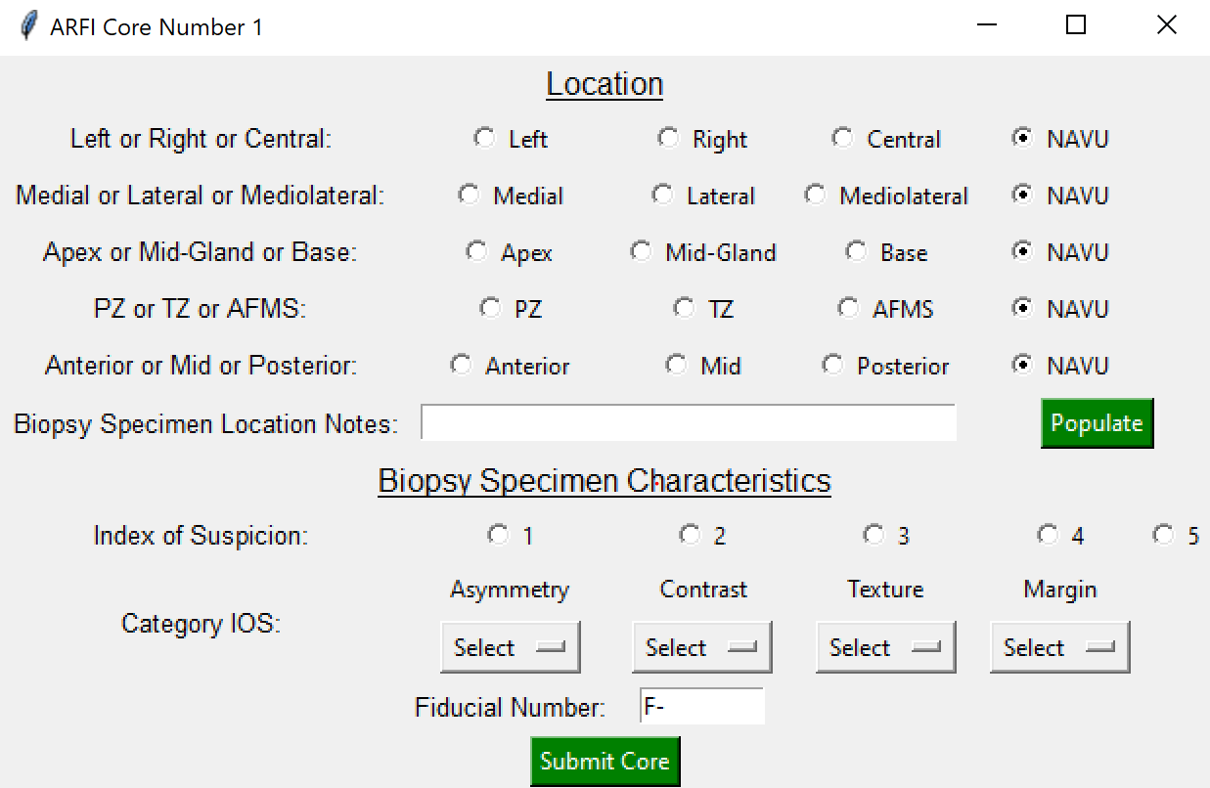

Automatically populates all location descriptions to display the core label

Label the IOS

Select the IOS for each category of the IOS Criteria

Map the number of the fiducial in Slicer to the core information

**10. Submit the core**

## Submit the Case

Once all ARFI Cores turn green, the **Submit Case** button will turn on and you can save the case data. **\*\*SAVE AND CLOSE YOUR SLICER SCENE FIRST\*\*** before moving to the next case

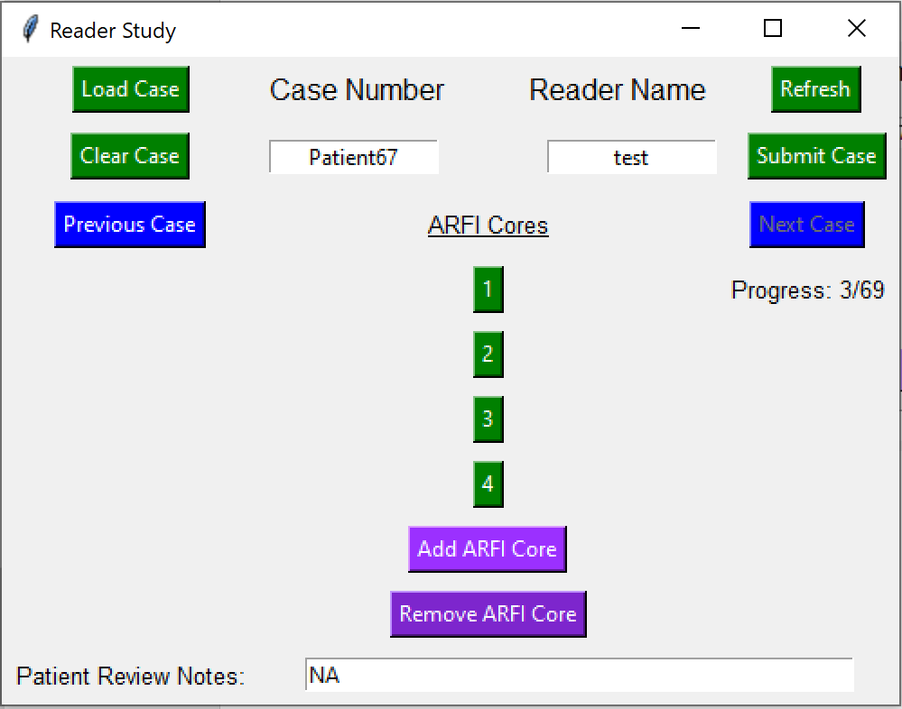

**11. Once your cores are properly completed, you can submit the case. Do this before you review the lesions on the case**

Once the case is submitted and you close the Slicer scene, you can progress to the next case. This will open a new interface and open the new Slicer scene

**11. All Cores will turn green when completed and ready to submit.**

## Review Segmentations in Case

**12. Turn on the ‘Lesions’ and ‘UnidentifiedCancer’ fiducials *or* turn on the segmentations to view identified cancer and compare to your targets.**

## Close and Save Slicer Scene to Your Directory

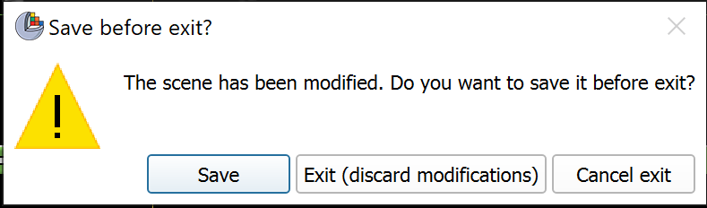When you close the Slicer Scene, a pop-up will open prompting you to save the scene. Save the scene and change the directory to the directory with your name. Then save. You will then have to close the Slicer Scene once more.

**13. Save the Slicer Scene**

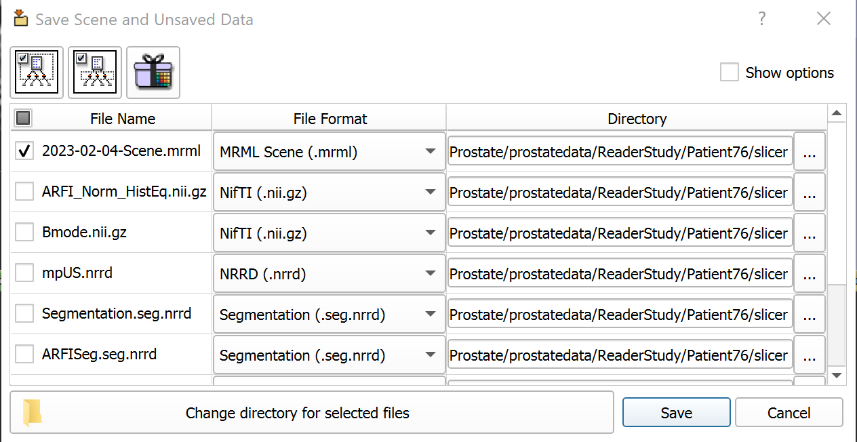

**13. Change the Folder Directory to your directory before hitting save**

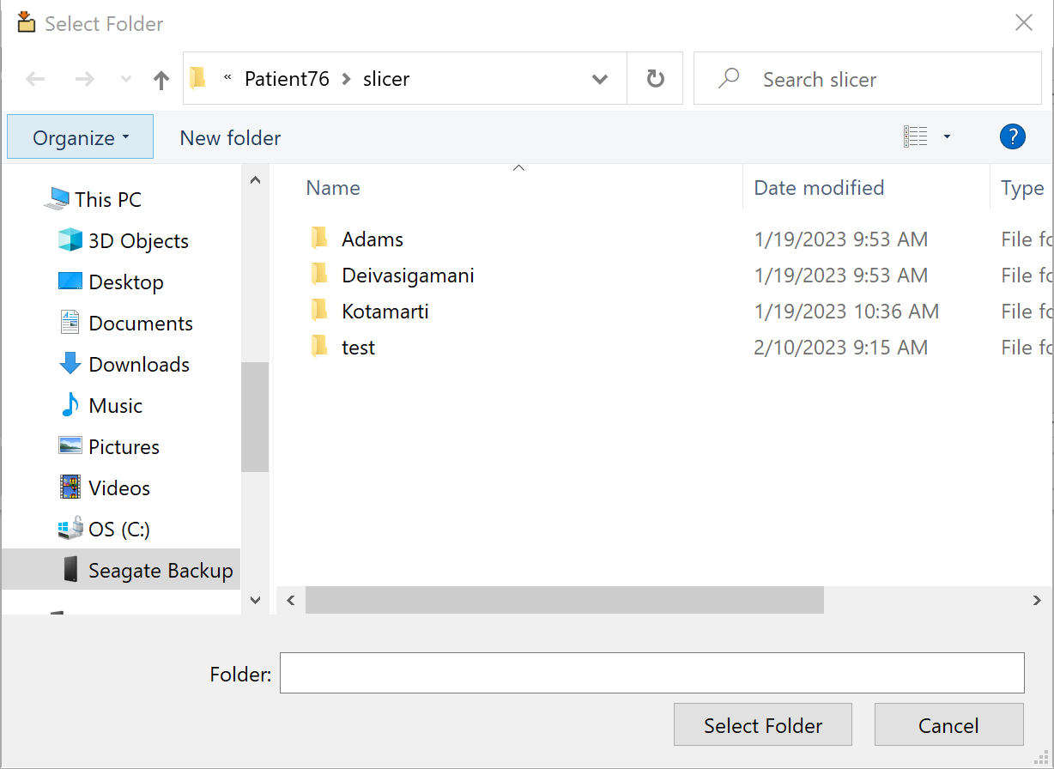

## Close the Slicer Scene and Progress to Next Case

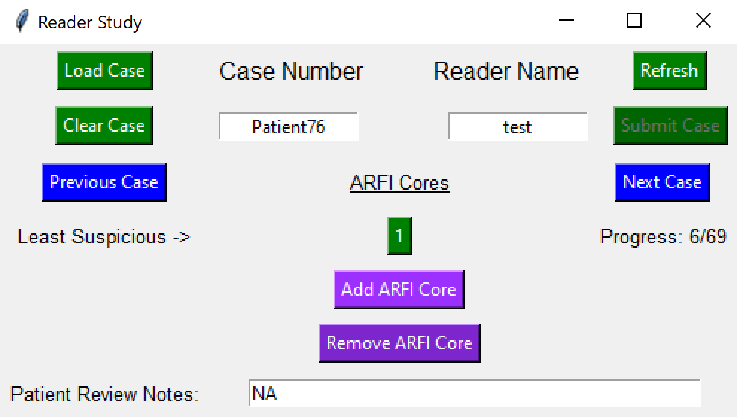Close the Slicer Scene and progress to the next case.

**14. Proceed to the next case.**