**Window Policy**

**All window replacements require a City of Austin Building Permit and must be up to the current code including energy efficiency ratings at the time of installation**

Replacement windows must comply with the standards set below; variances to these guidelines must be submitted to the Architectural Committee and approved by the HOA Board.

All windows must be rectangular single hung, aluminum or vinyl construction.

* Color: If installing all new windows, almond or similar to match the 2015 trim color. For single replacement, owner has choice of matching existing windows of unit (dark bronze) or the new trim color (almond or similar).
* Single Hung, Equal Sash
* Solar Screen is optional: Black or similar for solar insulation with trim matching that of the existing window (either bronze/black trim or almond)
* Grilles are optional: 6 panels per window
* Performance Rating: Must be up to City of Austin Building Code at time of install
* Double windows meaning joined windows, are considered as one window.
* Installation is the responsibility of the homeowner.
* Insurance is the responsibility of the homeowner.
* Window maintenance including replacement and cleaning is the responsibility of the homeowner.
* Replacement of seals is responsibility of the HOA
* Aluminum foil is not allowed in windows for insulation purposes
* Argon gas refill, or similar fill gas, will not covered by the HOA

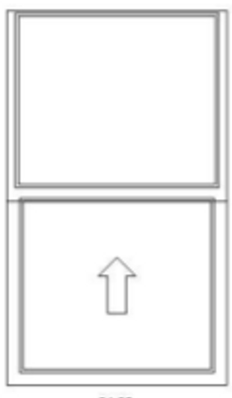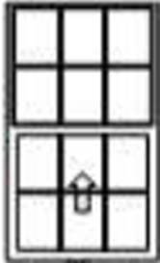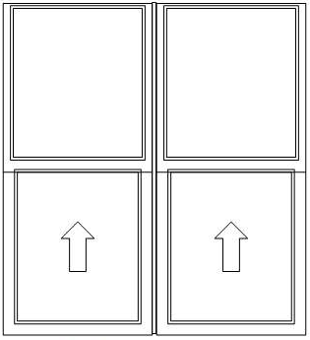



Approved:______________________________________ Date: ________4/30/15__________

Matthew Kuntz, Travis Oaks HOA President