**1. Which product has the highest sales in 2003 and 2004?**

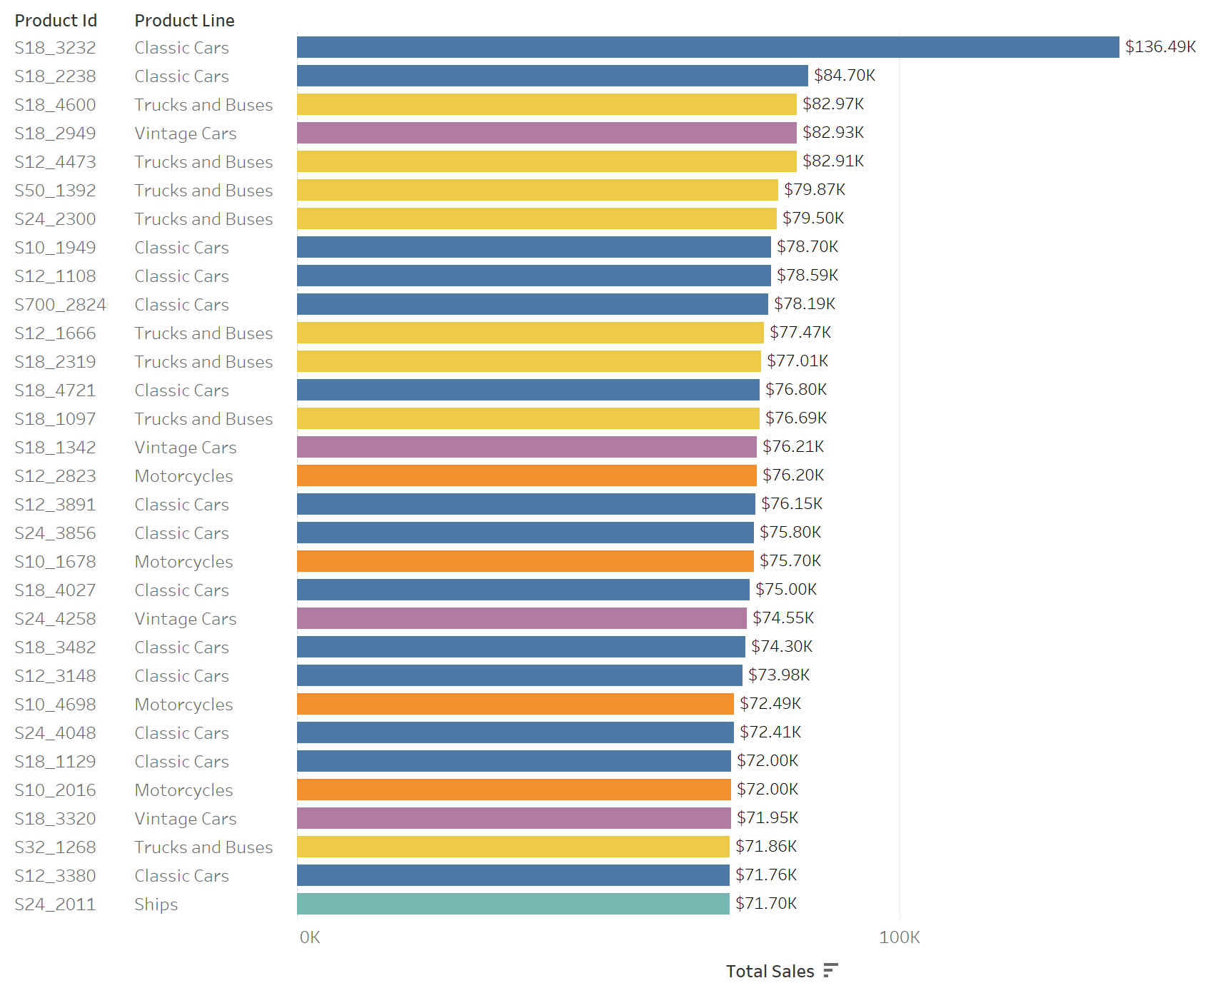

S18_3232 (Classic Car) has the highest sales in 2003 and 2004. When pulling out the data, I only pulled shipped and resolved orders assuming that the rest of order status are not finalized yet (or cancelled/disputed). I made this assumption for query # 3 as well.

**2. What is the average, minimum, and maximum sales price per deal size?**

To calculate the average sales price, I made the assumption that I can include all orders regardless of their status because these products once were sold.

1. Assuming that sales price is quantity multiplied by unit_price

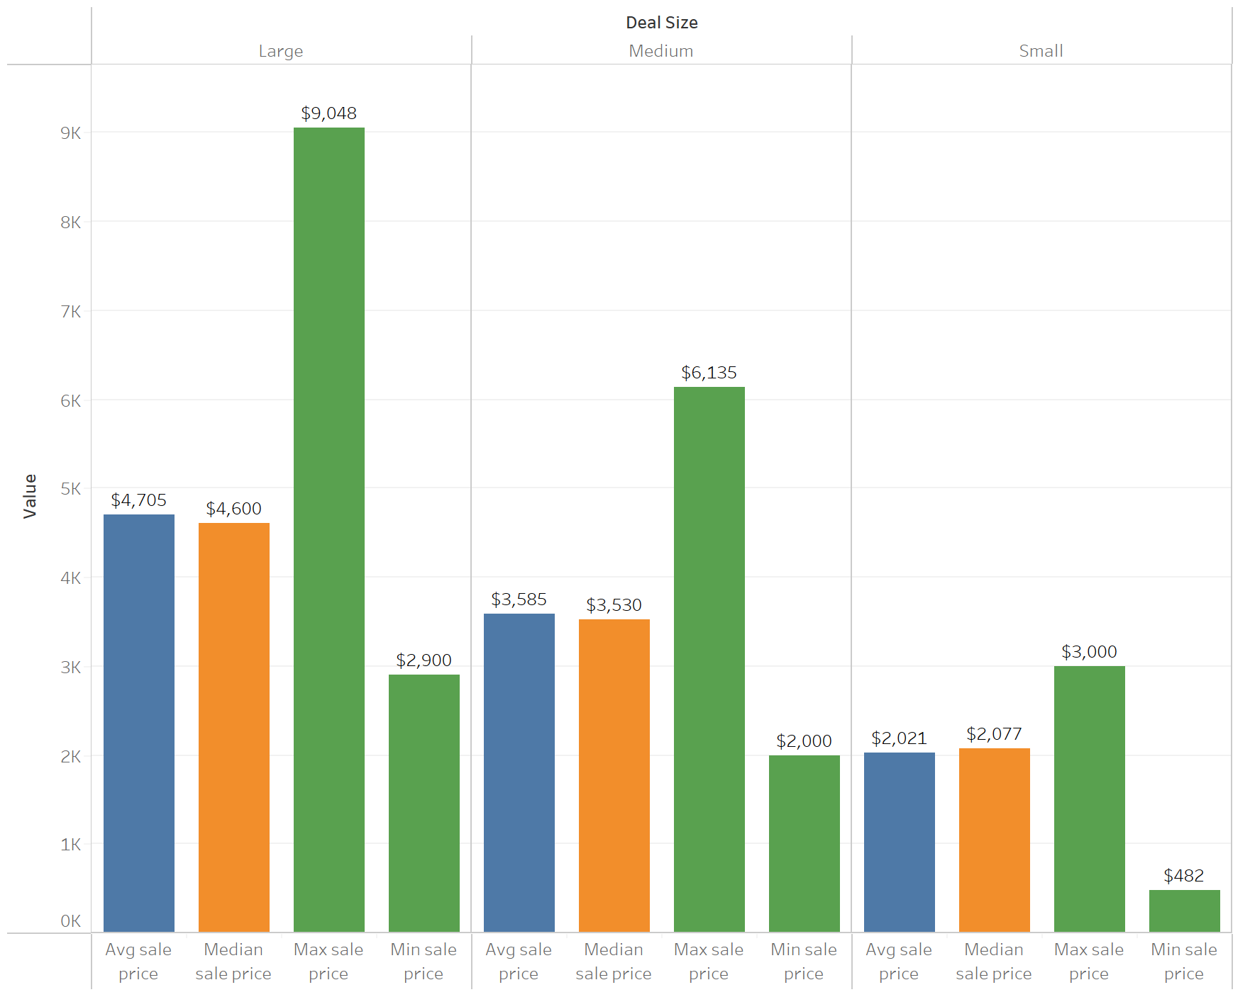

1. Assuming sales price refers to the unit price.

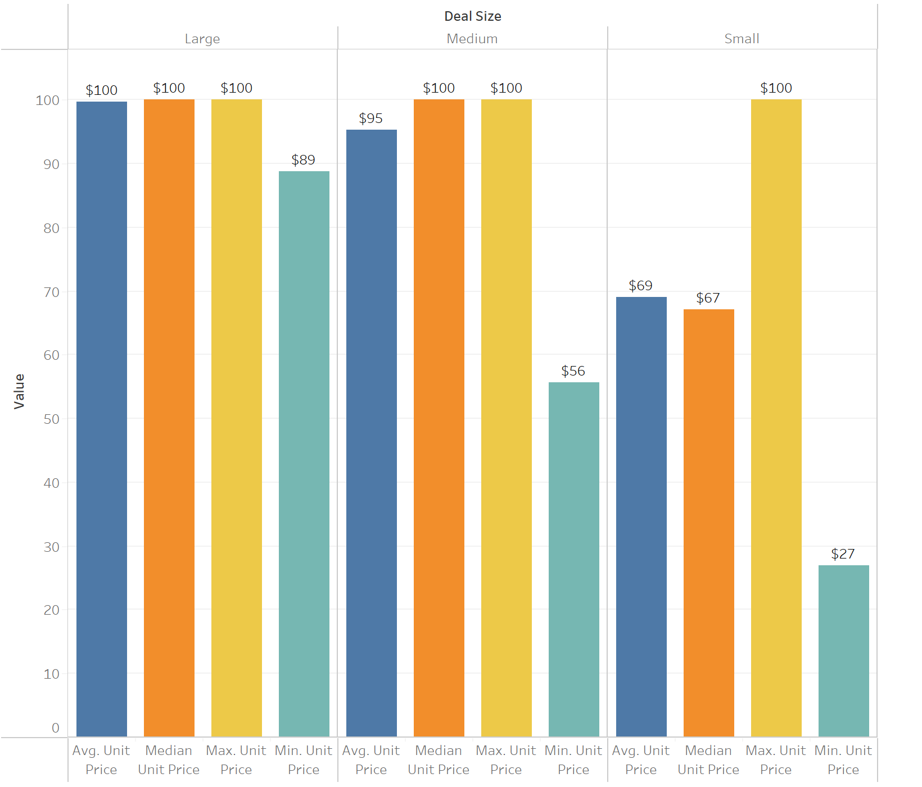

The median and the average sale price are the same for large deals, and pretty close/aligned for medium and small deals.

**3. What are the total sales, the most popular product line, and largest contributing country all per region?**

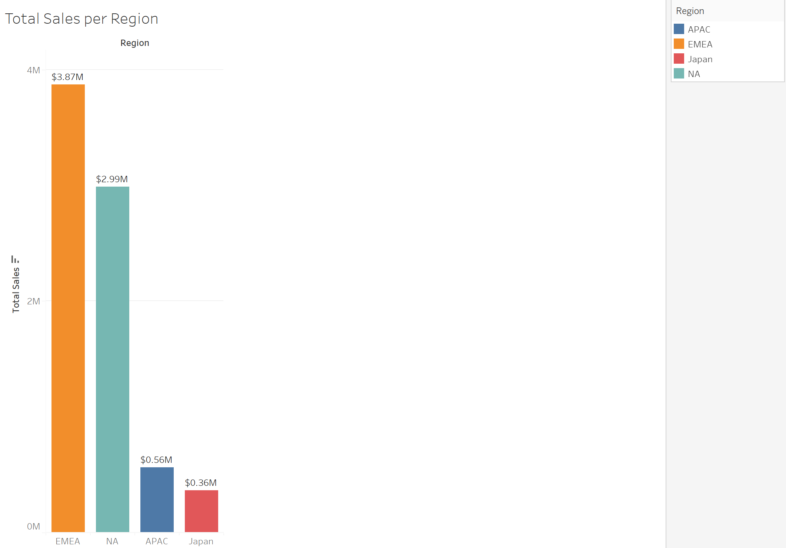

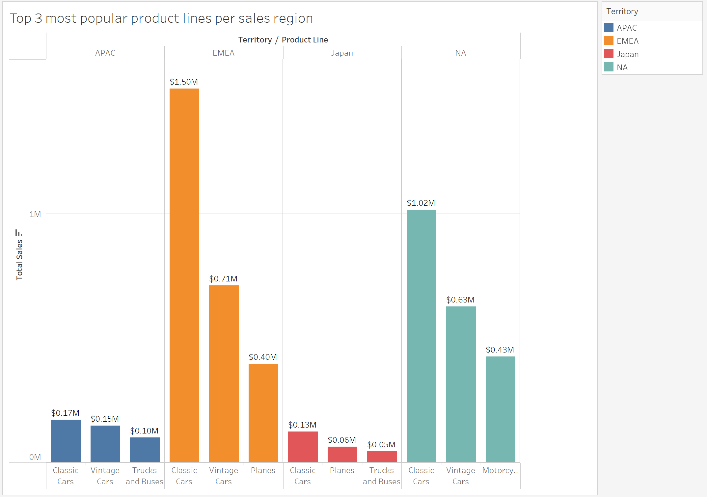

The most popular product lines for EMEA, NA, APAC, Japan are classic cars.

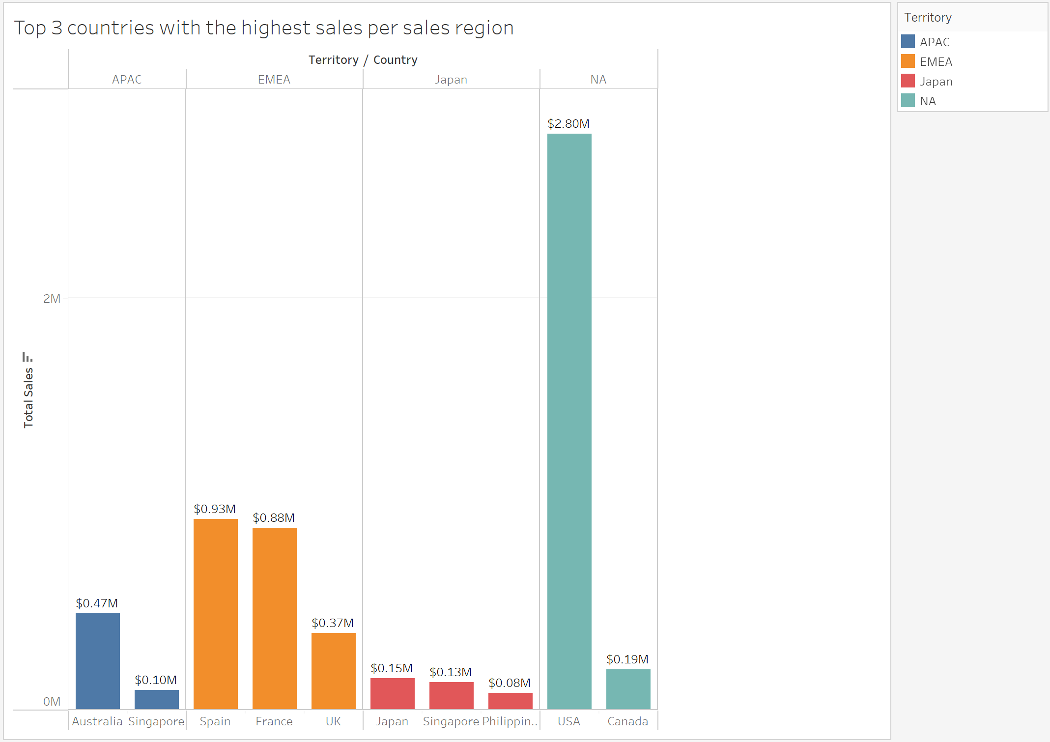

The largest contributing country for NA, EMEA, APAC, and Japan are USA, Spain, Australia and Japan respectively.