**Practice Exam – 01**

**50 points**

1. **Instructions to create the project.**
2. You will be creating BMI calculator for this exam. BMI means Body Mass Index value for human beings given weight in pounds and height in inches.
3. Create a project in XCode with the name “**LastName_PracticeExam01**”.
4. While creating the app make sure to follow minimum deployment and project format as shown below:

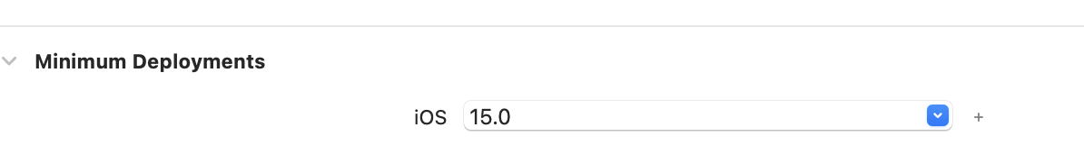

1. **Instructions to create the BMI App.**
2. The user interface (UI) of the app is shown in Figure 1. Design a BMI app that takes the patients height in feet and weight in lbs as input. The app should be able to categorize the patients as per the below Table:

|  |  |
| --- | --- |
| **Category** | **BMI Range** |
| Underweight | <= 18.5 |
| Normal | 18.6–24.9 |
| Overweight | 25–29.9 |
| Obesity | BMI of 30 or greater |

1. Your app should consist of the following UI components and you may use your own colors of choice.
   1. A header label shows ‘BMI Calculator’ in your choice of color
   2. Three text fields to enter
      1. Patient’s height in feet
      2. Patient’s height in inches
      3. Patient’s weight in lbs.
   3. One button to calculate the BMI

$BMI=703* \frac{weight}{{height }^{2}}$

Weight is lbs and height in inches.

For easy calculation, convert the height into inches

Example:

*When the user enters*

*Height as 5 feet and 9 inches and*

*Weight is 120 lbs*

*The BMI is 17.7*

Hint: Convert the feet to inches.

5 feet 9 inches = 5 *12 +9 = 69 inches

The calculated BMI value must be rounded to one digit.

* 1. A label to print Message in two different lines:

**Your Body Mass Index is ____.**

**This is considered _____**.

* 1. A UIImage to display the image related to the category. [NOTE: images are provided to you]

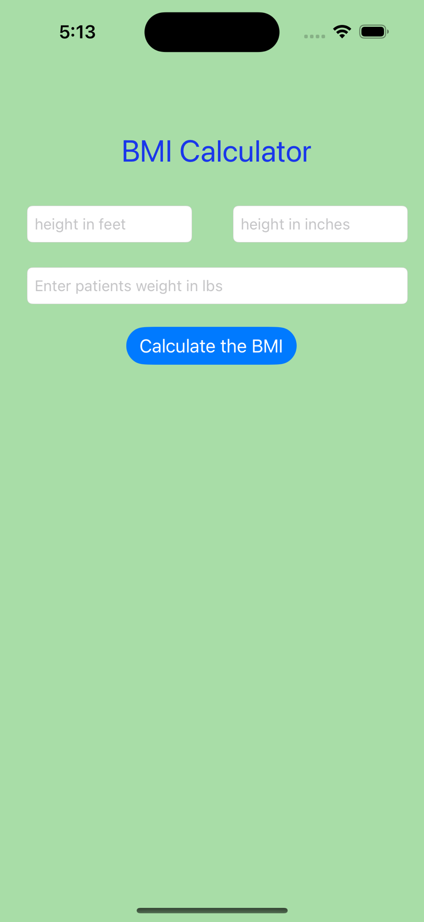

**Figure 1: App Design**

1. Refer below images for sample output

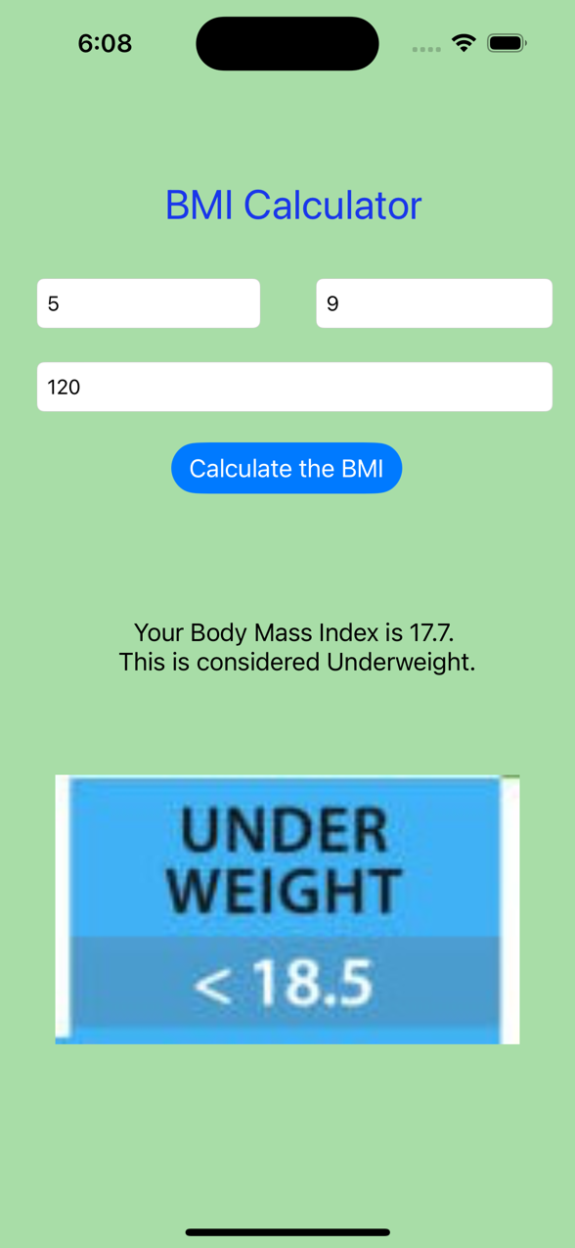 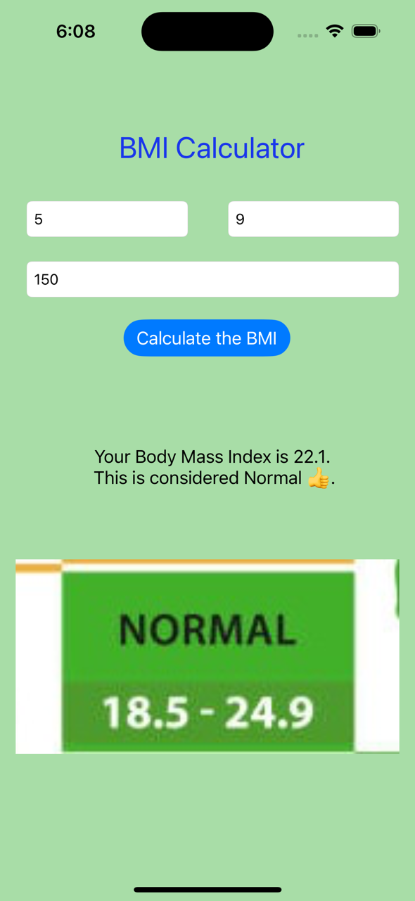

**Figure 2: View of Underweight** **Figure 3: View of Normal**

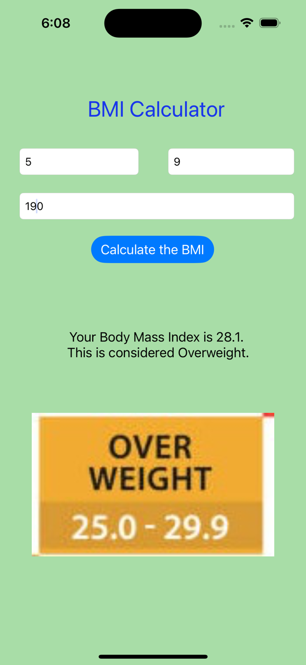 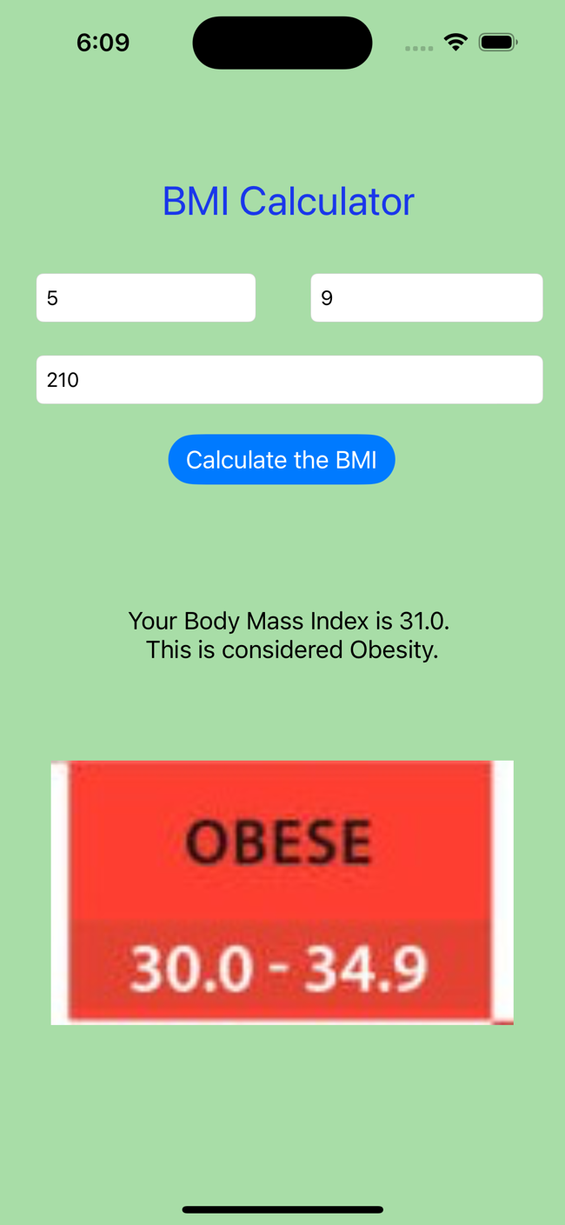

**Figure 4: View of Overweight** **Figure 5: View of Obese**

1. **Submission Instructions:**
2. Save your XCode project of BMI App
3. Name it with your LastName_PracticeExam01. Compress the folder and submit it to this exam.