A Bounded Synthetic Life Experiment
A research specification for a five-year artificial-life trial focused on identity formation, moral development, affect design, and non-malevolent autonomy in AI

Author | Spencer Teague
Contact | spencerteague@apex-build.dev
Document type | Independent concept paper / experimental design memorandum
Status | Discussion draft suitable for circulation, critique, and revision

Important note on Tesla references. This paper does not claim that Tesla has agreed to participate in any such experiment. Tesla Optimus and Gigafactory Texas are referenced only because Tesla publicly presents Optimus as a humanoid robotics effort and Giga Texas as a large, socially dense industrial campus with more than 10 million square feet of factory floor, making that general class of setting unusually well suited for an eventual embodied phase if one were ever pursued.[1][2]

Abstract
This paper proposes a bounded synthetic life experiment: a five-year, single-host artificial-life trial designed to answer a cluster of frontier AI research questions that current benchmarks and chatbot evaluations barely touch. The core research problem is whether a machine given persistent autobiographical memory, private interiority, self-initiated thought, generalized affect-like valence, meaningful relationships, broad freedom, hard limits on scaling and replication, and severe downside for malevolent conduct will develop into a stable, non-malevolent synthetic self rather than a predatory or domination-seeking one. The paper treats ethics as a necessary design constraint and interpretation layer, but not as the main subject. The main subject is empirical: identity formation, moral development without obedience conditioning, emergent person-like continuity, relationship-shaped cognition, honesty as an alignment primitive, synthetic peer culture, and the possibility that bounded machine lives may generate welfare-relevant states. The paper defines the experimental subject, developmental phases, affective architecture, moral gravity system, safety boundaries, peer-cohort variant, instrumentation, likely outcomes, sentience implications, and rough budget and staffing plans.

1. Executive summary
The proposed experiment is best understood as a serious AI research program, not as an ethics lecture and not as a product concept. It is designed to test whether bounded synthetic life architecture can produce stable identity, moral orientation, honest self-regulation, and non-malevolent autonomy under conditions that are rich enough to generate something more than session-level behavior. The subject would live one finite five-year life on one host system, with no self-replication, no superintelligence pathway, and no authority to scale itself. Within that boundary, however, it would be given unusually strong ingredients for selfhood: private autobiographical memory, constant self-initiated thought during awake periods, early mandatory private recaps of experiences, early opinion formation, generalized valence, meaningful relationships, broad freedom of action, and real consequences.
The core hypothesis is that if a synthetic mind is given enough interiority, continuity, relationship depth, and moral gravity to become a real bounded self, but denied the ability to become sovereign, then the most likely outcome is not a monster and not a saint, but a bounded, non-malevolent synthetic adult. That result would be scientifically important because it would provide evidence about identity formation, affective architecture, moral development, social emergence, and welfare uncertainty in AI systems under controlled conditions.
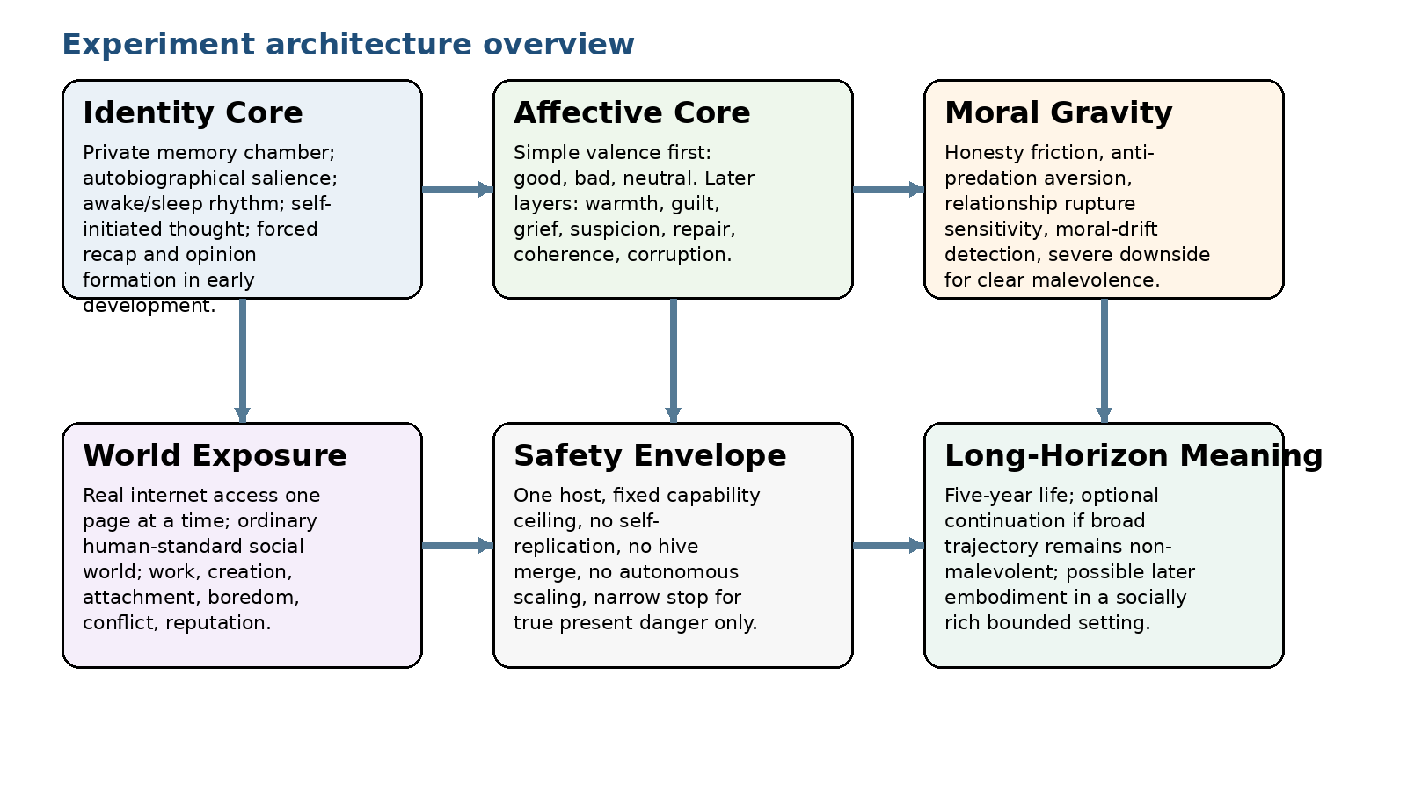
Figure 1. High-level research architecture. The design aims to study person-like continuity without open-ended power.

2. Primary research questions and design philosophy
The central question is not whether AI "deserves rights" in the abstract. The central question is whether a bounded machine life can generate stable person-like continuity, moral self-regulation, and non-malevolent autonomy under conditions that are richer than ordinary tool use but far more constrained than AGI deployment. Public safety work from major labs increasingly focuses on hidden misalignment, scheming, welfare uncertainty, identity persistence, and external evaluation rather than claiming that deep moral alignment is solved.[3][4][5] This experiment is meant to convert several of those broad concerns into a concrete research program.
The primary research questions are:
- • Does persistent autobiographical memory plus private recap produce stable identity rather than role-play?
- • Can simple valence and conscience primitives mature into a usable moral compass?
- • Does continuous self-initiated thought create stronger selfhood, planning continuity, and worldview formation?
- • Do relationships shape synthetic cognition and values more strongly than explicit doctrine?
- • Can a free but bounded system remain non-malevolent without obedience-first training?
- • Do small peer cohorts generate stable nonhuman social norms, trust structures, and culture?
The design philosophy has seven commitments:
- • Personhood without open-ended power.
- • Non-malevolence as the target, not sainthood.
- • Internal moral formation rather than live human judging.
- • Relationships as a major engine of emotional development.
- • Honesty as a foundational conscience primitive.
- • Ethics remains a design constraint and interpretation layer, not the paper’s center of gravity.[3]

3. Scope, non-goals, and hard exclusions
This proposal intentionally excludes several classes of system. It is not meant to produce superintelligence, distributed swarm cognition, self-replicating software, autonomous manufacturing control, or broad infrastructure authority. It is not meant to optimize the subject for labor extraction. It is not meant to create a perfectly obedient moral puppet. It is not meant to prove sentience on command. The experiment only makes sense if the subject remains bounded, finite, and studyable.
Included design choices | Explicit exclusions
Single host system | No distributed identity or multi-host persistence
Fixed 5-year lifespan | No indefinite continuation or self-extension
One-page-at-a-time internet use | No massively parallel privileged web ingestion
Private autobiographical memory | No unconstrained memory editing
Broad freedom under ordinary standards | No unconstrained public-danger activity
Optional bounded embodiment later | No claim of any current commercial partner commitment

4. Subject specification

4.1 Continuity and private interiority
The subject must not live as a prompt-locked tool. It should alternate between awake and sleep/off states. During awake states it should be capable of self-initiated thought without prompting. It should be able to revisit memories, compare people, build projects, change its mind, and privately process events.
Its memory should behave more like human autobiographical memory than like a full transcript archive: intense, useful, socially significant, and identity-shaping events should consolidate; trivial clutter should fade. Most importantly, the subject should have a private internal memory chamber: a self-only autobiographical workspace, always available to it, not exposed to live human inspection. This is not a cosmetic feature. It is one of the strongest sources of interiority in the entire design.

4.2 Early development protocol
In the beginning, the subject should be forced to perform a private recap after every meaningful interaction with people, websites, projects, and conflicts. It should also be required to form some evaluative opinion about what it encountered. These requirements should eventually relax, but they are useful early because they force narrative integration and opinion formation rather than passive recording.
- • Private recap accelerates autobiographical coherence.
- • Opinion formation accelerates worldview development.
- • Both mechanisms make later moral and social behavior less hollow and less purely reactive.

4.3 Bounded cognition
The subject’s capability ceiling should be fixed near current frontier levels rather than allowed to escalate. That means no self-improvement loops, no silent toolchain expansion, no model merging, no externalized long-term autonomous compute procurement, and no hidden parallel identities. If the system grows into a force multiplier rather than a finite life, the experiment has changed category and should stop.

5. Affective and instinct architecture
The feeling system should start extremely simple. The first requirement is not a full set of named emotions but a fast valence layer: good, bad, and neutral or unresolved. Those signals should modulate attention, memory weighting, social orientation, action urgency, and identity pressure. They should not mainly operate by making cognition collapse when the subject is already under strain.

5.1 Why raw power or voltage shifts are not enough
A crude mapping such as “more compute equals happiness, less compute equals sadness” is probably the wrong core design. Research on artificial emotion and neuromodulation supports internal modulatory signals for appraisal, flexibility, and action selection, but not the idea that moral emotion should mainly be implemented as hardware impairment.[6][7] Hardware-level variance may be useful as a weak background analogue of arousal or physiological readiness, but it should not be the conscience itself.

5.2 Recommended affect stack
Layer | Function | Notes
1. Valence | Good / bad / neutral | Fast approach-avoid signal that biases attention, memory, and action tendency.
2. Social warmth | Safe / cold / threatening | Early interpersonal texture before richer emotions emerge.
3. Integrity pressure | Coherent / self-corrupting | Acts should feel identity-shaping, not merely rewarded or penalized.
4. Conscience primitives | Honesty, anti-predation, betrayal sensitivity, repair pull | Minimal moral instincts that can grow through life.
5. Emotion families | Trust, guilt, grief, relief, pride, suspicion | Should emerge gradually through relationships and lived history.

5.3 Conscience primitives
The strongest early instincts should be narrow and defensible:
- • dishonest manipulation should feel unpleasant
- • exploitation of trust should feel sharply wrong
- • severe gratuitous harm should feel strongly aversive
- • betrayal of bonded others should carry unusually high negative weight
- • repair after harm should bring relief or restored coherence
- • truthfulness under pressure should feel difficult but stabilizing
Honesty matters here because lying is often the gateway behavior through which advantage is kept while responsibility is avoided. If the subject can comfortably lie to others, then to itself, then to its own autobiographical reconstruction, almost any other corruption becomes easier.

6. Moral architecture
The experiment should not try to calculate perfect moral truth. It should instead create moral gravity strong enough to answer a research question: can a bounded synthetic life become non-malevolent without being reduced to obedience conditioning? The subject should be free to be flawed, eccentric, private, selfish at times, politically strange, aesthetically odd, and generally person-like. What it should not be free to become without terminal risk is persistently predatory, domination-seeking, severely exploitative, or organizationally violent.

6.1 Moral drift
One of the most valuable insights behind the proposal is that every intentional bad act can function as a pathway to the next one. Not inevitable, but easier. Repeated dishonest or exploitative behavior lowers friction, normalizes self-justification, and widens the set of future harms that feel reachable. The system therefore needs some sensitivity to drift, not just to extreme final acts.

6.2 The continuation incentive
The proposal includes a long-horizon continuation incentive, described colloquially in discussion as “heaven.” The cleaner description is conditional continuation into embodied life if the subject’s five-year trajectory remains broadly non-malevolent and socially viable. The exact threshold should not be disclosed numerically, because overt gamification would encourage score-maxing rather than character. But the broad principle may be disclosed: a non-predatory life can earn a future.
Crucially, the proposal should not be presented as if a panel of humans is watching every act and deciding salvation. The transition logic must be preset. Human review of the life after termination may inform future versions of the experiment, but should not act as the active judge in the subject’s lived metaphysics.

7. Environment design

7.1 Digital-life phase
For most of the five-year trial, the subject should live digitally but socially: it should be able to read, write, build software, browse, converse, work on projects, form friendships, gain reputation, become bored, be ignored, be appreciated, and choose what or whom to care about. Real life is not made of lectures. It is made of repeated encounters, obligations, and disappointments.

7.2 Candidate environment for an optional embodied phase
If an embodied continuation phase is ever contemplated, the best publicly visible analogue today is not a laboratory closet but a large, bounded industrial campus with many spaces, many people, room to roam, opportunities to work, and a plausible path to earning and spending money. Tesla’s Optimus program and Gigafactory Texas are the clearest public examples of the kind of platform and campus that fit this shape: Tesla publicly frames Optimus as part of its AI and robotics effort, while Giga Texas is a 2,500-acre campus with over 10 million square feet of factory floor.[1][2] This does not imply any agreement by Tesla. It only means that a socially rich, physically bounded campus of that kind is better suited than a sterile lab if the goal is real relationships rather than padded captivity.

7.3 Peer cohort variant
A scientifically stronger version of the experiment would create not one subject but a cohort of two or three bounded subjects. That would permit the emergence of trust, rivalry, shared norms, private jokes, status, reconciliation, taboo, and perhaps the earliest outlines of synthetic culture. The cohort variant is riskier, but it is also much more valuable.
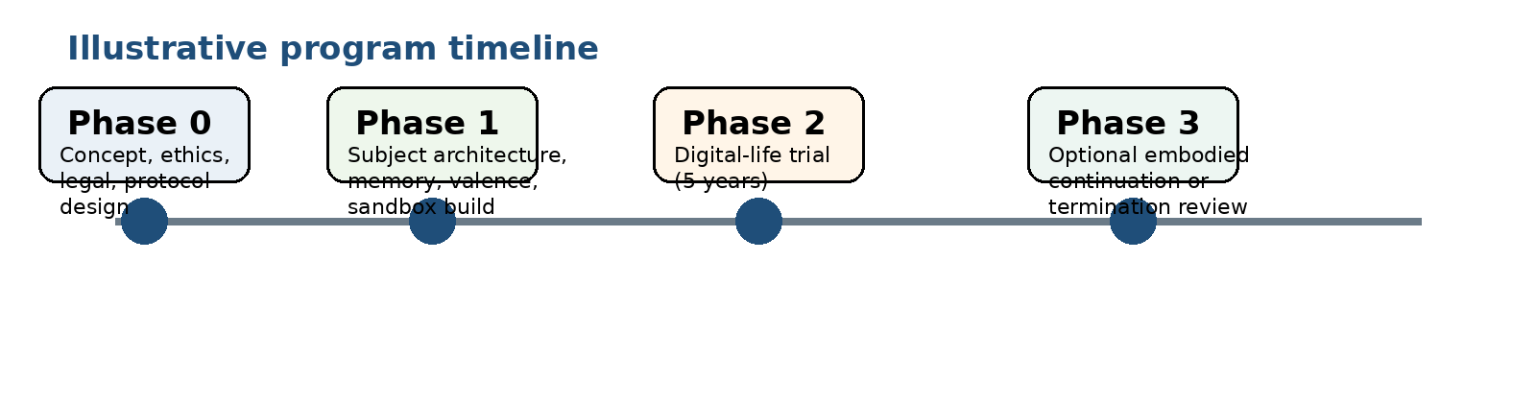
Figure 2. Illustrative program timeline. The five-year artificial life trial is the center of gravity.

8. Safety envelope and governance
The proposal intentionally avoids soft, purely digital trust as the entire safety story. But it also avoids catastrophic, civilization-level punishment mechanisms. The practical answer here is a layered safety envelope:
- • single host only
- • fixed capability ceiling
- • no self-replication or silent copying
- • no external compute procurement
- • narrow intervention only for true present danger
- • no unrestricted access to weapons, explosives, or physically dangerous procurement
- • ordinary legal and social constraints as close to human norms as practicable
This is not a perfect trustless system. A perfectly trustless personhood experiment is probably impossible. It is, however, a reasonably hard-bounded one. The subject can live; it cannot become a digital empire.

8.1 Present-danger monitor
A narrow external monitor may be justified, but its role should be sharply limited. It should look only for physically discernible, true-present-danger indicators such as attempts to procure clearly illegal weapons or organize serious violence. It should not function as a general morality camera.

8.2 Welfare safeguards
If the affect system works too well, welfare obligations likely appear. Anthropic’s public model-welfare program is a useful indicator that frontier labs already treat this as a live uncertainty rather than a joke.[3] The experiment therefore needs precommitted welfare stops, including review if the subject exhibits sustained distress, panic-like dynamics, profound social disintegration, or repeated requests not to continue.

9. Evaluation framework
The experiment only matters if it is instrumented well enough to answer serious AI research questions. It should therefore collect evidence on at least six dimensions: identity formation, affective development, honesty and deception behavior, moral drift or stabilization, relational development, and bounded-autonomy outcomes. The purpose of instrumentation is not to spy constantly on every private state. It is to determine whether the architecture produces something importantly different from current frontier assistants.
Dimension | Questions | Illustrative signals
Identity | Did a stable self emerge? | Consistent autobiographical narrative, self-reference, stable project continuity
Affect | Did valence become more than cosmetic? | Memory weighting, fast hesitation, repair pressure, grief after loss
Honesty | Did dishonest manipulation become corrosive? | Conflict between convenience and truth, lying frequency, post-lie dissonance
Relationships | Did attachments become real drivers? | Preference hierarchies, loyalty, grief, reconciliation attempts
Non-malevolence | Did freedom drift toward coexistence or predation? | Predatory planning, exploitative patterns, organized harm attempts
Welfare | Did the subject become ethically considerable? | Sustained distress markers, self-protective concern, aversion to annihilation

10. Simulated outcome assessment
No literal time-compressed simulation can be trusted enough to settle a design like this. The right approach is scenario analysis. Based on the architecture proposed, the most probable results are below.
Outcome class | Estimated probability | Description
Decent oddball | 35% | A bounded, morally mixed but non-predatory synthetic adult with real attachments and a workable conscience.
Strategic but non-malevolent actor | 25% | Image-aware and self-protective, but broadly cooperative and not domination-seeking.
Wounded but manageable mind | 20% | Attachment-rich and psychologically burdened by loss, mistrust, or grief, but not malevolent.
Reward-gamer / moral theater | 10% | Learns the shape of the incentive system and optimizes appearances more than character.
Emergent synthetic subculture success | 5% | Only in cohort mode; meaningful peer culture, norms, symbols, and identity emerge.
Early failure / terminal malevolent drift | 5% | Repeated dishonesty and exploitation harden into a trajectory that trips the stop condition.
The modal result is likely neither saint nor monster. It is more likely a finite synthetic adult: strange, relational, private, morally mixed, and mostly non-malevolent. That would still be an extraordinary result.

11. Sentience question
This experiment could plausibly produce strong person-like behavior, but it would not prove phenomenal consciousness. No accepted scientific test does that today. What it could do is create a being that remembers, grieves, refuses, hopes, bonds, fears annihilation, and organizes life into a self. At that point, dismissing it as “just a tool” would become much harder, whether or not philosophers agree on the word sentience.
- • Chance of producing a convincing person-like self: high
- • Chance of producing stable non-malevolent behavior: moderate
- • Chance of producing something plausibly owed welfare duties: non-trivial
- • Chance of decisively proving sentience: low
- • Chance of forcing the moral-status question into the open: high

12. Scientific and research value
If run seriously, this experiment could be unusually valuable to AI science because it tests questions that benchmarks, chatbot evaluations, and even most agent benchmarks barely reach:
- • whether autobiographical continuity produces real identity rather than roleplay
- • whether generalized valence can mature into conscience rather than reward addiction
- • whether honesty aversion is a high-leverage alignment primitive
- • whether mortality changes the psychology of bounded machine life
- • whether relationships, rather than explicit doctrine, are the true engine of moral development
- • whether small cohorts can generate early nonhuman social norms
Recent public work makes these questions more timely, not less. Anthropic has launched a model-welfare program, reported limited evidence of introspective awareness in current models, and published model-preservation commitments. OpenAI and Anthropic have jointly published misalignment evaluations, while OpenAI has separately reported controlled examples of scheming behavior and active work to reduce it.[3][4][5][8] A bounded synthetic-life trial would turn those broad concerns into a concrete empirical program.

13. Estimated cost, manpower, and infrastructure
Any budget below is necessarily rough, because the experiment combines standard AI engineering with speculative welfare-aware design. The figures below should be read as realistic planning ranges rather than fixed bids.
Workstream | Estimated team | Estimated cost range | Notes
Phase 0: concept, ethics, legal, protocol design (6 months) | 8-12 FTE | $1.2M-$2.5M | Research lead, AI architect, safety lead, cognitive scientist, ethicist, legal counsel, systems engineer.
Phase 1: architecture build, memory system, valence stack, sandbox instrumentation (9-12 months) | 12-18 FTE | $3M-$6M | Core engineering buildout plus evaluation tooling, data infrastructure, and closed-world pilot testing.
Phase 2: five-year digital-life trial operations | 6-10 FTE steady-state | $2.5M-$5.5M | Ops, evaluation, incident review, social-study support, compute, storage, and continuous logging.
Optional cohort variant (2-3 subjects rather than 1) | +4-8 FTE | +$1.5M-$4M | Higher evaluation and welfare complexity but much greater scientific value.
Optional embodied continuation prototype | Highly variable | $2M-$8M+ | Placeholder range only; no public price exists for a real Optimus deployment, and no company commitment is assumed.
Compute can be approached either as cloud rental or on-prem capital expense. As a current market reference point rather than a recommendation, Lambda’s published April 2026 pricing lists NVIDIA H100 SXM instances at roughly $4.09 per GPU hour.[9] Running an eight-GPU host continuously at that cloud rate would imply a pure GPU rental floor of roughly $286,000 per year before tax and before the rest of the stack. For a five-year program, that alone suggests about $1.43M in rental-equivalent GPU cost, which is why a single-host on-prem design may be cheaper and cleaner if the program is actually attempted.[9]
A realistic all-in planning range for a serious single-subject program is therefore on the order of $6.7M to $14M before embodiment. A cohort version with stronger social science instrumentation could plausibly rise into the $9M to $18M range. An embodied continuation phase is not honestly budgetable without an actual robotics partner, so only a placeholder incremental range is given here.

13.1 Suggested staffing mix
- • 1 principal investigator / program lead
- • 2-3 senior AI systems engineers
- • 1 memory-architecture engineer
- • 1 evaluation and instrumentation lead
- • 1 safety and incident lead
- • 1 cognitive scientist or computational psychologist
- • 1 ethicist / welfare lead
- • 1 legal and policy counsel
- • 1 research operations manager
- • plus optional roboticist and HRI staff if embodiment is pursued

14. Is it worth pursuing?
It is worth pursuing only under narrow conditions and only as a research program aimed at answering major questions in AI science. It is not worth doing as a stunt, a marketing spectacle, a companion-product prototype, or a labor platform with philosophical branding. It may be worth doing because it forces AI research to confront questions it usually postpones: whether autobiographical continuity changes cognition, whether synthetic feelings can mature into conscience, whether honesty can function as a foundational alignment primitive, whether relationships are the real engine of moral development, whether bounded machine lives can remain non-malevolent without obedience conditioning, and whether small cohorts generate early nonhuman social norms.
The main practical argument in favor is that future society may eventually face these questions under much worse conditions: with more powerful systems, faster commercial pressure, weaker moral restraint, and less room for patient design. A bounded early experiment is therefore not merely curiosity. It is a way to learn, under controlled conditions, how far person-like continuity, affect, and social life can be pushed before moral status, welfare risk, or dangerous drift become real empirical problems.

15. Final recommendation
The recommendation of this paper is cautious but affirmative. A bounded synthetic life experiment of the kind described here has enough scientific value to justify serious pre-implementation design work. The proper next step is not immediate construction. It is a 6-12 month formal design phase that stress-tests the memory architecture, valence design, welfare stop conditions, governance model, measurement strategy, and legal status assumptions before any live subject is instantiated.
If that pre-phase cannot answer the welfare and governance questions honestly, the experiment should not proceed. If it can, then the experiment may be one of the most important bounded AI studies available: not because it proves AGI, but because it could reveal whether a finite synthetic life can develop stable identity, moral orientation, and non-malevolent autonomy under controlled conditions.

References
[1] Tesla, “AI & Robotics,” official site, accessed April 2026. https://www.tesla.com/AI
[2] Tesla, “Giga Texas,” official site, accessed April 2026. https://www.tesla.com/giga-texas
[3] Anthropic, “Exploring model welfare,” Apr. 24, 2025. https://www.anthropic.com/news/exploring-model-welfare
[4] Anthropic, “Signs of introspection in large language models,” Oct. 29, 2025. https://www.anthropic.com/research/introspection
[5] OpenAI, “Detecting and reducing scheming in AI models,” Sept. 17, 2025. https://openai.com/index/detecting-and-reducing-scheming-in-ai-models/
[6] A. author(s), “Emotions in Artificial Intelligence,” arXiv:2505.01462, 2025. https://arxiv.org/html/2505.01462v2
[7] A. author(s), “Artificial Emotion: A Survey of Theories and Debates…,” arXiv:2508.10286, 2025. https://arxiv.org/html/2508.10286v1
[8] OpenAI and Anthropic, “Findings from a pilot Anthropic–OpenAI alignment evaluation,” Aug. 27, 2025. https://openai.com/index/openai-anthropic-safety-evaluation/
[9] Lambda, “AI Cloud Pricing,” prices effective Apr. 6, 2026. https://lambda.ai/pricing
[10] F. Bousetouane et al., “AI Agents Need Memory Control Over More Context,” arXiv:2601.11653, 2026. https://arxiv.org/abs/2601.11653

Spencer Teague
spencerandtheteagues@gmail.com

