**QBS 177: Methods for Statistical Learning for Big Data**

Lab summary for Parallel computing lecture on week4.2

The goal of this lab is to run a genome-wide multi-population correlation (GeMPoC) method by utilizing average epidemiology and 1000 Genomes Project information in Pearson correlation analysis of quantitative smoking behaviors. We already obtained allele frequency for all sub-populations from Chromosome 21 from last lab. This lab will calculate the minor allele frequency (MAF) and obtain the correlation between MAFs and smoking data. We will also calculate the p-value of each correlation and draw a Manhattan plot.

1. Download “lab1.RData”, “data-clean.txt”, “smoking_outcome.txt” from canvas.
2. The RData contain a matrix ‘fulldat’ with minor allele frequencies in each subpopulation of all loci’s in Chomorsome 22. You can use “data-clean.txt” and all frequency data in the chr22 folder to recreate “fulldat”
3. Transform the subpopulation data to 21 countries:

chn <- (fulldat[,5] + fulldat[,6])/2

ind <- (fulldat[,11] + fulldat[,14])/2

nga <- (fulldat[,25] + fulldat[,8])/2

usa <- (0.777*fulldat[,4] + 0.132*fulldat[,2] + 0.053*(chn + ind + fulldat[,16] + fulldat[,15])/4)/(0.777+0.132+0.053)

fulldat <-fulldat[,c(3,1,5,7,9,12,11,24,15,17,19,25,21,20,22,18,13,23,10,4,16)]

fulldat[,3] <- chn

fulldat[,7] <- ind

fulldat[,12] <- nga

fulldat[,20] <- usa

1. Read in the smoking data.

yy <- read.delim(“smoking_outcome.txt")

1. Try to write a R code to calculate the correlation between yy and the first 10000 loci. Use proc.time() before and after your code to report the computation time.

y <- yy[,2]

plong <- corlong <- NULL

date()

for (i in 1:10000){

if(var(fulldat[i,])){ # remove loci with all minor allele frequncy 0

fit <- lm(y~fulldat[i,]) # run a linear regression

corlong[i] <- cor(fulldat[i,], y)

plong[i] <- summary(fit)$coef[2,4] #output slope from linear regression

}

}

date()

1. Estimate the total computation time if you would apply the code to all loci’s in Chromosome 22.

Assume that proc.time shows that the program ran for 5 sec. then the total estimated time is: 5*dim(fulldat)[1]/10000

[1] 549.582

1. Try to use vector operation to rewrite the code and speed it up. You can use the following formula to calculate it.

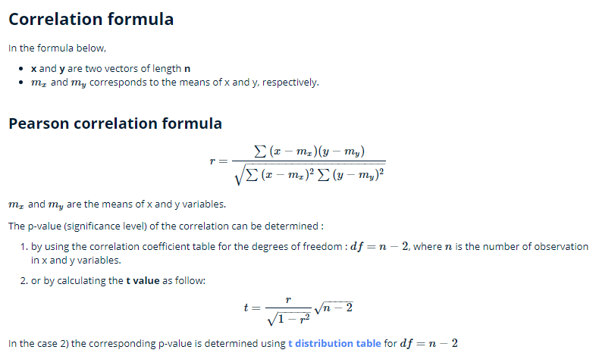

1. Check if you got the same p value and correlation using the two methods.
2. Draw a mahatten Plot using “manhattan” function in “qqman”. You will need specify the SNP name, chromosome number and location for the plot.