An Ergonomic Analysis of a 1993 Fleet of CAT 785D Haul Trucks

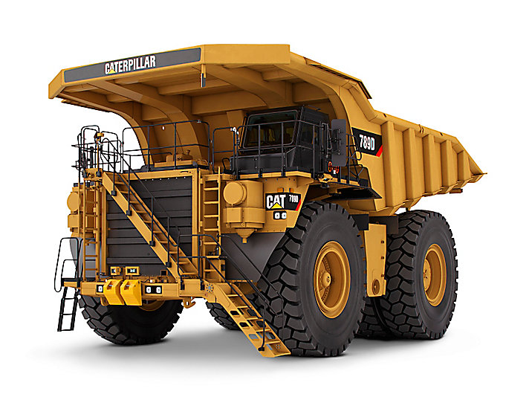

Figure 1 – A CAT 785 D-Series haul truck [1].

Completed By:

Spencer Blahey, B. Eng. April ‘21

Report Submitted:

March 12th, 2021

*Statement of Originality: “The title page containing the name above asserts that this is a wholly original work by the author, and any shared and external contributions to this work are documented within.”*



Table of Contents

Introduction 3

Assessment of Problem 3

Requirements 3

Current Design and Issues 4

Lighting and Sound Assessment 5

Ergonomic Data 6

Proposed Design 8

New Design Description 8

Justification of Design 11

Seating Justification 13

Sound Reduction Investigation 15

Lighting Analysis 16

Conclusion 17

Design Process Overview 17

Future Recommendations 18

References 19

# List of Figures

Figure 1 – A CAT 785 D-Series haul truck [1]. 1

Figure 2 – Visuals of the exterior cab, inner seating configuration and dashboard interface [2]. 5

Figure 3 – Three reference postures used to collect anthropometric data for the workspace design. 8

Figure 4 – A display of the workspace envelopes for each limb (left) and shoulder comfort zones (right) for a 75th percentile male. 9

Figure 5 – A functional model depicting two working scenarios within the newly designed cabin. 10

Figure 6 – Main dash assembly labelled with all components shown except the steering wheel. 10

Figure 7 – Center console assembly with the lower region foot pedals displayed. 11

Figure 8 – Upper console of the cabin consisting of ventilation and lighting controls. 11

Figure 9 – Adjustability controls of the seat and steering wheel, along with missed center console controls. 11

Figure 10 – Critical dimensions of the workspace displayed atop side and rear profiles. 12

Figure 11 – A display of the lower-limb workspace envelopes (yellow) and the pedals contained within. 12

Figure 12 – The haul truck’s dashboard and its relation to a 75th percentile male’s upper limb reach envelopes. 13

Figure 13 – A visualization performed by ClearMotion highlighting their EAVC technology [11]. 15

# List of Tables

Table 1 – Noise sound levels collected throughout the shift for the specified conditions. 7

Table 2 – Light levels collected throughout the shift for the specified conditions. 7

Table 3 – The measurements results extracted from the 2012 ANSUR database. 8

# Introduction

Owing to their shear size, the CAT785-D series 550 tonne haul trucks are best suited to high production industrial scenarios when large payloads are a necessity. Applied to an open-pit mining environment, with long cyclical journeys, this fleet of trucks is extremely beneficial with each trip rated to carry approximately 153 US tons of material.

One thing common with any company in the industry, especially with larger heavy equipment, is the mentality of stretching the service lives to the greatest extent possible. The justification for this is the idea of capitalizing upon the substantial initial expense, with regular preventative maintenance, rather than continually purchasing new equipment. However, from a non-financial perspective, a question that needs to be asked is, “at what cost?”.

The following report consists of an ergonomic analysis, and redesign, of an outdated fleet of 1993 CAT785-D haul truck cabins. The study is driven by research, field-level data collection and input from a daily operator. Using these sources, the weaknesses of the current design were resolved, and an iterative design process was performed to create an optimal working environment for a 75th percentile male. The final product accounts for any working tasks commonly performed, appropriately sized workspace envelopes, issues with lighting, sound or comfort, and all critiques voiced by the operator.

# Assessment of Problem

### Requirements

A critical portion of the investigation involved a virtual conversation with an employee from a local mine site. This was to first to assess the current design, but also to understand their daily interactions with the environment. From an outsider’s viewpoint, a haul truck-driver arrives at work, operates from a seated position for 12 hours, and travels home. However, the role is much more tolling than as described, requiring focus, precision, and strength.

Beginning with the standard operation of the vehicle, a wide range of physical user inputs, interactions and displays are required. These can be broken into six sub-systems similar to a traditional automobile, which typically are grouped together in the cabin. The first and most important, would be the steering/control system. This consists of the ignition, parking brake, retarder lever (service brakes), gear selector, steering wheel, and pedals. There are also many secondary systems required onboard, necessary to the sustainable use of the machine. To communicate with the mine’s dispatch and other personnel, a proper communication network is necessary. In all site vehicles one can expect a radio with adjustable channels, and/or a message center module that allows for user ‘key-ins’ and site-alerts. An added bonus to this group, common in haul trucks, is also a GPS device for route planning or traffic assessment. Another required system is a network of safety devices. This includes items like a fire extinguisher, back-up camera and a ‘bingo-board’ of warning lights. This lighting grid informs the operator of any onboard electrical or system failures that need to be addressed, requiring continual monitoring while driving. The last three groupings can be described as luxuries to the user, but with long-term usage perceived as a necessity. A variety of button toggles, levers and switches can be found throughout the cabin for seating adjustments, climate control and lighting. If the operator is not comfortable in their workspace, maximum production will not be attained during the shift.

Other, less frequent tasks can also be discussed. Some of the most physically exerting mentioned by the employee were manipulating wheel chalks, traversing the steep egress into the vehicle, performing a ‘pre-op’ inspection and cleaning. It is common to cleanse the cabin of dust/dirt, wash the windshield and clean the exterior mirrors many times throughout a shift. Lastly, minor tasks such as toggling the machine’s master switch or fueling were mentioned but termed much less significant.

### Current Design and Issues

Seeing that the workspace under investigation is within the bounds of private mining property, direct photographs were not possible to display given the privacy agreements. However, images found in a similar vehicle’s (CAT 789-C) 1998 service manual are shown [2]. Although the cabin is an imperfect representation of the study’s chosen equipment, it gives the reader an idea of the work environment described in the previous section.

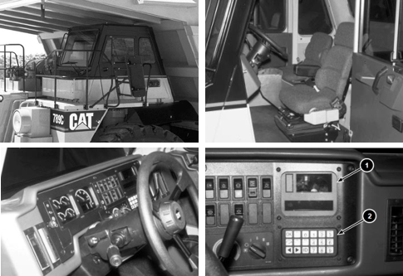

Figure 2 – Visuals of the exterior cab, inner seating configuration and dashboard interface [2].

Commencing the conversation with the employee, a prompt was made for them to voice any concerns with their workspace and no comments were made. However, through further targeted questions, the weaknesses began to amount. Commencing from the ground upwards, the first complaint was the narrow entrance ‘staircase’. Climbing if overweight or even with baggage is, “incredibly difficult”. Following this, a more minor, but common complaint across the operator crews was mentioned. The parking brake is driven by the left-foot as opposed to a button toggled approach. Many believe that it prompts ineffective use as the non-throttle bound foot is commonly resting in the general vicinity while driving and could accidentally actuate the system. From here, larger complaints began to surface, especially concerning the lighting conditions. Glare in the cabin was reported as one of the most difficult factors to overcome, especially at dawn/dusk with direct sunlight. Interior screens (e.g. backup camera) cannot be viewed effectively, and the exterior mirrors beam light into the cabin blinding the operator. Furthermore, on the opposite side of the spectrum, the cabin lighting does not suffice to locate certain controls during nightshift. The employee reported that on many occasions they found themselves using a cellphone light to find certain switches. To add to the list, cabin sealing around the doors/windows was also voiced for two reasons. The first being the diffusion of dust into the enclosed environment. The fine particles contain silica which is incredibly harmful to the capillaries of human lungs. It requires frequent cleaning throughout the shift to prevent excessive exposure. The other reason being the leakage of discomforting sound and a continual ‘hum’ throughout the shift, described in the following section. Lastly, a criticism that the employee also saw as ‘crew-wide’, was the comfort of the driver. Many yearn for an adjustable steering wheel (telescopic/tilting), and a more comfortable seat. It is typical for older drivers to stand when expecting a rough bump or jolt of acceleration, in fear of lower-back pain.

With the above being said, Caterpillar’s engineers definitely also succeeded in many aspects of the historic design. The operator offered compliments towards the interfaces ease of use, in that the buttons are well labelled, and therefore a novice would likely be able to ‘hop-in and go’. Furthermore, they claimed that the visibility from the driver’s seat is impressive, despite the massiveness of the equipment, and that the egress railing system does instill safety in those climbing the staircase or on the deck.

### Lighting and Sound Assessment

Experimental results were desired to quantify some of the cabin’s weaknesses. The operator downloaded phone applications to measure sound levels in decibels and light levels in lux (lm/m2). Sound measurements were taken in two different running conditions, engine idling or engine revving, with two varying enclosure configurations. Light measurements were taken at three different regions within the cab, at three times throughout the shift. Hauling crews run continuously, rotating between dayshift and nightshift. For the given study, the operator was on their day rotation and as such, a variety of lighting conditions were measured.

Table 1 – Noise sound levels collected throughout the shift for the specified conditions.



Table 2 – Light levels collected throughout the shift for the specified conditions.



Assessing the sound levels, some form of a hearing conservation program is undoubtedly required given that the permissible limit for an 8-hour shift is 85 decibels. The operator claimed that common practice was to use disposable silicon earplugs, and also discussed how important it was to follow this guidance. Many situations were described, when employees failed to use the protective sound barrier, and as a result reported temporary deafness and even Tinnitus. This discussion showcased a large area for improvement with the updated design and led to noise reduction research. From here, viewing the light levels, one can first understand the lack of ability to see certain controls in an early morning environment. Furthermore, viewing the Noon levels, the cause of glare across the interior monitor screens is also evident. Lighting adjustments were also required and implemented into the updated design.

# Ergonomic Data

To streamline anthropometric data collection, eliminate measurement errors, and appeal to a wider range of mining personnel, reputable data for a 75th percentile male was sourced from the Anthropometric Survey of US Army Personnel (ANSUR) database [3]. Given its substantial size, only specific measurements, considered beneficial to the design, were extracted. Three reference postures are shown in the figure below, corresponding to standing, sitting (from the side) and sitting (from behind) scenarios.

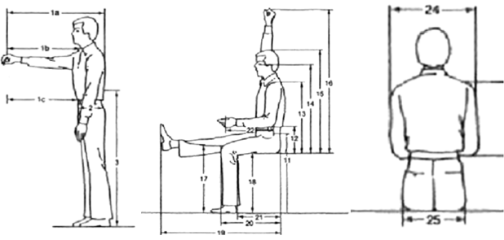

Figure 3 – Three reference postures used to collect anthropometric data for the workspace design.

Each measurement was assigned an index value, and the corresponding results are displayed in the table beneath.

Table 3 – The measurements results extracted from the 2012 ANSUR database.



Developing a 2D workspace envelope, such as Brines or Squires, for a 3D environment was pronounced impractical by Queen’s Professor Claire Davies. Instead, an approach similar to the design of an aircraft cockpit was recommended, in which Digital Human Modelling (DHM) is used. This computational ‘human factors’ methodology allows for the “advanced visualization, simulation and ergonomic assessment” of product development in its early stages [4]. NexGen Ergonomics was chosen as a software provider, and through conversation, a trial-license of their “HumanCAD” SolidWORKS plug-in was obtained. This allowed for the creation of a full-scale anthropometric model in the modelling environment. It also gave the ability to display shoulder comfort zones, the working envelope of each limb, and the capacity to construct static task scenarios within the developed cabin. Comfort zones can be used to classify certain tasks, enabled by shoulder movement, and the length for which they can be performed. Green represents continuously for 2 hours, yellow is intermediate and red corresponds to movements spanning 2 minutes or less [5]. The working envelope tool was used frequently during cabin design iteration to assess the ability of the subject to reach particular surfaces. Examples include the gas or brake pedals, the surrounding dashboard, and the roof controls. It displays the maximum functional reach of each limb while seated in an upright posture and therefore must be used cautiously for controls requiring functional grip. However, this is overcome with the possibility of manipulating the mannequin. It allows for the the visualization of typical movements performed within the workspace, and a validation of the design and reach constraints.

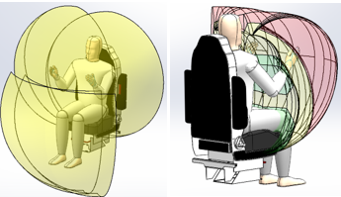

Figure 4 – A display of the workspace envelopes for each limb (left) and shoulder comfort zones (right) for a 75th percentile male.

Given the value of the software described above, calculating dynamic dimensions were omitted from the design process. Nonetheless, if required the ‘Estimation’ method would have been applied in which the dynamic height is 97% of the static, and dynamic arm reach is 120% of static arm length (1a).

# Proposed Design

### New Design Description

The new cabin was designed with user comfort, accessibility, and adaptability in mind. The required cabin controls, feedback from the current operator, experimental data and reach envelopes each played a role in developing the optimal workspace. As a product showcase, two static task scenarios were created within the cabin, shown below.

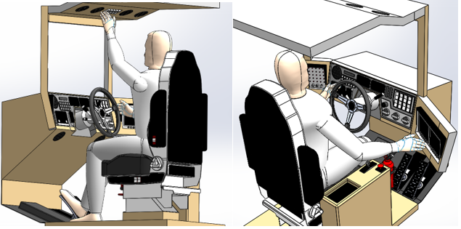

Figure 5 – A functional model depicting two working scenarios within the newly designed cabin.

In the left image, the operator is driving while reaching for a headlight switch in the upper console. In the right image, the truck is being loaded and the operator is planning their next haul with the onboard GPS/Traffic management system. The components contributing to the functionality of the cabin were initially grouped by system in the problem assessment but can also be split by region and will be presented as such. The first diagram represents the front facing dash which is angled at 15 degrees from the vertical and designed such that all surfaces are within the operator’s movement envelopes. The steering wheel was hidden from the assembly to show the components behind.

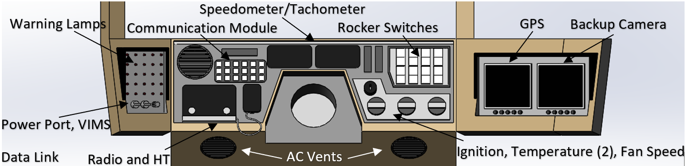

Figure 6 – Main dash assembly labelled with all components shown except the steering wheel.

From here, the center console controls, lower region and upper console are shown. Although the fire extinguisher does not require frequent interaction, it is worth including as it is a requirement of all mine-site vehicles.

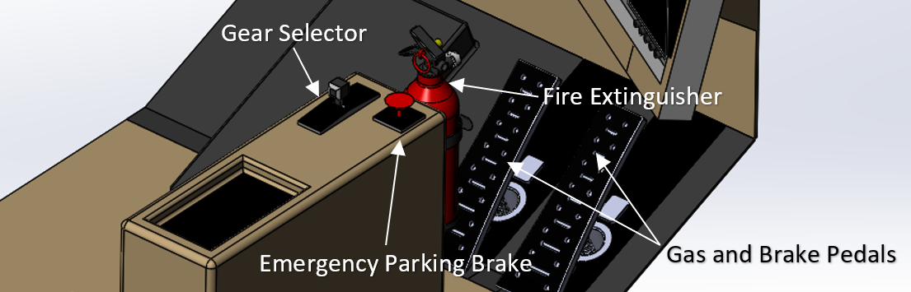

Figure 7 – Center console assembly with the lower region foot pedals displayed.

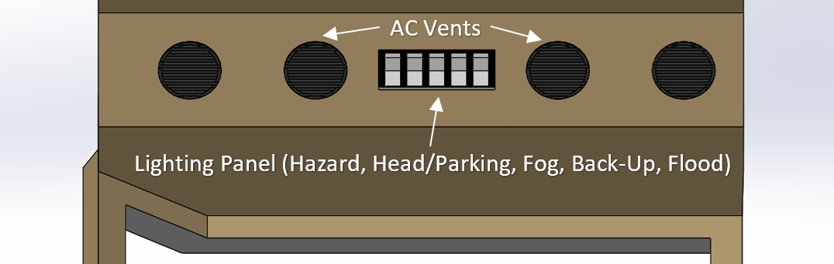

Figure 8 – Upper console of the cabin consisting of ventilation and lighting controls.

Lastly, the adjustability controls are shown along with few other components neglected in the above-presented diagrams.

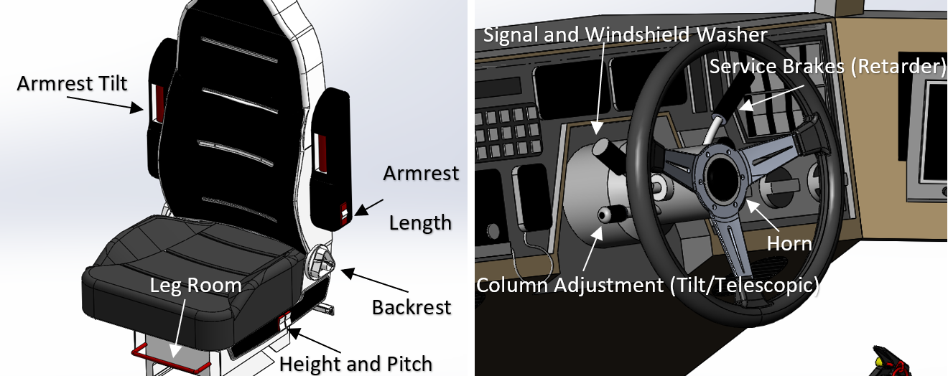

Figure 9 – Adjustability controls of the seat and steering wheel, along with missed center console controls.

As shown, the cabin is a relatively small, volume constrained, space that requires many strategically placed controls. Although one cannot expect complete dimensions of the environment, some of the most critical dimensions can be displayed which assisted with the development of the space. Most have some form of relation to the anthropometric data collected.

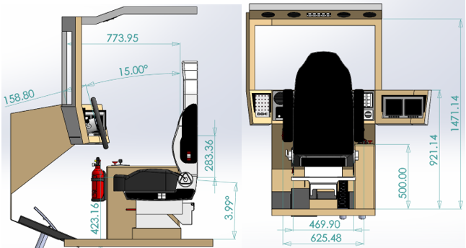

Figure 10 – Critical dimensions of the workspace displayed atop side and rear profiles.

### Justification of Design

The first portion of the design involved introducing the mannequin, an ergonomic seat, and therefore a baseline to design from. One of the key fundamentals of seating design is ensuring that the subject can sit with their feet flat on the floor and have knee angles of roughly 90 degrees. This eliminates the potential of popliteal pressure or hamstring tension, which can potentially lead to several negative effects discussed in the section below. As mentioned previously, the workspace was designed for a 75th percentile male, sitting comfortably in an upright position. The measurement form floor to thigh (18) was approximately 45 centimeters, and therefore a support cushion of roughly this height was required. A pre-modelled seat was sourced from GrabCAD and scaled to optimize both for the popliteal height and also the subject’s hip width of 35.5 centimeters [6]. Having anchored the mannequin to the seat, the rest of the cabin could then progress. The floor and angled pedal surfaces were next. These devices were modelled as ‘heel-operated controls’ and placed in the optimal region as defined by the *Aeronautical Systems Division (1980)* [7]. A validation was performed using the lower-limb work envelopes.

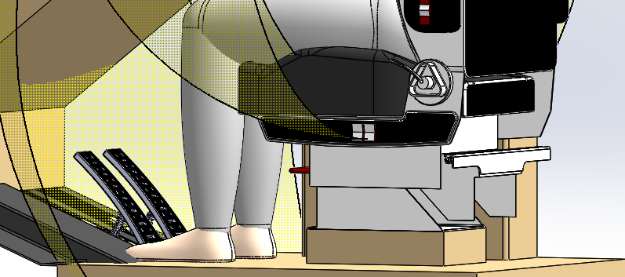

Figure 11 – A display of the lower-limb workspace envelopes (yellow) and the pedals contained within.

From here, a combination of factors played into shaping the dashboard. Analyzing from the side, the heigh of the back floorboard and angle tying it to the dash required an abundance of iteration. Adjustments were made until an appropriate clearance of the 57.75-centimeter knee height was established. Additionally, the height of the dash was somewhat pre-defined by an assessment of the driver’s line of site. It could not be too high as to block vision, but also not undersized as to diminish valuable space for control surfaces. An angle of 15 degrees was chosen for the surface, as found from the *Human Factors in Engineering* text, and the overhead ‘U’ shape was developed using the upper limb work envelopes [7]. The surfaces were positioned such that they rested along the boundaries of the volumes, maximizing dashboard surface area.

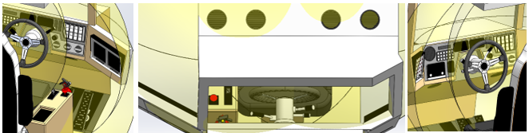

Figure 12 – The haul truck’s dashboard and its relation to a 75th percentile male’s upper limb reach envelopes.

The roof of the cabin was determined in a similar manner. A functional overhead reach of 134.64 centimeters was found in the database and the control surface was positioned such that either arm could comfortably reach the overhead switches or adjust the AC ventilation. Lastly, a center console was added to the right of the seat, placed just above popliteal height, at 50 centimeters. It was created to position the emergency brake and drive selector in comfortable reach, but also to mount the fire extinguisher. In the event of emergency, the pin and pressurized bottle would be conveniently located for the operator to reach.

In terms of upper-limb component layout, certain ergonomic principles were applied, and feedback from the initial interview was incorporated into the design. With the development of any product, the arrangement of controls is typically categorized by importance, frequency of use, functionality, or sequence. For the current design, the most important controls were centralized, accessible with both hands and either a part of the steering column or directly adjacent. This is with the exception of the center console, which contains the gear selector and parking brake. Traversing laterally outwards from the center plane, the degree of importance/frequency of use decreases. An example would be a comparison between the climate control knobs (frequently adjusted) and the outer GPS or backup screens (rare interactions). This follows the principle of developing different classes of controls and placing them as such.

Knowing the faults of the older style cabin, many newer features could be incorporated to mend the issues. With the new design, the steering wheel and seat have increased amounts of adjustability for the user, such that the perceived comfort level is under their control. Furthermore, there is a greater number of vents throughout the cabin which improve air circulation (dust removal) and the climate control. If the user is content with the inner air quality there will be no desire to open windows or the door, exposing themselves to the exterior atmosphere and substantial sound levels. Another key addition are the horizontal sun guards which shelter the two 6-inch display screens and panel of warning lamps. The deflectors prevent glare, allowing for a luminance ratio of at least 3:1, and therefore foster more effective usage. Lastly, the exalted switch and button labels throughout the cabin were preserved, but with the addition of backlighting for low-light conditions. During a nightshift there have been complaints voiced towards the legibility of descriptive text throughout the cabin and with the new design these should be waived.

### Seating Justification

One of the most important factors of any cockpit or cabin design is the seating. It is one of the only components that the operator is continuously interacting with and can therefore ‘make-or-break’ the experience. As stated by Bronson Du from the University of Waterloo, “professional truck drivers are at an increased risk for musculoskeletal problems such as lower back pain due to prolonged sitting, poor posture and whole-body vibration (WBV)” [8]. This same logic is applicable to a mining environment, but worsened due to the uneven terrain, substantial engine vibrations and non-uniformity of motion throughout the shift. There are many more sudden accelerations or starting and stopping situations when hauling within an open pit operation. Three seats were compared to decide upon the most optimal product. Regardless, it was assumed that some form of suspension was a necessity across all products to dampen cabin vibrations and the rough impacts of the terrain. The products are discussed in sequential order from worst to optimal.

The first, and cheapest solution, is Bostrom’s Baja Series truck seat [9]. It is a non-isolating, hi-back, air ride suspension chair praised for its ‘Flex Support Cushion System’. The product claims to be ergonomically designed and is made of vinyl, known to be durable in ‘demanding’ environments. The issue is the lack of isolators incorporated into the design. These are known to mitigate ‘rocking’ motion when the truck is accelerating and are necessary for an enticing product to be used in a haul-truck. Another solution, with an increased price, is Bostrom’s Wide Ride Serta Seriesseat [10]. It rests atop an isolating scissor suspension system with a high-performance damper that provides a smooth ride for long journeys. It is praised as a premium seat, and claimed to be the ‘most comfortable in the market’. It is covered with Serta’s Cool Action Gel memory foam which provides support and allows for the diffusion of heat away from the body. In offers incredible adjustability, including the tilt of both cushions and an innovative ‘BackCycler’ system that continuously inflates and deflates the lumbar region, preventing postural fixity. If an air-ride suspension seat were to be chosen, it would be the ideal candidate. However, one further improvement was possible, inspired by a study performed by Du relating to whole-body vibrations [8]. Active vibration-cancelling seats can reduce WBV by up to 50% on average, which can reduce the impact of adverse health effects like “headaches, sleeping problems and lower back pain”. The theory was proven through a study comparing the results of a Psychomotor Vigilance Test after trucking on either air-ride or active vibration-cancelling (EAVC) seats. Evident improvements in reaction times were observed over the course of a shift for EAVC users, which justified their worth. A diagram visualizing the motion of an operator in comparison to the road surface is displayed for both types of seating.

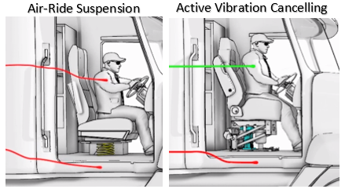

Figure 13 – A visualization performed by ClearMotion highlighting their EAVC technology [11].

Undeniably, this technology should be implemented in a budget free design study. ClearMotion is a leading provider of this advanced suspension technology and were chosen as a distributor for the product [11]. High precision sensors sample the cab motion over time, an internal processor computes the optimal reaction, and the motor counteracts the motion. Through endless population samples, the technology has proven to improve driver health, reduce back pain and diminish fatigue. Aside from the suspension, the seat offers an ergonomic design, adjustability, and an assortment of upholstery options.

### Sound Reduction Investigation

Analyzing the sound levels presented in the ‘Current Design’ section, an operator without hearing protection in the workspace would likely cause permanent damage both to the hair cells of their inner ear and the auditory nerve. At 102 dBA, the maximum permissible time of exposure can be calculated using OSHA Regulations.

(1)

This span is far from the length of the 12-hour shifts completed for 5 straight days. However, most individuals do wear ear plugs as a personal protective device, and the reduction can be quantified. With perfect usage, the typical NRR rating for a pair of 3M foam earplugs is roughly 29 dB [12].

(2)

The reduced value is still above the allowable limits, but likely acceptable given that 102 dBA is experienced only during peak situations. Regardless, the maximum permissible time can again be calculated.

(3)

Observing these results are frightening, especially for a younger operator planning on a lifelong career in the field. A permanent threshold shift would most certainly be expected, known as noise-induced hearing loss (NIHL). On top of this, conversation with a listener inside the cabin, or across the radio network would be incredibly difficult and require continual shouting. Lastly, system alarms and other vehicle horns would likely blend in with the perceived noise, making them challenging to hear. Ideally, some form of further noise reduction is required atop the use of traditional earplugs.

A study was performed across the United States where the cabin noise of haul trucks at 117 mine sites were sampled and assessed [13]. Across the entire investigation, greater than 90% of equipment exceeded the permissible exposure limit (PEL). The largest source of noise was generally the engine, which radiated sound by the exhaust, intake, and cooling fan. However, there are also other sources of noise such as the transmission, high-speed powertrain, or the hydraulic system. The two regions to apply noise control, other than at the receiver, are at the source or along the transmission path. Speaking in terms of the ‘source’, one can use mufflers, gaskets, or an enclosure to control emitted noise. Along the path, practices include the addition of barriers, dampers, or sound absorbent material surrounding the cabin. This would typically be a soft and porous material such as flexible polyurethane foam. Returning to the study results, cabins with these practices already implemented were classified as ‘newer-style’. The sample population consisted of 26 pieces of machinery, all of which measured cabin sound pressure levels beneath the 90 dBA PEL. A mean of 67.7 dB was measured with a standard deviation of 16.2 dB. Therefore, it is reasonable to state that the updated cabin model should apply the above-mentioned methods such that the exposure level can be reduced to a more appropriate level. Other methods of reduction, as mentioned by a graduate student from Queen’s, would be to reduce the radiator fan speed, avoid engine ignition frequency from cab acoustic modes, use thicker steel plating for the floor, reduce cabin leaks, or to use laminated glass for the enclosure windows.

### Lighting Analysis

The final portion of design work for the cabin involved an analysis of the required lighting. During daylight hours it was reported that natural lighting was sufficient to see all of working surfaces and controls. However, when operating amid a nightshift, many operators complained of the poor cabin lighting quality and would agree that an improved system would be beneficial. A straightforward analysis was performed to determine the optimal lamp to illuminate the cabin.

Given that only occasional visual tasks are performed within the environment, the cabin would likely fall under a Category C interior space with a suggested illuminance range of 100-200 lux. Designing for an individual under the age of 40, the lower of the threshold could be used. From here, the luminous intensity (cd) was found using a work surface to light distance of 97.1 centimeters. This corresponded to the center console controls which are the ‘worst-case’ scenario and should be dealt with primarily.

(4)

The required luminance could then also be calculated by dividing the required intensity (candela) by the area of the room (meters squares). Using the assembled CAD model, the area was estimated to be 0.833 meters by 1.56 meters, or 1.3 meters2.

(5)

Seeing that a wide range of colors will be present throughout the cabin, and not wanting to ‘gray-out’ any of which, a deluxe cool-white lamp will be used. These bulbs have a color temperature of 4100 K and a color rendering index (CRI) of 89. With these, the ideal lumens output is 2950. Comparing to the desired luminous intensity, one of these bulbs centrally mounted will effortlessly illuminate the environment. During a nightshift, an operator could toggle the lamp and expect to see all of the interior controls effectively.

# Conclusion

### Design Process Overview

Reviewing the design practice applied reveals that the project developed in a manner inordinately similar to a typical “Engineering Design Process”. Over the course of several summers working in a mining environment, many complaints were voiced towards the extended use of outdated equipment. Weighing this, along with the knowledge of an older style fleet of haul trucks at a local site, defined a clear problem to be analyzed. From here, background research was then collected to further understand the user interaction/control of the equipment and the ergonomic issues present. This information was sourced both from field-level knowledge, or through data collection and secondary studies that had been concluded previously. Next, the project requirements were determined, and preliminary brainstorming and sketching periods were complete. Gaining feedback fro m the employee on these results, the cabin surface design process was then begun and iterated. Once the environment was perceived as functional, and well suited to the work envelopes of the subject model, the modelling was finished. Certain task scenarios could then be created to validate the space. Lastly, an optimal seat was chosen, and the sound reduction and lighting levels were quantified using ergonomic principles. The results were surprising given that the sound levels were still above the permissible limits when using earplugs.

Updates to the existing design and added improvements can be summarized to clarify the outcomes of the study. Certain controls, like the emergency parking brake, were relocated and altered in shape or function for more intuitive use. As a whole, the cabin surface placement was optimized according to the reach envelopes of the subject, and the controls were positioned more efficiently. Primary controls like the steering wheel, ignition or horn were placed centrally, and secondary, less frequently used controls, were located near the borders of the cabin. Furthermore, components requiring visibility, like the display screens or light error board, were mounted under a sun guard to prevent glare, a commonly reported cabin issue. Adjustability was improved in the cabin, both with the addition of steering wheel controls (tilt/telescopic) and a more ergonomic seating system. Lastly, methods were proposed to reduce the cabin noise to a more desirable level, and a lighting assessment was performed to fit the cabin with an ideal lamp source.

### Future Recommendations

Completing the study, certain aspects of the design were naturally simplified or omitted in the essence of time and the prevention of complexity. Some items included in this were the non-cabin related equipment issues highlighted by the operator, certain ergonomic design practices and several advanced engineering models.

Aside from the shelter, further ergonomic design analysis should be applied towards the steep, narrow entrance staircase and the mounting brackets that restrain the wheel chalks when the vehicle is in motion. It was reported that many employees struggle with lifting these 20-pound blocks from the current position, which nears shoulder height. If the crews continue to do as described, there is a large potential for either lower back pain or injury. Within the cabin, there are many further analyses to be done. Firstly, a visibility assessment should be completed to verify that the enclosure is up to standard, and such that the worker is positioned to operate effectively. NexGen Ergonomics offers an additional SolidWORKS plug-in for this and would likely be used. Further, a reduction in whole body vibrations (WBV) was mentioned, but the actual cabin vibrations should either be measured experimentally or simulated in a computer environment. This would give a more thorough understanding of the actual amount of reduction generated with an active vibration cancelling seat. Another area to expand upon would be the dynamic modelling of different size mannequins performing a variety of tasks within the workspace. This would validate the adjustability of the seating or steering wheel and ensure that all components could be reached as required. Additionally, a material analysis of all surfaces should be performed. This would enable the prediction of wear and the possibility of determining light reflectivity or sound absorptivity. In turn, the sound and lighting models accuracy would be improved. Lastly, Fitts Law should be applied to all controls and pedals to determine their respective indices of difficult and link or sequence studies should be completed. These would work to certify the current placement of controls or provide suggestion towards a more optimal layout.

# References

[1] “785D Mining Truck / Haul Truck | Cat | Caterpillar,” *https://www.cat.com/en_US/products/new/equipment/off-highway-trucks/mining-trucks/18089285.html*. https://www.cat.com/en_US/products/new/equipment/off-highway-trucks/mining-trucks/18089285.html (accessed Mar. 12, 2021).

[2] “manual 789c - 785c - [Download PDF],” *fdocuments.net*. https://fdocuments.net/document/manual-789c-785c.html (accessed Mar. 12, 2021).

[3] “Anthropometric-Detailed-Data-Tables.pdf.” Accessed: Mar. 12, 2021. [Online]. Available: https://multisite.eos.ncsu.edu/www-ergocenter-ncsu-edu/wp-content/uploads/sites/18/2016/06/Anthropometric-Detailed-Data-Tables.pdf.

[4] L. Irshad, S. Ahmed, O. Demirel, and I. Y. Tumer, “Coupling Digital Human Modeling with Early Design Stage Human Error Analysis to Assess Ergonomic Vulnerabilities,” in *AIAA Scitech 2019 Forum*, 0 vols., American Institute of Aeronautics and Astronautics, 2019.

[5] “NexGen Ergonomics - Products - HumanCAD-MQSW.” http://www.nexgenergo.com/ergonomics/humancad2-MQSW.html (accessed Mar. 12, 2021).

[6] “Truck Seat, Heritage Silver | 3D CAD Model Library | GrabCAD.” https://grabcad.com/library/truck-seat-heritage-silver-1 (accessed Mar. 12, 2021).

[7] M. S. Sanders and E. J. McCormick, *Human Factors In Engineering and Design*, 7th edition. New York: McGraw-Hill Education, 1993.

[8] B. Du, “Effects of Seat Suspension Types on Truck Drivers’ Vigilance.” 2015, Accessed: Mar. 11, 2021. [Online]. Available: https://core.ac.uk/download/pdf/144148986.pdf.

[9] “Baja,” *Bostrom Seating*, Nov. 14, 2018. https://www.bostromseating.com/en-us/product/configure/seat/21531 (accessed Mar. 12, 2021).

[10] “Wide Ride+Serta®,” *Bostrom Seating*, Nov. 14, 2018. https://www.bostromseating.com/en-us/product/seat/wide-ride-serta (accessed Mar. 12, 2021).

[11] “Active Suspension Seat.” https://www.clearmotion.com/active-suspension-seat (accessed Mar. 12, 2021).

[12] “3MTM Foam Earplugs, Uncorded, 1100, 200 Pairs | B34757 - GLOBALindustrial.ca.” https://www.globalindustrial.ca/p/safety/ears/hearing-protection/3m-tm-foam-ear-plug-1100-1000-case?infoParam.campaignId=T9F&gclid=Cj0KCQiAnKeCBhDPARIsAFDTLTKofaCSRSOCGXsNBSLsiB0u6ew0MKomSMVAN4-ahcbZxk6Z5KNUwWcaArIlEALw_wcB (accessed Mar. 12, 2021).

[13] S. B. Bealko, “Mining Haul Truck Cab Noise: An Evaluation of Three Acoustical Environments.” Pittsburgh Research Laboratory, NIOSH, Accessed: Mar. 10, 2021. [Online]. Available: https://www.cdc.gov/niosh/mining/UserFiles/works/pdfs/mhtcna.pdf.