Assignment 3

Law Enforcement Crash Form

By Spencer Downey

10/3/2020

**Hardware and Software Requirements**

* Hardware
  + Police Laptop or Desktop Computer
* Software:
  + Google Chrome (Recommended), Safari, Mozilla Firefox, or any other web browser
  + Windows 7, 8, 8.1, 10 or later. For Mac, use OS X Yosemite 10.10 or later

**Interface Metaphor & Interaction Type**

* Interface Metaphor
  + Web Portal/Application
* Interaction type
  + Instruction – mainly just asking questions/prompts and getting them to select or type an answer or response

**Lexicon**

Incident, Witness, Testimony, Event Description, Hazards Present, Collision Type, Injuries Sustained, Liability Policy

**Scenario**

When Officer Bill heads to fill out a uniform traffic accident report, he first opens the application where he is greeted with a prompt to login using his work email, password, and his officer ID number. After signing in, he is immediately taken to a page to begin filling out a new crash report. This page shows the boxes for filling out the location and time portion of the report. After he finishes filling it out, he can click next to move on to the next section. When he clicks next, he will be taken to the vehicle and driver information section, and from here he will continue to fill out the form, happy that it isn’t too different from what he normally does and even makes it quicker through the use of drop down selection rather than having to type everything out. In the end, he can submit the form and close the application.

**Persona**



Officer Bill - **Age**: 58 **Sex**: Male **Status**: Single **Occupation**: Highway Patrol

**Location**: Dothan, AL

**Motivation**: Officer Bill has been a police officer for over 30 years. He has learned that a new way of entering in crash information is coming, and he’s worried that it will be too different from what he’s used to. He wants to learn how to effectively use it and does not want to seem like a burden by having to ask for help with it.

**Goals:** (1) To learn how to use the new system on his own. (2) To continue to be an effective officer with use of this system.

**Frustrations:** Having to adapt to a new way of doing things when he’s been doing it the same way with minimal change the past 30 years.

**Empathy Map**

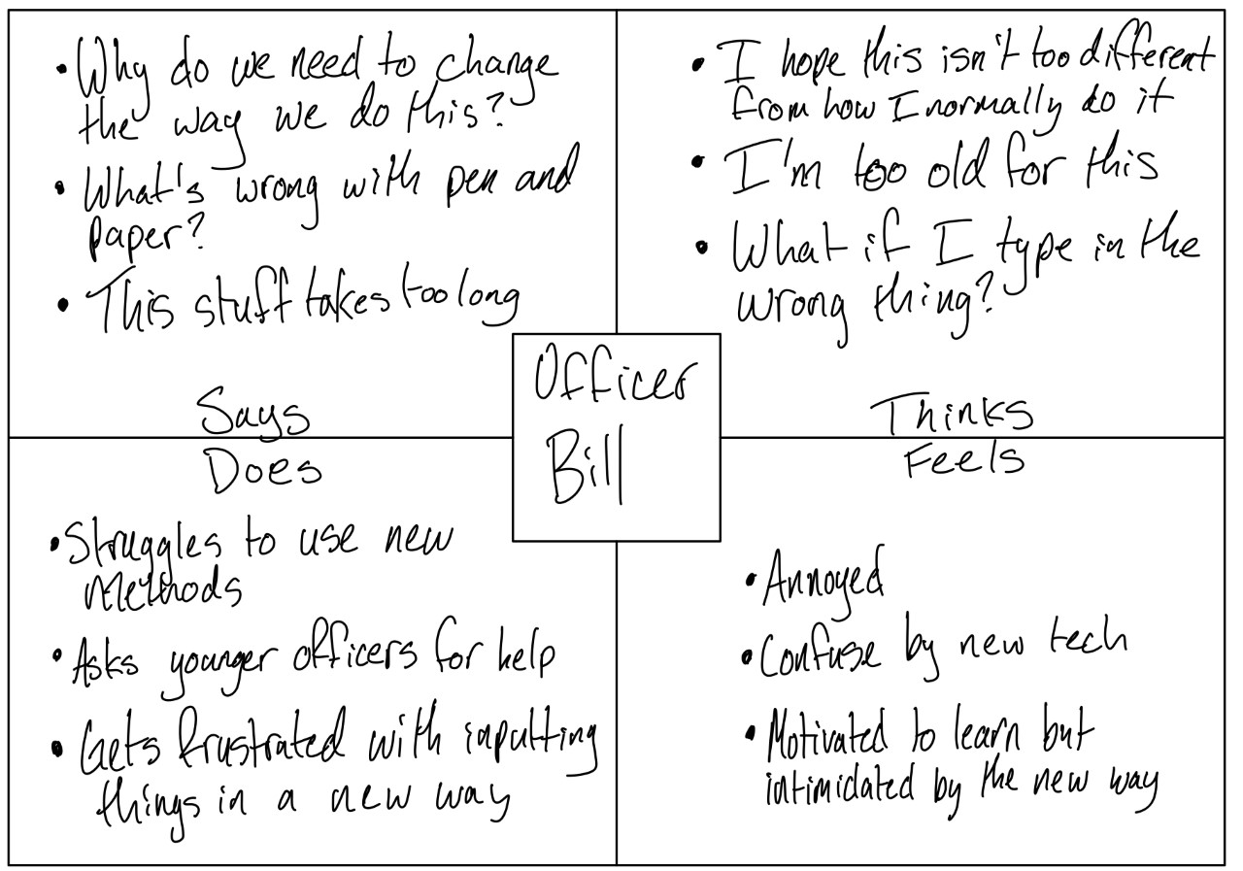

**Prototype**



