This is a new issue that happened in BW but normally user should not allow to do but it happened and we may to fix the data , then we see how the program should work here

What BW did was for Vendor  MCLEN001 they issue a  PO # 30959 for Non Inventory Item

MISC  for Qty 4 and did the good received QTY 4 and then when they did the AP invoice they load from PO and then change the Item Code to a Inventory Item  PCB1MSC and it created a Trans Number # 510152. and now it did another Inventory received for 4 QTY

and also it did another receive for 4 QTY and now Inventory item PCB1MSC

I have attached the Inventory report that show we have received 8 items but where it should be 4 items what BW says

Check the attached document for the inventory report 3 pages there

for now give me a data fix to fix this issue so they can proceed with inventory release

Below what client sent us in the Case 00098348

I entered an invoice for vendor MCLEN001, po # 30959.  
The Po was created using MISC, but it's an inventory item.  
To enter the invoice:  
I used the create from PO dropdown, selecting the correct PO number.  
I changed the MISC and used the inventory item code PCB1MSC.  
The report shows that there were 8 items received, but it should be 4.  
Trans# 510152.  
Can someone have a look.

Pre-Setup / Configuration

New Inventory Item

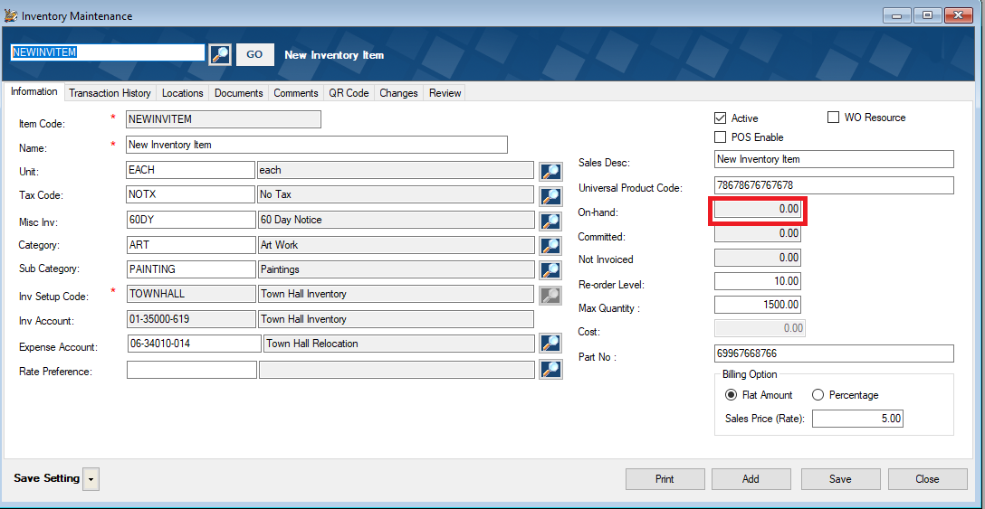

PO for non Inventory Item

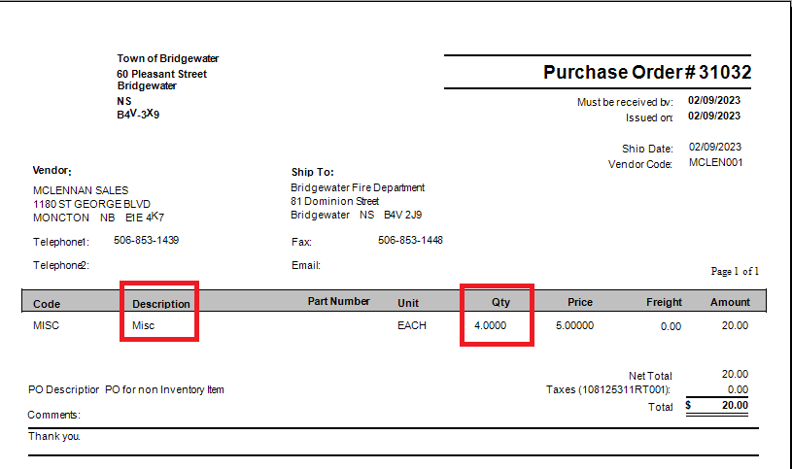

SQL

select \* from podist



select \* from pogldist



select \* from podisttrans



GRN for Non Inventory Item

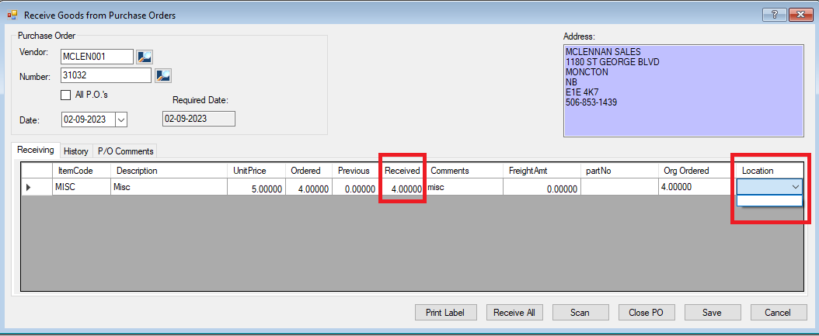

AP Invoice

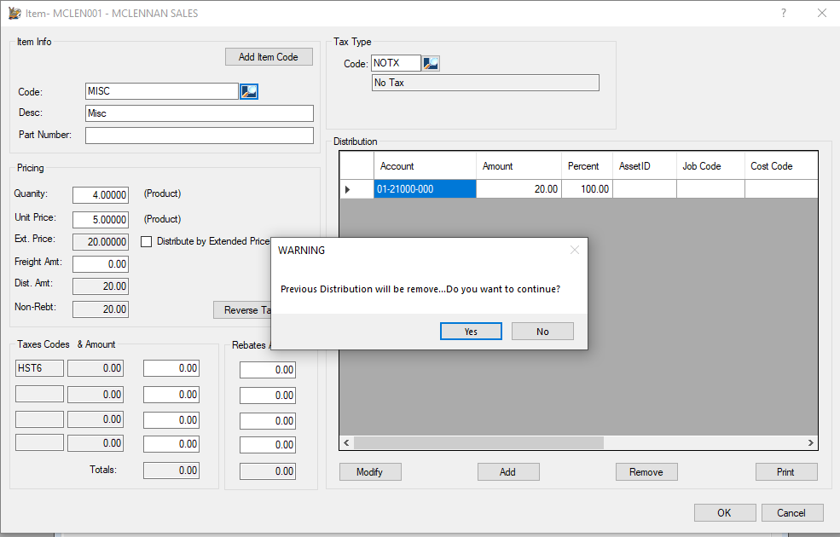

Change to New Inventory Item, edited no of times

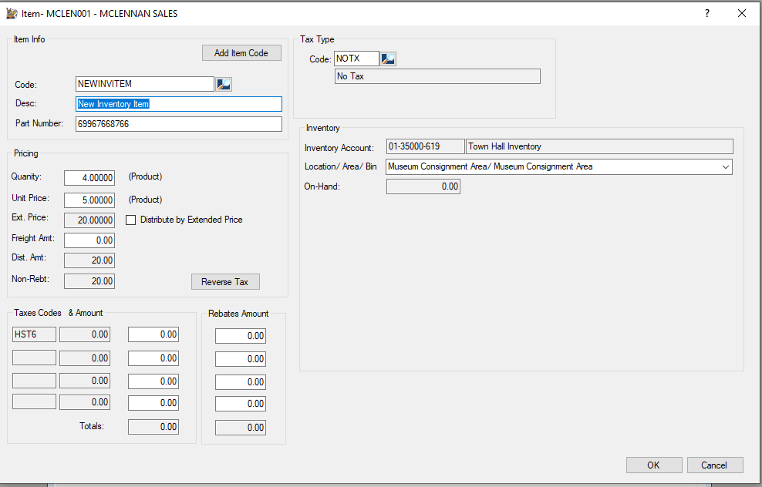

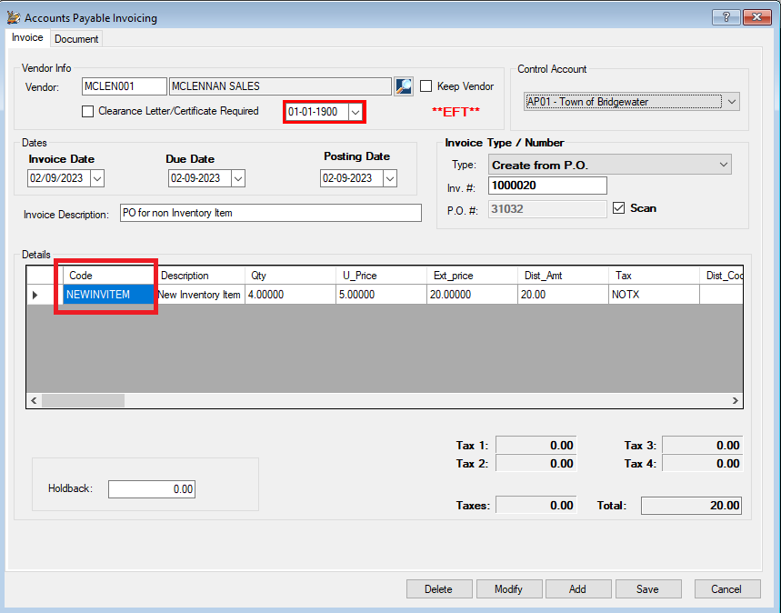

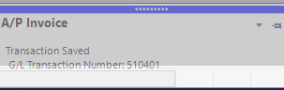

510401

SQL

Invstock





GLtrans



Inventory Item

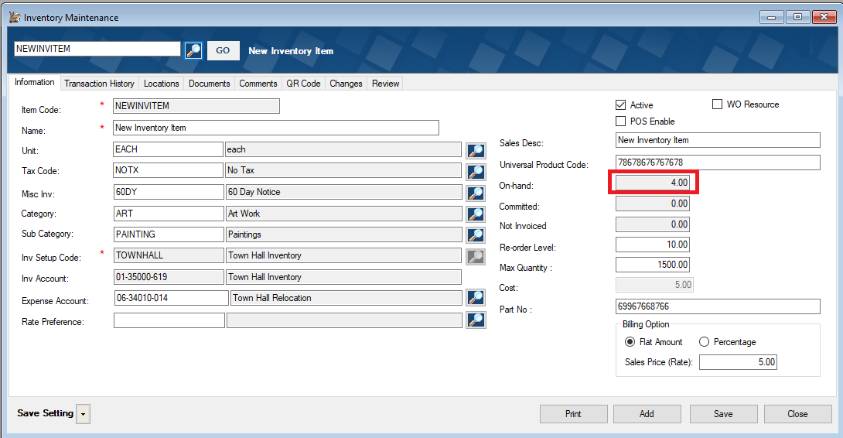

Inventory Transaction

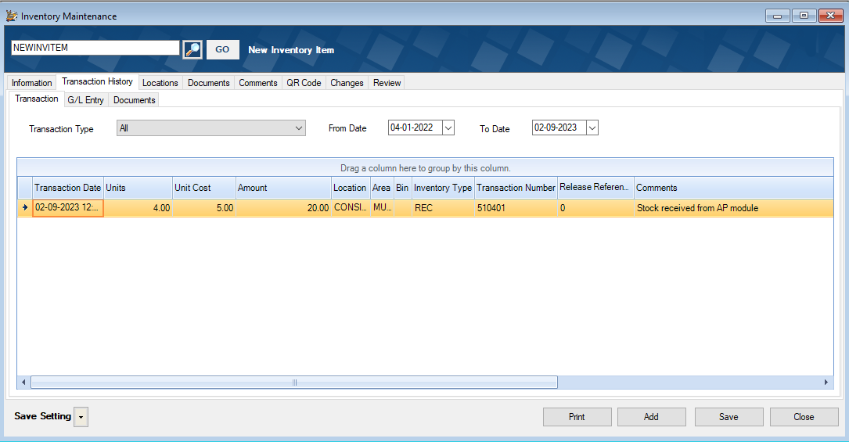

GL Entry

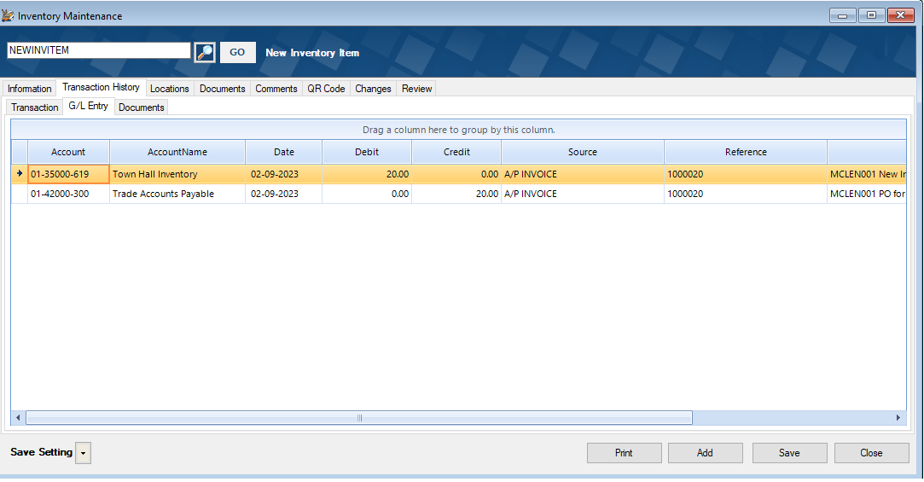

Works perfectly, cannot re-produce