Statistical Comparison of Connectomes in Subjects Suffering from Major Depressive Disorder

Spencer Matei Olson  
i6206490

Course: MSB1014, Network Biology  
Program: Master Systems Biology  
Faculty: FSE  
Academic Year: 2024/25

Date: 18 October 2024

# Introduction

People suffering from Major Depressive Disorder (MDD) experience feelings of sadness, emptiness, or hopelessness in addition to lack of motivation, insomnia, general fatigue, and many other mood altering symptoms. This can lead to a significantly lower quality of life for people suffering from the disorder [1]. Treatment of MDD can be varied and ranges from medications such as SSRIs and SRNIs, to psychotherapy and electroconvulsive therapy. Generally, a combination of these treatments achieves the greatest effect, however, some patients do not respond to certain therapies and this can add unnecessary stress to the patient as they seek appropriate treatment [2].

Some studies have shown that the physical axonal projections of neurons between brain regions (referred to collectively as the structural connectome for the rest of this report) of MDD patients are significantly altered (typically loss of connectivity), and could play a large role in predicting the outcome of treatment plans for patients [3–7]. These studies have also shown that the structural connectome disruptions can be correlated to a loss of cognitive functions that involve working memory and object recognition [7]. This research suggests that understanding the structural connectivity of brains affected by MDD may provide valuable insights into the mechanisms that alter cognition and how the illness may be treated.

In this project, I will investigate an independent dataset containing the connectomes of subjects, some of which have been diagnosed with MDD, with the aim of replicating the findings found in previous papers. More specifically, to identify differentially connected brain regions, identify gain or loss of connectivity and link them to cognitive functions. Ultimately, the aim of this research is to replicate the loss of structural brain connectivity found in previous literature.

# Materials and Methods

All scripts and data are stored in a GitHub repository and can be found here: <https://github.com/spencerolsondke/Network-Biology-Project>

## Dataset

The dataset is sourced from the NKI1 dataset [8] which contains 3 patients diagnosed with MDD and 13 controls. Each subject was imaged twice therefore providing 6 MDD images and 26 control images. Each of their connectome networks have already been inferred with 35 different parcellations of the cortex using the m2g pipeline [9]. These networks were provided as a sparse connectivity tables and were read into a Python script.

## Parcellations

The first step in this project was to decide which parcellation would be most appropriate for this investigation. The choice of parcellation is important because it affects the subsequent statistical analysis that is done. Given that the dataset only contains 6 MDD connectomes, the power of the study may not be strong enough to find significantly different network components in high resolution parcellations. After experimenting with different parcellations, the Brodmann parcellation was chosen for its commonly accepted division of brain regions and its relatively low region count, containing 41 parcels.

## NBS

To identify the statistically significant differences in connectivity between MDD and control groups, the network based statistic (NBS) was used. NBS is a two-step method that uses permutation testing to find network components that are defined by differentially connected edges. First, components of the network are built by selecting edges that have an unpaired t-test score higher than some threshold, *F*, when comparing between the two groups. To control for the family-wise error rate, a null distribution of component size is estimated by randomly exchanging group membership and performing the same component construction *M* times. The size of the original component is then compared to the null distribution to assign a p-value to the network component [10]. In this study, an F threshold of 2.7 was selected as this was the highest value at which statistically significant components could be found (assuming p-value <= 0.05) . NBS is most popularly implemented in the Brain Connectivity Toolbox for MatLab, but the Python port, bctpy, was used for this project [11].

## Clustering

To interpret the components retrieved through NBS, they were clustered into modules. These modules can be compared individually against literature to interpret how the change in connectivity may affect brain function. The Girvan-Newman algorithm was used for clustering and it was implemented in R (RCy3 package) and Cytoscape (GLay plugin).

# Results

## NBS

NBS using the 26 control and 6 MDD connectomes as two experimental groups produced the network seen in Figure 1. The p-value of this component was exactly 0.05 after rounding to the 4th decimal place. The resultant network contains 30 nodes and 44 edges that were identified to be significantly under- or overconnected in MDD patients. The value of each edge is defined as the log2 fold-change between controls and MDD subjects (positive value means higher value in control)

## Clustering

The clustering resulted in 4 modules that consisted of 13, 9, 4, and 4 nodes respectively. Each cluster also contained 14, 17, 4, and 3 edges respectively. The two largest modules are shown in Figure 2. Each node is then colored based on their general location in the brain. In the first module (Figure 2A), 6 out of 9 nodes are located in the temporal lobe and all the edges represent a loss-of-connection in these regions. In the second module (Figure 2B), 11 out of 13 nodes are connected to Brodmann area 28, with very few differential connections between node 28’s neighbors.

*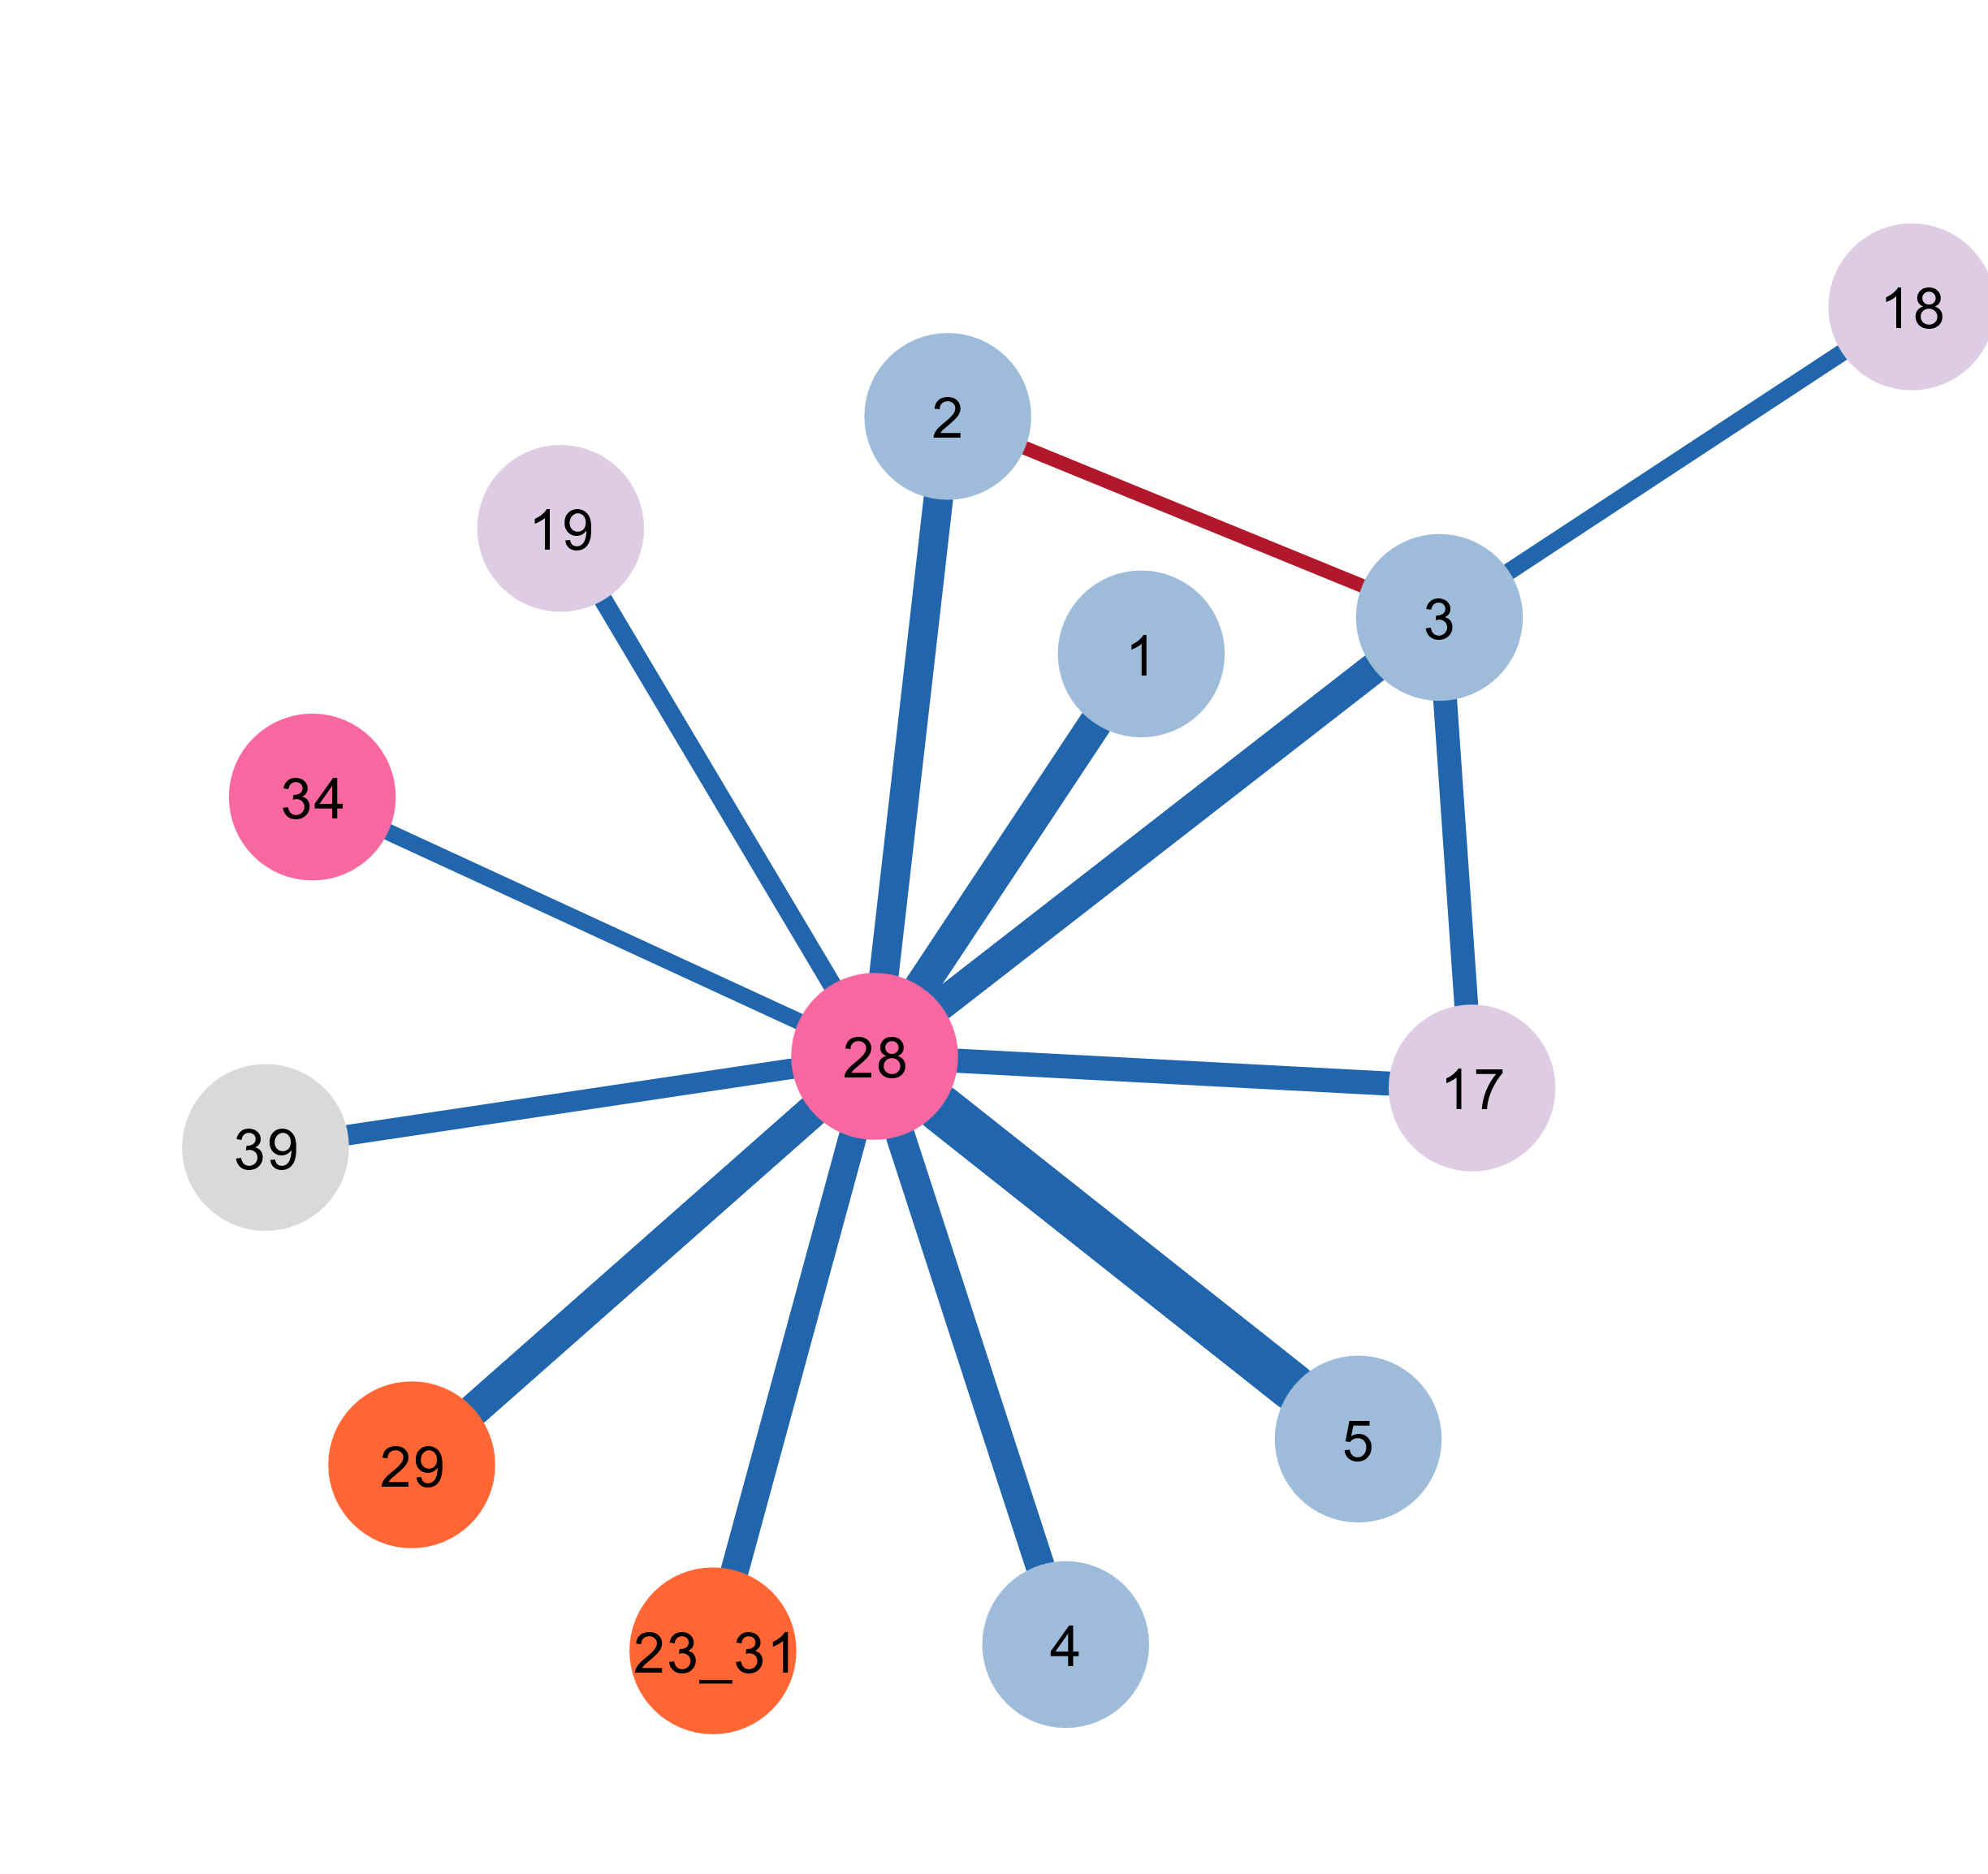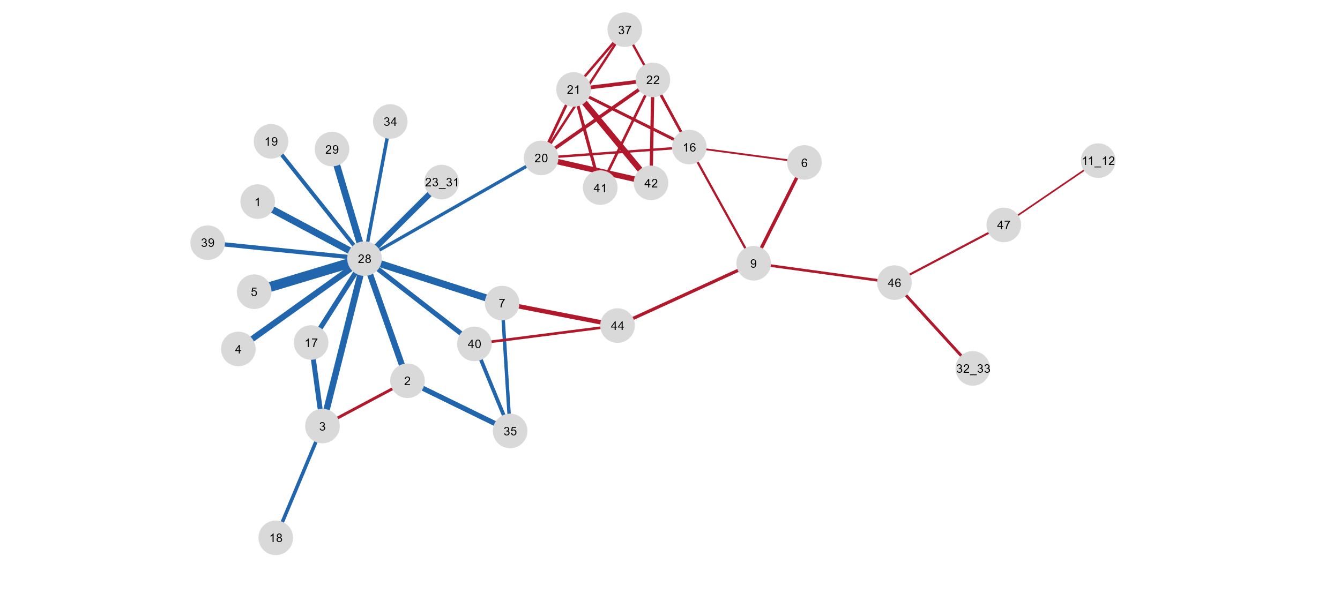Figure 1: Resulting network from NBS. The edges represent the differential connections between the MDD group and the control group. The nodes represent the Brodmann areas of the brain and the label describes which Brodmann area they correspond to*

*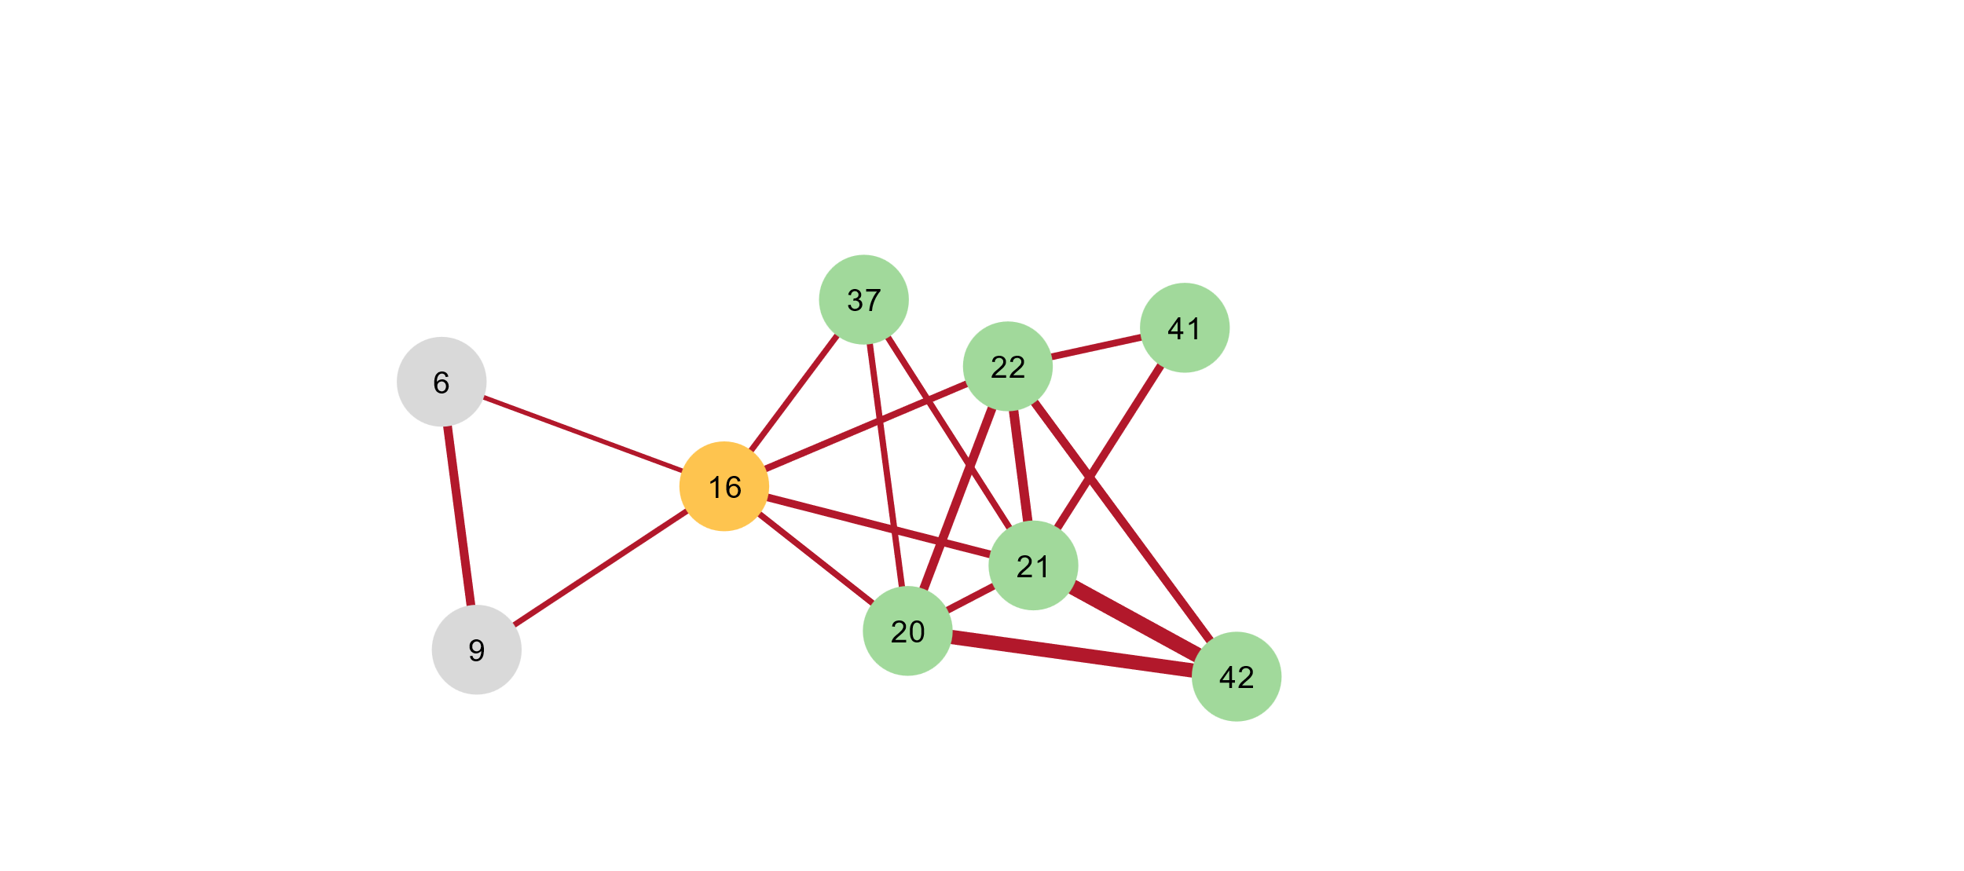Figure 2: The two largest clusters found using Girvan-Newman algorithm. Edges are represented the same as Figure 1. Nodes are colored based on larger scale organization and location in the brain. Nodes left in gray were not considered in the discussion of this project. (A) Module that characterizes the loss-of-connection in the MDD group. Most of the affected nodes are found in the temporal lobe (B) Module that characterizes the gain-of-connection in the MDD group. Nodes are more diverse in location and most nodes affected are projected from the entorhinal cortex*

B

A

# Discussion

The primary aim of this project was to identify whether the loss-of-connection in the structural connectome in MDD subjects could be replicated, and if so, to link it to the loss in cognitive function that was also found in literature. The results obtained through NBS and the clustering of its output found two modules of differential connectivity, one representing a loss-of-connection and another representing a gain-of-connection.

The first module found (see Figure 2A), shows a general loss of connectivity in the temporal lobe (represented by the lime colored nodes). More specifically, Brodmann areas 20, 21, 22, and 37 are all involved in higher level cognition and information processing. Area 20 plays a crucial role in the processing of visual information as it is a part of the dorsal processing stream which is responsible for the recognition of visual patterns, faces and objects [12]. Area 21 plays a similar role in facial and object recognition, but has also been shown to be involved in the interpretation of word meanings [13,14]. Area 22 is involved in facial emotion recognition and studies have also shown that it is a crucial region in the processing social contexts and cues [15,16]. Area 37 similarly plays a role in face, body, and word recognition and has been linked to synesthesia and dyslexia [18–20]. Finally, area 16 (insular cortex) has been shown to play a large role in abstract cognition such as interoception, self-awareness, pain, and abstract decision-making [21–24]. Overall, the loss of connection in these cognitively important brain regions aligns with the findings in literature that showed that subjects with MDD had a loss of connection in the temporal lobe that directly correlated with hindered performance in verbal learning tasks [7].

The second module (see Figure 2B) is characterized by a significant gain-of-connection in the MDD group. The structure of the module clearly shows that the increase in connectivity is primarily centered around Area 28. These connections are projected to diverse brain regions such as the parietal lobe (somatosensory and premotor cortices), the visual cortices, and parahippocampal brain areas. Area 28 is generally regarded as a major input/output structure for the formation of memory and acts as a network hub between the hippocampus and the neocortex [25] and so this diverse connectivity is expected. However, given that studies have shown a deficiency in memory tasks for MDD patients [7,26], it is surprising to see the connectivity of the entorhinal cortex being much higher in the MDD group. Research has found that the pathway between the entorhinal cortex and the visual cortices has a large role in regulating depressive symptoms and the loss of function in this pathway exacerbates such symptoms [27,28]. However, it has also been shown that all major groups of antidepressant medication specifically target the entorhinal cortex by activating it [29]. Therefore, the higher brain connectivity of the entorhinal cortex found in the second module could be directly related to the treatments that the MDD subjects underwent.

The methods used in this project were fairly simple, a network based statistical test and a rudimentary clustering algorithm. However, the simplicity of these methods allows for the easy processing of large amounts of data, the kind found in connectomic studies. Conversely, because of the large amounts of data in higher resolution connectomes, finding statistically differential subnetworks between groups requires many more subjects than is commonly available. This limits the maximum resolution that can be used to find statistically significant results.

In conclusion, the results of previous studies identifying disrupted structural connectivity in MDD subjects were replicated in an independent dataset. Specifically, the loss-of-connection found in the temporal lobe related to cognitive function aligned with previous research. Additionally, a module that could be related to the effects of antidepressants was also found, however without any data on the treatment of the MDD group, this cannot be confirmed.

# References

1. Mayo Clinic [Internet]. [cited 2024 Oct 4]. Depression (major depressive disorder) - Symptoms and causes. Available from: https://www.mayoclinic.org/diseases-conditions/depression/symptoms-causes/syc-20356007

2. Bains N, Abdijadid S, Miller JL. Major depressive disorder (nursing). In: StatPearls [Internet]. StatPearls Publishing; 2023.

3. Repple J, Mauritz M, Meinert S, de Lange SC, Grotegerd D, Opel N, et al. Severity of current depression and remission status are associated with structural connectome alterations in major depressive disorder. Molecular psychiatry. 2020;25(7):1550–8.

4. Chai XJ, Hirshfeld-Becker D, Biederman J, Uchida M, Doehrmann O, Leonard JA, et al. Functional and structural brain correlates of risk for major depression in children with familial depression. NeuroImage: Clinical. 2015 Jan 1;8:398–407.

5. Hubbard N, Siless V, Frosch I, Goncalves M, Lo N, Wang J, et al. Brain function and clinical characterization in the Boston adolescent neuroimaging of depression and anxiety study. NeuroImage: Clinical. 2020;27:102240.

6. Yun JY, Kim YK. Graph theory approach for the structural-functional brain connectome of depression. Progress in Neuro-Psychopharmacology and Biological Psychiatry. 2021;111:110401.

7. Gruber M, Mauritz M, Meinert S, Grotegerd D, de Lange SC, Grumbach P, et al. Cognitive performance and brain structural connectome alterations in major depressive disorder. Psychol Med. 53(14):6611–22.

8. Enhanced Nathan Kline Institute - Rockland Sample — Nathan Kline Institute - Rockland Sample documentation [Internet]. [cited 2024 Oct 4]. Available from: http://fcon_1000.projects.nitrc.org/indi/enhanced/

9. Kiar G, Bridgeford EW, Roncal WRG, Reproducibility (CoRR) C for R and, Chandrashekhar V, Mhembere D, et al. A High-Throughput Pipeline Identifies Robust Connectomes But Troublesome Variability [Internet]. bioRxiv; 2018 [cited 2024 Oct 18]. p. 188706. Available from: https://www.biorxiv.org/content/10.1101/188706v6

10. Zalesky A, Fornito A, Bullmore ET. Network-based statistic: identifying differences in brain networks. Neuroimage. 2010;53(4):1197–207.

11. aestrivex. aestrivex/bctpy [Internet]. 2024 [cited 2024 Oct 7]. Available from: https://github.com/aestrivex/bctpy

12. Creem SH, Proffitt DR. Defining the cortical visual systems:“what”,“where”, and “how.” Acta psychologica. 2001;107(1–3):43–68.

13. Pourtois G, de Gelder B, Bol A, Crommelinck M. Perception of facial expressions and voices and of their combination in the human brain. Cortex. 2005;41(1):49–59.

14. Acheson DJ, Hagoort P. Stimulating the brain’s language network: syntactic ambiguity resolution after TMS to the inferior frontal gyrus and middle temporal gyrus. Journal of cognitive neuroscience. 2013;25(10):1664–77.

15. Bigler ED, Mortensen S, Neeley ES, Ozonoff S, Krasny L, Johnson M, et al. Superior temporal gyrus, language function, and autism. Developmental neuropsychology. 2007;31(2):217–38.

16. Adolphs R. Is the human amygdala specialized for processing social information? Annals of the New York Academy of Sciences. 2003;985(1):326–40.

17. Kasai K, Shenton ME, Salisbury DF, Hirayasu Y, Lee CU, Ciszewski AA, et al. Progressive decrease of left superior temporal gyrus gray matter volume in patients with first-episode schizophrenia. American Journal of Psychiatry. 2003;160(1):156–64.

18. Cohen L, Dehaene S, Naccache L, Lehéricy S, Dehaene-Lambertz G, Hénaff MA, et al. The visual word form area: spatial and temporal characterization of an initial stage of reading in normal subjects and posterior split-brain patients. Brain. 2000;123(2):291–307.

19. Ghuman AS, Brunet NM, Li Y, Konecky RO, Pyles JA, Walls SA, et al. Dynamic encoding of face information in the human fusiform gyrus. Nature communications. 2014;5(1):5672.

20. Costandi M. Imaging of connectivity in the synaesthetic brain [Internet]. Mo Costandi. 2007 [cited 2024 Oct 18]. Available from: https://neurophilosophy.wordpress.com/2007/05/29/imaging-of-connectivity-in-the-synaesthetic-brain/

21. Xue G, Lu Z, Levin IP, Bechara A. The impact of prior risk experiences on subsequent risky decision-making: the role of the insula. Neuroimage. 2010;50(2):709–16.

22. Baliki MN, Geha PY, Apkarian AV. Parsing pain perception between nociceptive representation and magnitude estimation. Journal of neurophysiology. 2009;101(2):875–87.

23. Billeke P, Ossandon T, Perrone-Bertolotti M, Kahane P, Bastin J, Jerbi K, et al. Human anterior insula encodes performance feedback and relays prediction error to the medial prefrontal cortex. Cerebral Cortex. 2020;30(7):4011–25.

24. Karnath HO, Baier B, Nägele T. Awareness of the functioning of one’s own limbs mediated by the insular cortex? Journal of Neuroscience. 2005;25(31):7134–8.

25. Canto CB, Wouterlood FG, Witter MP. What does the anatomical organization of the entorhinal cortex tell us? Neural plasticity. 2008;2008(1):381243.

26. Dillon DG, Pizzagalli DA. Mechanisms of memory disruption in depression. Trends in neurosciences. 2018;41(3):137–49.

27. Kim IB, Park SC. The entorhinal cortex and adult neurogenesis in major depression. International Journal of Molecular Sciences. 2021;22(21):11725.

28. Lu J, Zhang Z, Yin X, Tang Y, Ji R, Chen H, et al. An entorhinal-visual cortical circuit regulates depression-like behaviors. Molecular Psychiatry. 2022;27(9):3807–20.

29. Ionov ID, Pushinskaya II, Gorev NP, Frenkel DD. Antidepressants upregulate c-Fos expression in the lateral entorhinal cortex and hippocampal dorsal subiculum: Study in rats. Brain research bulletin. 2019;153:102–8.