The Parable of the Sower
Matthew 13:3-23
Mark 4:3-20
Luke 8:5-15
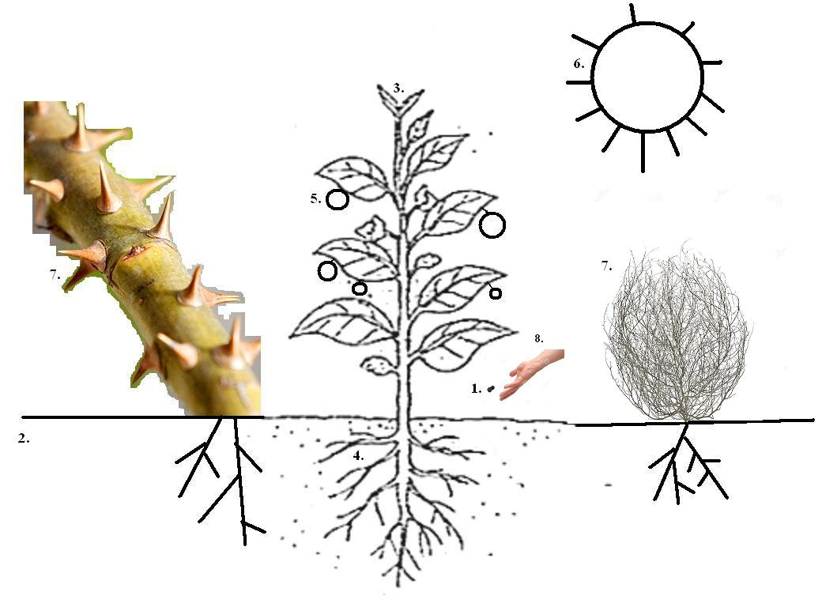
1. Seed: ________________________________________________________
2. Soil: ________________________________________________________
3. Plant: _______________________________________________________
4. Plant's Roots: _________________________________________________
5. Plant's Fruit: __________________________________________________
6. Scorching Sun: _______________________________________________
7. Weeds/Thorns: ________________________________________________
8. Sower: _______________________________________________________

