Exam 1

Spencer Swartz

Feb. 20, 2017

This is an exam. Do your own work and do not collaborate with others. Use any materials that you like, but no discussion please. You may ask questions of the instructor.

## Problem 1

Investigators studying the effects of sodium deficiency in chickens observed that birds deprived of sodium showed an increase in spontaneous activity, partly measured by pecking activity. The number of bird pecks per bird was recorded for 17 eleven-week old chickens that were fed a low-sodium diet for 22 days, and 15 eleven-week old chickens that were fed a standard ration for 22 days.

The data set is called BirdPecks.rda. Note, this data is *not* part of the DS705data package. To use it, set your working directory containing all of the files from the download pack and use load('BirdPecks.rda'). Other data for this exam is similar.

### Part 1a

Load the data set and create boxplots and histograms for the samples.

### -|-|-|-|-|-|-|-|-|-|-|- Answer 1a -|-|-|-|-|-|-|-|-|-|-|-

load('BirdPecks.rda')  
#head(BirdPecks)  
par(mfrow=c(2,2),mar=c(4,4,1,1))  
boxplot(BirdPecks$pecks[BirdPecks$group==1],ylab="# of pecks", main="Group 1")  
boxplot(BirdPecks$pecks[BirdPecks$group==2],ylab="# of pecks", main="Group 2")  
hist(BirdPecks$pecks[BirdPecks$group==1],xlab="# of pecks", main="Group 1")  
hist(BirdPecks$pecks[BirdPecks$group==2],xlab="# of pecks", main="Group 2")

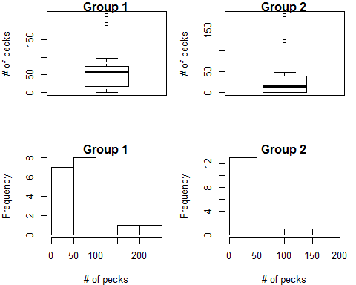

par(mfrow=c(1,1))

## [1] "Score for 1a : 0 / 6"

### Part 1b

Briefly describe the distributions with respect to their shape, variability, outliers.

### -|-|-|-|-|-|-|-|-|-|-|- Answer 1b -|-|-|-|-|-|-|-|-|-|-|-

It would look like in both Group 1 and Group 2 that the distribution is not normal. Both groups also have some outliers to the right.IT does not look as if the variances are the same for two groups.

## [1] "Score for 1b : 0 / 6"

### Part 1c

Test the for equality of population variances. Let $α=0.05$. Include all the steps, that is, be sure to state the null and alternative hypotheses, provide the R code and output for the test statistic and p-value, and state the conclusion for the test.

### -|-|-|-|-|-|-|-|-|-|-|- Answer 1c -|-|-|-|-|-|-|-|-|-|-|-

library(car)

## Warning: package 'car' was built under R version 3.3.2

leveneTest(BirdPecks$pecks~BirdPecks$group)

## Levene's Test for Homogeneity of Variance (center = median)  
## Df F value Pr(>F)  
## group 1 0.3359 0.5665  
## 30

Hypotheses:

$$H_{0}:σ_{group 1}^{2}=σ_{group 2}^{2}$$

$$H_{a}:σ_{group 1}^{2}≠σ_{group 2}^{2}$$

Test Statistic:

F-value = 0.3359

p-value:

p-value = 0.5665

Conclution:

Since the $P$ value ( $P$ = 0.5665) is greater than $α=0.05$, do not reject the null hypothesis that the population variances of bird pecks are the same for group 1 and group 2.

## [1] "Score for 1c : 0 / 8"

### Part 1d

Conduct tests for the normality of the number of bird pecks for each population. Let $α=0.05$ for each test. State the null and alternative hypotheses, provide the R code and output for the test statistics and p-values, and state the conclusions for each test.

### -|-|-|-|-|-|-|-|-|-|-|- Answer 1d -|-|-|-|-|-|-|-|-|-|-|-

Hypotheses:

$H_0: $ The sample was drawn from a normally distributed population.

$H_a: $ The sample was not drawn from a normally distributed population.

pecks1 <- BirdPecks$pecks[BirdPecks$group==1]  
pecks2 <- BirdPecks$pecks[BirdPecks$group==2]  
shapiro.test(pecks1)

##   
## Shapiro-Wilk normality test  
##   
## data: pecks1  
## W = 0.81645, p-value = 0.003441

shapiro.test(pecks2)

##   
## Shapiro-Wilk normality test  
##   
## data: pecks2  
## W = 0.69085, p-value = 0.0001987

Test Statistic:

$W_{group 1}$ = 0.81645

$W_{group 1}$ = 0.69085

p-value:

$P_{group 1}$ = 0.003441

$P_{group 2}$ = 0.0001987

Conclutions:

For group 1 the Shapiro-Wilk test of the pecks data gives a P-value of 0.0034. Since $P$ is less than $α$, reject the null hypothesis that the worm counts are normally distributed. For group 2, the P-value is 0.0001 and the conclusion is the same as for the group 1.

## [1] "Score for 1d : 0 / 8"

### Part 1e

Use R to construct an appropriate interval to estimate the difference (Diff = Low - Standard) in the central population values for the number of bird pecks for all chickens on the low sodium diet and the standard diet using a 90% level of confidence.

### Answer 1e

t.test(pecks~group,data = BirdPecks,conf.level=0.9,var.equal=TRUE)

##   
## Two Sample t-test  
##   
## data: pecks by group  
## t = 1.3663, df = 30, p-value = 0.182  
## alternative hypothesis: true difference in means is not equal to 0  
## 90 percent confidence interval:  
## -6.815983 63.098336  
## sample estimates:  
## mean in group 1 mean in group 2   
## 62.94118 34.80000

## [1] "Score for 1e : 0 / 6"

### Part 1f

Write an interpretation in the context of the problem for the 90% CI.

### -|-|-|-|-|-|-|-|-|-|-|- Answer 1f -|-|-|-|-|-|-|-|-|-|-|-

We are 90% confident that the population mean peck count for group 1 is -6.815983 to 63.09834 less than the population mean peck count for group 2.

## [1] "Score for 1f : 0 / 4"

### Part 1g

Was it necessary to make any assumptions about the data in order for the confidence interval for the difference in bird pecks to be accurate and valid? If so, what are they?

### -|-|-|-|-|-|-|-|-|-|-|- Answer 1g -|-|-|-|-|-|-|-|-|-|-|-

Yes, We assumed that the data was both normally distributed and that the variance was the same between the two data sets. On a previous test is was not conclusive that the two samples were normally distributed, making it possible that the CI derived is not accurate.

## [1] "Score for 1g : 0 / 4"

## Problem 2

Does strength training increase speed? To address this question a random sample of 35 college athletes were timed in a 100 meter dash both before and after a rigorous six-week strength training program.

The times before and after the training are in the data file StrengthSpeed.rda.

### Part 2a

Create a list of inference procedures that might be used to answer the research question.

### -|-|-|-|-|-|-|-|-|-|-|- Answer 2a -|-|-|-|-|-|-|-|-|-|-|-

1. paired t-test
2. Wilcoxon signed-rank
3. sign test

## [1] "Score for 2a : 0 / 4"

### Part 2b

Load the data and assess the data conditions for the statistical procedures you are considering.

### -|-|-|-|-|-|-|-|-|-|-|- Answer 2b -|-|-|-|-|-|-|-|-|-|-|-

load("StrengthSpeed.rda")  
#head(StrengthSpeed)  
StrengthSpeed$diff <- StrengthSpeed$after-StrengthSpeed$before  
par(mfrow=c(1,2))  
boxplot(StrengthSpeed$diff)  
hist(StrengthSpeed$diff)

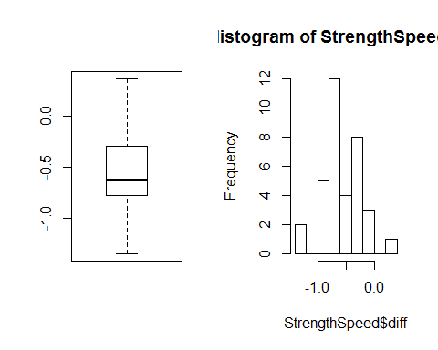

par(mfrow=c(1,1))  
shapiro.test(StrengthSpeed$diff)

##   
## Shapiro-Wilk normality test  
##   
## data: StrengthSpeed$diff  
## W = 0.97539, p-value = 0.6065

Based on the charts not looking extremely skewed and the Shapiro-Wilk test returning a p-value of .6065 it does not seem there is strong evidence against normality. because of this the t-test would be a good bet for this data as it is fairly robust, and given that it is the most powerful of the three procedures.

## [1] "Score for 2b : 0 / 8"

### Part 2c

Use R to conduct an appropriate hypothesis test to determine if strength training tends to increase speed in the target population. Use a 5% level of significance. State the null and alternative hypotheses, provide the R code and output for the test statistic and p-value, and state the conclusion for the test.

### -|-|-|-|-|-|-|-|-|-|-|- Answer 2c -|-|-|-|-|-|-|-|-|-|-|-

Hypotheses:

$$H_{0}:μ_{diff}=0$$

$$H_{a}:μ_{diff}>0$$

t.test(StrengthSpeed$after,StrengthSpeed$before,alternative = "greater",paired=TRUE)

##   
## Paired t-test  
##   
## data: StrengthSpeed$after and StrengthSpeed$before  
## t = -9.6083, df = 34, p-value = 1  
## alternative hypothesis: true difference in means is greater than 0  
## 95 percent confidence interval:  
## -0.6636269 Inf  
## sample estimates:  
## mean of the differences   
## -0.5643154

Test Statistic:

$t$ = -9.6083

p-value:

$p$-value = 1

Conclution:

Do not reject $H_{0}$ at $α=0.10$ (p-value = 1). There is not sufficient evidence to suggest that the population mean difference of speed increase is different than zero. In other words, there is no difference in speed before and after the strength training.

## [1] "Score for 2c : 0 / 12"

### Problem 3

The HLT is a test used to measure the level of hostility in a person. Researchers are interested in comparing the mean HLT among two populations: (1) college students after attending a college football game when their team won and (2) college students after attending a college football game when their team lost. Independent, random samples of 15 students were obtained to represent each population.

The data is as follows:

|  |  |
| --- | --- |
| Group | HLT Score |
| 1 | 79, 76, 74, 70, 81, 85, 73, 78, 69, 72, 83, 89, 72, 79, 75 |
| 2 | 78, 96, 85, 91, 77,103, 72, 93, 98, 86, 70, 110, 70, 91, 99 |

### Part 3a

Create a data frame for the data set in R.

### -|-|-|-|-|-|-|-|-|-|-|- Answer 3a -|-|-|-|-|-|-|-|-|-|-|-

students <- c(79, 76, 74, 70, 81, 85, 73, 78, 69, 72, 83, 89, 72, 79, 75, 78, 96, 85, 91, 77,103, 72, 93, 98, 86, 70, 110, 70, 91, 99)  
group <- c('g1','g1','g1','g1','g1','g1','g1','g1','g1','g1','g1','g1','g1','g1','g1','g2','g2','g2','g2','g2','g2','g2','g2','g2','g2','g2','g2','g2','g2','g2')  
studentsdf <- data.frame(students,group)  
head(studentsdf)

## students group  
## 1 79 g1  
## 2 76 g1  
## 3 74 g1  
## 4 70 g1  
## 5 81 g1  
## 6 85 g1

## [1] "Score for 3a : 0 / 4"

### Part 3b

Create a list of inference procedures that might be used to answer the research question.

### -|-|-|-|-|-|-|-|-|-|-|- Answer 3b -|-|-|-|-|-|-|-|-|-|-|-

1. Wilcoxon rank-sum test
2. pooled t-test
3. Welch t-test

## [1] "Score for 3b : 0 / 4"

### Part 3c

Assess the data conditions for the statistical procedures you are considering.

### -|-|-|-|-|-|-|-|-|-|-|- Answer 3c -|-|-|-|-|-|-|-|-|-|-|-

par(mfrow=c(2,2))  
boxplot(studentsdf$students[studentsdf$group=='g1'])  
boxplot(studentsdf$students[studentsdf$group=='g2'])  
hist(studentsdf$students[studentsdf$group=='g1'])  
hist(studentsdf$students[studentsdf$group=='g2'])

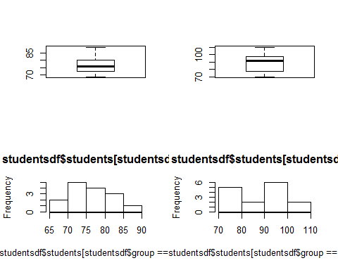

par(mfrow=c(1,1))  
shapiro.test(studentsdf$students[studentsdf$group=='g1'])

##   
## Shapiro-Wilk normality test  
##   
## data: studentsdf$students[studentsdf$group == "g1"]  
## W = 0.96154, p-value = 0.7191

shapiro.test(studentsdf$students[studentsdf$group=='g2'])

##   
## Shapiro-Wilk normality test  
##   
## data: studentsdf$students[studentsdf$group == "g2"]  
## W = 0.95388, p-value = 0.5876

leveneTest(students~group,data=studentsdf)

## Levene's Test for Homogeneity of Variance (center = median)  
## Df F value Pr(>F)   
## group 1 6.8743 0.01398 *  
## 28   
## ---  
## Signif. codes: 0 '***' 0.001 '**' 0.01 '*' 0.05 '.' 0.1 ' ' 1

Group 1 looks to be fairly close to normally distributed based on the charts, where as group 2 does not seem as conclusive. when the Shapiro-Wilk test was applyed it was not possible to rule out that the samples are not normally distributed ( $P−value_{group1}$ = .7191 , $P−value_{group2}$ = .5876). Since $P−value$ for the Levene's Test is smaller that $α=0.05$, we can reject the null hypothesis that the population variances of two groups are the same. With all the information stated above we believe the Welch t-test will be of best use for this data set.

## [1] "Score for 3c : 0 / 8"

### Part 3d

Use R to conduct an appropriate hypothesis test to compare the central population values for HLT scores for the two populations. Use a 5% level of significance. State the null and alternative hypotheses, provide the R code and output for the test statistic and p-value, and state the conclusion for the test.

### -|-|-|-|-|-|-|-|-|-|-|- Answer 3d -|-|-|-|-|-|-|-|-|-|-|-

Hypotheses:

$$H_{0}:μ_{group1}=μ_{group2}$$

$$H_{a}:μ_{group1}≠μ_{group2}$$

t.test(students~group,data=studentsdf ,var.equal=FALSE)

##   
## Welch Two Sample t-test  
##   
## data: students by group  
## t = -3.0854, df = 19.691, p-value = 0.00591  
## alternative hypothesis: true difference in means is not equal to 0  
## 95 percent confidence interval:  
## -18.332516 -3.534151  
## sample estimates:  
## mean in group g1 mean in group g2   
## 77.00000 87.93333

Test Statistic:

$t$ = -3.0854

P-value:

$p−value$ = 0.00591

Conclusion:

Reject $H_{0}$ at $α=0.05$ ( $P−value$ = 0.00591). There is sufficient evidence to suggest that the population mean HLT is different for students who have lost a game and who have won a game.

## [1] "Score for 3d : 0 / 12"

### Part 3e

What type of error could have possibly been made here? Explain your answer in the context of the problem.

### -|-|-|-|-|-|-|-|-|-|-|- Answer 3e -|-|-|-|-|-|-|-|-|-|-|-

Type I error, since we rejected $H_{0}$ this is the only type of error we can make. In this case the population mean actually would be the same for the two samples.

## [1] "Score for 3e : 0 / 4"

### Part 3f

Use a 95% confidence interval to estimate the population mean HLT score for all college students after attending a college football game when their team loses. Provide an interpretation for the interval.

### -|-|-|-|-|-|-|-|-|-|-|- Answer 3f -|-|-|-|-|-|-|-|-|-|-|-

t.test(studentsdf$students[studentsdf$group=='g2'])

##   
## One Sample t-test  
##   
## data: studentsdf$students[studentsdf$group == "g2"]  
## t = 27.324, df = 14, p-value = 1.512e-13  
## alternative hypothesis: true mean is not equal to 0  
## 95 percent confidence interval:  
## 81.03098 94.83569  
## sample estimates:  
## mean of x   
## 87.93333

We are 95% confident that the population mean HLT for the loseing team students is between 81.03 and 94.84.

## [1] "Score for 3f : 0 / 10"

### Part 3g

Use bootstrapping to estimate a 95% Studentized confidence interval for the population mean HLT score.

### -|-|-|-|-|-|-|-|-|-|-|- Answer 3g -|-|-|-|-|-|-|-|-|-|-|-

s <- sd(studentsdf$students[studentsdf$group=='g2'])  
s

## [1] 12.46404

zcrit <- qnorm(0.975)   
E <- 0.05  
n <- ceiling ( ( s * zcrit / E )^2 )  
n

## [1] 238712

xbar <- mean(studentsdf$students[studentsdf$group=='g2'])  
xbar

## [1] 87.93333

x <- rnorm(n)  
x <- ( x - mean(x) ) / sd(x)   
x <- s * x + xbar   
mean(x)

## [1] 87.93333

sd(x)

## [1] 12.46404

t.test(x)$conf.int

## [1] 87.88333 87.98333  
## attr(,"conf.level")  
## [1] 0.95

CI = (87.88333, 87.98333)

## [1] "Score for 3g : 0 / 10"

### Part 3h

Conduct a hypothesis test to determine if the population mean HLT score for all college students after attending a college football game when their team loses is less than 92. Let $α=0.01$ Provide all part of the test.

### -|-|-|-|-|-|-|-|-|-|-|- Answer 3h -|-|-|-|-|-|-|-|-|-|-|-

t.test(studentsdf$students[studentsdf$group=='g2'], mu = 92, alternative = 'less')

##   
## One Sample t-test  
##   
## data: studentsdf$students[studentsdf$group == "g2"]  
## t = -1.2636, df = 14, p-value = 0.1135  
## alternative hypothesis: true mean is less than 92  
## 95 percent confidence interval:  
## -Inf 93.60159  
## sample estimates:  
## mean of x   
## 87.93333

Hypothesis:

$$H_{0}:μ_{loss}=92$$

$$H_{a}:μ_{loss}<92$$

Test Statistic:

t = -1.2636

Degrees of Freedom:

DF = 14

P-value:

p = 0.1135

Conclusion:

Do not reject $H_{0}$ at $α=0.01$ ( $P−value$ = 0.1135). There is not sufficient evidence to conclude the population mean HLT is less than 92.

## [1] "Score for 3h : 0 / 12"

### Problem 4

In an experiment conducted at the University of Mississippi, eighteen randomly selected study participants are asked to perform a series of computer keystrokes in reaction to a stimulus. In one experiment, the participant must press a predefined sequence of keys on seeing a blue screen. Reaction time (in seconds) to press the key sequence is recorded. The same person is then asked to press a different key sequence on seeing a red screen, again with the reaction time measured. The order of the blue and red screens was randomized for each individual.

For the 18 study participants, with the reaction times for the red screen and the blue screen the difference in reaction times, with blue minus red, are in the data file called diffs.rda.

### Part 4a

Load the data set diffs.rda and assess the data conditions for the statistical procedures you are considering.

### -|-|-|-|-|-|-|-|-|-|-|- Answer 4a -|-|-|-|-|-|-|-|-|-|-|-

load('diffs.rda')  
head(diffs)

## diff  
## 1 8.78000000  
## 2 -4.25000000  
## 3 -0.04251807  
## 4 0.04110023  
## 5 12.45000000  
## 6 1.56861506

par(mfrow=c(1,2))  
boxplot(diffs$diff)  
hist(diffs$diff)

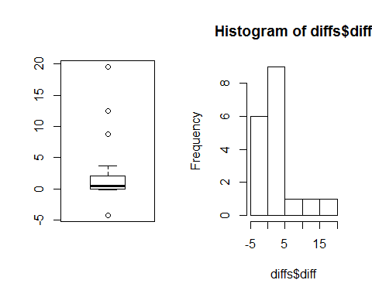

par(mfrow=c(1,1))  
shapiro.test(diffs$diff)

##   
## Shapiro-Wilk normality test  
##   
## data: diffs$diff  
## W = 0.7113, p-value = 0.0001084

The differences seem like they could be symmetrically distributed, but there are a few outliers indicating maybe a heavy tailed distribution. The Shapiro-Wilk test, when applied to the differences, yields $p.value$ = 0.0001 which indicates a strong departure from normlity. So we will use the Wilocoxon signed-rank test.

## [1] "Score for 4a : 0 / 8"

### Part 4b

Conduct a hypothesis test at $α=0.05$ to determine if the population location parameter for reaction time for the blue screen is greater than for the red screen. Report all details of the test.

### -|-|-|-|-|-|-|-|-|-|-|- Answer 4b -|-|-|-|-|-|-|-|-|-|-|-

wilcox.test(diffs$diff,mu=0,conf.int=TRUE, alternative = 'greater')

##   
## Wilcoxon signed rank test  
##   
## data: diffs$diff  
## V = 137, p-value = 0.01184  
## alternative hypothesis: true location is greater than 0  
## 95 percent confidence interval:  
## 0.1519446 Inf  
## sample estimates:  
## (pseudo)median   
## 0.9618578

Hypothesis:

$$H_{0}:M_{d}=0$$

$$H_{a}:M_{d}>0$$

Test Statistic:

V = 137

P-Value:

p = 0.01184

Conclusion:

Reject $H_{0}$ at $α=0.10$ ( $P−value$ = 0.01184). There is evidence to show there the population median for blue screen reaction time is greater than that of red screen reaction time.

## [1] "Score for 4b : 0 / 12"

## [1] "Total points earned 0 out of 150"