Spencer Swartz

* 1. Use *length* and *which* to determine how many schools have a per-student instructional expenditure higher than their out-of-state tuition.  Then use control flow to answer the same question.
     1. 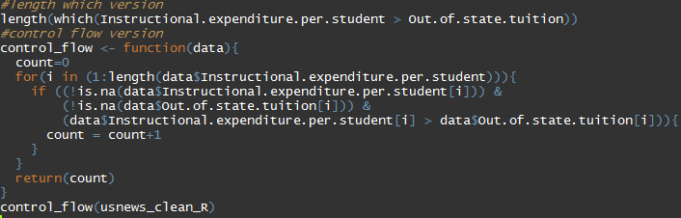
     2. 
  2. 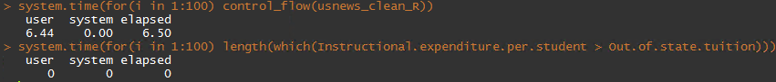
     1. The length/which approach is the quickest with a time of 0 between both user and system time. The control flow takes quite a bit more time mainly because of user time. User = 6.44 and system = 0.00. Both approaches were running 100 times.
     2. 
     3. 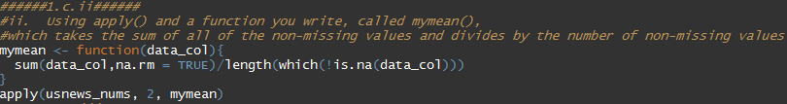
     4. 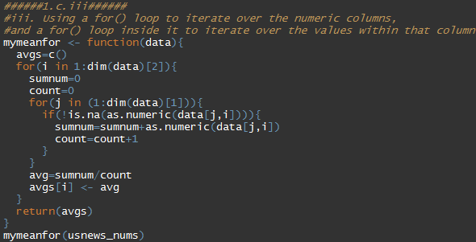
     5. I expect the code for part I to work the quickest as it uses tuned fuctions that are built into packages of R. the second quickest would be part II as this uses the apply function which is quicker than looping through each record of the data which is implemented in part III.
  3. 
     1. The apply function had the second lowest median run time at 5.14 milliseconds. The apply function with mymean was the fastest with a median time of 5.14 msec. and by no surprise the function that loops over all values has the slowest median run time of 1862.72 msec.
     2. The mymean function is faster that the apply function by 7% and faster than the looping function by over 3000%. The mymean function is faster because it uses vector calculation.