Platform: Linux, Unix like system
Usage: ./scanner [filename]
Abilities:

Tokens:
1. Delimiters
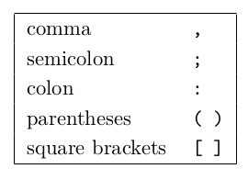
eg:
input => ;
output => <;>

2. Arithmetic, Relational, and Logical Operators
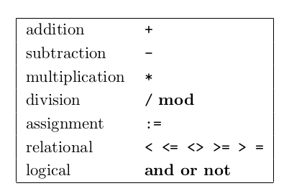
eg:
input => +
output => <+>

3. Keywords (case sensitive)

eg:
input => if
output => <KWif>

4. Identifiers
A string of letters and digits beginning with a letter. Case of letters is relevant, i.e. ident, Ident, and IDENT are different identifiers.
eg:
input => var abc
output => <Kwvar> <id: abc>

5. Constants
a. Integer Constants
As in the C language, an integer that begins with 0 is assumed to be octal; otherwise, it is assumed to be decimal.

b. Floating-Point Constants
A sequence of one or more digits with a dot (.) symbol separating the integral part from the fractional part.

c. Scientific Notations
All numbers are written like aEb or aeb. eg: 1.23E4, 1.23E+4, 1.23E-4, 123E4, etc.

d. String Constants
A string constant is a sequence of zero or more ASCII characters appearing between double-quote (”) delimiters. A double-quote appearing with a string must be written twice. For example, ”aa””bb” denotes the string constant aa”bb.

eg:
input => 12.23E1
output => <scientific: 12.23E1>

6. Discarded
Whitespace, C/C++ style comments, pseudocomments.
* Pseudocomments:
Define two options, S and T. S turns source program listing on or off, and T turns token listing on or off.
Eg:
//&S+
//&S-
//&S+&S-

