Mystery Binary Classification Challenge Report

Spencer Yue (sty223)

Kaggle Username: SpencerYue

**Overview**

I focused my efforts primarily on investigating how feature engineering would affect xgboost models. After experimenting and getting feedback from the public and private Kaggle scores, I have gained several practical lessons. These include the need to use (and believe the results of) cross validation, to establish a baseline with the simplest models without preprocessing first, and to spend time building a smooth pipeline for grid-searching and testing ideas. I’ve also observed many small insights about decision trees and possibly other models in general. The most significant of these observations was that the “curse of dimensionality” can be a major tradeoff to consider when adding newly engineered features (such as with one-hot encoding).

**Investigations and Experiments**

1. Unskew Transforms

My first question for this data set, and as a general curiosity, was whether the distributions of feature values could negatively affect a model’s performance. I had been investigating in the recent homework labs whether certain feature transformations that would result in a target distribution would help a given model, but I did not reach any conclusive results. (This had been mostly in the context of linear regression models. The initial idea of measuring skew as a feature transformation step was from Alexandru Papiu’s Housing Prices notebook.) Even though decision trees are not linear, I wanted to investigate this as a feature engineering step, because it is one of the few knobs that I as opposed to the model have direct control of and can graph to hopefully understand.

Here are the histograms of the initial vanilla data set with skew statistics included as labels. (F11 was not skewed according to scipy’s skewtest function so I omitted its label.)

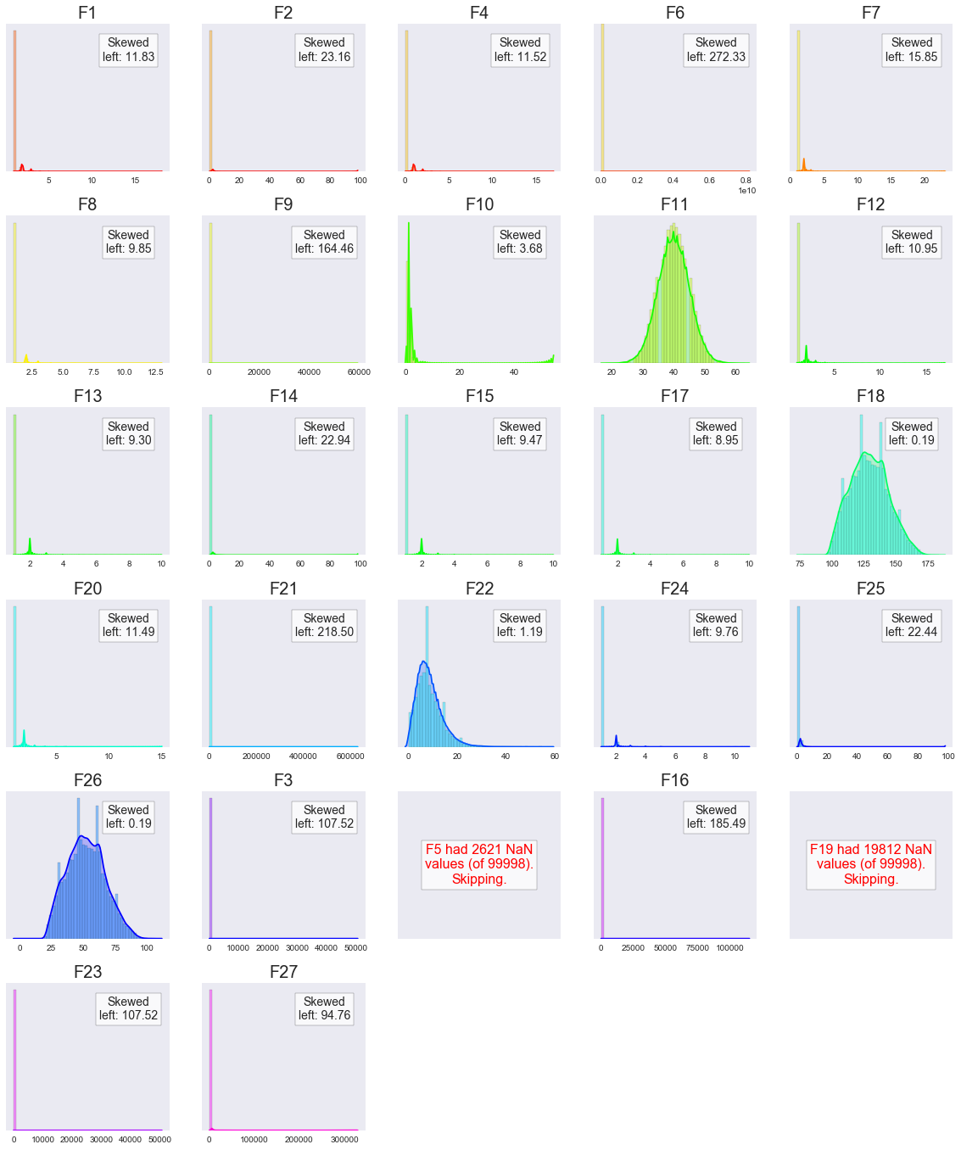



I wanted to target the normal distribution. To do this, I measured the “deviation from normal” using scipy’s skewtest and skew statistic functions. I applied several transformations to minimize this statistic for each feature. These transformations include log, square root, cube root, reciprocal, scipy’s Box-Cox function, and my custom implementation of the histogram flattening algorithm (a technique from the image processing domain).

The following are unskewed histograms of the continuous variables (“continuous” guessed by the number of unique values in the feature and the data type).

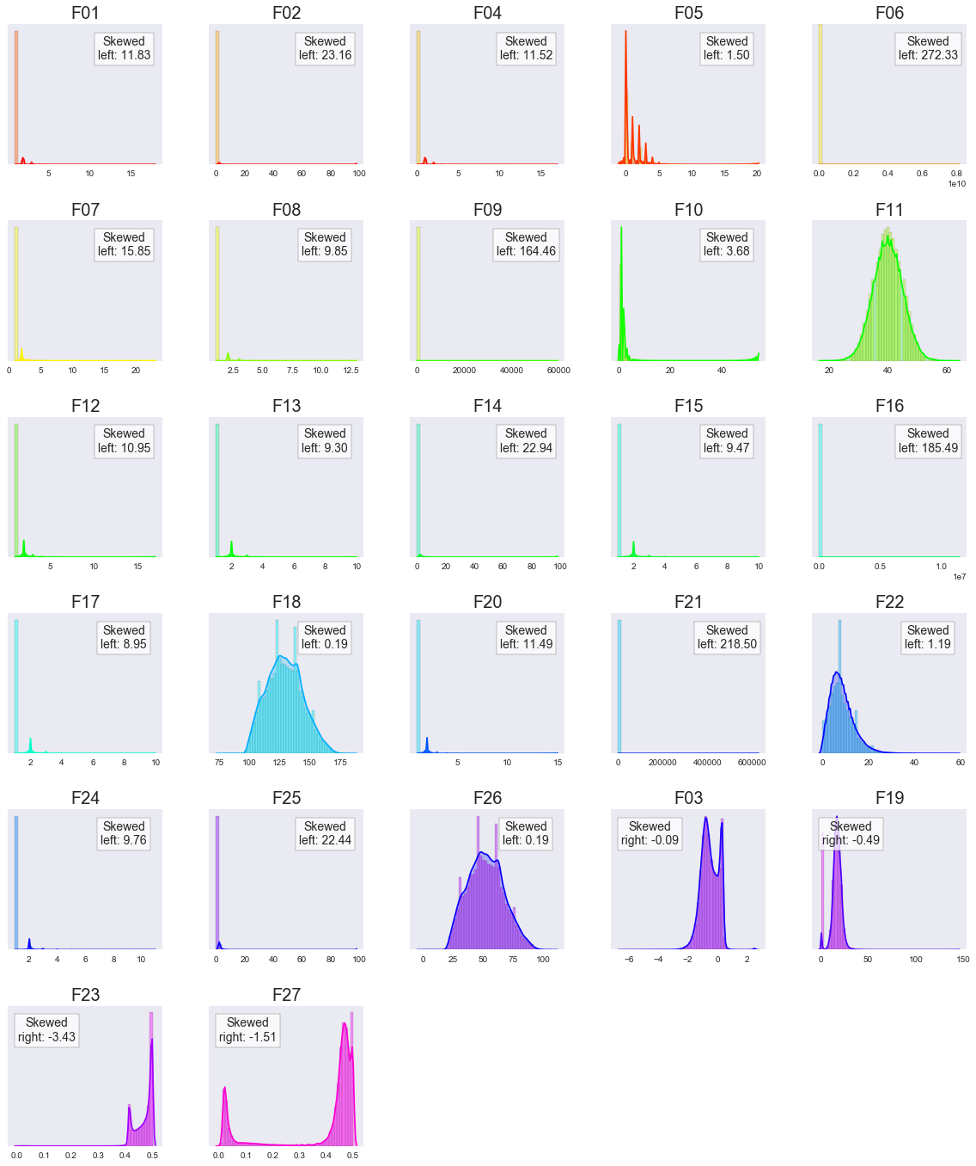

The transforms chosen to minimize the skew for these features were F3: Box-Cox, F19: histogram flatten, F23: Box-Cox, and F27: inverse of square-plus-one. These four numerical features contributed roughly 0.08 to the overall AUC-score included in the xgboost models versus being omitted. I could not, however, conclude if they helped xgboost more than their original counterparts however.

I also investigated feature distributions individually in more detail to try to learn something about the nature of the data. From the following transformed distributions, I saw that features F6 and F9 almost exactly followed an inverse power distribution, which suggested to me this data set was most likely artificial, and I did not pursue any further to try to find any meaning in the data.

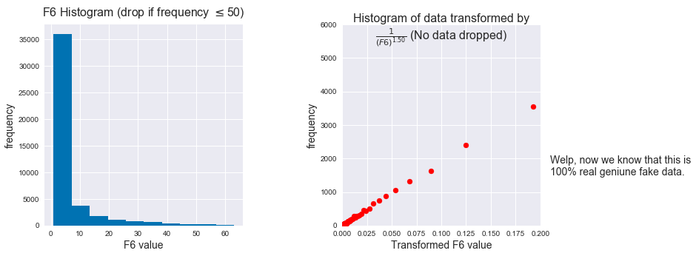

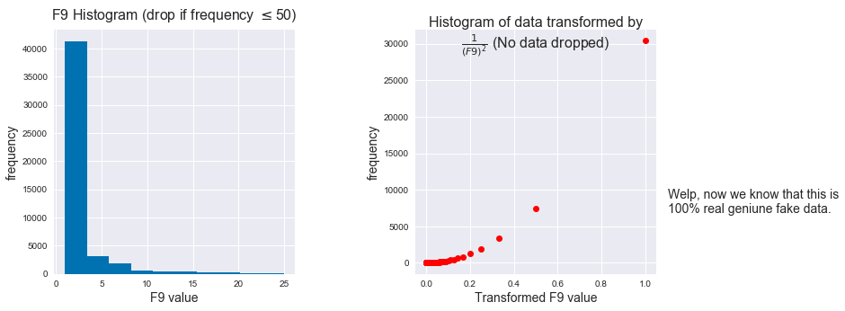

(Compare this 1.50 power above to the squared power below.)

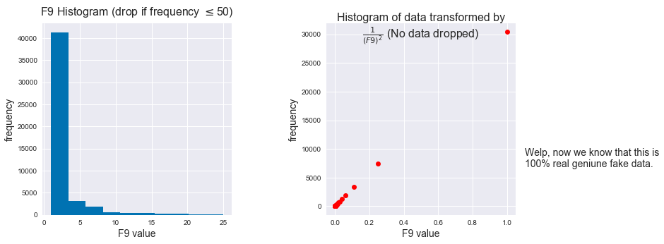

2. Feature engineering

I noticed that many of the features in the data set had very a relatively low number of unique values and were of integer type. This suggested the idea of treating them as categorical variables and one-hot encoding them. To do this efficiently, I found that using a SparseDataFrame and encoding the 0’s in the one-hot encoding as missing values saved considerably on space. I also read about the GPU implementation of xgboost to see if this would be efficient (<https://peerj.com/articles/cs-127.pdf>). In order to reduce the number of features generated by one-hot encoding, I grouped certain low-occuring feature values together. I measured the predicted effect this would have on the prediction using a custom measure I called *gain*. The gain of feature F1=1 for instance is defined as

gain(F1=1) = P(F1=1 and Y=0) – P(Y=0).

The absolute value of the gain is used to measure how independent the feature value is from the target class. This was also used to in a separate investigation after the contest ended to try feature selection on interaction pairs.

Here are some of the plots produced in the feature engineering process:

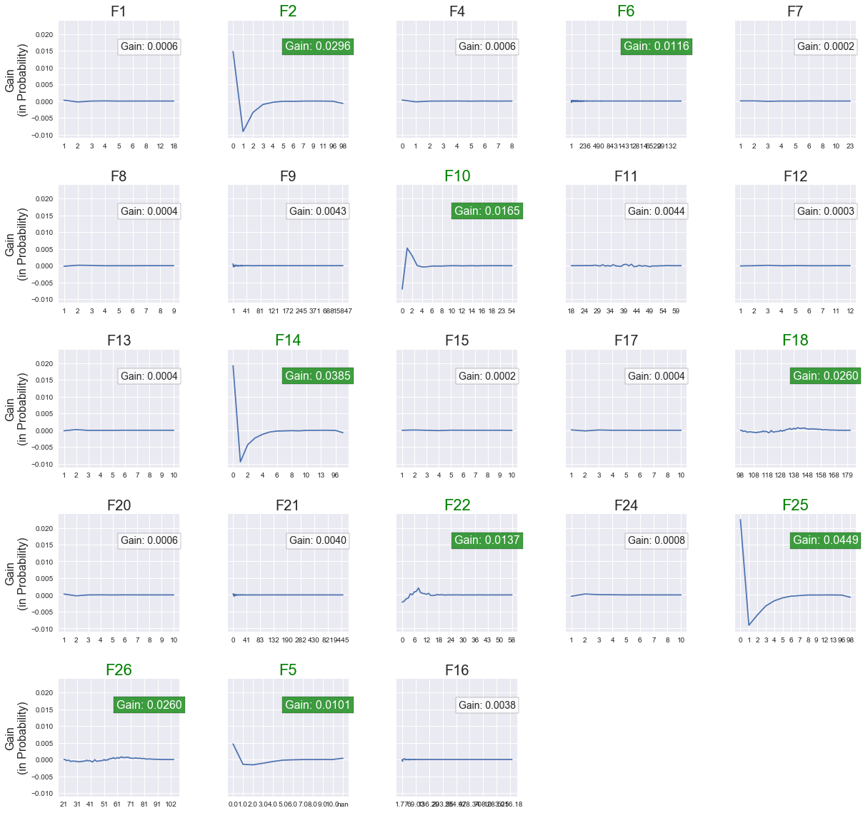

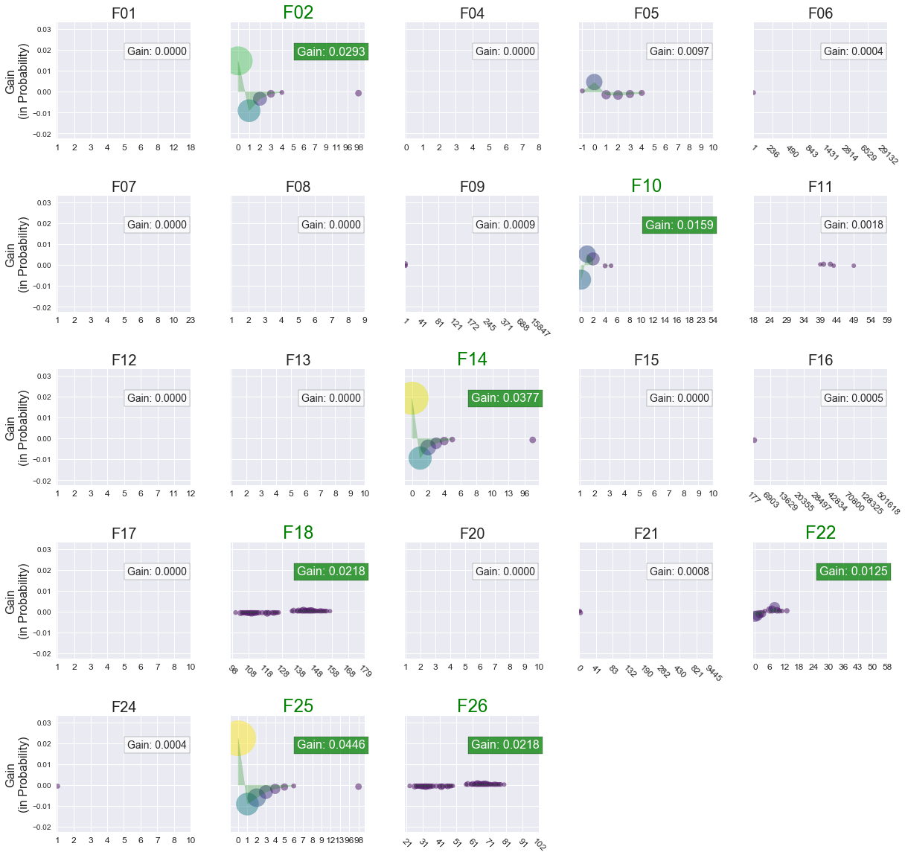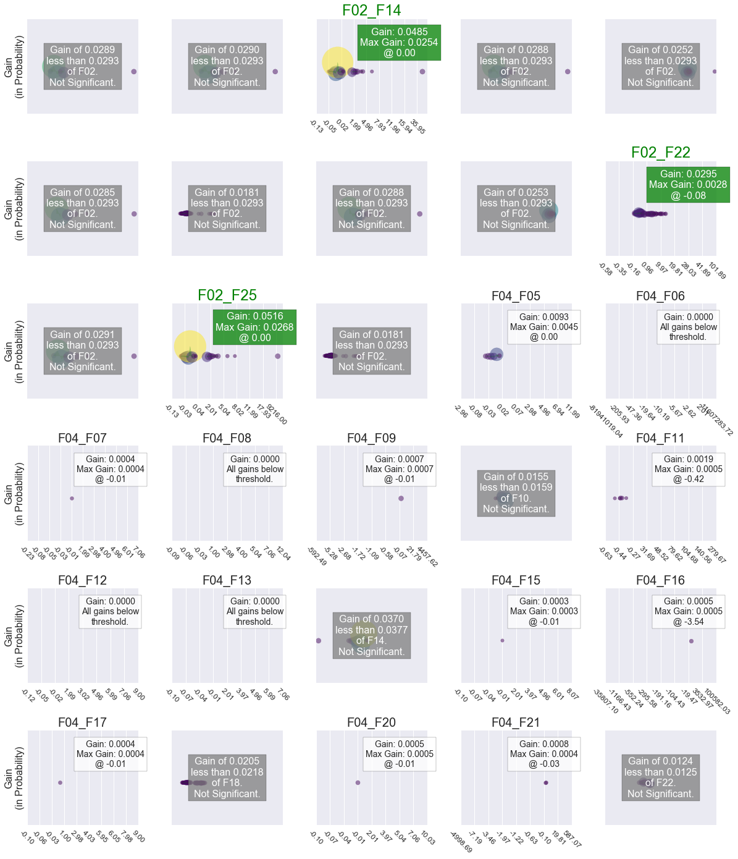

**Conclusions**

I was ranked 20 on the public leaderboards but dropped 20 ranks in the private leaderboards. I realize I should have trusted my local cross validation scores over the public leaderboard scores now. I also realized that it would have been better to set up a smoother pipeline that would facilitate more rapid preprocessing-testing cycles. These are lessons I will carry going forward.