Spencer Williams-Waldemar

Homework 7 Bayers

P(Party | near , event=True, Lazy=True) = 5/10\*2/5\*1\*3/5= .12

P(Study | near , event=True, Lazy=True) =3/10\*1/3\*0\*1/3 =0

P(TV| near , event=True, Lazy=True) =1/10\*1\*0\*1=0

P(Pub | near , event=True, Lazy=True) =1/10\*0\*0\*1=0

Iris output:

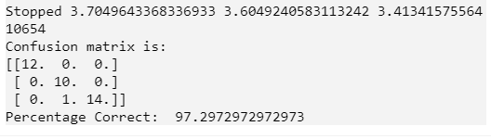

Ozone output:

