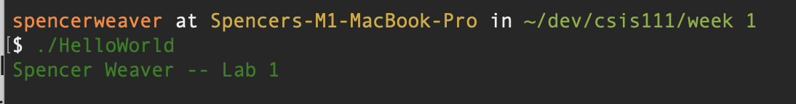

1. I have not shared the source code in my program with anyone other than my instructor’s approved human sources.
2. I have not used source code obtained from another student, or any other unauthorized source, either modified or unmodified.
3. If any source code or documentation used in my program was obtained from another source, such as a text book or course notes, that has been clearly noted with a proper citation in the comments of my program.
4. I have not knowingly designed this program in such a way as to defeat or interfere with the normal operation of any machine it is graded on or to produce apparently correct results when in fact it does not.

**Spencer Weaver**

1. If you have had some programming in the past and want to use language features in your solutions that we have not covered in class, you must get permission. Assuming I have given you permission you must add the following to the beginning of your Word document:

With {Instructor’s name} permission on (Date Given), I have used the following advanced features in my solution:

1. [Advanced feature 1]
2. [Advanced feature 2]
3. **Save the document in the project directory of the assignment you are working on** Save this file using the following format: firstname_lastname_lab#.doc or docx.

For more information on zipping up your projects , view the “Zipping up your project” presentation by Professor Sipantzi (located in your Labs folder).

1. Zip up the entire lab directory under...\Visual Studio 2019\Projects.

If you need help, **WATCH THIS VIDEO** - <https://www.youtube.com/watch?v=cnpMK6yLwAw>