**Name : Hetvi Bathani Subject : DBMS LAB**

**Class : AIA-3 Batch : B**

**Roll No : 2213684**

ASSIGNMENT NO: 02

**AIM**: Data Definition Commands for creating database and tables (relations)

1. Create a Table for Manufacturing industry / Hospital/ Company with min 5 columns add primary key.
2. Alter any one column from the above table.
3. Rename two columns from the above table
4. Truncate the table
5. Drop the table.

**INDEX TERMS**: DDL, DML, PL/SQL Stored Procedure, functions

# CLI Screenshots:

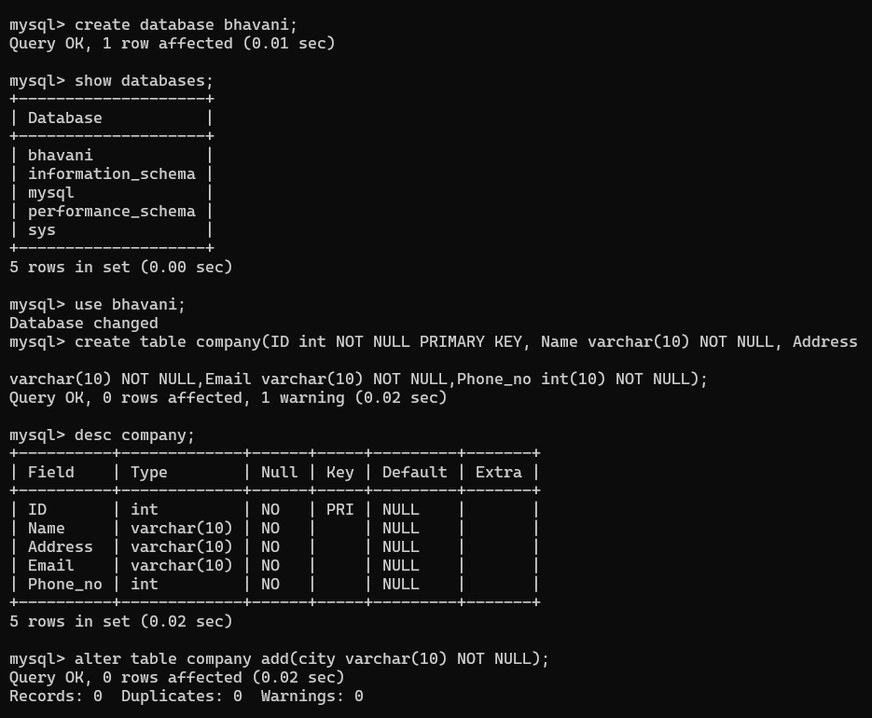

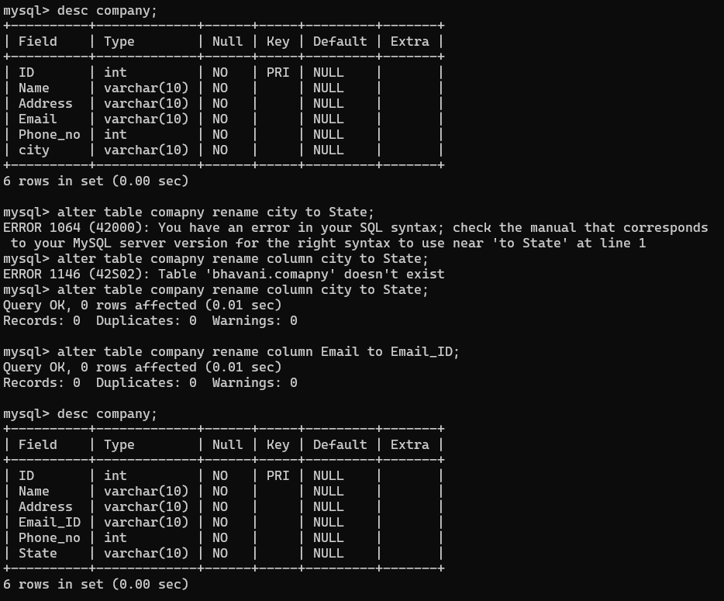

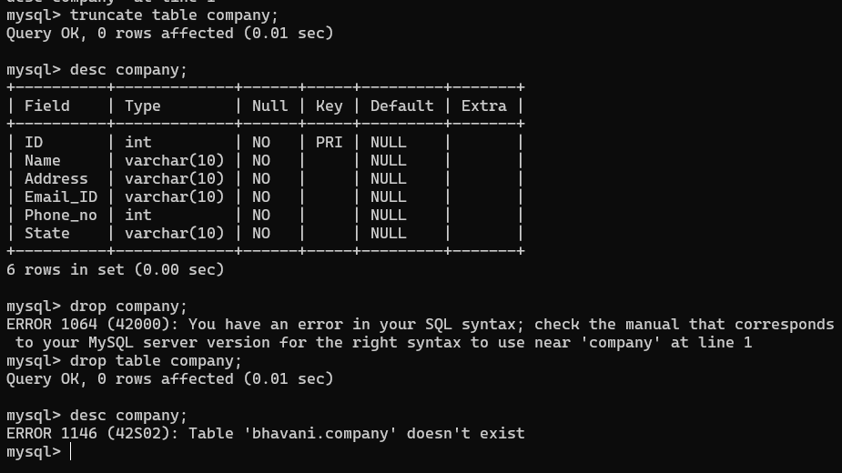

**Exercise :**

Evaluate query for following questions and perform operations Classicmodels database. 1)Report those payments greater than 100000;

**Ans) SELECT * FROM payments WHERE amount > 100000;**

1. Report total payments for october 28,2004;

**Ans) SELECT SUM(amount) AS total_payments FROM payments WHERE paymentDate = '2004-10-28';**

1. What is the minimum payment received?

**Ans) SELECT MIN(amount) AS min_payment FROM payments;**

1. How many employees are there in the company?

**Ans) SELECT COUNT(*) AS employee_count FROM employees;**

1. List the product lines that contain “Cars”;

**Ans) SELECT DISTINCT productLine FROM products WHERE productLine LIKE '%Cars%';**

1. How many products in each product line? (stored procedure)

**Ans) EXEC GetProductCountByProductLine**;

1. What are the names of executives with VP or Manager in their title?

**Ans) SELECT firstName, lastName FROM employees WHERE jobTitle LIKE '%VP%' OR jobTitle LIKE '%Manager%';**

1. What is the average percentage markup of the MSRP on buyPrice?

**Ans) SELECT AVG((MSRP - buyPrice) / buyPrice) * 100 AS average_markup_percentage FROM products;**

1. Which orders have a value greater than $5000?

**Ans) SELECT orderNumber, (quantityOrdered * priceEach) AS orderValue FROM orderdetails HAVING orderValue > 5000;**

1. List the value of “On Hold”; orders

**Ans) SELECT orderNumber, (quantityOrdered * priceEach) AS orderValue FROM orders JOIN orderdetails USING (orderNumber) WHERE status = 'On Hold';**

1. Report the number of orders “On Hold”; for each customer.

**Ans)SELECT customerName, COUNT(*) AS num_on_hold_orders FROM customers JOIN orders USING (customerNumber) WHERE status = 'On Hold' GROUP BY customerName;**

1. Who are the employees in Boston?

**Ans) SELECT employeeNumber, firstName, lastName FROM employees WHERE officeCode = '2';**

1. Report the products that have not been sold

**Ans) SELECT productCode, productName FROM products LEFT JOIN orderdetails USING (productCode) WHERE orderNumber IS NULL;**

1. Compute the commission for each sales representative , assuming the commision is 5% of the value of an order.sort by employee last name and first name

**Ans) SELECT employeeNumber, firstName, lastName, SUM(quantityOrdered * priceEach * 0.05) AS commission**

**FROM employees JOIN customers ON employees.employeeNumber = customers.salesRepEmployeeNumber JOIN orders USING (customerNumber) JOIN orderdetails USING (orderNumber) GROUP BY employeeNumber, firstName, lastName ORDER BY lastName, firstName;**

# FAQs:

* 1. What do you understand by a subquery? When is it used?

Ans) A subquery is a query that is embedded in WHERE clause of another SQL query. In other words, it is a query within another query. Subqueries can be used with SELECT,

UPDATE, INSERT, DELETE statements along with expression operator. It could be equality operator or comparison operator such as =, >, =, <= and Like operator.

* 1. What is difference between FUNCTION and PROCEDURE in PL/SQL

Ans) In PL/SQL, a procedure is a named PL/SQL block which performs one or more tasks. It may or may not return a value. On the other hand, a function is a named PL/SQL block which performs a specific action.

* 1. What is the difference between cross joins and natural joins?

Ans) In SQL, a cross join will produce cross or Cartesian product of two tables if there is no condition specifies. The resulting table will contain all the attributes of both the tables including duplicate or common columns also. On the other hand, a natural join joins two tables based on same attribute name and datatypes.

# Conclusion:

Out come of the experiment is understanding of

* Implement DDL,DML Statements, aggregate functions, all types of Joins.
* Implement Sub-Queries, PLSQL Stored procedure &amp; Functions