**Name : Hetvi Bathani Subject : DBMS LAB**

**Class : AIA-3 Batch : B**

**Roll No : 2213684**

# ASSIGNMENT NO: 03

**Aim:** Data Manipulation Commands for updating and retrieving of data from Tables and Transaction Control statements

* Insert 5 values in the Table for Manufacturing industry / Hospital/ Company.
* Update the values from the tables Manufacturing industry / Hospital/ Company.
* Delete minimum 2 values from Manufacturing industry / Hospital/ Company table

**Software Required**: MySQL

## CLI Screenshots:

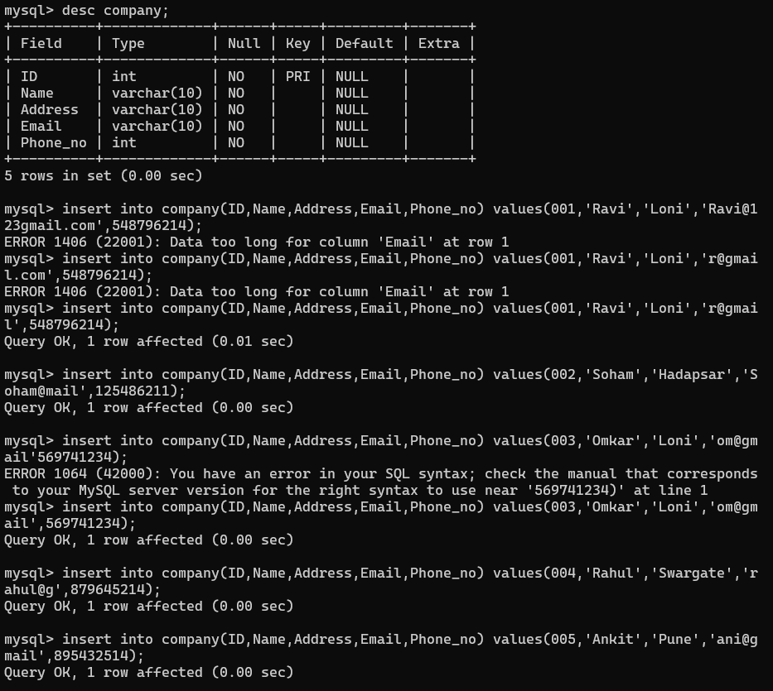

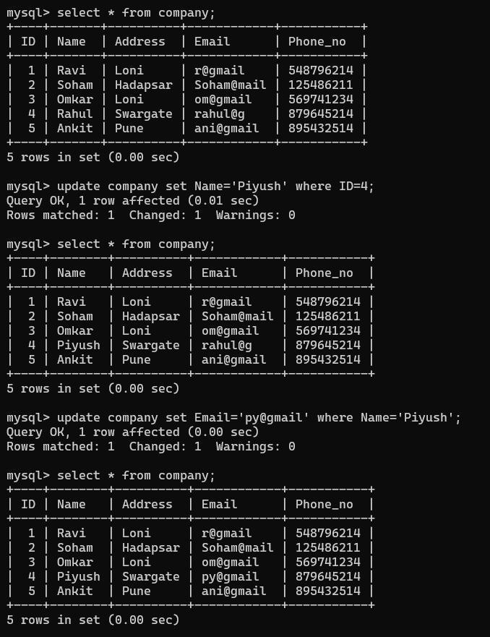

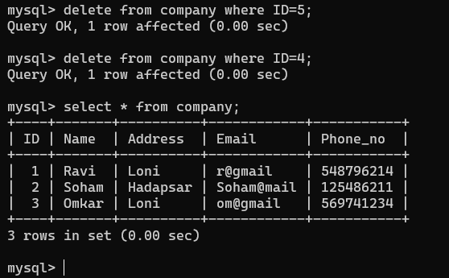

**FAQs:**

1. What is the purpose of the WHERE clause in SQL DML commands?

Ans) The WHERE clause is used to filter the rows returned by a SELECT statement or affected by an UPDATE or DELETE statement. It is used to specify a condition that must be met for a row to be returned by the query. The WHERE clause is followed by a condition that evaluates to true, false, or unknown. If the condition evaluates to true, the row is included in the result set. If it evaluates to false or unknown, the row is not included in the result set

1. How can I update multiple columns in a table using UPDATE?

Ans) The UPDATE statement is always followed by the SET command, which specifies the columns to update. Multiple columns can be specified by separating them with commas. The WHERE clause is used to specify which rows to update.

UPDATE table_name

SET column1 = value1, column2 = value2, ... WHERE condition;

1. Can I insert data into multiple tables at once?

Ans) No, you cannot insert data into multiple tables at once using a single SQL

statement. However, you can use transactions to ensure that multiple SQL statements are treated as a single unit of work. A transaction is a sequence of SQL statements that are executed as a single unit of work.

1. What is the difference between the INSERT and UPDATE commands?

Ans) The INSERT statement is used to insert new rows into a table. The values for each column are specified in the VALUES clause of the INSERT statement. If you don’t specify a value for a column, the column is set to NULL. The UPDATE statement is used to modify existing rows in a table. You can update one or more columns at once. The WHERE clause is used to specify which rows to update.

# Conclusion:

These DML commands provide the necessary functionality to manipulate and manage the data within a DBMS. They allow users to interact with the database by retrieving

inserting, updating, and deleting data according to their requirements.

## Additional problem statements:

1. Design an SQL command to insert a new product record into the “Products”; table of the online store database, including details such as product name, price, quantity available, and category.

## Ans) INSERT INTO Products (product_name, price, quantity_available, category) VALUES ('Product Name', price_value, quantity_value, 'Category Name');

1. Create a set of DML commands to update the “Employee”; table in the HR database, modifying the salary of an employee based on their performance rating and position.

Ans) **UPDATE Employee**

## SET salary = salary * 1.15 -- Increase salary by 15%

**WHERE performance_rating >= 4 AND position = 'Senior Manager';**

1. Develop an SQL script to delete all inactive user accounts from the “Users”; table of the social networking database, where the last login date is older than six

months.

Ans) **DELETE FROM Users**

## WHERE last_login_date < DATE_SUB(NOW(), INTERVAL 6 MONTH);

1. Design a series of DML commands to insert a new patient’s medical record into the “Patients”; table of the hospital database, capturing information like patient ID, name, date of birth, admission date, and medical condition.

## Ans) INSERT INTO Patients (patient_id, patient_name, date_of_birth, admission_date, medical_condition)

**VALUES (patient_id, patient_name, date_of_birth, admission_date, medical_condition);**

1. Create an SQL command to update the “Inventory”; table in the retail store database, increasing the quantity of a specific product that has been restocked.

Ans) **UPDATE Inventory**

**SET quantity = quantity + 50 WHERE product_id = 123;**