**Name : Hetvi Bathani Subject : DBMS LAB**

**Class : AIA-3 Batch : B**

**Roll No : 2213684**

# ASSIGNMENT NO: 05

**Aim:** Write a Database Query for Joins, Nested queries, Sub-queries of Manufacturing industry / Hospital/ Company table.

**Software required**: MySQL

# Theory:

Subquery: A subquery (also known as an inner query or nested query) is a query that is placed inside another query. It is used to retrieve data needed for the main query.

Subqueries can be used in various parts of a SQL statement, such as the SELECT, FROM, WHERE, and HAVING clauses.

Nested Query: A nested query is a type of subquery where one query is embedded within another query. This is often used to retrieve data that depends on the results of another query.

INNER JOIN: Returns records that have matching values in both tables

LEFT JOIN: Returns all records from the left table, and the matched records from the right table

RIGHT JOIN: Returns all records from the right table, and the matched records from the left table

CROSS JOIN: Returns all records from both tables

IN: Used to match a value against a list of specified values.

NOT IN: Used to exclude rows with values that match any value in a specified list. EXISTS: Checks for the existence of any rows in a subquery result.

NOT EXISTS: Checks for the absence of any rows in a subquery result. ALL: Compares a value to all values in a subquery's result set.

ANY or SOME: Compares a value to at least one value in a subquery's result set.

# CLI Screenshots:

1. **JOINS:**

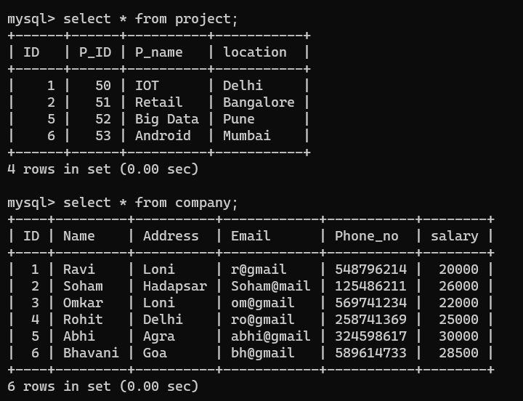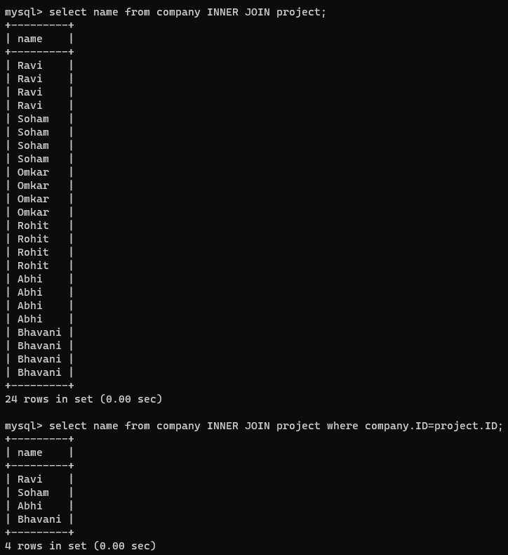

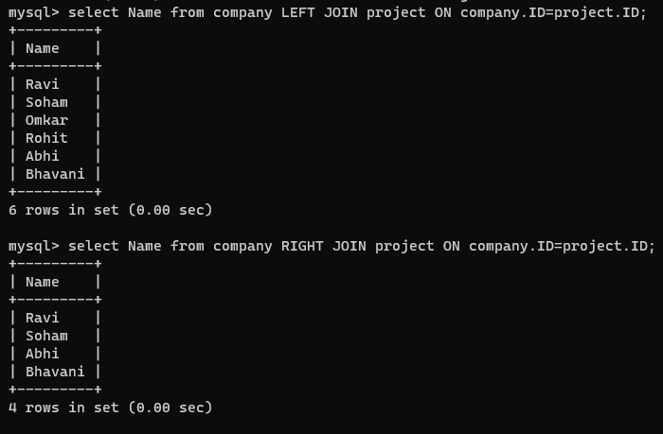

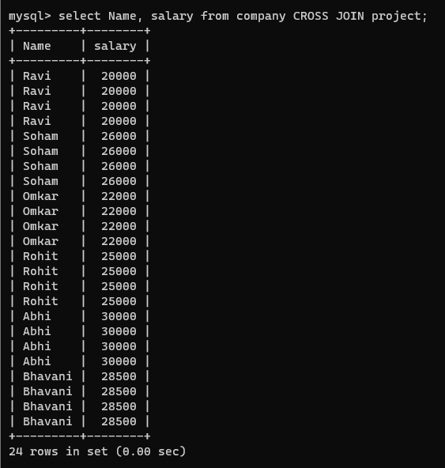

# Sub Queries:

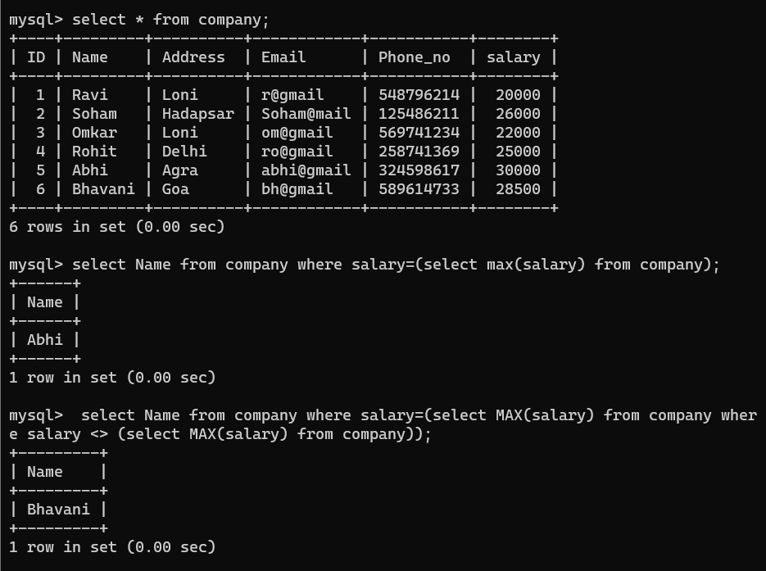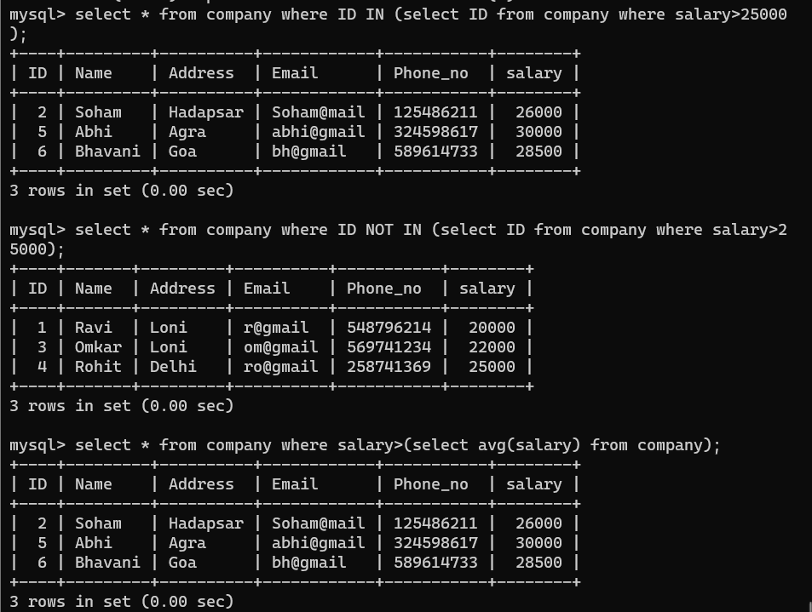

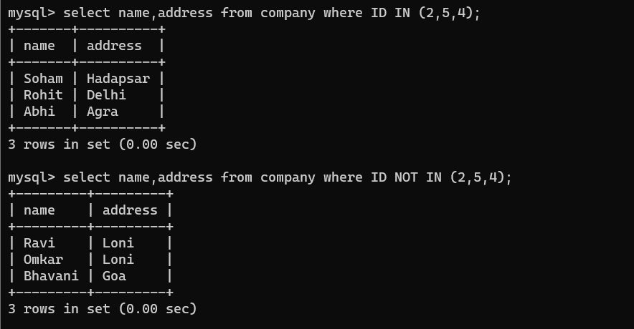

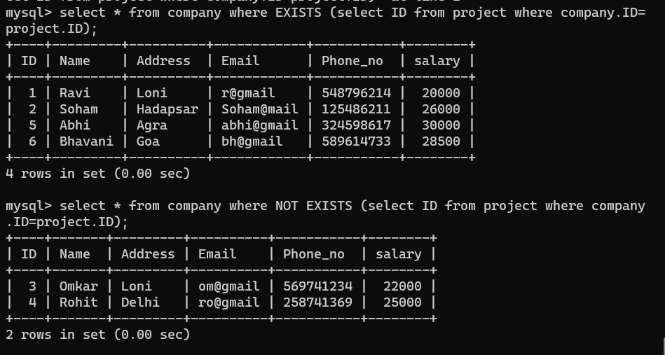

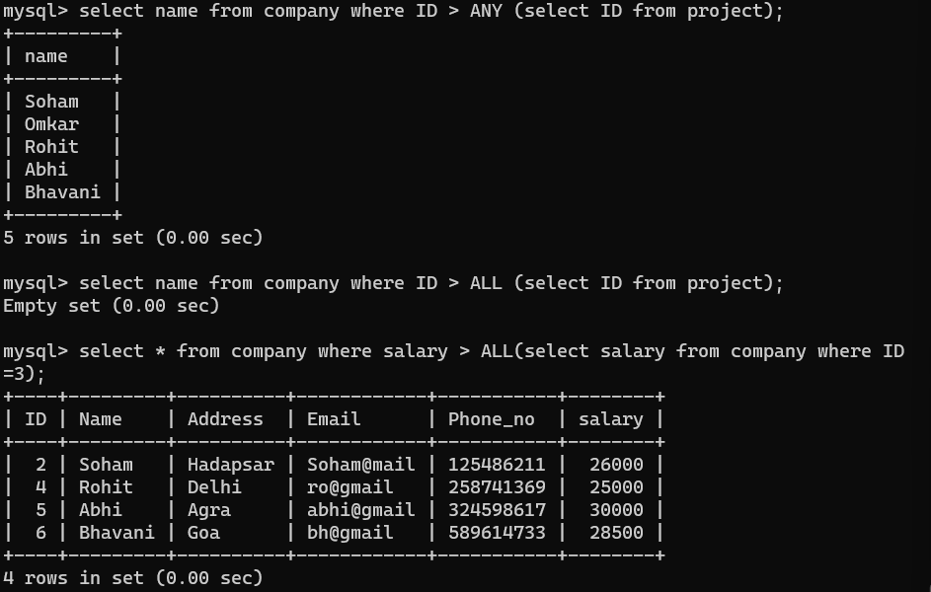

**Conclusion:**

In conclusion, the practical on DBMS joins and subqueries underscores their vital role in optimizing query performance and enabling intricate data retrieval. Mastery empowers efficient data manipulation.