**Name : Hetvi Bathani Subject : DBMS LAB**

**Class : AIA-3 Batch : B**

**Roll No : 2213684**

# ASSIGNMENT NO: 06

**Aim:** PL/SQL: Procedures and Functions.

1. Write a function to square the number taken from user.
2. Write a procedure to display the records from Manufacturing industry / Hospital/Company table

**Software required**: MySQL

# Theory:

The PL/SQL Function is very similar to PL/SQL Procedure. The main difference between procedure and a function is, a function must always return a value, and on the other hand a procedure may or may not return a value. Except this, all the other things of PL/SQL procedure are true for PL/SQL function too.

Syntax to create a function:

CREATE [OR REPLACE] FUNCTION function_name [parameters] [(parameter_name [IN | OUT | IN OUT] type [, ...])]

RETURN return_datatype

{IS | AS} BEGIN

&lt; function_body &gt; END [function_name];

Here:

* Function_name: specifies the name of the function.
* [OR REPLACE] option allows modifying an existing function.
* The optional parameter list contains name, mode and types of the parameters.
* IN represents that value will be passed from outside and OUT represents that this

parameter will be used to return a value outside of the procedure. The function must contain a return statement.

* RETURN clause specifies that data type you are going to return from the function.
* Function_body contains the executable part.
* The AS keyword is used instead of the IS keyword for creating a standalone function.

PL/SQL Function Example

1. create or replace function adder(n1 in number, n2 in number)
2. return number
3. is
4. n3 number(8);
5. begin

6. n3 :=n1+n2;

1. return n3;
2. end; 9. /

Now write another program to call the function.

1. DECLARE
2. n3 number(2);
3. BEGIN

4. n3 := adder(11,22);

1. dbms_output.put_line(&#39;Addition is: &#39; || n3);
2. END; 7. /

# Screenshots:

**A]**

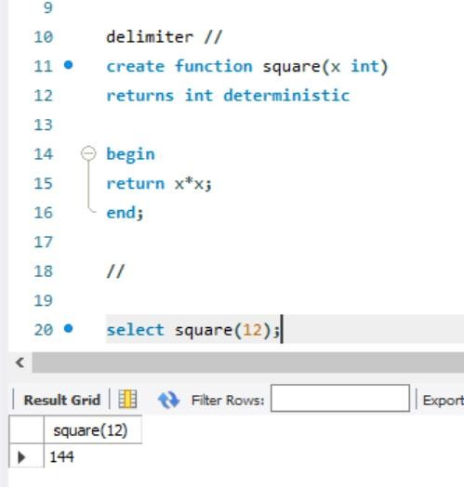

# B]

