**Name : Hetvi Bathani Subject : DBMS LAB**

**Class : AIA-3 Batch : B**

**Roll No : 2213684**

# ASSIGNMENT NO: 07

**Aim:** PL/SQL: Implicit and Explicit Cursors and Triggers.

1. Write a Trigger for purchase table where total will be calculated when value is inserted in the table.
2. 1. Use the table prodution.products with Product_id, Product_name, Brand_id,Category_id, model_year,list_price,
   1. Declare two variables to hold product name and list price, and a cursor to hold the result of a query that retrieves product name and list price from the production.products table
   2. fetch each row from the cursor and print out the product name and list price

**Software required**: MySQL

# Implementation:

**A]**

Write a Trigger for purchase table where total will be calculated when value is inserted in the table.

CREATE TABLE purchase ( product VARCHAR(15), price INT(6)

);

set @total = 0;

delimiter / create trigger tri

after insert on purchase for each row

begin

SET @total = (SELECT SUM(price) FROM purchase);

end;

/ delimiter ;

insert into purchase values('Sugar',500); insert into purchase values('Chocolate',100); insert into purchase values('Remote',300); select @total;

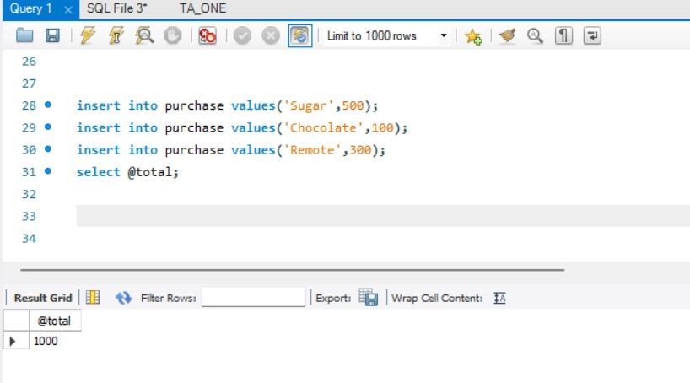

# B]

DELIMITER ;

CREATE TABLE products ( Product_name VARCHAR(255), Brand_id INT,

Category_id INT, model_year YEAR, list_price INT

);

drop table products;

INSERT INTO products (Product_name, Brand_id, Category_id, model_year, list_price) VALUES ('Laptop', 1, 2, 2023, 999),

('Smartphone', 2, 1, 2023, 599),

('Tablet', 3, 2, 2022, 349),

('Desktop Computer', 1, 2, 2023, 1299),

('Camera', 4, 3, 2023, 799);

delimiter /

CREATE PROCEDURE ListD() BEGIN

DECLARE done INT DEFAULT 0;

DECLARE prod_name VARCHAR(255); DECLARE prod_price INT;

DECLARE cur CURSOR FOR

SELECT Product_name,list_price FROM products;

DECLARE CONTINUE HANDLER FOR NOT FOUND SET done = 1;

OPEN cur; read_loop: LOOP

FETCH cur INTO prod_name,prod_price; IF done = 1 THEN

LEAVE read_loop; END IF;

SELECT CONCAT('Name :',prod_name,' Price :',prod_price) AS Prod_Info; END LOOP;

CLOSE cur;

END /

delimiter ;

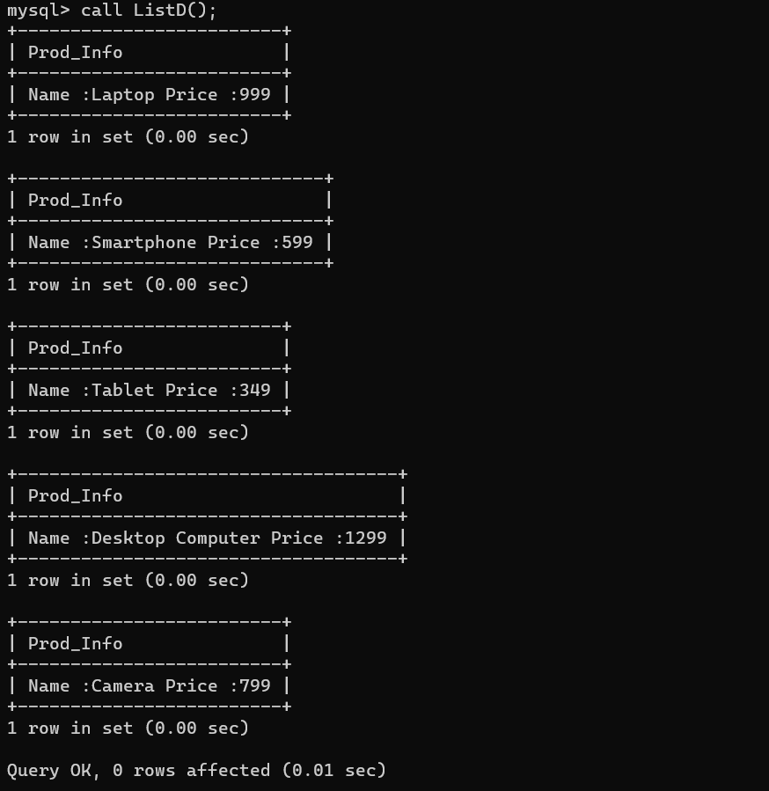

# Conclusion:

Hence, we have succesfully implmented Triggers and Cursors.