CS 6332.001 Computer Animation

Assignment 3 (Grade: 10 Points)

**Implement Forward Kinematics**

Write a program to animate a linkage with 3 joints and 9 degree of freedoms. Each bone is associated with 3 DOF, i.e. the rotation angles along **y, z, x** axis, respectively.

* For any 3 DOF bone, use the rotations **in the following order: y-axis, z-axis, x-axis**. The initial pose vector for each bone is $\left(θ^{y},θ^{z},θ^{x}\right)=(0,0,0)$, with all the numbers in **degrees**.
* The red root cube has its position: {2.0f, 1.0f, 2.0f}
* Each bone is model as a stretched cube. The scale vector for each cube is:
  + Red: {1.0f, 1.0f, 1.0f}
  + Yellow: {0.5f, 4.0f, 0.5f},
  + Purple: {0.5f, 3.0f, 0.5f},
  + Red: {0.5f, 2.0f, 0.5f}
* In the starting code, the red cube is already defined in the model class. Use the corresponding colors to render these four bones. The linkage should be straight up initially as shown in the following figure: **(Grade: 3 points)**

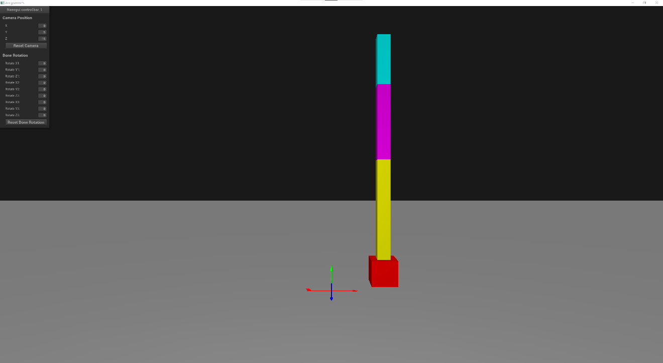

* Support interactive control of the 9 DOFs, saying the pose vector for each bone could be set separately. **(Grade: 6 points)**
  + Here are two example poses to check your result:
    - If we set the pose vector $(θ_{Blue}^{y},θ_{Blue}^{z},θ_{Blue}^{x},θ_{Pink}^{y},θ_{Pink}^{z},θ_{Pink}^{x},θ_{Red}^{y},θ_{Red}^{z},θ_{Red}^{x})$ to be (0, 30, 0, 0, 30, 0, 0, 30, 0), with all the numbers in degrees, we get the following result:

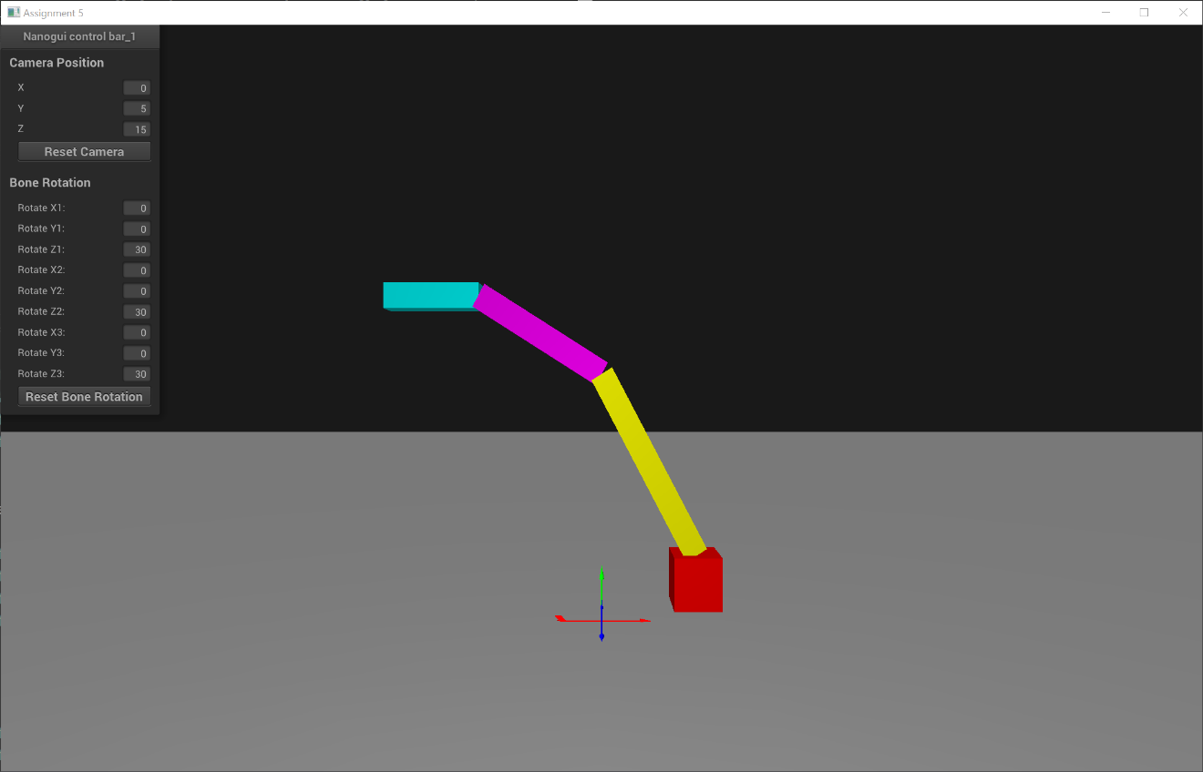

* + - If we set the pose vector $(θ_{Blue}^{y},θ_{Blue}^{z},θ_{Blue}^{x},θ_{Pink}^{y},θ_{Pink}^{z},θ_{Pink}^{x},θ_{Red}^{y},θ_{Red}^{z},θ_{Red}^{x})$ to be (0, -90, 0, 90, 90, 0, 0, 90, 0), with all the numbers in degrees, we get the following result:

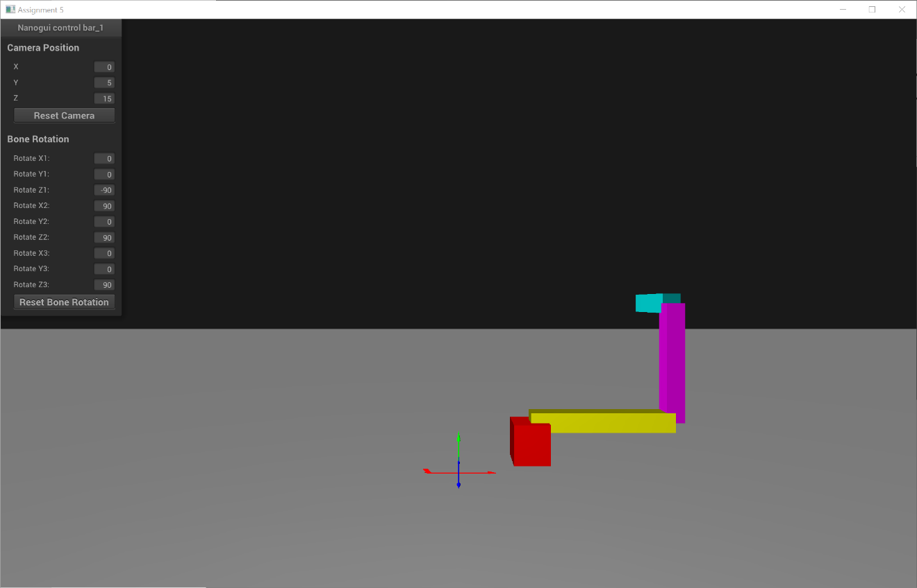

* Have a reset button to reset the linkage to the initial state. **(Grade: 1 point)**