CS 6323.501 Computer Animation

Project (Grade: 12 points)

3D Character Animation

Character animation is an important part of modern game development. In this project, you can use the free 3D avatar to create multiple character animation clips.

If you are using Unity game engine, it is recommended you use the FREE UMA avatar set - Here is the link to download the UMA (Unity Multipurpose Avatar) asset: <https://assetstore.unity.com/packages/3d/characters/uma-2-unity-multipurpose-avatar-35611#description>

If you are using Unreal game engine, it is recommended you use the FREE BungeeMan avatar – here is the link to download the asset: <https://www.unrealengine.com/marketplace/en-US/product/bungeeman>

Feel free to use other 3D avatar asset of your choice – just make sure it is full human (or human like) body with mesh, skeleton, skin, rigging, etc.

Regardless the choice of the game engine, the avatar comes with meshes, bones, and skins already, with custom FK/ IK solvers. Assume the initial pose is standing like shown below in figure 1. Please create the following animation clips for the avatar from the initial pose and back to initial pose. (Since different avatar may have different joints/bones setup, thus all poses here are demonstrated as skeleton, with no rigging, and animated move does not have to be as precise as the skeleton but should in general in consistent with the position and motion)

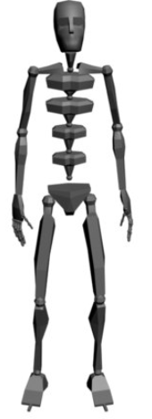

Figure . Standing Idle Pose

* Pose 1: Front attack/defense move as shown below in figure 2.

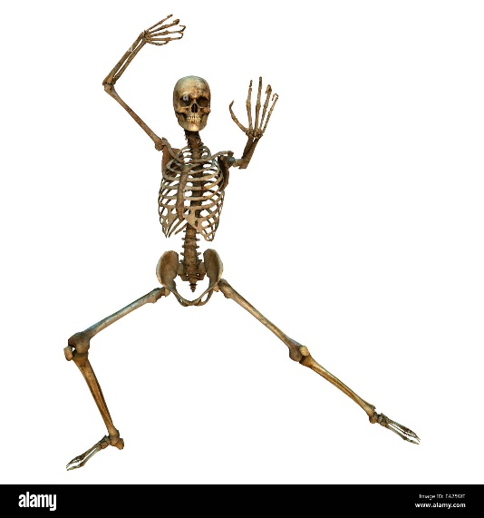

Figure . Pose 1: Front Attack/Defense

* Pose 2: Side Kick move as shown in Figure 3.

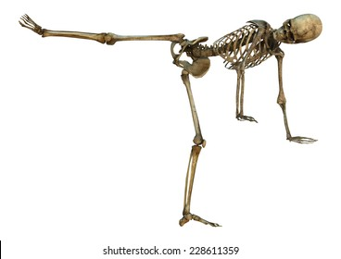

Figure . Side kick.

* Pose 3: Stretch move as shown in figure 4.

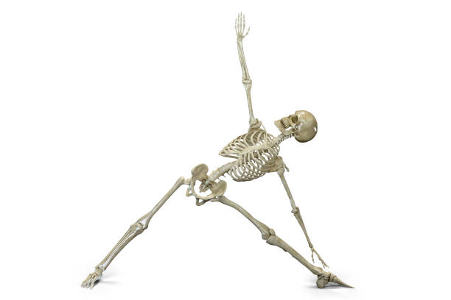

Figure . Stretch

Save all three animation clips in any format of Engine supported file and upload your project to eLearning.