Chapter 12 – Solutions to Instructor Reserve Problems

I-1 Instructor
The plant is given by
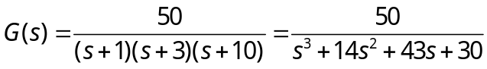
The characteristic polynomial for the plant with phase-variable state feedback is
The desired characteristic equation is
based upon 10% overshoot, 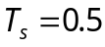 second, and a third pole ten times further from the imaginary axis than the dominant poles. Comparing both characteristic equations
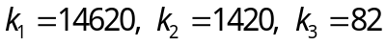

I-2 Instructor
a. The system in controller canonical form is:

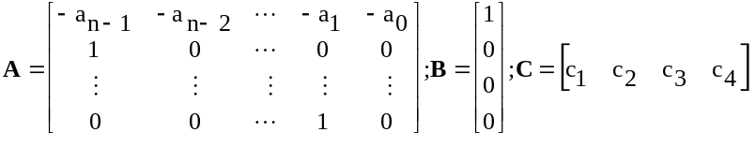******
The characteristic equation of the plant is:
sn + an-1sn-1 + . . . + a1s + a0 = 0
Forming the closed-loop system by feeding back each state variable and the input to u forming
u = -Kx + r
where
K = [k1 k2 . . . kn]
and substituting u into the state equation, we obtain
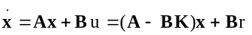
Forming A - BK:
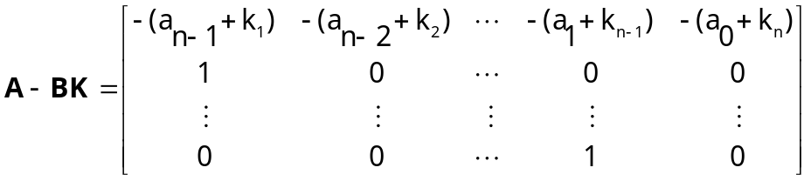
The characteristic equation is:
sn + (an-1 + k1)sn-1 + (an-2 + k2). . . + (a1 + kn-1)s + (a0 + kn) = 0
Assuming a desired characteristic equation,
sn + dn-1sn-1 + dn-2sn-2+ . . . + d2s2 + d1s + d0 = 0
Equating coefficients,
di = ai + kn-i ; i = 0, 1, 2, ... n-1
from which
kn-i = di – ai (1)
b. The desired characteristic equation is
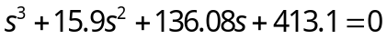
the characteristic equation of the plant is
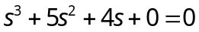
Using Eq. (1) above, k_{3-i} = d_{i} – a_{i}. Therefore, k₃ = d₀ – a₀ = 413.1 – 0 = 413.1; k₂ = d₁ – a₁ = 136.08 – 4 = 132.08; k₁ = d₂ – a₂ = 15.9 – 5 = 10.9. Hence,
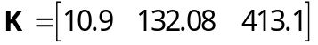
I-3 Instructor
Drawing the signal-flow diagram,

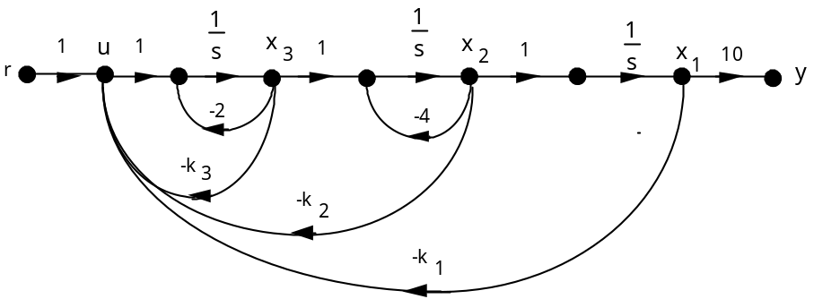
Writing the state equations yields the following A matrix:

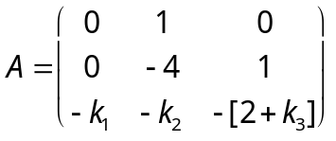
from which,

The desired characteristic equation is (s + 80)(s2 + 16s + 183.137) = s3 + 96s2 + 1463.1s + 14651 based upon 10% overshoot, Ts = 0.5 second, and a third pole ten times further from the imaginary axis than the dominant poles. Comparing the two characteristic equations, , k1 = 14651, k2 = 1095.1, and k3 = 90.
I-4 Instructor
From Eq. (12.46) we write the controller canonical form: 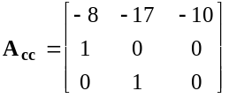,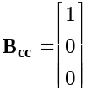 .
*******
The controllability matrices are found using Eq. (12.35). For the original system of Eq. (12.44),

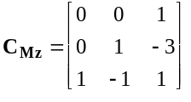. For the controller canonical form, 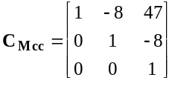. The transformation matrix is, P = CMzCMcc-1 = 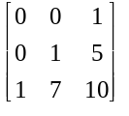. Comparing the first row of Acc with the desired characteristic equation, Eq. (12.50), Kcc = [ -2 -4 10]. Transforming back to the original system, Kz = KccP-1 = [-20 10 -2].
I-5 Instructor
Expanding by partial fractions,
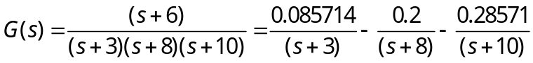
Writing the A and B matrices for the z system with ki's set to zero,

Az |  |  | Bz
-3 | 0 | 0 | 0.085714
0 | -8 | 0 | 0.2
0 | 0 | -10 | -0.28571

Writing the A and B matrices for the x (phase-variable) system,

Ax |  |  | Bx
0 | 1 | 0 | 0
0 | 0 | 1 | 0 | Phase-Variable Form
-240 | -134 | -21 | 1

From the phase variable from, the characteristic polynomial is s3 + 21s2 + 134s + 240.
Finding the controllability matrices and their determinants for the z and x systems shows that there is controllability,

CMz |  | Controllability Matrix of z |  |  |  | CMx |  | Controllability Matrix of x
0.085714 |  | -0.257142 |  | 0.771426 |  | 0 |  | 0 |  | 1
0.2 |  | -1.6 |  | 12.8 |  | 0 |  | 1 |  | -21
-0.28571 |  | 2.8571 |  | -28.571 |  | 1 |  | -21 |  | 307
 | Det(CMz) |  | 0.342850857 |  |  |  | Det(CMx) |  | -1

Using Eq. (12.39), the transformation matrix P and its inverse are found to be

P | Transformation Matrix z=Px |  | PINV
6.85712 | 1.542852 | 0.085714 | 0.33 | -0.50 | -0.25
6 | 2.6 | 0.2 | -1.00 | 4.00 | 2.50
-6.85704 | -3.14281 | -0.28571 | 3.00 | -32.00 | -25.00

Using the given transient requirements, and placing the third closed-loop pole over the zero at -6 yields the following desired closed-loop characteristic polynomial:
(s2 + 8s + 45.78)(s + 6) = s3 + 14s2 + 93.78s + 274.68
Using the phase-variable system with state feedback the characteristic polynomial is
s3 + (k3 + 21)s2 + (k2 + 134)s + (k1 + 240)
Equating the two characteristic polynomials yields the state feedback vector for the x system as

Kx | Controller for x
34.7062 | -40.2156 | -7
Using Eq. (12.42),
Kz | Controller for z
30.78443595 | 45.7845 | 65.78543678

I-6 Instructor
Draw signal-flow diagram showing state variables, z, at the output of each subsystem and the state variables, w, at the output of the integrators.
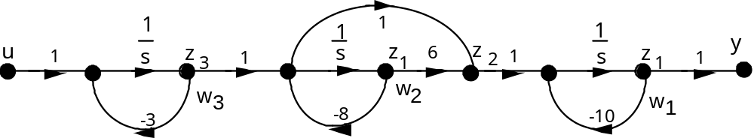

Recognizing that 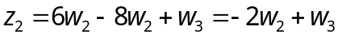, we can write the state equations for w as

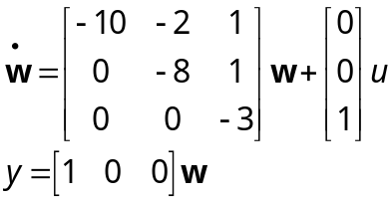
Writing the relationship between z and w yileds

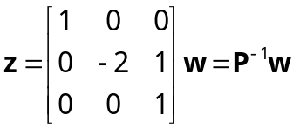
Thus
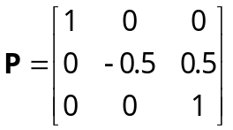
Converting the state equations in w to state equations in z, we use Eqs. (5.87) and obtain the A matrix and B vector as
Az |  |  | Bz
-10 | 1 | 0 | 0
0 | -8 | 3 | 1
0 | 0 | -3 | 1

Writing the A and B matrices for the x (phase-variable) system,

Ax |  |  | Bx
0 | 1 | 0 | 0
0 | 0 | 1 | 0 | Phase-Variable Form
-240 | -134 | -21 | 1

From the phase variable from, the characteristic polynomial is s3 + 21s2 + 134s + 240
Finding the controllability matrices and their determinants for the z and x systems shows that there is controllability,

CMz | Controllability Matrix of z |  | CMx | Controllability Matrix of x
0 | 1 | -15 | 0 | 0 | 1
1 | -5 | 31 | 0 | 1 | -21
1 | -3 | 9 | 1 | -21 | 307
Det(CMz) | -8 |  | Det(CMx) | -1

Using Eq. (12.39), the transformation matrix P and its inverse are found to be

P | Transformation Matrix z=Px |  | PINV
6 | 1 | 0 | -0.25 | -0.13 | 0.13
60 | 16 | 1 | 2.50 | 0.75 | -0.75
80 | 18 | 1 | -25.00 | -3.50 | 4.50

Using the given transient requirements, and placing the third closed-loop pole over the zero at -6 yields the following desired closed-loop characteristic polynomial:
(s2 + 8s + 45.78)(s + 6) = s3 + 14s2 + 93.78s + 274.68
Using the phase-variable system with state feedback the characteristic polynomial is
s3 + (k3 + 21)s2 + (k2 + 134)s + (k1 + 240)
Equating the two characteristic polynomials yields the state feedback vector for the x system as

Kx | Controller for x
34.68 | -40.22 | -7

Using Eq. (12.42),
Kz | Controller for z
65.78 | -10 | 3
I-7 Instructor
a.
>> A=[-0.014 0 -1.4 0 0; 0.023 -0.023 -0.023 0 0; 0.134 0.67 -0.67 0.38 0.003264; 0 0 0.06 -0.06 0; 0 0 0.0017 0 -0.001];
>> B = [1;0;0;0;0];
>> rank(ctrb(A,B))

ans =

5
The controllability matrix has full rank so the system is controllable.

b.
>> [P,Ad]=jordan(A) % P is the similarity transformation matrix used for diagonalization, Ad the diagonalized A matrix

P =

-0.0000 + 0.0000i 1.3181 + 0.1838i 0.0446 -1.6808 1.3181 - 0.1838i
-0.0000 + 0.0000i -0.0336 - 0.0948i -0.0286 0.0958 -0.0336 + 0.0948i
0.0000 - 0.0000i 0.1916 - 0.1798i 0.0014 -0.3845 0.1916 + 0.1798i
0.0000 - 0.0000i -0.0605 - 0.0176i 0.0370 0.0841 -0.0605 + 0.0176i
0.0012 - 0.0000i -0.0016 - 0.0002i -0.0000 0.0020 -0.0016 + 0.0002i

Ad =

-0.0010 0 0 0 0
0 -0.1875 + 0.2151i 0 0 0
0 0 -0.0577 0 0
0 0 0 -0.3343 0
0 0 0 0 -0.1875 - 0.2151i

>> Bd=inv(P)*B

Bd =

1.0000 + 0.0000i
1.0000
1.0000 + 0.0000i
1.0000 + 0.0000i
1.0000 + 0.0000i

I-8 Instructor
The A, L, and C matrices for the phase-variable system are:

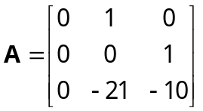

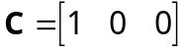
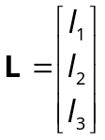
Hence,
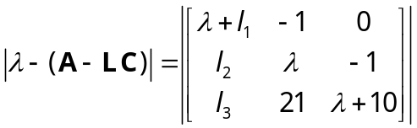
or
From Problem 19, the desired characteristic polynomial is λ3 + 360λ2 + 23625λ + 1687500.
Equating coefficients yields:
Solving successively,
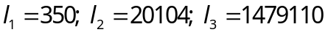
I-9 Instructor
a.
Representing the system in steady state yields
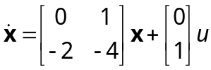
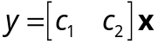
The observability matrix is
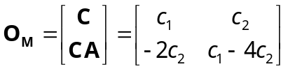
It’s determinant is
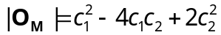
So the system is unobservable whenever 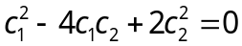 is satisfied.
b.
If 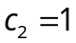 the condition becomes 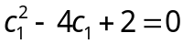 which as two solutions 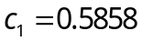 and 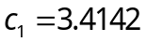.

I-10 Instructor

Expanding the plant by partial fractions, we obtain
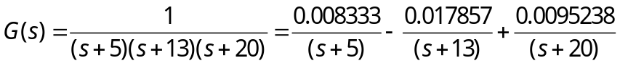

The A and C matrices for the system represented in parallel form is
Az
-5 | 0 | 0
0 | -13 | 0
0 | 0 | -20

Cz
1 | 1 | 1

The characteristic polynomial found from the transfer function of the plant is
s3 + 38s2 + 425s + 1300
From this characteristic polynomial, we can write the observer canonical form of the state equations. The A and C matrices of the observer canonical form are given below as
Ax
-38 | 1 | 0
-425 | 0 | 1
-1300 | 0 | 0

 |  | Cx
 |  | 1 |  | 0 |  | 0
To test observability, we write the observability matrices for both systems and show that both observability matrices have non zero determinants. Using Eq. (12.79),

OMz | Observability Matrix of z |  | OMx | Observability Matrix of x
1 | 1 | 1 | 1 | 0 | 0
-5 | -13 | -20 | -38 | 1 | 0
25 | 169 | 400 | 1019 | -38 | 1
Det(OMz) | -840 |  | Det(OMx) | 1
Using Eq. (12.89), we obtain the transformation matrix, P, and its inverse as

P | Transformation Matrix z=Px |  | PINV
0.2083333 | -0.04166667 | 0.008333333 | 1.00 | 1.00 | 1.00
-3.017857 | 0.232142857 | -0.01785714 | 33.00 | 25.00 | 18.00
3.8095238 | -0.19047619 | 0.00952381 | 260.00 | 100.00 | 65.00
Using the characteristic polynomial given in the problem statement, the plant’s characteristic equation, and Eq. (12.67), the observer for the observer canonical system is

Lx | Observer for x
562
39575
1498700

Using Eq. (12.92), the observer for the parallel system is found to be

Lz | Observer for z
10957.29167
-19271.4821
8876.190476
I-11 Instructor
The open-loop transfer function of the plant is T(s) = C(sI-A)-1B = 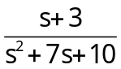.
Using Eqs. (12.115), the closed-loop state equations with integral control is

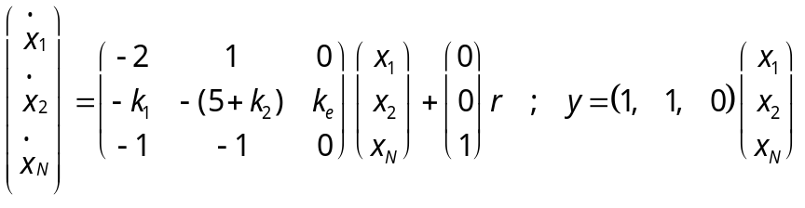
The characteristic polynomial is
s3 + (k2 + 7)s2 + (2k2 + k1 + ke + 10)s + 3ke
The desired characteristic polynomial is calculated from the desired transient response stated in the problem. Also, the third pole will be placed to cancel the zero at -3. Hence, the desired characteristic polynomial is
Equating coefficients of the characteristic polynomials yields,
ke = 183.137, k2 = 12, k1 = 14.003

SOLUTIONS TO DESIGN PROBLEMS

I-12 Instructor
a. The open loop characteristic polynomial is
The desired characteristic polynomial is
So we have
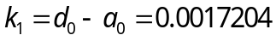
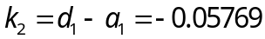
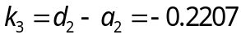

b.
>> A = [0 1 0; 0 0 1; -0.0005016 -0.1288 -0.854];
>> B=[0;0;1];
>> C = [0.000078 0.00414 0.01];
>> K=[0.0017204 -0.05769 -0.2207];
>> eig(A-B*K)

ans =

-0.49995739538301
-0.06584435043216
-0.06749825418482
I-13 Instructor
- The system’s transfer function 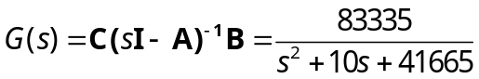
- From the transfer function by inspection
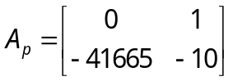; 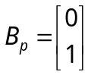; 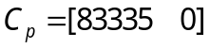
- A 20% overshoot gives 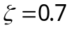, and 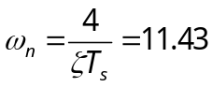so the desired characteristic equation is 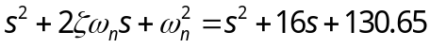
Equating gains we have
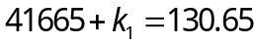 and 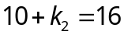 giving 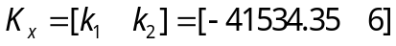

- The Controllability matrix for the original system is
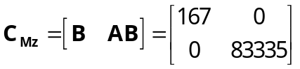
The Controllability matrix for the phase variable system is

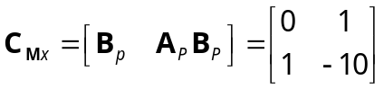
The transformation matrix is
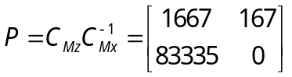
The set of gains for the original system is:
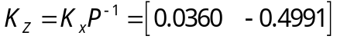
e. 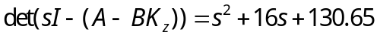
f.
>> A=[0 -83.33; 500 -10];
>> B = [166.67;0];
>> C=[0 1];
>> K=[0.0360 -0.499];
>> step(A-B*K,B,C,0)

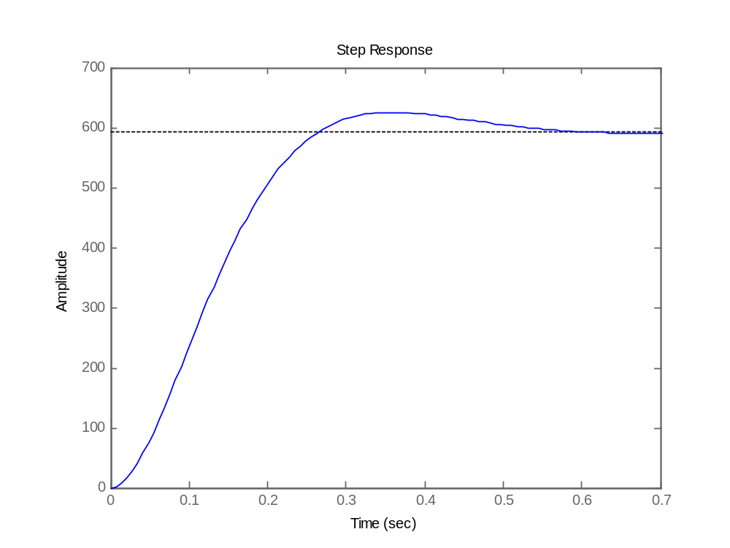

I-14 Instructor
a. We start by expressing the system in Observable Canonical form. From problem IV, the transfer function is 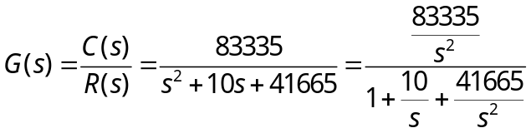, so we can write
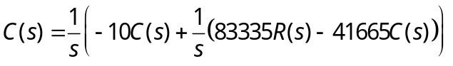 from which we get the following diagram:
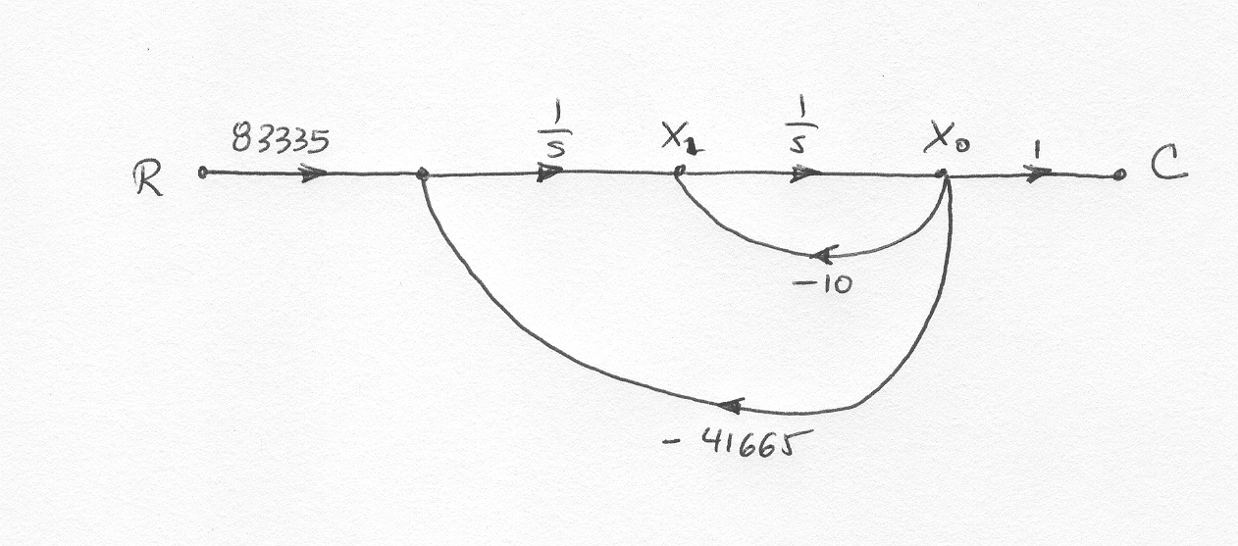

By direct inspection we can write
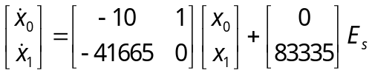 and 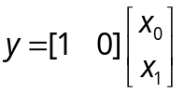

The characteristic equation for this system is 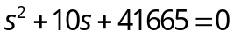with roots at
-5±j204.06. To make the observer 10 times faster its poles will be placed at -50±j2040.6
The desired characteristic equation is 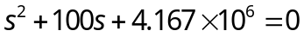
The error equation is given by
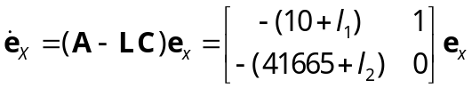 which has a characteristic equation 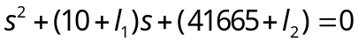
By equation coefficients with the desired characteristic equation we obtain
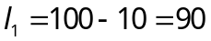 and 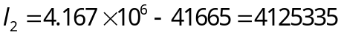

b.
