Chapter 13 – Solutions to Instructor Reserve Problems

I-1 Instructor
a.
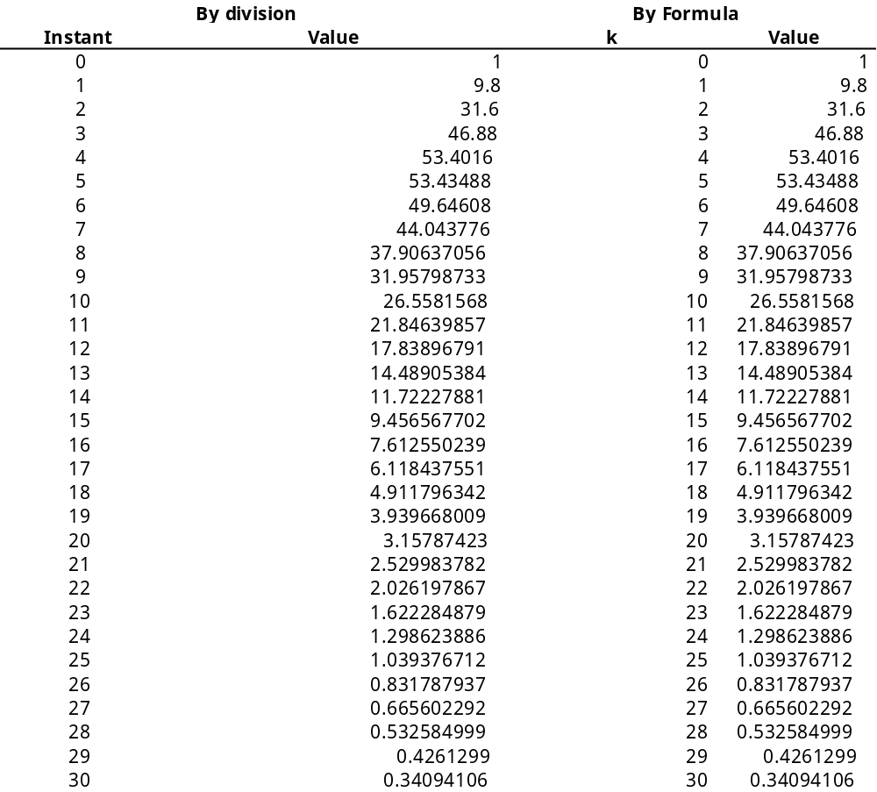

b.
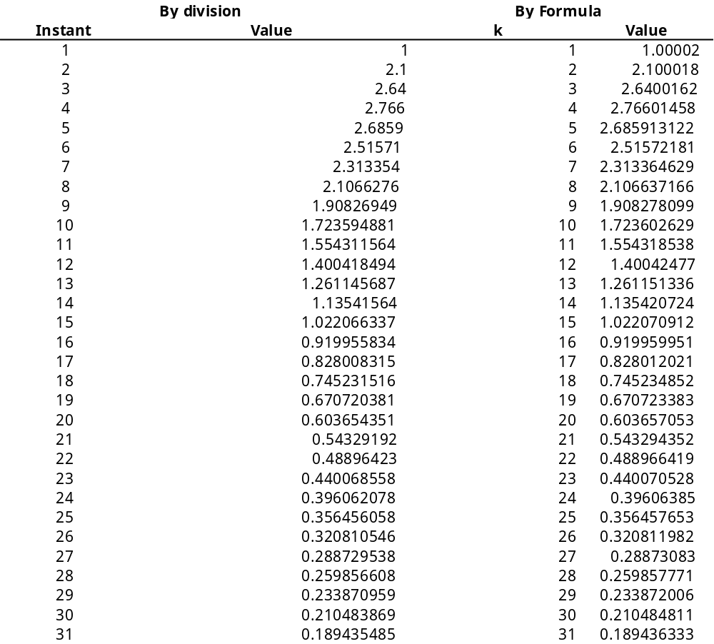

c.
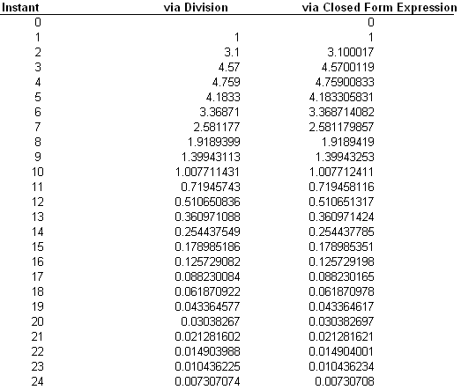

I-2 Instructor
Add phantom samplers after G₁(s), G₃(s), G₄(s), H₁(s), and H₂(s).

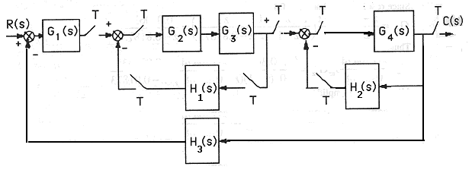

Push G1(s) and its sampler to the left past the summing junction. Also, push G4(s) and its input sampler to the right past the pickoff point. The resulting block diagram is,
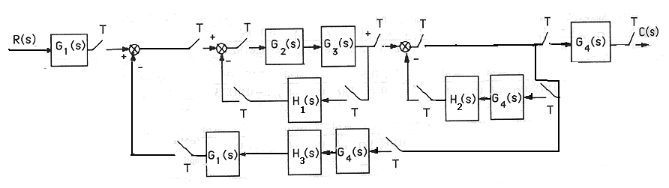
Converting to z transforms,
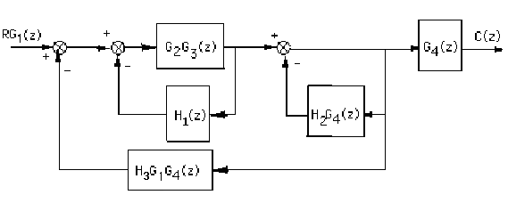

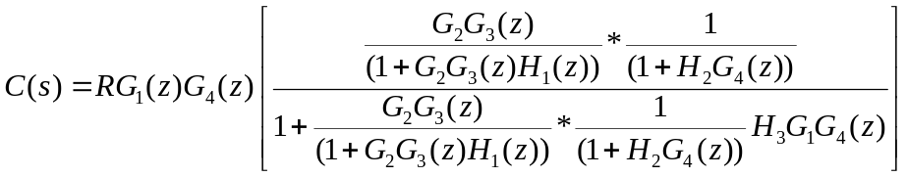

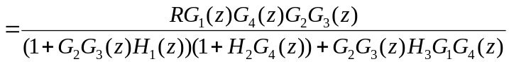

I-3 Instructor

Program:
numgz=0.13*[1 1];
dengz=poly([1 0.74]);
Gz=tf(numgz,dengz,0.1)
Gzpkz=zpk(Gz)
Tz=feedback(Gz,1)
linearSystemAnalyzer

Computer response:
Transfer function:
0.13 z + 0.13
-------------------
z^2 - 1.74 z + 0.74

Sampling time: 0.1

Zero/pole/gain:
0.13 (z+1)
--------------
(z-1) (z-0.74)

Sampling time: 0.1

Transfer function:
0.13 z + 0.13
-------------------
z^2 - 1.61 z + 0.87

Sampling time: 0.1

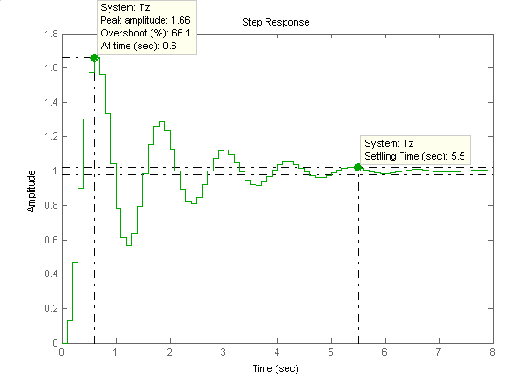

I-4 Instructor
First find G(z). G(z) = K z{} = K z{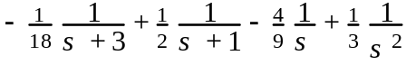}
For T=0.1, G(z) = K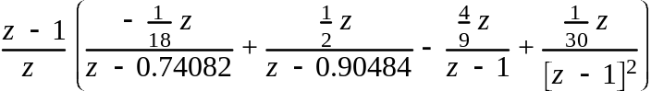
= K 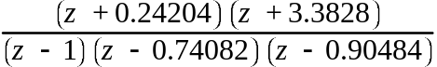. Plotting the root locus and overlaying the 20% overshoot curve, we select the point of intersection and calculate the gain: 0.00015103K = 1.789. Thus, K = 11845.33. Finding the intersection with the unit circle yields 0.00015103K = 9.85. Thus, 0 < K < 65218.83 for stability.

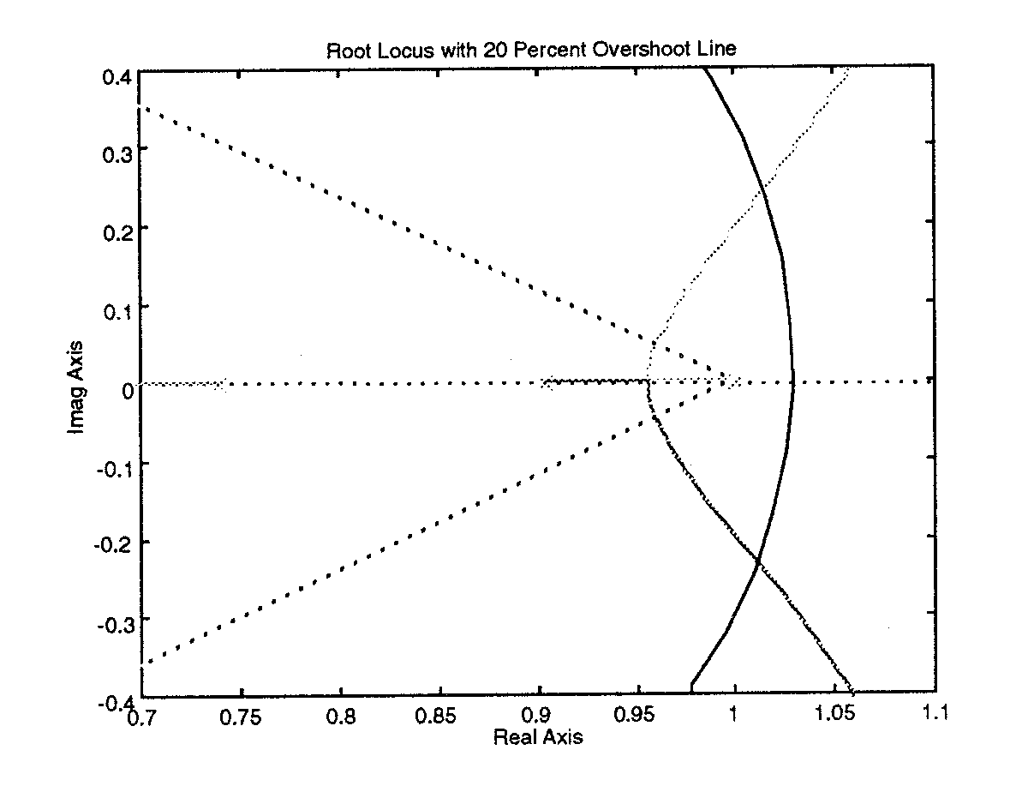
I-5 Instructor
In the modified Simulink model, shown below, the position reference step was set to start at t = 0 and the sample time in the zero-order hold was set to 0.01 sec. The PID controller settings were those found in part (d) of problem IX-z; e.g., K_{P} = 7, K_{D} = 2.44, and K_{I} = 0.676. The simulation was run for 40 sec. From the cart position (displayed on the scope and shown below) it could be seen that all requirements are met.
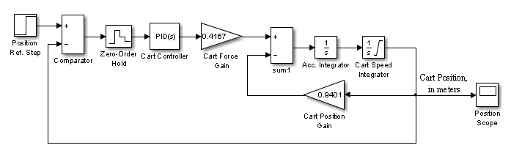

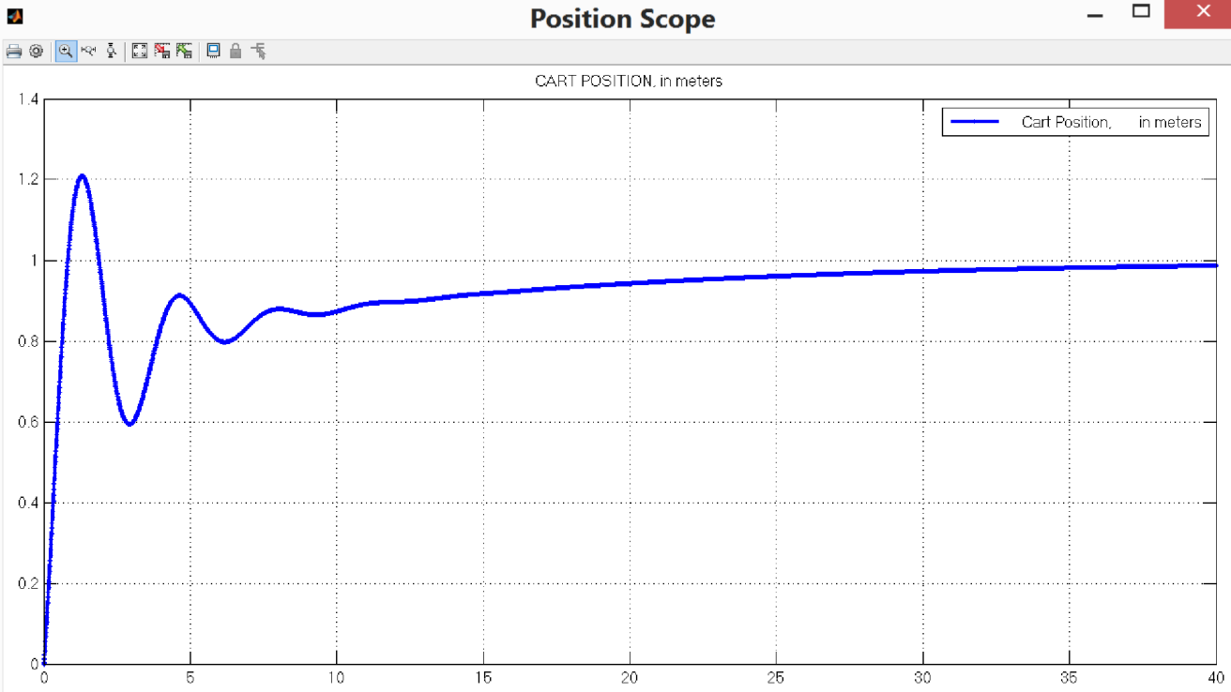

SOLUTIONS TO DESIGN PROBLEMS

I-6 Instructor
a. First find G(z). G(z) = K z{} = K z{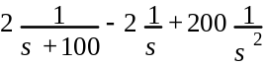}
For T = 0.01, G(z) = K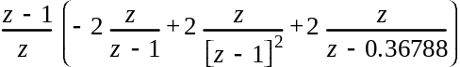
= K 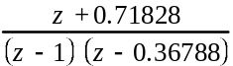.
b. Plotting the root locus. Finding the intersection with the unit circle yields 0.73576K = 1.178. Thus, 0 < K < 1.601 for stability.

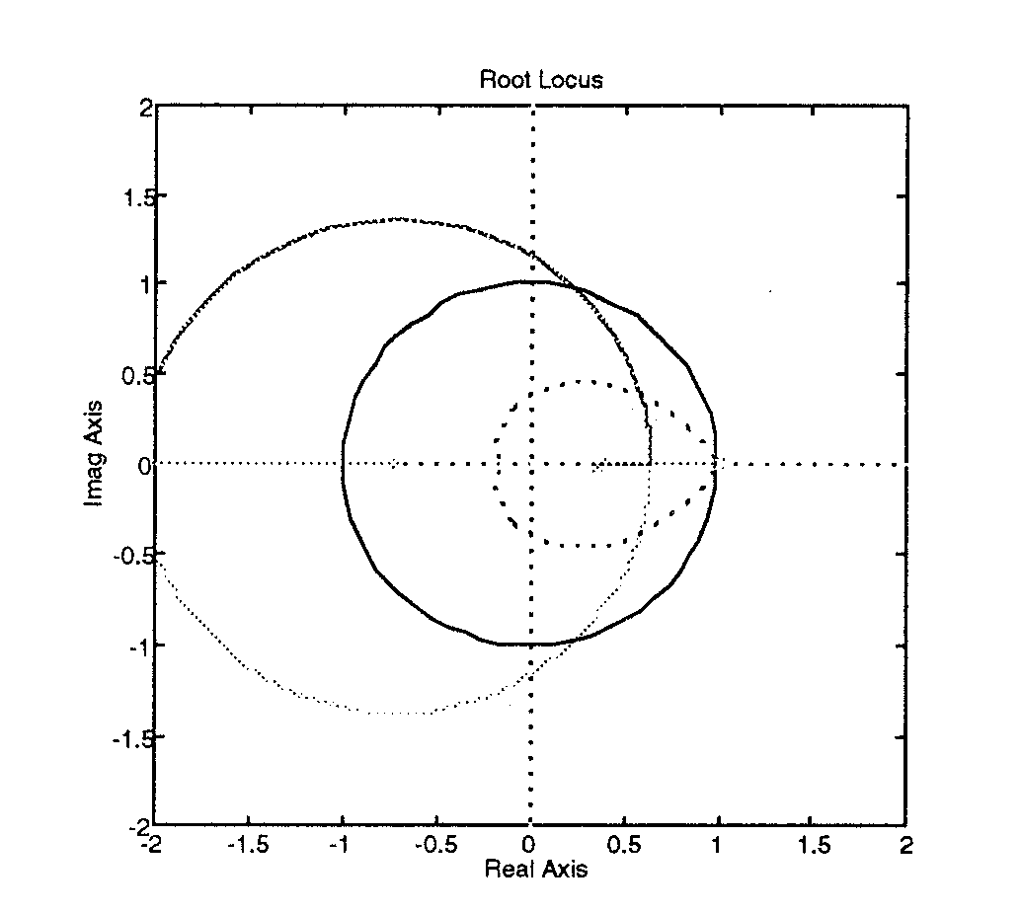

c. Using the root locus, we find the intersection with the 15% overshoot curve (ζ = 0.517) at
0.5955 + j0.3747 with 0.73576K = 0.24. Thus K = 0.326.
d.
Program:
%Digitize G1(s) preceded by a sample and hold
numg1=20000;
deng1=[1 100 0];
'G1(s)'
G1s=tf(numg1,deng1)
'G(z)'
Gz=c2d(G1s,0.01,'zoh')
[numgz,dengz]=tfdata(Gz,'v');
'Zeros of G(z)'
roots(numgz)
'Poles of G(z)'
roots(dengz)
%Input transient response specifications
Po=input('Type %OS ');
%Determine damping ratio
z=(-log(Po/100))/(sqrt(pi^2+log(Po/100)^2))
%Plot root locus
rlocus(Gz)
zgrid(z,0)
title(['Root Locus'])
[K,p]=rlocfind(Gz) %Allows input by selecting point on graphic.

Computer response:
ans =

G1(s)

Transfer function:
20000
-----------
s^2 + 100 s

ans =

G(z)

Transfer function:
0.7358 z + 0.5285
----------------------
z^2 - 1.368 z + 0.3679

Sampling time: 0.01

ans =

Zeros of G(z)

ans =

-0.7183

ans =

Poles of G(z)

ans =

1.0000
0.3679

Type %OS 15

z =

0.5169

Select a point in the graphics window

selected_point =

0.5949 + 0.3888i

K =

0.2509

p =

0.5917 + 0.3878i
  - - 0.3878
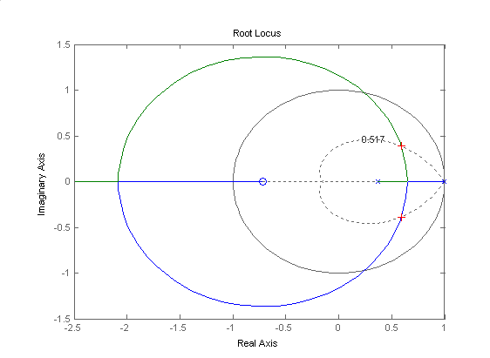

I-7 Instructor
  - A bode plot of the open loop transmission 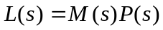 shows that the crossover frequency for this system is 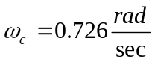. The recommended range for the sampling frequency is: 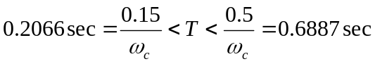. Arbitrarilly we choose 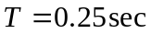.
  - Substituting 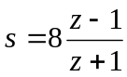 into 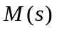, after algebraic manipulations we get
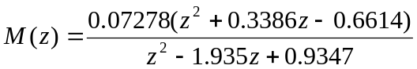

c.
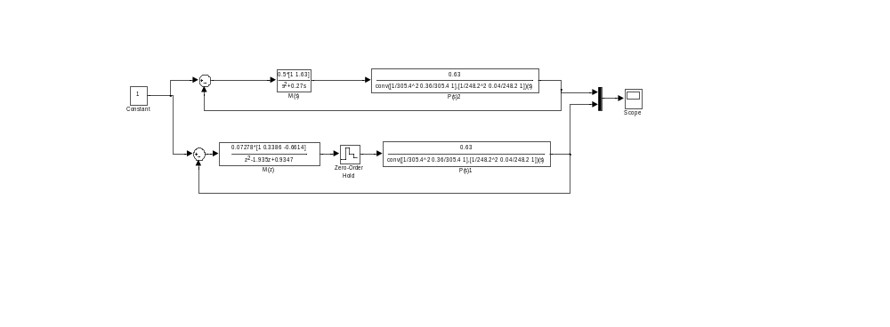
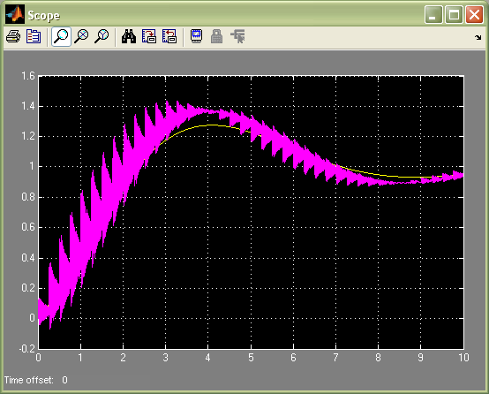

The output of the system exhibits oscillations caused by a plant high frequency resonance. This problem can be improved by using other discretization techniques.
I-8 Instructor
- A bode plot of the open loop transmission 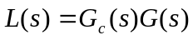 shows that the crossover frequency for this system is 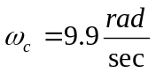. The recommended range for the sampling frequency is: 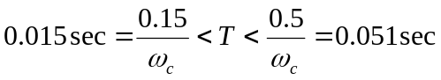. Arbitrarilly we choose 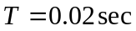.
- Substituting into 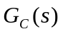, after algebraic manipulations we get
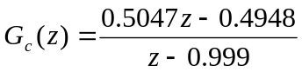
c.
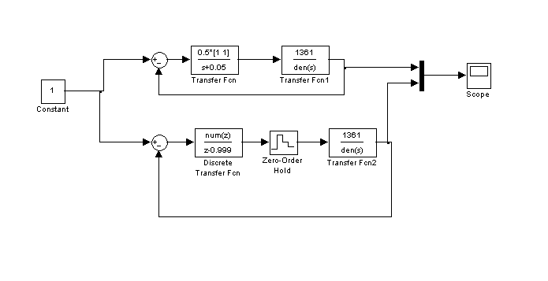
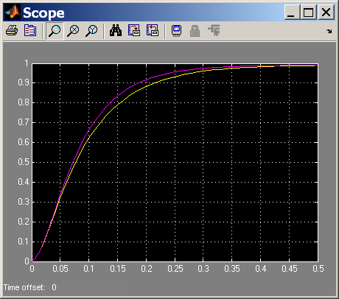

I-9 Instructor
- The pulse transfer function for the plant is 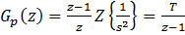. The desired , so the compensator is 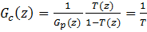
- The steady state error constant is given by 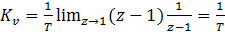. So the steady state error for a ramp input is 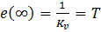
- The simulations diagram is shown next
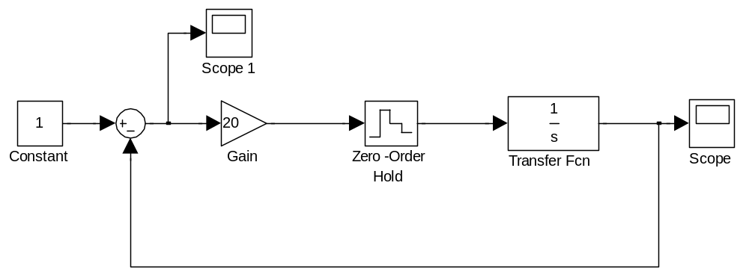
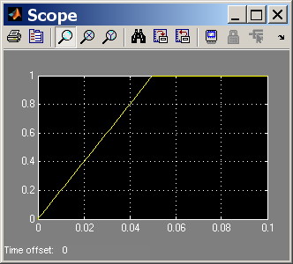
For a step input, the system reaches steady state within one sample.
For a ramp input the error signal is displayed:
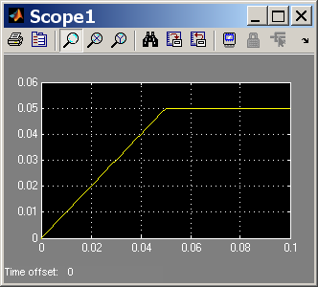
I-10 Instructor
a. The root locus is easily obtained noting that the characteristic equation is 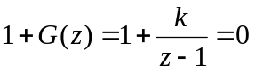 or 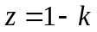. Shown in the next figure
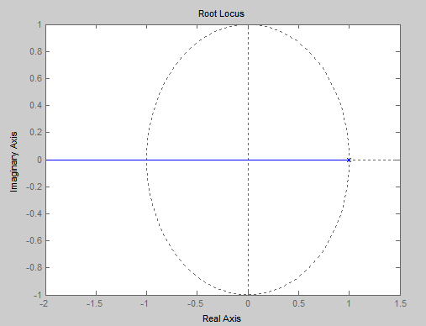
b. The roots of the characteristic equation will be within the unit circle as long as 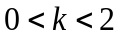.
c. To obtain the steady state error we find 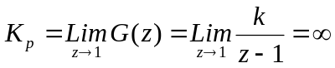. Follows that 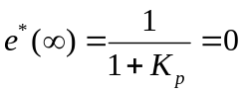
d. The fastest system response will be achieved when 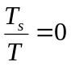 . This will occur when 

