T H I R T E E N

Digital Control

Systems

SOLUTIONS TO CASE STUDIES CHALLENGES

Antenna Control: Transient Design via Gain
a. From the answer to the antenna control challenge in Chapter 5, the equivalent forward transfer function found by neglecting the dynamics of the power amplifier, replacing the pots with unity gain, and including the integration in the sample-and-hold is

Ge(s) = 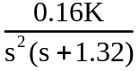
But,
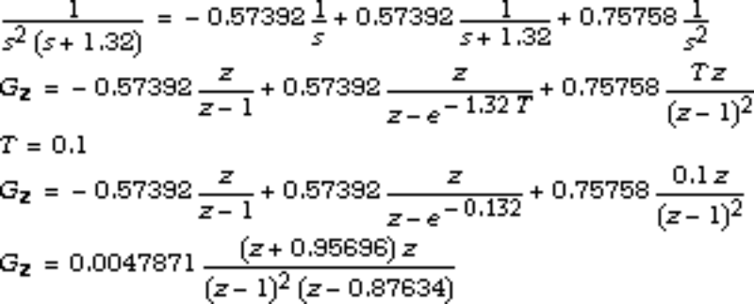
Thus, Ge(z) = 0.16K Gz , or,
Ge(z) = 7.659x10-4K
b. Draw the root locus and overlay it over the ζ = 0.5 (i.e. 16.3% overshoot) curve.

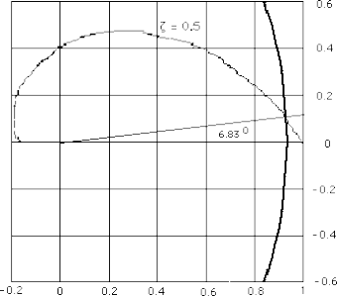

We find that the root locus crosses at approximately 0.93 ± j0.11 with 7.659x10-4K = 8.63x10-3. Hence, K = 11.268.
c.
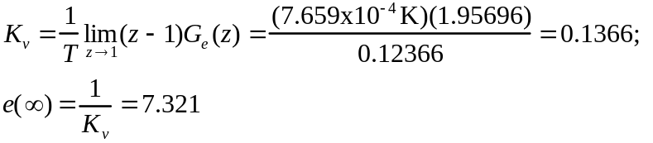
d.
Program:
T=0.1; %Input sampling time
numf=0.16; %Numerator of F(s)
denf=[1 1.32 0 0]; %Denominator of F(s)
'F(s)' %Display label
F=tf(numf,denf) %Display F(s)
numc=conv([1 0],numf); %Differentiate F(s) to compensate
%for c2dm which assumes series zoh
denc=denf; %Denominator of continuous system
%same as denominator of F(s)
C=tf(numc,denc); %Form continuous system, C(s)
C=minreal(C,1e-10); %Cancel common poles and zeros
D=c2d(C,T,'zoh'); %Convert to z assuming zoh
'F(z)'
D=minreal(D,1e-10) %Cancel common poles and zeros and display
rlocus(D)
pos=(16.3);
z=-log(pos/100)/sqrt(pi^2+[log(pos/100)]^2);
zgrid(z,0)
title(['Root Locus with ' , num2str(pos), ' Percent Overshoot Line'])
[K,p]=rlocfind(D) %Allows input by selecting point on
%graphic

Computer response:
ans =

F(s)

Transfer function:
0.16
--------------
s^3 + 1.32 s^2

ans =

F(z)

Transfer function:
0.0007659 z + 0.000733
----------------------
z^2 - 1.876 z + 0.8763

Sampling time: 0.1
Select a point in the graphics window

selected_point =

9.2969e-001 +1.0219e-001i

K =

9.8808e+000

p =

9.3439e-001 +1.0250e-001i
9.3439e-001 -1.0250e-001i

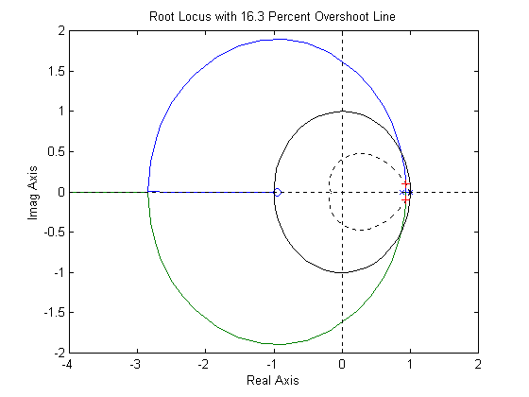

Antenna Control: Digital Cascade Compensator Design
a. Let the compensator be KG_{c}(s) and the plant be 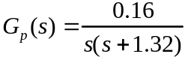. For 10% overshoot and a peak time of 1 second, ζ = 0.591 and ω_{n} = 3.895, which places the dominant poles at
–2.303 ± j3.142. If we place the compensator zero at –1.32 to cancel the plant’s pole, then the following geometry results.
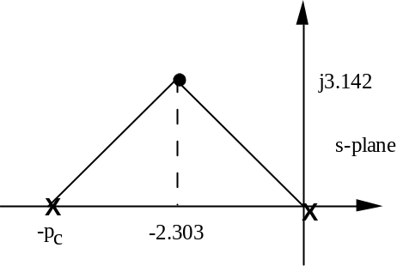
Hence, p_{c} = 4.606. Thus, 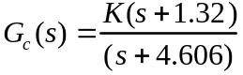 and 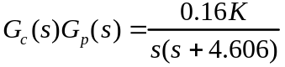. Using the product of pole lengths to find the gain, 0.16K = (3.896)², or K = 94.87. Hence,
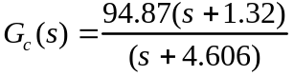. Using a sampling interval of 0.01 s, the Tustin transformation of G_{c}(s) is 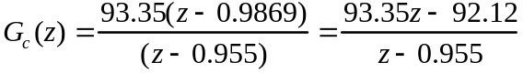.
b. Cross multiplying,
(z - 0.955)X(z) = (93.35z – 92.12)E(z)
Solving for the highest power of z operating on X(z),
zX(z) = (93.35z – 92.12)E(z) + 0.955X(z)
Solving for X(z),
X(z) = (93.35 – 92.12z-1)E(z) + 0.955z-1X(z)
Implementing this equation as a flowchart yields the following diagram

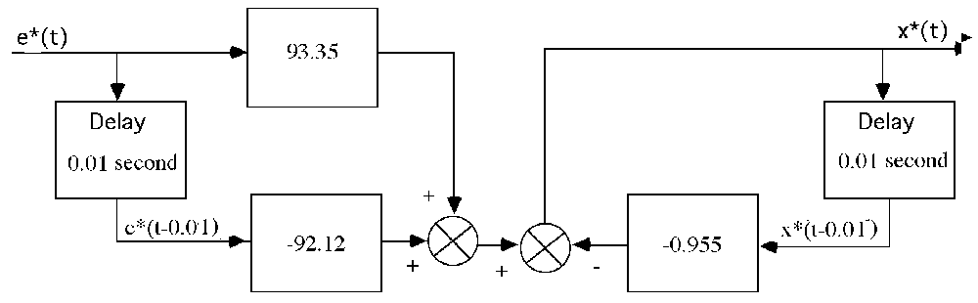
c.
Program:
's-plane lead design for Challenge - Lead Comp'
clf %Clear graph on screen.
'Uncompensated System' %Display label.
numg=0.16; %Generate numerator of G(s).
deng=poly([0 -1.32]); %Generate denominator of G(s).
'G(s)' %Display label.
G=tf(numg,deng); %Create G(s).
Gzpk=zpk(G) %Display G(s).
pos=input('Type desired percent overshoot ');
%Input desired percent overshoot.
z=-log(pos/100)/sqrt(pi^2+[log(pos/100)]^2);
%Calculate damping ratio.
Tp=input('Type Desired Peak Time ');
%Input desired peak time.
wn=pi/(Tp*sqrt(1-z^2)); %Evaluate desired natural frequency.
b=input('Type Lead Compensator Zero, (s+b). b= ');
%Input lead compensator zero.
done=1; %Set loop flag.

while done==1 %Start loop for trying lead
%compensator pole.
a=input('Enter a Test Lead Compensator Pole, (s+a). a = ');
%Enter test lead compensator pole.
numge=conv(numg,[1 b]); %Generate numerator of Gc(s)G(s).
denge=conv([1 a],deng); %Generate denominator of Gc(s)G(s).
Ge=tf(numge,denge); %Create Ge(s)=Gc(s)G(s).
clf %Clear graph on screen.
rlocus(Ge) %Plot compensated root locus with
%test lead compensator pole.
axis([-5 2 -8 8]); %Change axes ranges.
sgrid(z,wn) %Overlay grid on lead-compensated
%root locus.
title(['Lead-Compensated Root Locus with ' , num2str(pos),...
'% Overshoot Line, Lead Pole at ', num2str(-a),...
' and Required Wn']) %Add title to lead-compensated root
%locus.
done=input('Are you done? (y=0,n=1) ');
%Set loop flag.
end %End loop for trying compensator
%pole.
[K,p]=rlocfind(Ge); %Generate gain, K, and closed-loop
%poles, p, for point selected
%interactively on the root locus.
'Gc(s)' %Display label.
Gc=K*tf([1 b],[1 a]) %Display lead compensator.
'Gc(s)G(s)' %Display label.
Ge %Display Gc(s)G(s).
'Closed-loop poles = ' %Display label.
p %Display lead-compensated system's
%closed-loop poles.
f=input('Give pole number that is operating point ');
%Choose lead-compensated system
%dominant pole.
'Summary of estimated specifications for selected point on lead'
'compensated root locus' %Display label.
operatingpoint=p(f) %Display lead-compensated dominant
%pole.
gain=K %Display lead-compensated gain.
estimated_settling_time=4/abs(real(p(f)))
%Display lead-compensated settling
%time.
estimated_peak_time=pi/abs(imag(p(f)))
%Display lead-compensated peak time.
estimated_percent_overshoot=pos %Display lead-compensated percent
%overshoot.
estimated_damping_ratio=z %Display lead-compensated damping
%ratio.
estimated_natural_frequency=sqrt(real(p(f))^2+imag(p(f))^2)
%Display lead-compensated natural
%frequency.
s=tf([1 0],1); %Create transfer function, "s".
sGe=s*Ge; %Create sGe(s) to evaluate Kv.
sGe=minreal(sGe); %Cancel common poles and zeros.
Kv=dcgain(K*sGe) %Display lead-compensated Kv.
ess=1/Kv %Display lead-compensated steady-
%state error for unit ramp input.
'T(s)' %Display label.
T=feedback(K*Ge,1) %Create and display lead-compensated
%T(s).
'Press any key to continue and obtain the lead-compensated step'
'response' %Display label
pause
step(T) %Plot step response for lead
%compensated system.
title(['Lead-Compensated System with ' ,num2str(pos),'% Overshoot'])
%Add title to step response of PD
%compensated system.
pause
'z-plane conversion for Challenge - Lead Comp'
clf %Clear graph.
'Gc(s) in polynomial form' %Print label.
Gcs=Gc %Create Gc(s) in polynomial form.
'Gc(s) in polynomial form' %Print label.
Gcszpk=zpk(Gcs) %Create Gc(s) in factored form.
'Gc(z) in polynomial form via Tustin Transformation'
%Print label.
Gcz=c2d(Gcs,1/100,'tustin') %Form Gc(z) via Tustin
%transformation.
'Gc(z) in factored form via Tustin Transformation'
%Print label.
Gczzpk=zpk(Gcz) %Show Gc(z) in factored form.
'Gp(s) in polynomial form' %Print label.
Gps=G %Create Gp(s) in polynomial form.
'Gp(s) in factored form' %Print label.
Gpszpk=zpk(Gps) %Create Gp(s) in factored form.
'Gp(z) in polynomial form' %Print label.
Gpz=c2d(Gps,1/100,'zoh') %Form Gp(z) via zoh transformation.
'Gp(z) in factored form' %Print label.
Gpzzpk=zpk(Gpz) %Form Gp(z) in factored form.
pole(Gpz) %Find poles.
Gez=Gcz*Gpz; %Form Ge(z) = Gc(z)Gp(z).
'Ge(z) = Gc(z)Gp(z) in factored form'
%Print label.
Gezzpk=zpk(Gez) %Form Ge(z) in factored form.
'z-1' %Print label.
zm1=tf([1 -1],1,1/100) %Form z-1.
zm1Gez=minreal(zm1*Gez,.00001);
'(z-1)Ge(z)' %Print label.
zm1Gezzpk=zpk(zm1Gez)
pole(zm1Gez)
Kv=300*dcgain(zm1Gez)
Tz=feedback(Gez,1)
step(Tz)
title('Closed-Loop Digital Step Response')
%Add title to step response.

Computer response:
ans =

s-plane lead design for Challenge - Lead Comp

ans =

Uncompensated System

ans =

G(s)

Zero/pole/gain:
0.16
----------
s (s+1.32)

Type desired percent overshoot 10
Type Desired Peak Time 1
Type Lead Compensator Zero, (s+b). b= 1.32
Enter a Test Lead Compensator Pole, (s+a). a = 4.606
Are you done? (y=0,n=1) 0
Select a point in the graphics window

selected_point =

-2.3045 + 3.1056i

ans =

Gc(s)

Transfer function:
93.43 s + 123.3
---------------
s + 4.606

ans =

Gc(s)G(s)

Transfer function:
0.16 s + 0.2112
------------------------
s^3 + 5.926 s^2 + 6.08 s

ans =

Closed-loop poles =

p =

-2.3030 + 3.1056i
-2.3030 - 3.1056i
-1.3200

Give pole number that is operating point 1

ans =

Summary of estimated specifications for selected point on lead

ans =

compensated root locus

operatingpoint =

-2.3030 + 3.1056i

gain =

93.4281

estimated_settling_time =

1.7369

estimated_peak_time =

1.0116

estimated_percent_overshoot =

10

estimated_damping_ratio =

0.5912

estimated_natural_frequency =

3.8663

Kv =

3.2454

ess =

0.3081

ans =

T(s)

Transfer function:
14.95 s + 19.73
---------------------------------
s^3 + 5.926 s^2 + 21.03 s + 19.73

ans =

Press any key to continue and obtain the lead-compensated step

ans =

response

ans =

z-plane conversion for Challenge - Lead Comp

ans =

Gc(s) in polynomial form

Transfer function:
93.43 s + 123.3
---------------
s + 4.606

ans =

Gc(s) in polynomial form

Zero/pole/gain:
93.4281 (s+1.32)
----------------
(s+4.606)

ans =

Gc(z) in polynomial form via Tustin Transformation

Transfer function:
91.93 z - 90.72
---------------
z - 0.955

Sampling time: 0.01

ans =

Gc(z) in factored form via Tustin Transformation

Zero/pole/gain:
91.9277 (z-0.9869)
------------------
(z-0.955)

Sampling time: 0.01

ans =

Gp(s) in polynomial form

Transfer function:
0.16
------------
s^2 + 1.32 s

ans =

Gp(s) in factored form

Zero/pole/gain:
0.16
----------
s (s+1.32)

ans =

Gp(z) in polynomial form

Transfer function:
7.965e-006 z + 7.93e-006
------------------------
z^2 - 1.987 z + 0.9869

Sampling time: 0.01

ans =

Gp(z) in factored form

Zero/pole/gain:
7.9649e-006 (z+0.9956)
----------------------
(z-1) (z-0.9869)

Sampling time: 0.01

ans =

1.0000
0.9869

ans =

Ge(z) = Gc(z)Gp(z) in factored form

Zero/pole/gain:
0.0007322 (z+0.9956) (z-0.9869)
-------------------------------
(z-1) (z-0.9869) (z-0.955)

Sampling time: 0.01

ans =

z-1

Transfer function:
z - 1

Sampling time: 0.01

ans =

(z-1)Ge(z)

Zero/pole/gain:
0.0007322 (z+0.9956)
--------------------
(z-0.955)

Sampling time: 0.01

ans =

0.9550

Kv =

9.7362

Transfer function:
0.0007322 z^2 + 6.387e-006 z - 0.0007194
----------------------------------------
z^3 - 2.941 z^2 + 2.884 z - 0.9432

Sampling time: 0.01
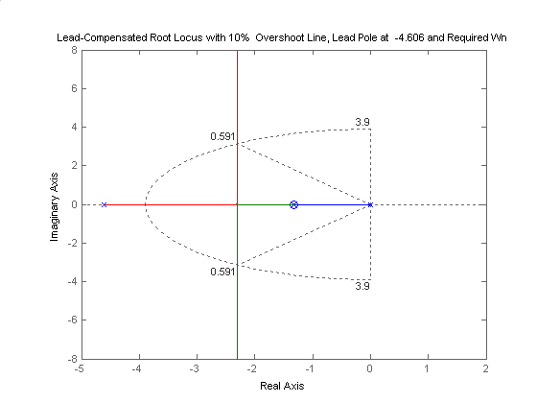

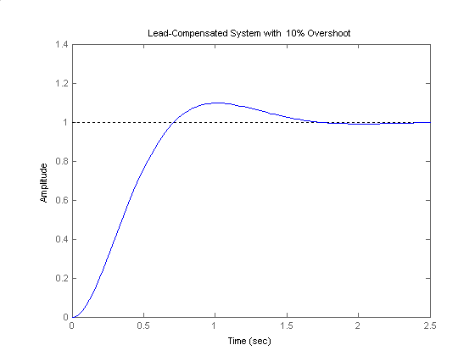

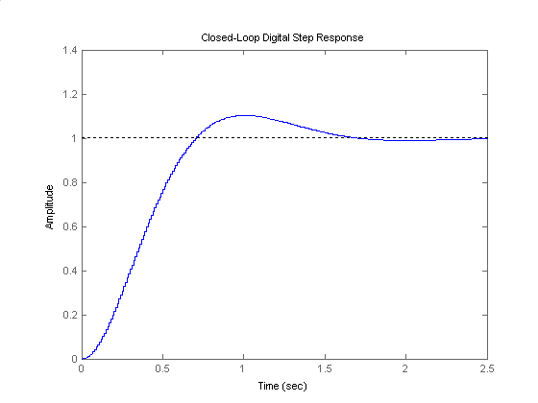
Answers to Review Questions
1. (1) Supervisory functions external to the loop; (2) controller functions in the loop
2. (1) Control of multiple loops by the same hardware; (2) modifications made with software, not hardware; (3) more noise immunity (4) large gains usually not required
3. Quantization error; conversion time
4. An ideal sampler followed by a sample-and-hold
5. z = esT
6. The value of the time waveform only at the sampling instants
7. Partial fraction expansion; division to yield power series
8. Partial fraction
9. Division to yield power series
10. The input must be sampled; the output must be either sampled or thought of as sampled.
11. c(t) is c*(t) = c(kT), i.e. the output only at the sampling instants.
12. No; the waveform is only valid at the sampling instants. Instability may be apparent if one could only see between the sampling instants. The roots of the denominator of G(z) must be checked to see that they are within the unit circle.
13. A sample-and-hold must be present between the cascaded systems.
14. Inside the unit circle
15. Raible table; Jury's stability test
16. z=+1
17. There is no difference.
18. Map the point back to the s-plane. Since z = esT, s = (1/T) ln z. Thus, σ = (1/T) ln (Re z), and
ω = (1/T) ln (Im z).
19. Determine the point on the s-plane and use z = esT. Thus, Re z = eσT cos ω, and Im z = eσT sin ω.
20. Use the techniques described in Chapters 9 and 11 and then convert the design to a digital compensator using the Tustin transformation.
21. Both compensators yield the same output at the sampling instants.

SOLUTIONS To Problems
1.
a. f(t) = e-at; f*(t) = ; F*(s) == 1 + e-aT e-Ts + e-a2T e-2Ts + . . . Thus,
F(z) = 1 + e-aT z-1 + e-a2T z-2 + . . . = 1 + x-1 + x-2 + . . . where x = e-aT z-1.

But, F(z) = = = .
b. f(t) = u(t); f*(t) = ; F*(s) =s = 1 + e-Ts + e-2Ts + . . .
Thus, F(z) = 1 + z-1 + z-2 + . . Since = 1 + z-1 + z-2 + z-3, F(z) = = = .
c. f(t) = t2 e-at; f*(t) = ; F*(s) = T2
= T2= T2= T2(x + 4x2 + 9x3 + 16x4 + . . . ) , where x = e- (s+a)T.
Let s1 = x + 4x2 + 9x3 + 16x4 + . . . Thus, xs1 = x2 + 4x3 + 9x4 + 16x5 + . . .
Let s2 = s1 - xs1 = x + 3x2 + 5x3 + 7x4 + . . .Thus, xs2 = x2 + 4x3 + 9x4 + 16x3 + . . .
Let s3 = s2 - xs2 = x + 2x2 + 2x3 + 2x4 + . . . Thus xs3 = x2 + 2x3 + 2x4 + 2x3 + . . .
Let s4 = s3 - xs3 = x + x2.
Solving for s3,
s3 =
and
s2 = =
and
s1 = =
Thus
F*(s) = T2 s1 = T2 = T2 =
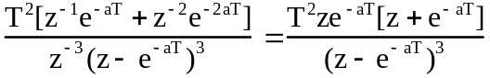
d. f(t) = cos(ωkT); f*(t) = 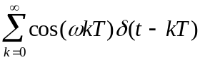; F*(s) =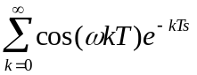
= 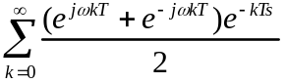= 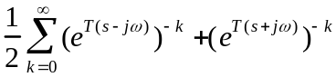
But,
= .
Thus,
F*(s) = 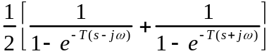= 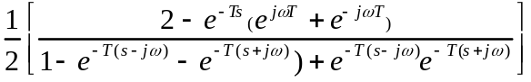
= 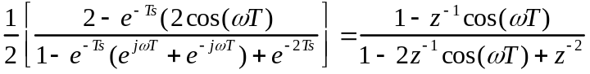
Therefore,
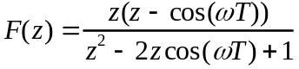
2.
Program:
syms T a w n %Construct symbolic objects for
%'T', 'a','w', and 'n'.
'(a)' %Display label.
'f(kT)' %Display label.
f=exp(-a*n*T); %Define f(kT).
pretty(f) %Pretty print f(kT)
'F(z)' %Display label.
F=ztrans(f); %Find z-transform, F(z).
pretty(F) %Pretty print F(z).

'(b)' %Display label.
'f(kT)' %Display label.
f=exp(-0*n*T); %Define f(kT)
pretty(f) %Pretty print f(kT)
'F(z)' %Display label.
F=ztrans(f); %Find z-transform, F(z).
pretty(F) %Pretty print F(z).

'(c)' %Display label.
'f(kT)' %Display label.
f=(n*T)^2*exp(-a*n*T); %Define f(kT)
pretty(f) %Pretty print f(kT)
'F(z)' %Display label.
F=ztrans(f); %Find z-transform, F(z).
pretty(F) %Pretty print F(z).

'(d)' %Display label.
'f(kT)' %Display label.
f=cos(w*n*T); %Define f(kT)
pretty(f) %Pretty print f(kT)
'F(z)' %Display label.
F=ztrans(f); %Find z-transform, F(z).
pretty(F) %Pretty print F(z).

Computer response:
ans =

(a)

ans =

f(kT)

exp(-a n T)
ans =

F(z)

z
-------------------------
/ z \
exp(-a T) |--------- - 1|
\exp(-a T) /
ans =

(b)

ans =

f(kT)

1
ans =

F(z)

z
-----
z - 1
ans =

(c)

ans =

f(kT)

2 2
n T exp(-a n T)
ans =

F(z)

2
T z exp(-a T) (z + exp(-a T))
------------------------------
3
(z - exp(-a T))
ans =

(d)

ans =

f(kT)

cos(w n T)
ans =

F(z)

(z - cos(w T)) z
---------------------
2
z - 2 z cos(w T) + 1

3.
a.
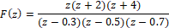
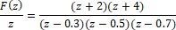
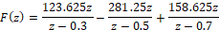
b.
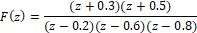
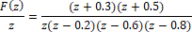
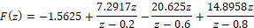
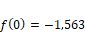
c.
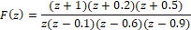
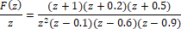
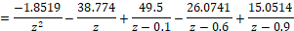
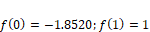

4.
Program:
'(a)'
syms z k
F=vpa(z*(z+2)*(z+4)/((z-0.3)*(z-0.5)*(z-0.7)),4);
pretty(F)
f=vpa(iztrans(F),4);
pretty(f)
'(b)'
syms z k
F=vpa((z+0.3)*(z+0.5)/((z-0.2)*(z-0.6)*(z-0.8)),4);
pretty(F)
f=vpa(iztrans(F),4);
pretty(f)
'(c)'
syms z k
F=vpa((z+1)*(z+0.2)*(z+0.5)/(z*(z-0.1)*(z-0.6)*(z-0.9)),4);
pretty(F)
f=vpa(iztrans(F),4);
pretty(f)

Computer Output:
ans =

(a)

z (z + 2.0) (z + 4.0)
-----------------------------
(z - 0.7) (z - 0.3) (z - 0.5)

n n n -31
123.6 0.3 - 281.2 0.5 + 158.6 0.7 - 1.562 10 kroneckerDelta(n, 0)

ans =

(b)

(z + 0.5) (z + 0.3)
-----------------------------
(z - 0.2) (z - 0.8) (z - 0.6)

n n n
7.292 0.2 - 20.63 0.6 + 14.9 0.8 - 1.563 kroneckerDelta(n, 0)

ans =

(c)

(z + 0.5) (z + 1.0) (z + 0.2)
-------------------------------
z (z - 0.9) (z - 0.1) (z - 0.6)

n n n
49.5 0.1 - 26.07 0.6 + 15.05 0.9 - 38.48 kroneckerDelta(n, 0) - 1.852 kroneckerDelta(n - 1.0, 0)

5.
a.
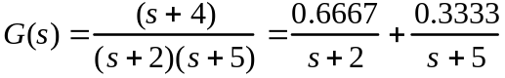

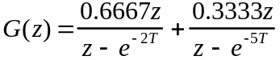
For T = 0.5 s,

b.
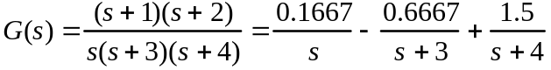

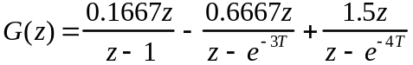
For T = 0.5 s,

c.
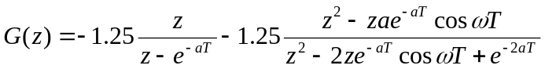
For 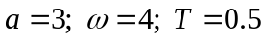,
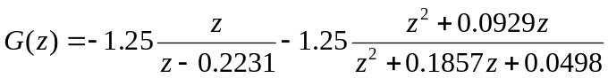
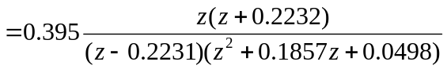
d.

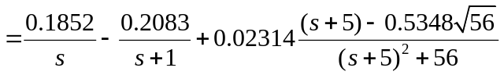
For 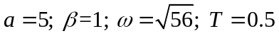,

6.
Program:
'(a)'
syms s z n T %Construct symbolic objects for
%'s', 'z', 'n',and 'T'.
Gs=(s+4)/((s+2)*(s+5)); %Form G(s).
'G(s)' %Display label.
pretty(Gs) %Pretty print G(s).
%'g(t)' %Display label.
gt=ilaplace(Gs); %Find g(t).
%pretty(gt) %Pretty print g(t).
gnT=compose(gt,n*T); %Find g(nT).
%'g(kT)' %Display label.
%pretty(gnT) %Pretty print g(nT).
Gz=ztrans(gnT); %Find G(z).
Gz=simplify(Gz); %Simplify G(z).
%'G(z)’ %Display label.
%pretty(Gz) %Pretty print G(z).
Gz=subs(Gz,T,0.5); %Let T = 0.5 in G(z).
Gz=vpa(simplify(Gz),6); %Simplify G(z) and evaluate numerical
%values to 6 places.
Gz=vpa(factor(Gz),6); %Factor G(z).
'G(z) evaluated for T=0.5' %Display label.
pretty(Gz) %Pretty print G(z) with numerical
%values.
'(b)'
Gs=(s+1)*(s+2)/(s*(s+3)*(s+4));
%Form G(s) = G(s).
'G(s)' %Display label.
pretty(Gs) %Pretty print G(s).
%'g(t)' %Display label.
gt=ilaplace(Gs); %Find g(t).
%pretty(gt) %Pretty print g(t).
gnT=compose(gt,n*T); %Find g(nT).
%'g(kT)' %Display label.
%pretty(gnT) %Pretty print g(nT).
Gz=ztrans(gnT); %Find G(z).
Gz=simplify(Gz); %Simplify G(z).
%'G(z)’ %Display label.
%pretty(Gz) %Pretty print G(z).
Gz=subs(Gz,T,0.5); %Let T = 0.5 in G(z).
Gz=vpa(simplify(Gz),6); %Simplify G(z) and evaluate numerical
%values to 6 places.
Gz=vpa(factor(Gz),6); %Factor G(z).
'G(z) evaluated for T=0.5' %Display label.
pretty(Gz) %Pretty print G(z) with numerical
%values.
'(c)'
Gs=20/((s+3)*(s^2+6*s+25)); %Form G(s) = G(s).
'G(s)' %Display label.
pretty(Gs) %Pretty print G(s).
%'g(t)' %Display label.
gt=ilaplace(Gs); %Find g(t).
%pretty(gt) %Pretty print g(t).
gnT=compose(gt,n*T); %Find g(nT).
%'g(kT)' %Display label.
%pretty(gnT) %Pretty print g(nT).
Gz=ztrans(gnT); %Find G(z).
Gz=simplify(Gz); %Simplify G(z).
%'G(z)’ %Display label.
%pretty(Gz) %Pretty print G(z).
Gz=subs(Gz,T,0.5); %Let T = 0.5 in G(z).
Gz=vpa(simplify(Gz),6); %Simplify G(z) and evaluate numerical
%values to 6 places.
Gz=vpa(factor(Gz),6); %Factor G(z).
'G(z) evaluated for T=0.5' %Display label.
pretty(Gz) %Pretty print G(z) with numerical
%values.
'(d)'
Gs=15/(s*(s+1)*(s^2+10*s+81));
%Form G(s) = G(s).
'G(s)' %Display label.
pretty(Gs) %Pretty print G(s).
%'g(t)' %Display label.
gt=ilaplace(Gs); %Find g(t).
%pretty(gt) %Pretty print g(t).
gnT=compose(gt,n*T); %Find g(nT).
%'g(kT)' %Display label.
%pretty(gnT) %Pretty print g(nT).
Gz=ztrans(gnT); %Find G(z).
Gz=simplify(Gz); %Simplify G(z).
%'G(z)' %Display label.
%pretty(Gz) %Pretty print G(z).
Gz=subs(Gz,T,0.5); %Let T = 0.5 in G(z).
Gz=vpa(simplify(Gz),6); %Simplify G(z) and evaluate numerical
%values to 6 places.
Gz=vpa(factor(Gz),6); %Factor G(z).
'G(z) evaluated for T=0.5' %Display label.
pretty(Gz) %Pretty print G(z) with numerical
%values.

Computer response:
ans =

(a)

ans =

G(s)

s + 4
---------------
(s + 2) (s + 5)
ans =

G(z) evaluated for T=0.5

z (z - .177350)
1.00000 ----------------------------
(z - .0820850) (z - .367880)
ans =

(b)

ans =

G(s)

(s + 1) (s + 2)
-----------------
s (s + 3) (s + 4)
ans =

G(z) evaluated for T=0.5

z (z - .296742) (z - .840812)
1.00000 ------------------------------------
(z - .135335) (z - .223130) (z - 1.)
ans =

ans =

(c)

ans =

G(s)

20
-----------------------
2
(s + 3) (s + 6 s + 25)

ans =

G(z) evaluated for T=0.5

(z + .223130) z
.394980 -----------------------------------------
2
(z - .223135) (z + .185705 z + .0497861)

ans =

(d)

ans =

G(s)

15
--------------------------
2
s (s + 1) (s + 10 s + 81)

ans =

G(z) evaluated for T=0.5

(z + .289175) (z + .116364) z
.0578297 --------------------------------------------------------
2
(z - .606535) (z - .999995) (z + .135489 z + .00673794)

7.
a.

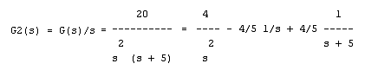
Thus,
Hence,

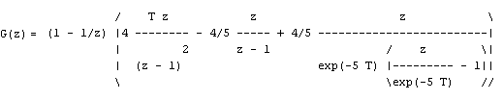
Letting T = 0.3,

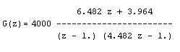

b.

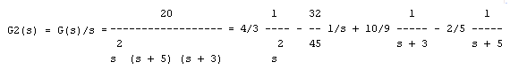
Thus,
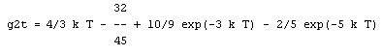

Hence,

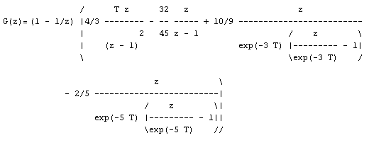
Letting T = 0.3,
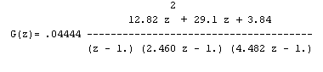
c.

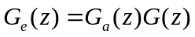
where 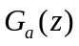 is the answer to part (a) and 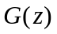, the pulse transfer function for 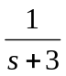in cascade with a zero-order-hold will now be found:

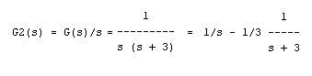
Thus,

Hence,

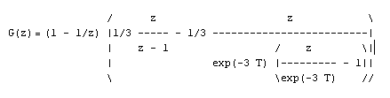
Letting T = 0.3,

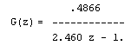
Thus,

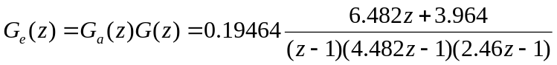

8.
a. Add phantom samplers at the input, output, and feedback path after H(s). Push G2 (s) and its input sampler to the right past the pickoff point. Add a phantom sampler after G1(s). Hence,

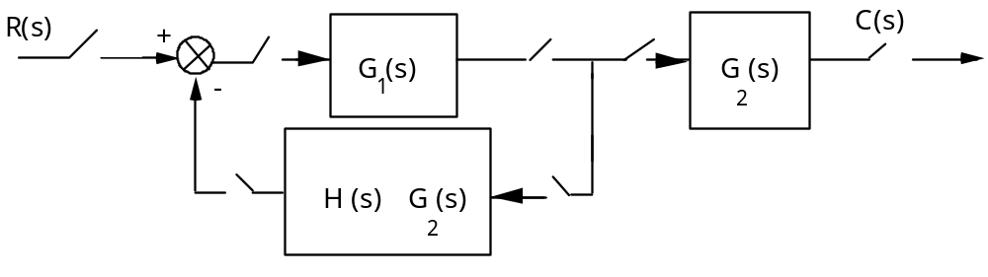

From this block diagram, T(z) = .
b. Add phantom samplers to the input, output, and the output of H(s). Push G1(s)G2(s) and its input sampler to the right past the pickoff point. Add a phantom sampler at the output.

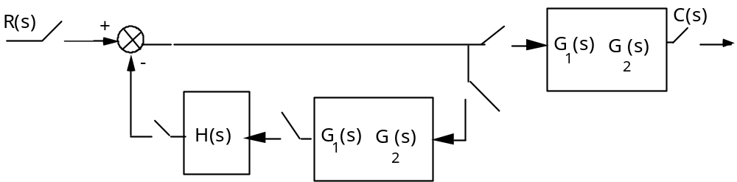

From this block diagram, T(z) = .

9.
Push gain of 5 to the left past the summing junction and add phantom samplers as shown.
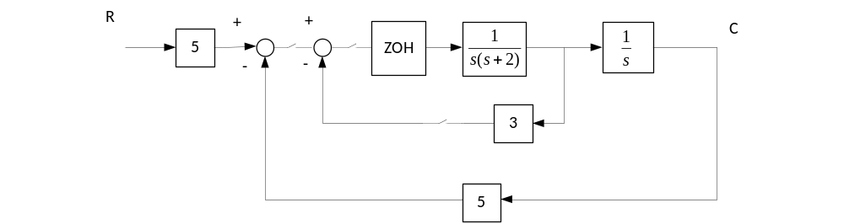

Push the ZOH and 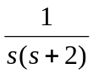 to the right past the pickoff point. Also, add a phantom sampler at the
output.

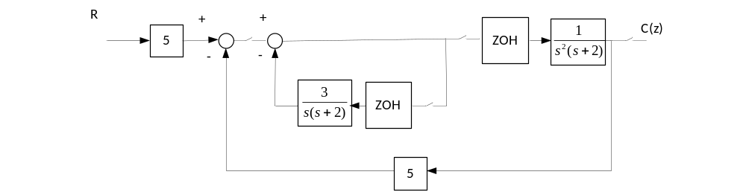

Add phantom samplers after the gain of 5 at the input and in the feedback. Also, represent the z.o.h.
as Laplace transforms.

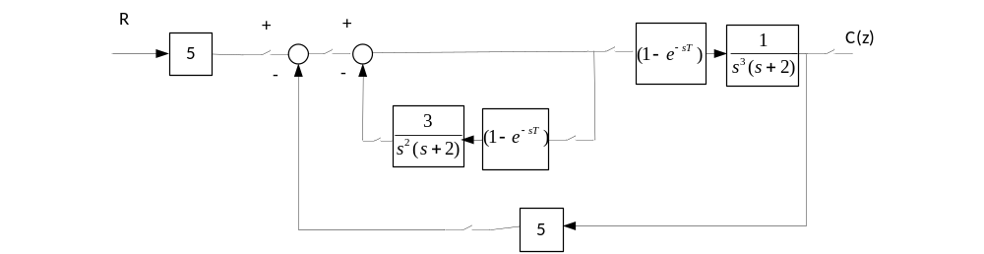
Push the last block to the right past the pickoff point and get,
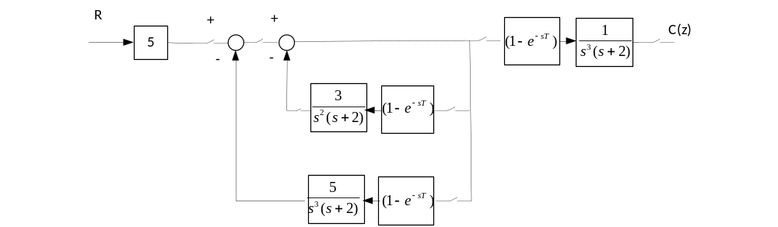
The closed loop transfer function is given by
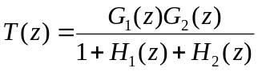
where
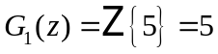
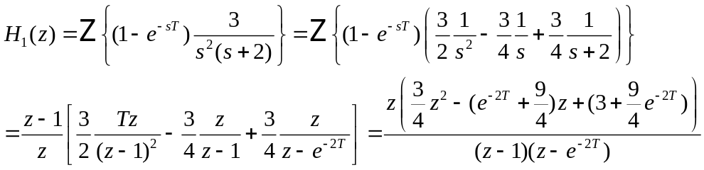
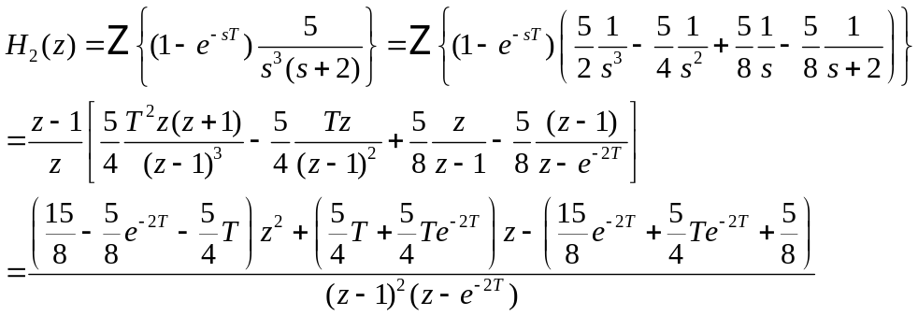
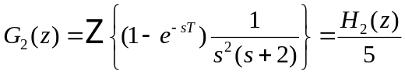

10.
Program:

numg1=20*[1 6];
deng1=poly([-1 -3 -4 -8]);
G1=tf(numg1,deng1);
for T=5:-.01:0;
Gz=c2d(G1,T,'zoh');
Tz=feedback(Gz,1);
r=pole(Tz);
rm=max(abs(r));
if rm<=1;
break;
end;
end;
T
r
rm

Computer response:

T =
2.8900

r =
-1.0000
-0.0622
-0.0001
0.0000

rm =
1.0000

11.

The system’s characteristic equation is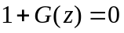
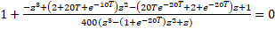

A numerical search shows that the roots of this equation are within the unit circle for
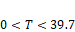

12.

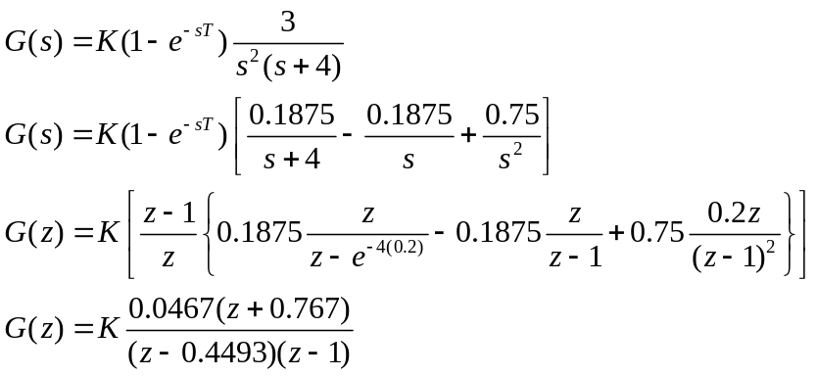

K = 0.736/0.0467 = 15.76
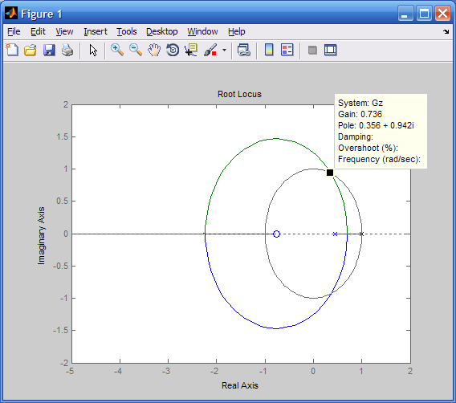

13.
a.
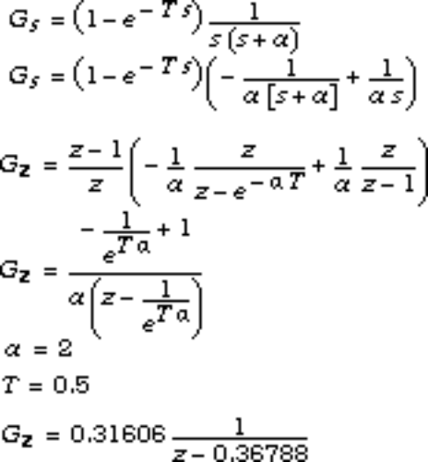

First, check to see that the system is stable.

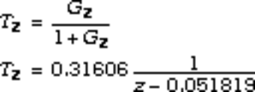

Since the closed-loop poles are inside the unit circle, the system is stable. Next, evaluate the static error constants and the steady-state error.
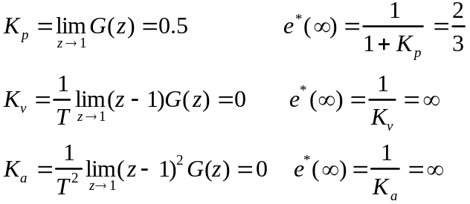

b.
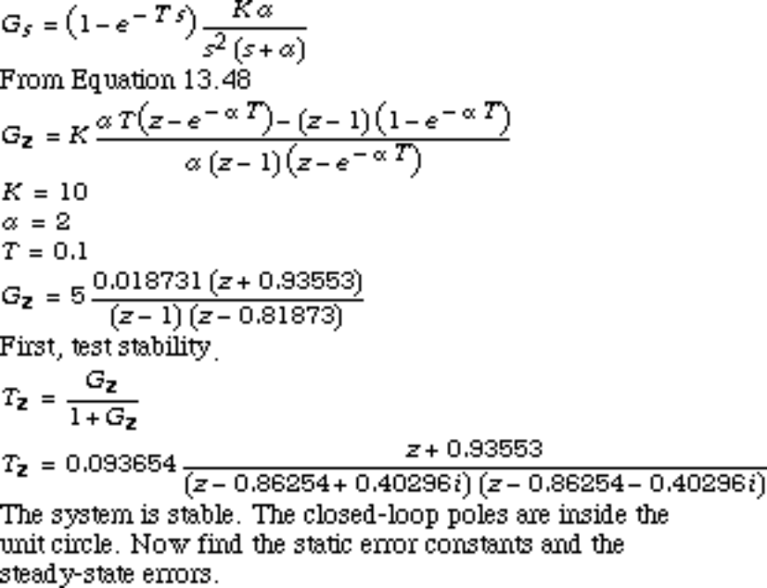

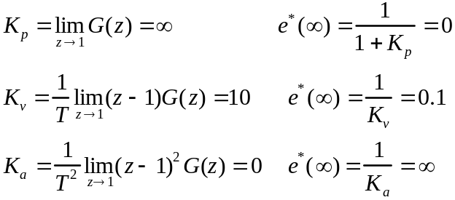

c.
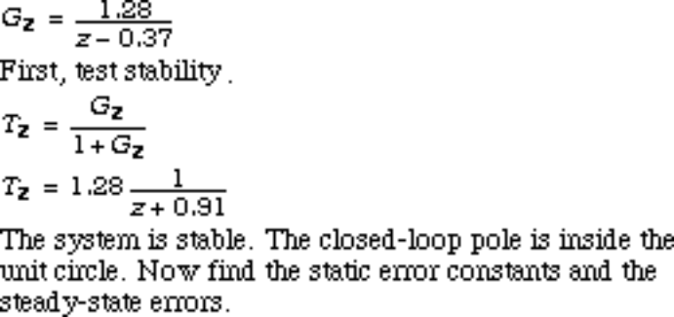

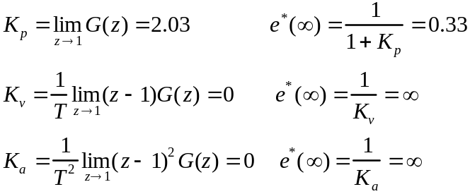
d.
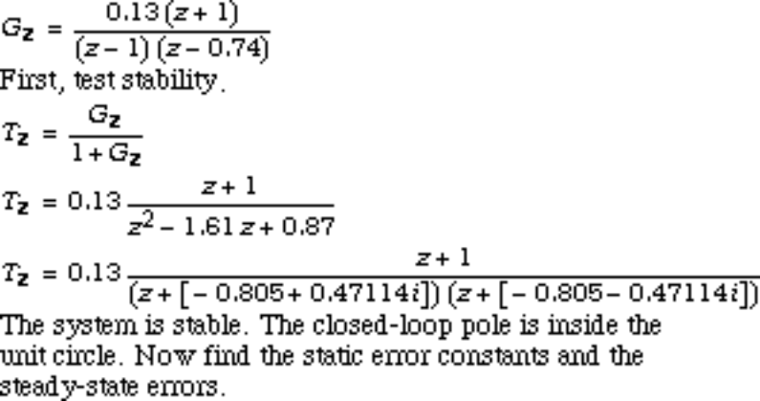

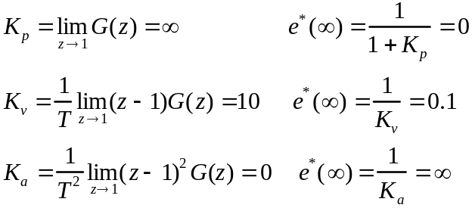
14.
Program:
T=0.1;
numgz=[0.04406 -0.03624 -0.03284 0.02857];
dengz=[1 -3.394 +4.29 -2.393 +0.4966];
'G(z)'
Gz=tf(numgz,dengz,0.1)
'Zeros of G(z)'
zeros=roots(numgz)
'Poles of G(z)'
poles=roots(dengz)
%Check stability
Tz=feedback(Gz,1);
'Closed-Loop Poles'
r=pole(Tz)
M=abs(r)
pause
'Find Kp'
Gz=minreal(Gz,.00001);
Kp=dcgain(Gz)
'Find Kv'
factorkv=tf([1 -1],[1 0],0.1); %Makes transfer function
%proper and yields same Kv
Gzkv=factorkv*Gz;

Gzkv=minreal(Gzkv,.00001); %Cancel common poles and %zeros
Kv=(1/T)*dcgain(Gzkv)
'Find Ka'
factorka=tf([1 -2 1],[1 0 0],0.1);%Makes transfer function
%proper and yields same Ka
Gzka=factorka*Gz;

Gzka=minreal(Gzka,.00001); %Cancel common poles and %zeros
Ka=(1/T)^2*dcgain(Gzka)

Computer response:
ans =

G(z)

Transfer function:
0.04406 z^3 - 0.03624 z^2 - 0.03284 z + 0.02857
-----------------------------------------------
z^4 - 3.394 z^3 + 4.29 z^2 - 2.393 z + 0.4966

Sampling time: 0.1

ans =

Zeros of G(z)

zeros =

-0.8753
0.8489 + 0.1419i
0.8489 - 0.1419i

ans =

Poles of G(z)

poles =

1.0392
0.8496 + 0.0839i
0.8496 - 0.0839i
0.6557

ans =

Closed-Loop Poles

r =

0.9176 + 0.1699i
0.9176 - 0.1699i
0.7573 + 0.1716i
0.7573 - 0.1716i

M =

0.9332
0.9332
0.7765
0.7765

ans =

Find Kp

Kp =

-8.8750

ans =

Find Kv

Kv =

0

ans =

Find Ka

Ka =

0

15.
First find G(z)
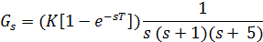

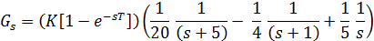

T = 0.1

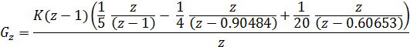

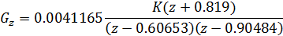

To plot the root locus and find the required gains and response the following M-file was written:.

clc % Clear command window
clf % Clear graph
numgz = 0.0041165*[1 0.819]; % Define numerator
dengz = poly([0.60653 0.90484]); % Define denominator
Gz = tf(numgz, dengz,[]) % Create and Display G(z)
rlocus(Gz) % Plot the root locus
title('Z-plane Root Locus')
axis([-1 1 0 1.6]) % Define axis to zoom root locus
zgrid % Display the damping grid
display 'Maximum Gain for Stability'
[K1,p1]=rlocfind(Gz) % Find the maximum gain for stability
% when locus crosses zero damping
pause
axis([0.4 0.8 0.2 0.6]) % Narrow range for damping around 0.5-0.55
display 'Gain for 15% Overshoot'
[K,p]=rlocfind(Gz) % Find the gain for a damping of 0.517
% corresponding to 15% overshoot
Tz=feedback(K*Gz,1); % Tz = closed-loop TF of the system
pause
step(Tz);
grid
title('Gain-Compensated Step Response')

The following root locus was obtained:
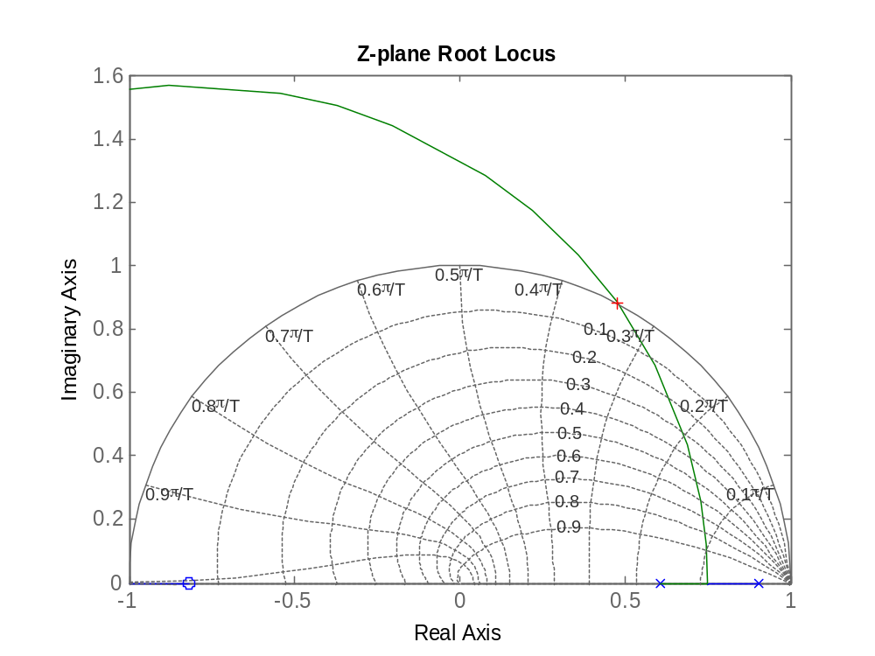

The maximum gain for stability is: K1 = 134.76. Thus, the range of gain for stability is:
0 < K < 134.76

To obtain an overshoot of 15% or less the gain was selected to be K = 18.42. The gain-compensated step response is shown below.

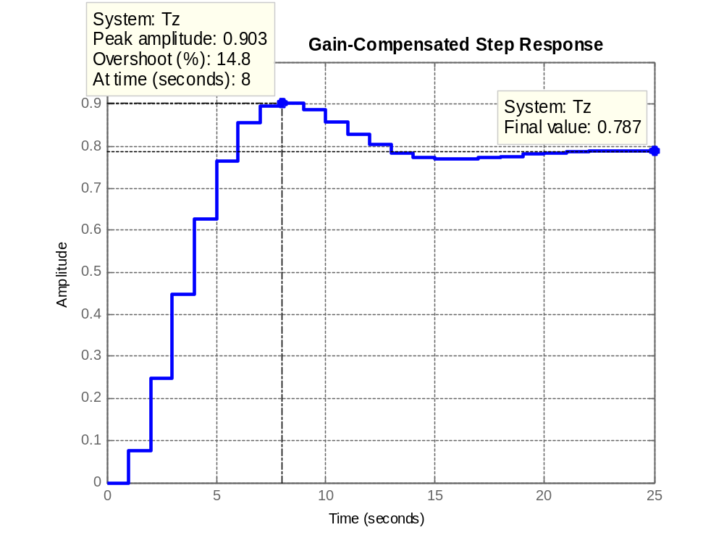

16.

In the Simulink model shown below, the unit step was set to start at t = 0 and the sample time in the zero-order hold was set to 0.1 sec. The simulation was run for 4 sec. as the time and controlled variable, c (t), were output to the workspace. The command: plot (t, c) was, then, used to plot and edit the graph of the step response of the system, which is shown below.

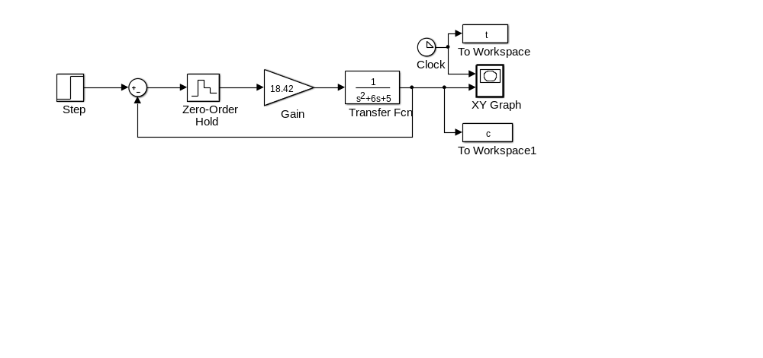

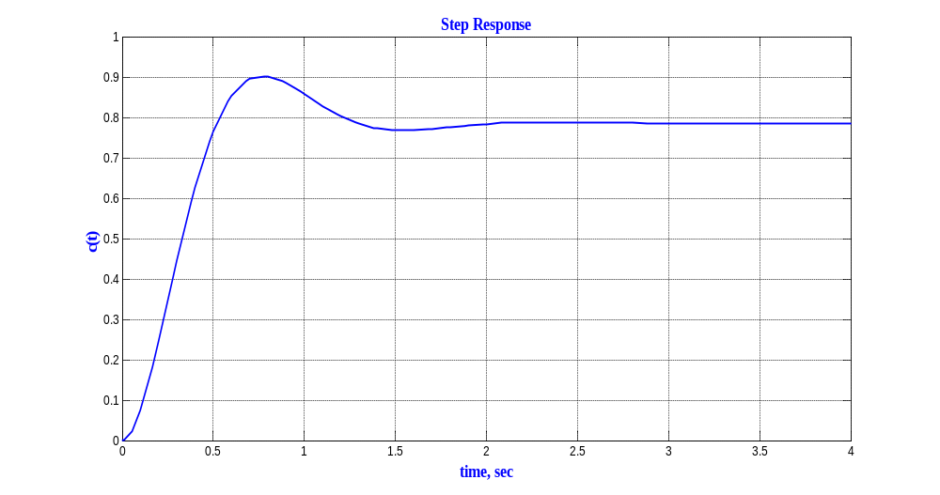

17.
Program:
%Digitize G1(s) preceded by a sample and hold
numg1=1;
deng1=poly([-1 -3]);
'G1(s)'
G1s=tf(numg1,deng1)
'G(z)'
Gz=c2d(G1s,0.1,'zoh')
%Input transient response specifications
Po=input('Type %OS ');
%Determine damping ratio
z=(-log(Po/100))/(sqrt(pi^2+log(Po/100)^2));
%Plot root locus
rlocus(Gz)
zgrid(z,0)
title(['Root Locus'])
[K,p]=rlocfind(Gz) %Allows input by selecting point on graphic
pause
'T(z)'
Tz=feedback(K*Gz,1)
step(Tz)

Computer response:

ans =

G1(s)

Transfer function:
1
-------------
s^2 + 4 s + 3

ans =

G(z)

Transfer function:
0.004384 z + 0.003837
----------------------
z^2 - 1.646 z + 0.6703

Sampling time: 0.1
Type %OS 16.3
Select a point in the graphics window

selected_point =

0.8016 + 0.2553i

K =

9.7200

p =

0.8015 + 0.2553i
0.8015 - 0.2553i

ans =

T(z)

Transfer function:
0.04262 z + 0.0373
----------------------
z^2 - 1.603 z + 0.7076

Sampling time: 0.1
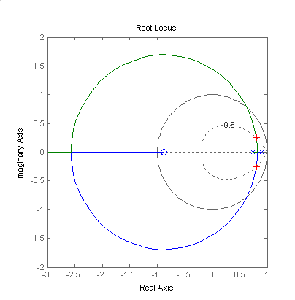
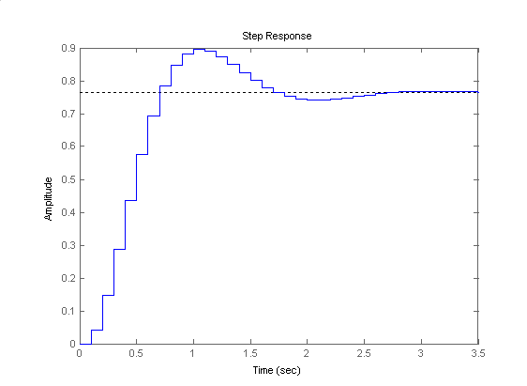

18.
Proceeding as in Problem 13.13 11

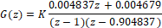

For sec, or . The system’s root locus is shown next with the corresponding 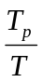 line drawn
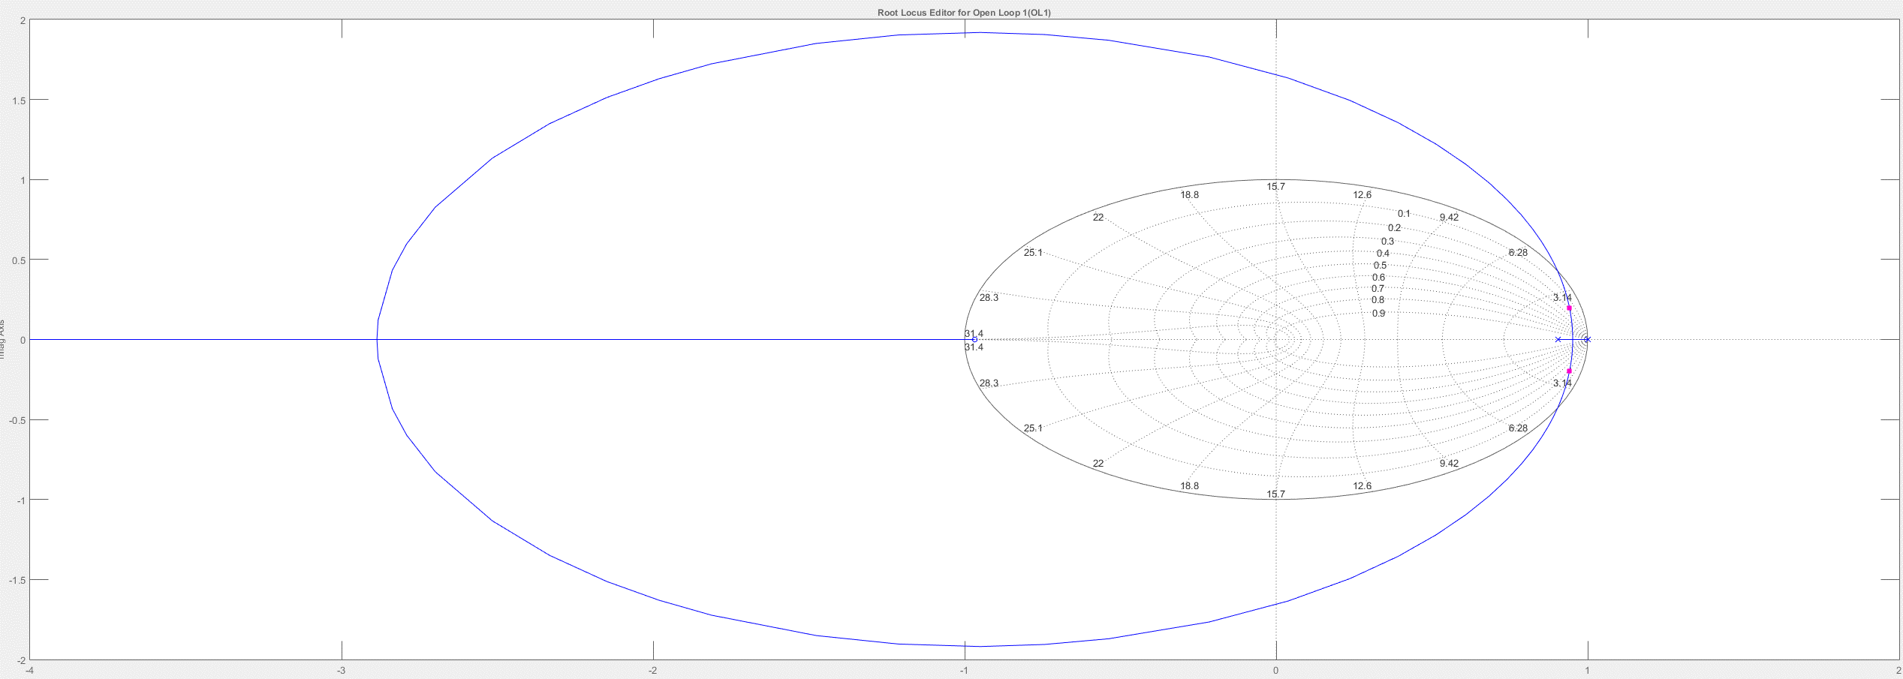
15º

The intersection of the line occurs at 0.93+j0.26 when 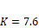 . From the root locus we also obtain that the system is closed loop stable for 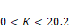.
19.
First find G(z).

For T=0.5,
Plotting the root locus and overlaying the Ts = 10 second circle, we select the point of intersection (0.723 + j0.382) and calculate the gain, K = 1.47. Finding the intersection with the unit circle we find that 0 < K < 7.16 for stability.
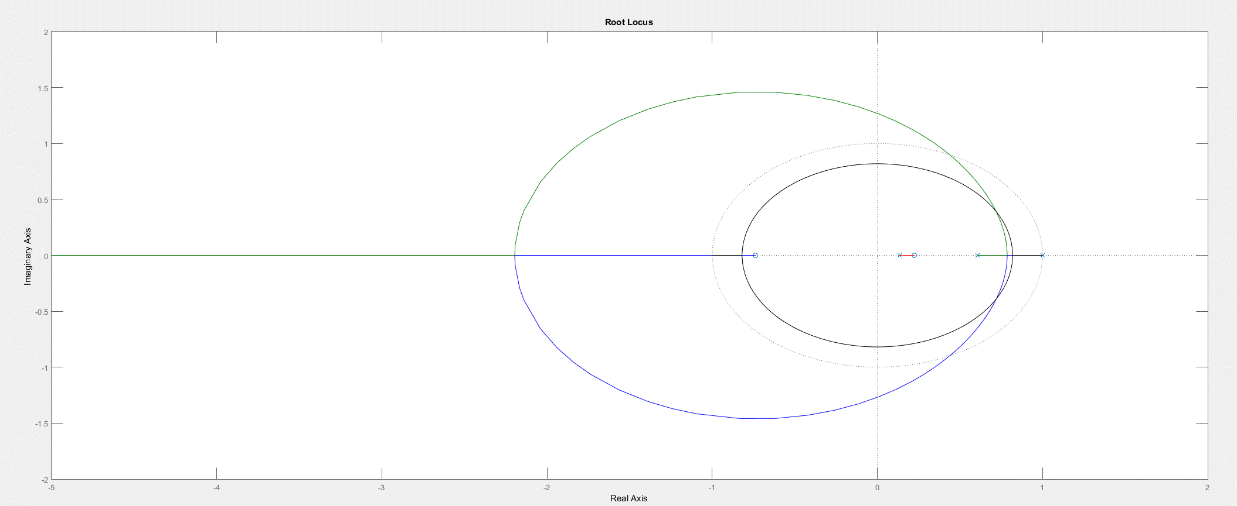

20.
Substituting equation (31.88) into 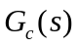 and letting 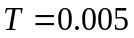 yields
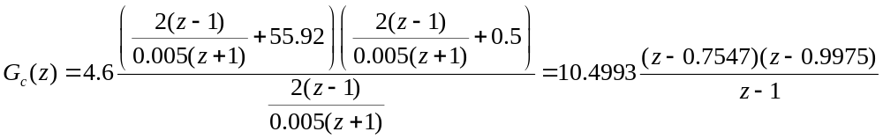

21.
Since %OS = 10%, ζ = = 0.591. Since Ts = = 2 seconds,
ωn = 3.383 rad/s. Hence, the location of the closed-loop poles must be –2 ± j2.729. The summation of angles from open-loop poles to –2 ± j2.729 is –198.84. Therefore, the design point is not on the root locus. A compensator whose angular contribution is 198.84o - 180o = 18.84o is required. Assume a compensator zero at -4 canceling the pole at -4. Adding the compensator zero at –4 to the plant’s poles yields –145.07⁰ at to –2 ± j2.729. Thus, the compensator’s pole must contribute 180⁰ – 145.07 = 34.93º. The following geometry results.

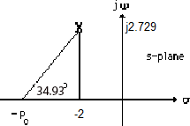
Thus,
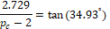
Hence, p_{c} = 5.91.Adding the compensator pole and zero to the system poles, the gain at the design point is found to be 138. Summarizing the results: 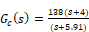. Substituting
Eq. (13.88) into G_{c}(s) and letting T = 0.05 yields

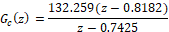

22.

Program:
'Design of digital lead compensation'
clf %Clear graph on screen.
'Uncompensated System' %Display label.
numg=1; %Generate numerator of G(s).
deng=poly([0 -4 -10]); %Generate denominator of G(s).
'G(s)' %Display label.
G=tf(numg,deng) %Create and display G(s).
pos=input('Type desired percent overshoot ');
%Input desired percent overshoot.
z=-log(pos/100)/sqrt(pi^2+[log(pos/100)]^2);
%Calculate damping ratio.
rlocus(G) %Plot uncompensated root locus.
sgrid(z,0) %Overlay desired percent overshoot
%line.
title(['Uncompensated Root Locus with ' , num2str(pos),...
'% Overshoot Line']) %Title uncompensated root locus.
[K,p]=rlocfind(G); %Generate gain, K, and closed-loop
%poles, p, for point selected
%interactively on the root locus.
'Closed-loop poles = ' %Display label.
p %Display closed-loop poles.
f=input('Give pole number that is operating point ');
%Choose uncompensated system
%dominant pole.
'Summary of estimated specifications for selected point on'
'uncompensated root locus' %Display label.
operatingpoint=p(f) %Display uncompensated dominant
%pole.
gain=K %Display uncompensated gain.
estimated_settling_time=4/abs(real(p(f)))
%Display uncompensated settling
%time.
estimated_peak_time=pi/abs(imag(p(f)))
%Display uncompensated peak time.
estimated_percent_overshoot=pos %Display uncompensated percent
%overshoot.
estimated_damping_ratio=z %Display uncompensated damping
%ratio.
estimated_natural_frequency=sqrt(real(p(f))^2+imag(p(f))^2)
%Display uncompensated natural
%frequency.
numkv=conv([1 0],numg); %Set up numerator to evaluate Kv.
denkv=deng; %Set up denominator to evaluate Kv.
sG=tf(numkv,denkv); %Create sG(s).
sG=minreal(sG); %Cancel common poles and zeros.
Kv=dcgain(K*sG) %Display uncompensated Kv.
ess=1/Kv %Display uncompensated steady-state
%error for unit ramp input.
'T(s)' %Display label.
T=feedback(K*G,1) %Create and display T(s).
step(T) %Plot step response of uncompensated
%system.
title(['Uncompensated System with ' ,num2str(pos),'% Overshoot'])
%Add title to uncompensated step
%response.
'Press any key to go to lead compensation'
%Display label.
pause
Ts=input('Type Desired Settling Time ');
%Input desired settling time.
b=input('Type Lead Compensator Zero, (s+b). b= ');
%Input lead compensator zero.
done=1; %Set loop flag.
while done==1 %Start loop for trying lead
%compensator pole.
a=input('Enter a Test Lead Compensator Pole, (s+a). a = ');
%Enter test lead compensator pole.
numge=conv(numg,[1 b]); %Generate numerator of Gc(s)G(s).
denge=conv([1 a],deng); %Generate denominator of Gc(s)G(s).
Ge=tf(numge,denge); %Create Ge(s)=Gc(s)G(s).
wn=4/(Ts*z); %Evaluate desired natural frequency.
clf %Clear graph on screen.
rlocus(Ge) %Plot compensated root locus with
%test lead compensator pole.
axis([-10,10,-10,10]) %Change lead-compensated root locus
%axes.
sgrid(z,wn) %Overlay grid on lead-compensated
%root locus.
title(['Lead-Compensated Root Locus with ' , num2str(pos),...
'% Overshoot Line, Lead Pole at ', num2str(-a),...
' and Required Wn']) %Add title to lead-compensated root
%locus.
done=input('Are you done? (y=0,n=1) ');
%Set loop flag.
end %End loop for trying compensator
%pole.
[K,p]=rlocfind(Ge); %Generate gain, K, and closed-loop
%poles, p, for point selected
%interactively on the root locus.
'Gc(s)' %Display label.
Gc=tf([1 b],[1 a]) %Display lead compensator.
'Gc(s)G(s)' %Display label.
Ge %Display Gc(s)G(s).
'Closed-loop poles = ' %Display label.
p %Display lead-compensated system's
%closed-loop poles.
f=input('Give pole number that is operating point ');
%Choose lead-compensated system
%dominant pole.
'Summary of estimated specifications for selected point on lead'
'compensated root locus' %Display label.
operatingpoint=p(f) %Display lead-compensated dominant
%pole.
gain=K %Display lead-compensated gain.
estimated_settling_time=4/abs(real(p(f)))
%Display lead-compensated settling
%time.
estimated_peak_time=pi/abs(imag(p(f)))
%Display lead-compensated peak time.
estimated_percent_overshoot=pos %Display lead-compensated percent
%overshoot.
estimated_damping_ratio=z %Display lead-compensated damping
%ratio.
estimated_natural_frequency=sqrt(real(p(f))^2+imag(p(f))^2)
%Display lead-compensated natural
%frequency.
s=tf([1 0],1); %Create transfer function, "s".
sGe=s*Ge; %Create sGe(s) to evaluate Kv.
sGe=minreal(sGe); %Cancel common poles and zeros.
Kv=dcgain(K*sGe) %Display lead-compensated Kv.
ess=1/Kv %Display lead-compensated steady-
%state error for unit ramp input.
'T(s)' %Display label.
T=feedback(K*Ge,1) %Create and display lead-compensated
%T(s).
'Press any key to continue and obtain the lead-compensated step'
'response' %Display label
pause
step(T) %Plot step response for lead
%compensated system.
title(['Lead-Compensated System with ' ,num2str(pos),'% Overshoot'])
%Add title to step response of PD
%compensated system.
pause
'Digital design' %Print label.
T=0.05 %Define sampling interval.
clf %Clear graph.
'Gc(s) in polynomial form' %Print label.
Gcs=K*Gc %Create Gc(s) in polynomial form.
'Gc(s) in polynomial form' %Print label.
Gcszpk=zpk(Gcs) %Create Gc(s) in factored form.
'Gc(z) in polynomial form via Tustin Transformation'
%Print label.
Gcz=c2d(Gcs,T,'tustin') %Form Gc(z) via Tustin transformation.
'Gc(z) in factored form via Tustin Transformation'
%Print label.
Gczzpk=zpk(Gcz) %Show Gc(z) in factored form.
'Gp(s) in polynomial form' %Print label.
Gps=G %Create Gp(s) in polynomial form.
'Gp(s) in factored form' %Print label.
Gpszpk=zpk(Gps) %Create Gp(s) in factored form.
'Gp(z) in polynomial form' %Print label.
Gpz=c2d(Gps,T,'zoh') %Form Gp(z) via zoh transformation.
'Gp(z) in factored form' %Print label.
Gpzzpk=zpk(Gpz) %Form Gp(z) in faactored form.
pole(Gpz) %Find poles of Gp(z).
Gez=Gcz*Gpz; %Form Ge(z) = Gc(z)Gp(z).
'Ge(z) = Gc(z)Gp(z) in factored form'
%Print label.
Gezzpk=zpk(Gez) %Form Ge(z) in factored form.
'z-1' %Print label.
zm1=tf([1 -1],1,T) %Form z-1.
zm1Gez=minreal(zm1*Gez,.00001); %Cancel common factors.
'(z-1)Ge(z)' %Print label.
zm1Gezzpk=zpk(zm1Gez) %Form & display (z-1)Ge(z) in
%factored form.
pole(zm1Gez) %Find poles of (z-1)Ge(z).
Kv=10*dcgain(zm1Gez) %Find Kv.
Tz=feedback(Gez,1) %Find closed-loop
%transfer function, T(z)
step(Tz) %Find step reponse.
title('Closed-Loop Digital Step Response')
%Add title to step response.

Computer response:
ans =

Design of digital lead compensation

ans =

Uncompensated System

ans =

G(s)

G =

1
-------------------
s^3 + 14 s^2 + 40 s

Continuous-time transfer function.

Type desired percent overshoot 10
Select a point in the graphics window

selected_point =

-1.4959 + 2.1176i

ans =

Closed-loop poles =

p =

-10.9737 + 0.0000i
-1.5131 + 2.1215i
-1.5131 - 2.1215i

Give pole number that is operating point 2

ans =

Summary of estimated specifications for selected point on

ans =

uncompensated root locus

operatingpoint =

-1.5131 + 2.1215i

gain =

74.5158

estimated_settling_time =

2.6435

estimated_peak_time =

1.4808

estimated_percent_overshoot =

10

estimated_damping_ratio =

0.5912

estimated_natural_frequency =

2.6058

Kv =

1.8629

ess =

0.5368

ans =

T(s)

T =

74.52
---------------------------
s^3 + 14 s^2 + 40 s + 74.52

Continuous-time transfer function.

ans =

Press any key to go to lead compensation

Type Desired Settling Time 2
Type Lead Compensator Zero, (s+b). b= 4
Enter a Test Lead Compensator Pole, (s+a). a = 5.91
Are you done? (y=0,n=1) 0
Select a point in the graphics window

selected_point =

-2.0132 + 2.7712i

ans =

Gc(s)

Gc =

s + 4
--------
s + 5.91

Continuous-time transfer function.

ans =

Gc(s)G(s)

Ge =

s + 4
-------------------------------------
s^4 + 19.91 s^3 + 122.7 s^2 + 236.4 s

Continuous-time transfer function.

ans =

Closed-loop poles =

p =

-11.9286 + 0.0000i
-4.0000 + 0.0000i
-1.9907 + 2.7650i
-1.9907 - 2.7650i

Give pole number that is operating point 3

ans =

Summary of estimated specifications for selected point on lead

ans =

compensated root locus

operatingpoint =

-1.9907 + 2.7650i

gain =

138.4659

estimated_settling_time =

2.0094

estimated_peak_time =

1.1362

estimated_percent_overshoot =

10

estimated_damping_ratio =

0.5912

estimated_natural_frequency =

3.4070

Kv =

2.3429

ess =

0.4268

ans =

T(s)

T =

138.5 s + 553.9
---------------------------------------------
s^4 + 19.91 s^3 + 122.7 s^2 + 374.9 s + 553.9

Continuous-time transfer function.

ans =

Press any key to continue and obtain the lead-compensated step

ans =

response

ans =

Digital design

T =

0.0500

ans =

Gc(s) in polynomial form

Gcs =

138.5 s + 553.9
---------------
s + 5.91

Continuous-time transfer function.

ans =

Gc(s) in polynomial form

Gcszpk =

138.47 (s+4)
------------
(s+5.91)

Continuous-time zero/pole/gain model.

ans =

Gc(z) in polynomial form via Tustin Transformation

Gcz =

132.7 z - 108.6
---------------
z - 0.7425

Sample time: 0.05 seconds
Discrete-time transfer function.

ans =

Gc(z) in factored form via Tustin Transformation

Gczzpk =

132.71 (z-0.8182)
-----------------
(z-0.7425)

Sample time: 0.05 seconds
Discrete-time zero/pole/gain model.

ans =

Gp(s) in polynomial form

Gps =

1
-------------------
s^3 + 14 s^2 + 40 s

Continuous-time transfer function.

ans =

Gp(s) in factored form

Gpszpk =

1
--------------
s (s+10) (s+4)

Continuous-time zero/pole/gain model.

ans =

Gp(z) in polynomial form

Gpz =

1.756e-05 z^2 + 5.922e-05 z + 1.238e-05
---------------------------------------
z^3 - 2.425 z^2 + 1.922 z - 0.4966

Sample time: 0.05 seconds
Discrete-time transfer function.

ans =

Gp(z) in factored form

Gpzzpk =

1.7561e-05 (z+3.148) (z+0.2239)
-------------------------------
(z-1) (z-0.8187) (z-0.6065)

Sample time: 0.05 seconds
Discrete-time zero/pole/gain model.

ans =

1.0000
0.8187
0.6065

ans =

Ge(z) = Gc(z)Gp(z) in factored form

Gezzpk =

0.0023304 (z+3.148) (z-0.8182) (z+0.2239)
-----------------------------------------
(z-1) (z-0.8187) (z-0.7425) (z-0.6065)

Sample time: 0.05 seconds
Discrete-time zero/pole/gain model.

ans =

z-1

zm1 =

z - 1

Sample time: 0.05 seconds
Discrete-time transfer function.

ans =

(z-1)Ge(z)

zm1Gezzpk =

0.0023304 (z+3.148) (z-0.8182) (z+0.2239)
-----------------------------------------
(z-0.8187) (z-0.7425) (z-0.6065)

Sample time: 0.05 seconds
Discrete-time zero/pole/gain model.

ans =

0.8187
0.7425
0.6065

Kv =

1.1715

Tz =

0.00233 z^3 + 0.005952 z^2 - 0.004787 z - 0.001344
--------------------------------------------------
z^4 - 3.165 z^3 + 3.729 z^2 - 1.928 z + 0.3674

Sample time: 0.05 seconds
Discrete-time transfer function.

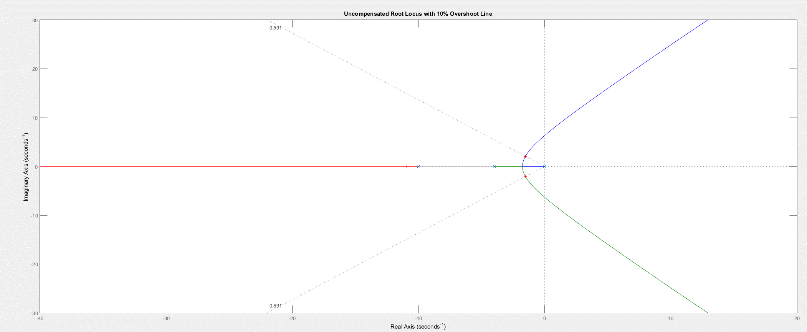

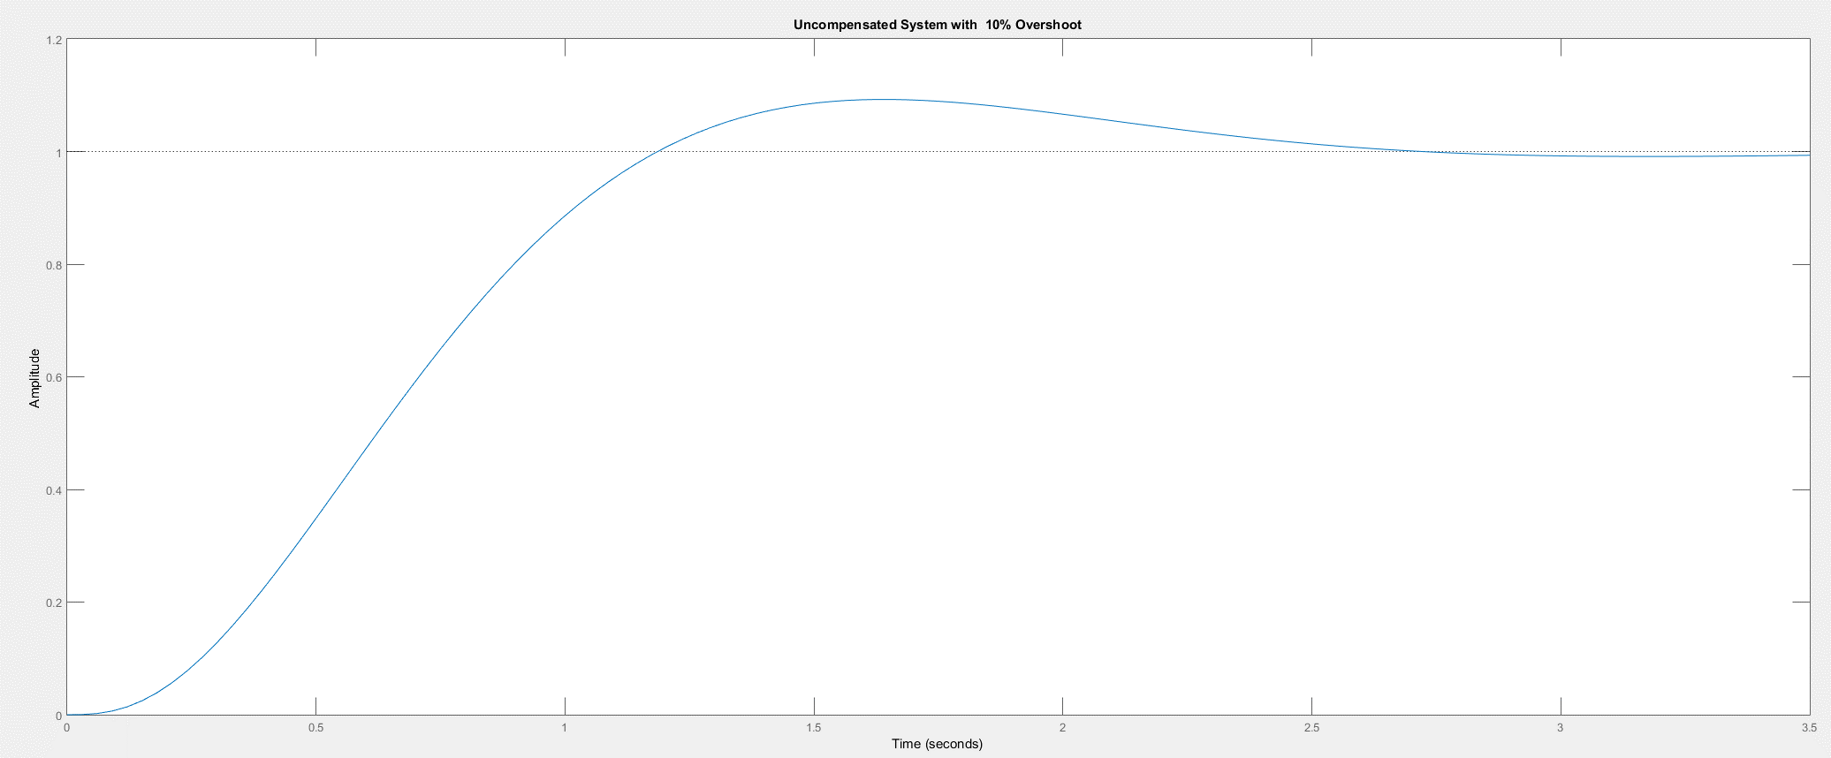

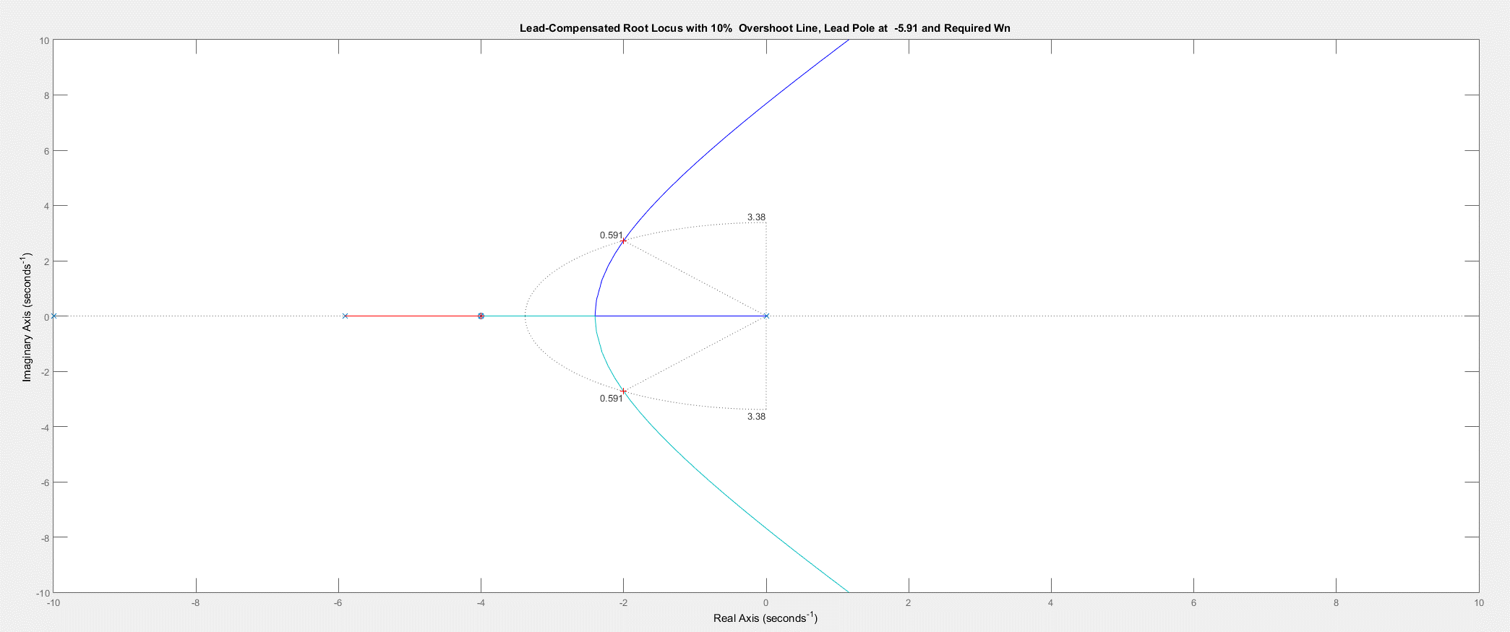
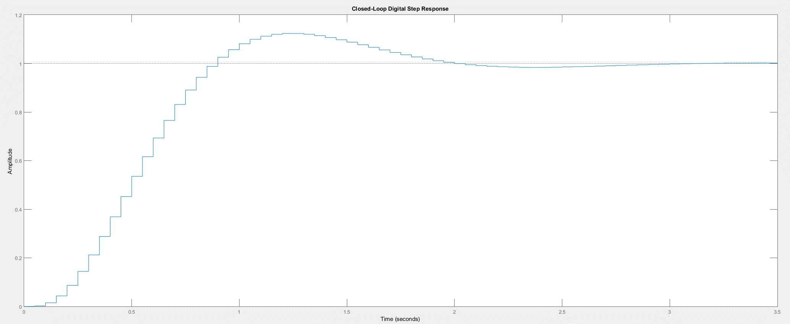

SOLUTIONS TO DESIGN PROBLEMS

23.

a. Push negative sign from vehicle dynamics to the left past the summing junction. The computer will be the area inside the large box with the inputs and outputs shown sampled. G(s) is the combined rudder actuator and vehicle dynamics. Also, the yaw rate sensor is shown equivalently before the integrator with unity feedback.

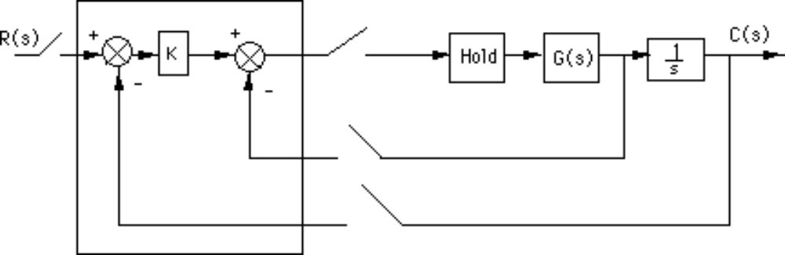

where G(s) = .
b. Add a phantom sampler at the output and push G(s) along with its sample and hold to the right past the pickoff point.

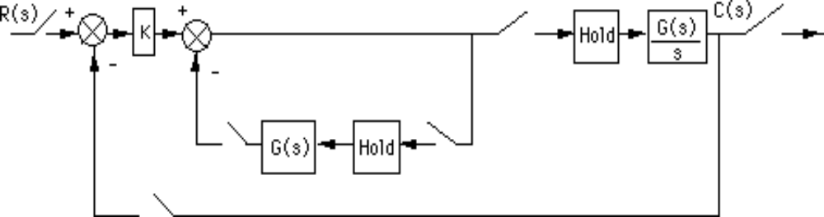

Move the outer-loop sampler to the output of and write the z transforms of the transfer functions.

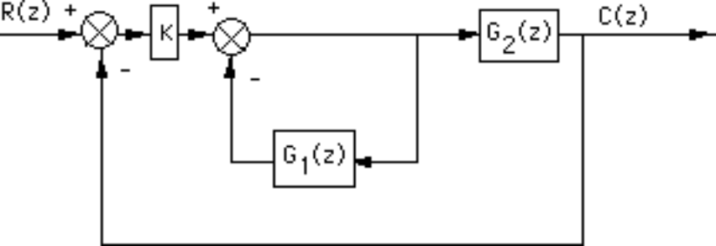

where
G1(s) = (1 - e-Ts)
and
G2(s) = (1 - e-Ts) .
Now find the z transforms of G1(s) and G2(s). For G1(z).
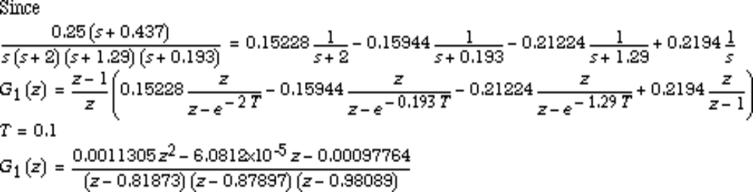
For G2(z):

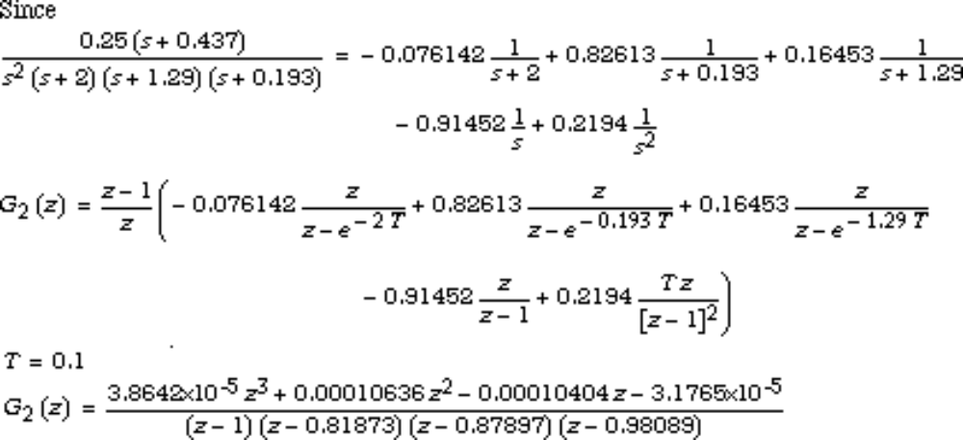
Now find the closed-loop transfer function. First find the equivalent forward transfer function.

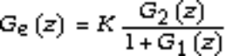

Thus,
T(z) =
Substituting values,

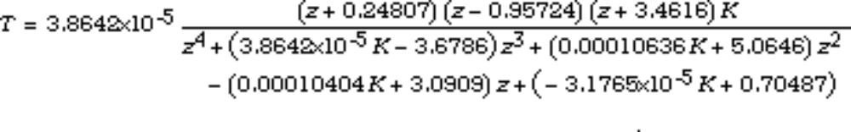
c. Using Ge(z), plot the root locus and see where it crosses the unit circle.

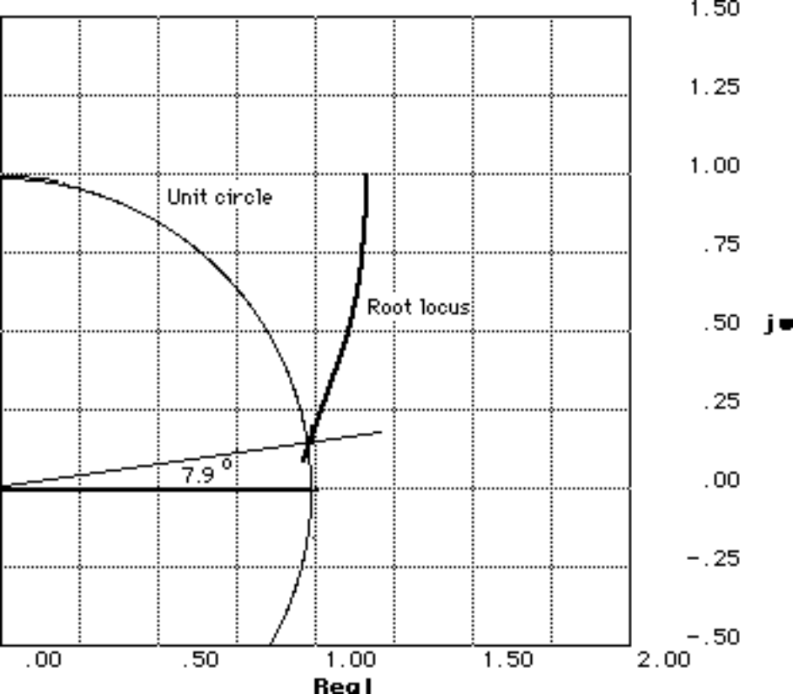

The root locus crosses the unit circle when 3.8642x10-5K = 5.797x10-4, or K = 15.

24.
a. With the zero order hold the open loop transfer function is

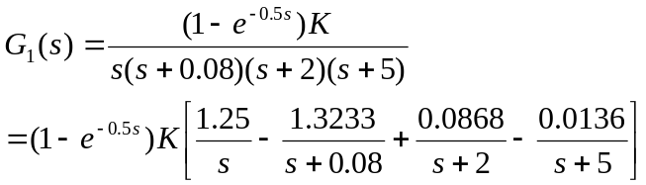
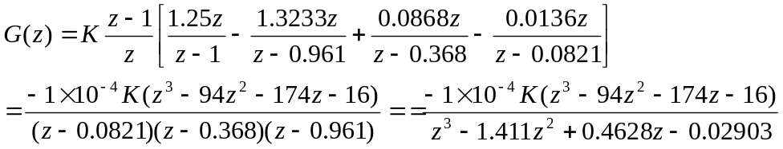
In MATLAB this system is defined as G=tf(-1e-4*[1 -94 -174 -16],[1 -1.411 0.4628 -0.02903]),0.5). Invoking SISOTOOL one gets

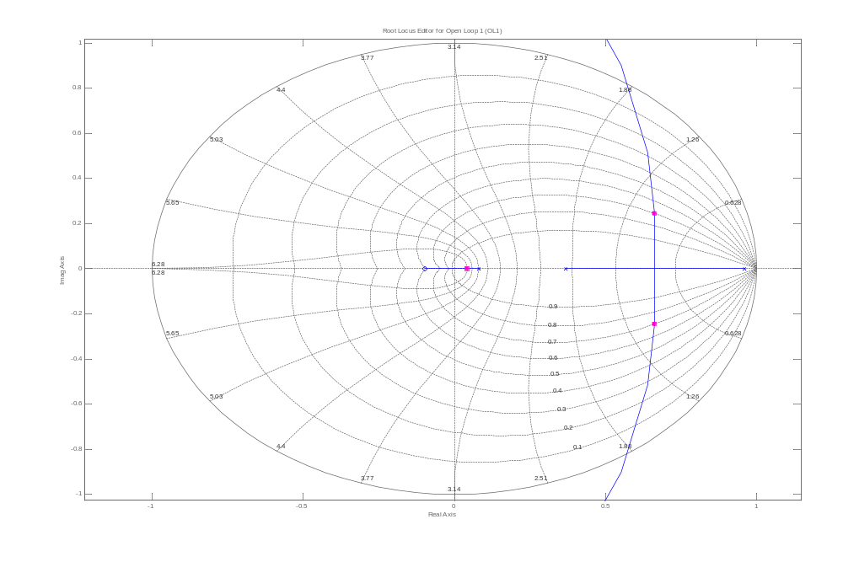
- 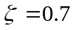 is achieved when K=5.15
- The closed loop poles are located at 0.661±j0.247. The radial distance from the origin is 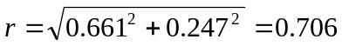, so 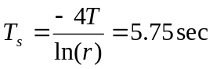. The radial angle from the origin is 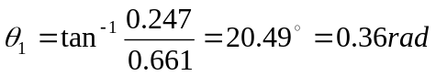, so 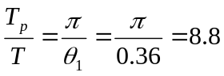or 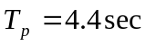
- We have that 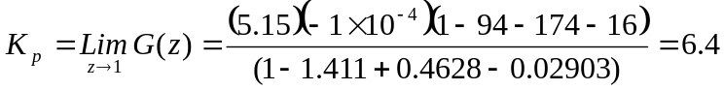. The steady state error is 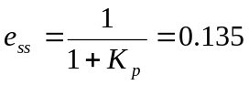. Then 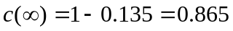
e.
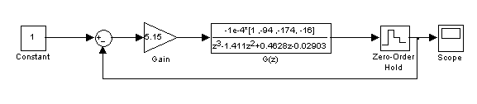

Block Diagram

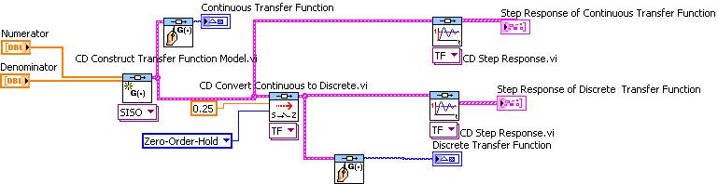

Front Panel
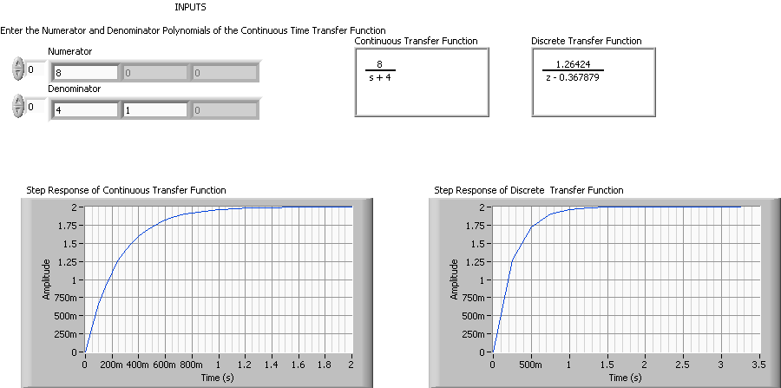

26.
Front panel
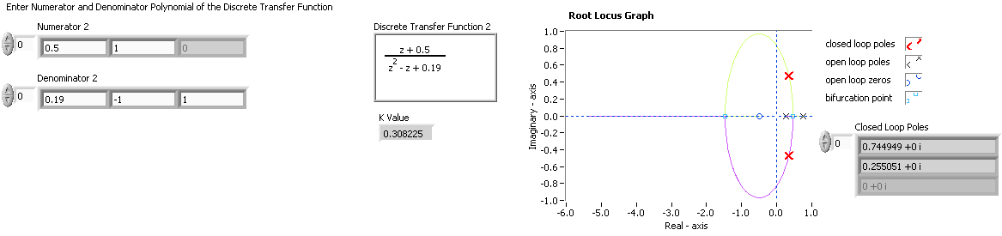
Note: K=0.3082 coincides with the answer for Skill-Assessment Exercise 13.8.

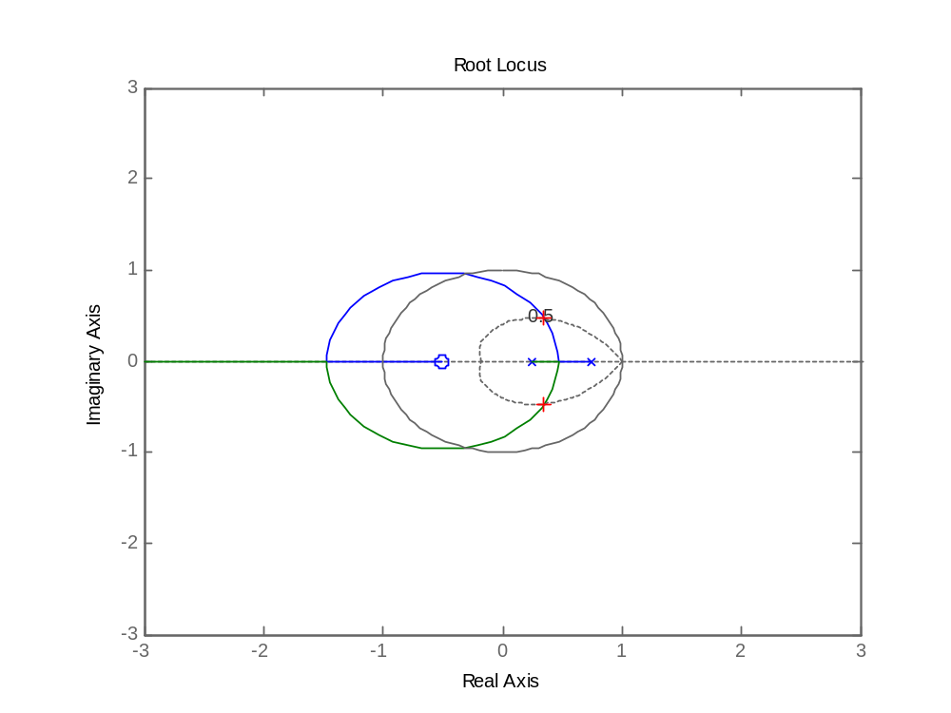
Root Locus Interactive. A trace of z=0.5 was made to guide the user’s selection of poles.
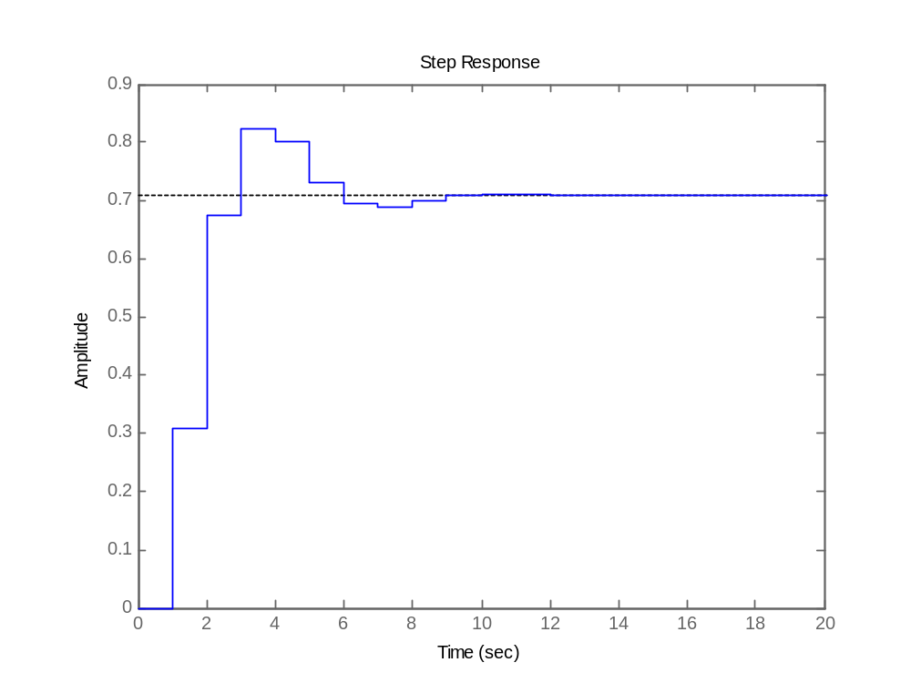
Step response of the close loop discrete system

Block Diagram
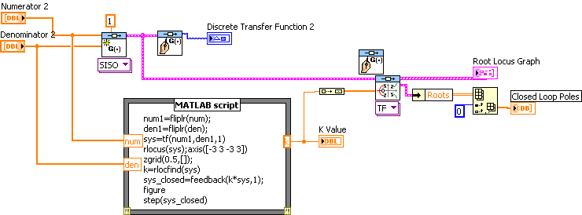

27.
a. Using a T=0.01 sec sampling rate,
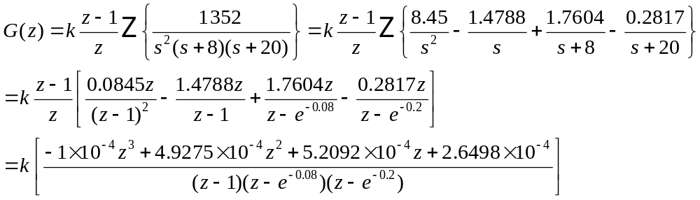
b. The resulting root locus is:
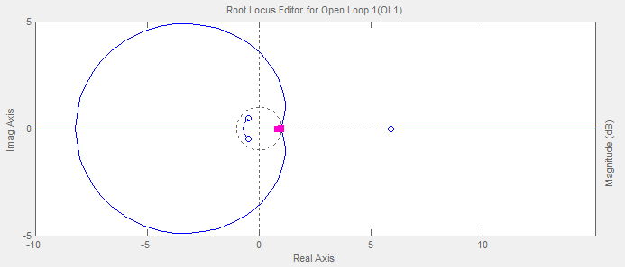
c. A detailed view of the root locus shows that the system is closed loop stable for 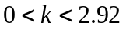
d. Using a second order approximation, a 5%OS corresponds to a damping factor 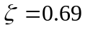. Searching for the corresponding damping factor line on the root locus we get 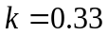.
e. The unit step response of the system is:
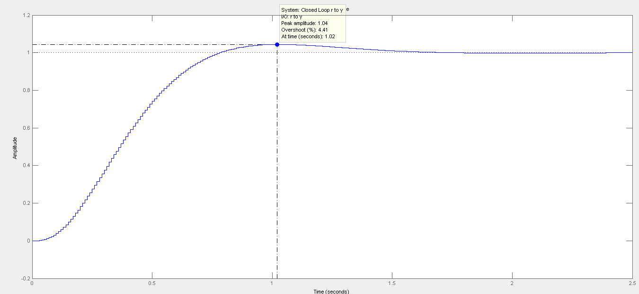

28.
%OS = 10%. ∴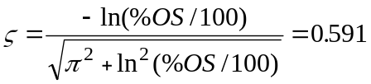.
Also Ts = 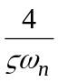= 0.1 sec. ∴ ω_{n} = 67.682 rad/s.
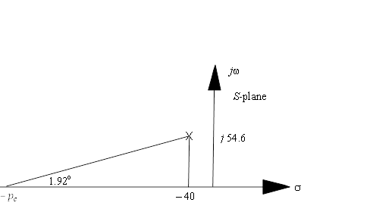
Hence, the location of the closed-loop poles must be – 40 ± j 54.6. The summation of angles from open-loop poles and zero to – 40 + j 54.6 is – 194.95º. Therefore, the design point is not on the root locus. A compensator whose angular contribution is 194.95º – 180º = 14.95º is needed. Assume a compensator zero at – 220 to cancel the pole at – 220. Adding that zero to the plant’s poles and zero yields –178.08º at – 40 ± j 54.6. Thus, the compensator’s pole must contribute 180º – 178.08º = 1.92º. The following geometry results.

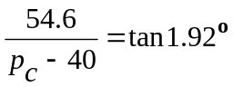. Hence, p_{c} = 1669. Adding the compensator pole and zero to the system poles and zero, the gain at the design point is found to be 12217535.
Summarizing the results: 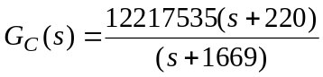.

Substituting Eq. (13.88) into G_{C}(s) and letting T = 0.001 yields:

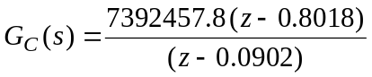

29.
- A bode plot of the open loop transmission 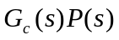shows that the open loop transfer function has a crossover frequency of 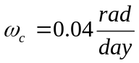. A convenient range for sampling periods is 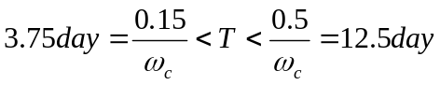. T=8 days fall within range.
- We substitute 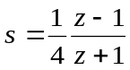into 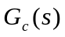we get 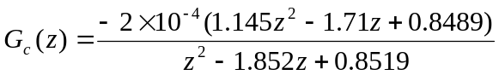

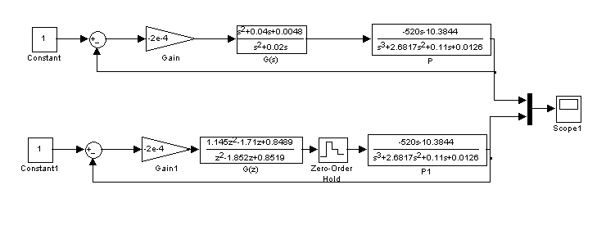
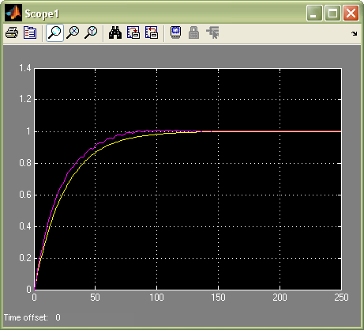

30.
- The following MATLAB M-file was developed

%Digitize G1(s) preceded by a sample and hold
%Input transient response specifications
Po=input('Type %OS ');
K = input('Type Proportional Gain of PI controller ');

numg1 = K*poly([-0.01304 -0.6]);
deng1 = poly([0 -0.01631 -0.5858]);
G1 = tf(numg1,deng1);
for T=5:-.01:0;
Gz=c2d(G1,T,'zoh');
Tz=feedback(Gz,1);
r=pole(Tz);
rm=max(abs(r));
if rm<=1;
break;
end;
end;
'G1(s)';
G1s=tf(numg1,deng1);
'G(z)';
Gz=c2d(G1s,0.75*T,'zoh');
%Determine damping ratio
z=(-log(Po/100))/(sqrt(pi^2+log(Po/100)^2));
%Plot root locus
rlocus(Gz)
zgrid(z,0)
title('Root Locus')
[K,p]=rlocfind(Gz); %Allows input by selecting point on graphic
pause
'T(z)';
Tz=feedback(K*Gz,1);
step(Tz)
- As the M-file developed in (a) was run and the values of the desired percent overshoot, %O.S. = 0, and PI speed controller’s proportional gain, K = 61 were entered, the root locus, shown below, was obtained.
- A point was selected on the root locus such that is inside the unit circle. That point is: 0.9837 + 0.0000i
- The sampled data transfer functions, G_{z} and T_{z}, obtained at a Sampling time, T = 0.0225 = 0.75*0.03 are:
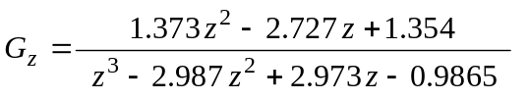
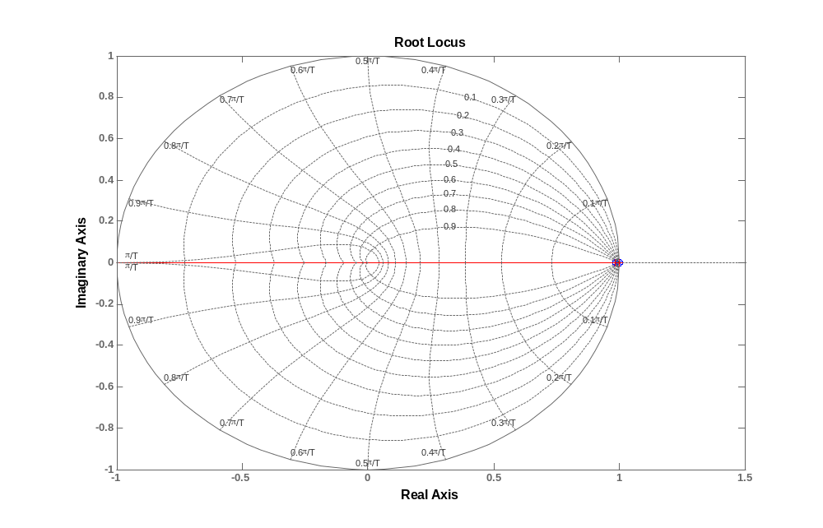
and 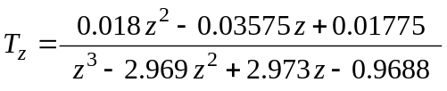
The poles, r, of the closed-loop transfer function, T_{z}, are:
– 0.8300, 0.9996, 0.9822
- The step response of this digital system, T_{z}, is shown below with the main transient response characteristics (the final value, rise time, and settling time) displayed on the graph. These are:
Final Value = c(∞) = 1 p. u.;
Rise Time = T_{r} = 2.68 seconds;
Settling Time = T_{s} = 4.82 seconds.

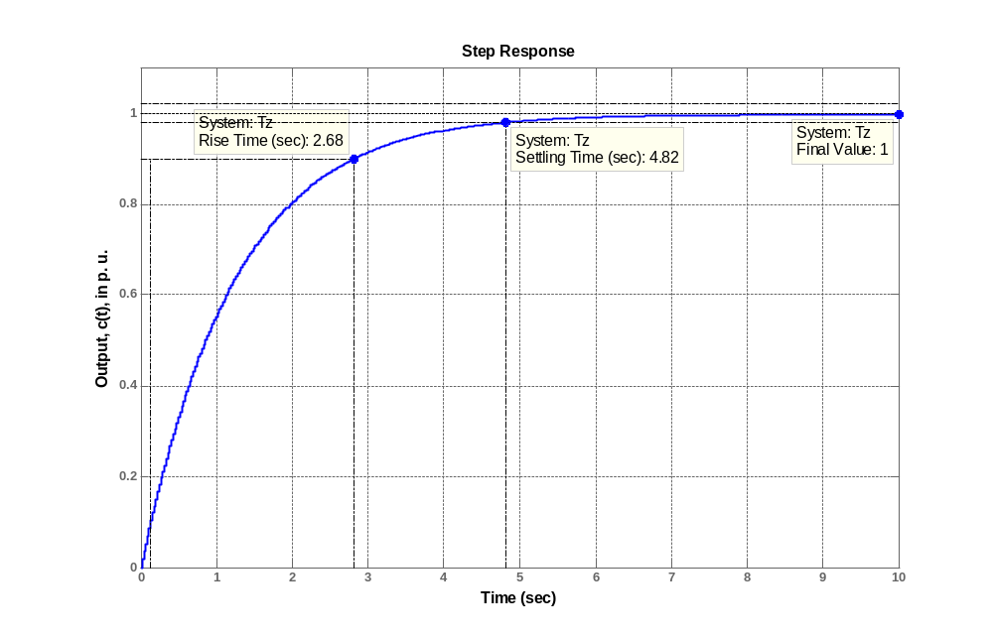

31.
- Below is a Bode plot of 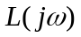 showing that 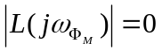 db when 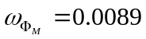 rad/sec. From Section 13.10 we that that 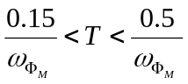 so the sampling period should be in 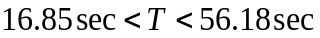. Within this range we arbitrarily choose 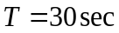 .
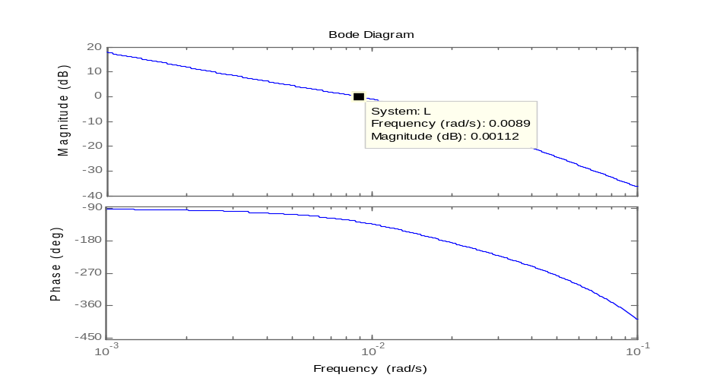

- We use equation 13.88 to get 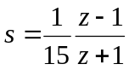 . Substituting into we get
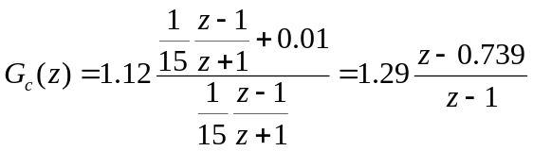
- The Simulink diagram and the simulations are shown next
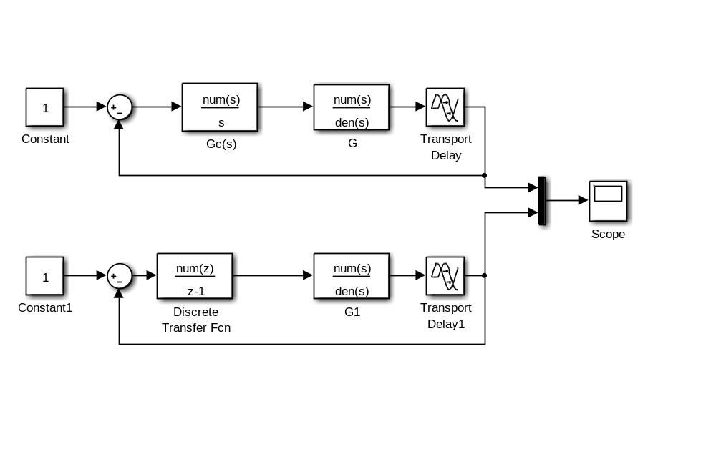
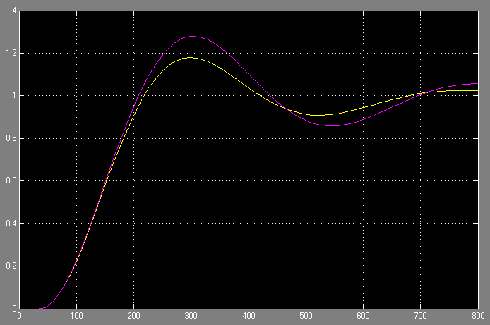

The yellow line indicates the continuous system and the purple the discrete compensated.

