**I-1 Instructor**

**Program:**

syms t

'a'

theta=45*pi/180

f=8*t^2*cos(3*t+theta);

pretty(f)

F=laplace(f);

F=simple(F);

pretty(F)

'b'

theta=60*pi/180

f=3*t*exp(-2*t)*sin(4*t+theta);

pretty(f)

F=laplace(f);

F=simple(F);

pretty(F)

**Computer response:**

ans =

a

theta =

0.7854

2 / PI \

8 t cos| -- + 3 t |

\ 4 /

1/2 2

8 2 (s + 3) (s - 12 s + 9)

------------------------------

2 3

(s + 9)

ans =

b

theta =

1.0472

/ PI \

3 t sin| -- + 4 t | exp(-2 t)

\ 3 /

1/2 2

1/2 1/2 3 3 s

12 s + 6 3 s - 18 3 + --------- + 24

2

------------------------------------------

2 2

(s + 4 s + 20)

**I-2 Instructor**

**Program:**

'Polynomial'

Gtf=tf([1 25 20 15 42],[1 13 9 37 35 50])

'Factored'

Gzpk=zpk(Gtf)

**Computer response:**

ans =

Polynomial

Transfer function:

s^4 + 25 s^3 + 20 s^2 + 15 s + 42

-----------------------------------------

s^5 + 13 s^4 + 9 s^3 + 37 s^2 + 35 s + 50

ans =

Factored

Zero/pole/gain:

(s+24.2) (s+1.35) (s^2 - 0.5462s + 1.286)

------------------------------------------------------

(s+12.5) (s^2 + 1.463s + 1.493) (s^2 - 0.964s + 2.679)

**I-3 Instructor**

**Program:**

syms s

'(a)'

Ga=45*[(s^2+37*s+74)*(s^3+28*s^2+32*s+16)]...

/[(s+39)*(s+47)*(s^2+2*s+100)*(s^3+27*s^2+18*s+15)];

'Ga symbolic'

pretty(Ga)

[numga,denga]=numden(Ga);

numga=sym2poly(numga);

denga=sym2poly(denga);

'Ga polynimial'

Ga=tf(numga,denga)

'Ga factored'

Ga=zpk(Ga)

'(b)'

Ga=56*[(s+14)*(s^3+49*s^2+62*s+53)]...

/[(s^2+88*s+33)*(s^2+56*s+77)*(s^3+81*s^2+76*s+65)];

'Ga symbolic'

pretty(Ga)

[numga,denga]=numden(Ga);

numga=sym2poly(numga);

denga=sym2poly(denga);

'Ga polynimial'

Ga=tf(numga,denga)

'Ga factored'

Ga=zpk(Ga)

**Computer response:**

ans =

(a)

ans =

Ga symbolic

2 3 2

(s + 37 s + 74) (s + 28 s + 32 s + 16)

45 -----------------------------------------------------------

2 3 2

(s + 39) (s + 47) (s + 2 s + 100) (s + 27 s + 18 s + 15)

ans =

Ga polynimial

Transfer function:

45 s^5 + 2925 s^4 + 51390 s^3 + 147240 s^2 + 133200 s + 53280

--------------------------------------------------------------------------------

s^7 + 115 s^6 + 4499 s^5 + 70700 s^4 + 553692 s^3 + 5.201e006 s^2 + 3.483e006 s

+ 2.75e006

ans =

Ga factored

Zero/pole/gain:

45 (s+34.88) (s+26.83) (s+2.122) (s^2 + 1.17s + 0.5964)

-----------------------------------------------------------------

(s+47) (s+39) (s+26.34) (s^2 + 0.6618s + 0.5695) (s^2 + 2s + 100)

ans =

(b)

ans =

Ga symbolic

3 2

(s + 14) (s + 49 s + 62 s + 53)

56 ----------------------------------------------------------

2 2 3 2

(s + 88 s + 33) (s + 56 s + 77) (s + 81 s + 76 s + 65)

ans =

Ga polynimial

Transfer function:

56 s^4 + 3528 s^3 + 41888 s^2 + 51576 s + 41552

--------------------------------------------------------------------------------

s^7 + 225 s^6 + 16778 s^5 + 427711 s^4 + 1.093e006 s^3 + 1.189e006 s^2

+ 753676 s + 165165

ans =

Ga factored

Zero/pole/gain:

56 (s+47.72) (s+14) (s^2 + 1.276s + 1.111)

---------------------------------------------------------------------------

(s+87.62) (s+80.06) (s+54.59) (s+1.411) (s+0.3766) (s^2 + 0.9391s + 0.8119)

**I-4 Instructor**

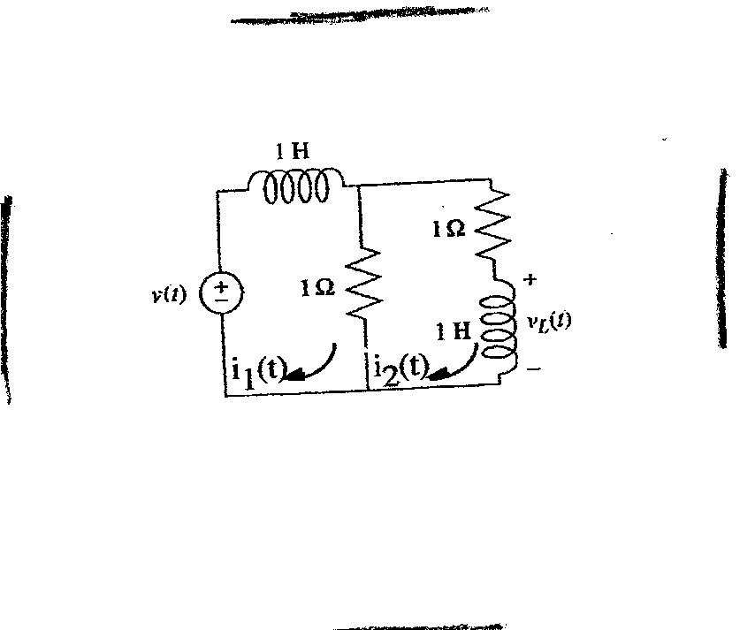

**2**

**2**

**2**

**2**



**b.**





Solving for I2(s):



Therefore, 

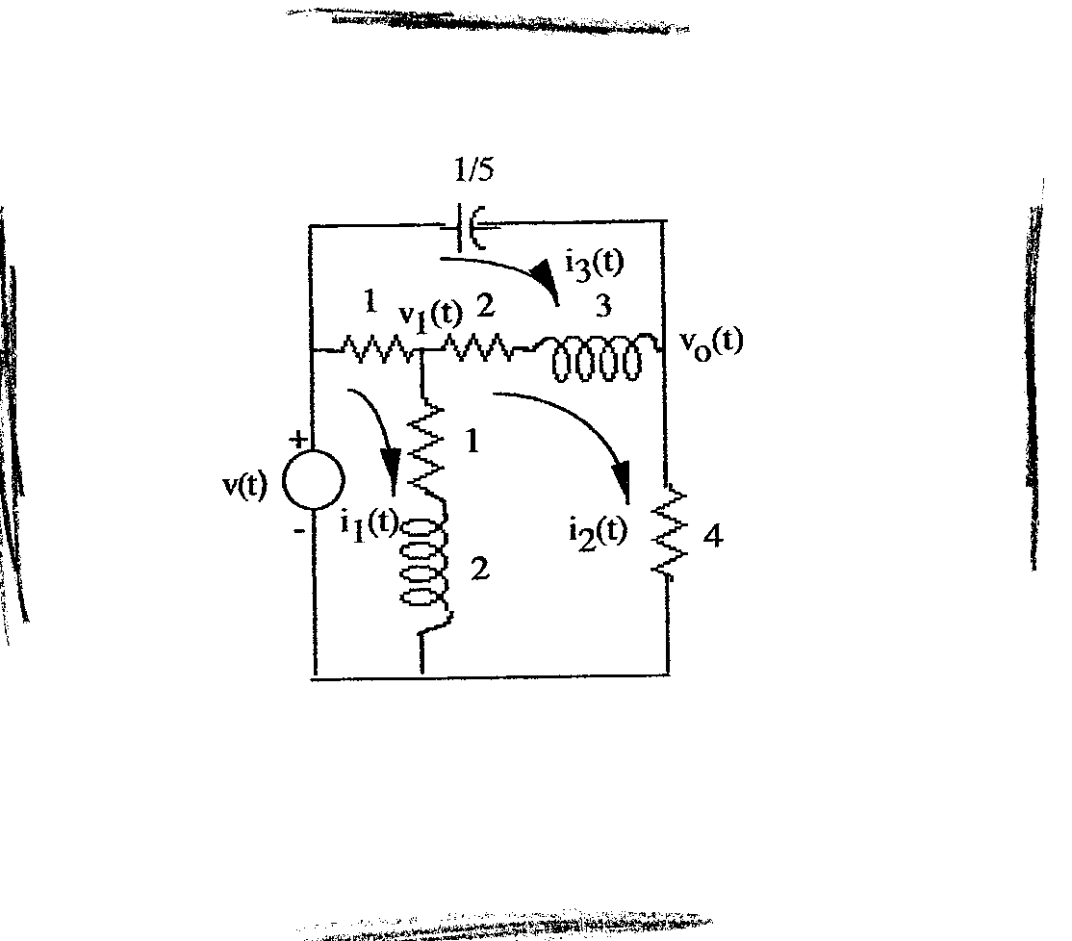

**1/9**

**2**

**4**

**6**

**2**

**4**

**8**

**I-5 Instructor**

**a.**

Mesh:

(4+4s)I1(s) - (2+4s)I2(s) - 2I3(s) = V(s)

- (2+4s)I1(s) + (14+10s)I2(s) - (4+6s)I3(s) = 0

-2I1(s) - (4+6s)I2(s) + (6+6s+)I3(s) = 0

Nodal:





or





**b.**

**Program:**

syms s V %Construct symbolic object for frequency

%variable 's' and V.

'Mesh Equations'

A2=[(4+4*s) V -2

-(2+4*s) 0 -(4+6*s)

-2 0 (6+6*s+(9/s))] %Form Ak = A2.

A=[(4+4*s) -(2+4*s) -2

-(2+4*s) (14+10*s) -(4+6*s)

-2 -(4+6*s) (6+6*s+(9/s))] %Form A.

I2=det(A2)/det(A); %Use Cramer's Rule to solve for I2.

Gi=I2/V; %Form transfer function, Gi(s) = I2(s)/V(s).

G=8*Gi; %Form transfer function, G(s) = 8*I2(s)/V(s).

G=collect(G); %Simplify G(s).

'G(s) via Mesh Equations' %Display label.

pretty(G) %Pretty print G(s)

'Nodal Equations'

A2=[(6*s^2+12*s+5)/(12*s^2+14*s+4) V/2

-1/(6*s+4) s*(V/9)] %Form Ak = A2.

A=[(6*s^2+12*s+5)/(12*s^2+14*s+4) -1/(6*s+4)

-1/(6*s+4) (24*s^2+43*s+54)/(216*s+144)]

%Form A.

Vo=simple(det(A2))/simple(det(A));

%Use Cramer's Rule to solve for Vo.

G1=Vo/V; %Form transfer function, G1(s) = Vo(s)/V(s).

G1=collect(G1); %Simplify G1(s).

'G(s) via Nodal Equations' %Display label.

pretty(G1) %Pretty print G1(s)

**Computer response:**

ans =

Mesh Equations

A2 =

[ 4*s + 4, V, -2]

[ - 4*s - 2, 0, - 6*s - 4]

[ -2, 0, 6*s + 9/s + 6]

A =

[ 4*s + 4, - 4*s - 2, -2]

[ - 4*s - 2, 10*s + 14, - 6*s - 4]

[ -2, - 6*s - 4, 6*s + 9/s + 6]

ans =

G(s) via Mesh Equations

3 2

48 s + 96 s + 112 s + 36

----------------------------

3 2

48 s + 150 s + 220 s + 117

ans =

Nodal Equations

A2 =

[ (6*s^2 + 12*s + 5)/(12*s^2 + 14*s + 4), V/2]

[ -1/(6*s + 4), (V*s)/9]

A =

[ (6*s^2 + 12*s + 5)/(12*s^2 + 14*s + 4), -1/(6*s + 4)]

[ -1/(6*s + 4), (24*s^2 + 43*s + 54)/(216*s + 144)]

ans =

G(s) via Nodal Equations

3 2

48 s + 96 s + 112 s + 36

----------------------------

3 2

48 s + 150 s + 220 s + 117

**I-6 Instructor**

Let *X*1(*s*) be the displacement of the left member of the spring and *X*3(*s*) be the displacement of the mass. Writing the equations of motion, gives:



The third equation may be rewritten as: 

From which we get: 

Substituting for *X3(s)* into the second equation and simplifying, gives the following set of two equations:



Solving for *X2(s)*,



Thus,

**I-7 Instructor**

Writing the equations of motion,



Solving for *X*3(*s*),



From which, .

**I-8 Instructor**

The corresponding impedance equations are:

|  |  |
| --- | --- |
| $θ_{1}$: | $$\left(s^{2}+s+1\right)θ_{1}-\left(s+1\right)θ_{2}=T$$ |
| $θ_{2}$: | $$-\left(s+1\right)θ_{1}+\left(s^{2}+s+2\right)θ_{2}=0$$ |

Solving for $θ_{1}$ one gets:

$$θ_{1}=\frac{\left|\begin{matrix}T & -(s+1) \\ 0 & s^{2}+s+2\end{matrix}\right|}{\left|\begin{matrix}s^{2}+s+1 & -(s+1) \\ -(s+1) & s^{2}+s+2\end{matrix}\right|}=\frac{T(s^{2}+s+2)}{{(s}^{2}+s+1)\left(s^{2}+s+2\right)-{(s+1)}^{2}}$$

Simplifying:

$$\frac{θ_{1}}{T}=\frac{s^{2}+s+2}{s^{4}+2s^{3}+3s^{2}+1}$$

**I-9 Instructor**

Reflect all impedances on the right to the viscous damper and reflect all impedances and torques on the

left to the spring and obtain the following equivalent circuit:



Writing the equations of motion,

(J1eqs2+K)2(s) -K3(s) = Teq(s)-K2(s)+(Ds+K)3(s) -Ds4(s) = 0-Ds3(s) +[J2eqs2 +(D+Deq)s]4(s) = 0

where: J1eq = J2+(Ja+J1)()2 ; J2eq = J3+(JL+J4)()2 ; Deq = DL()2 ; 2(s) = 1(s) .

**I-10 Instructor**

Draw the freebody diagrams,



Write the equations of motion from the translational and rotational freebody diagrams,

(Ms2+2fv s+K2)X(s) -fvrs(s) = F(s)

-fvrsX(s) +(Js2+fvr2s)(s) = 0

Solve for (s),



From which, = ­.

**I-11 Instructor**

Writing the equations of motion,

(J1s2+K1)1(s) - K12(s) = T(s)

-K11(s) + (J2s2+D3s+K1)2(s) +F(s)r -D3s3(s) = 0

-D3s2(s) + (J2s2+D3s)3(s) = 0

where F(s) is the opposing force on J2 due to the translational member and r is the radius of J2. But, for the translational member,

F(s) = (Ms2+fvs+K2)X(s) = (Ms2+fvs+K2)r(s)

Substituting F(s) back into the second equation of motion,

(J1s2+K1)1(s) - K12(s) = T(s)

-K11(s) + [(J2 + Mr2)s2+(D3 + fvr2)s+(K1 + K2r2)]2(s) -D3s3(s) = 0

-D3s2(s) + (J2s2+D3s)3(s) = 0

Notice that the translational components were reflected as equivalent rotational components by the

square of the radius. Solving for **2*(s*),  where  is the

determinant formed from the coefficients of the three equations of motion. Hence,

 

Since



40. •312-Wi-76-M.6 (Chap 2)**I-12 Instructor**

The following torque-speed curve can be drawn from the data given:



**1333.33**

**600**

**55**

Therefore, = =  ; *Kb* = = . Also, *Jm* = 7+105()2 = 9.92; *Dm* = 3. Thus,

= = . Since *L(s)* = *m(s)*,  = .

**I-13 Instructor**

**a.** Let x = x+0. Therefore,

.

**b.** Let x = x+ Therefore,



But, 

Therefore, 

Collecting terms, 

.

**I-14 Instructor**

The given curve can be described as follows:

f(x) = -6 ; -∞<x<-3;

f(x) = 2x; -3<x<3;

f(x) = 6; 3<x<+∞

Thus,



**I-15 Instructor**

**a.**

We have that







From the second equation



Obtaining Laplace transforms on both sides of the previous equation

 from which 

so that



1. Under constant velocity so the angle is



Obtaining inverse Laplace transform

, the load will sway with a frequency  .

1. From  and Laplace transformation we get



From which



Where 

1. From part c



Let then



After partial fraction expansions, so



From which it is clear that 

**I-16 Instructor**

**a.**  Obtaining Laplace transforms on both sides of the equation

 or 

By inverse Laplace transformation



* 1. Want to find the time at which



Obtaining ln on both sides of the equation

