**Chapter 4 – Solutions to Instructor Reserve Problems**

**I-1 Instructor**

**Program:**

'(a)'

num=5;

den=[1 5];

Ga=tf(num,den)

subplot(1,2,1)

step(Ga)

title('(a)')

'(b)'

num=20;

den=[1 20];

Gb=tf(num,den)

subplot(1,2,2)

step(Gb)

title('(b)')

**Computer response:**

ans =

(a)

Transfer function:

5

-----

s + 5

ans =

(b)

Transfer function:

20

------

s + 20

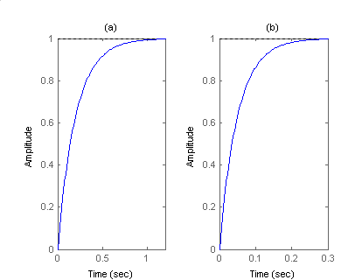

**I-2 Instructor**

**Program:**

Clf

M=1

num=1/M;

den=[1 6/M];

G=tf(num,den)

step(G)

pause

M=2

num=1/M;

den=[1 6/M];

G=tf(num,den)

step(G)

**Computer response:**

M =

1

Transfer function:

1

-----

s + 6

M =

2

Transfer function:

0.5

-----

s + 3

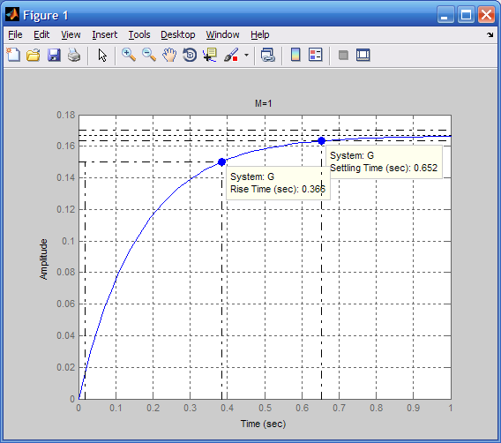

Tc

From plot, time constant =.0.16 s.

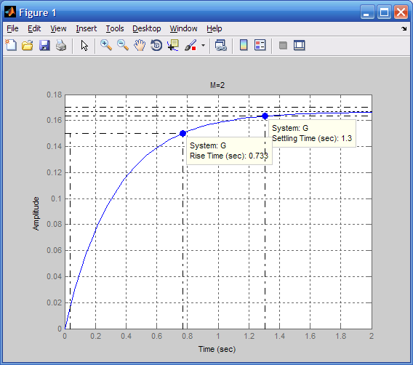

Tc

From plot, time constant = 0.33 s.

**I-3 Instructor**

Writing the node equation at the capacitor, VC(s) (+ + Cs) + = 0.   
Hence, = = . The step response is .The poles are at   
-10 ± j20. Therefore, vC(t) = Ae-10t cos (20t + ).

**I-4 Instructor**

**Program:**

num=[10 0];

den=[1 20 500];

G=tf(num,den)

step(G)

**Computer response:**

Transfer function:

10 s

----------------

s^2 + 20 s + 500

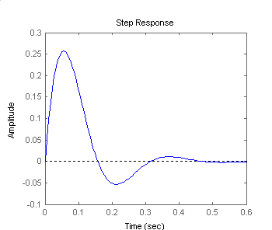

**I-5 Instructor**

C(s) = = - = -   
= - = -

Hence, 

= 1 - e-nt cos (nt - ) = 1 - e-nt cos (nt - ),   
where  = tan-1

**I-6 Instructor**

%OS = e- / x 100. Dividing by 100 and taking the natural log of both sides,   
ln () = - . Squaring both sides and solving for 2, 2 = . Taking the negative square root,  = .

**I-7 Instructor**

**a.**







**b.**







**c.**







**d.**









**e.**









**f.**







**I-8 Instructor**

The corresponding damping factor is $=\frac{-ln⁡(0.15)}{\sqrt{π^{2}+\ln^{2}(0.15)}}=0.517$. The settling time is $T_{s}=\frac{4}{ω_{n}}=0.7$ sec, so $ω_{n}=11.053$. The transfer function is $G\left(s\right)=\frac{ω_{n}^{2}}{s^{2}+2ω_{n}s+ω_{n}^{2}}=\frac{122.164}{s^{2}+11.43s+122.164}$.

**I-9 Instructor**

Note that

$$\frac{θ}{θ_{ref}}=\frac{53.176}{4.6s^{2}+31.281s+53.176}=\frac{11.56}{{\left(s+3.4\right)}^{2}}$$

So the system is critically damped. Therefore %OS=0, $T_{P}$ does not exist, and $T_{s}=\frac{5.834}{a}=\frac{5.834}{3.4}=1.72$ sec. For a unit step input $c_{final}=1$. So the output for an input with a magnitude of 3 will look as follows:



**I-10 Instructor**

The peak times are visually identified as 0.15, 0.2, 0.25, 0.35 and 0.45 sec. A %OS = 20% corresponds to a damping factor of ξ=0.456. Using $ω_{n}=\frac{π}{T_{p}\sqrt{1-{}^{2}}}$ the corresponding natural frequencies are 25.53, 17.65 14.12, 10.09 and 7.84 rad/sec. The real part of the poles is $-ω_{n}$ = -10.7311 -8.0483 -6.4386 - 4.5990 -3.5770. The imaginary part of the poles is $ω_{n}\sqrt{1-{}^{2}}$ = 20.9440 15.7080 12.5664 8.9760 6.9813. The corresponding plot is:

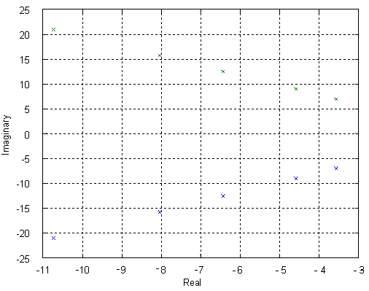

I-11 Instructor

**a.** = - = - .   
Thus c(t) = 1 - e-2t (cos4.532t+0.441 sin 4.532t) = 1-1.09e-2t cos(4.532t -23.80).

**b.**









Therefore, c(t) = 1 - 0.29e-10t - e-2t(0.71 cos 4.532t + 0.954 sin 4.532t)  
= 1 - 0.29e-10t - 1.189 cos(4.532t - 53.34o).

**c.**







Therefore, c(t) = 1 - 1.14e-3t + e-2t (0.14 cos 4.532t - 0.69 sin 4.532t)  
= 1 - 1.14e-3t + 0.704 cos(4.532t +78.53o).

**I-12 Instructor**

**a.**

(1)  **=**  **=**  **=** 

Taking the inverse Laplace transform

Ca1(t) = 0.17213 e-1.5t sin 5.8095t

(2)  **=**  **=**



**=** 

Taking the inverse Laplace transform

Ca2(t) = 0.055556 - e-1.5t (0.055556 cos 5.809t + 0.014344 sin 5.809t)

The total response is found as follows:

Cat(t) = Ca1(t) + Ca2(t) = 0.055556 - e-1.5t (0.055556 cos 5.809t - 0.157786 sin 5.809t)

Plotting the total response:



**b.**

(1) Same as (1) from part (a), or Cb1(t) = Ca1(t)

(2) Same as the negative of (2) of part (a), or Cb2 (t) = - Ca2(t)

The total response is

Cbt(t) = Cb1(t) + Cb2(t) = Ca1(t)- Ca2(t) = -0.055556 + e-1.5t (0.055556 cos 5.809t + 0.186474 sin 5.809t)



Notice the nonminimum phase behavior for Cbt(t).

**I-13 Instructor**



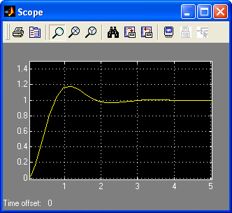

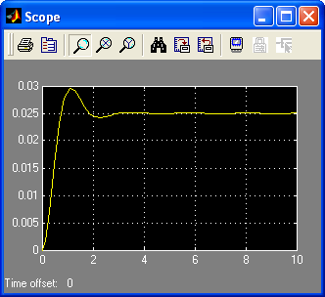

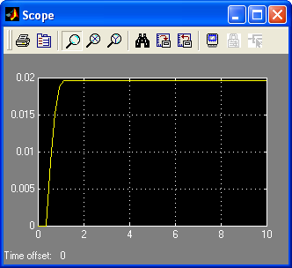

**I-14 Instructor**



|**I** - **A** | = 2 + 1













Solving for the Ai's and substituting into the state-transition matrix,



To find the state vector,















**I-15 Instructor**

**Program:**

A=[0 1 0;-12 -8 1;0 0 -2];

B=[0;0;1];

C=[1 1 0];

D=0;

S=ss(A,B,C,D);

stepplot(S)

**Computer response:**

S =

a =

x1 x2 x3

x1 0 1 0

x2 -12 -8 1

x3 0 0 -2

b =

u1

x1 0

x2 0

x3 1

c =

x1 x2 x3

y1 1 1 0

d =

u1

y1 0

Continuous-time state-space model.



**I-16 Instructor**

At steady state the input is ≈ 9V and the output is ≈ 6V Thus G(0)=6/9=0.667

The maximum peak is achieved at ≈ 285μ with a %OS = (7.5/6-1)*100 = 25%

This corresponds to a damping factor of





So the approximated transfer function is



**I-17 Instructor**

**a.**

>> A=[-8.792e-3 0.56e-3 -1e-3 -13.79e-3; -0.347e-3 -11.7e-3 -0.347e-3 0; 0.261 -20.8e-3 -96.6e-3 0; 0 0 1 0]

A =

-0.0088 0.0006 -0.0010 -0.0138

-0.0003 -0.0117 -0.0003 0

0.2610 -0.0208 -0.0966 0

0 0 1.0000 0

>> eig(A)

ans =

-0.1947

0.0447 + 0.1284i

0.0447 - 0.1284i

-0.0117

**b.**

Given the eigenvalues, the state-transition matrix will be of the form

 with



Thus 64 constants have to be found.

**I-18 Instructor**

**a.**  The equations are rewritten as





from which we obtain





1. To obtain the transfer function we first calculate



So





**I-19 Instructor**

**a.** Assuming that the input step amplitude is 560 (N-m) and that the settling time is 0.4 sec the transfer function is:

$$G(s)=\frac{\frac{40}{560}}{0.1s+1}=\frac{0.714}{s+10}$$

$b. T_{BRK}\left(t\right)=M*K\left(1-e^{-at}\right)=560*0.0714\left(1-e^{-10t}\right)=40\left(1-e^{-10t}\right)$ where M is the input step amplitude.

**C. $T_{BRK}\left(0.2\right)=40\left(1-e^{-10(0.2)}\right)=36.6$**  (Bar)

**SOLUTIONS TO DESIGN PROBLEMS**

**I-20 Instructor**

Writing the equation of motion, . Thus, the transfer function is . Hence, , or.

**15. Find J and K in the rotational system shown in Figure P.4.7 to yield a 30% overshoot and a settling time of 4 seconds for a step input in torque.**



Figure P.4.7

**I-21 Instructor**

Writing the equation of motion: (Js2+s+K)(s) = T(s). Therefore the transfer function is

= .

 = = 0.358.

Ts = = = 8J = 3.

Therefore J = . Also, Ts = 3 = = . Hence, n = 3.724. Now, = n2 = 13.868. Finally, K = 5.2.

16. •312-Sp-76-M.3 (Chap 4)

**16. Given the system shown in Figure P.4.8. Find the damping, D, to yield a 30% overshoot in output angular displacement for a step input in torque.**



Figure P.4.8

**17. •413-Wi-70-1.4 (Chap 4)**

**17. For the system shown in Figure P.4.9, find N1/N2 so that the settling time for a step torque input is 16 seconds.**



Figure P.4.9

**81** **I-22 Instructor**

The equivalent circuit is:



where Jeq = 1+()2 ; Deq = ()2; Keq = ()2. Thus,

= . Letting = n and substituting the above values into the transfer function,

= . Therefore, n = . Finally, Ts = = = 16. Thus n = 1.

**I-23 Instructor**

20. • Sp 4-20 (Response of higher order systems)

76For the circuit shown below



write the loop equations as





Solving for I2(s)



But, . Thus,



Substituting component values,



For 8% overshoot,  = 0.6266. For Ts = 0.001, n = = 4000. Hence, n = 6383.66. Thus,



or,

 (1)

Also,

 (2)

Solving (1) and (2) simultaneously,  , and *C* = 2.4305 x 10-2 F.