**Chapter 8 – Solutions to Instructor Reserve Problems**

**I-1 Instructor**

  

**a. b. c.**

 

**d.**

**I-2 Instructor**

1. The characteristic equation is given by  or . The Routh array is

|  |  |  |
| --- | --- | --- |
|  |  |  |
|  |  |  |
| 1 |  |  |

For , the first column of the Routh array will have no sign changes when either or when . The system is closed loop unstable in the range .

1. There are no asymptotes in this root locus. To calculate the break-in and breakaway points, let . Then  So the only break-in point occurs when .

It is helpful to calculate directly the root positions from the characteristic equation. The closed loop poles are located at 

It can be seen that when , both poles are complex conjugate with a real part =-1; when  the two poles are real.

The root locus is:

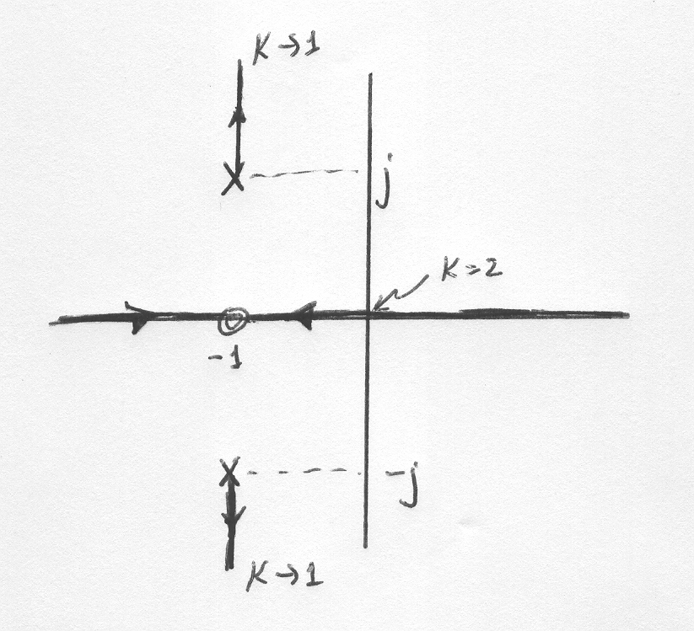

1. When the poles are at . When , the solution of the quadratic equation above gives 

**I-3 Instructor**



**I-4 Instructor**

****Breakaway:  = -3.436 for K = 1.781. System is never unstable. System is marginally stable for K = ∞.

**I-5 Instructor**

**a.**



Imaginary axis crossing: j1.41 at K = 1.5. Stability: K < 1.5. Breakaway: -1.41 at K = 0.04. Points on root locus: -1.5 ± j0, K = 0.0345; -0.75 ± j1.199, K = 0.429; 0 ± j1.4142, K = 1.5;

0.75 ± j1.1989, K = 9. Finding angle of arrival: 90 - 1 - 2 + 3 = 90o - tan-1(1/3) - tan-1(1/2) + 3 = 180o. Thus, 3 = 135o.

**b.**



Imaginary axis crossing: j1.41 at K = 1. Stability: K < 1. Breakaway: -1.41 at K = 0.03. Break-in: 1.41 at K = 33.97. Points on root locus: -1.5 ± j0, K = 0.02857; -0.75 ± j1.199, K = 0.33;

0 ± j1.4142, K = 1; 0.75 ± j1.1989, K = 3.

**I-6 Instructor**

1. With *G(s)* represented as: , the following M-file is written to plot the root locus shown below.

numg = [1 30 200];

deng = [1 20 70 3000];

G = tf(numg, deng);

rlocus(G);



1. 2.88 < *K* < ∞
2. *K* = 34 @ –13.4 ± j13.4
3. At the break-in point, *s* = –15.8, *K* = 121.

**I-7 Instructor**

T(s) = = . Thus an equivalent system has G(s) = and H(s) = s. Plotting a root locus for G(s)H(s) = , we obtain,



**29. I-8 Instructor**

The root locus intersects the 0.55 damping ratio line at –7.217 + j10.959 with *K* = 134.8. A

justification of a second-order approximation is not required. The problem stated the requirements in terms of damping ratio and not percent overshoot, settling time, or peak time. A second-order approximation is required to draw the equivalency between percent overshoot, settling time, and peak time and damping ratio and natural frequency.

**I-9 Instructor**

**Program:**

pos=10;

z=-log(pos/100)/sqrt(pi^2+[log(pos/100)]^2)

numg=1;

deng=poly([0 -3 -4 -8]);

G=tf(numg,deng)

Gzpk=zpk(G)

rlocus(G,0:1:100)

pause

axis([-2,0,-2,2])

sgrid(z,0)

pause

[K,P]=rlocfind(G)

T=feedback(K*G,1)

pause

step(T)

**Computer response**:

z =

0.5912

Transfer function:

1

----------------------------

s^4 + 15 s^3 + 68 s^2 + 96 s

Zero/pole/gain:

1

-------------------

s (s+8) (s+4) (s+3)

Select a point in the graphics window

selected_point =

-0.7994 + 1.0802i

K =

81.0240

P =

-7.1058

-6.2895

-0.8023 + 1.0813i

-0.8023 - 1.0813i

Transfer function:

81.02

------------------------------------

s^4 + 15 s^3 + 68 s^2 + 96 s + 81.02

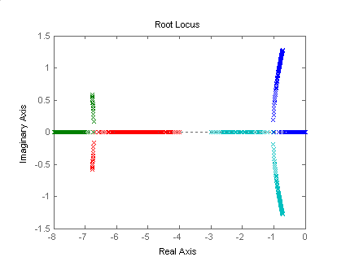

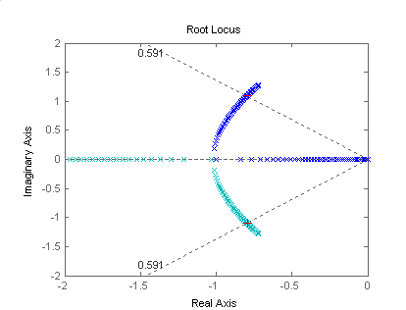

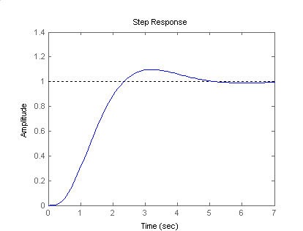

**I-10 Instructor**

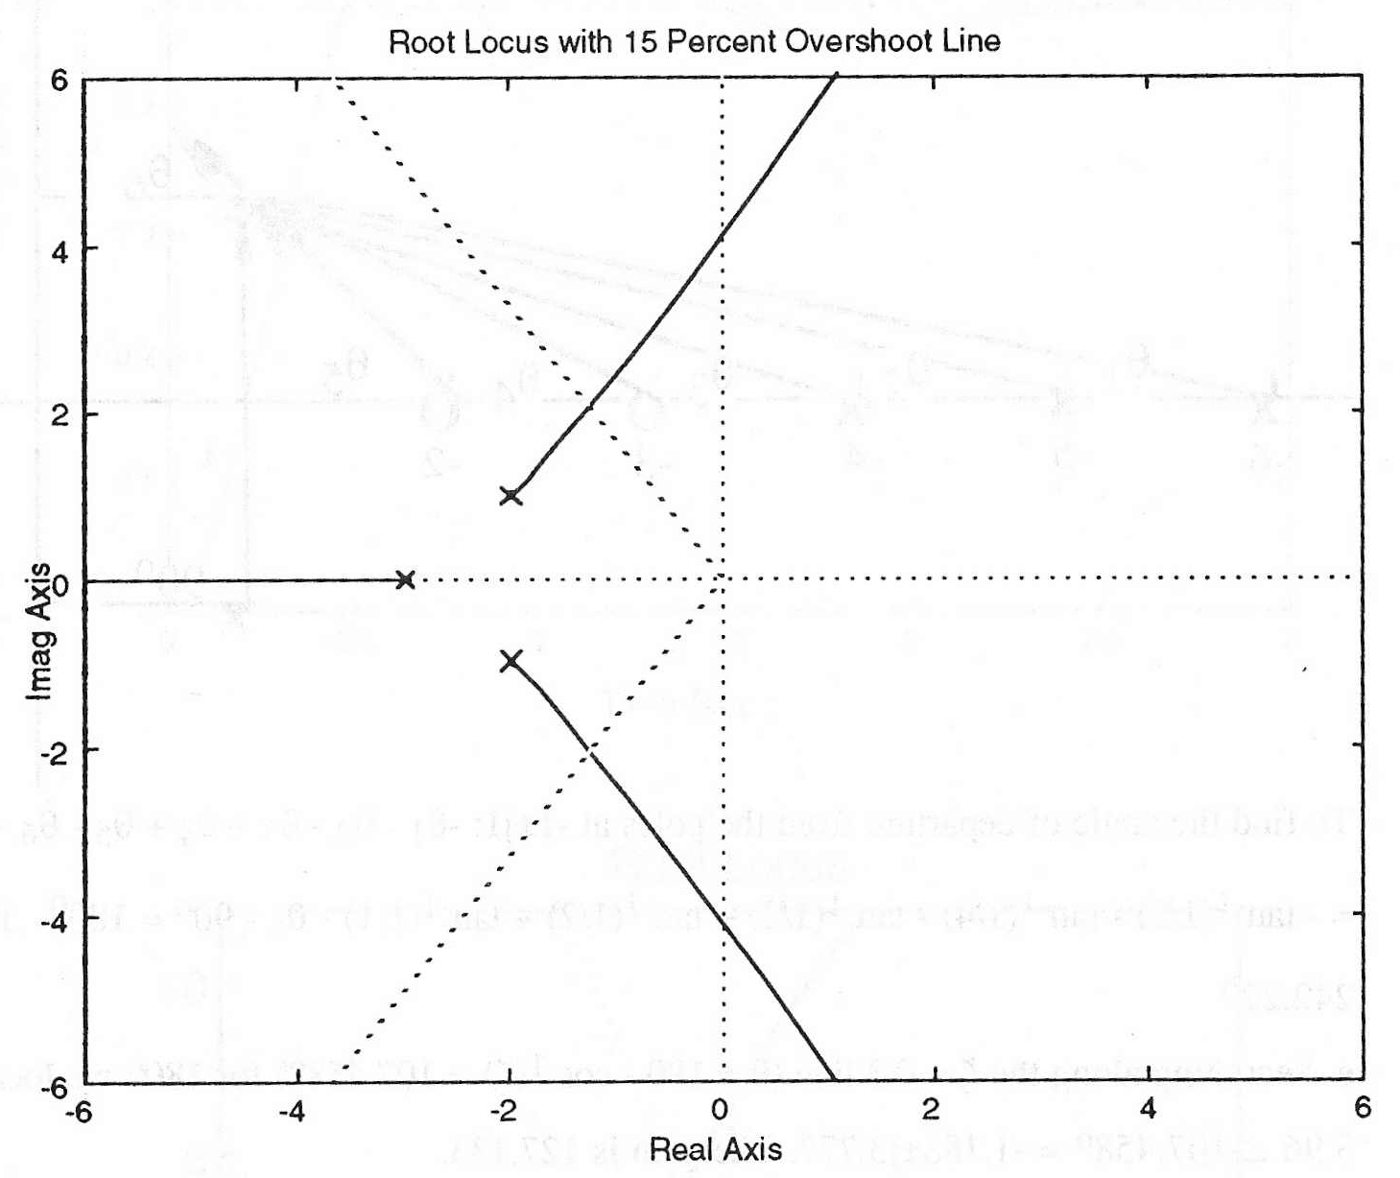

**a.** Searching the 15% overshoot line (    = □) for 180o, we find the point 2.404  □ = -1.243 + j2.058.

**b.** K = 11.09.

**c.** Another pole is located left of -3. Searching for a gain of 11.09 in that region, we find the third pole at -4.514.

**d.** The third pole is not 5 times farther than the dominant pair from the j axis. the second-order approximation is estimated to be invalid.

**I-11 Instructor**



Differentiating the characteristic equation, *s*3 + 9.25*s*2 + 10*s* + *K* = 0, yields,



Solving for ,



The sensitivity of *s* to *K* is



The following M-file was written to plot the root locus, shown below.

numg = 1;

deng = poly ([0 -1.25 -8]);

G = tf(numg, deng);

rlocus(G) % Draw root locus

axis([-1 -0.5 -2 2]) % Define range on axes for root

% locus close-up view.

title('Close-up') % Define title for close-up root

% locus

z=[0.456,0.591]; % Define damping ratio values : 0.456

% snd 0.591.

wn=0:0.25:2; % Define natural frequency values:

% 0 to 2 in steps of 0.25.

sgrid(z,wn) % Generate damping ratio and natural

% frequency grid lines for root locus.



**a.** Search along the  = 0.591 line and find the root locus intersects at:

*s =* – 0.557 + *j*0.76 with *K* = 7.25. Substituting *s* and *K* into *Ss:K* yields



**b.** Search along the  = 0.456 line and find the root locus intersects at:

*s =* – 0.523 + *j*1.02 with *K* = 10.8. Substituting *s* and *K* into *Ss:K* yields



**c.** Least sensitive:  = 0.456.

**I-12 Instructor**

 

**a b**

 

**c** **d**

**I-13 Instructor**

1. The open loop transmission is . The characteristic equation is or . If is considered variable, then this equation can be written as . In this case there is one asymptote. The break-in point is found by writing and computing . The numerator has roots at . The root locus is:

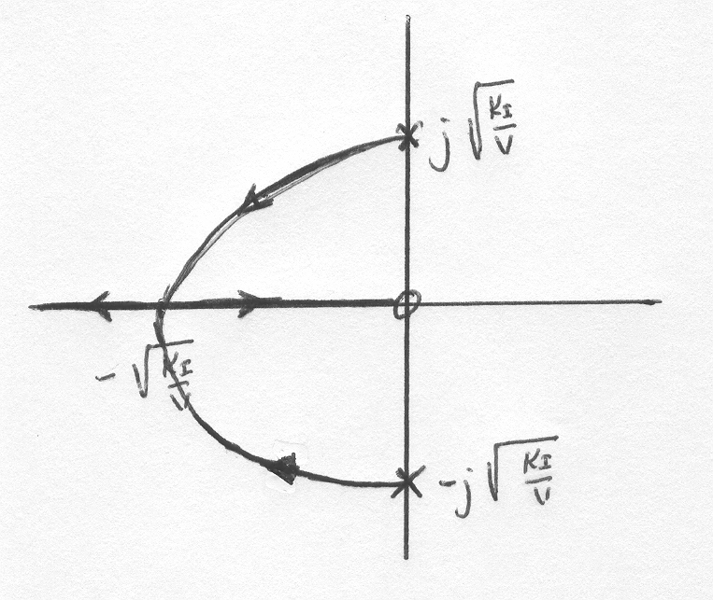

1. The characteristic equation can now be written as . There are now two asymptotes with angles  and real axis intersection . The break-in breakaway point can be found by calculating . Differentiating we get so . The root locus is:

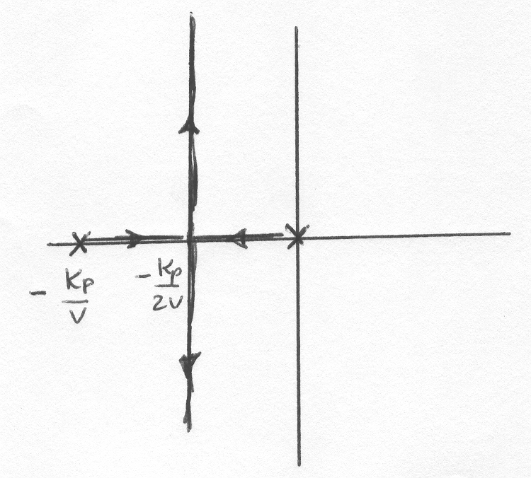

**I-14 Instructor**

After applying the Padé approximation  so this is a positive feedback system.

We start by finding out the range of for closed loop stability. The characteristic equation is  or . The Routh array is

|  |  |  |
| --- | --- | --- |
|  | 1 |  |
|  | 55.67 |  |
|  |  |  |
| 1 |  |  |

The resulting stability range is 

The root locus will have two asymptotes with angles 

For the breakaway break-in points, write  . The derivative of this expression is



The roots of the numerator are: of which the latter two are in the root locus.

We find the values of at 2.14 and -1.88 as follows

 giving  and

 giving 

The root locus is:

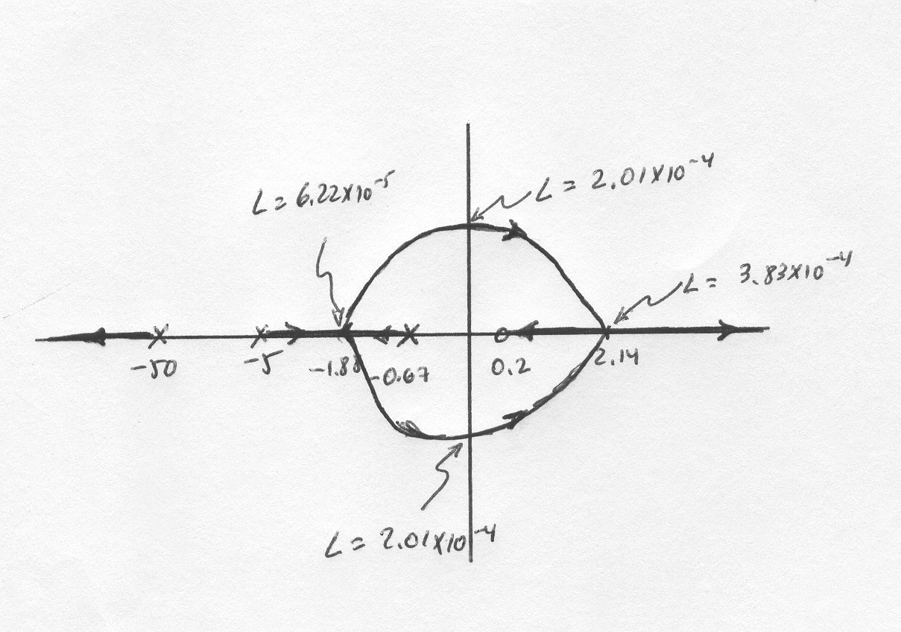

**SOLUTIONS TO DESIGN PROBLEMS**

**I-15 Instructor**

**a**. The open loop transfer function can be expressed as . The Acceleration Error Constant is given by . For a parabolic input  . This gives 

**b**. The characteristic equation is  or  We start by finding the range of for closed loop stability. The Routh array is

|  |  |  |
| --- | --- | --- |
|  | 1 |  |
|  | 2.89 | 0.003 |
|  |  |  |
| 1 | 0.003 |  |

So for closed loop stability 

To draw the root locus we write the characteristic equation asor 

There are two asymptotes with  and real axis intersection . To find the break-in and breakaway points we write . We obtain  The roots of the numerator are . We obtain the values of  at -0.0326 and -1,443 from

giving  and

giving 

The root locus is:

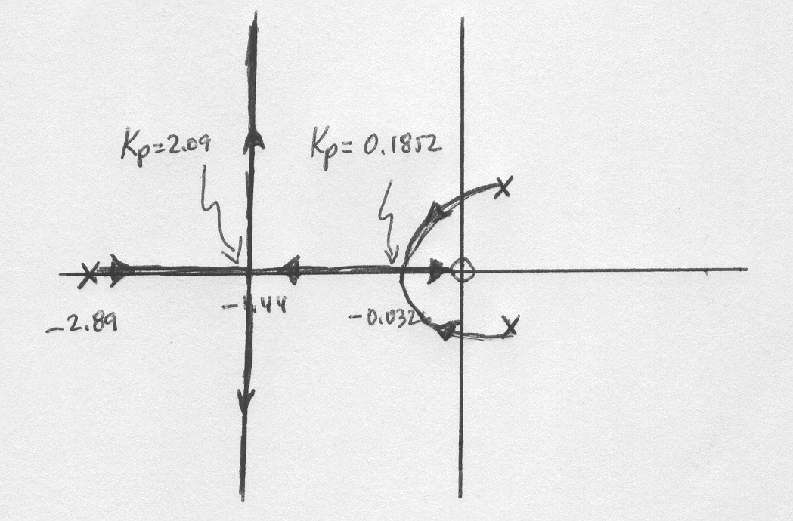

**c**. The value of when the system has a closed loop pole at -1 is obtained from

resulting in . With this value of gain the characteristic equation becomes . This equation has roots at 

**I-16 Instructor**

**a**.

>> s=tf('s');

>> Ga=10.26/(s^2+11.31*s+127.9);

>> F=6.667e-5*s^2/(s^2+0.2287*s+817.3);

>> Gm=s/(s^2+5.181*s+22.18);

>> G=Ga*F*Gm;

>> sisotool

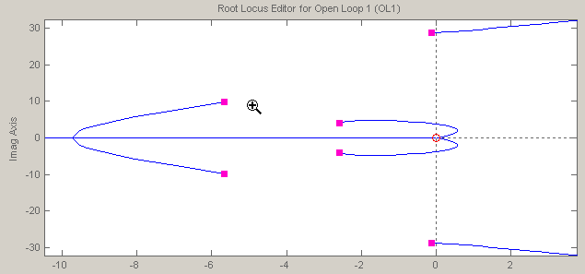

**b**. The system will be closed loop stable for

**c.** The system cannot be overdamped because there will always be two undamped poles very close to the jω axis.

**I-17 Instructor**

**a**.

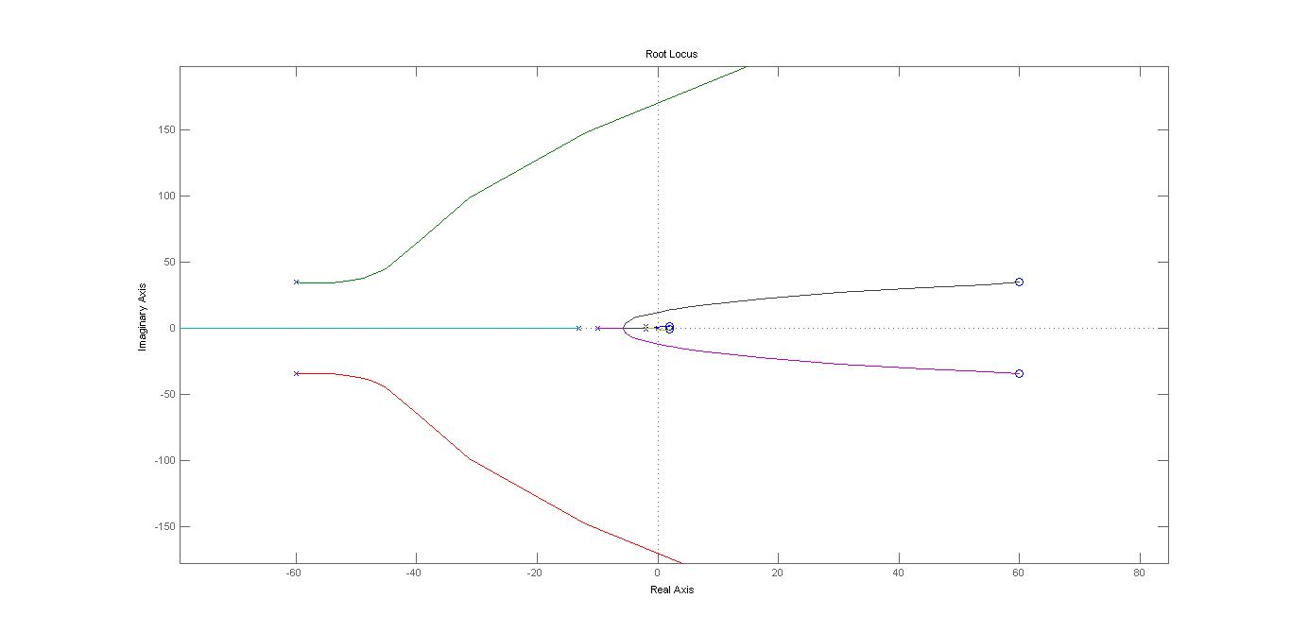

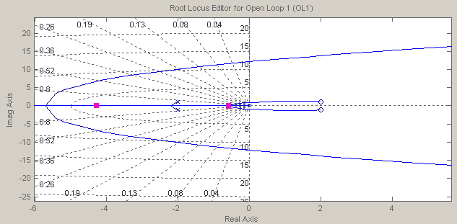

**b.** It can readily found that for closed loop stability 0<K<0.0059

**c.** The fastest response will be obtained when the closest poles to the jω axis are both real and identical. This will occur when K=0.00136

**d.** When K=0.00136 the dominant poles are situated at -0.57. The settling time

**e.** The actual settling time is 9.7 sec as shown in the figure below.

