**Chapter 10 – Solutions to Instructor Reserve Problems**

**I-1 Instructor**

**a.**



**b.**



**c.**



**I-2 Instructor**

**Program:**

numg=[1 5];

deng=conv([1 6 100],[1 4 25]);

G=tf(numg,deng);

'G(s)'

Gzpk=zpk(G)

nyquist(G)

axis([-3e-3,4e-3,-5e-3,5e-3])

w=0:0.1:100;

[re,im]=nyquist(G,w);

for i=1:1:length(w)

M(i)=abs(re(i)+j*im(i));

A(i)=atan2(im(i),re(i))*(180/pi);

if 180-abs(A(i))<=1;

re(i);

im(i);

K=1/abs(re(i));

fprintf('\nw = %g',w(i))

fprintf(', Re = %g',re(i))

fprintf(', Im = %g',im(i))

fprintf(', M = %g',M(i))

fprintf(', Angle = %g',A(i))

fprintf(', K = %g',K)

Gm=20*log10(1/M(i));

fprintf(', Gm = %g',Gm)

break

end

end

**Computer response:**

ans =

G(s)

Zero/pole/gain:

(s+5)

----------------------------------

(s^2 + 4s + 25) (s^2 + 6s + 100)

w = 10.1, Re = -0.00213722, Im = 2.07242e-005, M = 0.00213732, Angle = 179.444, K = 467.898, Gm = 53.4026

ans =

G(s)

Zero/pole/gain:

(s+5)

----------------------------------

(s^2 + 4s + 25) (s^2 + 6s + 100)

w = 10.1, Re = -0.00213722, Im = 2.07242e-005, M = 0.00213732, Angle = 179.444, K = 467.898, Gm = 53.4026

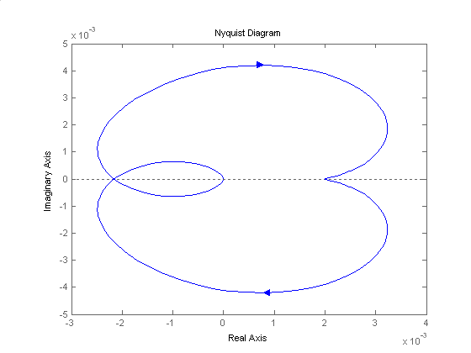

**I-3 Instructor**

**Program:**

numg=8000;

deng=poly([-6 -20 -35]);

G=tf(numg,deng)

ltiview

**Computer response:**

Transfer function:

8000

----------------------------

s^3 + 61 s^2 + 1030 s + 4200

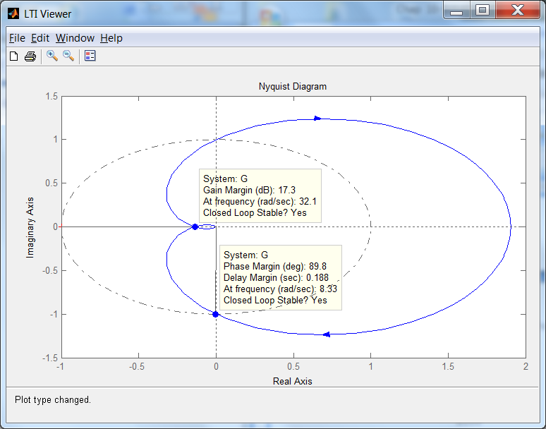

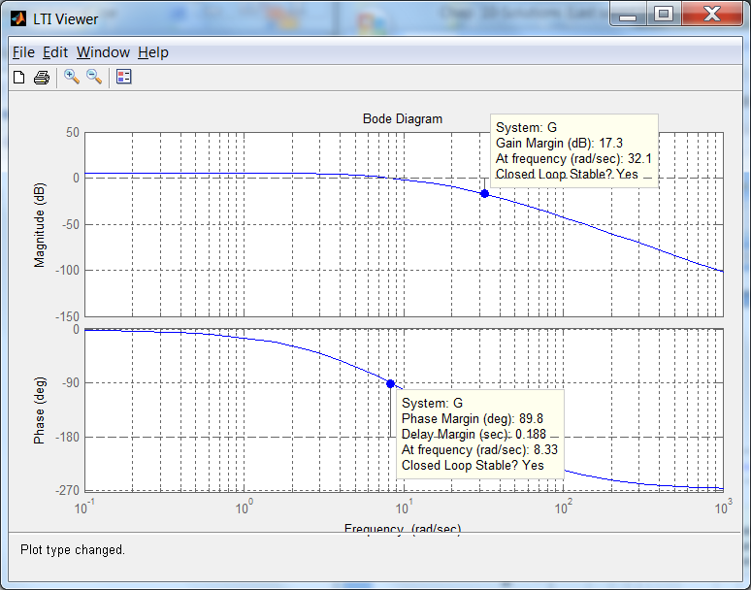

**I-4 Instructor**

**Program:**

%Enter G(s)************************************

numg=5*[1 6];

deng=[1 4 15 0];

'Open-Loop System'

'G(s)'

G=tf(numg,deng)

clf

w=.10:1:10;

nichols(G,w)

ngrid

title('Nichols Plot')

[M,P]=nichols(G,w);

for i=1:1:length(M);

if M(i)<=0.45;

BW=w(i);

break

end

end

pause

MpdB=input('Enter Mp in dB from Nichols Plot ');

Mp=10^(MpdB/20);

z2=roots([4,-4,(1/Mp^2)]);%Since Mp=1/sqrt(4z^2(1-z^2))

z1=sqrt(z2);

z=min(z1);

Pos=exp(-z*pi/(sqrt(1-z^2)));

Ts=(4/(BW*z))*sqrt((1-z^2)+sqrt(4*z^4-4*z^2+2));

Tp=(pi/(BW*sqrt(1-z^2)))*sqrt((1-z^2)+sqrt(4*z^4-4*z^2+2));

'Closed-Loop System'

'T(s)'

T=feedback(G,1)

bode(T)

title('Closed-Loop Frequency Response Plots')

fprintf('\nDamping Ratio = %g',z)

fprintf(', Percent Overshoot = %g',Pos*100)

fprintf(', Bandwidth = %g',BW)

fprintf(', Mp (dB) = %g',MpdB)

fprintf(', Mp = %g',Mp)

fprintf(', Settling Time = %g',Ts)

fprintf(', Peak Time = %g',Tp)

pause

step(T)

title('Closed-Loop Step Response')

**Computer response:**

ans =

Open-Loop System

ans =

G(s)

Transfer function:

5 s + 30

------------------

s^3 + 4 s^2 + 15 s

Enter Mp in dB from Nichols Plot 0

ans =

Closed-Loop System

ans =

T(s)

Transfer function:

5 s + 30

-----------------------

s^3 + 4 s^2 + 20 s + 30

Damping Ratio = 0.707107, Percent Overshoot = 4.32139, Bandwidth = 5.1, Mp (dB) = 0, Mp = 1, Settling Time = 1.35847, Peak Time = 1.06694>>

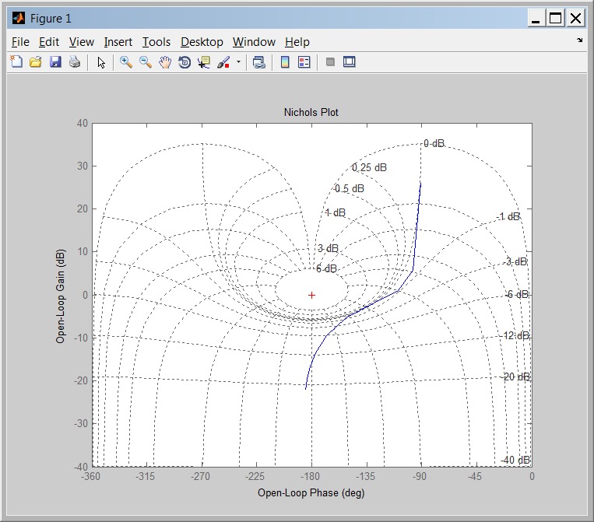

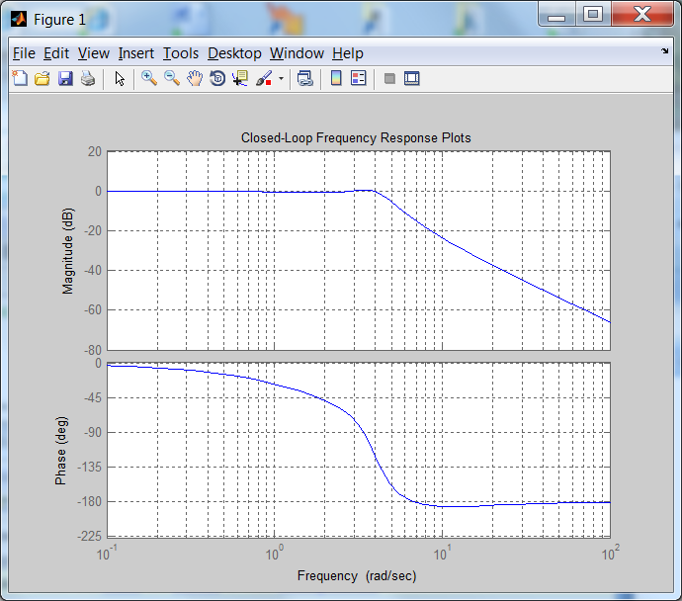

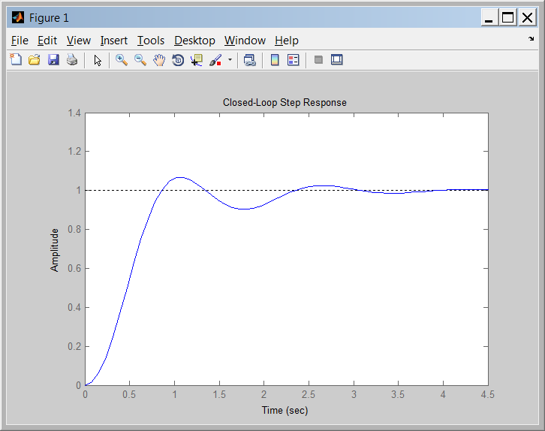

**I-5 Instructor**

The phase margin of the given system is 20o. Using Eq. (10.73),  = 0.176. Eq. (4.38) yields 57% overshoot. The system is Type 1 since the initial slope is - 20 dB/dec. Continuing the initial slope down to the 0 dB line yields Kv = 4. Thus, steady-state error for a unit step input is zero; steady state error for a unit ramp input is  = 0.25; steady-state error for a parabolic input is infinite.

**I-6 Instructor**

The Bode plots for K = 1 and 0.5 second delay is:

The phase is -180o at 2.12 rad/s. At this frequency, the gain is -34.76 dB. Thus the gain can be raised by 34.76 dB = 54.71. Hence for stability, 0<K<54.71.

**I-7 Instructor**

The Bode plot is:



The frequency response is , there is no imaginary part so the phase will be either -180o or 0o. As , so its phase is -180o. When , . Then for the phase is 0o. When , . And for . decreases in the intervals in which and , and will increase when .

**I-8 Instructor**

The exact Bode plot and the asymptotic approximations are shown on the following figure. The magnitude asymptotes are obtained by noting that when , . So when , and the slope of the line is -6db/oct. This means that . So a line is drawn between these two points until is reached. For higher frequencies the slope is -12db/oct, so the line is continued.

To plot the phase asymptote at very low frequencies the phase is -180° due to the integrator until 2.89/10=0.289rad/sec. At very high frequencies from 2.89*10=28.9 rad/sec and up the phase will be -270° due to the plant’s pole contribution. A line is drawn between 0.289 and 28.9 rad/sec with -135° at 2.89 rad/sec.



**I-9 Instructor**

1. The Nichols Chart is shown below.
2. It can be seen there that . From figure 10.40 the %OS≈35%. From the Nichols chart, the phase margin is , and from figure 10.48 in the text this corresponds to a damping ratio. It follows from figure 10.41a that since the open loop bandwidth is , the settling time is . The system is type 1 so .



**c.**

>> syms s

>> s=tf('s');

>> P=0.63/(1+0.36*s/305.4+s^2/305.4^2)/(1+0.04*s/248.2+s^2/248.2^2);

>> G=0.5*(s+1.63)/s/(s+0.27);

>> L=G*P;

>> T=L/(1+L)

>> step(T)

It can be seen in the following figure that we slightly overestimated the %OS, but the settling time is close to the predicted.



106.44o = 73.56o . Using Eq. (10.73),  = 0.9. Using Eq. (4.38), %OS = 0.15%.

**I-10 Instructor**

1. The Nyquist plot will approximately loop as follows (for positive ω(:

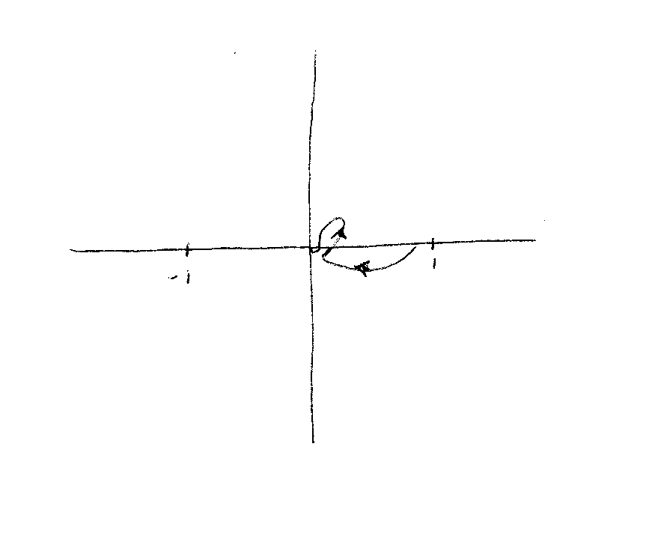

1. For K=1, it can be seen that there are no encirclements of the -1 point.
2. The system will be stable for 0<K<∞, because the phase never exceeds -90 degrees, so there can be no encirclements of the -1 point.

**I-11 Instructor**

**a.** The Bode plot is



**b.** From the Bode plot it can be seen that the phase is -180° at 56.9 rad/sec. At this point the magnitude is -49.9 dB. So the gain margin is 49.9 dB. The phase margin is ∞ because the open loop magnitude is always < 0 dB.

**c.** The Nyquist diagram is:



1. The system is closed loop stable for .