**Chapter 11 – Solutions to Instructor Reserve Problems**

**I-1 Instructor**

**a**. A 20% overshoot corresponds to a damping factor of  and from equation 10.73 to a . The bode plot of  with  is



We search on the Bode diagram for the frequency at which the phase is . This occurs at a frequency of 1.37 rad/sec. At this frequency  dB. Thus the magnitude characteristic must be raised by this quantity;  .

**b**.

>> s=tf('s');

>> G=2.267*(s+10)*(s+15)/s/(s+2)/(s+5)/(s+20);

>> T=feedback(G,1);

>> step(T)



**I-2 Instructor**

**a.** For Kv = 1000, K = 1473. Plotting the Bode for this value of K:

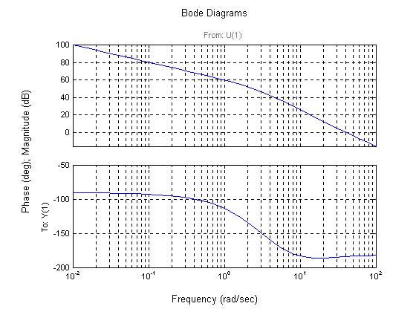

Using Eqs. (4.39) and (10.73) a percent overshoot = 15 is equivalent to a  = 0.517 and M = 53.17. Using an extra 10o, the phase margin is 63.17o. The phase-margin frequency = 1.21 rad/s. At this frequency, the magnitude = 57.55 dB = 754.2. Hence the lag compensator K = 1/754.2 = 0.001326. Following Steps 3 and 4 of the lag compensator design procedure in Section 11.3,

Glag(s) = 0.001326

**b.**

**Program**:

%Input system

numg=1473*poly([-10 -11]);

deng=poly([0 -3 -6 -9]);

G=tf(numg,deng);

numc=0.001326*[1 0.121];

denc=[1 0.0001604];

Gc=tf(numc,denc);

Ge=G*Gc;

T=feedback(Ge,1);

step(T)

**Computer response:**

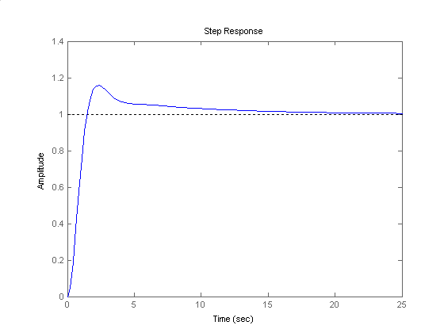

**I-3 Instructor**

For , *K* = 2400. Plotting the Bode plot for this gain,



We will design the system for a phase margin 100 larger than the specification. Thus *m* = 550. The phase margin frequency is where the phase angle is –1800 + 550 = -1250. From the Bode plot this frequency is  rad/s. At this frequency the magnitude is 23.37 dB. Start the magnitude of the lag compensator at –23.37 dB and draw it to 1 decade below , or 1.1 rad/s. Then begin a +20 dB/dec climb until 0 dB is reached. Read the break frequencies as 0.0746 rad/s and 1.1 rad/s from the Bode plot as shown below.



Ensuring unity dc gain, the transfer function of the lag is . The compensated forward-path transfer function is thus the product of the plant and the compensator, or



**I-4 Instructor**

Bode plots for K = 1: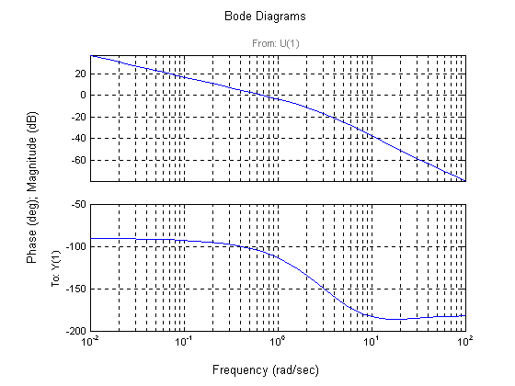Using Eqs. (4.39) and (10.73) a percent overshoot = 15 is equivalent to a  = 0.517 and M = 53.17o. The phase-margin frequency = 1.66 rad/s. The magnitude = -9.174 dB = 0.3478. Hence K = 1/ 0.3478 = 2.876.

**b.**

Bode plots for K = 2.876.

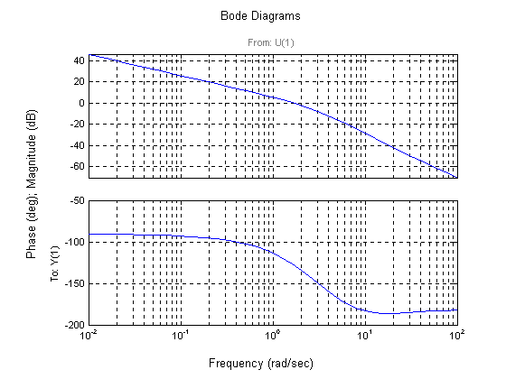

Adding 10o to the phase margin yields 63.17. Thus, the required phase is –1800 + 63.170 = -116.830, which occurs at a frequency of 1.21 rad/s. The magnitude = 3.366 dB = 1.473. Hence, the lag compensator K = 1/ 1.473 = =0.6787. Selecting the break a decade below the phase-margin frequency,

Gc(s) = 0.6787

**c.**

**Program:**

%Input system

numg=2.876*poly([-10 -11]);

deng=poly([0 -3 -6 -9]);

G=tf(numg,deng);

numc=0.6787*[1 0.121];

denc=[1 0];

Gc=tf(numc,denc);

Ge=G*Gc;

T=feedback(Ge,1);

step(T)

**Computer response:**



**I-5 Instructor**

If G(s) = , Kv = 40. Also, for a 0.1 second peak time, and  = 0.456 (20% overshoot), Eq. (10.56) yields a required bandwidth of 46.59 rad/s. Using Eq. (10.73), the required phase margin is 48.15o. Let us assume that we raise the phase margin frequency to 39 rad/s. The phase angle of the uncompensated system at this frequency is -158.6o. To obtain the required phase margin, the compensator must contribute 26.75o more at 39 rad/s. Assume the following form for the compensator: Gc(s) = K'KD(s+). The angle contributed by the compensator is

c = tan-1  = 26.75o. Letting  = 39 rad/s, KD = 0.0129. Hence, the compensator is

Gc(s) = 0.0129 (s+77.37). The compensated forward path is



The closed-loop bandwidth is approximately 50 rad/s, which meets the requirements.

The lag compensated forward path is

G(s) = 7.759

**16. 11**

**a.** Bode plots and specifications for gain compensated system are the same as Problem 13. Required phase margin and required bandwidth is the same as Problem 13. Select a phase margin frequency 7 rad/s higher than the bandwidth = 9 + 7 = 16 rad/s. The phase angle at the new phase-margin frequency is -201.60. The phase contribution required from the compensator is –1800 + 201.60 + 58.590 = 80.20 at the phase-margin frequency. Using the geometry below:



tan (80.2) = . Therefore, zc = 2.76. Thus, Gc (s) = .

The PD compensated Bode plots:



Compensated phase margin is 62.942o.

**b.**

**Program:**

numg=1000;

deng=poly([0 -5 -20]);

G=tf(numg,deng);

numc=(1/2.76)*[1 2.76];

denc=1;

Gc=tf(numc,denc);

Ge=G*Gc;

T=feedback(Ge,1);

step(T)

title('PD Compensated')

**Computer response:**

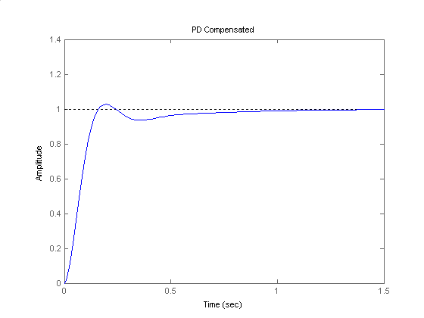

**I-6 Instructor**

**Program:**

%PD Compensator Design via Frequency Response

%Input system

%Uncompensated system

K=input('Type K to meet steady-state error ');

numg=K*[1 1];

deng=poly([0 -2 -6]);

G=tf(numg,deng);

T=feedback(G,1);

step(T)

title('Gain Compensated')

'Open-loop system'

'G(s)'

Gzpk=zpk(G)

%Input transient response specifications

Po=input('Type %OS ');

%Ts=input('Type settling time ');

Tp=input('Type peak time ');

%Determine required bandwidth

z=(-log(Po/100))/(sqrt(pi^2+log(Po/100)^2));

%wn=4/(z*Ts);

wn=pi/(Tp*sqrt(1-z^2));

wBW=wn*sqrt((1-2*z^2)+sqrt(4*z^4-4*z^2+2));

%Make a Bode plot and get Bode data

%Get Bode data

bode(G)

title('Gain Compensated')

w=0.01:0.1:100;

[M,P]=bode(G,w);

%Find current phase margin

[Gm,Pm,wcp,wcg]=margin(M,P,w);

%Calculate required phase margin

z=(-log(Po/100))/(sqrt(pi^2+log(Po/100)^2));

Pmreq=atan(2*z/(sqrt(-2*z^2+sqrt(1+4*z^4))))*(180/pi)+20;

%Determine a phase margin frequency

wpm=wBW+7;

%Find phase angle at new phase margin frequency and

%calculate phase required from the compensator

for i=1:1:length(w);

if w(i)-wpm>=0;

wpm=w(i);

Pwpm=P(i);

break

end

end

%Design PD compensator

Pc=Pmreq-(180+Pwpm);

zc=wpm/tan(Pc*pi/180);

Kc=1/zc;

numc=Kc*[1 zc];

denc=1;

'Gc(s)'

Gc=tf(numc,denc);

Gczpk=zpk(Gc)

%Display data

fprintf('\nK = %g',K)

fprintf(' Percent Overshoot = %g',Po)

fprintf(', Damping Ratio = %g',z)

%fprintf(', Settling Time = %g',Ts)

fprintf(', Peak Time = %g',Tp)

fprintf(', Current Phase Margin = %g',Pm)

fprintf(', Required Phase Margin = %g',Pmreq)

fprintf(', Required Bandwidth = %g',wBW)

fprintf(', New phase margin frequency = %g',wpm)

fprintf(', Phase angle at new phase margin frequency = %g',Pwpm)

fprintf(', Required Phase Contribution from Compensator = %g',Pc)

fprintf(' Compensator gain, Kc = %g',Kc)

fprintf(' Compensator zero,= %g',-zc)

pause

%Generate compensated Bode plots

%Make a Bode plot and get Bode data

%Get Bode data

'G(s)Gc(s)'

Ge=G*Gc;

Gezpk=zpk(Ge)

bode(Ge)

title('PD Compensated')

w=0.01:0.1:100;

[M,P]=bode(Ge,w);

%Find compensated phase margin

[Gm,Pm,wcp,wcg]=margin(M,P,w);

fprintf('\nCompensated Phase Margin,= %g',Pm)

pause

%Generate step response

T=feedback(Ge,1);

step(T)

title('PD Compensated')

**Computer response:**

Type K to meet steady-state error 360

ans =

Open-loop system

ans =

G(s)

Zero/pole/gain:

360 (s+1)

-------------

s (s+6) (s+2)

Type %OS 10

Type peak time 0.1

ans =

Gc(s)

Zero/pole/gain:

0.05544 (s+18.04)

K = 360 Percent Overshoot = 10, Damping Ratio = 0.591155, Peak Time = 0.1, Current Phase Margin = 21.0851, Required Phase Margin = 78.5931, Required Bandwidth = 45.1795, New phase margin frequency = 52.21, Phase angle at new phase margin frequency = -172.348, Required Phase Contribution from Compensator = 70.9409 Compensator gain, Kc = 0.0554397 Compensator zero,= -18.0376

ans =

G(s)Gc(s)

Zero/pole/gain:

19.9583 (s+18.04) (s+1)

-----------------------

s (s+6) (s+2)

Compensated Phase Margin,= 69.546 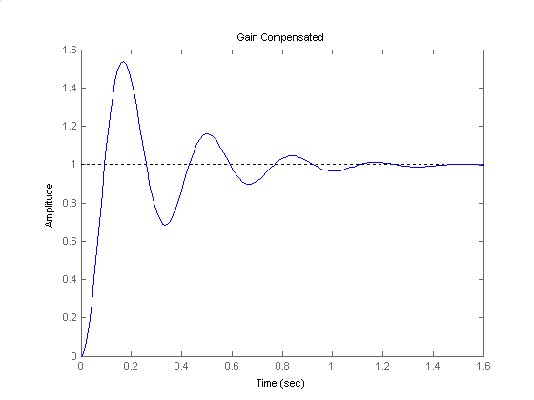

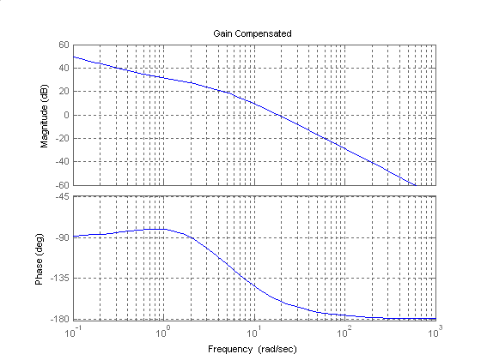

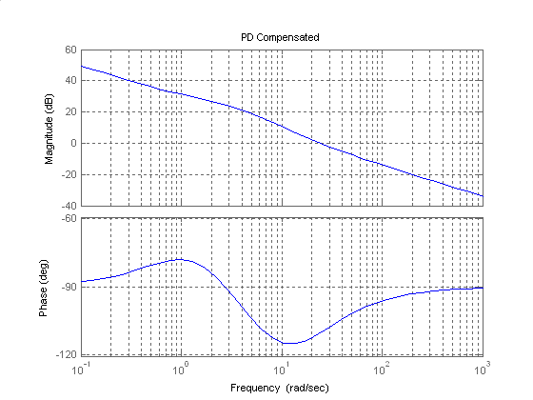

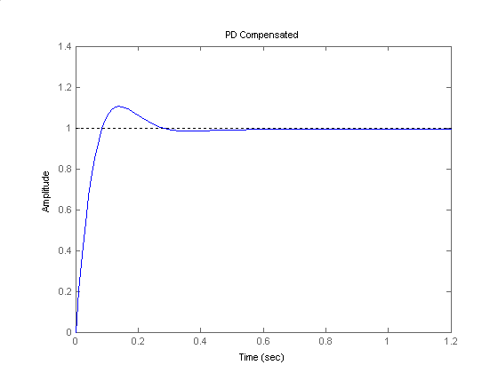

**SOLUTIONS TO DESIGN PROBLEMS**

**I-7 Instructor**

**a**. The bode plot for the open loop transmission is obtained and shown next:

>> syms s

>> s=tf('s');

>> M=0.005/(s+0.005);

>> P=140625/(s+2.67)/(s+10);

>> set(P,'inputdelay',0.1)

>> L=M*P

Transfer function:

703.1

exp(-0.1*s) * ----------------------------------

s^3 + 12.68 s^2 + 26.76 s + 0.1335

>> bode(L)



It can be seen that with , the system is closed loop unstable. The desired %OS=15% corresponds to a damping factor of . In turn this corresponds to a phase margin of . For this to occur the open loop transmission must have a phase of at the point where the open loop transmission has a magnitude of 0db. The open loop transmission attains this phase when rad/sec, and at that frequency the open loop transmission has a magnitude of 26.2db. So the open loop transmission must be decreased by this amount resulting in .

**b.**



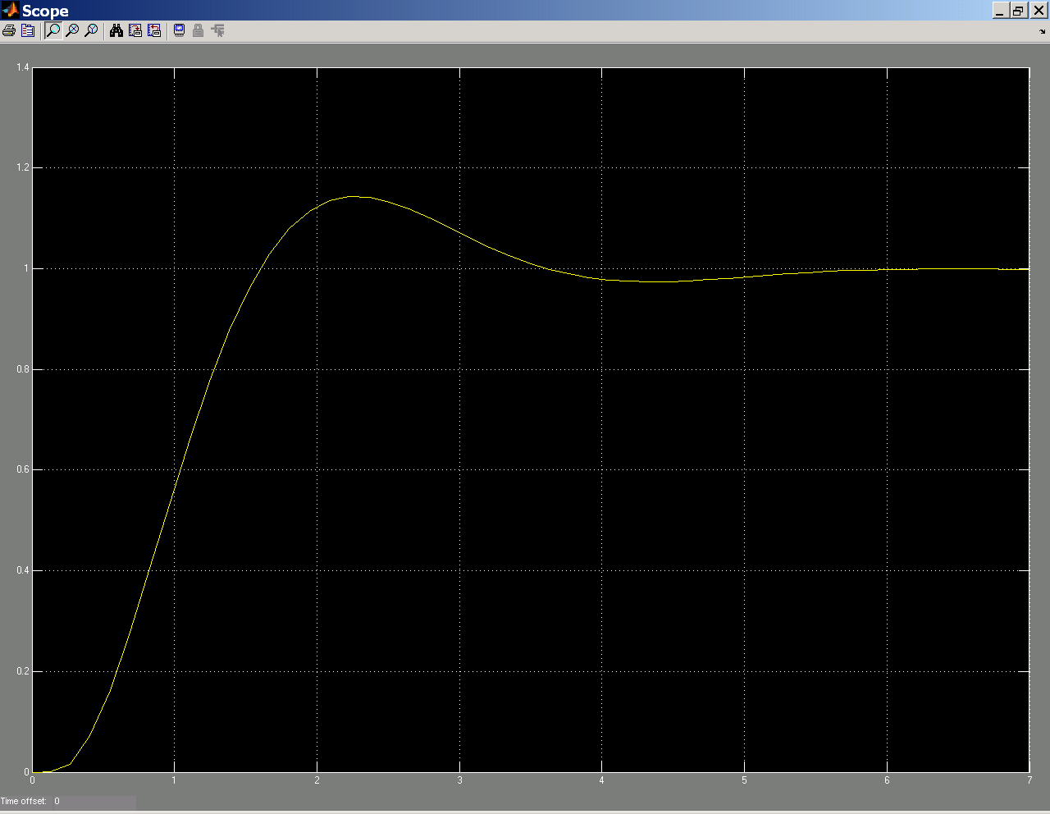

The figure shows a %OS slightly smaller than 15%.

**I-8 Instructor**

1. Using equation (4.39), x=0.7. Then from equation (10.52) Mp=1=0db. For zero steady state error we add an integrator, and then we raise the system’s gain.

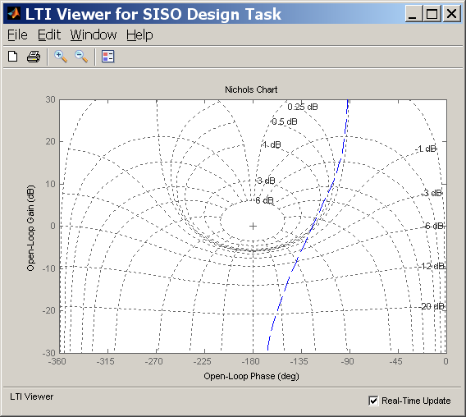

Then we design an appropriate lead compensator. So far, $G_{lead}=\frac{3.038(s+4.6)}{s(s+13.7)}$ as shown in the figure with a slight violation of the 1db requirement.

The resulting Kv=8.306 so a factor of 2.4 is needed to reach the required 20. The lag compensator is designed by arbitrarily adding a pole zero pair at 0.1 and 0.24 respectively, giving $G_{lag}=\frac{s+0.24}{s+0.1}$. The total compensation is $G_{c}=\frac{3.038\left(s+0.24\right)(s+4.6)}{s\left(s+0.1\right)(s+13.7)}$

1. For this design, we start by adding an integrator to the compensator. The resulting Kv=8.14 so a K=2.46 is needed to obtain Kv=20. Then enough lead is provided to satisfy the Mp<1db requirement. The resulting $G=\frac{35(s+2.18)}{s(s+31)}$. The resulting $ω_{B}=32$ rad/sec as shown in the next figure.

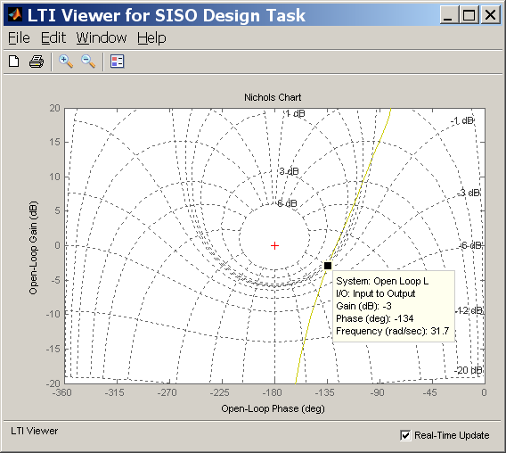

1. The following figure shows the step response of both designs. The faster design corresponds to part b with the larger bandwidth.



**I-9 Instructor**

Including the additional integrator and gain the open loop transfer function becomes



Let  to achieve the steady state requirement on ramp inputs. A 13% overshoot corresponds to a  damping factor. Using equation (4.42) . The required bandwidth is obtained using equation (10.54)  rad/sec. The phase margin is obtained using equation (10.73) with an additional  ; . A new phase margin frequency is chosen close to the bandwidth frequency  rad/sec. The Bode plot for and the integrator is



At the new phase margin frequency the phase angle is  . The contribution from the lead compensator must be . Using equation (11.11) .

Lag compensator design:  ;  ;  ; 

Lead compensator design: Using equations (11.6), (11.9) and (11.12)  ;  ;  ;  ; 

A unit step input simulation is performed:



The overshoot obtained is certainly unacceptable; it can be corrected by iterating on the pole of the lag compensator:  . In this case the overshot is corrected at detriment of the settling time:

