O N E

Introduction

Answers to Review Questions

1. Guided missiles, automatic gain control in radio receivers, satellite tracking antenna

2. Yes - power gain, remote control, parameter conversion; No - Expense, complexity

3. Motor, low pass filter, inertia supported between two bearings

4. Closed-loop systems compensate for disturbances by measuring the response, comparing it to the input response (the desired output), and then correcting the output response.

5. Under the condition that the feedback element is other than unity

6. Actuating signal

7. Multiple subsystems can time share the controller. Any adjustments to the controller can be implemented with simply software changes.

8. Stability, transient response, and steady-state error

9. Steady-state, transient

10. It follows a growing transient response until the steady-state response is no longer visible. The system will either destroy itself, reach an equilibrium state because of saturation in driving amplifiers, or hit limit stops.

11. Natural response

12. Determine the transient response performance of the system.

13. Determine system parameters to meet the transient response specifications for the system.

14. True

15. Transfer function, state-space, differential equations

16. Transfer function - the Laplace transform of the differential equation

State-space - representation of an nth order differential equation as n simultaneous first-order differential equations

Differential equation - Modeling a system with its differential equation

SOLUTIONS to Problems

**1.**

15 turns yield 50V, therefore $K=\frac{50}{15×2π}=0.53$

$$v_{o}(t)$$

$$θ(t)$$

0.53

**2.**



**3**



**4**



**5**



**6**

-

+

Desired Light Intensity

Brain

Internal eye muscles

Retina + Optical Nerves

Retina’s Light Intensity

Nervous system electrical impulses

**a.**

Nervous system electrical impulses

-

+

Desired Light Intensity

Brain

Internal eye muscles

Retina + Optical Nerves

Retina’s Light Intensity

External

Light

Beam

**b.**

If the narrow light beam is modulated sinusoidally the pupil’s diameter will also vary sinusoidally (with a delay see part c) in problem)

1. If the pupil responded with no time delay the pupil would contract only to the point where a small amount of light goes in. Then the pupil would stop contracting and would remain with a fixed diameter.

**7.**

-

+

Desired vertical angle

Amplifier

+ Motors

Gyroscopic sensors

Actual vertical angle

HT’s

Controller

**8.**



**9.**



**10.**



**11**

**a.**



**b.**



**12.**

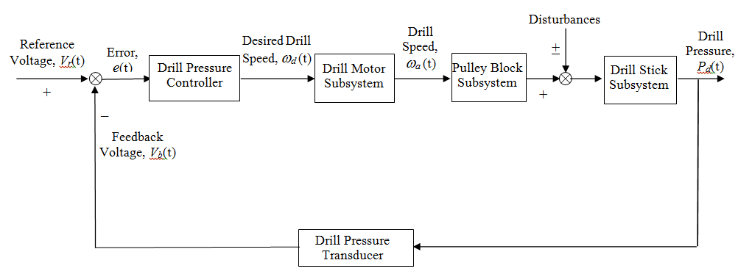

**13.**

**a.** L+ Ri = u(t)

**b.** Assume a steady-state solution iss = B. Substituting this into the differential equation yields RB = 1,   
from which B = . The characteristic equation is LM + R = 0, from which M = -. Thus, the total solution is i(t) = Ae-(R/L)t +. Solving for the arbitrary constants, i(0) = A +  = 0. Thus, A = - . The final solution is i(t) =  -- e-(R/L)t = .

**c.**



**14.**

**a.** Writing the loop equation, 

**b.** Differentiating and substituting values, **

Writing the characteristic equation and factoring,



The general form of the solution and its derivative is





Using *i*(0) = 0; 

*i*(0) = A = 0 and 

The solution is: 

**c.**



**15.**

**a.** The solution is given as $x\left(t\right)=x_{h}\left(t\right)+x_{p}(t)$. To find $x_{h}\left(t\right)$ write the characteristic equation from the homogeneous equation to get $λ+5=0$, from which $x_{h}\left(t\right)=Ae^{λt}=Ae^{-5t}$.

For the particular solution, we guess an answer $x_{p}\left(t\right)=B\cos{3t}+C\sin{3t}$. Substituting into the original differential equation we get $\left(3C+5B-2\right)\cos{3t+\left(-3B+5C\right)\sin{3t=0}}$. Follows that $3C+5B=2$ and $-3B+5C=0$. Solving simultaneously, one gets $B=\frac{5}{17}$, $C=\frac{3}{17}$. So $x\left(t\right)=Ae^{-5t}+\frac{5}{17}\cos{3t}+\frac{3}{17}\sin{3t}$. To find $A$, use $x\left(0\right)=0=A+\frac{5}{17}$ in the latter. Finally, $x\left(t\right)=-\frac{5}{17}e^{-5t}+\frac{5}{17}\cos{3t}+\frac{3}{17}\sin{3t}$.

**b.** Again $x\left(t\right)=x_{h}\left(t\right)+x_{p}(t)$. To find $x_{h}\left(t\right)$, the characteristic equation is $λ^{2}+4 λ+2=0$ with two solutions: $λ_{1}=-0.5858$, $λ_{2}=-3.4142$. Thus $x_{h}\left(t\right)=Ae^{-0.5858t}+Be^{-3.4142t}$. To find $x_{p}(t)$ we postulate $x_{p}\left(t\right)=C\cos{t}+D\sin{t}$. Follows that $x_{p}^{'}\left(t\right)=D\cos{t}-C\sin{t}$ and $x_{p}^{''}\left(t\right)=-C\cos{t}-D\sin{t}$. Substituting into the original differential equation $\left(C+4D\right)\cos{t+\left(D-4C\right)\sin{t=2\sin{t}}}$, from which $C+4D=0$ and $-4C+D=2$ which are solved simultaneously to yield $C=-\frac{8}{17}$ and $D=\frac{2}{17}$. The complete solution is $x\left(t\right)=Ae^{-0.5858t}+Be^{-3.4142t}-\frac{8}{17}\cos{t}+\frac{2}{17}\sin{t}$. To find $A$ and $B$ we use initial conditions noting that $x\left(0\right)=A+B-\frac{8}{17}=0$, and since $x^{'}\left(t\right)=-0.5858Ae^{-0.5858t}-3.4142Be^{-3.4142t}+\frac{8}{17}\sin{t}+\frac{2}{17}\cos{t}$, $x^{'}\left(0\right)=-0.5858A-3.4142B+\frac{2}{17}=0$. Solving simultaneously for $A$ and $B$ gives $A=0.5265$, $B=-0.0559$. Substituting gives the final solution $x\left(t\right)=0.5265e^{-0.5858t}-0.0559e^{-3.4142t}-\frac{8}{17}\cos{t}+\frac{2}{17}\sin{t}$.

**c.** In this case the characteristic equation is $λ^{2}+6 λ+20=0$ with solutions $λ_{1,2}=-3±j3.3166$ so the homogeneous solution is $x_{h}\left(t\right)=Ae^{\left(-3+j3.3166\right)t}+Be^{\left(-3-j3.3166\right)t}$. The postulated particular solution is $x_{p}\left(t\right)=C.$ Substituting the particular solution into the original differential equation one gets $C=0.25$. So, we have $x\left(t\right)=0.25+Ae^{\left(-3+j3.3166\right)t}+Be^{\left(-3-j3.3166\right)t}$. To find $A$ and $B$ note that $x\left(0\right)=0.25+A+B=0$. Also, since $x^{'}\left(t\right)=(-3+j3.3166)Ae^{\left(-3+j3.3166\right)t}+(-3-j3.3166)Be^{\left(-3-j3.3166\right)t}$, and $x^{'}\left(0\right)=\left(-3+j3.3166\right)A+\left(-3-j3.3166\right)B=0$. Solving simultaneously for $A$ and $B$ gives $A=-0.125+j0.1131= B^{*}$. Therefore $x\left(t\right)=0.25+(-0.125+j0.1131)e^{\left(-3+j3.3166\right)t}+(-0.125-j0.1131)e^{\left(-3-j3.3166\right)t}$. This expression can be simplified into $x\left(t\right)=0.25-e^{-3t}\left[0.25\cos{3.3166t}+0.2262\sin{3.3166t}\right]$.

**16.**

**a.** Assume a particular solution of



Substitute into the differential equation and obtain



Equating like coefficients,





From which, C = - and D = - .

The characteristic polynomial is



Thus, the total solution is



Solving for the arbitrary constants, x(0) = A - = 2. Therefore, A = . Also, the derivative of the solution is



Solving for the arbitrary constants, = - A + B - 0.2 = -3. Therefore, B = . The final solution is

Equating like coefficients, C = 5, D = 1, and 2D + E = 0.

From which, C = 5, D = 1, and E = - 2.

The characteristic polynomial is



Thus, the total solution is



Solving for the arbitrary constants, x(0) = A + 5 - 2 = 2 Therefore, A = -1. Also, the derivative of the solution is



Solving for the arbitrary constants, = B - 8 = 1. Therefore, B = 9. The final solution is



**c.** Assume a particular solution of

xp = Ct2 + Dt + E

Substitute into the differential equation and obtain



Equating like coefficients, C = , D = 0, and 2C + 4E = 0.

From which, C = , D = 0, and E = - .

The characteristic polynomial is



Thus, the total solution is



Solving for the arbitrary constants, x(0) = A - = 1 Therefore, A = . Also, the derivative of the solution is



Solving for the arbitrary constants, = 2B = 2. Therefore, B = 1. The final solution is





**b.** Assume a particular solution of

xp = Ce-2t + Dt + E

Substitute into the differential equation and obtain



**17.**

-

+

+

Patient

Controller

-

Amount of HIV viruses

RTII

PI

Desired Amount of HIV viruses

**18.**

**a.**

Desired Speed

Speed Error

Actual Speed

Motive Force

ECU

Vehicle Dynamics

Electric

Motor

Aerodynamic Drag Force

Climbing &

Rolling Resistances

Aerodynamic Drag

Speed Sensor

+

+

_

_

_

Inverter

Control Command

Controlled Voltage

Inverter

**b.**

Desired Speed

Speed Error

Actual Speed

Motive Force

ECU

Accelerator Displacement

Vehicle Dynamics

Accelerator, Engine

& Motor

Aerodynamic Drag Force

Climbing &

Rolling Resistances

Aerodynamic Drag

Speed Sensor

+

+

_

_

_

**c.**

Desired Speed

Speed Error

Actual Speed

Total Motive Force

ECU

Vehicle Dynamics

Aerodynamic Drag Force

Climbing &

Rolling Resistances

Aerodynamic Drag

Speed Sensor

+

+

_

_

_

Power Option

Selected

Planetary Gear Control

+

+

Inverter Control Command

Inverter &

Electric

Motor

Motor

Motive Force

Accelerator Displacement

Accelerator & Engine

ICE

Motive Force

**19.**

