T W O

Modeling in the

Frequency Domain

SOLUTIONS TO CASE STUDIES CHALLENGES

**Antenna Control: Transfer Functions**

Finding each transfer function:

Pot: = ;

Pre-Amp: = K;

Power Amp: =

Motor: Jm = 0.05 + 5()2 = 0.25

Dm =0.01 + 3()2 = 0.13

=

=

Therefore: = =

And: = =

**Transfer Function of a Nonlinear Electrical Network**

Writing the differential equation, . Linearizing i2 about i0,



Substituting into the differential equation yields, + 2i02 + 4i0i - 5 = v(t). But, the

resistor voltage equals the battery voltage at equilibrium when the supply voltage is zero since

the voltage across the inductor is zero at dc. Hence, 2i02 = 5, or i0 = 1.58. Substituting into the linearized differential equation, + 6.32i = v(t). Converting to a transfer function, = . Using the linearized i about i0, and the fact that vr(t) is 5 volts at equilibrium, the linearized vr(t) is vr(t) = 2i2 = 2(i0+i)2 = 2(i02+2i0i) = 5+6.32i. For excursions away from equilibrium, vr(t) - 5 = 6.32i = vr(t). Therefore, multiplying the transfer function by 6.32, yields, = as the transfer function about v(t) = 0.

ANSWERS TO REVIEW QUESTIONS

**1.** What mathematical model permits the easy interconnection of physical systems?Transfer function

**2.** To what classification of systems can the transfer function be best applied?Linear time-invariant

4. What are the physical implications of an unstable system?Physical destruction or limited response

**3.** What transformation turns the solution of differential equations into algebraic manipulations?Laplace

**4.** Define the transfer function.G(s) = C(s)/R(s), where c(t) is the output and r(t) is the input.

**5.** What assumption is made concerning initial conditions when dealing with transfer functions?Initial conditions are zero

**6.** What is the name of the mechanical equations written in order to evaluate the transfer function?Equations of motion

**7.** If we understand the form that the mechanical equations take, what step do we avoid in the evaluation of the transfer function?Free body diagram

**8.** Why do transfer functions for mechanical networks look identical to transfer functions for electrical networks?There are direct analogies between the electrical variables and components and the mechanical variables and components.

**9.** What function do gears perform?Mechanical advantage for rotating systems

**10.** What are the component parts of the mechanical constants of a motor's transfer function?Armature inertia, armature damping, load inertia, load damping

**11.** Since the motor's transfer function relates armature displacement to armature voltage, how can the transfer function that relates load displacement and armature voltage be determined?Multiply the transfer function by the gear ratio relating armature position to load position.

**12.** Summarize the steps taken to linearize a nonlinear system.(1) Recognize the nonlinear component, (2) Write the nonlinear differential equation, (3) Select the equilibrium solution, (4) Linearize the nonlinear differential equation, (5) Take the Laplace transform of the linearized differential equation, (6) Find the transfer function.

SOLUTIONS TO PROBLEMS

**1. • Sp 2-13 (Solved)**

**1. Derive the Laplace transform for the following time functions: (a) u(t), (b) tu(t), (c)sin vt u(t) (d) cos vt u(t)**

**1.**

**a. **

**b. **

Using L'Hopital's Rule



**c. **

**d. **

**2.**

e**a.a.a.** Using the frequency shift theorem and the Laplace transform of sin t, F(s) = .

**b.** Using the frequency shift theorem and the Laplace transform of cos t, F(s) = .

**c.** Using the integration theorem, and successively integrating u(t) three times, = t; = ; = , the Laplace transform of t3u(t), F(s) = .

**3.**

**a.** Taking the sum of the voltages around the loop and assuming zero initial conditions yields:

**

**b.** Applying Laplace transform and solving for *I(s)/V(s)* gives:

**

Substituting the values of *R, L,* and *LC*, we have:

**

Solving for *I(s)* and noting that *V(s) = 1/s*, we get:

**

Observing that the denominator has complex roots, we re-write the above equation as:

**

Applying the frequency shift theorem to the Laplace transform of sin *t* *u(t)*, we find that the transform for  is **.

Comparing *F(s)* to *I(s)*, we conclude that in the latter: *a =* 1 and **  . Thus, the current, *i(t)*, may be given by:



**c.**



43. •Sp 2-2 (Solved)

**3. Repeat •FProblem 9 in Chapter 1 using Laplace transforms. Assume that the forcing functions are zero prior to t=o-.**

44**.**

a.

The Laplace transform of the differential equation, assuming zero initial conditions, is,

Solving for and expanding by partial fractions,

Multiplying by the lowest common denominator and equating the same powers of *s* on both sides,

$$A+B=0, 5B+C=2, 9A+5C=0$$

Combining equations,

$$A=-\frac{5}{17}, B=\frac{5}{17}, C=\frac{9}{17},$$

Thus,

$$X\left(s\right)=\frac{-\frac{5}{17}}{s+5}+\frac{\frac{5}{17}s}{s^{2}+3^{2}}+\frac{\frac{9}{17}.\frac{1}{3}.3}{s^{2}+9}$$

Taking the inverse Laplace transform,

$$x\left(t\right)=-\frac{5}{17}e^{-5t}+\frac{5}{17}\cos{3t}+\frac{3}{17}\sin{3t}$$

b.

The Laplace transform of the differential equation, assuming zero initial conditions, is,

$$\left(s^{2}+4s+2\right)X\left(s\right)=\frac{2}{s^{2}+1}$$

Solving for $X(s)$ and expanding by partial fractions using the two real roots of the quadratic,

$$X\left(s\right)=\frac{2}{\left(s^{2}+4s+2\right)(s^{2}+1)}=\frac{A}{s+3.414}+\frac{B}{s+0.586}+\frac{Cs+D}{s^{2}+1}$$

Multiplying by the lowest common denominator and equating the same powers of *s* on both sides,

$$A+B+C=0, 0.586A+3.414B+4C+D=0,$$

$A+B+2C+4D=0,$ 0.586A+3.414B+2D=2

Combining equations,

A=-0.56, B=0.527, C=-8/17, D=2/17

Therefore,

X $\left(s\right)=\frac{2}{\left(s^{2}+4s+2\right)(s^{2}+1)}=\frac{-0.56}{s+3.414}+\frac{0.527}{s+0.586}-\frac{\frac{8}{17}s}{s^{2}+1}+\frac{\frac{2}{17}}{s^{2}+1}$

Taking the inverse Laplace transform,

$$x\left(t\right)=-0.56e^{-3.414t}+0.527e^{-0.586t}-\frac{8}{17}\cos{t}+\frac{2}{17}\sin{t}$$

c.

The Laplace transform of the differential equation, assuming zero initial conditions, is

$$(\left(s^{2}+6s+20\right)X\left(s\right)=\frac{5}{s}$$

Solving for $X(s)$ and expanding by partial fractions,

Multiplying by the lowest common denominator and equating the same powers of *s* on both sides,

$$A+B=0, 6A+C=0, 20A=5$$

Combining equations,

$$A=\frac{1}{4}, B=-\frac{1}{4}, C=-\frac{3}{2}$$

Thus,

$$X\left(s\right)=\frac{\frac{1}{4}}{s}-\frac{\frac{1}{4}s+\frac{3}{2}}{s^{2}+6s+20}$$

The roots of the quadratic are complex and located at $-3±3.317$

Thus, use the following form for exponentially damped sinusoids.

$$X\left(s\right)=\frac{\frac{1}{4}}{s}-\frac{\frac{1}{4}(s+3)+\frac{3}{4\sqrt{11}}\sqrt{11}}{{(s+3)}^{2}+11}$$

Taking the inverse Laplace transform,

)

4. •Sp 2-15 (Not completely solved)

**4. Repeat •FProblem 10 in Chapter 1 using Laplace transforms. Assume that the forcing functions are zero prior to t=o-5.**

Obtaining the Laplace transform on both sides of the equation one gets

$$s^{2}X\left(s\right)-2s+2+2\left(sX\left(s\right)-2\right)+2X\left(s\right)=\frac{2}{s^{2}+4}$$

From which

$$\text{X(s)=2}\frac{s^{3}+s^{2}+4s+5}{(s^{2}+4)(s^{2}+2s+2)}=\frac{As+B}{(s^{2}+4)}+\frac{Cs+D}{(s^{2}+2s+2)}$$

with $A=-0.2$, $B=-0.2$, $C=2.2$, $D=2.6$. So, the latter expression can be written as

$$\text{X(s)=}\frac{-0.2s}{(s^{2}+4)}-0.1\frac{2}{\left(s^{2}+4\right)}+\frac{2.2\left(s+1\right)}{{\left(s+1\right)}^{2}+1}+\frac{0.4}{{\left(s+1\right)}^{2}+1}$$

Inverse Laplace transformation yields

$$\text{x(t)=-0.2 cos 2t -0.1 sin 2t + 2.2 }e^{-t}\cos{t+0.4 e^{-t}\sin{t}}$$

Laplace transformation on both sides gives

$$s^{2}X\left(s\right)-s-1+2\left(sX\left(s\right)-1\right)+X\left(s\right)=\frac{5}{s+2}+\frac{1}{s^{2}}$$

or

$$\text{X(s)=}\frac{s^{4}+5s^{3}+11s^{2}+s+2}{s^{2}{\left(s+1\right)}^{2}(s+2)}=\frac{A}{s^{2}}+\frac{B}{s}+\frac{C}{{(s+1)}^{2}}+\frac{D}{s+1}+\frac{E}{s+2}$$

It is found that $A=1$, $B=-2$, $C=8$, $D= -2$, $E=5$.

The inverse Laplace transform of

$$\text{X(s)=}\frac{1}{s^{2}}-\frac{2}{s}+\frac{8}{{\left(s+1\right)}^{2}}-\frac{2}{s+1}+\frac{5}{s+2}$$

gives

$$x\left(t\right)=t-2+8te^{-t}-2e^{-t}+5e^{-2t}$$

Laplace transforms on both sides of the differential equation gives

$$s^{2}X\left(s\right)-0-1+4X\left(s\right)=\frac{2}{s^{3}}$$

or

$$X\left(s\right)=\frac{s^{3}+2}{s^{3}(s^{2}+4)}=\frac{A}{s^{3}}+\frac{B}{s^{2}}+\frac{C}{s}+\frac{Ds+E}{s^{2}+4}$$

The constants are found to be $A=\frac{1}{2}$, $B=0$, $C=-\frac{1}{8}$, $D=\frac{1}{8}$, $E=1$. So,

$$X\left(s\right)=\frac{1}{4}\frac{2!}{s^{3}}-\frac{1}{8}\frac{1}{s}+\frac{1}{8}\frac{s}{s^{2}+4}+\frac{1}{2}\frac{2}{s^{2}+4}$$

Obtaining the inverse Laplace transform

$$x\left(t\right)=\frac{t^{2}}{4}-\frac{1}{8}+\frac{\cos{2t}}{8}+\frac{\sin{2t}}{2}$$

**6**

**Program:**

syms s

'a'

G=(s^2+3*s+10)*(s+5)/[(s+3)*(s+4)*(s^2+2*s+100)];

pretty(G)

g=ilaplace(G);

pretty(g)

'b'

G=(s^3+4*s^2+2*s+6)/[(s+8)*(s^2+8*s+3)*(s^2+5*s+7)];

pretty(G)

g=ilaplace(G);

pretty(g)

**Computer response:**

ans =

a

2

(s + 5) (s + 3 s + 10)

--------------------------------

2

(s + 3) (s + 4) (s + 2 s + 100)

/ 1/2 1/2 \

| 1/2 11 sin(3 11 t) |

5203 exp(-t) | cos(3 11 t) - -------------------- |

20 exp(-3 t) 7 exp(-4 t) \ 57233 /

------------ - ----------- + ------------------------------------------------------

103 54 5562

ans =

b

3 2

s + 4 s + 2 s + 6

-------------------------------------

2 2

(s + 8) (s + 8 s + 3) (s + 5 s + 7)

/ 1/2 1/2 \

| 1/2 4262 13 sinh(13 t) |

1199 exp(-4 t) | cosh(13 t) - ------------------------ |

\ 15587 /

----------------------------------------------------------- -

417

/ / 1/2 \ \

| 1/2 | 3 t | |

| / 1/2 \ 131 3 sin| ------ | |

/ 5 t \ | | 3 t | \ 2 / |

65 exp| - --- | | cos| ------ | + ---------------------- |

\ 2 / \ \ 2 / 15 / 266 exp(-8 t)

---------------------------------------------------------- - -------------

4309 93

**7.**

The Laplace transform of the differential equation, assuming zero initial conditions, is,

(s3+3s2+5s+1)Y(s) = (s3+4s2+6s+8)X(s).

Solving for the transfer function, = .

6. •Sp 2-4 (Chap 2)

8.

**6. For each transfer function below, write the corresponding differential equation.**

**(a) =**

**(b) =**

**a.** We cross-multiply and expand the original expression

$$\left(s^{2}+7s+80\right)X(s)=10F(s)$$

$$s^{2}X(s)+7sX(s)+80X(s)=10F(s)$$

Then obtain the inverse Laplace transform on both sides with zero initial conditions

$$\frac{d^{2}x(t)}{dt^{2}}+7\frac{dx(t)}{dt}+80x\left(t\right)=10f(t)$$

**b.** It is convenient to express the denominator as a polynomial before cross-multiplying

$$\frac{X(s)}{F(s)}=\frac{100}{(s+3)(s+17)}=\frac{100}{s^{2}+20s+51}$$

$$(s^{2}+20s+51)X(s)=100F(s)$$

$$s^{2}X(s)+20sX(s)+51X(s)=100F(s)$$

Inverse Laplace transform with zero initial conditions gives:

$$\frac{d^{2}x(t)}{dt^{2}}+20\frac{dx(t)}{dt}+51x\left(t\right)=100f(t)$$

**c.** Cross-multiplying

$$(s^{3}+10s^{2}-7s+30)X(s)=\left(s-8\right)F(s)$$

$$s^{3}X\left(s\right)+10s^{2}X\left(s\right)-7sX\left(s\right)+30X\left(s\right)=sF\left(s\right)-8F(s)$$

Inverse Laplace transforms with zero initial conditions gives

7. •307-Sp-65-1B.1(a) (Chap 2)

**7. Write the differential equation for the system shown in Figure P.2.1.**



Figure P.2.1

**9.**

The transfer function is = .

Cross multiplying, (s6+7s5+3s4+2s3+s2+5)C(s) = (s5+2s4+4s3+s2+4)R(s).

Taking the inverse Laplace transform assuming zero initial conditions,

+ 7+ 3+ 2+ + 5*c* = + 2+ 4+ + 4*r*.

8. •307-Sp-64-1.1(a) (Chap 2)

**8. Write the differential equation that is mathematically equivalent to the block diagram shown in Figure P.2.2. Assume that r(t) = t3 .**



Figure P.2.2

**10.**

The block diagram represents the transfer function

$$\frac{C(s)}{R(s)}=\frac{s^{4}+2s^{3}+3s^{2}+s+1}{s^{5}+5s^{4}+8s^{3}+2s^{2}+3s+4}$$

Cross-multiplying

$${(s}^{5}+5s^{4}+8s^{3}+2s^{2}+3s+4)C(s)={(s}^{4}+2s^{3}+3s^{2}+s+1)R(s)$$

$$s^{5}C(s)+5s^{4}C(s)+8s^{3}C(s)+2s^{2}C(s)+3sC(s)+4C(s)=s^{4}R(s)+2s^{3}R(s)+3s^{2}R(s)+sR(s)+R(s)$$

Now we obtain the inverse Laplace transform on both sides of the equation with zero initial conditions

$$\frac{d^{5}c(t)}{dt^{5}}+5\frac{d^{4}c(t)}{dt^{4}}+8\frac{d^{3}c(t)}{dt^{3}}+2\frac{d^{2}c(t)}{dt^{2}}+3\frac{dc\left(t\right)}{dt}+4c\left(t\right)=\frac{d^{4}r(t)}{dt^{4}}+2\frac{d^{3}r(t)}{dt^{3}}+3\frac{d^{2}r(t)}{dt^{2}}+\frac{dr\left(t\right)}{dt}+r(t)$$

Substituting the corresponding derivatives for the input signal:

9. A system is described by the following differential equation:

**+ 2+ 3x = 1**

**with the following initial conditions:**

**x(0) = 1; = -1**

**Show a block diagram of the system giving its transfer function and all pertinent inputs and outputs. (Hint: the initial conditions will show up as added inputs to an effective system with zero initial conditions)**

**11.**

Taking Laplace transform of the differential equation:



Collecting terms: 

Solving for *X(s)*, 

The block diagram is shown below, where *R(s) = 1/s*.

X(s)



+

R(s)

+

*s* +3

X(s)

R(s)

+

+

**12.**

**Program:**

'Factored'

Gzpk=zpk([-15 -26 -72],[0 -55 roots([1 5 30])' roots([1 27 52])'],5)

'Polynomial'

Gp=tf(Gzpk)

**Computer response:**

ans =

Factored

Zero/pole/gain:

5 (s+15) (s+26) (s+72)

--------------------------------------------

s (s+55) (s+24.91) (s+2.087) (s^2 + 5s + 30)

ans =

Polynomial

Transfer function:

5 s^3 + 565 s^2 + 16710 s + 140400

--------------------------------------------------------------------

s^6 + 87 s^5 + 1977 s^4 + 1.301e004 s^3 + 6.041e004 s^2 + 8.58e004 s

**13.**

**Program:**

numg=[-5 -70];

deng=[0 -45 -55 (roots([1 7 110]))' (roots([1 6 95]))'];

[numg,deng]=zp2tf(numg',deng',1e4);

Gtf=tf(numg,deng)

G=zpk(Gtf)

[r,p,k]=residue(numg,deng)

**Computer response:**

Transfer function:

10000 s^2 + 750000 s + 3.5e006

-------------------------------------------------------------------------------

s^7 + 113 s^6 + 4022 s^5 + 58200 s^4 + 754275 s^3 + 4.324e006 s^2 + 2.586e007 s

Zero/pole/gain:

10000 (s+70) (s+5)

------------------------------------------------

s (s+55) (s+45) (s^2 + 6s + 95) (s^2 + 7s + 110)

r =

-0.0018

0.0066

0.9513 + 0.0896i

0.9513 - 0.0896i

-1.0213 - 0.1349i

-1.0213 + 0.1349i

0.1353

p =

-55.0000

-45.0000

-3.5000 + 9.8869i

-3.5000 - 9.8869i

-3.0000 + 9.2736i

-3.0000 - 9.2736i

0

k =

[]

**14.**

**a.** The circuit elements are converted into their Laplace transform equivalents. The equivalent parallel of the rightmost inductor in parallel with the resistor is $Z=s||2= \frac{2s}{s+2}$. Applying the voltage divider rule one gets

$$\frac{V_{o}}{V_{i}}=\frac{\frac{2s}{s+2}}{2+\frac{2s}{s+2}}=\frac{s}{2(s+1)}$$

**b.** The circuit elements are converted into their Laplace transform equivalents. The rightmost resistor in parallel with the branch with an inductor and a capacitor in series is $Z=1||\left(2s+\frac{1}{s}\right)=\frac{2s+\frac{1}{s}}{1+2s+\frac{1}{s}}=\frac{2s^{2}+1}{2s^{2}+s+1}$. Applying the voltage divider rule gives the voltage at the node between the resistors and inductor, $V_{h}$

$$V_{h}=\frac{\frac{2s^{2}+1}{2s^{2}+s+1}}{1+\frac{2s^{2}+1}{2s^{2}+s+1}}V_{i}=\frac{2s^{2}+1}{4s^{2}+s+2}V_{i}$$

Applying the voltage divider rule for the inductor and capacitor

$$V_{o}=\frac{\frac{1}{s}}{2s+\frac{1}{s}}V_{h}=\frac{1}{2s^{2}+1}V_{h}$$

Substituting for $V_{h}$

$$V_{o}=\frac{1}{2s^{2}+1}×\frac{2s^{2}+1}{4s^{2}+s+2}V_{i}=\frac{1}{4s^{2}+s+2}V_{i}$$

**15.**

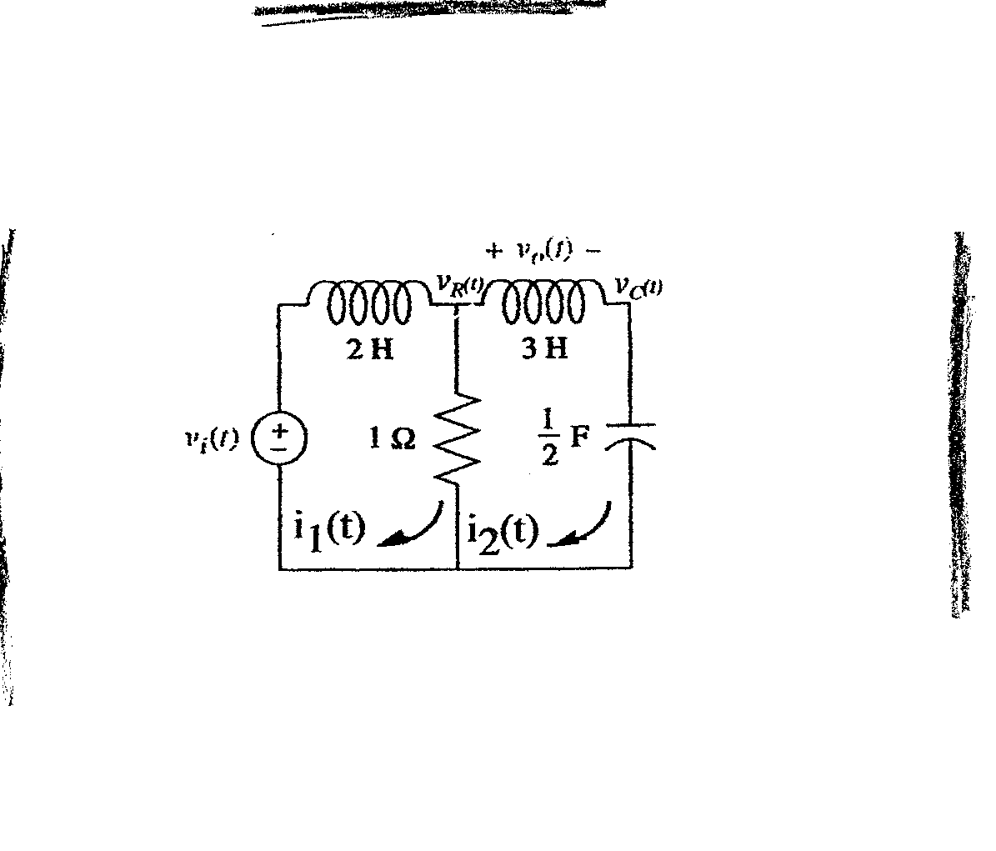**a.**

Writing mesh equations,

(2s + 1)I1(s) – I2(s) = Vi(s)

-I1(s) + (3s + 1 + 2/s)I2(s) = 0

Solving for I2(s),



Solving for I2(s)/Vi(s),



But Vo(s) = I2(s)3s. Therefore , G(s) = 3s2/(6s3 + 5s2 +4s + 2).

**b.** Transforming the network yields,

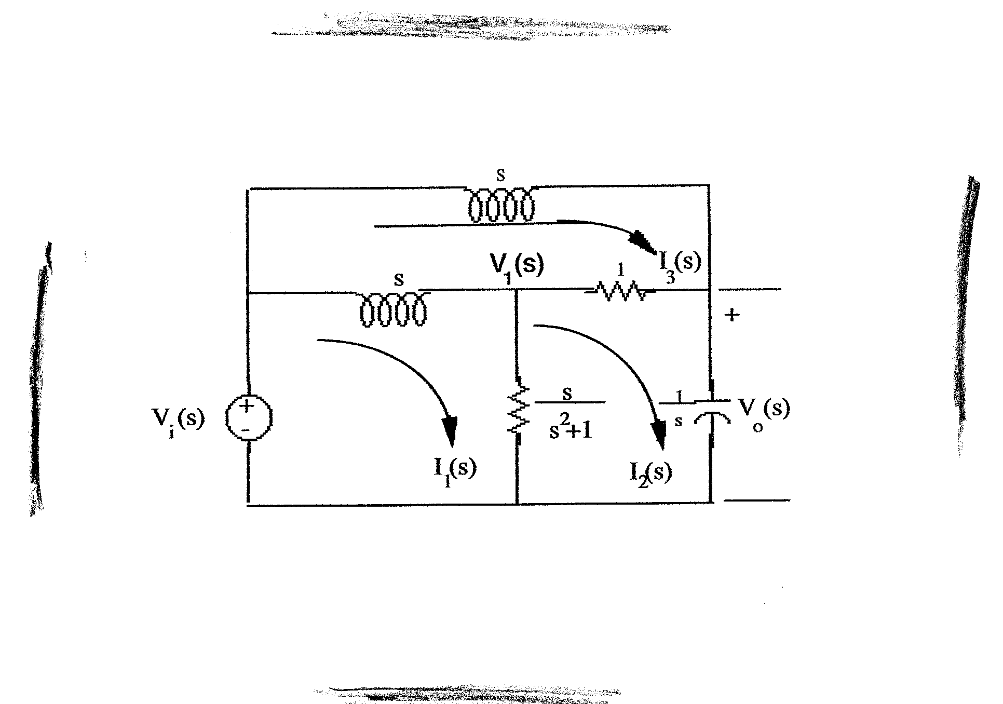

Writing the loop equations,







Solving for I2(s),



But, Vo(s) = = . Therefore,



**16.**

**a.** Writing the nodal equations yields,



Rewriting and simplifying,



Solving for *VR(s)* and *VC(s)*,



Solving for *Vo(s)/Vi(s)*



**b.** Writing the nodal equations yields,



Rewriting and simplifying,



Solving for Vo(s)

Vo(s) = .

Hence,



**17.**

**a.** The amplifier is in an inverting amplifier configuration. Therefore $G\left(s\right)=\frac{V_{o}}{V_{i}}\left(s\right)=-\frac{Z_{f}(s)}{Z_{i}(s)}$ where $Z_{f}\left(s\right)=200k+\frac{1}{2μs}$ and $Z_{i}\left(s\right)=500k+\frac{1}{2μs}$. The transfer function is:

$$G\left(s\right)=-\frac{200k+\frac{1}{2μs}}{500k+\frac{1}{2μs}}=-0.4\frac{s+2.5}{s+1}$$

**b.** The amplifier is in an inverting amplifier configuration. Therefore $G\left(s\right)=\frac{V_{o}}{V_{i}}\left(s\right)=-\frac{Z_{f}(s)}{Z_{i}(s)}$ where $Z_{f}\left(s\right)=100k+200k||\frac{1}{2μs}$ and $Z_{i}\left(s\right)=100k+\frac{1}{1μs}$. The transfer function is:

$$G\left(s\right)=-\frac{100k+200k||\frac{1}{2μs}}{100k+\frac{1}{1μs}}=-\frac{100k+\frac{2×{10}^{5}}{0.4s+1}}{100k+\frac{1}{1μs}}=-\frac{s(s+7.5)}{(s+2.5)(s+10)}$$

**18.**

**a.**



Therefore,



**b.**



Therefore,



**1916. Find the transfer function, G(s) = X1(s)/F(s), for the translational mechanical system shown in Figure P.2.7.**



Figure P.2.7

**.**

The system has two independent translational displacements: $x_{1}(t)$, shown in the figure, and a displacement $x_{2}(t)$ on the right-hand side of the spring where the force is applied. We can write the following two equations:

$$\begin{matrix}X_{1}: \left(2s^{2}+4s+5\right)X_{1}\left(s\right)-5X_{2}\left(s\right)=0 \\ X_{2}: -5X_{1}\left(s\right)-5X_{2}\left(s\right)=F(s)\end{matrix}$$

Using Cramer’s rule

$$X_{1}\left(s\right)=\frac{\left|\begin{matrix}0 & -5 \\ F(s) & 5\end{matrix}\right|}{\left|\begin{matrix}2s^{2}+4s+5 & -5 \\ -5 & 5\end{matrix}\right|}=\frac{F(s)}{2s^{2}+4s}$$

The transfer function is $G\left(s\right)=\frac{X_{1}}{F}\left(s\right)=\frac{1}{2s(s+2)}$.

**20.**

Writing the equations of motion,



Solving for X2(s),



From which,

.

**21.**

The system has two independent translational displacements, so we can write the following two equations:

$$\begin{matrix}X_{1}: & \left(s^{2}+2s+7\right)X_{1}\left(s\right)-(s+5)X_{2}\left(s\right)=0 \\ X_{2}: & - \left(s+5\right)X_{1}\left(s\right)+\left(2s^{2}+3s+5\right)X_{2}\left(s\right)=F(s)\end{matrix}$$

Solving we get:

$$X_{2}\left(s\right)=\frac{\left|\begin{matrix}s^{2}+2s+7 & 0 \\ -(s+5) & F(s)\end{matrix}\right|}{\left|\begin{matrix}s^{2}+2s+7 & -(s+5) \\ -(s+5) & 2s^{2}+3s+5\end{matrix}\right|}=\frac{(s^{2}+2s+7)F(s)}{\left(s^{2}+2s+7\right)\left(2s^{2}+3s+5\right)-{(s+5)}^{2}}=\frac{(s^{2}+2s+7)F(s)}{2s^{4}+7s^{3}+24s^{2}+21s+10}$$

The resulting transfer function can be written as $\frac{X_{2}(s)}{F(s)}=\frac{1}{2}\frac{s^{2}+2s+7}{s^{4}+3.5s^{3}+12s^{2}+10.5s+5}$.

.

**22.**

**a.**



Solving for X3(s),



or,



**b.**



Solving for X3(s),



or

=

)

**23.**

Writing the equations of motion,



**24.**

a.

*x* = 0 is at equilibrium.

$M\frac{d^{2}x}{{dt}^{2}}+Kx=0$

b.

$$M\left[s^{2}X\left(s\right)-sx\left(0\right)-x^{'}\left(0\right)\right]+KX\left(s\right)=0$$

$$M\left[s^{2}X\left(s\right)-sx_{0}-x_{1}\right]+KX\left(s\right)=0$$

$$(Ms^{2}+K)X\left(s\right)=M(sx_{0}+x_{1})$$

Solving for $X\left(s\right)$

$$X\left(s\right)=\frac{Mx_{0}\left(s+\frac{x_{1}}{x_{0}}\right)}{M\left(s^{2}+\frac{K}{M}\right)}=\frac{x_{0}\left(s+\frac{x_{1}}{x_{0}}\right)}{\left(s^{2}+\frac{K}{M}\right)}=\frac{x_{0}s}{s^{2}+\frac{K}{M}}+\frac{x_{1}}{s^{2}+\frac{K}{M}}=\frac{x_{0}s}{s^{2}+\frac{K}{M}}+\frac{\sqrt{\frac{M}{K}}x_{1}\sqrt{\frac{K}{M}}}{s^{2}+\frac{K}{M}}$$

c.

Taking the inverse Laplace transform

$x(t)$ = $x_{0}cos\sqrt{\frac{K}{M}}t+\sqrt{\frac{M}{K}}x_{1}sin\sqrt{\frac{K}{M}}t$

d.

$ω$ = $\sqrt{\frac{K}{M}}$ rad/sec,

Thus

$f=\frac{1}{2π}\sqrt{\frac{K}{M}}Hz$

**25.**

**a.**

Writing the equations of motion,



**b.**

Defining

$$θ_{1}\left(s\right)=\text{rotation of} J_{1}$$

$$θ_{2}\left(s\right)=\text{rotation }\text{between} K_{1 }\text{and} D_{1}$$

$$θ_{3}\left(s\right)=\text{rotation of} J_{2}$$

$$θ_{4}\left(s\right)=\text{rotation }\text{of right-hand side of} K_{2 }$$

$$θ_{5}\left(s\right)=\text{rotation of} J_{3}$$

the equations of motion are

$$\left(J_{1}s^{2}+K_{1}\right)θ_{1}\left(s\right)-K_{1}θ_{2}\left(s\right)=T\left(s\right)$$

$$-K_{1}θ_{1}\left(s\right)+\left(D_{1}s+K_{1}\right)θ_{2}\left(s\right)-D_{1}sθ_{3}\left(s\right)=0$$

$$-D_{1}sθ_{2}\left(s\right)+\left(J_{2}s^{2}+D_{1}s+K_{2}\right)θ_{3}\left(s\right)-K_{2}θ_{4}\left(s\right)=0$$

$$-K_{2}θ_{3}\left(s\right)+\left(D_{2}s+K_{2}+K_{3}\right)θ_{4}\left(s\right)-\left(D_{2}s+K_{3}\right)θ_{5}\left(s\right)=0$$

$$(J_{3}s^{2}+D_{2}s+K_{3)}θ_{5}\left(s\right)=0$$

**26.**

This system has two independent rotations. One, shown in the figure $θ_{2}$, and $θ_{1}$ associated with the inertia where the input torque is applied. The two impedance equations that describe the system are:

$$\begin{matrix}θ_{1}: & \left(2s^{2}+3s+1\right)θ_{1}\left(s\right)-(2s+1)θ_{2}\left(s\right)=T(s) \\ θ_{2}: & - \left(2s+1\right)θ_{1}\left(s\right)+\left(3s+1\right)θ_{2}\left(s\right)=0\end{matrix}$$

Solving for $θ_{2}$ we get:

$$θ_{2}\left(s\right)=\frac{\left|\begin{matrix}{2s}^{2}+3s+1 & T \\ -(2s+1) & 0\end{matrix}\right|}{\left|\begin{matrix}2s^{2}+3s+1 & -(2s+1) \\ -(2s+1) & 3s+1\end{matrix}\right|}=\frac{\left(2s+1\right)T(s)}{\left(2s^{2}+3s+1\right)\left(3s+1\right)-{(2s+1)}^{2}}=\frac{\left(2s+1\right)T(s)}{6s^{3}+7s^{2}+2s}$$

which can be re-expressed in transfer function form as $\frac{θ_{2}(s)}{T(s)}=\frac{s+0.5}{3s(s^{2}+1.667s|0.333)}$.

**27.**

Reflecting impedances to 3,

(Jeqs2+Deqs)3(s) = T(s) ()

Thus,

= 

whereJeq = J4+J5+(J2+J3) 2 + J12, and 

**28.**

Reflecting all impedances to 2(s),

{[J2+J1()2+J3 ()2]s2 + [f2+f1()2+f3()2]s + [K()2]}2(s) = T(s)

Substituting values,

{[1+2(3)2+16()2]s2 + [2+1(3)2+32()2]s + 64()2}2(s) = T(s)(3)

Thus,

=

29. •312-Sp-77-2.1**(Chap 2)**

**29.**

Reflecting impedances across gears from the right hand side to the left hand side one gets:

$$J_{eq}=2+100{\left(\frac{5}{25}\right)}^{2}+150{\left(\frac{5}{50}\right)}^{2}=7.5$$

$$D_{eq}=300{\left(\frac{5}{25}\right)}^{2}=12$$

$$K_{eq}=2+400{\left(\frac{5}{50}\right)}^{2}=6$$

So $\left(7.5s^{2}+12s+6\right)θ\left(s\right)=T\left(s\right)$. Since $\frac{θ}{θ_{2}}=\frac{N_{2}}{N_{1}}=10$, $\left(7.5s^{2}+12s+6\right) 10 θ_{2}\left(s\right)=T\left(s\right)$

$$\frac{θ_{2}(s)}{T(s)}=\frac{1}{75s^{2}+120s+60}=\frac{0.0133}{s^{2}+1.6s+0.8}$$

**30.**

Reflecting impedances and applied torque to respective sides of the spring yields the following

equivalent system:

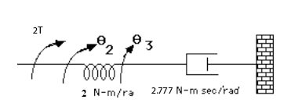

Writing the equations of motion,

2(s) -2 3(s) = 2T(s)

-22(s) + (2.7777s+2)3(s) = 0

Solving for 3(s),



Hence, . But, . Thus, 

**31.**

Reflecting the 0.02 Nm/rad damper towards the left we get



The corresponding impedance equations are:

|  |  |
| --- | --- |
| $θ_{1}$: | $$\left(s^{2}+2s\right)θ_{1}-2sθ_{2}=T_{1}$$ |
| $θ_{2}$: | $$-2sθ_{1}+\left(2.32s+2\right)θ_{2}=0$$ |

Solving:

$$θ_{2}=\frac{\left|\begin{matrix}s^{2}+2s & T_{1} \\ -2s & 0\end{matrix}\right|}{\left|\begin{matrix}s^{2}+2s & -2s \\ -2s & 2.32s+2\end{matrix}\right|}=\frac{2sT_{1}}{\left(s^{2}+2s\right)\left(2.32s+2\right)-4s^{2}}=\frac{2sT_{1}}{2.32s^{3}+2s^{2}+4.64s^{2}+4s-4s^{2}}=\frac{2T_{1}}{2.32s^{2}+2.64s+4}$$

So

$$\frac{θ_{2}}{T_{1}}=\frac{2}{2.32s^{2}+2.64s+4}$$

Using the gear ratios we get $\frac{T}{T_{1}}=\frac{5}{20}=\frac{1}{4}$ and $\frac{θ_{2}}{θ_{L}}=\frac{10}{40}=\frac{1}{4}$. It follows that $\frac{θ_{L}}{T_{1}}=\frac{\frac{θ_{L}}{4}}{4T}=\frac{1}{16}\frac{θ_{L}}{T}$. Finally

$$\frac{θ_{L}}{T}=\frac{32}{2.32s^{2}+2.64s+4}=\frac{13.8}{s^{2}+1.14s+1.72}$$

**32.**

Reflect impedances to the left of J5 to J5 and obtain the following equivalent circuit:



Writing the equations of motion,

[Jeqs2+(Deq+D)s+(K2+Keq)]5(s) -[Ds+K2]6(s) = 0

-[K2+Ds]5(s) + [J6s2+2Ds+K2]6(s) = T(s)

From the first equation, = . But, = . Therefore,

= ,

where Jeq = [J1()2 + (J2+J3)()2 + (J4+J5)], Keq = K1()2 , and

Deq = D[()2 + ()2 + 1].

**33.**

Draw a freebody diagram of the translational system and the rotating member connected to the translational system.



**2**

**2**

**3**

From the freebody diagram of the mass, F(s) = (2s2+2s+3)X(s). Summing torques on the rotating member,  
(Jeqs2 +Deqs)(s) + F(s)2 = Teq(s). Substituting F(s) above, (Jeqs2 +Deqs)(s) + (4s2+4s+6)X(s) = Teq(s). However, (s) = . Substituting and simplifying,

Teq = [(+4)s2 +(+4)s+6]X(s)

But, Jeq = 3+3(4)2 = 51, Deq = 1(2)2 +1 = 5, and Teq(s) = 4T(s). Therefore,

[ s2 +s+6]X(s) = 4T(s). Finally, = .

**34.**

Reflecting through gears the inertia and damping from the load side to motor shaft one gets,

$J_{m}=6+24{\left(\frac{50}{150}\right)}^{2}=8.667$ and $D_{m}=50+{36\left(\frac{50}{150}\right)}^{2}=54$

Note from the motor load curve that $\frac{K_{t}}{R_{a}}=\frac{T_{stall}}{e_{a}}=\frac{150}{60}=2.5$ and $K_{b}=\frac{e_{a}}{ω_{no-load}}=\frac{60}{100}=\frac{3}{5}$.

Substituting all of the above, one gets

$$\frac{θ_{m}}{E_{a}}=\frac{\frac{K_{t}}{R_{a}J_{m}}}{s\left(s+\frac{1}{J_{m}}\left(D_{m}+\frac{K_{t}K_{b}}{R_{a}}\right)\right)}=\frac{0.2885}{s(s+6.4036)}$$

Noting that $\frac{θ_{m}}{θ_{L}}=\frac{N_{2}}{N_{1}}=3$

$$\frac{θ_{L}}{E_{a}}=\frac{0.09615}{s(s+6.4036)}$$

**35.**

The parameters are:

; ;

; 

Thus,



Since: ; then:



**36.**

From Eqs. (2.45) and (2.46),

*RaIa(s)* + *Kbs(s)* = *Ea(s)* (1)

Also,

*Tm(s)* = *KtIa(s)* = (*Jms*2+*Dms)(s)*. Solving for *(s)* and substituting into Eq. (1), and simplifying yields

=  (2)

Using *Tm(s)* = *KtIa(s)* in Eq. (2),

= 

**37.**

For the rotating load, assuming all inertia and damping has been reflected to the load,

(JeqLs2+DeqLs)L(s) + F(s)r = Teq(s), where F(s) is the force from the translational system, r=2 is the radius of the rotational member, JeqL is the equivalent inertia at the load of the rotational load and the armature, and DeqL is the equivalent damping at the load of the rotational load and the armature. Since JeqL = 1(2)2 +1 = 5, and DeqL = 1(2)2 +1 = 5, the equation of motion becomes, (5s2+5s)L(s) + F(s)r = Teq(s). For the translational system, (s2+s)X(s) = F(s). Since X(s) = 2L(s), F(s) = (s2+s)2L(s). Substituting F(s) into the rotational equation, (9s2+9s) L(s) = Teq(s). Thus, the equivalent inertia at the load is 9, and the equivalent damping at the load is 9. Reflecting these back to the armature, yields an equivalent inertia of and an equivalent damping of . Finally, = 1; Kb = 1. Hence, = = . Since L(s) = m(s), = . But X(s) = rL(s) = 2L(s). therefore, = .

**38.**

The equations of motion in terms of velocity are:



For the series analogy, treating the equations of motion as mesh equations yields

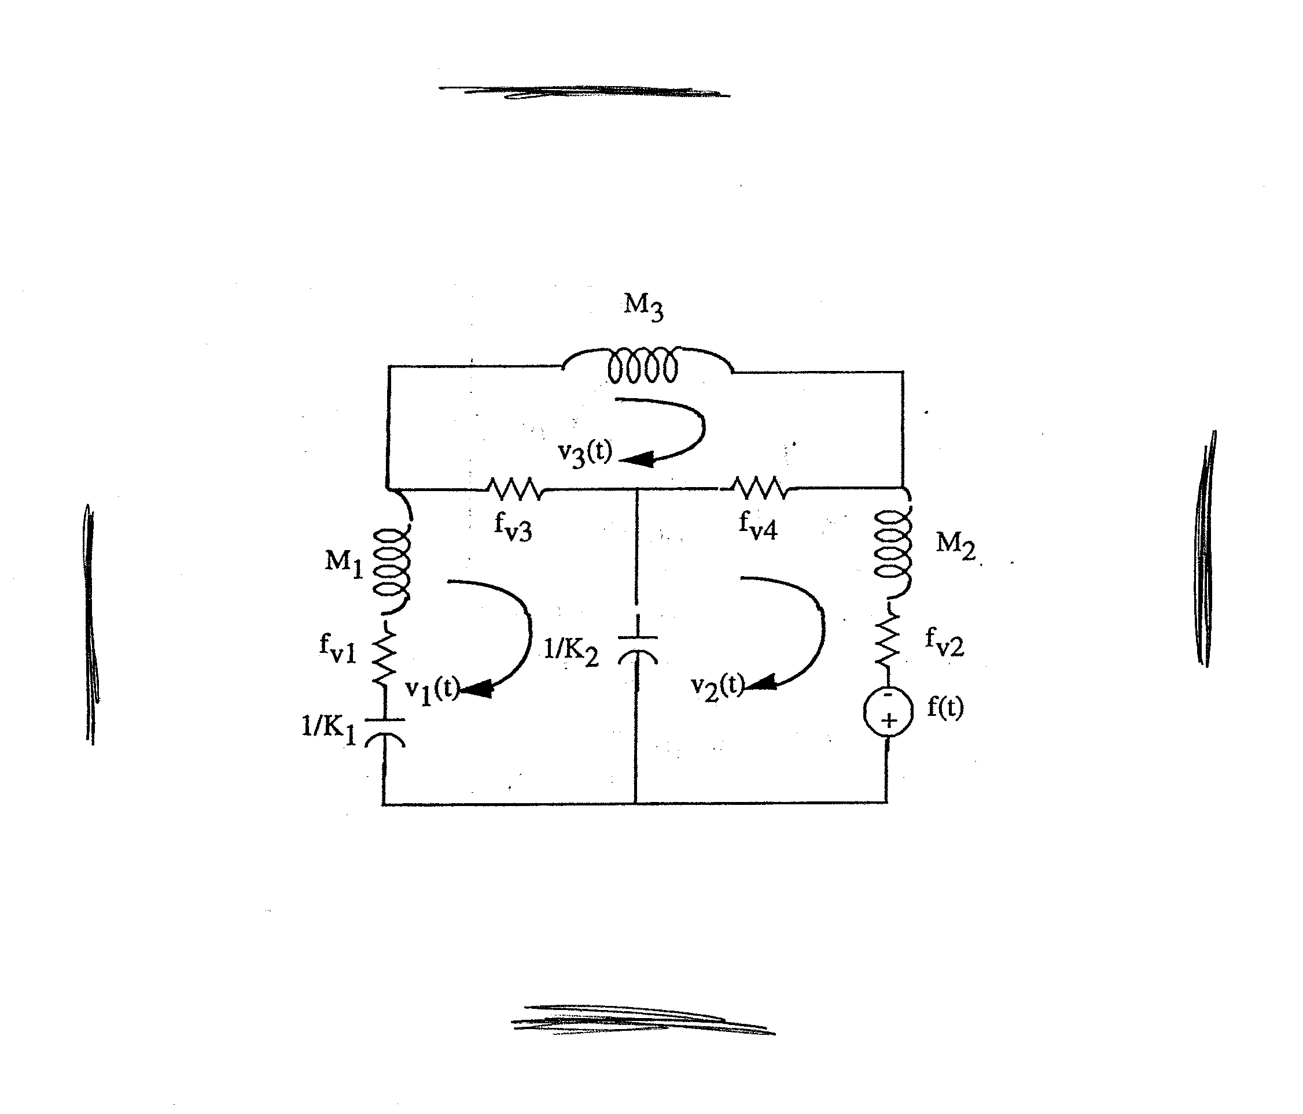

In the circuit, resistors are in ohms, capacitors are in farads, and inductors are in henries.

For the parallel analogy, treating the equations of motion as nodal equations yields

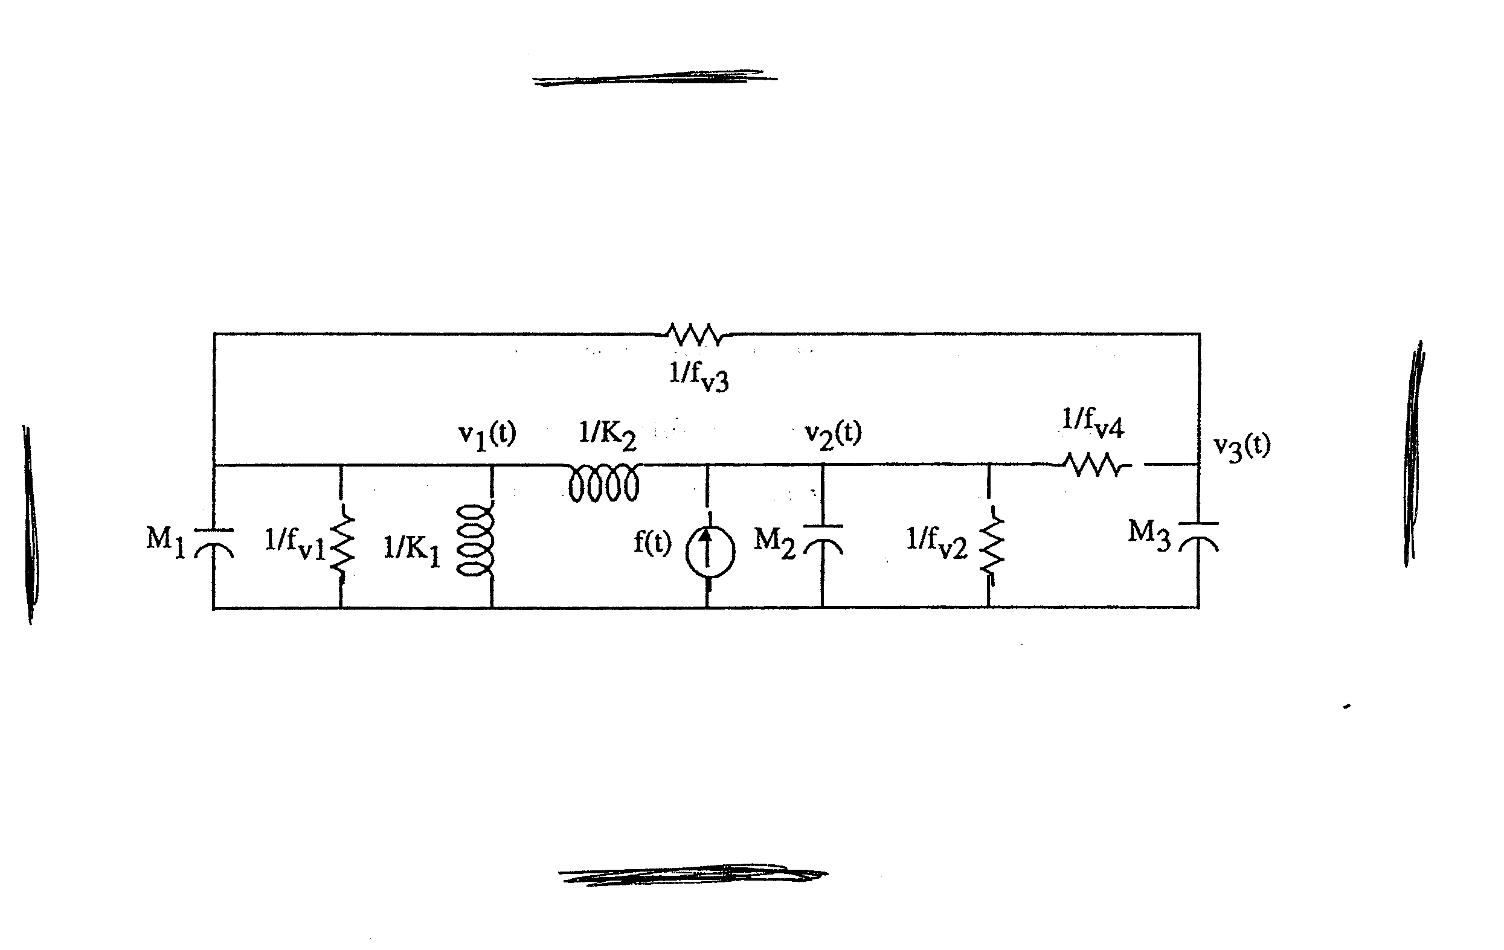

In the circuit, resistors are in ohms, capacitors are in farads, and inductors are in henries.

**39.**

Writing the equations of motion in terms of angular velocity, (s) yields



For the series analogy, treating the equations of motion as mesh equations yields

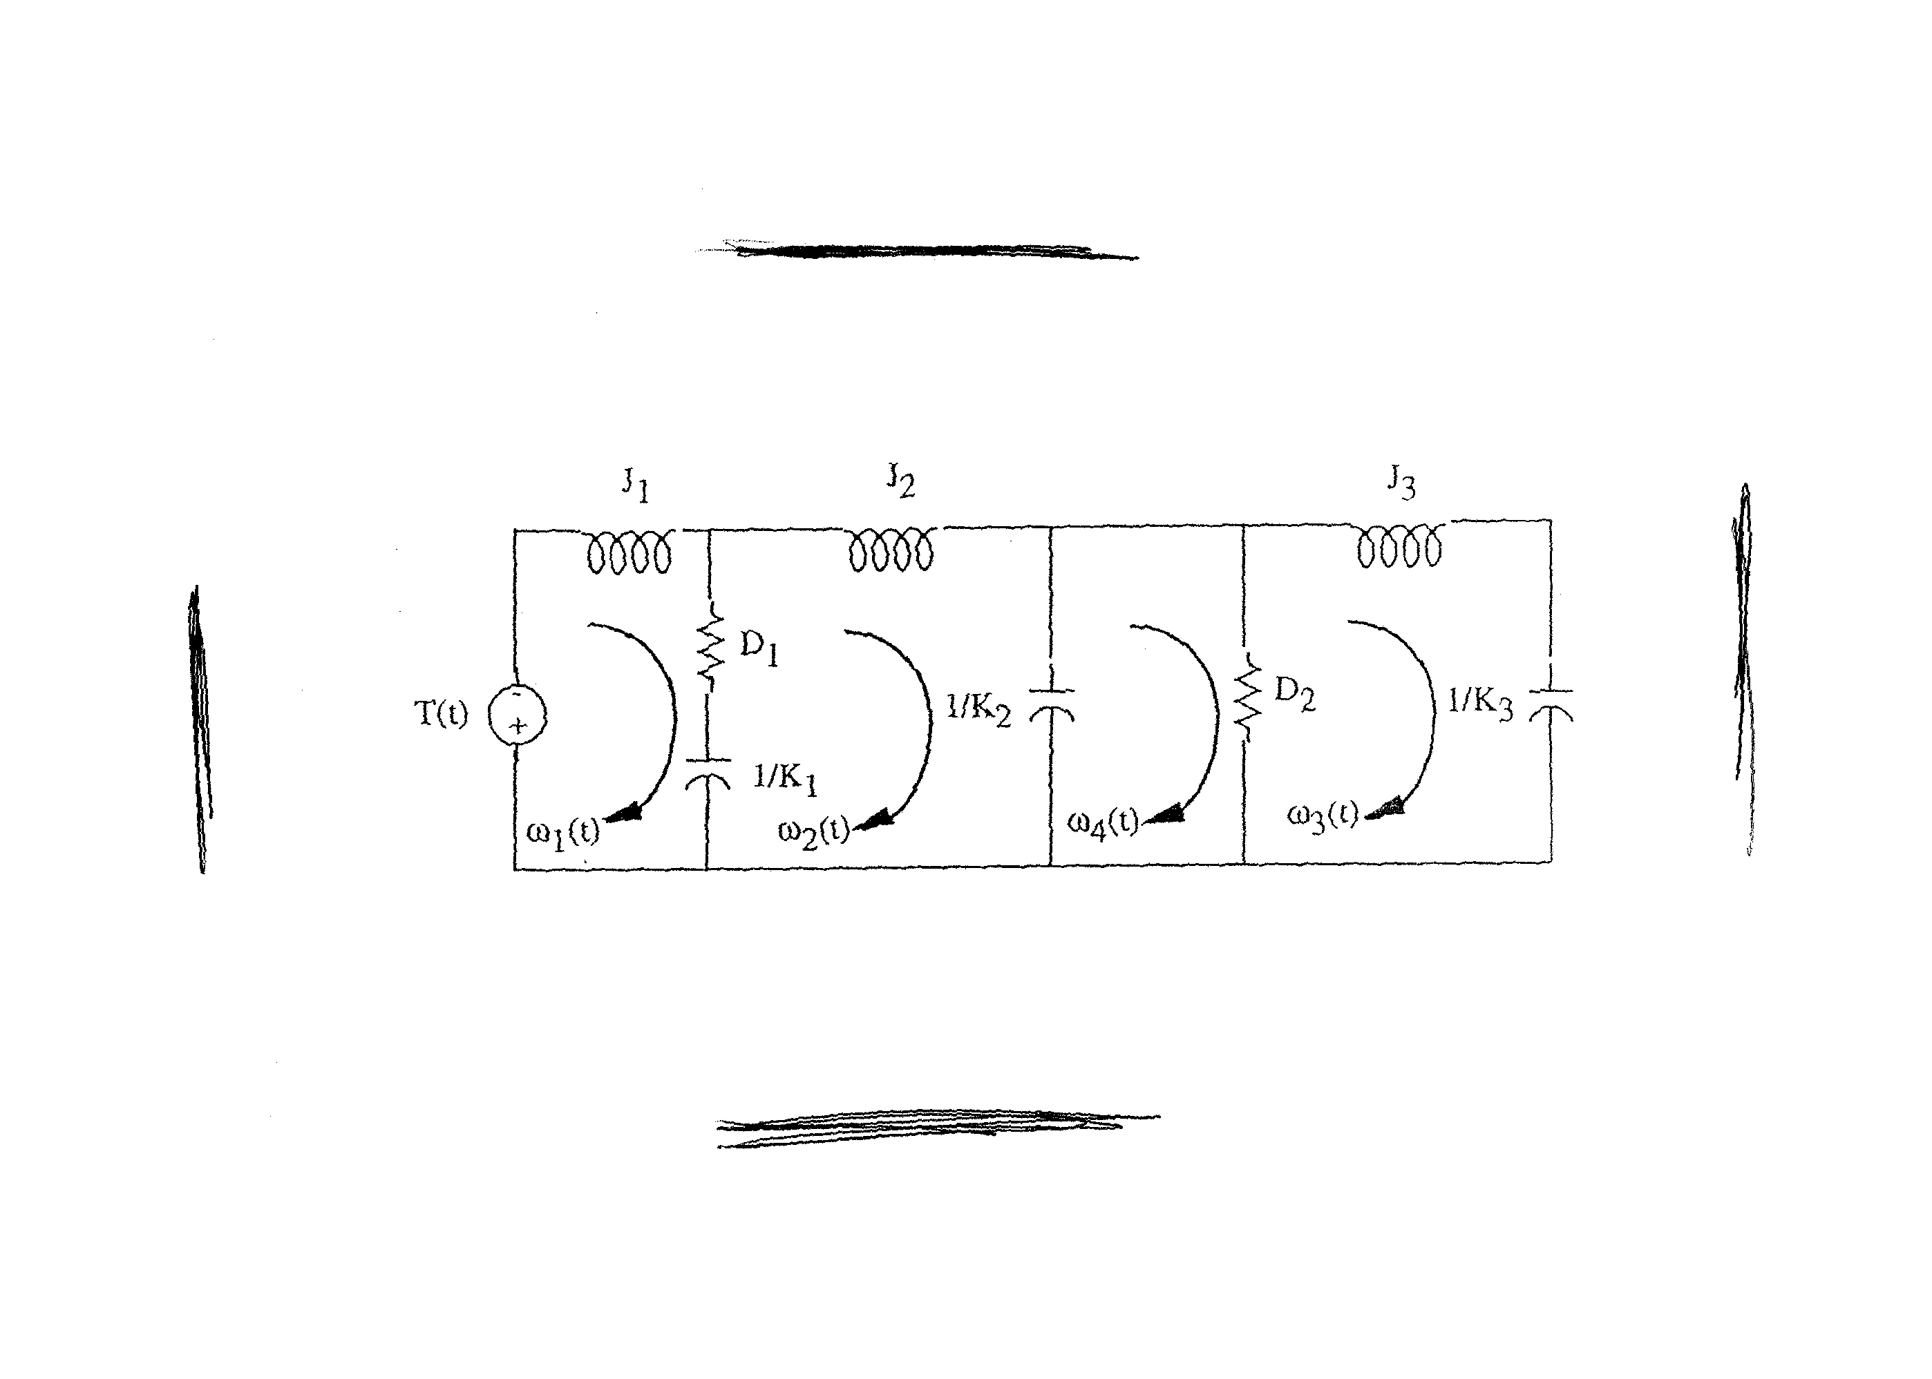

In the circuit, resistors are in ohms, capacitors are in farads, and inductors are in henries.

For the parallel analogy, treating the equations of motion as nodal equations yields

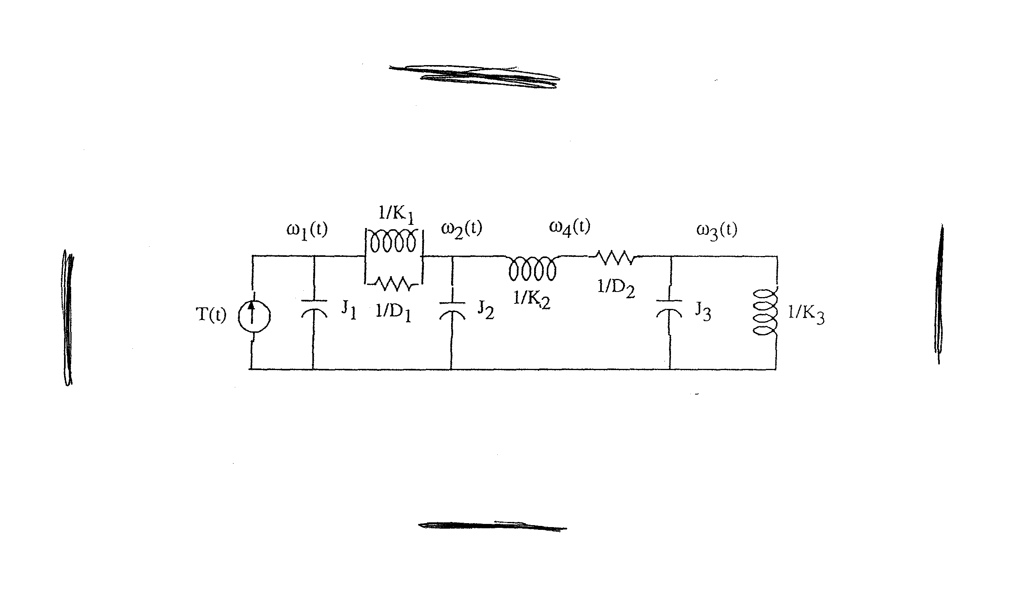

In the circuit, resistors are in ohms, capacitors are in farads, and inductors are in henries.

**40.**

An input r1 yields c1 = 5r1+7. An input r2 yields c2 = 5r2 +7. An input r1 +r2 yields, 5(r1+r2)+7 =

5r1+7+5r2 = c1+c2-7. Therefore, not additive. What about homogeneity? An input of Kr1 yields c = 5Kr1+7 ≠ Kc1. Therefore, not homogeneous. The system is not linear.

**41.**

The truncated Taylor series expansion of $f\left(x\right)=3e^{-5x}≈f\left(0\right)+f^{'}\left(0\right)x=3-15x$

Letting $x=δx$ and substituting for $f(x)$ one gets

$$\frac{d^{3}δx}{dt^{3}}+10\frac{d^{2}δx}{dt^{2}}+20\frac{dδx}{dt}+15δx=3-15δx$$

Simplifying

$$\frac{d^{3}δx}{dt^{3}}+10\frac{d^{2}δx}{dt^{2}}+20\frac{dδx}{dt}+30δx=3$$

**42.**

The relationship between the nonlinear spring’s displacement, *x­s(t)* and its force, *fs(t)* is



Solving for the force,  (1)

Writing the differential equation for the system by summing forces,

 (2)

Letting *x(t)* = *x0* + *x* and *f(t)* = 1 + *f*, linearize ln(1 – *x(t)*).



Solving for ln(1 – *x*),

 (3)

When f = 1, x = 0. Thus from Eq. (1), 1 = -ln(1 – *x0* ).

Solving for x0, 1 – x0 = e-1 , or x0 = 0.6321.

Substituting x0 = 0.6321 into Eq. (3),



Placing this value into Eq. (2) along with *x(t)* = *x0* + *x* and *f(t)* = 1 + *f* , yields the linearized differential equation, 

or 

Taking the Laplace transform and rearranging yields the transfer function,



**43.**

1. The three equations are transformed into the Laplace domain:







The three equations are algebraically manipulated to give:









By direct substitutions it is obtained that:















**44.**

Eliminate  by direct substitution. This results in



Obtaining Laplace transform on both sides of this equation and eliminating terms one gets that:

$$\frac{Θ}{T_{d}}(s)=\frac{\frac{1}{J}s}{s^{3}+ηs^{2}+ks-ρ}$$

**45.**

The Laplace transform of the systems output is

$$L\left\{T(t)\right\}=T\left(s\right)=\frac{T_{ref}}{s}-\frac{T_{ref}}{s+λ}+\frac{2aπf}{s^{2}+4π^{2}f^{2}}=\frac{T_{ref}λ}{s(s+λ)}+\frac{2aπf}{s^{2}+4π^{2}f^{2}}$$

Dividing by the input one gets

$$\frac{T}{U}\left(s\right)=\frac{λ}{s+λ}+\frac{2aπf}{T_{ref}}\frac{s}{s^{2}+4π^{2}f^{2}}$$

**46.**

1. By direct differentiation 
2. 

Lambda = 2.5;

alpha = 0.1;

V0=50;

t=linspace(0,100);

V=V0.*exp(Lambda.*(1-exp(-alpha.*t))/alpha);

plot(t,V)

grid

xlabel('t (days)')

ylabel('mm^3 X 10^-3')



1. From the figure  mm3X 10-3

From part c  mm3X 10-3

**47.**

Using the impedance method the two equations are:

|  |  |
| --- | --- |
| $x_{1}$**:** | $$\left(ms^{2}+k\right)x_{1}-x_{m}k=F_{1}$$ |
| $x_{m}$**:** | $$-x_{1}k+(Bs+k)x_{m}=F_{iso}$$ |

Solving both equations simultaneously, one gets

$$x_{1}=\frac{\left|\begin{matrix}F_{1} & -k \\ F_{iso} & Bs+k\end{matrix}\right|}{\left|\begin{matrix}ms^{2}+k & -k \\ -k & Bs+k\end{matrix}\right|}=\frac{F_{1}\left(Bs+k\right)+F_{iso}k}{\left(ms^{2}+k\right)\left(Bs+k\right)-k^{2}}=\frac{F_{1}Bs+k(F_{1}+F_{iso})}{s(mBs^{3}+kms+kB)}$$

**48.**

Opening the current source, we find the contribution of the voltage source, *Va*(s), to the ac current, *IacF*1(s).



Short-circuiting the voltage source, *Va*(s), we find the contribution of the current source, *IacR*(s), to the ac current, *IacF*2(s).



Thus, the total current, *IacF* (s), is given by:



**49.**

Writing the loop equation around the armature circuit for the motor in Figure 2.35:

$$e_{a}\left(t\right)=R_{a}i_{a}+L_{a}\frac{di_{a}}{dt}+K_{b}\frac{dθ_{m}}{dt}$$

Taking the Laplace transform:

 (1)

The torque developed at the motor is:



Taking the Laplace transform:



But . Solving for and substituting for 



Substituting in (1) for and simplifying



Thus



**50.**

**a.** Expressing  as a Taylor series around *h0i*

 (1)

Also,

 (2)

and

 (3)

Substituting (1), (2), and (3) into the given nonlinear equation and eliminating the equilibrium values yields the linear equation



Thus the transfer function is



**b.** Substituting into 



Rearranging



Simplifying,



Taking the Laplace transform



From which,



**51.**

1. The first two equations are nonlinear because of the  products on their right hand side. Otherwise the equations are linear.
2. To find the equilibria let 

Leading to







The first equilibrium is found by direct substitution. For the second equilibrium, solve the last two equations for T*

 and . Equating we get that 

Substituting the latter into the first equation after some algebraic manipulations we get that . It follows that .

**52**.

1. From ****, we have:  (1)

Substituting for the motive force, *F*, and the resistances *FRo*, *FL*, and *F*st using the equations given in the problem, yields the equation:

 (2)

1. Noting that constant acceleration is assumed, the average values for speed and acceleration are:

*aav* = 20 (km/h)/ 4 s = 5 km/h.s = 5x1000/3600 m/s2 = 1.389 m/s2

*vav* = 50 km/h = 50,000/3,600 m/s = 13.89 m/s

The motive force, *F* (in N), and power, *P* (in kW) can be found from eq. 2:

*Fav* = 0.011 x 1590 x 9.8 + 0.5 x 1.2 x 0.3 x 2 x 13.892 + 1.2 x 1590 x 1.389 = 2891 N

*Pav* = *Fav. v* / *η*= 2891 x 13.89 / 0.9 = 44, 617 N.m/s = 44.62 kW

To maintain a speed of 60 km/h while climbing a hill with a gradient α = 5o, the car engine or motor needs to overcome the climbing resistance:

N

Thus, the additional power, *Padd*, the car needs after reaching 60 km/h to maintain its speed while climbing a hill with a gradient α = 5o is:

* =* 1358 x 60 x 1000/(3,600 x 0.9) = 25, 149 W = 25.15 kW

1. Substituting for the car parameters into equation 2 yields:



or  (3)

To linearize this equation about *vo* = 50 km/h = 13.89 m/s, we use the truncated taylor series:

 (4), from which we obtain:

 (5)

Substituting from equation (5) into (3) yields:

 or

 (6)

Equation (6) may be represented by the following block-diagram:

Car Speed, *v(t)*

Gv

+

*F*o = *69.46 N*

+

Motive Force,

*F (t)*

_

Excess Motive Force, *Fe(t)*

*FRo* = *171.4 N*

1. Taking the Laplace transform of the left and right-hand sides of equation (6) gives,

 (7)

Thus the transfer function, *Gv(s)*, relating car speed, *V(s)* to the excess motive force, *Fe(s)*, when the car travels on a level road at speeds around vo = 50 km/h = 13.89 m/s under windless conditions is:

 (8)

**53.**

Since the system’s transfer function exhibits a pure time delay of T seconds, the unit step response of the system is the unit step response of a first order system delayed T seconds, namely

$$h\left(t\right)=K\left(1-e^{-\frac{t-T}{τ}}\right)u\left(t-T\right)$$

**b.**



**c.**

The output will he delayed T seconds, thus writing

$$\frac{H(s)}{Q(s)}=\frac{K}{(1+τs)}e^{-sT}$$

Then cross-multiplying

$$H\left(s\right)\left(1+τs\right)e^{sT}=KQ(s)$$

And obtaining the inverse Laplace transform, one gets:

$$τ\frac{d}{dt}h\left(t+T\right)+h\left(t+T\right)=Kq(t)$$